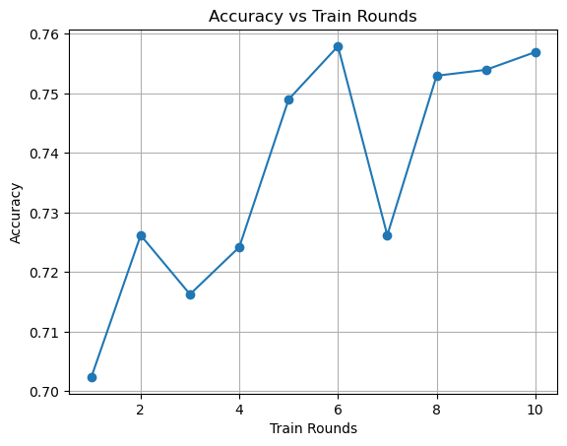

lr=5e-5

bert-base-chinese

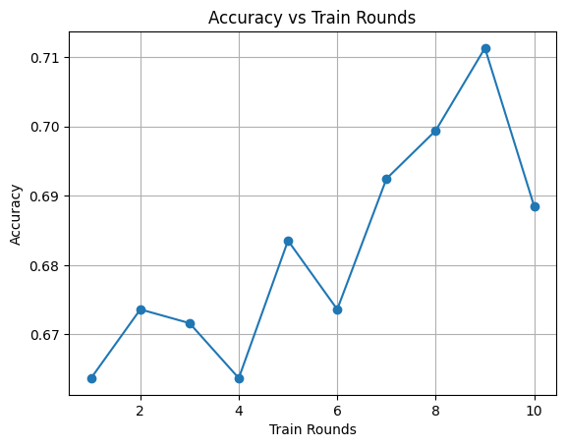

bert-base-chinese

lr=5e-3

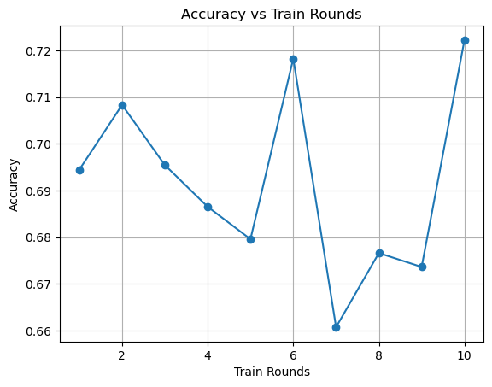

bert-base-multilingual-uncased

lr=5e-5

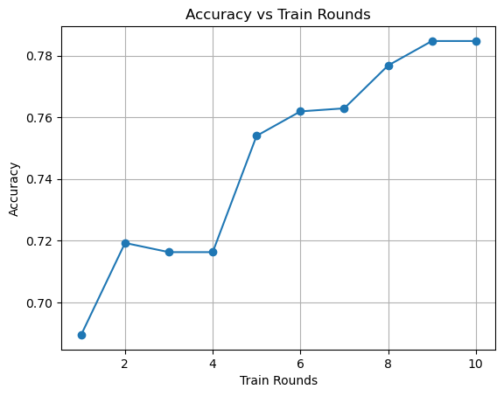

bert-base-chinese

lr=4e-5