





Coal Trader

Monday, September 16, 2024

**US OTC coals open week with unchanged finishes**

September weather expected at or near norms

NYMEX natural gas contract adds 6.8 cents

US over-the-counter coals opened the week on Sept. 16 with a slate of stable assessments, holding with average temperatures expected nationwide in this shoulder season.

S&P Global PointLogic data points to temperatures within 2 degrees Fahrenheit of seasonal norms through the end of the month. The Northeast forecast follows that expectation, while Midcontinent temperatures could rise to 6 degrees above normal in the next week. Southeast temperatures are expected to stay at or below seasonal averages through September.

|  |
| --- |
| **Now available digitally on Platts Connect** |

|  |
| --- |
| [Get access to this content](http://plattsconnect.spglobal.com  )  [plattsconnect.spglobal.com](http://plattsconnect.spglobal.com  ) | ci.support@spglobal.com |

**Platts daily physical OTC assessments, Sep 16**

|  |  |  |  |  |  |
| --- | --- | --- | --- | --- | --- |
| Prompt month price | Symbol | Btu/lb | Mode | $/st | Change |
| CAPP rail (CSX) OTC | CAKM001 | 12,500 | Rail | 73.50 | 0.00 |
| PRB 8,800 OTC | CTAM001 | 8,800 | Rail | 13.95 | 0.00 |
| PRB 8,400 OTC | CTBM001 | 8,400 | Rail | 11.40 | 0.00 |
| IB 11,500* OTC | CISM001 | 11,500 | Barge | 40.50 | 0.00 |

*Maximum 0.35% chlorine. See Platts Methodology and Specifications Guide at Platts.com for details.

**Platts daily physical assessments, Sep 16**

|  |  |  |  |  |  |
| --- | --- | --- | --- | --- | --- |
| Prompt price | Symbol Kcal/kg | | Basis | $/mt | Change |
| CIF ARA | CSARM01 | 6,000 | NAR | 110.80 | -1.50 |

(continued on page 9) **NYMEX Henry Hub natural gas futures, Sep 16**

**Inside this Issue**   
Asian met coal market sees fresh trade at lower level; sellers await China’s return.. 2 Energy Transfer NGLs line catches fire near Houston, forcing evacuations........... 2 New York gets funding to expand EV fast charging, increasing power demand amid tighter supply........................................................................ 4 IAEA sees potential for global nuclear capacity more than doubling by 2050........ 5 Alberta July coal production holds mostly steady on month at 1.3 MMt: AER........ 6 Colombia seaborne coal exports remain flat on week at 1.1 MMt: CAS................ 7 SOUTH KOREA DATA: August coal imports fall 5.5% on year on decline from small importers............................................................................ 8 Russia’s Rosatom says it could restart occupied Ukrainian nuclear plant............ 8

**Platts final monthly averages** (Aug) Based on Platts daily physical OTC assessments ($/st)

|  |  |  |  |  |
| --- | --- | --- | --- | --- |
| CAPP rail (CSX) OTC | CAKOM01 | Aug-24 | Jul-24 | Change |
| 73.52 | 72.68 | +0.84 |
| PRB 8,800 OTC | CTAOM01 | 13.81 | 13.80 | +0.01 |

|  |  |  |  |
| --- | --- | --- | --- |
| Prompt price | Symbol | $/MMBtu | Change |
| Henry Hub | NMNG001 | 2.373 | +0.068 |



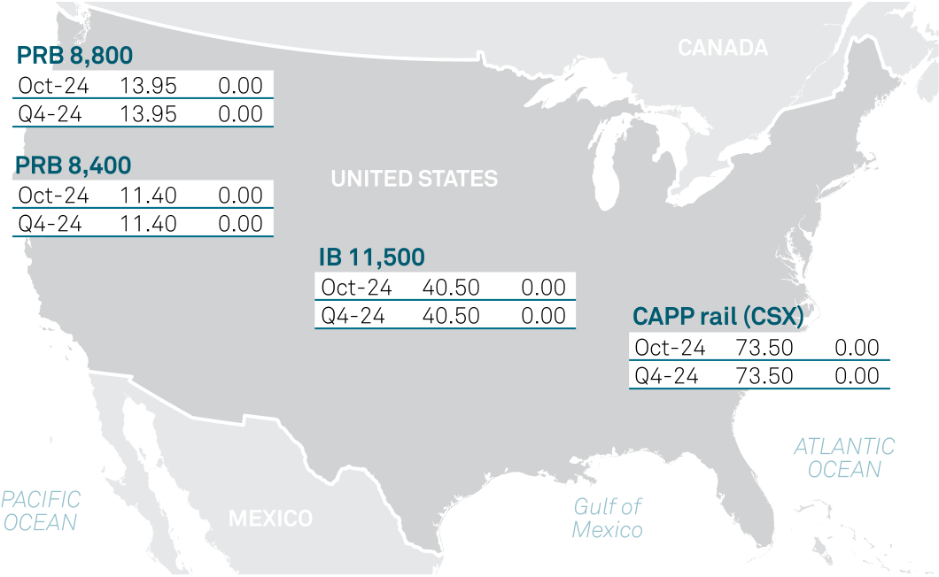

PRB 8,400 OTC CTBOM01 11.36 11.35 +0.01



 



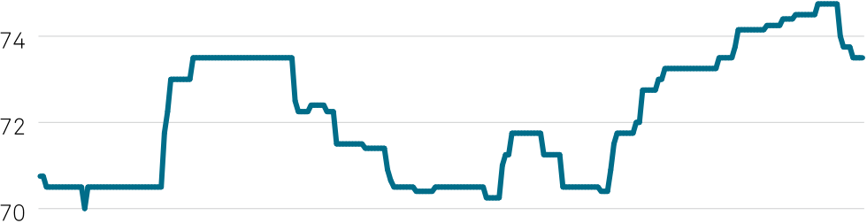















|  |  |  |
| --- | --- | --- |
|  |  |  |
| www.spglobal.com/commodityinsights |  | www.twitter.com/SPGCIShipping |

|  |  |  |  |  |  |  |  |
| --- | --- | --- | --- | --- | --- | --- | --- |
| Coal Trader | Monday, September 16, 2024 | **US FOB coal assessments, Sep 16** | | |  |  |  |
|  | |
| **Asian met coal market sees fresh trade at lower level; sellers await China’s return** | | Code | $/mt | Change |
| Kcal/kg NAR | | Sulfur |
| FOB Baltimore | 6900 | 3.00% | CUATB04 | 74.30 | +0.25 |

Oct-loading PLV sold at $180/mt FOB

Indian mill seek offers for 30,000-35,000 mt Sep/Oct-loading PMV

Asian metallurgical coal prices were largely stable with a prime coal cargo sold at a lower level Sept. 16, although most sellers were on the sidelines awaiting China’s return after the Mid-Autumn Festival on Sept. 17.

Platts assessed Premium Low-Vol (PLV) Hard Coking Coal $1/mt lower on the day at $180/mt FOB Australia Sept. 16; PLV CFR China was assessed steady at $196/mt over the same time period.

A cargo was heard traded via globalCOAL at $180/mt FOB Australia, Sept. 16, for 70,000 mt of PLV coal with Peak Downs or BMA PLV in seller’s option, loading Oct. 10-19. The cargo was understood to be resold by an international steelmaker to an Asian trader.

An international steelmaker source said they believed the Australian prime coal market still has room for downward correction given the reselling interest for Q4-loading cargoes, on top of the position cargoes that traders are struggling to liquidate.

Another international steelmaker source, meanwhile, said it remains difficult to gauge market direction currently. “[It’s] purely [a] function [of] how China behaves,” the source said.

A seller source said it was holding back offers as multiple markets in Northeast Asia were away for holidays.

Despite expectations of a potential market rebound in China, the procurement of a full Panamax of forward-delivery cargo is still considered a “big bet” for Chinese mills, which are prioritizing cash flow management, the seller source said.

Pockets of demand were seen coming from India, where a steelmaker is poised to collect offers by Sept.16 for 30,000-35,000 mt of Australian premium mid-vol coal loading in September/October.

Indian steel demand was still sluggish and such significant volume demand for coking coal was not expected to arise from the country in the near term, an Indian steelmaker said.

A source with another India-based end-user said offers were limited with sellers being inactive amid China’s absence.

The market direction is still quite unclear, the source said, adding even with China’s return, upside potential should be

|  |  |  |  |  |  |
| --- | --- | --- | --- | --- | --- |
| FOB New Orleans | 6000 | 2.90% | CUAFA04 | 70.90 | +0.50 |

Normalized

|  |  |  |  |  |  |
| --- | --- | --- | --- | --- | --- |
| FOB Baltimore | 6000 | 3.00% | CUADA04 | 64.60 | +0.20 |

Loading 15-60 day basis.

limited as Chinese mills have yet to absorb the seaborne prime coal volume at the Chinese ports.

The PLV trade on the day caught the attention from some China-based market participants.

A Chinese steelmaker source, who followed the trade, said a net-forward level is deemed suitable for procurement as it is only slightly above Yuan 1,600/mt on a DDP basis, which is more competitive than domestic PLV.

The source added they can only procure 10,000 mt should they decide to buy.

“It’s still hard for Chinese mills to commit to a full Panamax, and most would prefer to buy port stock in smaller quantities,” a Chinese trader said.

In the met coke segment, both the FOB China and CFR India prices were unchanged on the day.

With respect to the pending price hike for China’s domestic met coke, a local cokery source said the outcome would hinge on the steel product price movement after the holiday.

Platts is part of S&P Global Commodity Insights.

*— [Staff](mailto:support@platts.com)*

News

**Energy Transfer NGLs line catches fire near Houston, forcing evacuations**

20-inch pipeline carried Y-grade NGLs

Fire expected to burn into the night

Early reports of car in right of way before fire

Local authorities in Houston ordered evacuations and shelter-in-place orders Sept. 16 after an Energy Transfer pipeline carrying natural gas liquids caught fire.

The city of La Porte said its fire department responded at 9:55 am CT to the fire, which occurred in the neighboring city of Deer Park. Authorities expect the fire to continue to burn for hours,

|  |  |  |  |  |  |  |  |  |  |  |  |  |  |  |
| --- | --- | --- | --- | --- | --- | --- | --- | --- | --- | --- | --- | --- | --- | --- |
| **Platts daily physical coal assessments, Sep 16** ($/st) | | | | | Oct  average | | Daily av. change | Q3 final  average | | Q4 daily  assessment | | Q4  average | | Daily av. change |
| Coal product specifications | Sep final  monthly av. | | Oct daily  assessment | |
| CAPP rail (CSX) (12,500 Btu/lb) OTC | CTJBM01 | 74.34 | CTJM001 | 73.50 | CTNAO03 | 74.17 | -0.04 | CTJBQ01 | 71.89 | CTJQ001 | 73.50 | CTNAO05 | 74.17 | -0.04 |
| PRB 8,800 Btu/lb OTC | CTKBM01 | 13.93 | CTKM001 | 13.95 | CTNAP03 | 13.95 | 0.00 | CTKBQ01 | 13.70 | CTKQ001 | 13.95 | CTNAP05 | 13.95 | 0.00 |
| PRB 8,400 Btu/lb OTC | CTLBM01 | 11.40 | CTLM001 | 11.40 | CTNAR03 | 11.40 | 0.00 | CTLBQ01 | 11.26 | CTLQ001 | 11.40 | CTNAR05 | 11.40 | 0.00 |

Note: The daily prompt month price is identical to the Daily Physical OTC assessments table on Page 1.

|  |  |
| --- | --- |
| © 2024 by S&P Global Inc. All rights reserved. | 2 |

|  |  |
| --- | --- |
| Coal Trader | Monday, September 16, 2024 |
|  | |

Deer Park Mayor Jerry Mouton said during a press conference Sept. 16.

“All of the product has to burn off,” Mouton said. First   
responders contained the fire, but it could burn “if not into tonight then tomorrow.”  
 Energy Transfer confirmed the fire occurred on a 20-inch line carrying Y-grade NGLs, saying that no injuries were reported. Local authorities later said one firefighter was treated for minor injuries.

Y-grade NGLs include ethane, propane, butane and natural gasolines, according to Energy Transfer product specifications and prices spiked as a result.

Platts propane values rose to 67.50 cents/gal, up Y on the day and the highest since Sept. 5, according to S&P Global Commodity Insights.

A position for propane entered the Platts Market on Close assessment process for the first time in a week, and traded at 67.50 cents/gal, 4.75 cents/gal higher than the previous close. The price was last reported higher on Sept. 5 at 69.75 cents/gal.

“The line has been isolated so that the residual product in the line can safely burn itself out,” Energy Transfer spokesperson Cassidy Lamb said in a statement. “We have no timeline at this point on how long that process will take, but we are working closely with local authorities.”  
 The pipeline operator also said it was “aware of early reports indicating that an unknown passenger car entered our right of way and struck the [valve] location.”  
 Mouton acknowledged the presence of a vehicle near the burning pipeline but declined to speculate whether it caused the fire.

The Railroad Commission of Texas announced that its pipeline safety inspectors are also investigating the fire alongside local authorities. The regulator said the fire occurred within a pipeline corridor and that it is “notifying other pipeline operators in the corridor of the incident and getting information on measures they are taking to ensure safety of their systems.”  
 *— [Jeremy Beaman](mailto:jeremy.beaman@spglobal.com), [Binish Azhar](mailto:binish.azhar@spglobal.com)*





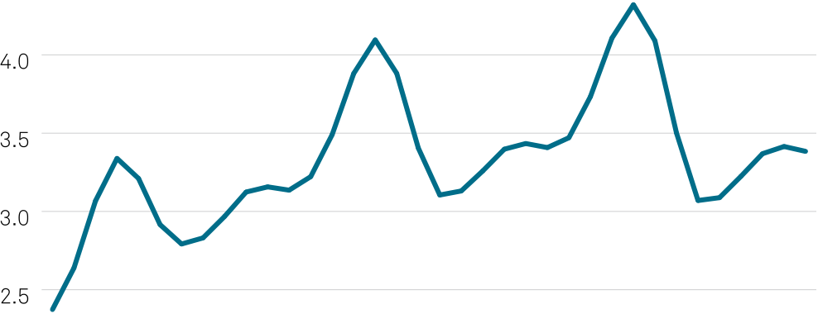





**NYMEX Henry Hub gas futures contract, Sep 16**

|  |  |  |  |  |  |
| --- | --- | --- | --- | --- | --- |
| Oct 2024 | Settlement | High | Low | +/- | Volume |
| 2.373 | 2.397 | 2.265 | +0.068 | 62791 |
| Nov 2024 | 2.639 | 2.656 | 2.547 | +0.050 | 22702 |
| Dec 2024 | 3.067 | 3.075 | 2.986 | +0.042 | 6128 |
| Jan 2025 | 3.339 | 3.345 | 3.261 | +0.038 | 5333 |
| Feb 2025 | 3.211 | 3.218 | 3.137 | +0.033 | 2114 |
| Mar 2025 | 2.916 | 2.924 | 2.853 | +0.028 | 1467 |
| Apr 2025 | 2.792 | 2.801 | 2.734 | +0.025 | 1580 |
| May 2025 | 2.831 | 2.839 | 2.775 | +0.021 | 1197 |
| Jun 2025 | 2.968 | 2.976 | 2.919 | +0.015 | 452 |
| Jul 2025 | 3.124 | 3.134 | 3.078 | +0.012 | 900 |
| Aug 2025 | 3.157 | 3.166 | 3.115 | +0.007 | 361 |
| Sep 2025 | 3.136 | 3.145 | 3.095 | +0.005 | 467 |
| Oct 2025 | 3.222 | 3.231 | 3.177 | +0.006 | 1026 |
| Nov 2025 | 3.491 | 3.496 | 3.443 | +0.011 | 138 |
| Dec 2025 | 3.881 | 3.885 | 3.828 | +0.018 | 229 |
| Jan 2026 | 4.096 | 4.098 | 4.053 | +0.009 | 234 |
| Feb 2026 | 3.882 | 3.884 | 3.843 | +0.007 | 109 |
| Mar 2026 | 3.406 | 3.410 | 3.372 | +0.011 | 83 |
| Apr 2026 | 3.105 | 3.114 | 3.075 | +0.015 | 104 |
| May 2026 | 3.131 | 3.133 | 3.104 | +0.014 | 59 |
| Jun 2026 | 3.259 | 3.264 | 3.235 | +0.011 | 22 |
| Jul 2026 | 3.398 | 3.399 | 3.381 | +0.007 | 28 |
| Aug 2026 | 3.434 | 3.444 | 3.417 | +0.006 | 40 |
| Sep 2026 | 3.408 | 3.416 | 3.388 | +0.006 | 40 |
| Oct 2026 | 3.471 | 3.481 | 3.456 | +0.006 | 8 |
| Nov 2026 | 3.733 | 3.733 | 3.733 | +0.008 | 0 |
| Dec 2026 | 4.107 | 4.111 | 4.107 | +0.011 | 52 |
| Jan 2027 | 4.321 | 4.335 | 4.321 | -0.004 | 6 |
| Feb 2027 | 4.090 | 4.093 | 4.090 | -0.003 | 1 |
| Mar 2027 | 3.502 | 3.529 | 3.502 | -0.002 | 27 |
| Apr 2027 | 3.070 | 3.070 | 3.068 | +0.016 | 1 |
| May 2027 | 3.088 | 3.088 | 3.088 | +0.018 | 0 |
| Jun 2027 | 3.225 | 3.225 | 3.225 | +0.020 | 0 |
| Jul 2027 | 3.369 | 3.369 | 3.369 | +0.022 | 0 |
| Aug 2027 | 3.415 | 3.529 | 3.502 | +0.024 | 0 |
| Sep 2027 | 3.384 | 3.384 | 3.368 | +0.026 | 1 |



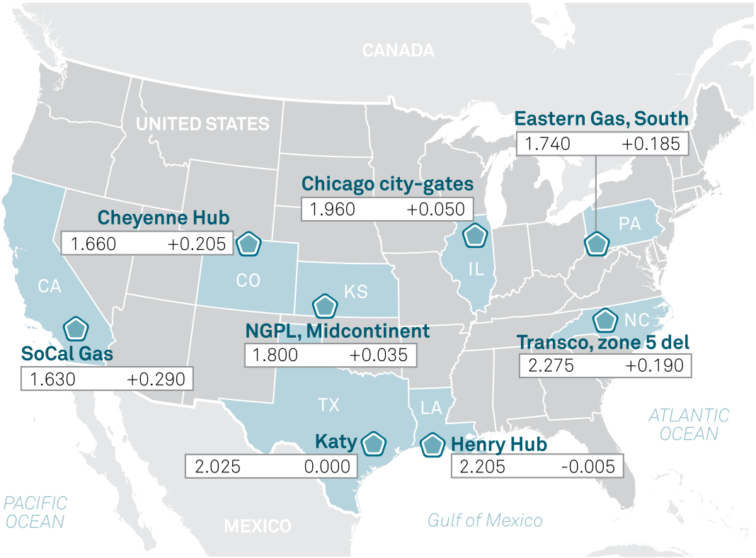

|  |  |  |
| --- | --- | --- |
|  |  |  |
| © 2024 by S&P Global Inc. All rights reserved. | 3 |  |

|  |  |
| --- | --- |
| Coal Trader | Monday, September 16, 2024 |
|  | |

**New York gets funding to expand EV fast charging, increasing power demand amid tighter supply**

$21 million available for DC fast chargers

Preliminary NYISO study shows power market tightening

New York makes $21 million available to install electric vehicle fast chargers along major corridors across the state with the sites required to have no less than 150 kW of capacity which will increase power demand, along with additional electrification efforts and the construction of several large load projects   
including data centers.

The EV charging initiative is being funded by a federal National Electric Vehicle Infrastructure grant, according to a Sept. 13 statement from New York Governor Kathy Hochul’s office.

The state has created a competitive “Upstate NEVI   
Direct Current Fast Charger” program to help expand DCFC infrastructure making it easier for EV drivers to access a reliable charging network, the governor’s office said.

The first funding round focuses on locations along and north of Interstate 84, including parts of the state north to the Canadian border and west to Buffalo, the statement said.

The funding will be available to qualified infrastructure developers for installing and operating DCFC stations at one or more sites along Federal Highway Administration-designated “Alternative Fuel Corridors, or AFCs.

“Proposed sites must meet all federal requirements, including being located within one travel mile of an exit, being publicly accessible 24 hours a day, seven days a week, and having the ability to charge at least four electric vehicles simultaneously,” according to the statement.





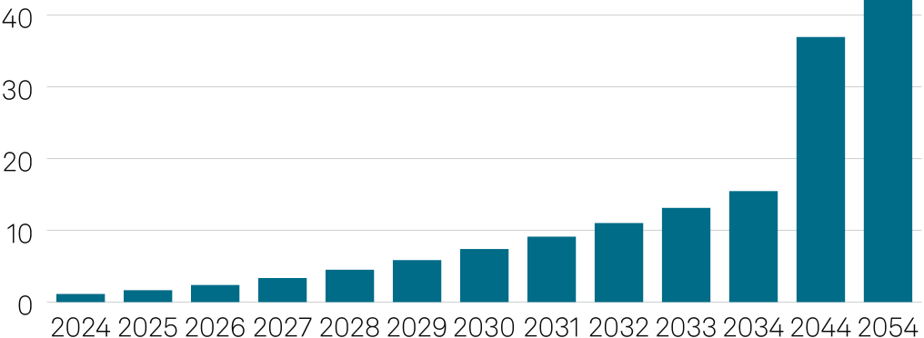



Charging sites must also have no less than 150 kW of capacity and must meet federal uptime requirements regarding the percentage of time the charging stations are functional.

“As we make the transition away from [gasoline] gas-powered vehicles, New York is accelerating the number of electric vehicle fast chargers available to reduce harmful emissions and improve air quality in our communities,” Governor Hochul said.

**Platts daily metallurgical coal assessments, Sep 16** Atlantic coking coal ($/mt)

|  |  |  |  |  |  |  |  |  |
| --- | --- | --- | --- | --- | --- | --- | --- | --- |
| Low Vol HCC | Symbol | FOB US East Coast | | | Change | VM | Ash | S |
| AAWWR00 | | 190.00 | 0.00 19.25% 8.25% 0.95% | | | | |
| High Vol A | AAWWS00 | | 185.00 | 0.00 32.25% 7.5% 0.95% | | | | |
| High Vol B | AAWWT00 | | 171.00 | +2.00 | | 36% | 8% | 1% |
| PLV NetForward | CFR NW Europe Change | | | | | VM | Ash | S |
| PLVHE00 | | 194.55 | -1.00 | | 21.5% 9.3% 0.50% | | |

Asia-Pacific coking coal ($/mt)

|  |  |  |  |  |  |  |
| --- | --- | --- | --- | --- | --- | --- |
| Premium Low Vol | FOB Australia | | Change | VM | Ash | S |
| PLVHA00 | 180.00 | -1.00 21.50% 9.3% 0.5% | | | |
| Low Vol HCC | HCCAU00 | 155.00 | 0.00 25.50% 9.0% 0.6% | | | |

US low-vol HCC Penalties & Premia; Differentials ($/mt)

|  |  |  |  |
| --- | --- | --- | --- |
| Per 1% CSR | Within  Min-Max | % of US low-vol  HCC FOB USEC  assessment price | Net value ($/mt) |
| 50-64% | 0.50% | 0.95 |
|  | 40-49% | 0.50% | 0.95 |
| Per 0.1% S | 0.70-1.05% | 0.85% | 1.62 |
|  | 1.06-1.25% | 1.80% | 3.42 |
| Per 1% TM (as received) | 6-11% | 1.00% | 1.90 |
| Per 1% Ash | 5-10% | 1.75% | 3.33 |

Detailed methodology and specifications are found here: http://platts.com/IM.Platts. Content/MethodologyReferences/MethodologySpecs/metcoalmethod.pdf

**Spot dry bulk freight assessments, Sep 16**

|  |  |  |  |
| --- | --- | --- | --- |
| Capesize | Platts symbol | $/mt | Chg |
| Australia-China | CDANC00 | 13.60 | +0.35 |
| Queensland-Japan | CIGAJ00 | 15.30 | +0.45 |
| New South Wales-Korea | CINAK00 | 16.45 | +0.45 |
| Bolivar-Rotterdam | CIBCR00 | 11.20 | -0.15 |
| Roberts Bank-Japan | CDRKJ00 | 15.20 | +0.30 |

Panamax

|  |  |  |  |
| --- | --- | --- | --- |
| Richards Bay-India West | CSAKL00 | 14.75 | +0.05 |
| Kalimantan-India West | CSAKP00 | 9.75 | +0.05 |
| Richards Bay-India East | CSAKN00 | 15.00 | +0.05 |
| Kalimantan-India East | CSAKR00 | 8.20 | +0.05 |
| Ventspils-Rotterdam | CILTN00 | 7.75 | 0.00 |
| USEC-India | CDBUI00 | 39.00 | +0.50 |
| USEC-Rotterdam | CDBUR00 | 12.00 | +0.50 |
| Mobile-Rotterdam | CDMAR00 | 15.25 | +0.50 |
| Roberts Bank-Japan | CDRBK00 | 17.15 | -0.05 |
| Australia-China | CDBFA00 | 14.95 | +0.10 |
| Australia-India | CDBFAI0 | 15.95 | +0.05 |

Supramax

|  |  |  |  |
| --- | --- | --- | --- |
| Richards Bay-Port Qasim | CRBPB00 | 17.45 | +0.05 |
| South Kalimantan-Krishnapatnam | CISKK00 | 12.70 | +0.10 |

**Platts physical thermal coal netbacks, Sep 16**

|  |  |  |  |  |  |  |
| --- | --- | --- | --- | --- | --- | --- |
| Coal ($/mt) | Code | CV  (kcal/kg) | Basis | Sulfur | $/mt | Chg |
| CIF ARA | CSARM01 | 6,000 | NAR | 1.0% | 110.80 -1.50 | |
| Platts NEAT | JKTCA00 | 5,750 | NAR | 1.0% 112.44 +0.11 | | |
| CFR India West | CIWCI00 | 5,500 | NAR | 0.8% 104.20 +0.05 | | |
| Panamax Freight ($/mt) | | | 12.00 +0.50 | | | |
| USEC-Rotterdam | CDBUR00 | |
| Mobile-Rotterdam | CDMAR00 | | 15.25 +0.50 | | | |
| Roberts Bank-Japan | CDRBK00 | | 17.15 -0.05 | | | |
| Richards Bay-India West | CSAKL00 | | 14.75 +0.05 | | | |
| Penalties & Premia ($/mt) | | | 1.32 -0.10 | | | |
| Per 0.1% Sulfur (USGC) | COPAP00 | |
| Total S discount (USGC) | COPBP00 | | 25.08 -1.90 | | | |
| Netbacks ($/mt) | | | NAR max 1% 95.30 +0.15 | | | |
| FOB West Coast North America CTVCB00 | | 5,750 |
| Netbacks ($/st) | | | GAR | 1.0% | 99.59 -2.02 | |
| FOB US East Coast* | COUSC00 12,500 | |
| FOB US Gulf Coast* | COUGU00 11,500 | | GAR | 2.9% 65.53 -0.13 | | |

* CV = Btu/lb

|  |  |
| --- | --- |
| © 2024 by S&P Global Inc. All rights reserved. | 4 |

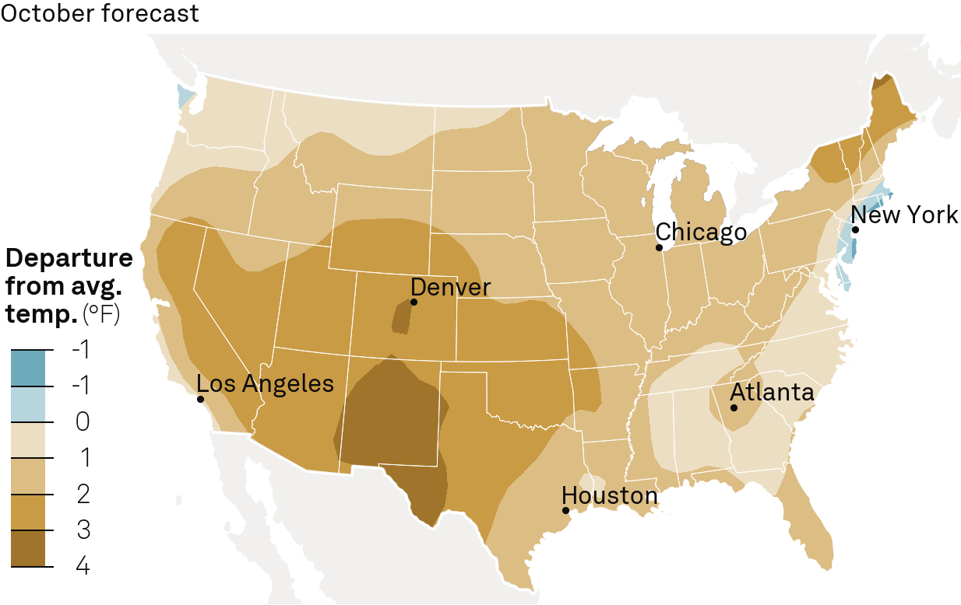

|  |  |
| --- | --- |
| Coal Trader | Monday, September 16, 2024 |
|  | |

**Grid operator reliability concerns**   
 As the state moves ahead with multiple strategies to comply with its aggressive climate law, the Climate Leadership and Community Protection Act, a recent New York Independent System Operator power grid study has indicated the power supply is tightening.

New York is advancing measures to ensure that all new passenger cars and trucks sold be zero emissions by 2035, as well as having all school buses be zero emissions the same year, according to the statement.

The state is also working to electrify space heating in   
commercial buildings and homes, which will further increase power demand. At the same time, power demand is increasing due to construction of new industrial facilities and data centers.

A preliminary NYISO study has found the state could be at risk of insufficient power supplies of at least 1,000 MW by 2034 due to increasing power demand as well as assumed natural gas unavailability.

Part of the concern is that while power demand is increasing from efforts to combat climate change and increase economic development, tighter regulations for gas-fired power plants are causing some power plants to retire, thus reducing supply while demand is increasing.

The NYISO study also found that there could be a New York City transmission security margin baseline deficiency starting in 2031 due to expected New York Power Authority small gas-fired power plant retirements, growing to 275 MW by 2034 due to demand growth, according to preliminary Reliability Needs Assessment results.

By 2034, NYISO expects 2,821 MW of incremental power   
generation capacity to be added to the system and 1,216 MW to be removed. Additionally, power demand from large loads during the summer peak increases from 368 MW in 2024 to 2,268 MW by 2034, with similar results for the winter peak.

Demand from EVs is forecast to increase from 1,124 GWh in 2024 to 36,937 GWh by 2044, according to NYISO data.

Additionally, power demand from electrifying buildings is expected to outstrip power demand from EVs by around 2040.

By 2044, the combined power demand from EVs and building electrification is 81,821 GWh, up from a total of 1,378 GWh in 2024, NYISO data shows.

*— [Jared Anderson](mailto:jared.anderson@spglobal.com)*

**IAEA sees potential for global nuclear capacity more than doubling by 2050**

In scenario with less supportive actions, capacity could rise 40%

Small reactors could be a quarter of new capacity

Slow growth in North America, Europe, jump seen in Asia

World nuclear power capacity may more than double by 2050, a report from the International Atomic Energy Agency said Sept. 16. The IAEA report assumed a strong roll out of small modular

**Heating/cooling degree day outlook**

|  |  |  |  |  |
| --- | --- | --- | --- | --- |
| NERC Region | Oct-24 | Departure  from normal | Nov-24 | Departure  from normal |
| WECC | 81 | -18% | 225 | -12% |
| SPP | 118 | -1% | 451 | 0% |
| SERC | 56 | -26% | 317 | -4% |
| RFC | 243 | -16% | 630 | -1% |
| NPCC | 183 | -20% | 527 | -1% |
| MRO | 325 | -5% | 728 | 0% |
| FRCC | 0 | 0% | 29 | -15% |
| ERCOT | 7 | +123% | 136 | +4% |

Note: Heating Degree Days run September 1 to April 30, Cooling Degree Days run May 1 to August 31   
Source: CustomWeather



|  |
| --- |
|  |



reactors, along with national investments in grids, reactor demonstration projects, and standards harmonization.

From a base of 372 GW global nuclear operational capacity at the end of 2023, the report looked at high and low estimates for likely nuclear power output by 2050, depending on policy and business actions.

“In the high case, global nuclear operational capacity is projected to increase to 2.5 times the current capacity, reaching 950 GW by 2050,” the report said. In the low case, an increase of about 40% is predicted, taking total installed capacity to 514 GW in 2040.

SMRs would account for about a quarter (24%) of total installed capacity added between 2023 and 2050 in the high case. In the low case the capacity added by SMRs was 6%.

“SMRs have the potential to support smaller grids in   
developing countries, power electricity-hungry data centers, or even provide low-carbon propulsion for commercial shipping vessels,” IAEA Director General Rafael Grossi said during the opening session of the organization’s general conference Sept. 16. “But they still have challenges to overcome before they can be deployed,” he added, noting that the IAEA is promoting regulatory harmonization to make SMR deployment more efficient.

|  |  |
| --- | --- |
| © 2024 by S&P Global Inc. All rights reserved. | 5 |

|  |  |
| --- | --- |
| Coal Trader | Monday, September 16, 2024 |
|  | |

The IAEA said the high case is “plausible and technically feasible, and it is possible that capacity could increase beyond that projected.”  
 However, “enabling factors” needed to reach or exceed the high case predictions include “national policies and strategies,” in for instance “supporting investment, demonstration projects for new reactor technologies, investment in grids, supply chain management for reactor construction, regulatory collaboration and global harmonization (particularly for SMR development).” In North America, the low case assumed 89 GW installed capacity in 2050, or 228 GW in the high case, compared with 109.5 in 2023. For north, west and southern Europe, the 2050 low and high estimates figures are 69 GW or 135 GW, respectively. The low case represented a decline from 2023 levels of 93.8 GW.

Most growth would be seen in Central and Eastern Asia with 207 GW in the low case and 297 GW in the high case, up from 91.9 GW in 2023. Considerable growth was forecast in Eastern Europe and South Asia in both scenarios.

**Fossil fuels still dominate power mix**   
 Hydro power and nuclear were the largest sources of “low carbon electricity” in 2023, the report said. Nuclear contributed 9.2% of global electricity production in 2023, with hydro power adding about 15% although “its share has been gradually   
declining since 1980.” Wind and solar provided 13% in 2023.

“The share of hydro and nuclear has declined gradually over the past 30-40 years owing to a lack of investment,” the report found. However, “with a share of about 60%, fossil fuels —   
particularly coal — have remained dominant energy sources for electricity production since 1980.”  
 The report assumes that global final energy consumption will have dropped by 2% by 2050 and that electricity production will

“more than” double.

European industry representatives Nuclear Europe said [in an email] they planned to publish their own report “in the coming weeks looking at what different nuclear capacity scenarios in 2050 would bring as benefits to the European energy system.” *— [Emily Waterfield](mailto:support@platts.com)*

Export Markets

**Alberta July coal production holds**   
**mostly steady on month at 1.3 MMt: AER**

Coal Valley production surge boosts total

Province exports 609,709 t to South Korea

A spike in output from producer Coal Valley helped monthly Alberta coal production remain mostly stable in July, according to Sept. 16 data from the Alberta Energy regulator.

The province posted 1.3 million metric tons of output in July, just 1,820 t ahead of its June production total and 80,723 t above its 2024 monthly average.

AER reports monthly totals roughly six weeks after the conclusion of the production period.

Coal Valley’s 425,707 t output total was 154,282 t higher than its June production number and 215,359 t above the July 2023 figure. The output was its highest since March 2023 and pushed its monthly average for the year to 269,354 t.

Coalspur’s July production total fell to a 2024-low 818,378 t, down 172,429 t, or 13.3%, from June. The company’s 2024 monthly output average fell to 869,857 t.

Alberta’s July thermal coal production dipped 1.3% to 1.25 MMt, and 16,915 t that moved its monthly average up to 1.143

|  |  |  |  |  |  |
| --- | --- | --- | --- | --- | --- |
|  | | | | *Coal Trader* is published every business day by S&P Global Commodity Insights, a division of S&P Global, registered office: 20 Canada Square, Canary Wharf, London, E14 5LH. | merchantability or fitness for a particular purpose or use as to the Data, or the results obtained by its use or as to the  performance thereof. Data in this publication includes  independent and verifiable data collected from actual market participants. Any user of the Data should not rely on any  information and/or assessment contained therein in making any investment, trading, risk management or other decision. S&P Global Commodity Insights, its affiliates and their third-party licensors do not guarantee the adequacy, accuracy, timeliness and/or completeness of the Data or any component thereof or |
|  | | | |
| Officers of the Corporation: Richard E. Thornburgh, Non-Executive Chairman; Doug Peterson, President and Chief Executive Officer; Christopher Craig Interim Chief Financial Officer; Steve Kemps, Executive Vice President, General Counsel |
| Coal Trader | | | |
| ISSN: | 1555-3485 | | | © 2024 by S&P Global Inc. All rights reserved. |
|  |
| Contact Client Services: ci.support@spglobal.com Americas: +1-800-752-8878  Europe & Middle East: +44-20-7176-6111  Asia Pacific: +65-6530-64300 | | | | S&P Global, the S&P Global logo, S&P Global Commodity Insights, and Platts are trademarks of S&P Global Inc. Permission for any commercial use of these trademarks must be obtained in writing from S&P Global Inc. | any communications (whether written, oral, electronic or in other format), and shall not be subject to any damages or liability, including but not limited to any indirect, special, incidental, punitive or consequential damages (including but not limited to, |
| You may view or otherwise use the information, prices, indices, |
| Head of Global Coal – Pricing  Deepak Kannan, +91-124-612-7258, deepak.kannan@spglobal.com | | | | assessments and other related information, graphs, tables and images (“Data”) in this publication only for your personal use or, if you or your company has a license for the Data from S&P Global Commodity Insights and you are an authorized user, for your company’s internal business use only. You may not publish,  reproduce, extract, distribute, retransmit, resell, create any  derivative work from and/or otherwise provide access to the Data or any portion thereof to any person (either within or outside your company, including as part of or via any internal electronic system or intranet), firm or entity, including any subsidiary, parent, or other entity that is affiliated with your company, without S&P Global Commodity Insights’ prior written consent or as otherwise authorized under license from S&P Global Commodity Insights.  Any use or distribution of the Data beyond the express uses authorized in this paragraph above is subject to the payment of additional fees to S&P Global Commodity Insights. | loss of profits, trading losses and loss of goodwill). |
| ICE index data and NYMEX futures data used herein are provided under S&P Global Commodity Insights’ commercial licensing agreements with ICE and with NYMEX. You acknowledge that the ICE index data and NYMEX futures data herein are confidential and are proprietary trade secrets and data of ICE and NYMEX or its licensors/suppliers, and you shall use best efforts to prevent the unauthorized publication, disclosure or copying of the ICE index data and/or NYMEX futures data. |
| Associate Editor  Michael Fox, +1-832-450-1549, michael.fox@spglobal.com Morgan Snook, +1-570-505-9285, morgan.snook@spglobal.com | | | |
| Global Head of Generating Fuels & Electric Power Pricing Francis Browne | | | | Permission is granted for those registered with the Copyright Clearance Center (CCC) to copy material herein for internal  reference or personal use only, provided that appropriate  payment is made to the CCC, 222 Rosewood Drive, Danvers, MA 01923, phone +1-978-750-8400. Reproduction in any other form, or for any other purpose, is forbidden without the express prior permission of S&P Global Inc. For article reprints contact: The YGS |
| President of S&P Global Commodity Insights Saugata Saha | | | |
| Advertising  Tel: +1-212-884-9534 | | Manager, Advertisement Sales Joseph Mennella,  joseph.mennella@spglobal.com | | S&P Global Commodity Insights, its affiliates and all of their third-party licensors disclaim any and all warranties, express or  implied, including, but not limited to, any warranties of | Group, phone +1-717-505-9701 x105 (800-501-9571 from the U.S.). |
| For all other queries or requests pursuant to this notice, please contact S&P Global Inc. via email at ci.support@spglobal.com. |
| © 2024 by S&P Global Inc. All rights reserved. | | | 6 |  |  |

|  |  |
| --- | --- |
| Coal Trader | Monday, September 16, 2024 |
|  | |

MMt. The province’s metallurgical coal output reached 52,696 t, up 55.2%, or 18,735 t, from June.

The province exported 662,623 t of coal in July, down 68,140 t, or 9.3%, from June’s total. The 609,709 t exported from Alberta to South Korea was the highest total to the Asian country in 15 years of records. The province also exported coal to Japan and Brazil in July.

Platts, part of S&P Global Commodity Insights, assessed FOB US West Coast North American 5,750 Kcal/kg coal for prompt-month delivery at $95.30/t on Sept. 16, up 15 cents from its previous assessment.





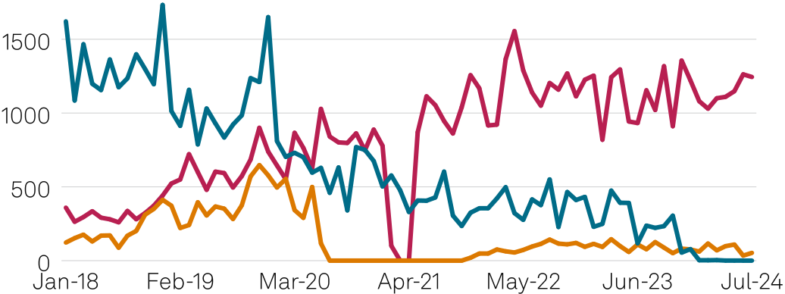



**Weekly coal production totals** (thousand st)

|  |  |  |  |  |
| --- | --- | --- | --- | --- |
| Wyoming & Montana | Week ended  09/07/24 09/07/23 | | Year-to-date  09/07/24 09/07/23 | |
| 4,723 | 5,299 | 145,001 | 182,020 |
| Central Appalachia | 1,425 | 1,393 | 51,005 | 52,660 |
| Northern Appalachia | 1,570 | 1,598 | 54,542 | 60,953 |
| Illinois Basin | 1,346 | 1,378 | 48,673 | 54,172 |
| US Total | 10,402 | 11,075 | 345,361 | 399,587 |

Source: EIA

**Weekly price survey, traditional physical market, week ending Sep 13**

|  |  |  |  |  |  |
| --- | --- | --- | --- | --- | --- |
| Origin/Product | Btu/lb | SO2 lb | Transport | Prompt | Change |
| mode | quarter ($/st) | |

Northern Appalachia

|  |  |  |  |  |  |  |
| --- | --- | --- | --- | --- | --- | --- |
| Pittsburgh Seam | 13,000 | 4 | Rail | CNDQ001 | 49.85 | -0.15 |
| Upper Ohio River | 12,500 | 6+ | Barge | CNEQ001 | 46.00 | +0.10 |

Central Appalachia

|  |  |  |  |  |  |  |
| --- | --- | --- | --- | --- | --- | --- |
| CAPP barge physical | 12,000 | 1.67 | Barge | CNNQ001 | 71.25 | -1.00 |
| CAPP rail (CSX) physical 12,500 | | 1.6 | CSX | CAEQ001 | 73.50 | -0.50 |
| Thacker/Kenova | 12,500 | 1.6 | NS | CAGQ001 | 74.75 | -0.50 |

Illinois Basin

|  |  |  |  |  |  |
| --- | --- | --- | --- | --- | --- |
| 11,800 | 5 | Rail | CIAQ001 | 40.00 | -0.65 |
| 11,800* 5 | | Barge | CTPQ001 | 42.00 | -0.65 |
| 11,500 | 5 | Barge | CIEQ001 | 43.50 | -0.65 |
| 11,000 | 5 | Barge | CICQ001 | 38.00 | -0.65 |

Powder River Basin

|  |  |  |  |  |  |
| --- | --- | --- | --- | --- | --- |
| 9,400 | 0.8 | Rail | CRPQ001 | 14.95 | 0.00 |

|  |  |  |  |  |  |  |
| --- | --- | --- | --- | --- | --- | --- |
|  | 8,800 | 0.8 | Rail | CRAQ001 | 13.95 | 0.00 |
| *— [Michael Fox](mailto:michael.fox@spglobal.com)* | 8,400 | 0.8 | Rail | CRBQ001 | 11.40 | 0.00 |

**Colombia seaborne coal exports remain flat on week at 1.1 MMt: CAS**

Thermal coal exports fall 0.3% on week to 945,766 t

Rocky Mountains

|  |  |  |  |  |  |  |
| --- | --- | --- | --- | --- | --- | --- |
| Colorado | 11,300 | 0.8 | Rail | CURQ001 | 78.50 | 0.00 |
| Utah | 11,500 | 0.8 | Rail | CUDQ001 | 80.50 | 0.00 |

*High chlorine (max 0.35%)   
**Physical bids, offers and trades, Sep 16**

|  |  |  |  |  |  |  |  |
| --- | --- | --- | --- | --- | --- | --- | --- |
| Panama is primary thermal coal destination, to receive | Type | Product | Term | Year | Price | Vol/m Notes | Tons |
| 181,342 t | ($/st) | (‘000) |

FOB Colombia 6,000 kcal/kg NAR coal price rises $1 to $85/t

Colombia seaborne thermal and metallurgical coal exports were flat on the week at 1.1 million metric tons in the week [ended Sept. 15, acco](https://www.spglobal.com/commodityinsights/en/ci/products/commodities-at-sea.html)rding to Sept. 16 data from S&P Global [Commodities at Sea](https://www.spglobal.com/commodityinsights/en/ci/products/commodities-at-sea.html).

[Seaborne therma](https://www.spglobal.com/commodityinsights/en/ci/products/commodities-at-sea.html)l coal exports ticked 0.3% lower on the week to 945,766 t. Metallurgical coal exports declined 18.8% to 140,031 t.

Platts, part of S&P Global Commodity Insights, assessed FOB Colombia 6,000 kcal/kg NAR 0.8%S coal up $1 on the session at $85/t on Sept. 13. The Colombia thermal coal price has been rangebound between $84/t and $85/t since the Aug. 16, 2024, session.

Panama was the primary destination for Colombia seaborne thermal coal exports, due to receive 181,342 t exported in the week ended Sept. 16, followed by Brazil with 168,431 t and the Netherlands with 166,000 t. The remaining destinations were South Korea with 154,161 t, Poland with 90,985 t, Chile with 80,104 t, the Dominican Republic with 66,628 t and Puerto Rico with 38,115 t.

|  |  |  |  |  |
| --- | --- | --- | --- | --- |
| I | CSX | October | 2024 | 72.5 |
| I | PRB 8800 | October | 2024 | 14 |
| I | PRB 8400 | October | 2024 11.55 | |
| I | IB 11500 | October | 2024 39.75 | |
| I | CSX | Q4 | 2024 | 72.5 |
| I | PRB 8800 | Q4 | 2024 | 14 |
| I | PRB 8400 | Q4 | 2024 11.55 | |
| I | IB 11500 | Q4 | 2024 39.75 | |
| I | CSX | October | 2024 | 74.5 |
| I | PRB 8800 | October | 2024 | 13.9 |
| I | PRB 8400 | October | 2024 11.25 | |
| I | IB 11500 | October | 2024 41.25 | |
| I | CSX | Q4 | 2024 | 74.5 |
| I | PRB 8800 | Q4 | 2024 | 13.9 |
| I | PRB 8400 | Q4 | 2024 11.25 | |
| I | IB 11500 | Q4 | 2024 41.25 | |
| I | CSX | October | 2024 | 74.5 |
| I | PRB 8800 | October | 2024 | 13.9 |
| I | PRB 8400 | October | 2024 11.25 | |
| I | IB 11500 | October | 2024 41.25 | |
| I | CSX | Q4 | 2024 | 74.5 |
| I | PRB 8800 | Q4 | 2024 | 13.9 |
| I | PRB 8400 | Q4 | 2024 11.25 | |
| I | IB 11500 | Q4 | 2024 41.25 | |

|  |  |
| --- | --- |
| © 2024 by S&P Global Inc. All rights reserved. | 7 |

|  |  |
| --- | --- |
| Coal Trader | Monday, September 16, 2024 |
|  | |

The top thermal coal loading port in Colombia in the week ended Sept. 15 was Puerto Drummond at 712,362 t, followed by Puerto Bolivar at 154,161 t and Puerto Nuevo, 79,243 t.

Three companies shipped thermal coal in the latest reported week, according to CAS data — Drummond shipped 712,362 t, Cerrejon shipped 154,161 t and Prodeco Group shipped 79,243 t.

Colombia seaborne met coal exports were bound for four destinations. Poland was due to receive 54,506 t loaded from Puerto Brisa, Denmark was due to receive 37,339 t loaded from Mamonal, Brazil was due to receive 27,126 t loaded from Barranquilla and China was due to receive 21,060 t loaded from Buenaventura.

*— [Morgan Snook](mailto:morgan.snook@spglobal.com)*

**SOUTH KOREA DATA: August coal imports fall 5.5% on year on decline from small importers**

Australia replaces Indonesia as top supplier

Indonesia, Russia coal exports to South Korea rise

South Korean imports fell 5.5% on the year to 11.11 million mt in August due to a sharp decline in shipments from small importers and Australia, despite lower average landed prices, according to customs data seen Sept. 16.

The average landed price of total imports fell to $136.78/mt in August, from $145.95/mt in the year ago period, the data showed. The average landed price in July was $128.15/mt.

Even as Indonesia’s coal exports to South Korea rose 9.9% year on year to 2.49 million mt in August, Australia was the biggest supplier in August at 2.81 million mt exported. The   
average landed price of Australian thermal coal rose to $195.24/ mt in August, from $187.07/mt a year ago. However, the average landed price for Indonesian coal fell to $83.84/mt in August from $84.59/mt in the same month a year ago.

The average price of FOB Newcastle Australian 5,500 kcal/kg NAR stood at $87.33/mt in August, down from $87.80/mt in July, according to Platts assessments from S&P Global Commodity Insights. Platts assessed the price at $86.75/mt on Sept. 13.

Coal supplies from Mozambique and South Africa to South Korea fell sharply in August. Exports of coal from Mozambique plunged 67.7% on the year in August to 53,022 mt. Meanwhile, there were no exports of coal from South Africa to South Korea in August, compared to South Africa having sent 976,455 mt in August 2023.

Thermal coal prices fell in August due to sluggish demand from top importers. Rainfall in China and India, coupled with sufficient stocks at ports, reduced coal buying appetite from India and China, which decreased demand for spot cargoes.

Market participants anticipated demand to pick up as rains subside and as China begins restocking for the winter season and building stocks for the upcoming festival season.

Russia was the third largest supplier to South Korea in August, sending 2.42 million mt of coal, up 6.2% on the year. The average landed price of Russian imports fell to $120.83/mt in August from

$136.40/mt a year ago.

The Platts NEAT index assessment for 5,750 kcal/kg NAR delivered to Kinuura, Japan, on a CFR basis averaged $112.68/mt in August, up from $109.13/mt a year ago. This assessment is a popular price reference point for cargoes supplied in Northeast Asia, including to South Korea and Taiwan.

South Korea imported 119.46 million mt of coal in all of 2023, down from 125.15 million in 2022.

*— [Aditya Saroha](mailto:aditya.saroha@spglobal.com)*

**Russia’s Rosatom says it could restart occupied Ukrainian nuclear plant**

Rosatom may put Zaporizhzhia back   
online following a two-year outage

Likhachev blames Ukrainian authorities for damaging plant’s infrastructure

Obligations under international contracts are fulfilled despite sanctions

Rosatom is ready to start work on resuming operation of the Zaporizhzhia nuclear plant controlled by Russian forces as soon as the military situation permits, Alexey Likhachev, CEO of Russian state nuclear company Rosatom, said Sept. 16.

Speaking at the International Atomic Energy Agency   
general conference in Vienna, Likhachev did not elaborate on the conditions necessary for the plant to resume generating electricity, only stressing the plant’s physical safety and security were Rosatom’s “unconditional priority.” He added that the   
Russian nuclear company ensures a constant thermal, water, and power supply to the facility.

Rosenergoatom, Rosatom’s department for Russian nuclear plant management, shut Zaporizhzhia-6, the last unit at the nuclear plant remaining in operation at that time. Rosenergoatom cited mounting security concerns as a rationale behind the decision.

The Zaporizhzhia plant has been under the control of the Russian troops since early March while remaining near the frontline and suffering from constant shelling.

On Oct. 6, Putin issued a decree to transfer the plant to Rosatom. Ukraine described the decree as illegal and called on Western countries to impose sanctions against Rosatom.

Likhachev blamed the Ukrainian authorities for “reckless actions,” which he emphasized “threaten not only Russia but also the entire nuclear energy” industry. The threats are not potential, and some of them have fully materialized, referring to “recorded damage” to the plant’s infrastructure, social facilities and “places where plant employees live,” he added.

Ukraine has also threatened the Kursk nuclear plant in Russia, Likhachev stated. Ukrainian forces have taken over a portion of the region in which that plant is located.

“Kyiv’s behavior requires an adequate response, including from international organizations,” he said.

|  |  |
| --- | --- |
| © 2024 by S&P Global Inc. All rights reserved. | 8 |

|  |  |
| --- | --- |
| Coal Trader | Monday, September 16, 2024 |
|  | |

The IAEA has stationed observers at Zaporizhzhia in an effort to support nuclear safety. It has called for a halt to fighting around all nuclear plants in the region, and has supported   
the Ukrainian nuclear regulator’s decision to order all units at Zaporizhzhia shut due to safety concerns.

Ukrainian authorities have blamed Russia for damage to Zaporizhzhia and surrounding transmission infrastructure.

Likhachev also said Rosatom was committed to fulfilling its obligations under international agreements “despite   
unprecedented and illegal sanction pressure.”  
 “None of our construction projects have been stopped,”   
Likhachev said. Rosatom commissioned Ostravets-2 in Belarus in 2023 and is proceeding with large-capacity nuclear plant projects in Bangladesh, Egypt, Hungary, Iran and Turkey, he added.

Rosatom’s press office confirmed Likhachev’s comments, initially carried on Russian state media, in an email Sept. 16, but declined to provide additional comments.

*— [Vladislav Vorotnikov](mailto:support@platts.com)*

**US OTC coals open week with unchanged finishes**

...from page 1

All assessed prompt-month and -quarter coals remained at parity.

Platts assessed Central Appalachian 12,500 Btu/lb CSX rail coal for October delivery at $73.50/st, a number influenced by broker indications of value at $74.50/st and $72.50/st. The assessment has held in the last four sessions. Prompt-quarter CAPP rail coal drew identical indications.

Illinois Basin 11,500 Btu/lb barge coal for October has held at $40.50/st for a week, an assessment influenced by indications at $41.25/st and $39.75/st.

The Powder River Basin coals have held their assessments throughout prompt-month October. PRB 8,800 Btu/lb for October drew indications of value at $13.90/st and $14/st on its way to a $13.95/st assessment. Prompt-month and -quarter PRB 8,400 fuels continued at $11.40/st.

All coal assessments were tested in the market until 4:30 pm ET.

The day’s movement for OTC coal interests came from the NYMEX Henry Hub natural gas market, which added 6.8 cents to finish at $2.373/MMBtu. One year ago, the contract stood at $2.644/MMBtu.

Platts is part of S&P Global Commodity Insights.

*— [Michael Fox](mailto:michael.fox@spglobal.com)*

Assessment Rationales

**Platts Coal US PRB 8,800 OTC Daily Rationale**   
 Platts assessed physical PRB 8,800 Btu/lb coal for October delivery at $13.95/st Sept. 16, unchanged from the previous session, based on indications of value at $13.90/st and $14/ st, tested in the market through 4:30 pm ET. The assessment excluded no data.

Platts is part of S&P Global Commodity Insights.

This rationale applies to symbol(s) <CTAM001>.

**Platts Coal US CAPP Rail CSX OTC Daily Rationale**  Platts assessed physical CAPP rail (CSX) coal for October delivery at $73.50/st Sept. 16, unchanged from the previous session, based on indications of value at $74.50/st and $72.50/ st, tested in the market through 4:30 pm ET. The assessment excluded no data.

Platts is part of S&P Global Commodity Insights.

This rationale applies to symbol(s) <CAKM001>.

**Coal EMEA CIF ARA Daily**   
 Platts assessed the 15- to 60-day price of CIF ARA 6,000 kcal/ kg NAR coal at $110.80/mt Sept. 16, down $1.50/mt from Sept. 13.

A bid and an offer for CIF ARA 6,000 kcal/kg NAR coal were heard at $110.75/mt and $111.50/mt, respectively, for an October-loading 50,000-mt cargo.

Another bid and offer were heard at $110.50/mt and $112.25/ mt, respectively, for a November-loading 50,000-mt cargo.

No trades were heard for the CIF ARA 6,000 kcal/kg NAR coal. Platts is part of S&P Global Commodity Insights.

The above rationale applies to the CIF ARA 6,000 kcal/kg NAR assessment, with the associated code: CSARM01

|  |  |
| --- | --- |
| © 2024 by S&P Global Inc. All rights reserved. | 9 |



LIVE

**Community**

Stay current on the most significant   
events in global energy and commodities markets and connected with the   
industry’s most influential thought leaders.

Visit **cilive.com**