Ip addr

**Name:-Prerna Ganesh Patil; Roll no :-165**

**UID no :122CP1094B ; Batch no :A3**

**Exp no 7**

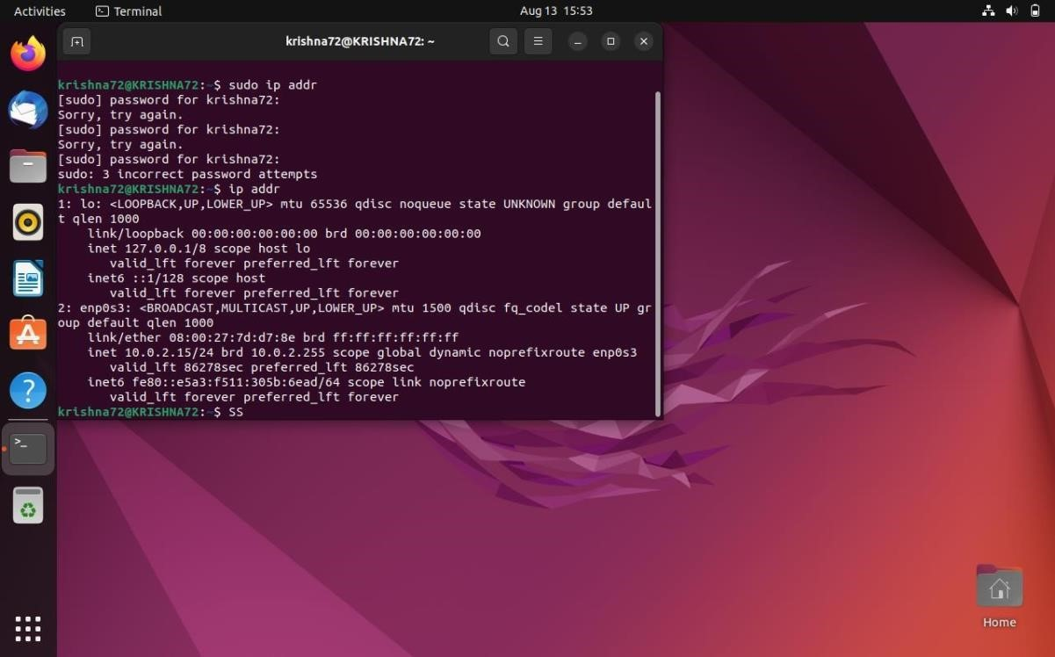

 sudo ip address show enp0s3

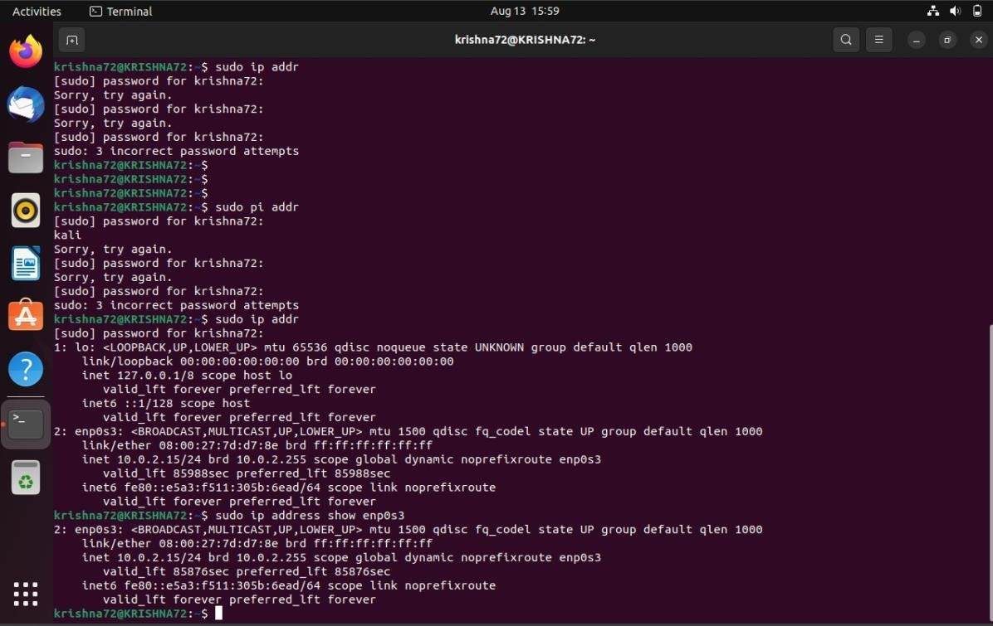

sudo ping 192.168.1.104

nestat -rn

