Exp: 10

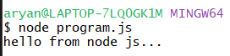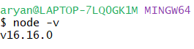

Code:

const http = require("http");

http.createServer((req, res)=>{

res.writeHead(200, {'Content-Type':'text/html'});

res.end("Hello from nodeJS");

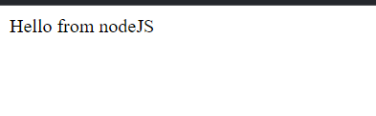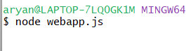}).listen(5000);

Exp-11

Code:

const fs = require('fs');

fs.readFile("./file.txt", (err, data)=>{

if(err){

console.error(err);

}else{

console.log("readFile Async: \n" + data.toString());

}

})

const data = fs.readFileSync("./file.txt")

console.log("readFile Sync:\n" + data.toString());

output:

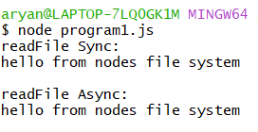

Code:

const EventEmitter = require('events');

let eventEmitter = new EventEmitter();

let EventHandler = ()=>{

console.log("Hello from event loop");

}

eventEmitter.on('event1', EventHandler);

eventEmitter.emit("event1");

output:



Exp-12

Code:

const express = require("express");

const path = require('path')

const app = express();

app.use("/static", express.static(path.join(__dirname, 'static')))

app.get("/", (req, res)=>{

res.send("welcome to Home page");

})

app.get("/image", (req, res)=>{

res.sendFile(path.join(__dirname, "static", "image.png"));

})

app.listen(3000, ()=>{

console.log('Server running on port 3000')

})

