Problem: 01

CODE:

<!DOCTYPE html>

<html lang="en">

<head>

    <title>multiplication table</title>

</head>

<body>

    <script>

        const rows = prompt("Enter number of rows");

        const cols = prompt("Enter number of cols");

        let data = `<table border="1" cellspacing="0" cellpadding="5">`;

        for(var i=1; i<=rows; i++){

            data += "<tr>";

            for(var j=1; j<=cols; j++){

                data += `<td>${i\*j}</td>`;

            }

            data += "</tr>";

        }

        data += "</table>";

        document.write(data);

    </script>

</body>

</html>

OUTPUT:

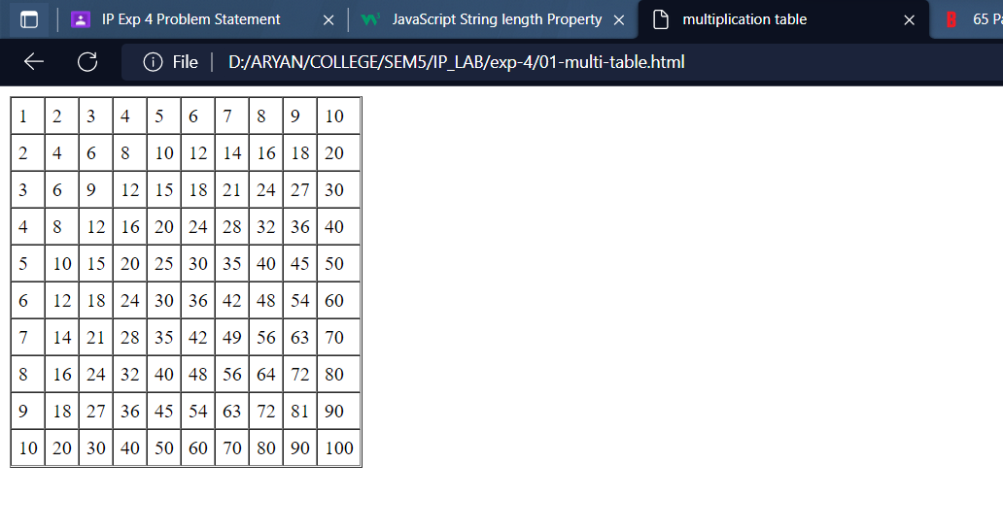

Problem 02:

CODE:

<!DOCTYPE html>

<html lang="en">

<head>

    <title>palindrome name</title>

</head>

<body>

    <script>

        const isPallindrome = (data)=>{

            let end = data.length - 1;

            for(let start=0; start <= data.length/2; start++){

                if(data[start] !== data[end]) return false;

                end--;

            }

            return true;

        }

        let names = [];

        for(var i=1; i<=10; i++){names.push(prompt(`Enter name of ${i}th student`));}

        let pallName = [];

        names.forEach(name => {if(isPallindrome(name)) pallName.push(name);})

        document.write(`<h1>From <em>[${names}]</em> <br/> <em>[${pallName}]</em> are pallindrome names</h1>`);

    </script>

</body>

</html>

CODE:

