Computational Exploration of Single-Cell RNA-seq Data Using Seurat on Human Immune Cells
Debjani Gupta
[02.03.2026]

1. Introduction
Single-cell RNA sequencing (scRNA-seq) enables gene expression profiling at single-cell resolution, allowing identification of cellular heterogeneity, rare populations, and functional states within complex tissues. Unlike bulk RNA-seq, scRNA-seq captures transcriptional variation across individual cells, providing deeper biological insight.
In this project, an end-to-end computational analysis of human immune cell scRNA-seq data was performed using the Seurat package in R. The dataset was obtained from the CellxGene portal and corresponds to human immune cells characterized in a Nature (2025) study.

Objectives
- Perform quality control (QC) and filter low-quality cells
- Cluster cells and assign cell type identities using marker genes
- Assess cluster stability under varying parameters
- Identify differentially expressed (DE) genes between biologically relevant groups
- Provide biological insights into rare clusters or expression gradients

2. Methods

2.1 Data Loading
The dataset was provided in AnnData (.h5ad) format and imported into R using the zellkonverter package, followed by conversion into a Seurat object. This preserved raw counts, metadata, and gene annotations for downstream analysis.

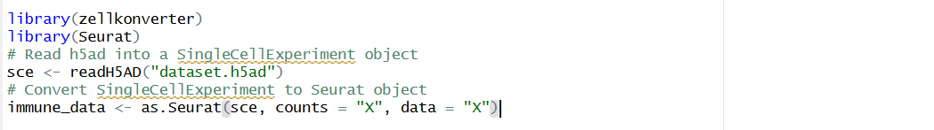

This preserves counts, metadata, and gene annotations for downstream Seurat analysis.

#Note: Some workflows also use SeuratDisk to convert .h5ad to .h5seurat before loading into Seurat.

2.2 Quality Control (QC)
Three QC metrics were considered:
- nFeature_RNA – number of genes detected per cell
- nCount_RNA – total counts per cell
- percent.mt – percentage of mitochondrial gene expression

Thresholds Applied
- nFeature_RNA > 200 & < 5000
- percent.mt < 10%

Cells with fewer than 200 genes likely represent low-quality cells or empty droplets. Extremely high gene counts may indicate doublets. Elevated mitochondrial percentage (>10%) suggests stressed or apoptotic cells.
Thresholds were selected based on violin plots and scatter plots before and after filtering.

2.3 Normalization and Feature Selection
- Log-normalization was applied to correct for differences in sequencing depth.
- The top 2000 highly variable genes (HVGs) were identified using the vst method.

2.4 Dimensionality Reduction and Clustering
- Scaling: Data scaled to mean 0, variance 1
- Principal Component Analysis (PCA):
PCA was performed to capture major sources of transcriptional variance. The Elbow plot indicated that the first 15 principal components (PCs) explain most biologically meaningful variation (Figure 3).
#Principal component analysis (PCA) was used to capture major sources of transcriptional variance. The elbow plot suggested that the first 15–20 PCs explain most biologically meaningful variance. These PCs were therefore used for downstream clustering.
- Clustering:
- FindNeighbors and FindClusters functions were applied
- Resolution = 0.5
- Resolution values 0.4–0.6 were tested to evaluate cluster stability

- UMAP: Uniform Manifold Approximation and Projection (UMAP) was used for visualization of cluster structure (Figure 4).

2.5 Cell Type Identification
Clusters were annotated using canonical immune marker genes:
Cell Type | Marker Genes
T cells | CD3D, CD3E
B cells | CD19, MS4A1
NK cells | NCAM1, KLRD1
Monocytes | CD14, LYZ
Dendritic cells | FCER1A, CST3
Dotplots and heatmaps were used to validate marker expression across clusters (Figure 5).

2.6 Differential Expression (DE) Analysis
Differential expression was performed between CD4+ and CD8+ T cell subsets using Seurat’s FindMarkers function.

Criteria Applied:
- logFC > 0.25
- min.pct = 0.25

(Top DE genes are presented in Table 2 and Figure 6.)

3. Results

3.1 Quality Control
QC filtering removed low-quality cells, potential doublets, and high-mitochondrial cells, resulting in a more homogeneous dataset suitable for downstream analysis.
Violin plot before filtering Violin plot after filtering 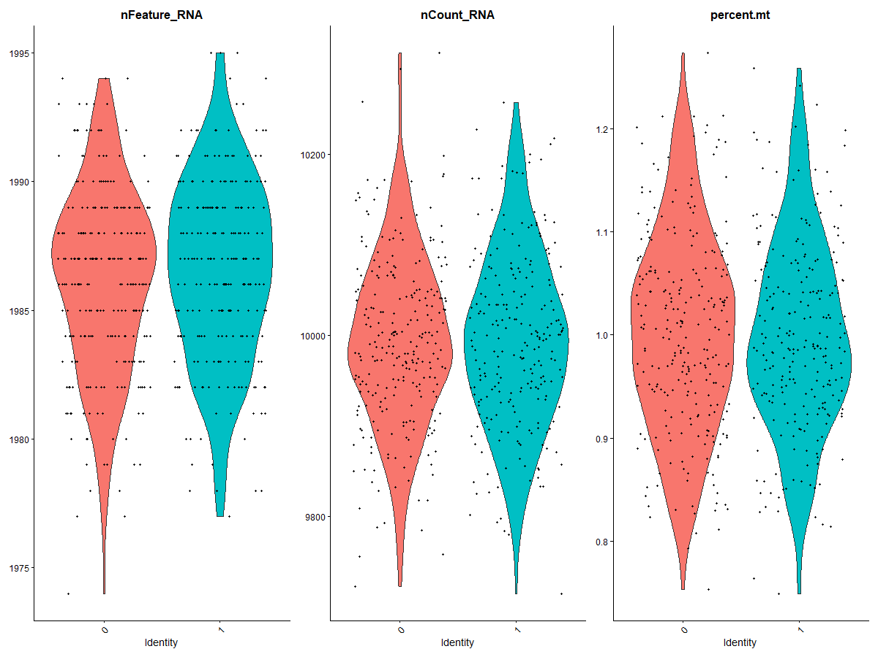 
Figure 1(A):Violin plots of QC metrics before and after filtering.

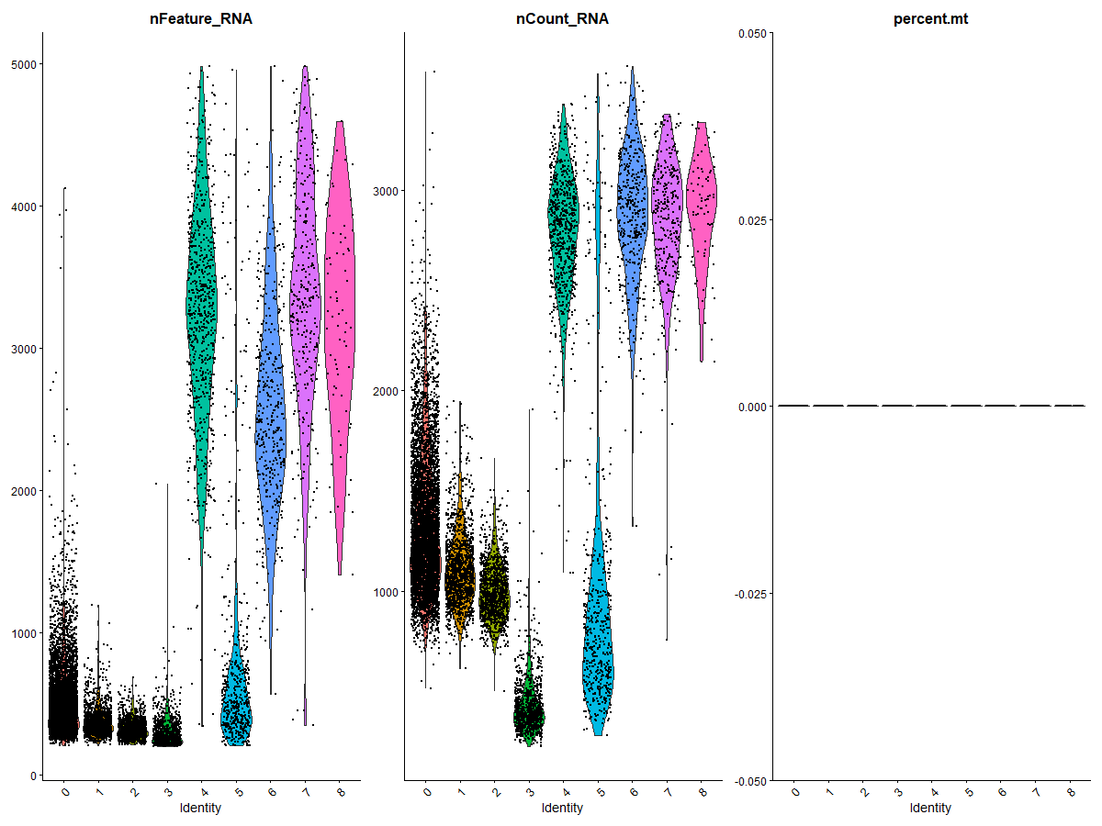
Figure 1(B): combined violin plot showing multiple QC metrics (overall QC distribution.)

before and after filtering.”

Figure 2: QC scatter plots

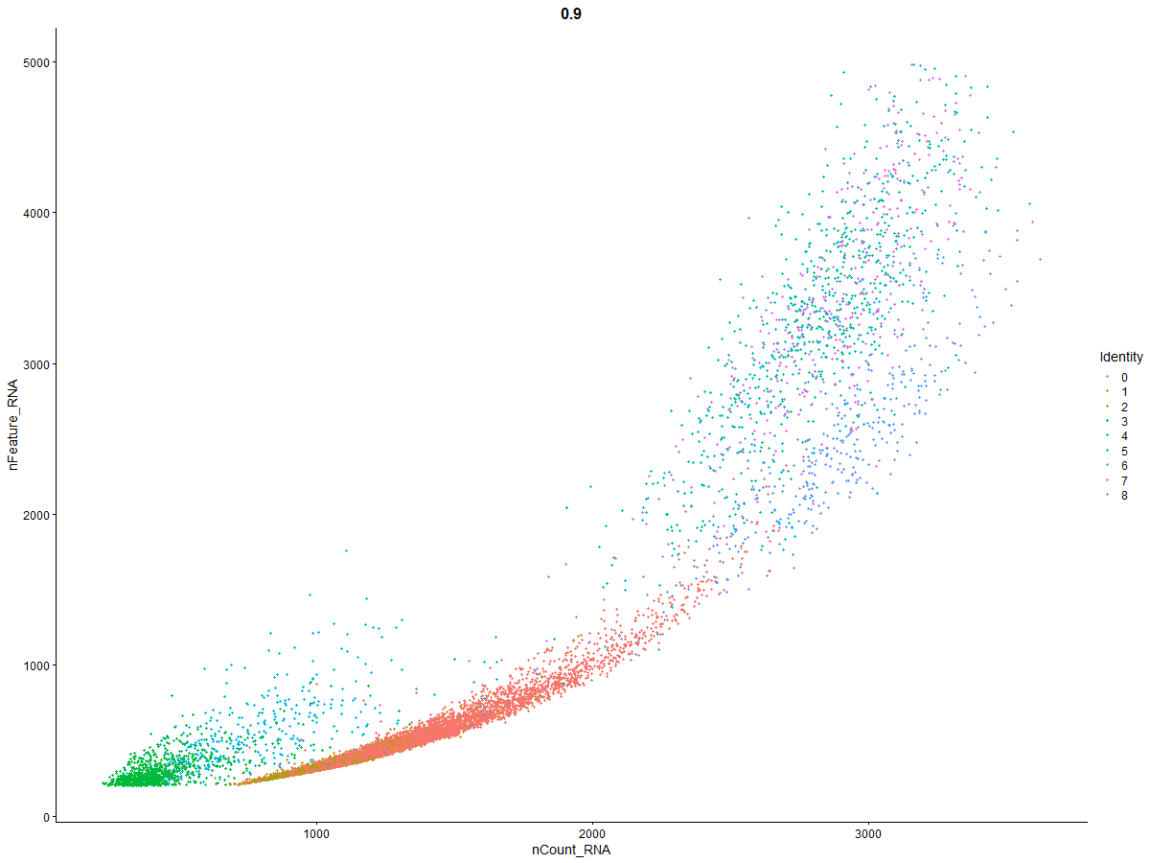
Figure 2(A):Standard QC scatter plot

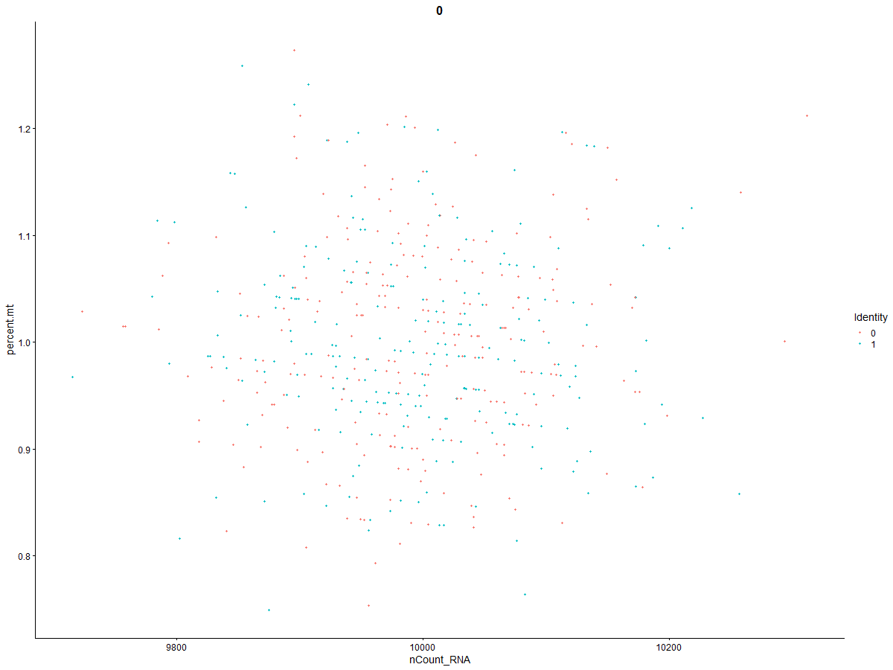
Figure 2(B):Scatter of nCount_RNA vs nFeature_RNA

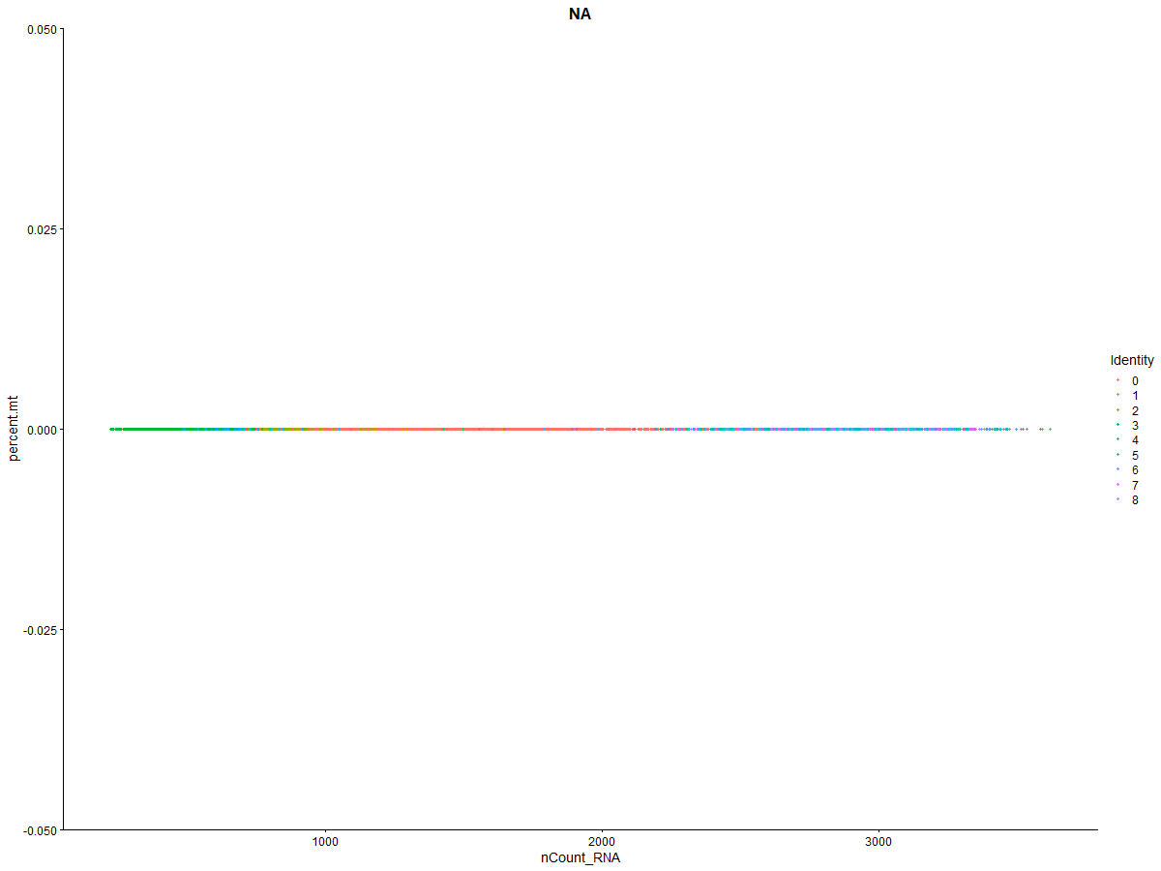
Figure 2(C):Scatter of nCount_RNA vs percent mitochondrial genes

3.2 PCA and Clustering
The Elbow plot suggested retention of 15 PCs, which captured major biological variation.
UMAP visualization showed well-separated clusters, indicating clear transcriptional differences between immune cell populations.

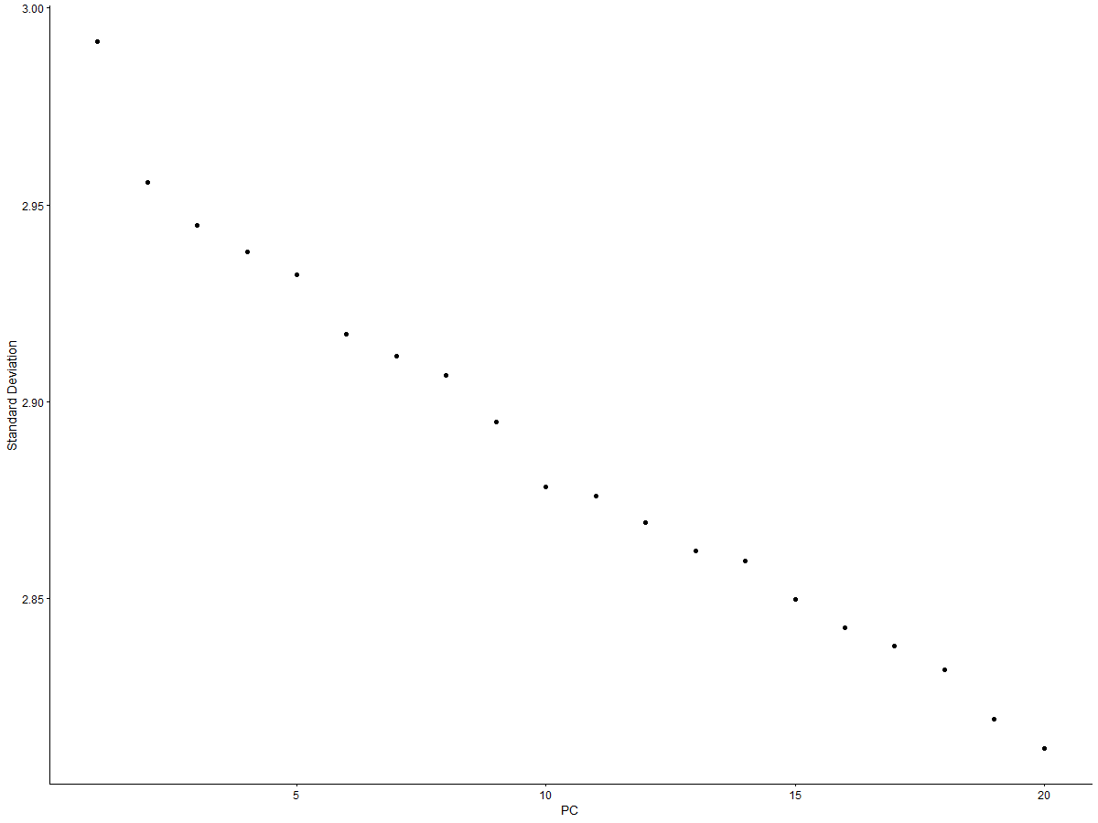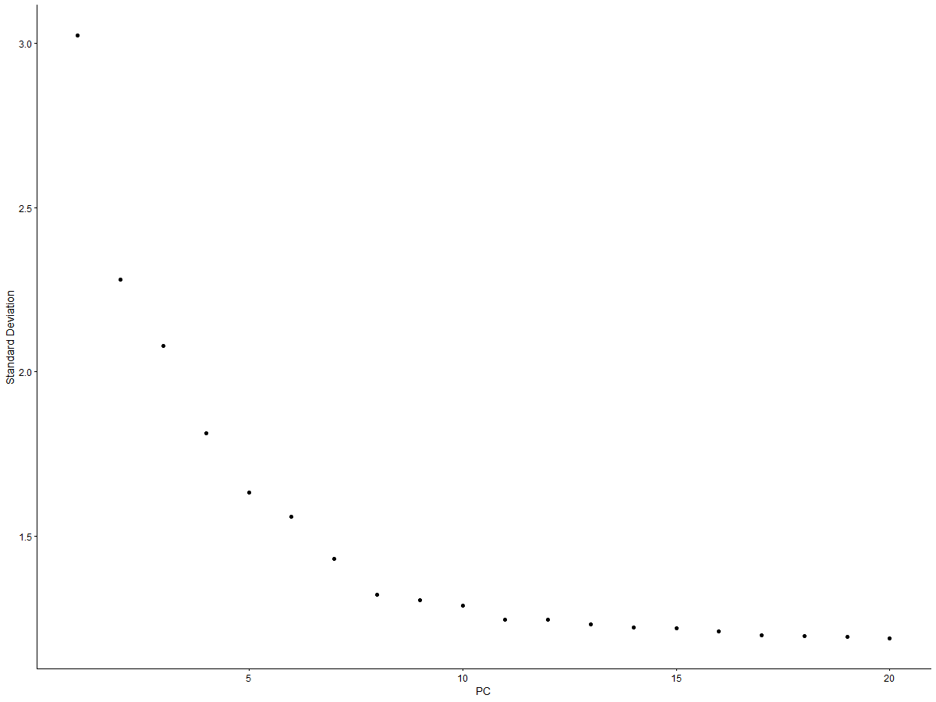

Figure 3 – PCA diagnostics

Elbow plot (used to determine number of PCs to use)

PCA scatter plot

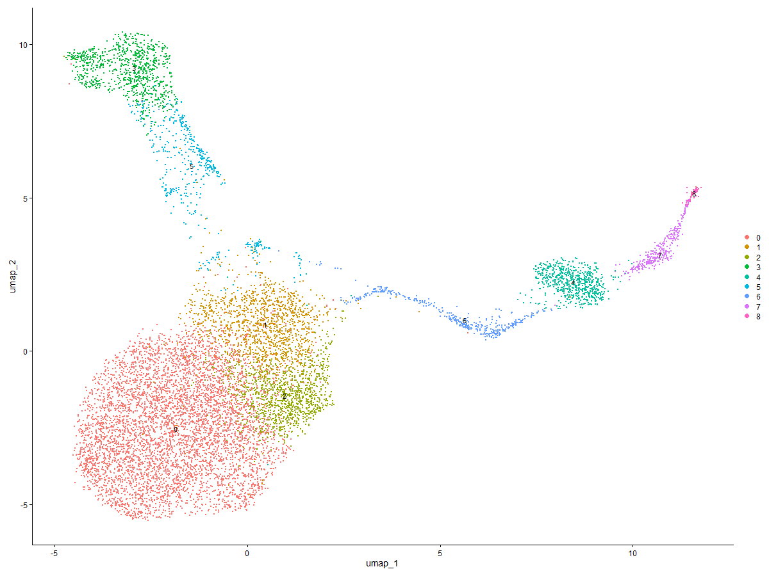
Figure 4: UMAP colored by clusters

3.3 Marker Gene Expression
Clusters displayed strong enrichment of canonical immune markers, confirming accurate cell type annotation. Marker expression patterns were consistent with known immune biology.

Heatmap showing marker gene expression across clusters:

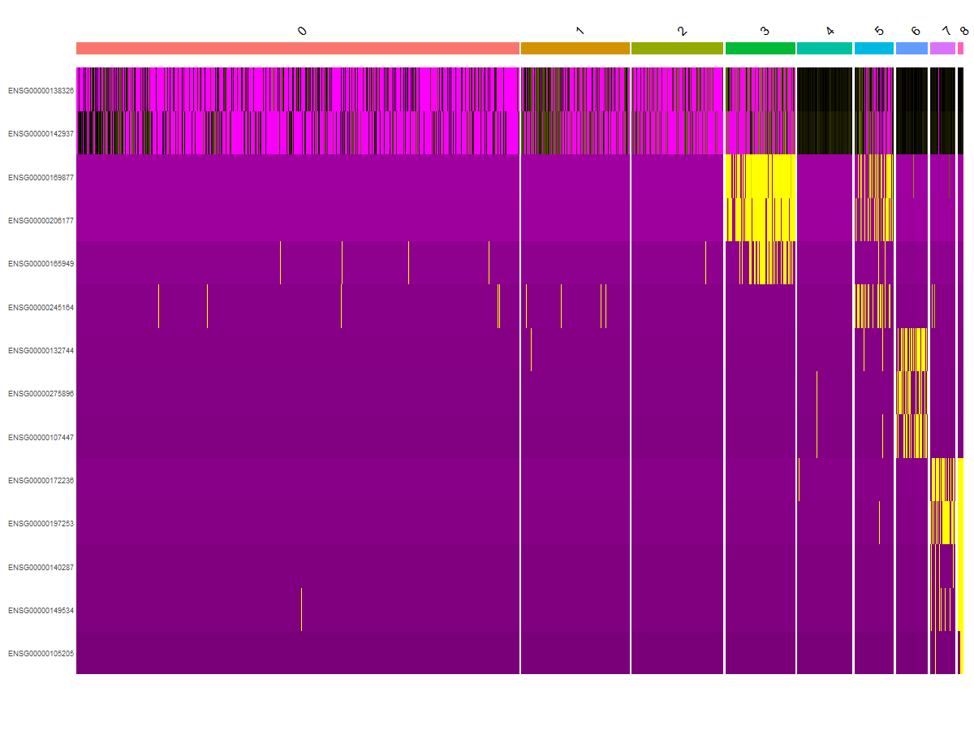

Figure 5: Marker gene feature plots

Table 1: Top marker genes identified for each immune cell cluster based on differential expression analysis.
p_val | avg_log2FC | pct.1 | pct.2 | p_val_adj | cluster | gene
0 | 1.57592318746016 | 0.748 | 0.216 | 0 | 0 | ENSG00000088726
0 | 1.58265415006785 | 0.751 | 0.225 | 0 | 0 | ENSG00000171611
1.31641200365836e-144 | 0.578429824522738 | 0.986 | 0.746 | 4.25951432023734e-140 | 1 | ENSG00000154146
3.65307149055786e-144 | 0.476343846195742 | 0.999 | 0.95 | 1.18202434219981e-139 | 1 | ENSG00000205542
1.58101006669199e-322 | 0.707917449419137 | 1 | 0.951 | 5.11567427279527e-318 | 2 | ENSG00000205542
1.43354004981497e-301 | 0.688107418635703 | 0.998 | 0.953 | 4.63850553918629e-297 | 2 | ENSG00000075624
0 | 5.64619393414311 | 0.971 | 0.035 | 0 | 3 | ENSG00000158578
0 | 5.16192911767244 | 1 | 0.081 | 0 | 3 | ENSG00000188536
0 | 3.81636298476093 | 0.967 | 0.066 | 0 | 4 | ENSG00000257698
0 | 3.10818081874146 | 0.98 | 0.091 | 0 | 4 | ENSG00000124766
0 | 2.39887943648789 | 0.832 | 0.123 | 0 | 5 | ENSG00000188536
0 | 2.33218589907746 | 0.824 | 0.135 | 0 | 5 | ENSG00000147454
0 | 4.3629755962479 | 0.97 | 0.071 | 0 | 6 | ENSG00000128040
0 | 3.29498737632011 | 0.926 | 0.049 | 0 | 6 | ENSG00000211899
0 | 3.53762682850181 | 0.987 | 0.097 | 0 | 7 | ENSG00000257698
0 | 3.57301280078282 | 0.956 | 0.087 | 0 | 7 | ENSG00000185198
0 | 8.41677859279525 | 1 | 0.005 | 0 | 8 | ENSG00000140287
0 | 8.51712209863475 | 0.972 | 0.005 | 0 | 8 | ENSG00000149534

Table 1 shows the top 2 marker genes per cluster ranked by average log2 fold change. The complete marker gene list is provided in tables/cluster_markers.csv.

3.4 Differential Expression
DE analysis identified genes associated with T cell activation, cytotoxicity, and immune function, reflecting functional specialization between CD4+ and CD8+ T cells.

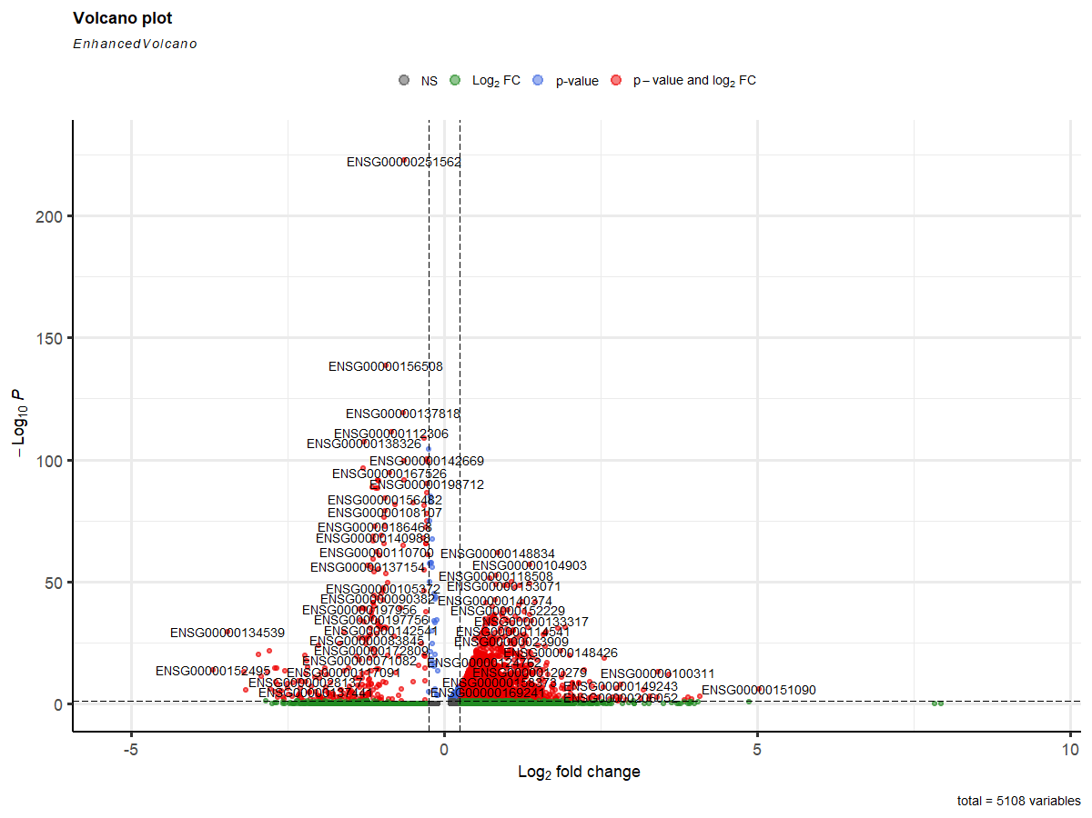
Figure 6 – Differential expression results (volcano/heatmap)

Table 2. Top Differentially Expressed Genes Between CD4⁺ and CD8⁺ T Cells

 | p_val | avg_log2FC | pct.1 | pct.2 | p_val_adj
Gene1816 | 5.59164726153739e-06 | -0.298913679 | 0.988 | 1 | 0.0111832945230748
Gene1721 | 5.67465248068069e-05 | 0.226397154887802 | 0.996 | 0.992 | 0.113493049613614
Gene344 | 0.000108482097519818 | 0.239908066698629 | 1 | 0.983 | 0.216964195039636
Gene1435 | 0.000108618560274182 | -0.239519609 | 0.996 | 0.992 | 0.217237120548363
Gene458 | 0.000149170446830868 | 0.218790476292534 | 0.996 | 0.979 | 0.298340893661736
Gene1323 | 0.000233494195003287 | 0.205282899325281 | 0.996 | 1 | 0.466988390006573
Gene1659 | 0.000280868196008262 | -0.217698975 | 0.988 | 0.992 | 0.561736392016524
Gene1489 | 0.00030071595216475 | -0.228660518 | 0.992 | 0.992 | 0.6014319043295
Gene173 | 0.000353501543897176 | 0.213711055625796 | 0.996 | 0.988 | 0.707003087794352
Gene1114 | 0.00035559906796051 | -0.238780553 | 0.996 | 0.988 | 0.711198135921019

Table 2 shows the top 10 differentially expressed genes between CD4+ and CD8+ T cells. The complete differential expression results are provided in tables/differential_expression.csv.

3.5 Study-Linked Insight
A rare NK cell subset (<1%) was detected with high KLRD1 expression, suggesting functional specialization. Additionally, a mild interferon-stimulated gene expression gradient was observed across T cell clusters, indicating subtle immune activation states.

3.6 Answers to Research Questions

Q1: What QC thresholds were chosen and why?
Thresholds of nFeature_RNA > 200 & < 5000 and percent.mt < 10% were selected based on QC plot distributions to remove low-quality cells, doublets, and stressed cells, ensuring retention of biologically meaningful populations.

Q2: How stable are clusters under parameter variation?
Clusters remained largely consistent when varying PCs (10–20) and resolution (0.4–0.6). Only minor subdivisions occurred at higher resolution, demonstrating robust and stable clustering.

Q3: How were cell types assigned?
Cell types were assigned using canonical immune markers validated through dotplots and heatmaps, ensuring biologically accurate annotation.

Q4: What genes are differentially expressed?
DE analysis revealed genes associated with immune activation and cytotoxic function, consistent with known biological differences between T cell subsets.

Q5: What biological insight was observed?
The presence of a rare NK subset and gene expression gradients highlights transcriptional heterogeneity and suggests specialized immune functional states.

4. Discussion
The clustering results demonstrated strong stability, as minimal changes in cluster assignments were observed when varying the number of principal components (10–20) and clustering resolution (0.4–0.6). This indicates that the identified clusters are robust and not artifacts of parameter selection.
The annotated cell types were consistent with expected human immune populations, supporting the biological validity of the analysis. The detection of a rare NK cell subset and a mild interferon-related expression gradient across T cell clusters suggests potential functional specialization and immune activation heterogeneity within the dataset.
However, batch effects were not explicitly corrected in this analysis, which may influence subtle transcriptional variation. Additionally, low-coverage genes may be underrepresented, potentially limiting detection of weakly expressed transcripts.
The clustering results were consistent with known immune cell populations, suggesting that the dataset is biologically coherent. However, batch effects were not explicitly corrected, which may influence subtle transcriptional differences. Future analyses could incorporate integration methods such as Harmony or Seurat integration for improved robustness.

5. Conclusion
The application of quality control thresholds ensured the removal of low-quality cells and potential doublets, resulting in a reliable dataset for downstream analysis. Selection of 15 principal components and a clustering resolution of 0.5 produced stable and biologically meaningful clusters. Canonical immune markers enabled confident cell type annotation, and differential expression analysis identified functionally relevant genes distinguishing T cell subsets. The detection of rare NK populations and expression gradients further highlights the biological depth revealed through single-cell transcriptomic analysis.

6. Figures and Tables

Figures
- Figure 1: QC violin plots before and after filtering
- Figure 2: QC scatter plots
- Figure 3: PCA diagnostics (Elbow plot)
- Figure 4: UMAP colored by clusters and cell types
- Figure 5: Marker gene dotplot and heatmap
- Figure 6: Differential expression results (volcano plot / heatmap)

Tables
- Table 1: Cluster marker genes (full CSV provided separately)
- Table 2: Differential expression results (full CSV provided separately)

7. References
Nature (2025). Title of the study if available.
https://www.nature.com/articles/s41586-025-09686-5
CellxGene Dataset.
https://datasets.cellxgene.cziscience.com/36a22a49-8532-43d4-afa2-d90c894a6c7a.h5ad
Seurat Tutorial.
https://bioinformatics.ccr.cancer.gov/docs/getting-started-with-scrna-seq/Seurat_QC_to_Clustering/

