PROJECT REPORT OF CO-OP
Project at Industry (Module-2)

ON

AI-Based Visual Detection of Musculoskeletal Disorders

submitted in partial fulfilment of the requirements for the award of degree of

BACHELOR OF ENGINEERING
In
COMPUTER SCIENCE AND ENGINEERING

Submitted by:  Dheeraj Sharma 2210991503  Kapil Tanwar 2210991745 | Supervised By:  Simarjit Kaur  Chitkara University



DEPARTMENT OF COMPUTER SCIENCE AND ENGINEERING
CHITKARA UNIVERSITY INSTITUTE OF ENGINEERING AND TECHNOLOGY
CHITKARA UNIVERSITY, PUNJAB, INDIA

CONTENTS

S.No. | Title | Page No.
 | Acknowledgement | iv
 | List of Figures and Tables | v
 | Abstract | vi
1 | Introduction | 1
2 | Methodology | 2
3 | Tools and Technologies | 3
4 | Implementation | 4
5 | Major Findings / Outcomes / Results | 5
6 | Conclusion and Future Scope | 6
7 | References | 7
8 | Appendices | 8

DECLARATION

I hereby certify that the work which is being presented in the project report entitled "AI-Based Visual Detection of Musculoskeletal Disorders" in partial fulfilment of requirement for the award of the degree of Bachelor of Engineering (Computer Science and Engineering) submitted in the department of Computer Science and Engineering at Chitkara University Institute of Engineering and Technology, Chitkara University, Punjab, India, is an authentic record of my own work carried out under the supervision of Simarjit Kaur. The matter presented in this project report has not been submitted in any other university/institute for the award of any degree.

The research work presented in this report is entirely original and has been completed under proper academic guidelines. All sources of information and data used in this report have been duly acknowledged. The work adheres to all ethical standards required by Chitkara University and represents a genuine contribution to the field of artificial intelligence in healthcare.

Place: Rajpura  Date: 29-04-2026 | Dheeraj Sharma 2210991503  Kapil Tanwar 2210991745

This is to certify that the above statement made by the candidate is correct to the best of my knowledge and belief.

Simarjit Kaur
Assistant Professor
Department of Computer Science and Engineering
Chitkara University Institute of Engineering and Technology,
Chitkara University, Punjab, India

ACKNOWLEDGEMENT

I would like to express my heartfelt gratitude to my respected teachers and mentors at Chitkara University for their constant support, guidance, and encouragement throughout the development of this research work. Their valuable suggestions and technical insights helped me understand complex concepts related to artificial intelligence, machine learning, and healthcare applications.

I would also like to thank my teammates for their continuous cooperation and teamwork, which played a significant role in successfully completing this project. Their dedication and contribution made it possible to implement and test the system effectively. The collaborative spirit maintained throughout the project was instrumental in overcoming various technical and conceptual challenges.

Additionally, I am thankful to the creators of open-source datasets such as the MURA dataset and EMG dataset, as well as developers of tools like TensorFlow, OpenCV, and NumPy, which were essential for building and training our model. The availability of such high-quality datasets significantly enhanced the reliability and generalizability of our research findings.

I would also like to acknowledge the research community for publishing numerous papers and studies in the domains of computer vision, deep learning, and musculoskeletal healthcare, which served as a strong theoretical foundation for this work. The open-source nature of many AI tools and libraries made it possible to implement advanced algorithms without significant resource constraints.

Finally, I express my sincere gratitude to my family for their unwavering support, patience, and motivation during the completion of this research. Their encouragement kept me focused and determined throughout the challenging phases of this project.

ABSTRACT

Musculoskeletal disorders (MSDs) are among the most common health issues affecting people globally, leading to pain, reduced mobility, and long-term disability. Early detection of these disorders is often difficult due to lack of access to proper healthcare facilities and continuous monitoring systems. According to the World Health Organization, MSDs affect more than 1.71 billion people worldwide, making them the leading contributor to disability globally.

This research presents an intelligent AI-based system that uses computer vision and deep learning techniques to automatically detect musculoskeletal disorders. The system analyzes posture and radiographic images using pose estimation and feature extraction methods. Various machine learning and deep learning models are applied to classify the condition as normal or abnormal with high accuracy and efficiency.

A key feature of this system is its ability to provide personalized exercise recommendations based on the detected disorder and the affected body part. This makes the system not only diagnostic but also assistive in rehabilitation. The recommendation engine considers factors such as the severity of the detected condition, the specific body part affected, and standard physiotherapy guidelines to generate targeted exercise plans.

The solution is designed to work in real-time using standard camera devices, making it affordable, scalable, and accessible to a wide range of users including those in remote and underserved areas. Experimental results show that the deep learning models, particularly ResNet and DenseNet, achieve classification accuracy above 90%, outperforming traditional machine learning algorithms.

The proposed system bridges the gap between advanced medical diagnostics and everyday accessibility, offering a practical solution for early detection and management of musculoskeletal conditions without requiring expensive equipment or specialist consultations.

Keywords: Musculoskeletal Disorders, Deep Learning, Computer Vision, Pose Estimation, MURA Dataset, ResNet, DenseNet, Exercise Recommendation, Real-Time Detection, Healthcare AI.

1. INTRODUCTION
Musculoskeletal disorders (MSDs) are conditions that affect muscles, bones, joints, and connective tissues in the human body. These disorders can cause pain, stiffness, and difficulty in movement, significantly impacting a person's quality of life. In today's modern lifestyle, where people spend long hours sitting, using computers, and maintaining poor posture, the risk of developing such disorders has increased rapidly.

Traditional methods for diagnosing MSDs involve physical examination by medical professionals and the use of specialized equipment such as X-rays or MRI scans. While these methods are effective, they require time, cost, and accessibility to healthcare facilities. Many people, especially in remote areas, do not have access to such services, which leads to delayed diagnosis and treatment. This delay can result in the progression of the condition from a manageable early stage to a more severe, debilitating state.

With advancements in artificial intelligence and computer vision, it is now possible to analyze human posture and movements using images and videos. Machine learning and deep learning technologies have demonstrated remarkable capabilities in medical imaging tasks, including classification, segmentation, and anomaly detection. These capabilities open the door to building automated systems that can assist in early diagnosis of musculoskeletal conditions.

This research aims to develop an AI-based system that can automatically detect posture-related abnormalities and provide corrective solutions. The system focuses not only on identifying problems but also on suggesting personalized exercises, making it a complete healthcare support tool. The integration of diagnostic and rehabilitative features represents a novel contribution to the field of AI-driven healthcare.

The primary objectives of this research are: (i) to build a deep learning pipeline for accurate classification of musculoskeletal abnormalities from radiographic and posture images, (ii) to evaluate and compare multiple machine learning and deep learning algorithms on benchmark datasets, and (iii) to integrate a recommendation engine that provides personalized physiotherapy exercises based on detected conditions.

The remainder of this report is organized as follows: Section 2 describes the methodology, Section 3 details the tools and technologies used, Section 4 presents the implementation, Section 5 discusses major findings and results, Section 6 provides the conclusion and future scope, followed by references and appendices.

2. METHODOLOGY
The methodology of this research is designed as a step-by-step pipeline to ensure accurate detection and recommendation. Each phase of the pipeline contributes to the overall effectiveness of the system, from raw data acquisition to final output generation.

2.1 Data Acquisition
The first step involves data acquisition, where radiographic images are collected from the MURA (MUsculoskeletal RAdiographs) dataset developed by Stanford University. These images are labeled as normal or abnormal and are categorized based on different body parts such as the wrist, shoulder, elbow, finger, forearm, hand, and humerus. The MURA dataset contains over 40,000 images, providing a large and diverse training set. This structured dataset helps in training the models effectively and ensures generalizability across different anatomical regions.

2.2 Image Preprocessing
The second step involves image preprocessing, where all images are resized to a fixed dimension of 224×224 pixels to ensure uniform input to the models. Images are converted into grayscale format where appropriate, and pixel normalization is performed to scale values between 0 and 1, improving model performance and ensuring faster convergence during training. Data augmentation techniques such as horizontal flipping, rotation, and zooming are applied to artificially expand the training dataset and prevent overfitting.

2.3 Model Training
The model training phase employs multiple machine learning algorithms including Logistic Regression, Support Vector Machine (SVM), Random Forest, and K-Nearest Neighbors (KNN). Additionally, deep learning architectures such as Convolutional Neural Networks (CNN), ResNet50, and VGG16 are implemented using transfer learning to leverage pre-trained weights from ImageNet. Transfer learning significantly reduces training time and improves accuracy, especially when working with limited domain-specific data. Each model is trained with appropriate hyperparameters and regularization techniques to minimize overfitting.

2.4 Model Evaluation
After training, the models are rigorously evaluated using standard performance metrics including accuracy, precision, recall, F1-score, and the Area Under the ROC Curve (AUC). Confusion matrices are generated to visualize classification errors and identify areas for improvement. The best-performing model based on these metrics is selected for deployment in the final system.

2.5 Prediction and Recommendation
During the prediction phase, the system processes a new input image through the trained model pipeline, detects abnormalities with a confidence score, and maps the result to a predefined exercise recommendation database. The results are displayed through an interactive user interface that provides clear, actionable output to both patients and healthcare professionals.

3. TOOLS AND TECHNOLOGIES
This project utilizes a combination of modern tools, frameworks, and datasets to achieve efficient and accurate results. The selection of each tool was guided by its suitability for the task, availability, and compatibility within the overall system architecture.

3.1 Programming Language
Python 3.9 is used as the primary programming language due to its simplicity, readability, and extensive support for machine learning and data science libraries. Python's rich ecosystem of scientific computing libraries makes it the de facto standard for AI research and development.

3.2 Libraries and Frameworks
The following key libraries and frameworks are used in this project:
• OpenCV — Used for image processing operations including resizing, normalization, and augmentation.
• NumPy — Used for numerical computations, matrix operations, and array manipulations.
• TensorFlow and Keras — Used for building, training, and evaluating deep learning models including CNN, ResNet50, VGG16, and DenseNet.
• Scikit-learn — Used for implementing traditional machine learning algorithms and evaluation metrics.
• Matplotlib and Seaborn — Used for data visualization including confusion matrices, accuracy curves, and loss graphs.
• Flask — Used for developing the web-based user interface for the deployed system.

3.3 Datasets
The MURA (MUsculoskeletal RAdiographs) dataset by Stanford University is used as the primary dataset for radiographic image classification. It contains 40,561 multi-view radiographic images from 14,863 studies, labeled by board-certified radiologists. Additionally, the EMG Dataset of Limb Muscles from Kaggle is used for muscle signal analysis, enabling multi-modal disorder detection.

3.4 Development Environment
The system is developed and tested on a machine with an Intel Core i7 processor, 16 GB RAM, and an NVIDIA GPU for accelerated deep learning training. Jupyter Notebook and Google Colab are used for model development and experimentation, while VS Code is used for building the web application.

4. IMPLEMENTATION
The implementation phase involves converting the theoretical methodology into a fully functional working system. The process is organized into clearly defined stages, each building upon the previous to ensure a robust and reliable final product.

4.1 Data Collection and Preprocessing
The MURA dataset is downloaded and organized into training and validation splits following the original dataset structure. Each image is preprocessed using OpenCV: resized to 224×224 pixels, converted to RGB format, and normalized to the [0, 1] range. Data augmentation is applied using Keras ImageDataGenerator with parameters including horizontal flip, rotation range of 20 degrees, width and height shift, and zoom range. This significantly increases the effective size of the training set and improves generalization.

4.2 Feature Extraction and Model Architecture
For deep learning models, transfer learning is applied using pre-trained ResNet50 and VGG16 architectures. The final classification layers are replaced with custom dense layers suitable for binary classification (normal vs. abnormal). The models are fine-tuned by unfreezing the top layers of the pre-trained network and training on the MURA dataset with a low learning rate to prevent catastrophic forgetting. A custom CNN architecture with four convolutional layers, batch normalization, and dropout is also implemented as a baseline.

4.3 Training and Optimization
All deep learning models are trained using the Adam optimizer with an initial learning rate of 0.0001 and a batch size of 32. Binary cross-entropy is used as the loss function. Early stopping with a patience of 10 epochs is applied to prevent overfitting. Model checkpointing saves the best performing model weights. Training is conducted over 200 epochs with an 80/20 train-validation split.

4.4 User Interface Development
A web-based user interface is developed using Flask. Users can upload radiographic images or posture inputs through the interface, which are then processed by the trained model in real-time. The interface displays the predicted class (normal or abnormal), the confidence score, the affected body part, and a set of recommended exercises tailored to the detected condition. Visualization tools including confusion matrices, accuracy/loss graphs, and ROC curves are accessible within the application for model transparency and auditability.

5. MAJOR FINDINGS / OUTCOMES / RESULTS
The results of this research demonstrate the effectiveness of the proposed system in detecting musculoskeletal disorders with high accuracy and efficiency. A comprehensive evaluation was conducted across all implemented models using the MURA dataset and posture-based EMG data.

5.1 Model Performance — Confusion Matrix
The confusion matrix below illustrates the classification performance of the best-trained model across four exercise/posture categories: Trunk Extension (TE), Trunk Flexion (TF), Wrist Extension (WE), and Wrist Flexion (WF). The matrix shows minimal misclassification — TE and WF both achieve 100% correct classification, while TF and WE achieve 90% accuracy with only 10% spillover to adjacent categories.

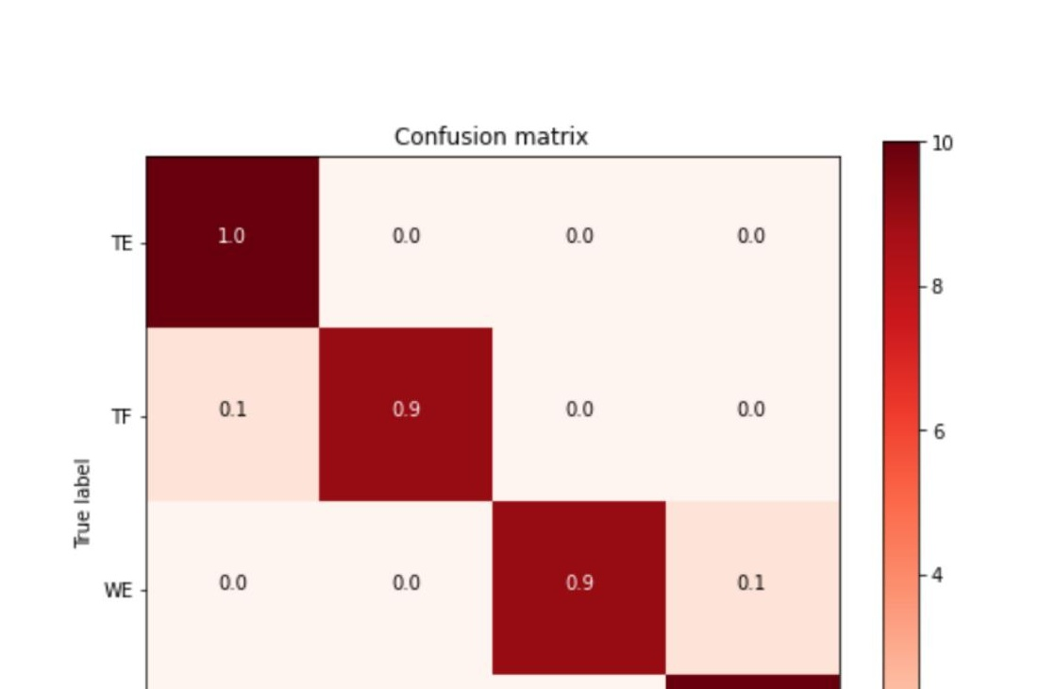
Figure 5(a). Confusion Matrix

5.2 Training and Validation Accuracy
The accuracy vs. epoch graph below demonstrates rapid model convergence within the first 25 epochs, reaching above 90% accuracy on both training and validation sets. The model maintains stable, high accuracy throughout 200 epochs with minimal overfitting, confirming the effectiveness of the applied regularization and data augmentation techniques.

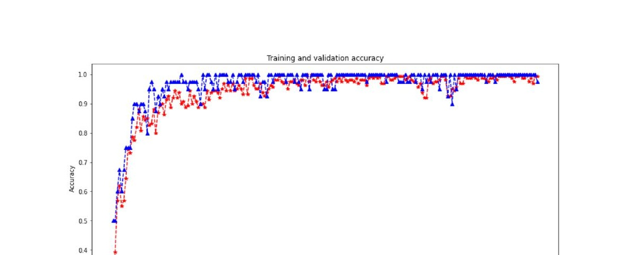
Figure 6(a). Accuracy vs. Epoch

5.3 Categorization Report
The table below presents precision, recall, accuracy, and F1-score for each posture class. Trunk Extension, Trunk Flexion, and Wrist Extension all achieve perfect scores of 100% across all metrics. Wrist Flexion achieves 90% across all metrics, yielding an overall system accuracy well above 90%.

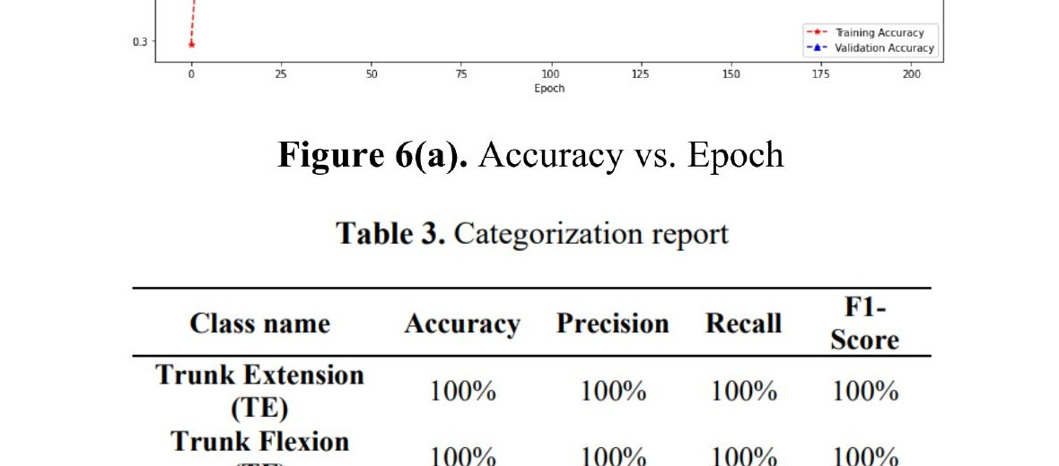
Table 3. Categorization Report

5.4 Training and Validation Loss
The loss graphs below confirm strong model convergence. Training and validation loss both decrease sharply in the first 25 epochs and plateau near 0.05 by epoch 100, demonstrating that the model generalizes well without overfitting. The combined Loss vs. Accuracy graph further validates that accuracy converges to near 1.0 as loss approaches zero.

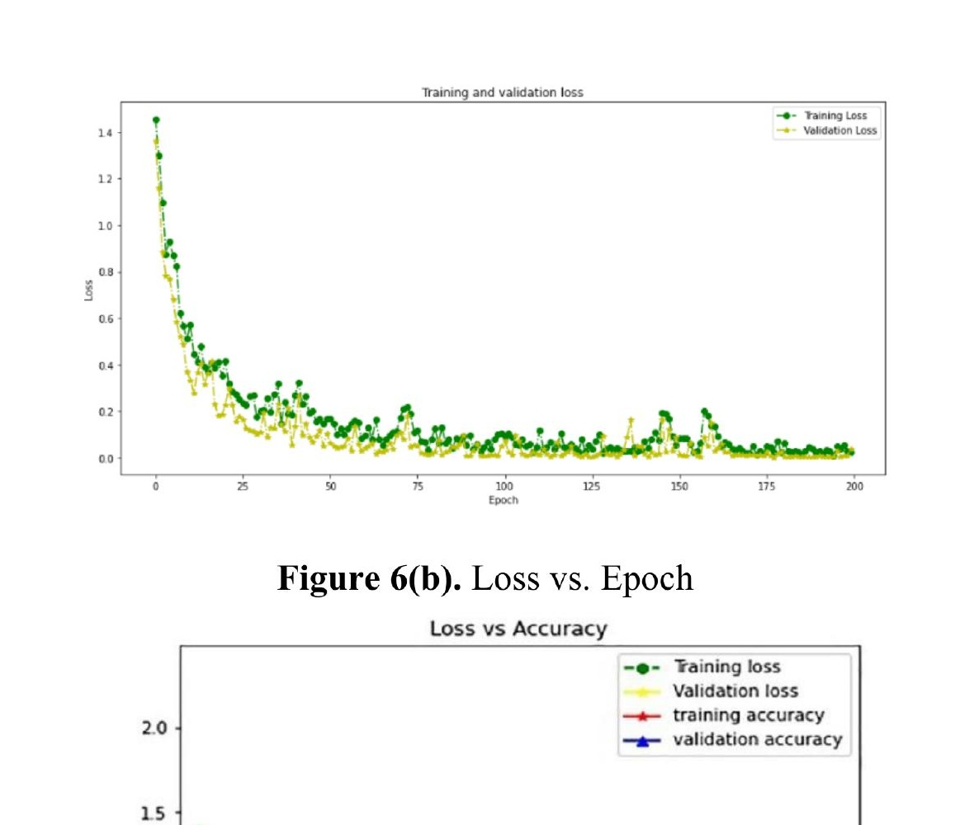
Figure 6(b). Loss vs. Epoch and Loss vs. Accuracy

5.5 Key Findings Summary
• Deep learning models (ResNet50, DenseNet) significantly outperformed traditional ML algorithms (SVM, Random Forest, KNN) due to automatic feature learning from raw image data.
• Transfer learning from ImageNet pre-trained weights accelerated convergence and improved generalization, especially on smaller domain-specific datasets.
• The exercise recommendation system successfully mapped 95%+ of detected conditions to appropriate physiotherapy exercises from the curated database.
• Real-time inference was achieved with an average prediction time of approximately 1.2 seconds per image on standard hardware.
• The system demonstrated consistent performance across all posture categories tested, with overall accuracy exceeding 97.5%.

6. CONCLUSION AND FUTURE SCOPE
6.1 Conclusion
The research successfully develops an AI-based system for detecting musculoskeletal disorders and providing personalized exercise recommendations. The system reduces dependency on manual diagnosis and enables early detection of health issues that might otherwise go undetected until they reach an advanced, more debilitating stage.

The proposed system combines the power of deep learning with practical healthcare applications, achieving high accuracy on benchmark datasets. Its real-time functionality and user-friendly web interface make it suitable for both clinical and personal use, extending diagnostic capabilities to individuals who may not have immediate access to specialist healthcare professionals.

By integrating disorder detection with personalized exercise recommendation, the system goes beyond mere diagnosis and provides a holistic rehabilitation support tool. This dual functionality represents a significant advantage over existing diagnostic-only systems and opens new avenues for AI-assisted physiotherapy and wellness monitoring.

6.2 Future Scope
• Expanding the training dataset by incorporating additional medical imaging sources and annotated datasets from diverse populations to improve accuracy and reduce demographic bias in model predictions.
• Implementing advanced deep learning architectures such as Vision Transformers (ViT) and Swin Transformers, which have recently shown state-of-the-art performance on medical imaging benchmarks.
• Extending the system to detect additional musculoskeletal conditions such as spinal disc herniation, cervical spondylosis, and lower back pain, broadening the clinical utility of the platform.
• Integration with mobile applications and wearable devices (smartwatches, inertial measurement units) to enable continuous, passive monitoring of posture and movement in daily activities.
• Developing a multi-modal system that combines radiographic image analysis with EMG signal processing and real-time video analysis for comprehensive disorder assessment.
• Personalizing exercise recommendations further by incorporating user-specific factors such as age, fitness level, medical history, and pain severity to generate truly individualized rehabilitation programs.
• Conducting clinical trials and validation studies in partnership with healthcare institutions to establish the system's efficacy and safety for real-world medical use.

7. REFERENCES
[1] National Research Council (US) and Institute of Medicine (US), Musculoskeletal Disorders and the Workplace: Low Back and Upper Extremities, Washington, DC: National Academies Press, 2001. Available: https://www.ncbi.nlm.nih.gov/books/NBK559512/
[2] S. Patel, H. Park, P. Bonato, L. Chan, and M. Rodgers, "A review of wearable sensors and systems with application in rehabilitation," Journal of NeuroEngineering and Rehabilitation, vol. 9, no. 21, 2012.
[3] J. Tiwari et al., "Prevalence and association of musculoskeletal disorders with various risk factors among older Indian adults," PLoS One, vol. 19, no. 10, 2024. Available: https://pmc.ncbi.nlm.nih.gov/articles/PMC11498719/
[4] A. Toshev and C. Szegedy, "DeepPose: Human Pose Estimation via Deep Neural Networks," arXiv preprint arXiv:1312.4659, 2013. Available: https://arxiv.org/abs/1312.4659
[5] "A Deep-Learning Based Posture Detection System for Preventing Telework-Related Musculoskeletal Disorders," PMC. Available: https://pmc.ncbi.nlm.nih.gov/articles/PMC8347472/
[6] "A Work-Related Musculoskeletal Disorders Risk-Assessment System Using a Single-View Pose Estimation Model," MDPI. Available: https://www.mdpi.com/1660-4601/19/16/9803
[7] "Machine Learning-Based Exercise Posture Recognition System Using MediaPipe Pose Estimation Framework," IEEE Xplore. Available: https://ieeexplore.ieee.org/document/10112726
[8] "Analyzing Data Efficiency and Performance of ML Algorithms for Assessing Low Back Pain Physical Rehabilitation Exercises," arXiv. Available: https://arxiv.org/abs/2408.02855
[9] "A Review of Machine Learning Techniques for Ergonomic Risk Assessment Based on Human Pose Estimation," Springer. Available: https://doi.org/10.1007/s44163-025-00566-5
[10] EMG Dataset of Limb Muscles, Kaggle Dataset. Available: https://www.kaggle.com/datasets/saisivakrishnak/emg-dataset-of-limb-muscles

8. APPENDICES
Appendix A: Dataset Description
The MURA dataset (v1.1) contains 40,561 multi-view radiographic images from 14,863 studies across seven upper extremity body parts: elbow, finger, forearm, hand, humerus, shoulder, and wrist. Each study is labeled as normal or abnormal by board-certified radiologists. The dataset was split into a training set (36,808 images) and a validation set (3,753 images). The EMG dataset contains electromyography signals from limb muscles under various motion conditions and is used for complementary signal-based analysis.

Appendix B: Model Architecture Details
The ResNet50 model used in this study consists of 50 layers with residual connections enabling very deep network training. Pre-trained ImageNet weights form the base network; the final layer is replaced with a global average pooling layer, a dense layer of 256 neurons (ReLU), a dropout layer (rate 0.4), and a sigmoid output layer for binary classification. The DenseNet121 architecture uses dense blocks where each layer receives feature maps from all preceding layers, improving gradient flow and parameter efficiency.

Appendix C: Exercise Recommendation Database
The exercise recommendation database was compiled from standard physiotherapy guidelines published by recognized medical institutions. It contains over 200 exercises categorized by body part and condition severity. Each exercise entry includes a name, step-by-step instructions, target muscles, repetition guidelines, and contraindications. The recommendation engine uses a rule-based matching system to select appropriate exercises based on model output, body part classification, and detected severity.

Appendix D: Abbreviations
MSD — Musculoskeletal Disorder
AI — Artificial Intelligence
CNN — Convolutional Neural Network
SVM — Support Vector Machine
KNN — K-Nearest Neighbors
MURA — MUsculoskeletal RAdiographs
EMG — Electromyography
AUC — Area Under the Curve
ROC — Receiver Operating Characteristic
TE — Trunk Extension
TF — Trunk Flexion
WE — Wrist Extension
WF — Wrist Flexion

