**Name**: Raj K Patel

**Roll No**: 20BCE218

**Course**: 2CSDE93 - Blockchain Technology

**Practical No**: 7

**Aim**: To perform a thorough study of blockchain development on Hyperledger Fabric using Composer

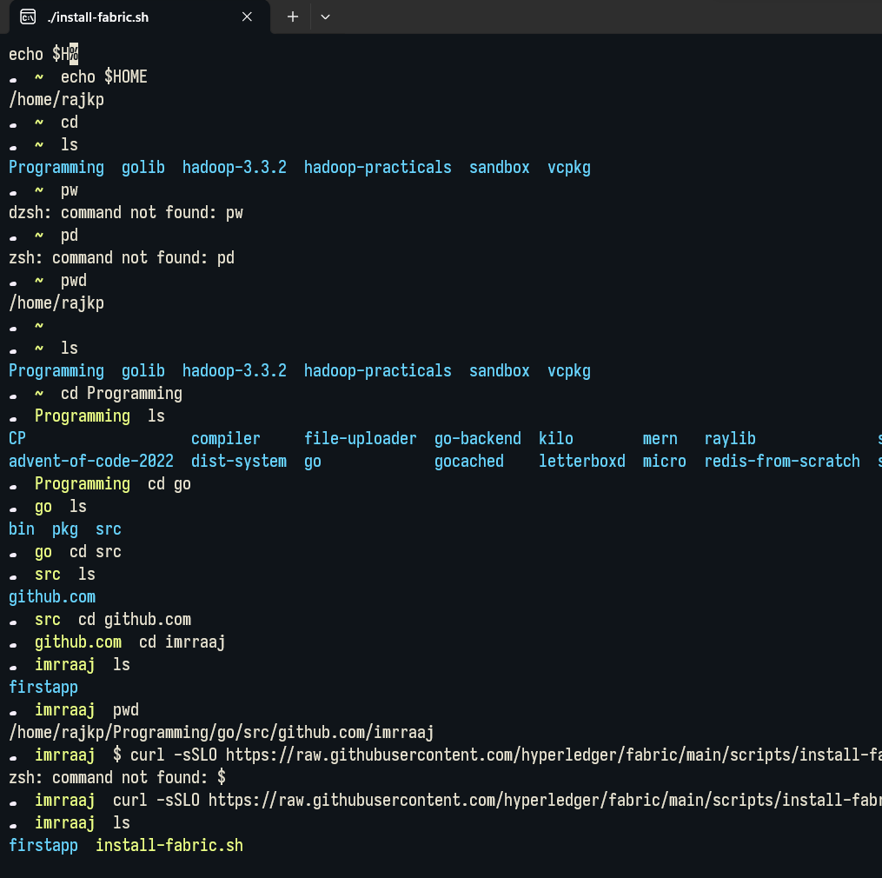

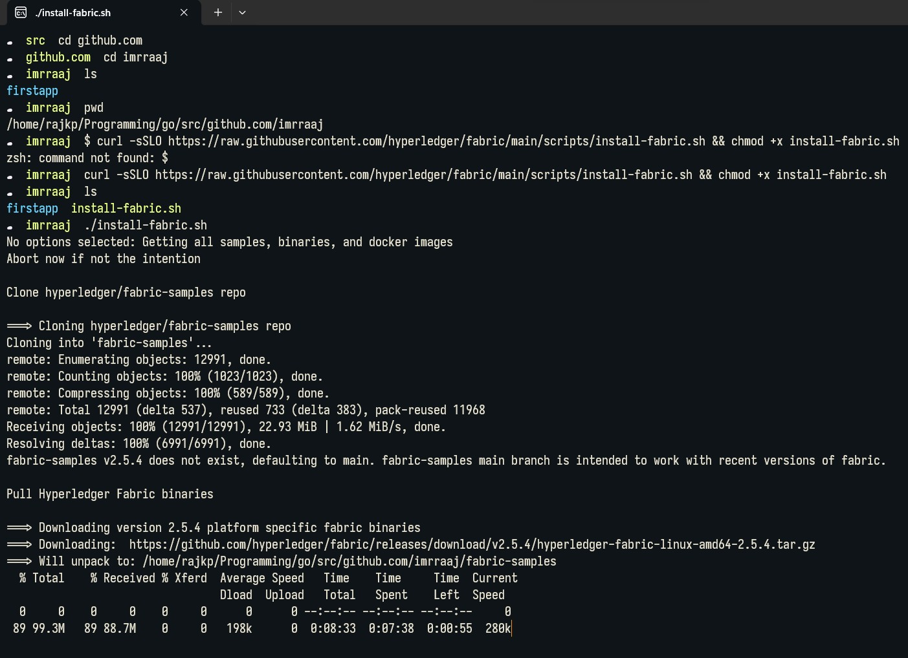

@ **./install-fabric.sh** X + V

main

branch is intended

. imrraaj ./install-fabric.sh

No options selected: Getting all samples, binaries, and docker images Abort now if not the intention

Clone hyperledger/fabric-samples repo

# Changing directory to fabric-samples

fabric-samples v2.5.4 does not exist, defaulting to

# main. fabric-samples

Pull Hyperledger Fabric binaries

Downloading version 2.5.4 platform specific fabric binaries

Downloading: https://github.com/hyperledger/fabric/releases/download/v2.5.4/hyperledger-fab Will unpack to: /home/rajkp/Programming/go/src/github.com/imrraaj/fabric-samples

% Total % Received% Xferd Average Speed Time Time Time Current

□load Upload Total

Spent Left Speed

0 0 0 0 0 0

100 99.3M 100 99.3M 0 0

0

966k

0 --:--:-- --:--:-- --:--:-- 0

0 0:01:45 0:01:45 --:--:-- 931k

Done.

Downloading version 1.5.7 platform specific fabric-ca-client binary

Downloading: https://github.com/hyperledger/fabric-ca/releases/download/v1.5.7/hyperledger- Will unpack to: /home/rajkp/Programming/go/src/github.com/imrraaj/fabric-samples

% Total % Received% Xferd Average Speed Time Time Time Current

□load Upload Total Spent Left Speed

0 0 0 0 0 0 0

100 34.0M 100 34.0M

Done.

0 0 1308k

0 --:--:-- 0:00:04 --:--:-- 0

0 0:00:26 0:00:26 --:--:-- 1613k

Pull Hyperledger Fabric docker images

FABRIC_IMAGES: peer orderer ccenv tools baseos Pulling fabric Images

docker.io/hyperledger/fabric-peer:2.5.4 2.5.4: Pulling from hyperledger/fabric-peer 01085d60b3a6: Pull complete

5920bb1ab585: Pull complete

X + V

§1 **..b.com/imrraaj**

cc16ebc66c1e: Pull complete cfb66da0a833: Pull complete daa87923bf69: Pull complete

Digest: sha256:cab2ed27ed8d27e4cacde447a1de51884f0bd9e103a6119e74521e1b90b6d106 Status: Downloaded newer image for hyperledger/fabric-baseos:2.5.4 docker.io/hyperledger/fabric-baseos:2.5.4

Pulling fabric ca Image

====:> docker.io/hyperledger/fabric-ca:1.5.7 1.5.7: Pulling from hyperledger/fabric-ca edaedc954fb5: Pull complete

793f509072c1: Pull complete 40231dd4f3a4: Pull complete 5799c17ab94e: Pull complete

Digest: sha256:db814e013fc29f94f75a5df6e3920c08a4e96e53a079152df2ffa99e6db24861 Status: Downloaded newer image for hyperledger/fabric-ca:1.5.7 docker.io/hyperledger/fabric-ca:1.5.7

List out hyperledger images

hyperledger/fabric-ca 1.5

hyperledger/fabric-ca 1.5.7

hyperledger/fabric-ca latest hyperledger/fabric-tools 2.5

hyperledger/fabric-tools 2.5.4

hyperledger/fabric-tools latest hyperledger/fabric-peer 2.5

hyperledger/fabric-peer 2.5.4

hyperledger/fabric-peer latest hyperledger/fabric-orderer 2.5

hyperledger/fabric-orderer 2.5.4

hyperledger/fabric-orderer latest hyperledger/fabric-ccenv 2.5

hyperledger/fabric-ccenv 2.5.4

hyperledger/fabric-ccenv latest hyperledger/fabric-baseos 2.5

hyperledger/fabric-baseos 2.5.4

hyperledger/fabric-baseos latest

. imrraaj

0f07bbee6fb8 0f07bbee6fb8 0f07bbee6fb8 b2f3af4021be b2f3af4021be b2f3af4021be 4f8d1b54d8b0 4f8d1b54d8b0 4f8d1b54d8b0 7a73187b5c49

7a73187b5c49

7a73187b5c49

6dac93f94c87 6dac93f94c87 6dac93f94c87 3854817b987d

3854817b987d

3854817b987d

2 months ago

2 months ago

1. months ago
2. months ago

3 months ago

3 months ago

3 months ago

3 months ago

3 months ago

3 months ago

3 months ago

3 months ago

3 months ago

3 months ago

3 months ago

3 months ago

3 months ago

3 months ago

223MB

223MB

223MB

551MB

551MB

551MB

135MB

135MB

135MB

106MB

106MB

106MB

656MB

656MB

656MB

122MB

122MB

122MB

@

**../test-network**

. imrraaj ls fabric-samples

. imrraaj cd

. test-network

X + V

firstapp install-fabric.sh fabric-samples/test-network [main]./network.sh down

locally

[+] Running 7/0

Volume compose_peer0.org2.example.com Removed Volume compose_orderer2.example.com Removed Volume compose_orderer4.example.com Removed Volume compose_peer0.org1.example.com Removed Volume compose_orderer3.example.com Removed Volume compose_peer0.org3.example.com Removed Volume compose_orderer.example.com Removed

Error response from daemon: get docker_orderer.example.com: no such volume Error response from daemon: get docker_peer0.org1.example.com: no such volume Error response from daemon: get docker_peer0.org2.example.com: no such volume

Unable to find image 1busybox:latest1 latest: Pulling from library/busybox 3f4d90098f5b: Pull complete

Digest: sha256:3fbc632167424a6d997e74f52b878d7cc478225cffac6bc977eedfe51c7f4e79 Status: Downloaded newer image for busybox:latest

. test-network [main]

§) ../test-network X + V

C 1·eated Volume "compose_peer0.org2.example.com" C i-eated Volume "compose_orderer.example.com" C 1·eated

Volume "compose_peer0.org1.example.com" C 1·eated

Star·ted Sta r·ted

Container orderer.example.com Sta r·ted

Container cli Sta1·ted

MAGE

NAMES

hyperledger/fabric-tools:latest cli

hy

peer0.org2.example.com hyperledger/fabric-peer:latest

peer0.org1.example.com 4dd39fa35a4a hyperledger/fabric-orderer:latest tcp orderer.example.com cb7e42e90b5a mysql:latest

bc9574e55c53 8446-8447/tcp 1253d3c0ae5a

no

ko

po

-

test-network [main]

kong-database

stgres:13

kong-gateway

ng/kong-gateway:3.4.1.1

node_kong

de_kong

nervous_cannon

perledger/fabric-peer:latest

I

CONTAINER ID

Container peer0.org2.example.com

Container peer0.org1.example.com

Networkfabric_test

e6959c78454b

+

org2.example.com

+

res=0

cryptogen generate --config=./organizations/cryptogen/crypto-config-org2.yaml --output=organizations

+ cryptogen generate --config=./organizations/cryptogen/crypto-config-orderer.yaml --output=organizations

+ res=0

|  |
| --- |
| 2dc82591cb45 |
| 5edce006ead9 |
| a9b199080c42 |

|  |  |  |  |  |
| --- | --- | --- | --- | --- |
| COMMAND |  | | | |
| "/bin/bash" | | |  | |
| "peer node start" | | | |  |
| "peer node start" | | | |
| "orderer" | |  | | |
| "docker-entrypoint.s. | | | | |
| "docker-entrypoint.s. | | | | |
| "/entrypoint.sh kong. | | | | |
| "docker-entrypoint.s. | | | | |

|  |  |  |  |
| --- | --- | --- | --- |
| CREATED | |  | |
| 2 seconds ago | | | |
| 2 seconds ago | | | |
| 2 seconds ago | | | |
| 2 seconds ago | | | |
| 3 | days | ago |  |
| 3 | days | ago |
| 3 | days | ago |
| 3 | days | ago |

|  |  |  |  |  |
| --- | --- | --- | --- | --- |
| STATUS | |  | | |
| Up | Less than as | | | |
| Up | Less than as | | | |
| Up | Less than as | | | |
| Up | Less than as | | | |
| Exited | | (255 | ) | 7 m |
| Exited | | (255) 3 d | | |
| Exited | | (255) 3 d | | |
| Exited | | (255) 3 d | | |

**§I ./network.sh** X + V

* test-network [main] ./network .sh createChannel

Neh1ork Running Already

/home/ raj kp/Programming/go/src/github. com/imrraaj /fabric-samples/test-network/ .. /bin/conf igtxgen

+ I [ I 0 -eq 1 I l '

+ conf igtxgen -profile ChannelUsingRaft -outputBlock . / channel-artifacts/mychannel.block -channelIO mychannel

[common. tools.conf igtxgen] rnai11 Loading configuration

[common. tools.configtxgen.localconfig] completelni tialization orderer type: etcdraft [common. tools.conf igtxgen.localconfig] completeInitialization Orderer. EtcdRaft.Options unse

rtbeat_ tick:1 max_inflight_blocks:5 snapshot_interval_size:16777216

[common. tools.configtxgen.localconfig] Loall Loaded configuration: /home/rajkp/Programming/g

f igtx/configtx. yaml

[common. tools.configtxgen] cloOutputBlock Generating genesis block

[common. tools.configtxgen] cloOutputBlock Creating application channel genesis block [common. tools.configtxgen] lloOutputBlock I/riting genesis block

+ res=0

+ . scripts/orderer.sh mychannel

+ ' [' 0 -eq 1 ']'

+ res=0

Status: 201

{

**11name11:**

**11mychannel** 11,

"url": "/participation/v1/channels/mychannel", "consensusRelation": "consenter",

"height": 1

**11s tatus11:**

**11acti ve11,**

Channel 'mychannel' created

c, X

../test-network

+ peer channel fetch config config_block.pb -o orderer.example.com:7050 --ordererTLSHostnameOverride orderer.example.com -c mychannel --tls --cafile /opt/gopath/src/github.com/hyperledger/ fabric/peer/ organizations/orde rerOrganizations/example. com/ tl sea/ tl sea.example. com-cert. pem

[channelCmd] lnitCmclFactOl"y Endorser and orderer connections initialized [cli.common] r·eadBlock Received block: 1

[channelCmd] fetcll Retrieving last config block: 1 [cli.common] r·eadBlock Received block: 1

+ configtxlator proto_decode --input config_block.pb --type common.Block --output config_block.json

+ jq '.data.data[8].payload.data.config' config_block.json

+ jq '.channel_group.groups.Application.groups.Org2MSP.values += {"AnchorPeers":{"mod_policy": "Admins", "value":{"anchor _peers": [{"host": "peer0.org2.example.com","port": 9051}]}, "version ": "0"}}' Org2MSPconfig.json

+ configtxlator proto_encode --input Org2MSPconfig.json --type common.Config --output original_config.pb

+ configtxlator proto_encode --input Org2MSPmodified_config.json --type common.Config --output modified_config.pb

+ configtxlator compute_update --channel_id mychannel --original original_config.pb --updated modi fied_config.pb --output config_update .pb

+ configtxlator proto_decode --input config_update.pb --type common.ConfigUpdate --output config_update.json

+ jq.

++ cat config_update.json

+ echo '{"payload":{"header":{"channel_header":{"channel_id":"mychannel", "type":2}},"data":{"config_update":{' '"channel_id":' '"mychannel",' '"isolated_data":' '{},' '"read_set":' '{' '"

groups":''{' '"Application":''{' '"groups":''{' '"Org2MSP":' '{''"groups":''{},' '"mod_policy":' '"",''"policies":''{' '"Admins":' '{' '"mod_policy":' '"",' '"policy":' null, '"vers

ion":' 1118111 '},' '"Endorsement":' '{' '"mod_policy":' '"",' '"policy":' null, '"version":' 1118111 '},' '"Readers":' '{' '"mod_policy":' '"",' '"policy":' null, '"version":' 1118111 '},' '"Wr

iters":' '{' '"mod_policy":' '"",' '"policy":' null, '"version":' '"0"' '}' '},' '"values":' '{' '"MSP":' '{' '"mod_policy":' '"",' '"value":' null, '"version":' '"0"' '}' '},' '"version":

'1118111 '}' '},' '"mod_policy":' '"",''"policies":''{},' '"values":''{},' '"version":' 1118111 '}' '},' '"mod_policy":' '"",''"policies":''{},' '"values":''{},' '"version":' 1118111 '},'

'"write_set":' '{''"groups":''{' '"Application":''{' '"groups":''{' '"Org2HSP":' '{''"groups":''{},' '"mod_policy":' '"Admins",' '"policies":''{' '"Admins":' '{' '"mod_policy":' '"

",' '"policy":' null, '"version":' 1118111 '},' '"Endorsement":' '{' '"mod_policy":' '"",' '"policy":' null, '"version":' 1118111 '},' '"Readers":' '{' '"mod_policy":' '"",' '"policy":' null,

'"version":' 1118111 '},' '"Writers":' '{' '"mod_policy":' '"",' '"policy":' null, '"version":' 111811' '}' '},' '"values":' '{' '"AnchorPeers":' '{' '"mod_policy":' '"Admins",' '"value":' '{'

'"anchor_peers":' '[''{''"host":' '"peer0.org2.example.com",' '"port":' 9051 '}' ']''},''"version":' 1118111 '},' '"MSP":' '{' '"mod_policy":' 11111,1 '"value":' null, '"version":' 1118111

"'0"' '}' '))}}'

'"1"'

'}''},''"version":'

'}' '},' '"mod_policy":' '"",''"policies":''{},' '"values":''{},' '"version":' 1118111 '}' '},' '"mod_policy":' '"",''"policies":''{},' '"values":''{},' '"v

ersion":'

+ configtxlator proto_encode --input config_update_in_envelope.json --type common.Envelope --output Org2HSPanchors.tx

[channelCmd] lnitCmclFactOl"y Endorser and orderer connections initialized [channelCmd] upclate Successfully submitted channel update

A11cl101" 1iee1· set for· Ol"ij 'Or·u2MSP' 011 cl1a1111el 'mycl1a1111el' Cl1a1111el 'mycl1a1111el' joi11ecl

.. test-network [main]

* test-network [main]
* test-network [main] ./network.sh deployCC -ccn basic -ccp .. /asset-transfer-basic/chaincode-go -eel go

### executing with the following

* CHANNEL_NAME: mycl1a1117e]
* CC_NAME: l1asic
* **CC_SRC_PATH:** .. / cl s set-tra11sf er·-l>c1sic/c l1a i 11cocle-go
* CC_SRC_LANGUAGE: uo
* CC_VERSION: 1.0.1
* CC_SEQUENCE: auto
* CC_END_POLICY: IIA
* CC_COLL_CONFIG: IIA
* CC_INIT _FCN: IIA
* DELAY: 3
* MAX_RETRY: 5
* VERBOSE: false

### executing with the following

* CC_NAME: l1as1c
* **CC_SRC_PATH:** .. /as set-trcrnsfe1· -l>c1s ic/ c l1a i 11cocle-go
* CC_SRC_LANGUAGE: uo
* CC_VERSION: 1.0.1

•/Programming/go/src/github.com/ imrraaj /fabric-samples/asset-transfer-basic/chaincode-go •/Programming/go/src/gi thub.com/ imrraaj /fabric- samples/test-network

go: downloading github.com/hyperledger/fabric-contract-api-go v1 .2.1 go: downloading github.com/stretchr/testify v1 .8.2

go: downloading google.golang.org/grpc vl.53.0

go: downloading github.com/hyperledger/fabric-protos-go v0.3.0

go: downloading github.com/hyper ledger /f abric-chaincode-go v0.0. 0-20230228194215-b84622ba6a7a

Finislied vendo1·ing Go dependencies

go: downloading github.com/go-openapi/spec vB.20.8 go: downloading github.com/gobuffalo/packr vl.30.1 go: downloading github.com/gobuffalo/packd vl.0.1

go: downloading github.com/xeipuuv/gojsonschema v1 .2.8

go: downloading github.com/golang/protobuf vl.5.2

+ '[' **false= true** ']'

+ **peer li fecycle chaincode package basic. tar.gz --path** .. **/asset-transfer-basic/chaincode-go** -- **lang golang** -- **label basic_1. 0.**1

+ **res=0**

Cliainco(le is packaged

+ **peer li fecycle chaincode query installed --output j son**

+ **jq -r 'try (.installed_chaincodes[].package_id)'**

+ **grep ''basic_**1 . **0. 1: 650b7b4f5a8545d710651dc01edee8cf83518ef4b36a67a08be061ba14da653a$'**

+ **test** 1

+

+

**peer li fecycle chaincode install basic. tar. gz**

**-ne 0**

**res=0**

**Installed**

**remotely: response:<status:200 pa**

**[cli.lifecycle.chaincode]** submi tlnstal!Pl'Oposal

## 518ef4b36a67a08be061ba14da653a\022\013basic_1 . 0. 1" >

**Chaincode code package identifier: basic_1.**

**[cli.lifecycle.chaincode]** sulJmitlnstallPl'Oposal

**61ba14da653a**

Cl1ainc0lle is installed on pee1·0.O1·gl

+ **peer li fecycle chaincode queryinstalled --output j son**

+ **jq -r 'try (.installed_chaincodes[].package_id)'**

+ **grep ''basic_**1 . **0 .1: 650b7b4f5a8545d710651dc01edee8cf83518ef4b36a67a08be061ba14da653a$'**

+ **test** 1 **-ne 0**

+ **peer lifecycle chaincode install basic. tar .gz**

[] **./network.sh** X + y

Cl1ai11code is i11stalled 011 pee1·0.01·g1

+ peer lifecycle chaincode queryinstalled --output json

+ jq -r 'try (. installed_chaincodes[].package_id)'

+ grep '·basic_1. 0.1: 650b7b4f5a8545d710651dc01edee8cf83518ef4b36a67a08be061ba14da653a$'

+ test 1 -ne 0

+ peer lifecycle chaincode install basic.tar.gz

+ res=0

[cli.**li** fecycle. chaincode] suhmi tins tallPrnposal Installed remotely: response:<status:200 payload:"\

518ef4b36a6 7a08be061ba14da653a\022\013basic_ **1**.0. 1" >

[cl i. lifecycle.chaincode] suhmi tins ta11Prnposa 1 Chaincode code package identifier: basic_1. 0. 1:650b

61ba14da653a

Cl1aincode is i11stalled 011 pee1·8.01·g2

* peer lifecycle chaincode querycommitted --channelID mychannel --name basic
* sed -n '/Version:/{s/.*Sequence: //; s/, Endorsement Plugin:.*$//; p;}' Error: query failed with status: 404 - namespace basic is not defined

+ COMMITTEO_CC_SEQUENCE=

+ res=0

+ peer lifecycle chaincode queryinstalled --output json

+ jq -r 'try (. installed_chaincodes[].package_id)'

+ grep '·basic_1. 0.1: 650b7b4f5a8545d710651dc01edee8cf83518ef4b36a67a08be061ba14da653a$'

+ res=0

basic_1. 0. 1: 650b7b4f5a8545d710651dc01edee8cf83518ef4b36a67a08be061ba14da653a Que1·y irrstallecl successful 011 pee1·0.orgl 011 cl1a1111el

+ peer **li** fecycle chaincode approveformyorg -o localhost: 7050 --ordererTLSHostnameOverride orderer. example. com --tls --cafile /home/ raj kp/Pro s/test-network/organizations/ordererOrganizations/example. com/tlsca/ tlsca.example .com-cert .pem --channel ID mychannel --name basic --version 0651dc01edee8c f83518ef 4b36a67a08be061ba14da653a --sequence 1

+ res=0

[chaincodeCmd] Client'.-la it txid [1722fc25c2ed15ffd598ca2bfee4a41ac86b5972ac7849e8f18b747cbce0c15a] c Chaincode clefi11itio11 apprnvecl on peerO.orgl 011 cha1111el 'mychannel'

+ peer lifecycle chaincode checkcommitreadiness --channel!□mychannel --name basic --version 1.0.1 --sequence 1 --output json

+ res=0

**11approvals11:**

"Org1MSP": true, "Org2MSP": false

+ peer lifecycle chaincode checkcommitreadiness --channel!□mychannel --name basic --version 1.0.1 --sequence **1** --output json

+ res=0

11**approvals** 11:

"Org1MSP": true, "Org2MSP": false

+ peer **li** fecycle chaincode approveformyorg -o localhost: 7050 --ordererTLSHostnameOverride orderer .example. com --tls --cafile /home/ raj kp/Progr s/ test-network/organizations/ordererOrganizations/example.com/tlsca/tlsca.example.com-cert.pem --channelIO mychannel --name basic --version 1. 0651dc01edee8cf83518ef4b36a67a08be061bal 4da653a --sequence 1

+ res=0

[ chaincodeCmd] C lient','iai t txid [32e6107a665d7553665794d132b369df7b0f1a11db13f335f984d4954f50eed5] com

**@j ../te!.t-network** X + V

**11approvals11:** {

**110rg1MSP11: true,**

"Org2MSP": true

+ peer li fecycle chaincode commit -o localhost: 7050 --ordererTLSHostnameOverride orderer .example.com --tls --cafile /home/ rajkp/Programming/go/src/githu twork/ organizations/ordererOrganizations/ example. com/ tlsca/ tlsca.example. com-cert.pem - -channelIO mychannel --name basic - -peer Addresses localhost: 7051 amming/ go/src/ gi thub.com/ imrraaj /fabric-samples/test-network/organizations/peerOrganizations/ orgl. example. com/ tlsca/ tlsca.orgl .example. com-cert. pem --pe CertFiles /home/ raj kp/Programming/go/src/ gi thub. com/ imrraaj /fabric-samples/test-network/organizations/peer rganizations/ org2.example. com/ tlsca/ tlsca.org

□

. 1 --sequence 1

+ **res=0**

[chaincodeCmd] C!ie11t',,lai t

[chaincodeCmd] Cl ie11t',,Ja it Chai11cocle clefi1ii tio11 cornmi ttecl Oil cl1a1111el 1rnycha1111el 1

txid [ ecla9805f43d521320f8fc802fcb5led690f90f46f5f54ea947e6f60a49f5614] committed wit txid [ ecla9805f43d521320f8fc802fcb5led690f90f46f5f54ea947e6f60a49f5614] committed ,,,it

+ peer lifecycle chaincode querycommi tted --channelID mychannel --name basic

+ **res=0**

Committed chaincode definition for chaincode 'basic' on channel 'mychannel':

Version: 1.0.1, Sequence: 1, Endorsement Plugin: escc, Validation Plugin: vscc, Approvals: [OrglMSP: true, Org2MSP: true] Quer-y chai11cocle clefi1litio11 successful 011 1leer0.01-u1 011 cl1a1111el 1mycha1111el 1

+ peer lifecycle chaincode querycommitted --channel!D mychannel --name basic

+ **res=0**

Committed chaincode definition for chaincode 'basic' on channel 'mychannel':

Version: 1.0.1, Sequence: 1, Endorsement Plugin: escc, Validation Plugin: vscc, Approvals: [OrglMSP: true, Org2MSP: true] Quer·y chaincocle clefi11ition successful 011 11eer0.01·g2 011 cliar111el 1mycha1111el 1

* test-network [main]