**Roll No.:** 20BCE204

**Subject:** Big Data Analytics

**Practical:** 9

<https://www.datastax.com/products/datastax-astra>

**Installation:**

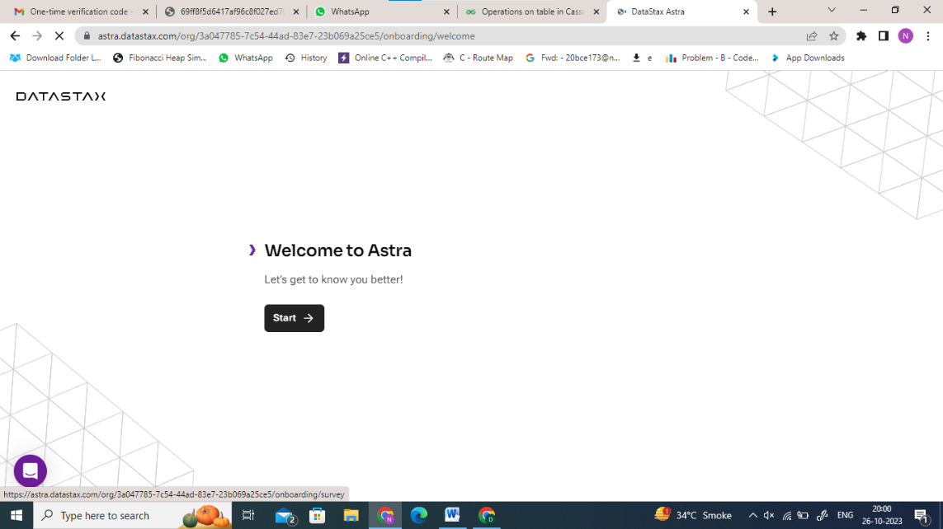

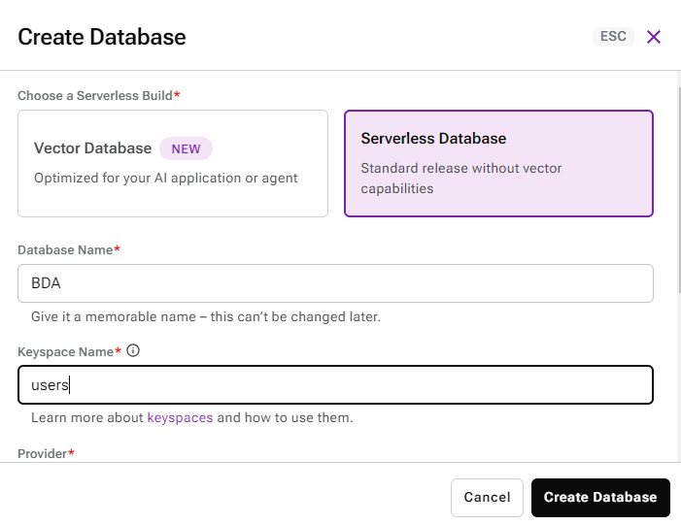

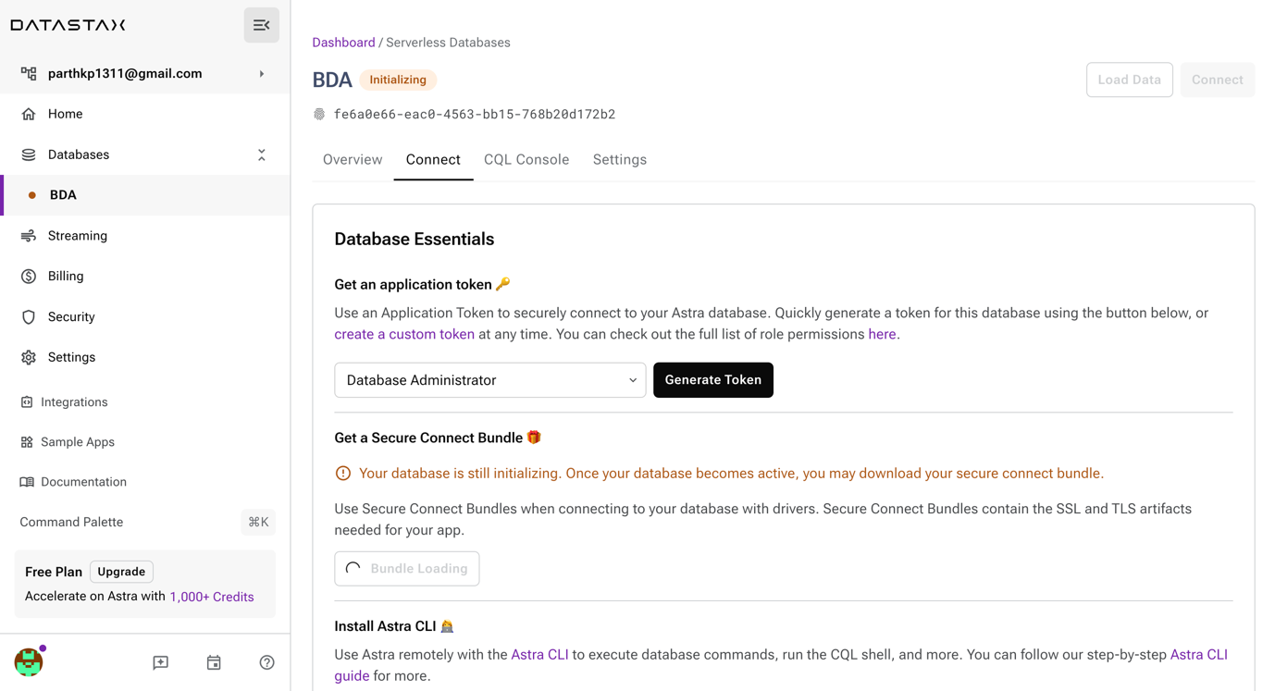

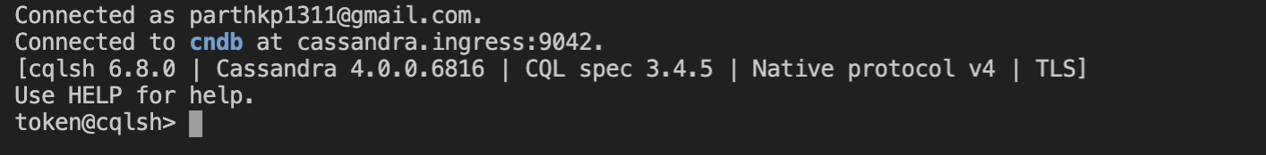

1. **Create:**

**USE users;**

**Create table Address( id uuid primary key, name text, city text);**

1. **Insert**

Insert into Address(id, name, city) values (uuid(),'Parth', 'Ahmedabad');

Insert into Address(id, name, city) values (uuid(),'Deep', 'Mumbai');

Insert into Address(id, name, city) values (uuid(), 'Dhruvil', 'Pune');



1. **Retrieve**

**Select * from Address;**

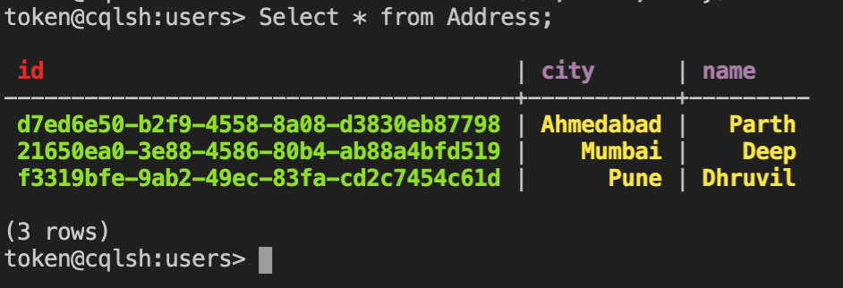

1. **Describe**

Describe table Address;

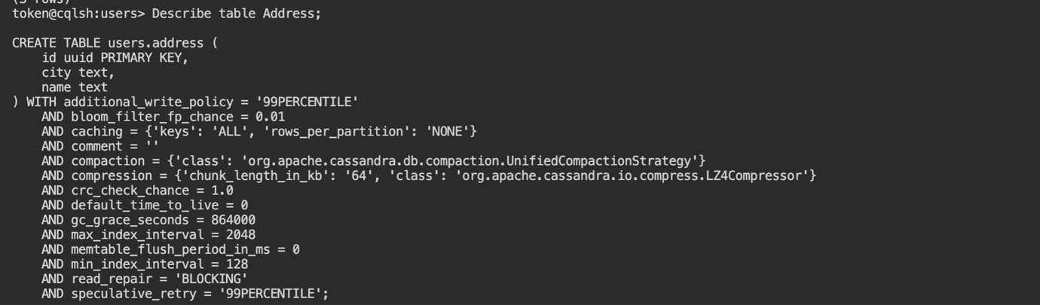

1. **Update**

**Update Address set city = 'Goa' where id = f3319bfe-9ab2-49ec-83fa-cd2c7454c61d;**

**Select * from Address;**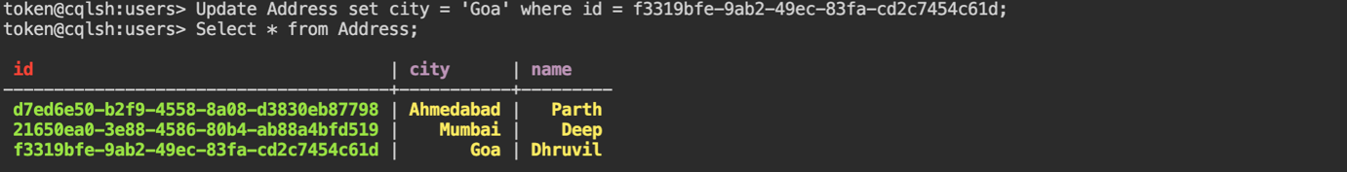

1. **Delete**

**Truncate Address;**

**Select * from Address;**