**Roll No:** 20BCE204

**Course:** 2CSDE67 Cloud Computing

**Practical No:** 4

**Aim:** Working with an IaaS Cloud Computing: Using AWS (Amazon Web Services) to understating the following concept. Do load balancing in amazon EC2

**Introduction:**

AWS Lambda is an event-driven, serverless computing platform provided by Amazon as a part of Amazon Web Services. It is a computing service that runs code in response to events and automatically manages the computing resources required by that code.

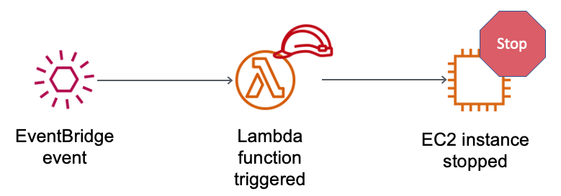

**Already running instances of EC2**

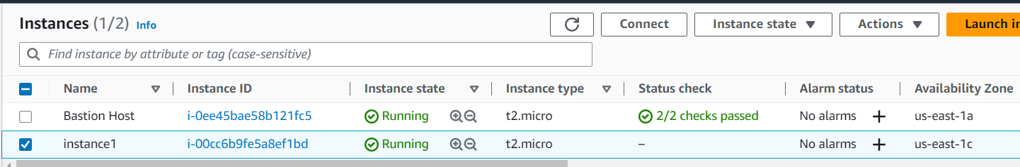

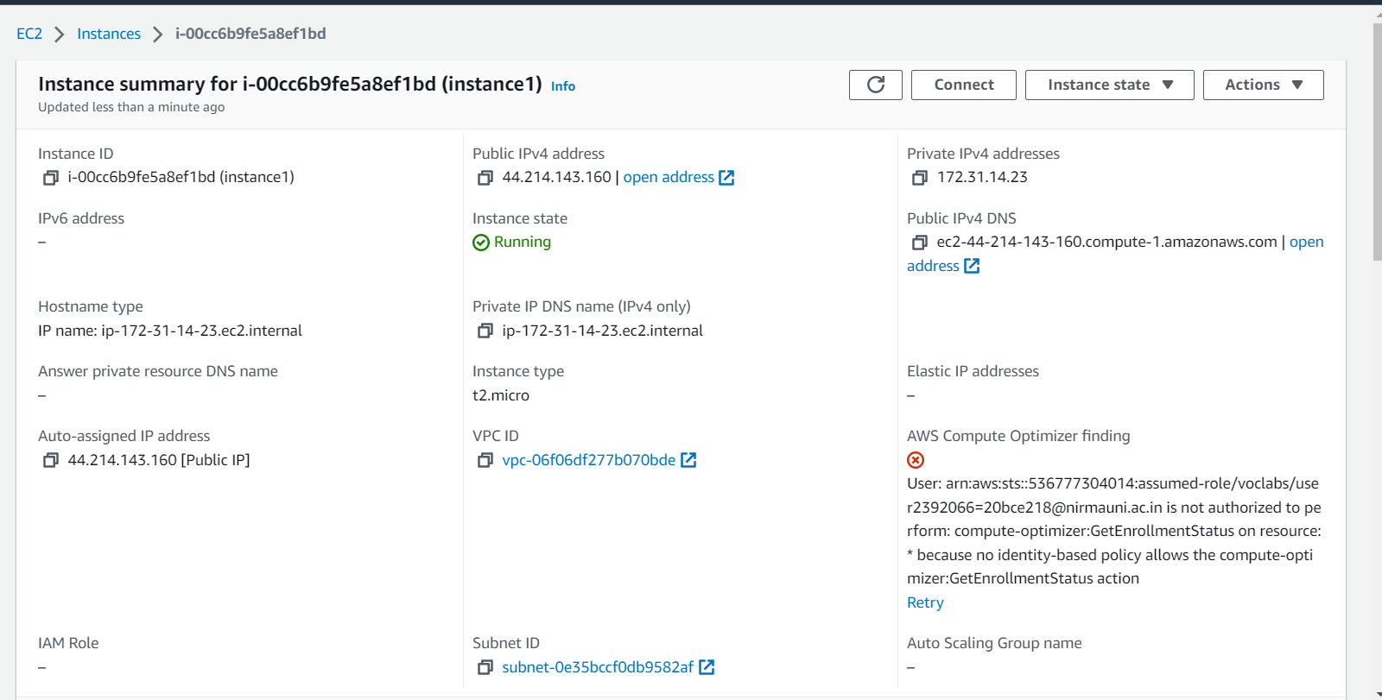

**Creating a Lambda function in AWS console**

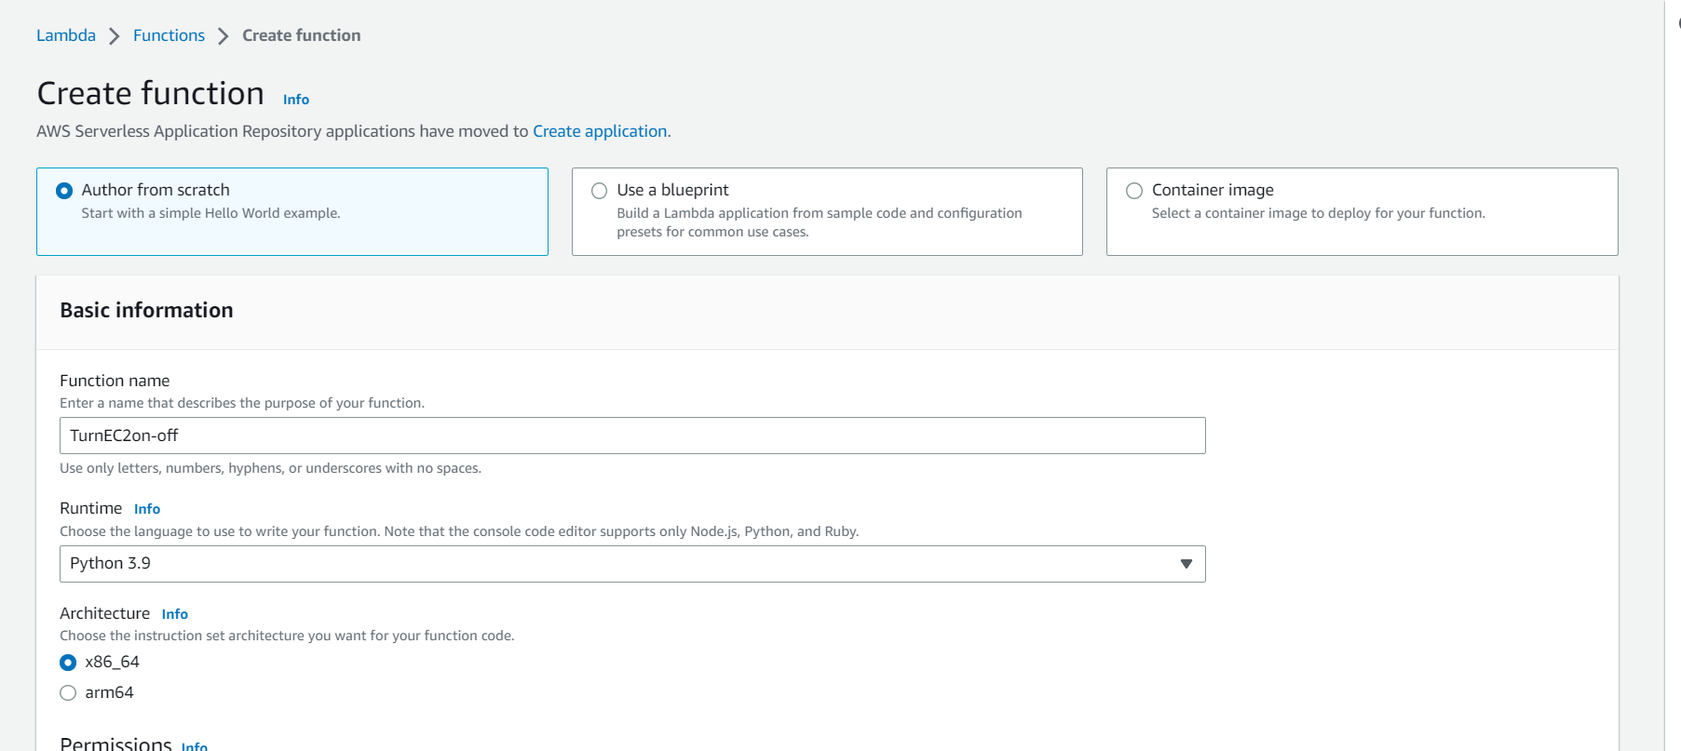

**Lambda function dashboard:**

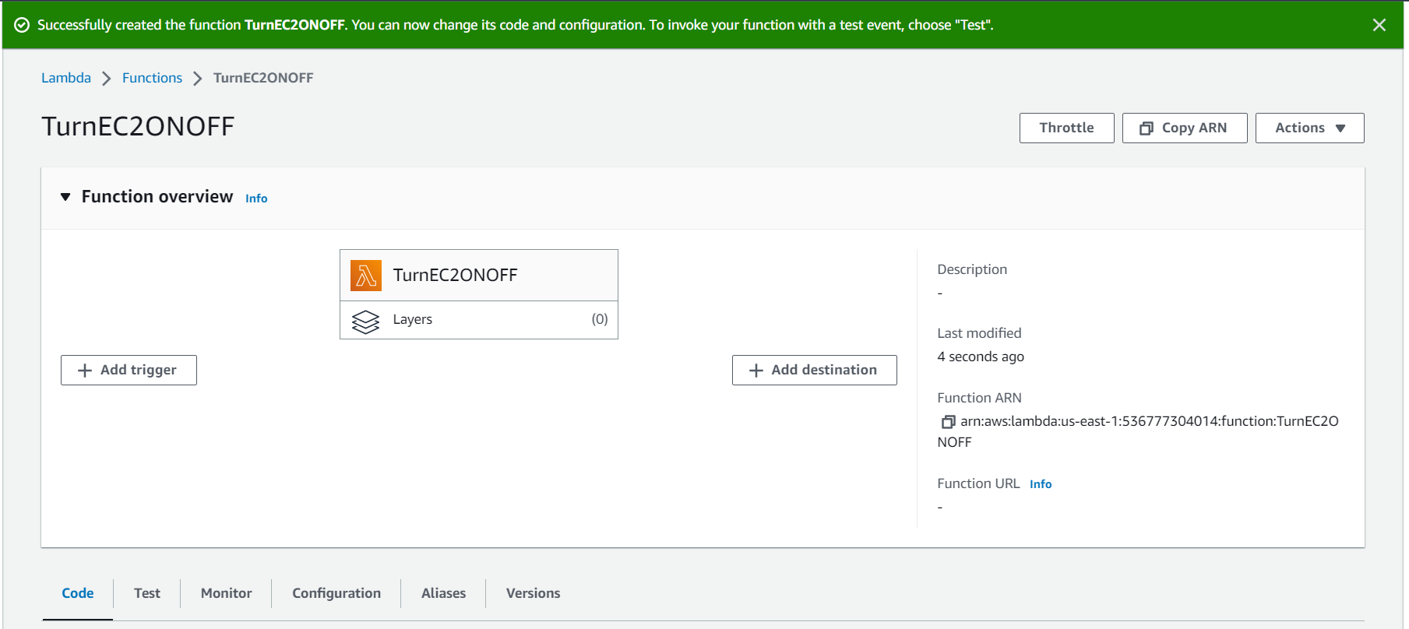

**Creating a trigger for the function to run:**

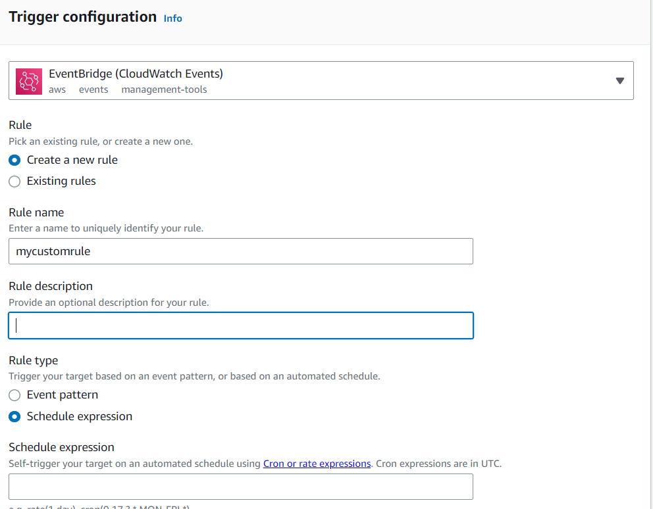

**Providing the rate of execution** 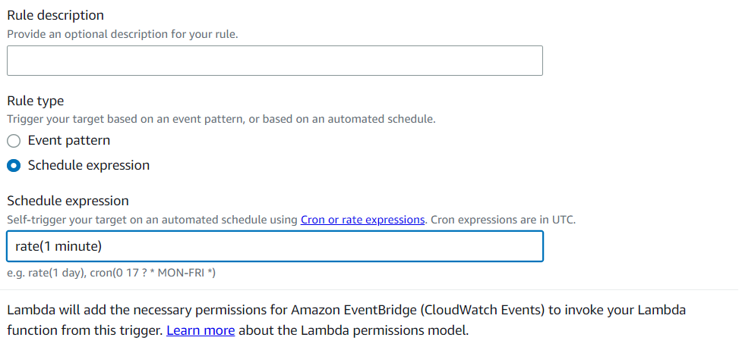

**Configured function**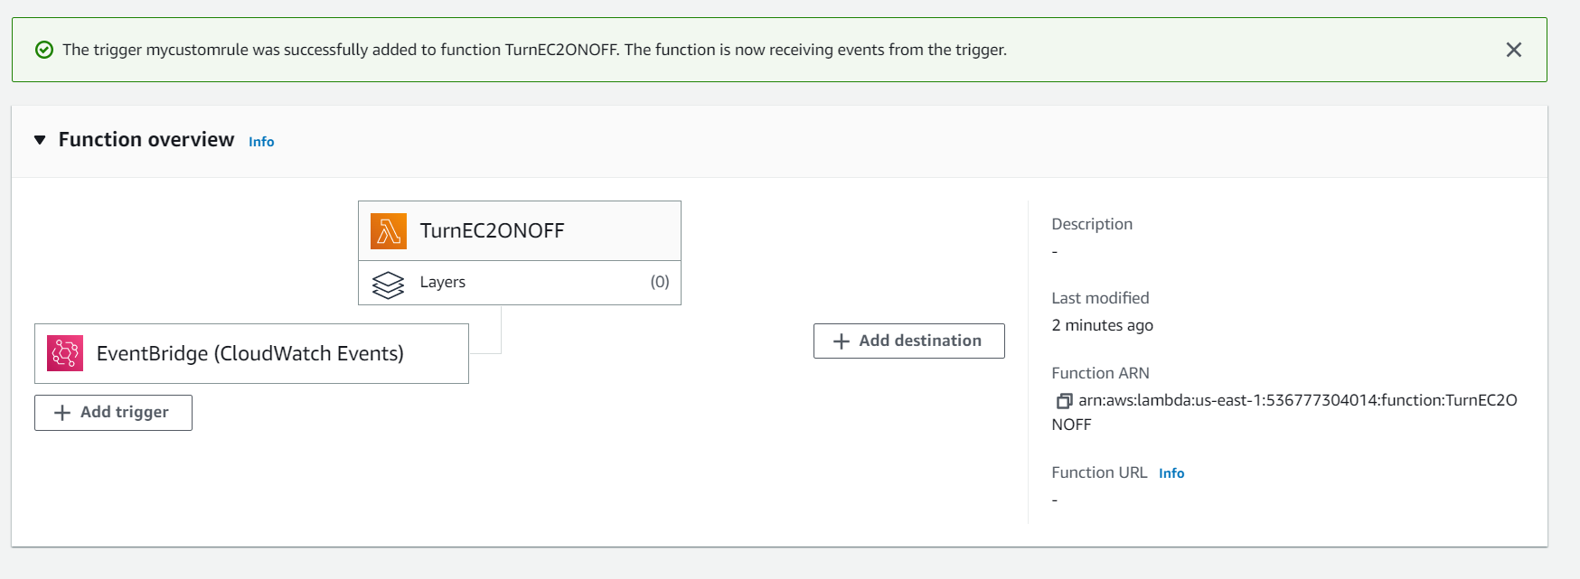

**Creating a custom test event to test the function:**

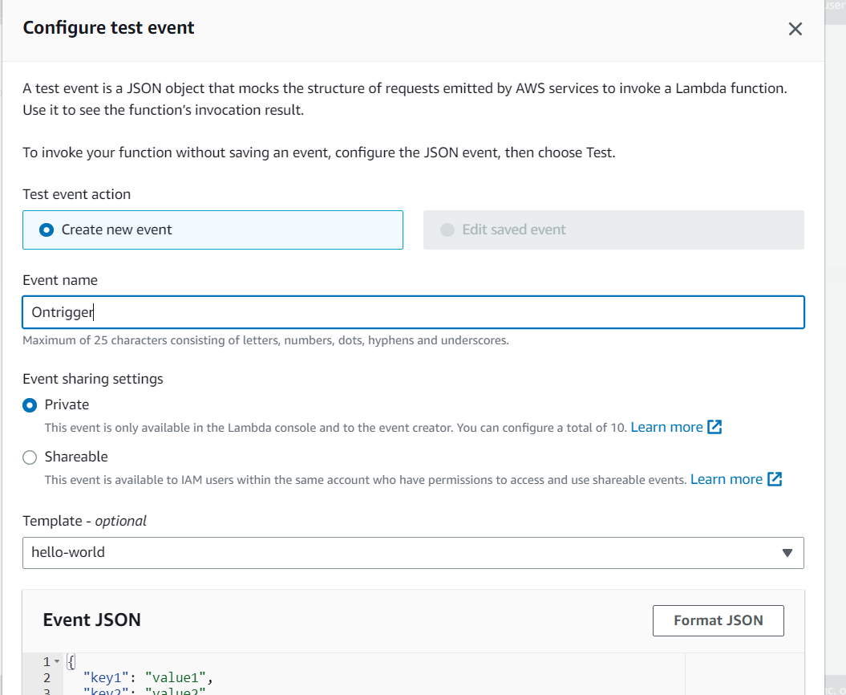

**Function body:**

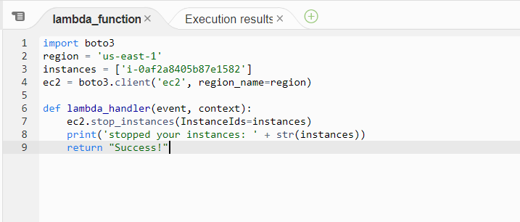

**Execution result of the function:**

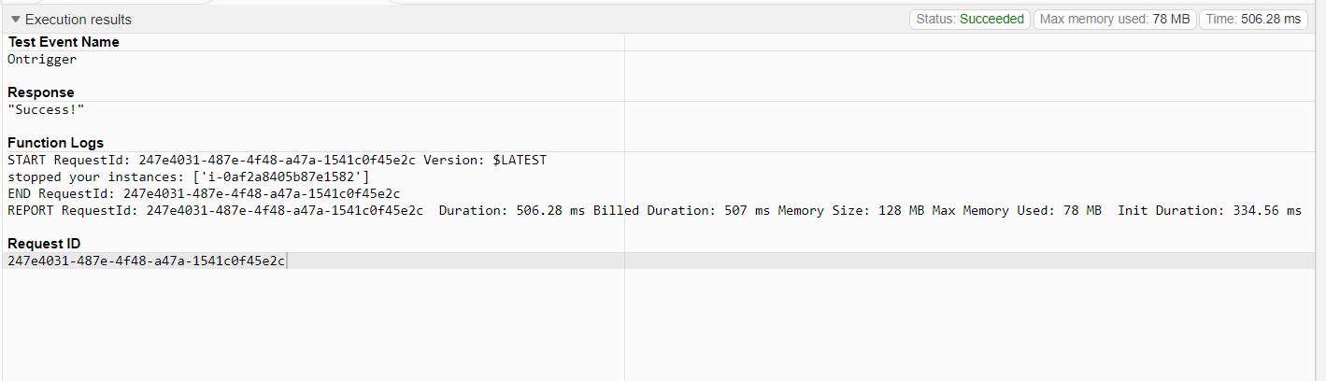

**The VM instance is stopped by executing the Function**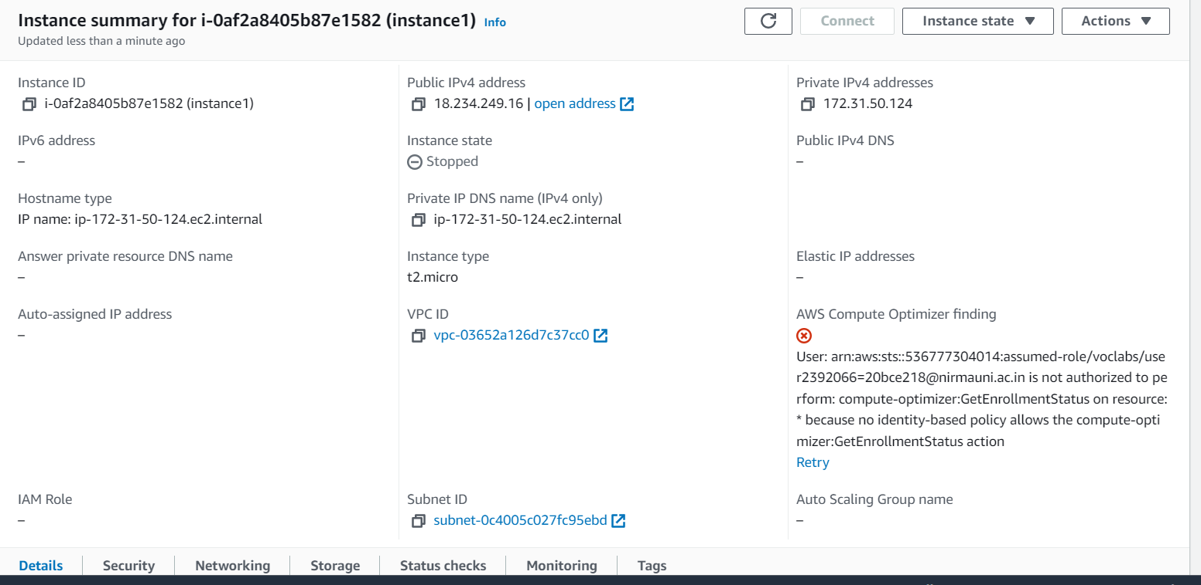

**Function body to turn the instance on:**

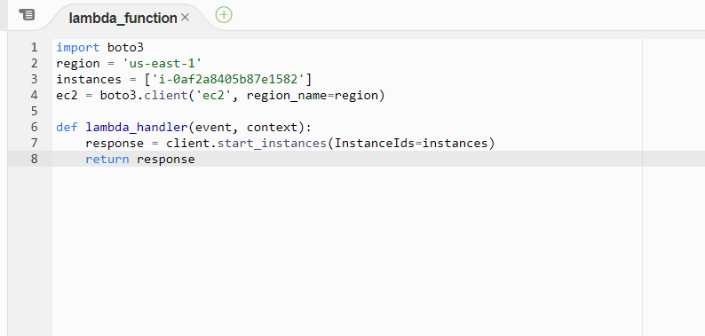

**Execution result:**

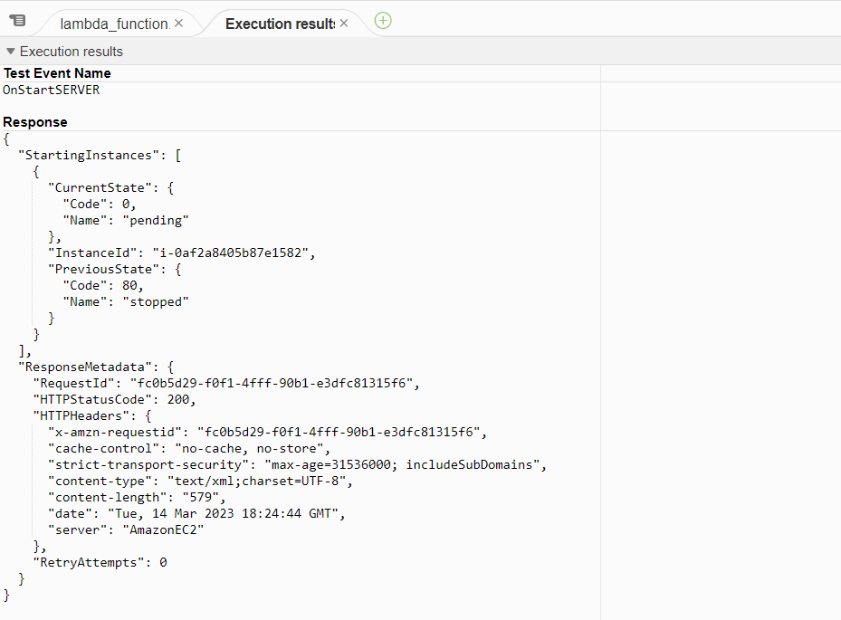

**The instance is started by executing the function:**

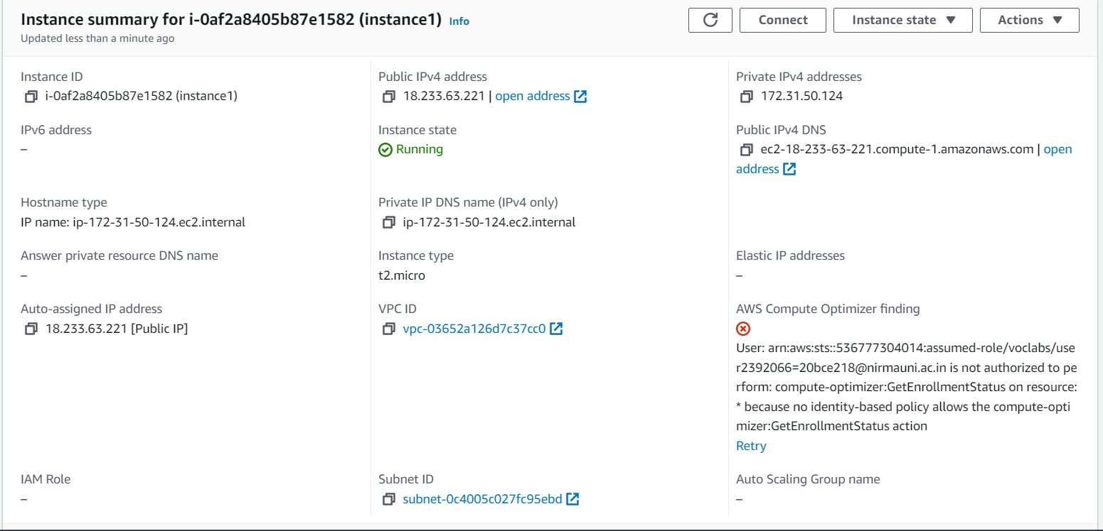

**Conclusion:**

In this practical I have learnt about the Amazon Lambda function service. I have created a Lambda function on the AWS cloud and configured it to start and stop the VM instance provided by AWS.