Roll no.: 20BCE204

Subject: MOS

Practical: 3

Aim: User Interfaces for Android based Mobile Applications: List view, Spinner

1. ***List-view***

* Create a New project (Empty View Activity)

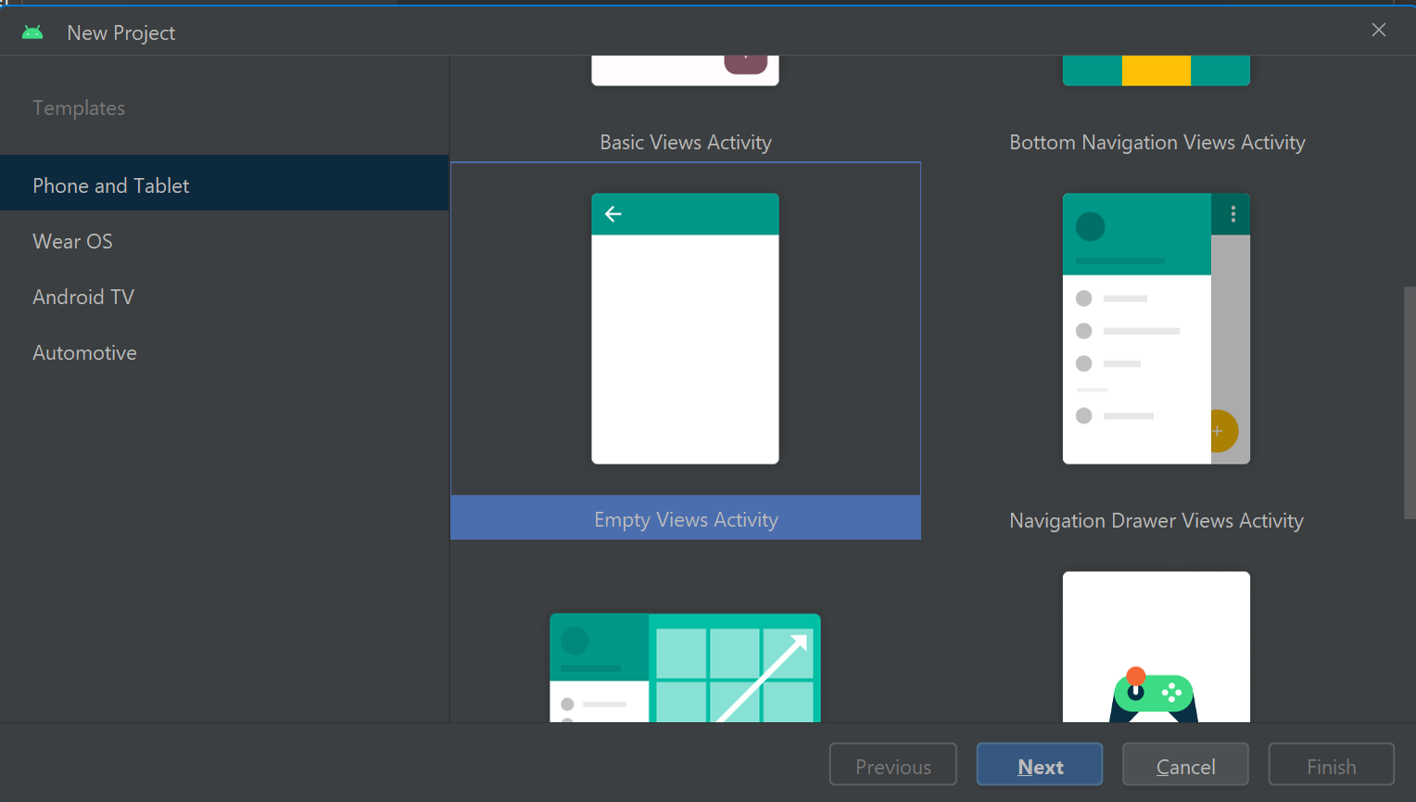

* Now set the layout of the screen as per requirement

***activity_main.xml***

<?xml version="1.0" encoding="utf-8"?>  
<LinearLayout xmlns:android="http://schemas.android.com/apk/res/android"  
 xmlns:app="http://schemas.android.com/apk/res-auto"  
 xmlns:tools="http://schemas.android.com/tools"  
 android:layout_width="match_parent"  
 android:layout_height="match_parent"  
 android:orientation="vertical"  
 android:padding="16dp"  
 tools:context=".MainActivity">  
  
  
 <EditText  
 android:id="@+id/taskEditText"  
 android:layout_width="match_parent"  
 android:layout_height="wrap_content"  
 android:hint="Enter a new task"  
 android:minHeight="48dp" />  
  
 <Button  
 android:layout_width="wrap_content"  
 android:layout_height="wrap_content"  
 android:text="Add Task"  
 android:backgroundTint="#590DE1"  
 android:textColor="@color/white"  
 android:paddingLeft="20dp"  
 android:paddingRight="20dp"  
 android:onClick="addTask" />  
  
 <ListView  
 android:id="@+id/listView"  
 android:layout_width="match_parent"  
 android:layout_height="wrap_content"  
 android:layout_marginTop="16dp" />  
  
  
</LinearLayout>

* Now we will write the business logic of calculator in Java

***MainActivity.java***

package com.example.practical3listview;  
  
import androidx.appcompat.app.AppCompatActivity;  
  
import android.os.Bundle;  
import android.app.Activity;  
import android.view.View;  
import android.widget.ArrayAdapter;  
import android.widget.EditText;  
import android.widget.ListView;  
import java.util.ArrayList;  
  
public class MainActivity extends Activity {  
  
 private ListView listView;  
 private EditText taskEditText;  
 private ArrayAdapter<String> adapter;  
 private ArrayList<String> tasks;  
  
 @Override  
 protected void onCreate(Bundle savedInstanceState) {  
 super.onCreate(savedInstanceState);  
 setContentView(R.layout.*activity_main*);  
  
 listView = findViewById(R.id.*listView*);  
 taskEditText = findViewById(R.id.*taskEditText*);  
  
 tasks = new ArrayList<>();  
 adapter = new ArrayAdapter<>(this, android.R.layout.*simple_list_item_1*, tasks);  
 listView.setAdapter(adapter);  
  
  
 }  
  
 public void addTask(View view) {  
 String newTask = taskEditText.getText().toString().trim();  
 if (!newTask.isEmpty()) {  
 tasks.add(newTask);  
 adapter.notifyDataSetChanged();  
 taskEditText.setText("");  
 }  
 }  
}

Output:

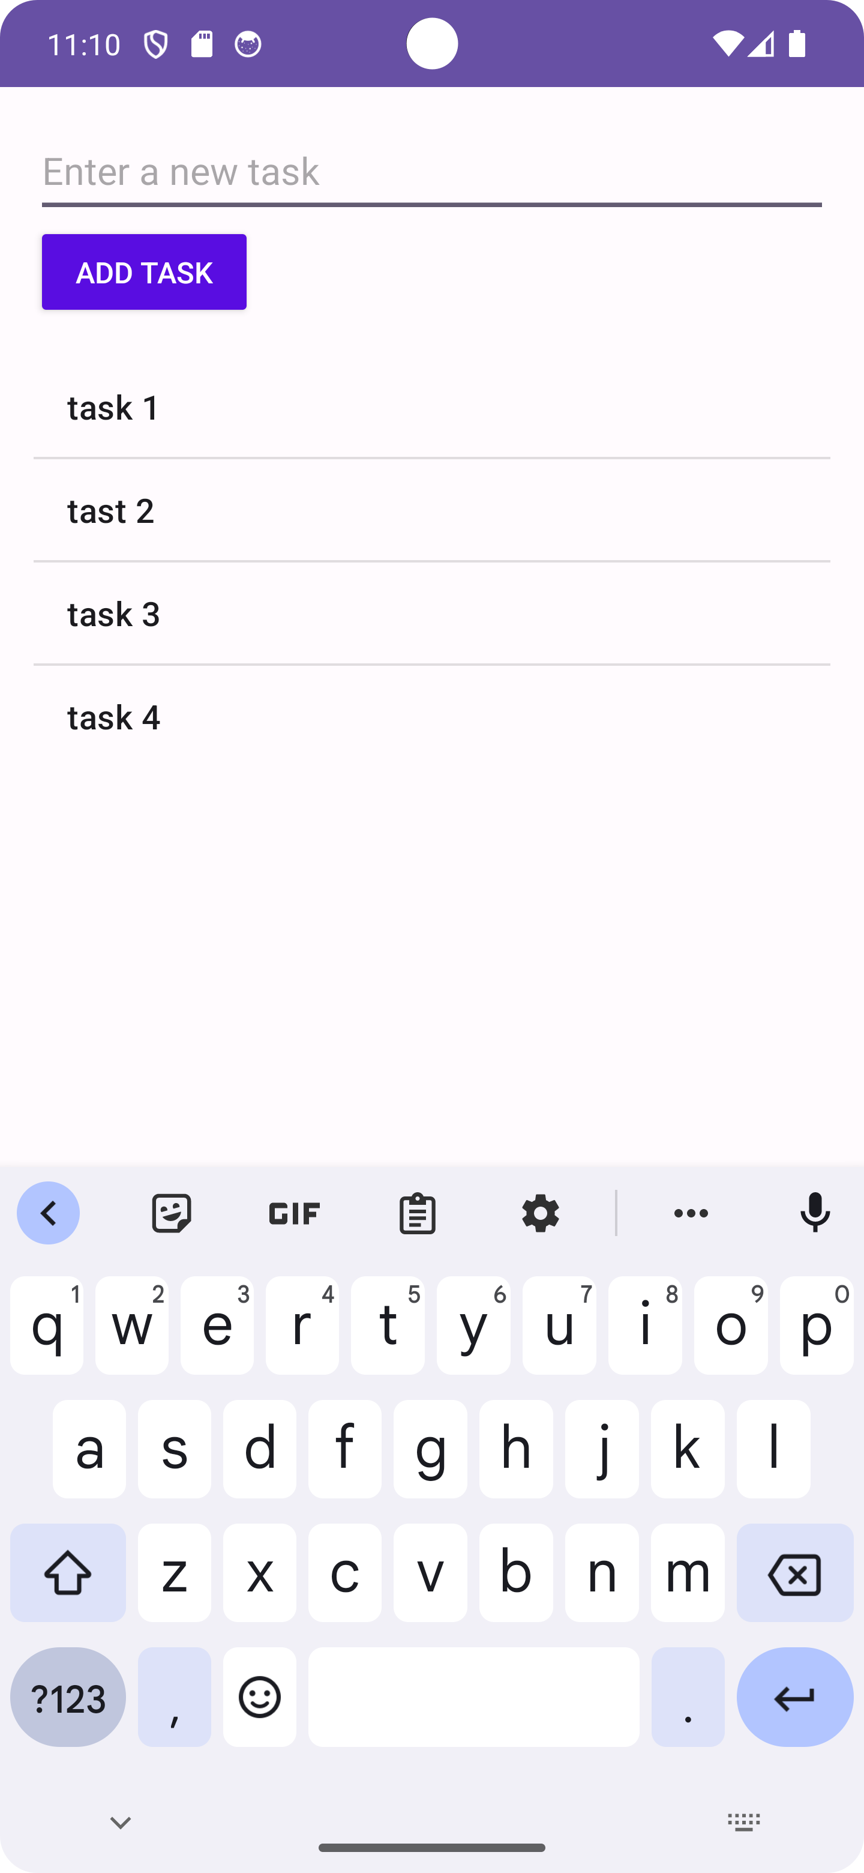

1. ***Spinner***

* ***activity_main.xml***
* <?xml version="1.0" encoding="utf-8"?>  
  <LinearLayout xmlns:android="http://schemas.android.com/apk/res/android"  
   xmlns:app="http://schemas.android.com/apk/res-auto"  
   xmlns:tools="http://schemas.android.com/tools"  
   android:layout_width="match_parent"  
   android:layout_height="match_parent"  
   android:orientation="vertical"  
   android:padding="16dp"  
   android:layout_gravity="center"  
   tools:context=".MainActivity">  
    
   <TextView  
   android:id="@+id/textView"  
   android:layout_width="match_parent"  
   android:layout_height="250dp"  
   android:padding="16dp"  
   android:textAlignment="center"  
   android:gravity="center"  
   android:text="Change Background"  
   android:textSize="18sp" />  
    
   <Spinner  
   android:id="@+id/colorSpinner"  
   android:layout_width="match_parent"  
   android:layout_height="wrap_content"  
   android:layout_marginTop="16dp"  
   android:padding="20dp"/>  
    
   <Button  
   android:id="@+id/clearButton"  
   android:layout_width="match_parent"  
   android:layout_height="wrap_content"  
   android:layout_marginTop="16dp"  
   android:text="Clear Background" />  
    
  </LinearLayout>
* ***MainActivity.java***
* package com.example.spinnerandlistview;  
    
  import androidx.appcompat.app.AppCompatActivity;  
    
  import android.graphics.Color;  
  import android.os.Bundle;  
  import android.view.View;  
  import android.widget.AdapterView;  
  import android.widget.ArrayAdapter;  
  import android.widget.Button;  
  import android.widget.Spinner;  
  import android.widget.TextView;  
    
  import java.util.ArrayList;  
    
  public class MainActivity extends AppCompatActivity {  
    
   private TextView textView;  
    
   private ArrayList<String> colors = new ArrayList<>();  
    
   @Override  
   protected void onCreate(Bundle savedInstanceState) {  
   super.onCreate(savedInstanceState);  
   setContentView(R.layout.*activity_main*);  
    
   textView = findViewById(R.id.*textView*);  
   Spinner colorSpinner = findViewById(R.id.*colorSpinner*);  
   Button clear = findViewById(R.id.*clearButton*);  
    
    
   colors.add("#FFFFFF");  
   colors.add("#FF0000"); // Red  
   colors.add("#00FF00"); // Green  
   colors.add("#0000FF"); // Blue  
   colors.add("#FFFF00"); // Yellow  
    
   ArrayAdapter<String> adapter = new ArrayAdapter<>(  
   this,  
   android.R.layout.*simple_spinner_item*,  
   colors  
   );  
    
   adapter.setDropDownViewResource(android.R.layout.*simple_spinner_dropdown_item*);  
   colorSpinner.setAdapter(adapter);  
    
   colorSpinner.setOnItemSelectedListener(new AdapterView.OnItemSelectedListener() {  
   @Override  
   public void onItemSelected(AdapterView<?> adapterView, View view, int i, long l) {  
   String selectedColorHex = colors.get(i);  
   int color = Color.*parseColor*(selectedColorHex);  
   textView.setBackgroundColor(color);  
   textView.setText(selectedColorHex);  
   textView.setTextColor(Color.*WHITE*);  
   }  
    
   @Override  
   public void onNothingSelected(AdapterView<?> adapterView) {  
   String selectedColorHex = colors.get(0);  
   int color = Color.*parseColor*(selectedColorHex);  
   textView.setBackgroundColor(color);  
   textView.setText(selectedColorHex);  
   }  
   });  
    
   clear.setOnClickListener(new View.OnClickListener() {  
   @Override  
   public void onClick(View view) {  
   textView.setBackgroundColor(Color.*WHITE*);  
   textView.setText("Change Background Color");  
   textView.setTextColor(Color.*BLACK*);  
   }  
   });  
   }  
  }

Output

