Roll no.: 20BCE204

Subject: MOS

Practical: 4

Aim: Android Components – Intent

Create a New project (Empty View Activity)

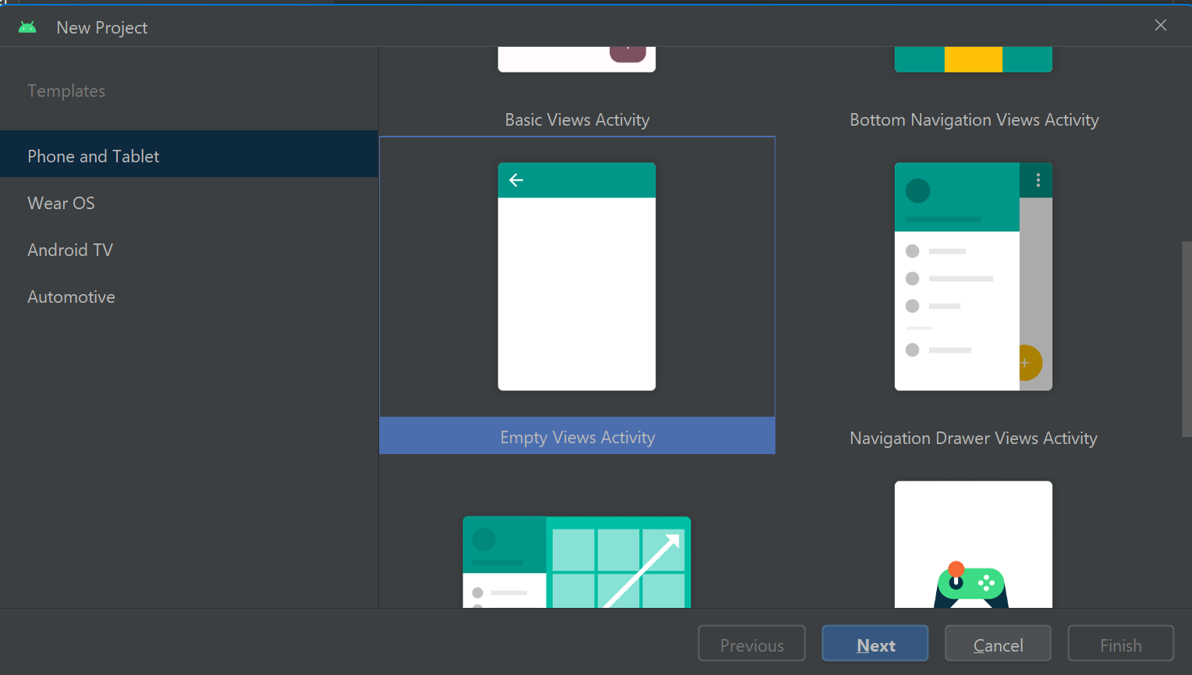

* Now set the layout of the screen as per requirement

***activity_main.xml***

<?xml version="1.0" encoding="utf-8"?>  
<LinearLayout xmlns:android="http://schemas.android.com/apk/res/android"  
 xmlns:app="http://schemas.android.com/apk/res-auto"  
 xmlns:tools="http://schemas.android.com/tools"  
 android:layout_width="match_parent"  
 android:layout_height="match_parent"  
 android:orientation="vertical"  
 android:gravity="center"  
 android:padding="20dp"  
 tools:context=".MainActivity">  
  
 <TextView  
 android:layout_width="match_parent"  
 android:layout_height="wrap_content"  
 android:layout_marginBottom="10dp"  
 android:padding="20dp"  
 android:text="Welcome to App"  
 android:textColor="#1E1E1E"  
 android:textAlignment="center"  
 android:textSize="34sp"  
 android:textStyle="bold" />  
 <EditText  
 android:id="@+id/name"  
 android:layout_width="match_parent"  
 android:layout_height="wrap_content"  
 android:padding="10dp"  
 android:hint="Name"  
 android:layout_marginBottom="10dp"  
 />  
  
 <EditText  
 android:id="@+id/email"  
 android:layout_width="match_parent"  
 android:layout_height="wrap_content"  
 android:padding="10dp"  
 android:hint="Email"  
 android:layout_marginBottom="10dp"  
 tools:ignore="InvalidId" />  
  
 <Button  
 android:id="@+id/login"  
 android:layout_width="match_parent"  
 android:layout_height="wrap_content"  
 android:text="Login"  
 android:padding="10dp"  
 android:layout_marginBottom="10dp"  
 />  
</LinearLayout>***l***

***Activity_home_page.xml***

<?xml version="1.0" encoding="utf-8"?>  
<LinearLayout xmlns:android="http://schemas.android.com/apk/res/android"  
 xmlns:app="http://schemas.android.com/apk/res-auto"  
 xmlns:tools="http://schemas.android.com/tools"  
 android:orientation="vertical"  
 android:gravity="center"  
 android:layout_width="match_parent"  
 android:layout_height="match_parent"  
 android:padding="20dp"  
 tools:context=".HomePage">  
  
 <TextView  
 android:id="@+id/LoginMsg"  
 android:layout_width="wrap_content"  
 android:layout_height="wrap_content"  
 android:layout_marginBottom="40dp"  
 android:padding="20dp"  
 android:text="Login SuccessFull"  
 android:textAlignment="center"  
 android:textColor="#4FE74F"  
 android:textSize="30dp"  
 android:textStyle="bold" />  
 <TextView  
 android:id="@+id/name"  
 android:layout_width="match_parent"  
 android:layout_height="wrap_content"  
 android:padding="10dp"  
 android:text="Name:"  
 android:layout_marginBottom="10dp"  
 />  
 <TextView  
 android:id="@+id/email"  
 android:layout_width="match_parent"  
 android:layout_height="wrap_content"  
 android:padding="10dp"  
 android:text="Email:"  
 android:layout_marginBottom="10dp"  
 />  
  
 <Button  
 android:id="@+id/logout"  
 android:layout_width="match_parent"  
 android:layout_height="wrap_content"  
 android:text="Log Out"  
 android:padding="10dp"  
 android:layout_marginBottom="10dp"  
 />  
  
</LinearLayout>

***MainActivity.java***

package com.example.practical4intent;  
  
import androidx.appcompat.app.AppCompatActivity;  
  
import android.annotation.SuppressLint;  
import android.content.Intent;  
import android.os.Bundle;  
import android.util.Patterns;  
import android.view.View;  
import android.widget.Button;  
import android.widget.EditText;  
import android.widget.Toast;  
  
public class MainActivity extends AppCompatActivity {  
  
 private EditText Name;  
  
 private EditText Email;  
  
 private Button Login;  
  
 @SuppressLint("MissingInflatedId")  
 @Override  
 protected void onCreate(Bundle savedInstanceState) {  
 super.onCreate(savedInstanceState);  
 setContentView(R.layout.*activity_main*);  
  
 Name = findViewById(R.id.*name*);  
  
 Email = findViewById(R.id.*email*);  
  
 Login = findViewById(R.id.*login*);  
  
 Intent receiverIntent = getIntent();  
 if(receiverIntent != null){  
 String message = receiverIntent.getStringExtra("message");  
 if (message != null) {  
 Toast.*makeText*(this, message, Toast.*LENGTH_SHORT*).show();  
 }  
 }  
  
  
 Login.setOnClickListener(new View.OnClickListener() {  
 @Override  
 public void onClick(View view) {  
 String name = Name.getText().toString();  
 String email = Email.getText().toString();  
  
 // Create an Intent to start SecondActivity and pass data  
 Intent intent = new Intent(MainActivity.this, HomePage.class);  
 intent.putExtra("name", name);  
 intent.putExtra("email", email);  
 startActivity(intent);  
 }  
 });  
  
 }  
}

***HomePage.java***

package com.example.practical4intent;  
  
import androidx.appcompat.app.AppCompatActivity;  
  
import android.content.Intent;  
import android.os.Bundle;  
import android.view.View;  
import android.widget.Button;  
import android.widget.TextView;  
  
public class HomePage extends AppCompatActivity {  
  
 private TextView Name;  
  
 private TextView Email;  
  
  
 private Button Logout;  
  
 @Override  
 protected void onCreate(Bundle savedInstanceState) {  
 super.onCreate(savedInstanceState);  
 setContentView(R.layout.*activity_home_page*);  
  
 Name = findViewById(R.id.*name*);  
 Email = findViewById(R.id.*email*);  
 Logout = findViewById(R.id.*logout*);  
  
  
 Bundle extras = getIntent().getExtras();  
 if (extras != null) {  
 String name = extras.getString("name");  
 String email = extras.getString("email");  
  
 Name.setText("Name: "+name);  
 Email.setText("Email: "+email);  
 }  
  
  
 Logout.setOnClickListener(new View.OnClickListener() {  
 @Override  
 public void onClick(View view) {  
 // Create an Intent to go back to MainActivity  
 Intent intent = new Intent(HomePage.this, MainActivity.class);  
 intent.putExtra("message", "log out successfully");  
 startActivity(intent);  
 finish(); // Finish the current activity  
 }  
 });  
 }  
}

Output:

