Roll no.: 20BCE204

Subject: MOS

Practical: 5

Aim: Video and image capture

Create a New project (Empty View Activity)

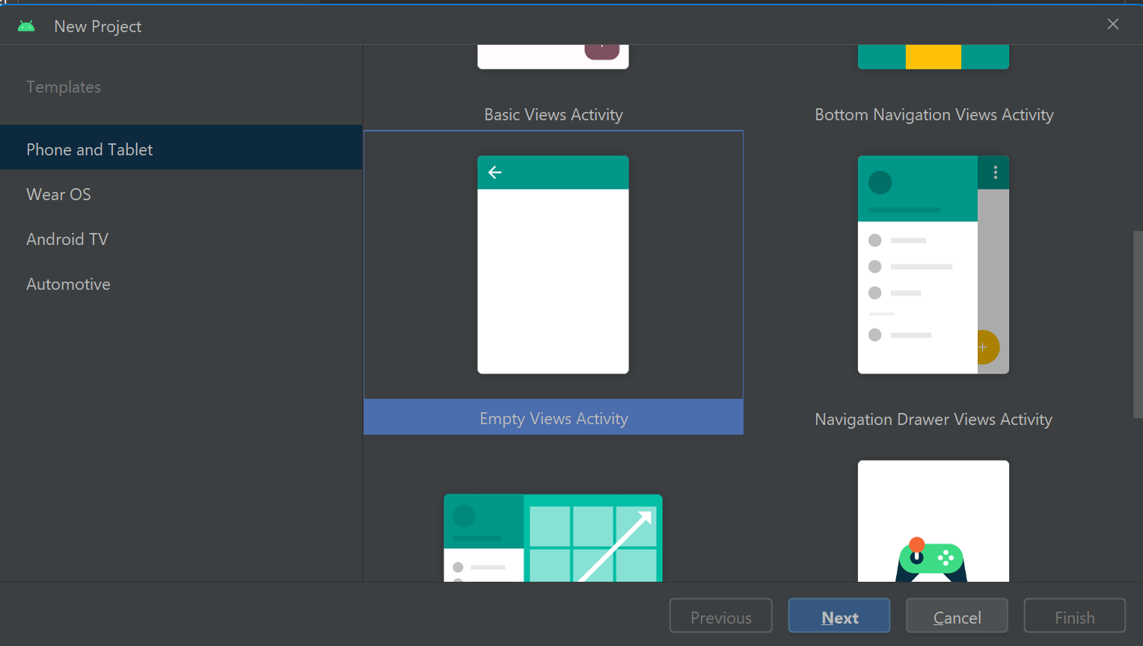

* Now set the layout of the screen as per requirement

***activity_main.xml***

­<?xml version="1.0" encoding="utf-8"?>  
<LinearLayout xmlns:android="http://schemas.android.com/apk/res/android"  
 xmlns:app="http://schemas.android.com/apk/res-auto"  
 xmlns:tools="http://schemas.android.com/tools"  
 android:layout_width="match_parent"  
 android:layout_height="match_parent"  
 android:gravity="center"  
 android:orientation="vertical"  
 tools:context=".MainActivity">  
  
 <Button  
 android:layout_width="match_parent"  
 android:layout_height="wrap_content"  
 android:layout_margin="30dp"  
 android:id="@+id/btnForImageCapturing"  
 android:text="Click to Capture Image"  
 android:textSize="20sp"/>  
  
 <Button  
 android:layout_width="match_parent"  
 android:layout_height="wrap_content"  
 android:layout_margin="30dp"  
 android:id="@+id/btnForVideoCapturing"  
 android:text="Click to Capture Video"  
 android:textSize="20sp"/>  
  
</LinearLayout>

***Image capture***

<?xml version="1.0" encoding="utf-8"?>  
<LinearLayout xmlns:android="http://schemas.android.com/apk/res/android"  
 xmlns:app="http://schemas.android.com/apk/res-auto"  
 xmlns:tools="http://schemas.android.com/tools"  
 android:layout_width="match_parent"  
 android:layout_height="match_parent"  
 android:gravity="start"  
 android:orientation="vertical"  
 android:padding="10dp"  
 tools:context=".ImageCaptureActivity">  
  
 <ImageView  
 android:layout_width="match_parent"  
 android:layout_height="400dp"  
 android:id="@+id/imgCapture"  
 />  
 <Button  
 android:layout_width="match_parent"  
 android:layout_height="wrap_content"  
 android:layout_marginTop="30dp"  
 android:id="@+id/btnImageCapture"  
 android:text="Capture Image"  
 android:textSize="20sp"/>  
</LinearLayout>

***Video capture***

<?xml version="1.0" encoding="utf-8"?>  
<LinearLayout xmlns:android="http://schemas.android.com/apk/res/android"  
 xmlns:app="http://schemas.android.com/apk/res-auto"  
 xmlns:tools="http://schemas.android.com/tools"  
 android:layout_width="match_parent"  
 android:layout_height="match_parent"  
 android:gravity="start"  
 android:orientation="vertical"  
 android:padding="10dp"  
 tools:context=".VideoCaptureActivity">  
  
 <VideoView  
 android:layout_width="match_parent"  
 android:layout_height="400dp"  
 android:id="@+id/vdoCapture"  
 />  
  
 <Button  
 android:layout_width="match_parent"  
 android:layout_height="wrap_content"  
 android:layout_marginTop="30dp"  
 android:id="@+id/btnVideoCapture"  
 android:text="Capture Video"  
 android:textSize="20sp"/>  
  
</LinearLayout>

***Mainactivity.java***

package com.example.practical5phtocapture;  
  
import androidx.annotation.NonNull;  
import androidx.appcompat.app.AppCompatActivity;  
import androidx.core.app.ActivityCompat;  
  
import android.content.Intent;  
import android.content.pm.PackageManager;  
import android.os.Bundle;  
import android.view.View;  
import android.widget.Button;  
import android.widget.Toast;  
  
public class MainActivity extends AppCompatActivity {  
  
 Button btnForImageCapturing, btnForVideoCapturing;  
  
 static int *CAMERA_REQUEST_CODE* = 100;  
  
 @Override  
 protected void onCreate(Bundle savedInstanceState) {  
 super.onCreate(savedInstanceState);  
 setContentView(R.layout.*activity_main*);  
  
 btnForImageCapturing = findViewById(R.id.*btnForImageCapturing*);  
 btnForVideoCapturing = findViewById(R.id.*btnForVideoCapturing*);  
  
 btnForImageCapturing.setEnabled(true);  
 btnForVideoCapturing.setEnabled(true);  
  
 checkPermission("android.permission.CAMERA", *CAMERA_REQUEST_CODE*);  
  
  
 btnForImageCapturing.setOnClickListener(new View.OnClickListener() {  
 @Override  
 public void onClick(View view) {  
 Intent intent = new Intent(MainActivity.this, ImageCaptureActivity.class);  
 startActivity(intent);  
 }  
 });  
  
 btnForVideoCapturing.setOnClickListener(new View.OnClickListener() {  
 @Override  
 public void onClick(View view) {  
 Intent intent = new Intent(MainActivity.this, VideoCaptureActivity.class);  
 startActivity(intent);  
 }  
 });  
   
 }  
  
 private void checkPermission(String permission , int cameraRequestCode) {  
 if (ActivityCompat.*checkSelfPermission*(this, permission)!= PackageManager.*PERMISSION_GRANTED*) {  
 ActivityCompat.*requestPermissions*(this, new String[] {permission}, cameraRequestCode);  
 }  
 else {  
 btnForImageCapturing.setEnabled(true);  
 btnForVideoCapturing.setEnabled(true);  
 Toast.*makeText*(MainActivity.this, "Permission already granted", Toast.*LENGTH_LONG*).show();  
 }  
 }  
  
 @Override  
 public void onRequestPermissionsResult(int requestCode, @NonNull String[] permissions, @NonNull int[] grantResults) {  
 super.onRequestPermissionsResult(requestCode, permissions, grantResults);  
 if (requestCode == *CAMERA_REQUEST_CODE*)  
 {  
 if (grantResults.length >0 && grantResults[0] == PackageManager.*PERMISSION_GRANTED*)  
 {  
 btnForImageCapturing.setEnabled(true);  
 btnForVideoCapturing.setEnabled(true);  
 }  
 else  
 {  
 Toast.*makeText*(MainActivity.this, "CAMERA Permission Denied", Toast.*LENGTH_LONG*).show();  
 }  
  
 }  
 }  
}

***imagecapture.java***

package com.example.practical5phtocapture;  
  
import androidx.activity.result.ActivityResult;  
import androidx.activity.result.ActivityResultCallback;  
import androidx.activity.result.ActivityResultLauncher;  
import androidx.activity.result.contract.ActivityResultContract;  
import androidx.activity.result.contract.ActivityResultContracts;  
import androidx.appcompat.app.AppCompatActivity;  
  
import android.content.Intent;  
import android.graphics.Bitmap;  
import android.os.Bundle;  
import android.provider.MediaStore;  
import android.view.View;  
import android.widget.Button;  
import android.widget.ImageView;  
import android.widget.Toast;  
  
public class ImageCaptureActivity extends AppCompatActivity {  
  
 ImageView imgCapture;  
  
 Button btnImageCapture;  
  
 ActivityResultLauncher<Intent> activityResultLauncher;  
  
 @Override  
 protected void onCreate(Bundle savedInstanceState) {  
 super.onCreate(savedInstanceState);  
 setContentView(R.layout.*activity_image_capture*);  
  
 imgCapture = findViewById(R.id.*imgCapture*);  
  
 btnImageCapture = findViewById(R.id.*btnImageCapture*);  
  
  
 activityResultLauncher = registerForActivityResult(new ActivityResultContracts.StartActivityForResult(),  
 new ActivityResultCallback<ActivityResult>() {  
 @Override  
 public void onActivityResult(ActivityResult result) {  
 if (result.getResultCode() == *RESULT_OK*)  
 {  
 Bitmap bitmap = (Bitmap) result.getData().getExtras().get("data");  
 imgCapture.setImageBitmap(bitmap);  
 }  
 else if (result.getResultCode() ==*RESULT_CANCELED*)  
 {  
 Toast.*makeText*(getApplicationContext() , "Error in capturing image", Toast.*LENGTH_LONG*).show();  
 }  
 else  
 {  
 Toast.*makeText*(getApplicationContext() , "Unknown result code occurred", Toast.*LENGTH_LONG*).show();  
 }  
 }  
 });  
  
 btnImageCapture.setOnClickListener(new View.OnClickListener() {  
 @Override  
 public void onClick(View view) {  
 Intent intent = new Intent(MediaStore.*ACTION_IMAGE_CAPTURE*);  
 activityResultLauncher.launch(intent);  
  
 }  
 });  
 }  
}

***videocapture.java***

package com.example.practical5phtocapture;  
  
import androidx.activity.result.ActivityResult;  
import androidx.activity.result.ActivityResultCallback;  
import androidx.activity.result.ActivityResultLauncher;  
import androidx.activity.result.contract.ActivityResultContracts;  
import androidx.appcompat.app.AppCompatActivity;  
  
import android.content.Intent;  
import android.os.Bundle;  
import android.provider.MediaStore;  
import android.util.Log;  
import android.view.View;  
import android.widget.Button;  
import android.widget.Toast;  
import android.widget.VideoView;  
  
public class VideoCaptureActivity extends AppCompatActivity {  
  
 VideoView vdoCapture;  
  
 Button btnVideoCapture;  
  
 ActivityResultLauncher<Intent> activityResultLauncher;  
  
 @Override  
 protected void onCreate(Bundle savedInstanceState) {  
 super.onCreate(savedInstanceState);  
 setContentView(R.layout.*activity_video_capture*);  
  
 vdoCapture = findViewById(R.id.*vdoCapture*);  
  
 btnVideoCapture = findViewById(R.id.*btnVideoCapture*);  
  
  
 activityResultLauncher = registerForActivityResult(new ActivityResultContracts.StartActivityForResult(),  
 new ActivityResultCallback<ActivityResult>() {  
 @Override  
 public void onActivityResult(ActivityResult result) {  
 if (result.getResultCode() == *RESULT_OK*)  
 {  
 vdoCapture.setVideoURI(result.getData().getData());  
 Log.*i*("Video", "URI: "+result.getData().getData());  
 vdoCapture.start();  
 }  
 else if (result.getResultCode() ==*RESULT_CANCELED*)  
 {  
 Toast.*makeText*(getApplicationContext() , "Error in recording video", Toast.*LENGTH_LONG*).show();  
 }  
 else  
 {  
 Toast.*makeText*(getApplicationContext() , "Unknown result code occured", Toast.*LENGTH_LONG*).show();  
 }  
 }  
 });  
  
 btnVideoCapture.setOnClickListener(new View.OnClickListener() {  
 @Override  
 public void onClick(View view) {  
 Intent intent = new Intent(MediaStore.*ACTION_VIDEO_CAPTURE*);  
 activityResultLauncher.launch(intent);  
  
 }  
 });  
  
 }  
}

***Output:***

