Name: Dhyan Patel

Roll no.: 20BCE204

Subject: MOS

Practical: 1

Aim: To configure and understand the Android structure and IDE tool with Android Studio.

Description: Make sure you have installed at least 2 APIs of android and run Hello World program on virtual and real device.

* Download Android studio

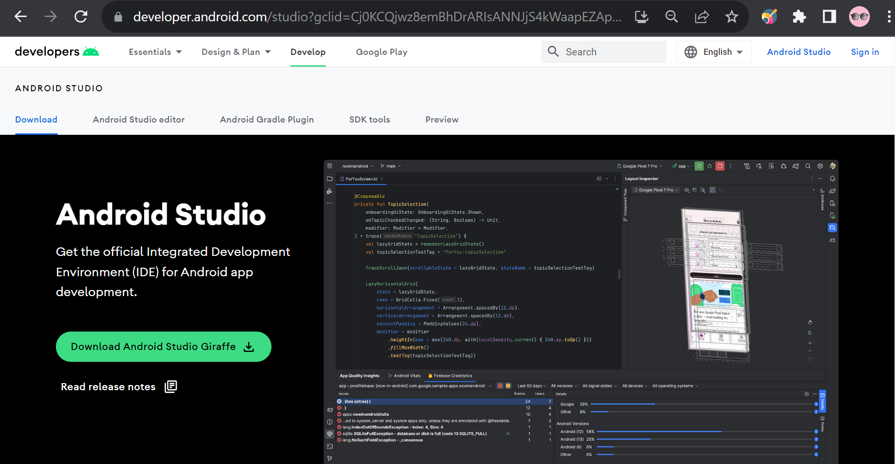

Download the android studio latest version from the official website of android studio.

* Launch the android studio application
* Create a new project from files

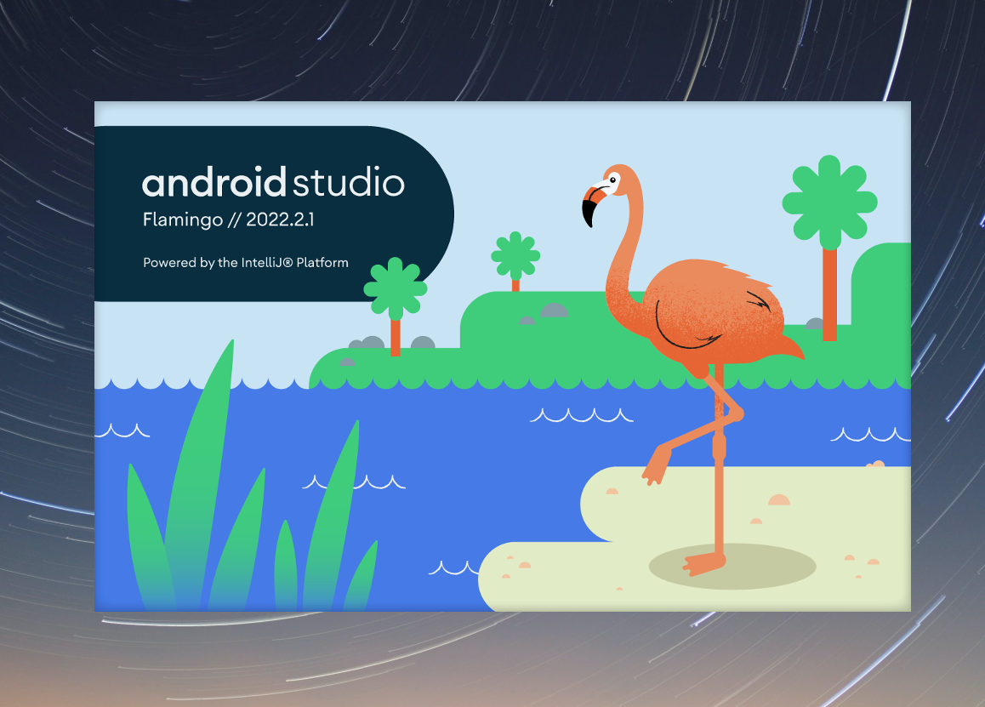

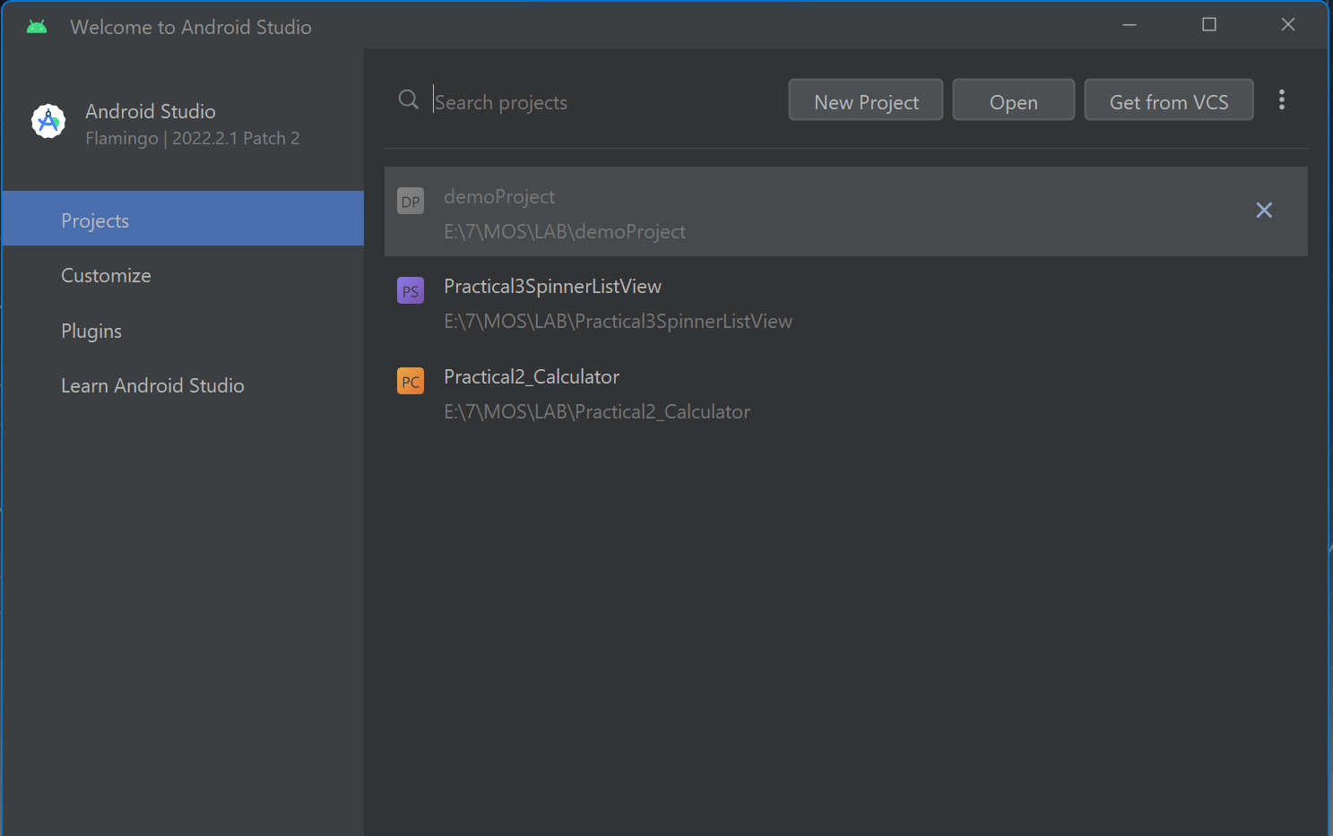

* Select the template of empty view activity

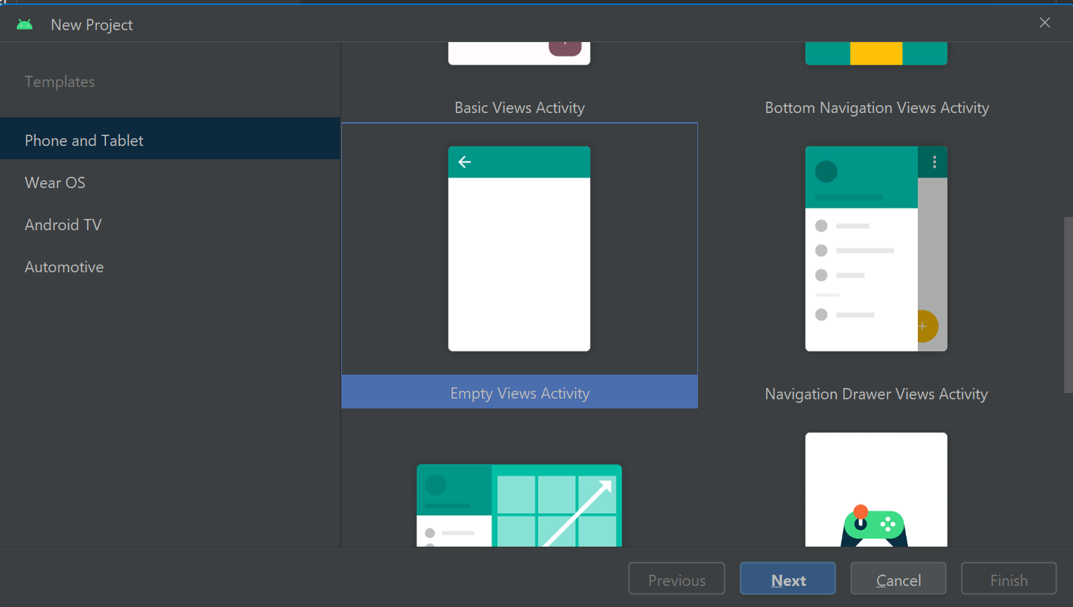

* Name your project, your project location and language. We also need to decide with android version should be minimum required for our application to run

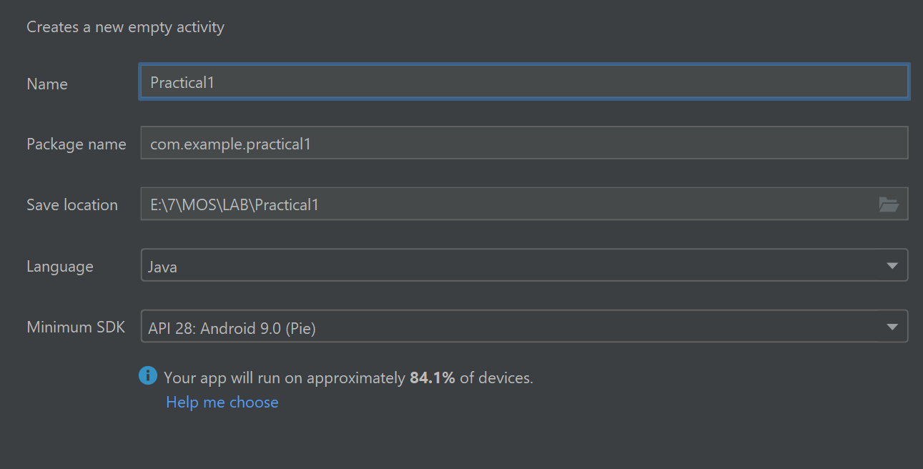

* We need to wait till the project gets ready, after downloading all the required files like gradle and all.

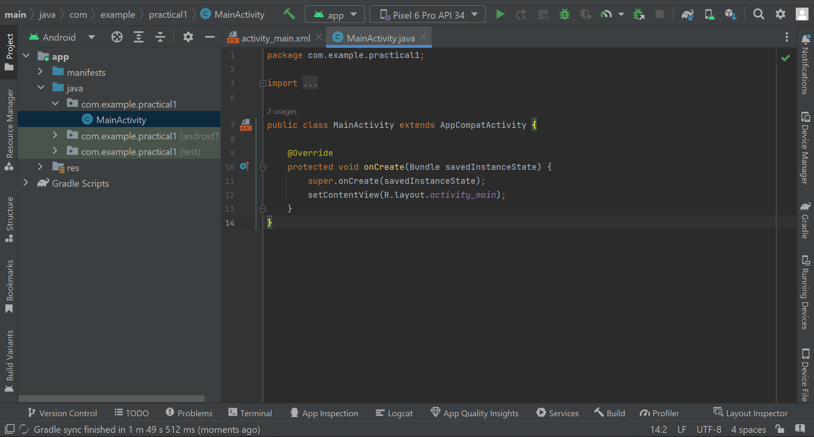

* This is the project structure of a android studio project, which is given to us by default by android studio when we create a new project

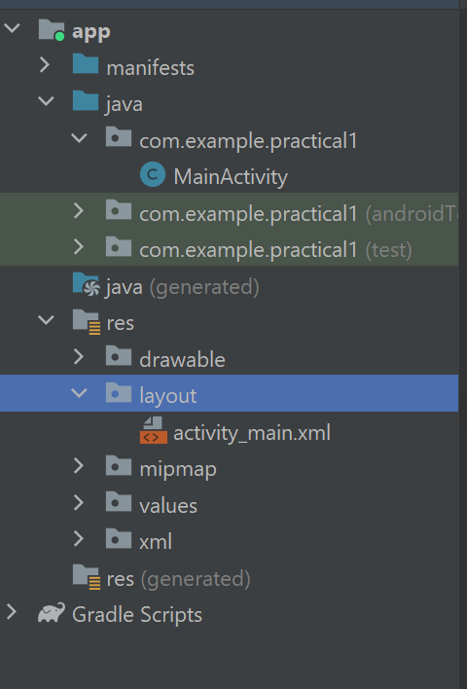

* Now we can see 2 files will be open by default which is ***activity_main.xml*** and ***MainActivity.java***
* Activity_main.xml
  + It is used for design purpose of the application

<?xml version="1.0" encoding="utf-8"?>  
<LinearLayout xmlns:android="http://schemas.android.com/apk/res/android"  
 xmlns:app="http://schemas.android.com/apk/res-auto"  
 xmlns:tools="http://schemas.android.com/tools"  
 android:layout_width="match_parent"  
 android:layout_height="match_parent"  
 android:orientation="vertical"  
 tools:context=".MainActivity">  
  
 <TextView  
 android:layout_width="match_parent"  
 android:layout_height="wrap_content"  
 android:text="Hello World!"  
 android:layout_marginTop="25dp"  
 android:textAlignment="center"  
 android:textSize="40dp"  
 app:layout_constraintBottom_toBottomOf="parent"  
 app:layout_constraintEnd_toEndOf="parent"  
 app:layout_constraintStart_toStartOf="parent"  
 app:layout_constraintTop_toTopOf="parent" />  
  
 <TextView  
 android:layout_width="match_parent"  
 android:layout_height="wrap_content"  
 android:layout_marginLeft="10dp"  
 android:layout_marginTop="50dp"  
 android:layout_marginRight="10dp"  
 android:text="Welcome to Mobile Operating System Lab"  
 android:textAlignment="center"  
 android:textSize="40dp"  
 app:layout_constraintBottom_toBottomOf="parent"  
 app:layout_constraintEnd_toEndOf="parent"  
 app:layout_constraintStart_toStartOf="parent"  
 app:layout_constraintTop_toTopOf="parent" />  
  
</LinearLayout>

* MainActivity.java
  + It comprises the business logic of the application

package com.example.practical1;  
  
import androidx.appcompat.app.AppCompatActivity;  
  
import android.os.Bundle;  
  
public class MainActivity extends AppCompatActivity {  
  
 @Override  
 protected void onCreate(Bundle savedInstanceState) {  
 super.onCreate(savedInstanceState);  
 setContentView(R.layout.*activity_main*);  
 }  
}

* Now to run the application we need to click on the run button on top left



* After clicking on run the application will start to build and will download the apk of application to the stimulator.

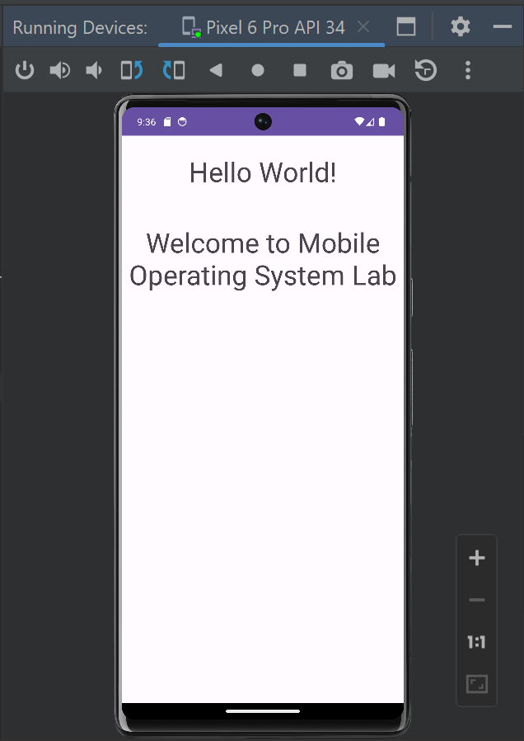

* Here we can see our application is built and its running proper.

This was the basic application of Android Studio and installation of android studio