Roll no.: 20BCE204

Subject: MOS

Practical: 2

Aim: Android activity, Basic User Interface: Calculator Design and develop basic level calculator which include input items from user and perform operations like: addition, subtraction, multiplication, division etc. and display the results to the user

* Create a New project (Empty View Activity)

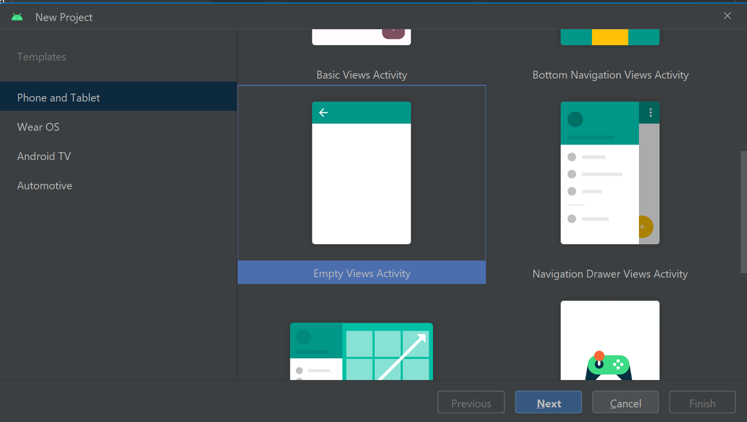

* Now set the layout of the screen as per requirement

***activity_main.xml***

<?xml version="1.0" encoding="utf-8"?>  
<androidx.constraintlayout.widget.ConstraintLayout xmlns:android="http://schemas.android.com/apk/res/android"  
 xmlns:app="http://schemas.android.com/apk/res-auto"  
 xmlns:tools="http://schemas.android.com/tools"  
 android:layout_width="match_parent"  
 android:layout_height="match_parent"  
 android:textAlignment="center"  
 tools:context=".MainActivity">  
  
 <EditText  
 android:id="@+id/op1"  
 android:layout_width="128dp"  
 android:layout_height="69dp"  
 android:contentDescription="operand 1"  
 android:ems="10"  
 android:hint="Operand 1"  
 android:inputType="numberDecimal"  
 android:textAlignment="center"  
 android:textStyle="bold"  
 app:layout_constraintBottom_toBottomOf="parent"  
 app:layout_constraintEnd_toStartOf="@+id/op2"  
 app:layout_constraintHorizontal_bias="0.606"  
 app:layout_constraintStart_toStartOf="parent"  
 app:layout_constraintTop_toTopOf="parent"  
 app:layout_constraintVertical_bias="0.108" />  
  
 <EditText  
 android:id="@+id/op2"  
 android:layout_width="144dp"  
 android:layout_height="70dp"  
 android:layout_marginEnd="48dp"  
 android:ems="10"  
 android:hint="Operand 2"  
 android:inputType="numberDecimal"  
 android:selectAllOnFocus="false"  
 android:singleLine="false"  
 android:textAlignment="center"  
 android:textStyle="bold"  
 app:layout_constraintBottom_toBottomOf="parent"  
 app:layout_constraintEnd_toEndOf="parent"  
 app:layout_constraintTop_toTopOf="parent"  
 app:layout_constraintVertical_bias="0.106" />  
  
 <LinearLayout  
 android:id="@+id/linearLayout"  
 android:layout_width="381dp"  
 android:layout_height="wrap_content"  
 android:layout_marginTop="164dp"  
 android:orientation="horizontal"  
 app:layout_constraintEnd_toEndOf="parent"  
 app:layout_constraintHeight="wrap_content"  
 app:layout_constraintHeight_default="wrap"  
 app:layout_constraintHeight_max="wrap"  
 app:layout_constraintHeight_min="wrap"  
 app:layout_constraintHorizontal_bias="0.533"  
 app:layout_constraintStart_toStartOf="parent"  
 app:layout_constraintTop_toTopOf="parent">  
  
 <Button  
 android:id="@+id/add"  
 android:layout_width="wrap_content"  
 android:layout_height="wrap_content"  
 android:layout_marginHorizontal="5dp"  
 android:layout_weight="1"  
 android:backgroundTint="#EDC126"  
 android:textSize="25dp"  
 android:text="+" />  
  
 <Button  
 android:id="@+id/sub"  
 android:layout_width="wrap_content"  
 android:layout_height="wrap_content"  
 android:layout_marginHorizontal="5dp"  
 android:layout_weight="1"  
 android:backgroundTint="#EDC126"  
 android:textSize="25dp"  
 android:text="-" />  
  
 <Button  
 android:id="@+id/mul"  
 android:layout_width="wrap_content"  
 android:layout_height="wrap_content"  
 android:layout_marginHorizontal="5dp"  
 android:layout_weight="1"  
 android:backgroundTint="#EDC126"  
 android:textSize="25dp"  
 android:text="x" />  
  
 <Button  
 android:id="@+id/div"  
 android:layout_width="wrap_content"  
 android:layout_height="wrap_content"  
 android:layout_marginHorizontal="5dp"  
 android:layout_weight="1"  
 android:backgroundTint="#EDC126"  
 android:textSize="25dp"  
 android:text="/" />  
  
 </LinearLayout>  
  
 <TextView  
 android:id="@+id/result"  
 android:layout_width="match_parent"  
 android:layout_height="56dp"  
 android:layout_marginBottom="204dp"  
 android:fallbackLineSpacing="false"  
 android:hapticFeedbackEnabled="false"  
 android:text=""  
 android:textAlignment="center"  
 android:gravity="center"  
 android:textSize="24sp"  
 app:layout_constraintBottom_toBottomOf="parent"  
 app:layout_constraintEnd_toEndOf="parent"  
 app:layout_constraintHorizontal_bias="0.498"  
 app:layout_constraintStart_toStartOf="parent"  
 app:layout_constraintTop_toBottomOf="@+id/linearLayout"  
 app:layout_constraintVertical_bias="0.482" />  
  
 <TextView  
 android:id="@+id/result2"  
 android:layout_width="wrap_content"  
 android:layout_height="wrap_content"  
 android:layout_marginBottom="204dp"  
 android:fallbackLineSpacing="false"  
 android:hapticFeedbackEnabled="false"  
 android:text="Practical 2 : Calculator"  
 android:textAlignment="center"  
 android:textAllCaps="false"  
 android:textSize="24sp"  
 android:textStyle="bold|italic"  
 app:layout_constraintBottom_toBottomOf="parent"  
 app:layout_constraintEnd_toEndOf="parent"  
 app:layout_constraintHorizontal_bias="0.497"  
 app:layout_constraintStart_toStartOf="parent"  
 app:layout_constraintTop_toBottomOf="@+id/linearLayout"  
 app:layout_constraintVertical_bias="1.0" />  
  
 <Button  
 android:id="@+id/clearall"  
 android:layout_width="wrap_content"  
 android:layout_height="wrap_content"  
 android:layout_marginTop="52dp"  
 android:backgroundTint="#3DBE29"  
 android:textSize="25dp"  
 android:text="Clear All"  
 app:layout_constraintBottom_toTopOf="@+id/result"  
 app:layout_constraintEnd_toEndOf="parent"  
 app:layout_constraintHorizontal_bias="0.498"  
 app:layout_constraintStart_toStartOf="parent"  
 app:layout_constraintTop_toBottomOf="@+id/linearLayout"  
 app:layout_constraintVertical_bias="0.0" />  
  
  
  
</androidx.constraintlayout.widget.ConstraintLayout>

* Now we will write the business logic of calculator in Java

***MainActivity.java***

package com.example.practical2_calculator;  
  
import androidx.appcompat.app.AppCompatActivity;  
  
import android.annotation.SuppressLint;  
import android.content.Intent;  
import android.os.Bundle;  
import android.view.View;  
import android.widget.Button;  
import android.widget.EditText;  
import android.widget.TextView;  
import android.widget.Toast;  
  
public class MainActivity extends AppCompatActivity {  
 private EditText opr1;  
  
 private EditText opr2;  
  
 private Button btnadd;  
  
 private Button btnsub;  
  
 private Button btnmul;  
  
 private Button btndiv;  
  
 private Button btnclr;  
  
 private TextView txtresult;  
  
// private Button nextscr;  
  
 @Override  
 protected void onCreate(Bundle savedInstanceState) {  
 super.onCreate(savedInstanceState);  
 setContentView(R.layout.*activity_main*);  
  
 opr1 = (EditText) findViewById(R.id.*op1*);  
  
 opr2 = (EditText) findViewById(R.id.*op2*);  
  
 btnadd = (Button) findViewById(R.id.*add*);  
  
 btnsub = (Button) findViewById(R.id.*sub*);  
  
 btnmul = (Button) findViewById(R.id.*mul*);  
  
 btndiv = (Button) findViewById(R.id.*div*);  
  
 btnclr = (Button) findViewById(R.id.*clearall*);  
  
 txtresult= (TextView) findViewById(R.id.*result*);  
  
// nextscr = (Button) findViewById(R.id.next);  
  
  
 btnadd.setOnClickListener(new View.OnClickListener() {  
 @SuppressLint("SetTextI18n")  
 @Override  
 public void onClick(View v) {  
 if ((opr1.getText().length() > 0) && (opr2.getText().length() > 0)) {  
 double opera1 = Double.*parseDouble*(opr1.getText().toString());  
 double opera2 = Double.*parseDouble*(opr2.getText().toString());  
 double result = opera1 + opera2;  
 txtresult.setText(opera1 + " + "+opera2+ " = "+Double.*toString*(result));  
 }  
 else {  
 Toast toast= Toast.*makeText*(MainActivity.this,"Enter The Required Numbers",Toast.*LENGTH_LONG*);  
 toast.show();  
 }  
 }  
 });  
  
 btnsub.setOnClickListener(new View.OnClickListener() {  
 @Override  
 public void onClick(View v) {  
 if ((opr1.getText().length() > 0) && (opr2.getText().length() > 0)) {  
 double opera1 = Double.*parseDouble*(opr1.getText().toString());  
 double opera2 = Double.*parseDouble*(opr2.getText().toString());  
 double result = opera1 - opera2;  
 txtresult.setText(opera1 + " - "+opera2+ " = "+Double.*toString*(result));  
 }  
 else {  
 Toast toast= Toast.*makeText*(MainActivity.this,"Enter The Required Numbers",Toast.*LENGTH_LONG*);  
 toast.show();  
 }  
 }  
 });  
  
 btnmul.setOnClickListener(new View.OnClickListener() {  
 @Override  
 public void onClick(View v) {  
 if ((opr1.getText().length() > 0) && (opr2.getText().length() > 0)) {  
 double opera1 = Double.*parseDouble*(opr1.getText().toString());  
 double opera2 = Double.*parseDouble*(opr2.getText().toString());  
 double result = opera1 * opera2;  
 txtresult.setText(opera1 + " x "+opera2+ " = "+Double.*toString*(result));  
 }  
 else {  
 Toast toast= Toast.*makeText*(MainActivity.this,"Enter The Required Numbers",Toast.*LENGTH_LONG*);  
 toast.show();  
 }  
 }  
 });  
  
 btndiv.setOnClickListener(new View.OnClickListener() {  
 @Override  
 public void onClick(View v) {  
 if ((opr1.getText().length() > 0) && (opr2.getText().length() > 0)) {  
 double opera1 = Double.*parseDouble*(opr1.getText().toString());  
 double opera2 = Double.*parseDouble*(opr2.getText().toString());  
 double result = opera1 / opera2;  
 txtresult.setText(opera1 + " / "+opera2+ " = "+Double.*toString*(result));  
 }  
 else {  
 Toast toast= Toast.*makeText*(MainActivity.this,"Enter The Required Numbers",Toast.*LENGTH_LONG*);  
 toast.show();  
 }  
 }  
 });  
  
 btnclr.setOnClickListener(new View.OnClickListener() {  
 @Override  
 public void onClick(View v) {  
 opr1.setText("");  
  
 opr2.setText("");  
  
 txtresult.setText("");  
  
 opr1.requestFocus();  
 }  
 });  
 }  
}

Output:

