**Assignment 3**

**Date** : 20/10/2023

**Roll No. and Name :** 20BCE204 Dhyan Patel

**Course Code :** Road Safety and Management 2CLOE28

1. **Why is the problem of accident is very acute in road transportation?**

The problem of accidents is very acute in road transportation due to a number of factors, including:

* Human error: Human error is the leading cause of road accidents. This can include things like distracted driving, speeding, drunk driving, and driving while fatigued.
* Road conditions: Poor road conditions, such as potholes, uneven surfaces, and inadequate lighting, can also contribute to accidents.
* Vehicle defects: Vehicle defects, such as faulty brakes, steering, or tires, can also lead to accidents.
* Traffic congestion: Traffic congestion can increase the risk of accidents, as drivers may be more likely to make mistakes when they are frustrated and impatient.
* Mixed traffic: Road transportation often involves a mix of different types of vehicles, including cars, trucks, motorcycles, bicycles, and pedestrians. This can make it difficult for drivers to anticipate the actions of other road users and can increase the risk of accidents.

In addition to these factors, there are a number of other things that can contribute to road accidents, such as adverse weather conditions, wildlife on the road, and criminal activity.

Road accidents can have devastating consequences, both physically and emotionally. They can lead to serious injuries, death, and property damage. They can also have a significant impact on the families and friends of those involved.

There are a number of things that can be done to reduce the risk of road accidents, such as:

* Educating drivers and other road users about traffic safety: This can help people to understand the risks involved in road transportation and to take steps to reduce those risks.
* Improving road infrastructure: This can include things like repairing potholes, improving lighting, and building safer intersections.
* Enforcing traffic laws: This can help to deter people from engaging in risky behaviors on the road.
* Encouraging people to use public transportation or to walk or bike whenever possible: This can help to reduce the number of vehicles on the road and make it safer for everyone.

Reducing the problem of road accidents is a complex challenge, but it is one that must be addressed. By taking steps to educate road users, improve road infrastructure, enforce traffic laws, and encourage sustainable transportation options, we can make our roads safer for everyone.

1. **Enlist six objectives of road accidents.**

Six objectives of road accidents are:

1. To reduce the number of road accidents.
2. To reduce the severity of road accidents.
3. To reduce the number of fatalities and injuries resulting from road accidents.
4. To reduce the economic and social costs of road accidents.
5. To improve the safety of road users.
6. To create a more sustainable and equitable road transportation system.

These objectives are inter-related and can be achieved by implementing a comprehensive range of road safety measures, including:

* Educating road users about traffic safety and encouraging them to adopt safe behaviors.
* Improving road infrastructure and design to make it safer for all road users.
* Enforcing traffic laws and regulations.
* Promoting sustainable transportation options, such as public transportation, walking, and cycling.

By working to achieve these objectives, we can make our roads safer for everyone and reduce the devastating impact of road accidents.

1. **Explain how improper Road design and its condition cause accidents.**

Improper road design and its condition can cause accidents in a variety of ways. Some common examples include:

* Narrow lanes: Narrow lanes can make it difficult for drivers to stay in their own lane, especially when making turns or when there is oncoming traffic. This can lead to head-on collisions, sideswipes, and other types of accidents.
* Blind curves: Blind curves can make it difficult for drivers to see oncoming traffic, which can lead to head-on collisions.
* Poor lighting: Poor lighting can make it difficult for drivers to see the road ahead of them, as well as other vehicles and pedestrians. This can lead to a variety of accidents, including rear-end collisions, pedestrian accidents, and run-off-the-road accidents.
* Missing or damaged signs: Missing or damaged signs can leave drivers confused about the rules of the road, which can lead to accidents. For example, a missing stop sign can lead to a T-bone collision, and a damaged speed limit sign can lead to drivers speeding.
* Poor road conditions: Poor road conditions, such as potholes, cracks, and uneven pavement, can cause drivers to lose control of their vehicles. This can lead to a variety of accidents, including run-off-the-road accidents, rollovers, and head-on collisions.

In addition to these specific examples, improper road design and its condition can also contribute to accidents in more general ways. For example, roads that are not designed to handle the volume of traffic that they receive can lead to congestion and accidents. Additionally, roads that are not properly maintained can develop hazards such as potholes and debris, which can also lead to accidents.

It is important to note that improper road design and its condition is not always the sole cause of an accident. Other factors, such as driver error and weather conditions, can also play a role. However, improper road design and its condition can certainly increase the risk of an accident occurring.

Here are some tips for staying safe on roads with improper design and/or condition:

* Be aware of the potential hazards and adjust your driving accordingly. For example, if you know that there is a blind curve ahead, slow down and be prepared to stop if necessary.
* Use caution when driving in low-light conditions. Turn on your headlights and be extra vigilant for other vehicles and pedestrians.
* Be careful when driving on roads with poor road conditions. Avoid potholes and cracks whenever possible, and slow down if necessary.
* If you see a missing or damaged sign, report it to the appropriate authorities.

By following these tips, you can help to reduce your risk of being involved in an accident on a road with improper design and/or condition.

1. **Discuss how Road user contributes in Road Accidents.**

Road users contribute to road accidents in a number of ways, including:

* Human error: Human error is the leading cause of road accidents. This can include things like distracted driving, speeding, drunk driving, and driving while fatigued.
* Disobeying traffic laws: Disobeying traffic laws, such as running red lights, failing to yield the right-of-way, and speeding, can also lead to accidents.
* Aggressive driving: Aggressive driving behaviors, such as tailgating, cutting off other drivers, and road rage, can also increase the risk of accidents.
* Driving under the influence of alcohol or drugs: Driving under the influence of alcohol or drugs is one of the most dangerous things a road user can do. It significantly impairs a driver's ability to operate a vehicle safely.
* Not wearing a seat belt: Seat belts are one of the most effective safety devices in vehicles. Not wearing a seat belt can significantly increase the risk of serious injuries or death in the event of a crash.

In addition to these factors, there are a number of other ways that road users can contribute to accidents, such as:

* Not being aware of their surroundings: This can include things like not paying attention to other vehicles, pedestrians, or cyclists, or not being aware of road conditions.
* Driving too fast for conditions: Driving too fast for conditions, such as wet or icy roads, can make it difficult to control a vehicle and can increase the risk of an accident.
* Not properly maintaining their vehicle: Poor vehicle maintenance, such as faulty brakes or tires, can also lead to accidents.
* Not using headlights at night: Using headlights at night helps to make drivers and other road users more visible. Not using headlights can make it difficult to see and can increase the risk of an accident.

Road users have a responsibility to drive safely and to obey traffic laws. By doing so, they can help to reduce the risk of road accidents and make our roads safer for everyone.

Here are some tips for road users to help reduce the risk of accidents:

* Always be aware of your surroundings and pay attention to other vehicles, pedestrians, and cyclists.
* Drive at a safe speed for the conditions.
* Obey all traffic laws and regulations.
* Never drive under the influence of alcohol or drugs.
* Always wear a seat belt.
* Properly maintain your vehicle.
* Use headlights at night.

By following these tips, road users can help to create a safer environment for everyone on the road.

1. **Discuss how the 'Vehicle' contributes in road accidents.**

Vehicles can contribute to road accidents in a number of ways, including:

* Vehicle defects: Mechanical defects, such as faulty brakes, steering, or tires, can cause drivers to lose control of their vehicles. This can lead to a variety of accidents, including run-off-the-road accidents, rollovers, and head-on collisions.
* Poor vehicle maintenance: Poor vehicle maintenance, such as not changing the oil regularly or not rotating the tires, can lead to vehicle defects. Additionally, poor vehicle maintenance can cause vehicles to become less safe, such as when headlights are not properly aligned or when taillights are not working.
* Overloading: Overloading vehicles can make them more difficult to control and can also increase the risk of tire blowouts. This can lead to a variety of accidents, including run-off-the-road accidents, rollovers, and jackknifes.
* Vehicle design: In some cases, vehicles may be designed in a way that makes them more likely to be involved in accidents. For example, vehicles with high centers of gravity are more likely to rollover. Additionally, vehicles with large blind spots can make it difficult for drivers to see other vehicles and pedestrians.

It is important to note that vehicles do not cause accidents on their own. Driver error is always a factor. However, vehicles can certainly contribute to accidents, especially when they are not properly maintained or when they have defects.

Here are some tips for reducing the risk of vehicle-related accidents:

* Have your vehicle inspected regularly by a qualified mechanic.
* Keep your vehicle in good repair and replace any defective parts immediately.
* Avoid overloading your vehicle.
* Be aware of the limitations of your vehicle and drive accordingly.

By following these tips, you can help to reduce your risk of being involved in a vehicle-related accident.

1. **Discuss how Road Traffic and Environmental Factors cause Road Accidents.**

Road traffic and environmental factors can cause road accidents in a number of ways, including:

Road traffic factors:

* Heavy traffic congestion: Traffic congestion can increase the risk of accidents, as drivers may be more likely to make mistakes when they are frustrated and impatient.
* Mixed traffic: Road transportation often involves a mix of different types of vehicles, including cars, trucks, motorcycles, bicycles, and pedestrians. This can make it difficult for drivers to anticipate the actions of other road users and can increase the risk of accidents.
* Poor road design and infrastructure: Poor road design and infrastructure, such as narrow lanes, sharp curves, and inadequate lighting, can also contribute to accidents.
* Road defects: Road defects, such as potholes, uneven surfaces, and inadequate signage, can also lead to accidents.

Environmental factors:

* Adverse weather conditions: Adverse weather conditions, such as rain, snow, fog, and ice, can reduce visibility and make it difficult for drivers to control their vehicles.
* Smoke and dust: Smoke and dust can also reduce visibility and increase the risk of accidents.
* Wildlife on the road: Wildlife on the road can also pose a hazard to drivers, especially at night.

Road traffic and environmental factors can interact with each other to further increase the risk of accidents. For example, heavy traffic congestion in poor weather conditions can make it very difficult for drivers to see and react to hazards.

There are a number of things that can be done to reduce the risk of road accidents caused by road traffic and environmental factors, such as:

* Improving road design and infrastructure: This can include things like widening lanes, improving lighting, and installing safety features such as guardrails and rumble strips.
* Maintaining roads: This includes repairing potholes and other road defects, and ensuring that signs and signals are properly maintained.
* Educating road users about road safety: This can help people to understand the risks involved in road transportation and to take steps to reduce those risks.
* Enforcing traffic laws: This can help to deter people from engaging in risky behaviors on the road.

By taking these steps, we can make our roads safer for everyone and reduce the number of accidents caused by road traffic and environmental factors.

1. **Enlist the five steps involved in accident data studies.**

The five steps involved in accident data studies are:

1. Data collection: The first step is to collect data on accidents. This data can come from a variety of sources, such as police reports, insurance claims, and hospital records.
2. Data cleaning: Once the data has been collected, it needs to be cleaned and organized. This involves removing any errors or inconsistencies in the data.
3. Data analysis: Once the data has been cleaned and organized, it can be analyzed to identify trends and patterns. This analysis can be used to identify the causes of accidents and to develop strategies to prevent them from happening in the future.
4. Reporting: The results of the data analysis should be reported to the appropriate stakeholders. This report should include the findings of the study, as well as recommendations for preventing future accidents.
5. Implementation: The final step is to implement the recommendations of the report. This may involve making changes to road design, vehicle safety standards, or driver education programs.

It is important to note that these steps are not always linear. For example, data analysis may lead to new questions that require additional data collection. Additionally, the implementation of recommendations may lead to changes in the data collection and analysis process.

Accident data studies can play an important role in improving road safety. By identifying the causes of accidents and developing strategies to prevent them, accident data studies can help to reduce the number of accidents that occur each year.

1. **Discuss accident data collection** as per IRC:53-1982.

The Indian Roads Congress (IRC) has published a number of guidelines on road safety, including IRC:53-1982, which provides guidance on accident data collection.

IRC:53-1982 recommends that accident data be collected at all levels, from the local to the national level. This data should be collected in a standardized format so that it can be easily compared and analyzed.

The following are some of the key elements of accident data collection as per IRC:53-1982:

* Location: The location of the accident should be recorded in detail, including the road name, intersection number, and distance from a known landmark.
* Time: The time of the accident should be recorded as accurately as possible.
* Date: The date of the accident should be recorded.
* Type of accident: The type of accident should be recorded, such as car-car, car-bike, car-pedestrian, etc.
* Severity of accident: The severity of the accident should be recorded, such as minor, major, or fatal.
* Number of vehicles involved: The number of vehicles involved in the accident should be recorded.
* Number of casualties: The number of casualties resulting from the accident should be recorded, including the number of injuries and fatalities.
* Other relevant information: Any other relevant information about the accident should be recorded, such as the weather conditions, road conditions, and any contributing factors.

Accident data can be collected from a variety of sources, including:

* Police reports: Police reports are a valuable source of accident data. They typically include information about the location, time, date, type, and severity of the accident, as well as the number of vehicles involved and the number of casualties.
* Hospital records: Hospital records can also provide valuable information about accident victims, such as the nature and severity of their injuries.
* Eyewitness accounts: Eyewitness accounts can also provide important information about accidents. However, it is important to note that eyewitness accounts can be unreliable, so they should be carefully corroborated with other information.

Once accident data has been collected, it should be analyzed to identify trends and patterns. This information can then be used to develop and implement road safety measures to reduce the number and severity of accidents.

Here are some of the benefits of collecting accident data as per IRC:53-1982:

* Improved understanding of road accidents: Accident data can help us to better understand the causes of road accidents and to identify risk factors.
* Better road safety planning: Accident data can be used to develop and implement more effective road safety measures.
* Improved law enforcement: Accident data can be used to identify areas where traffic law enforcement is needed and to target enforcement efforts more effectively.
* Reduced insurance costs: Accident data can be used to set insurance rates more accurately, which can lead to lower costs for consumers.

By collecting and analyzing accident data as per IRC:53-1982, we can make our roads safer for everyone.

1. **Explain the 'Engineering uses' of Accident Data Collection.**

Accident data collection has a variety of engineering uses, including:

* Identifying hazardous road locations: Accident data can be used to identify road locations where accidents are more likely to occur. This information can then be used to improve the safety of these locations, such as by installing new traffic signals, making changes to road geometry, or improving pavement markings.
* Evaluating the effectiveness of safety measures: Accident data can be used to evaluate the effectiveness of safety measures that have been implemented. For example, data can be collected before and after a new traffic signal is installed to see if there is a reduction in the number of accidents at that location.
* Designing safer roads and vehicles: Accident data can be used to design safer roads and vehicles. For example, data on the types of accidents that occur at intersections can be used to design intersections that are less likely to have accidents. Additionally, data on the types of injuries that occur in crashes can be used to design vehicles that are better able to protect occupants in the event of a crash.
* Developing new safety technologies: Accident data can be used to develop new safety technologies. For example, data on the types of accidents that occur at night can be used to develop new headlight technologies that improve visibility. Additionally, data on the types of accidents that occur in icy conditions can be used to develop new traction control systems.

Overall, accident data collection is an important tool for engineers who are working to improve road safety. By understanding the causes of accidents and developing strategies to prevent them, engineers can help to reduce the number of accidents that occur each year.

Here are some specific examples of how accident data has been used to improve road safety:

* In the United States, accident data was used to identify intersections that were particularly hazardous for pedestrians. As a result, many of these intersections were redesigned to make them safer for pedestrians.
* In Europe, accident data was used to evaluate the effectiveness of speed cameras. As a result, speed cameras were installed in many locations, which has led to a reduction in the number of accidents and fatalities.
* In Japan, accident data was used to design safer roads for cyclists. As a result, many roads in Japan now have dedicated bike lanes and other features that make cycling safer.

These are just a few examples of how accident data has been used to improve road safety. Engineers continue to use accident data to develop new and innovative ways to make our roads safer for everyone.

1. **With a neat sketch explain Condition Diagram.**

A condition diagram is a scale drawing of a crash location that depicts the physical conditions as they existed at the time of the crash. It is used to document the scene and to help investigators understand the factors that may have contributed to the crash.

Condition diagrams typically include the following information:

* Road layout, including lane widths, markings, and signs
* Traffic signals and other control devices
* Location of vehicles, pedestrians, and other road users at the time of the crash
* Weather and road conditions
* Damage to vehicles and other property
* Any other relevant physical evidence

Condition diagrams can be hand-drawn or created using computer software. They should be drawn to scale and should be as accurate as possible.

Here is a sketch of a simple condition diagram for a two-vehicle crash:

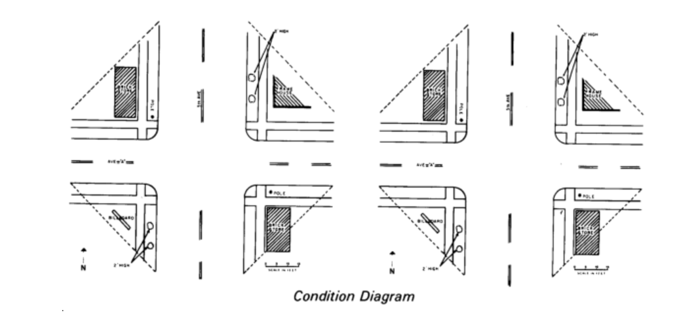

The diagram shows a two-lane road with a solid center line. The two vehicles are involved in a head-on collision. Vehicle A is in the northbound lane and Vehicle B is in the southbound lane. The impact point is at the center of the road.

The condition diagram also shows the following information:

* The weather is clear and the road is dry.
* Vehicle A is a red car and Vehicle B is a blue car.
* Vehicle A has damage to the front end and Vehicle B has damage to the rear end.
* There are no skid marks on the road.

This condition diagram can be used by investigators to reconstruct the crash and to identify the factors that may have contributed to it. For example, the fact that there are no skid marks on the road suggests that neither driver was braking heavily before the impact. This could mean that one or both drivers may have been distracted or speeding.

Condition diagrams are an important tool for crash investigators. They can help to identify the factors that contributed to the crash and to develop recommendations to prevent similar crashes from happening in the future.

1. **With a neat sketch explain Collision Diagram.**

A collision diagram is a sketch or drawing of a traffic accident. It shows the location of the vehicles involved in the accident, as well as the direction they were traveling and the point of impact. Collision diagrams can also include other relevant information, such as skid marks, debris, and traffic signs and signals.

Here is a neat sketch of a collision diagram:

The sketch shows a two-vehicle collision at an intersection. The red car was traveling north when it collided with the blue car, which was traveling east. The point of impact is shown by the black X. The sketch also shows skid marks from the red car, indicating that the driver of the red car tried to brake before the impact.

Collision diagrams can be used for a variety of purposes, including:

* To document the scene of an accident
* To investigate the cause of an accident
* To develop strategies to prevent future accidents
* To be used as evidence in court

Collision diagrams are an important tool for accident reconstructionist and other professionals who work to improve road safety.

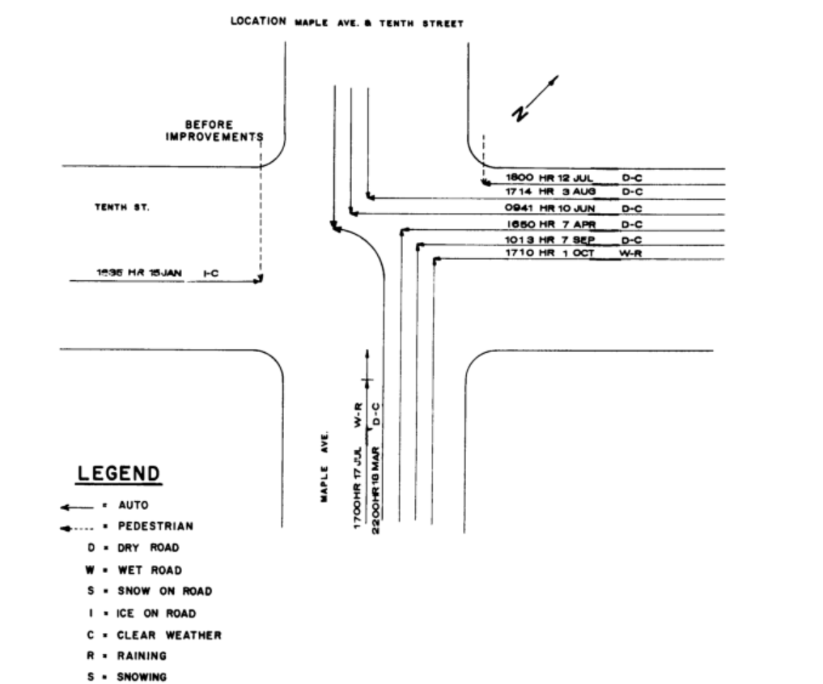

How to draw a collision diagram:

To draw a collision diagram, you will need to gather some information about the accident, such as:

* The location of the accident
* The direction the vehicles were traveling
* The point of impact
* The presence of skid marks, debris, and traffic signs and signals

Once you have this information, you can begin to sketch the diagram. Start by drawing the road or intersection where the accident occurred. Then, draw the vehicles involved in the accident, showing their direction of travel and the point of impact. If there are any skid marks, debris, or traffic signs and signals, be sure to include them in your sketch.

Here are some tips for drawing a collision diagram:

* Use a ruler and pencil to draw your diagram. This will help you to draw straight lines and accurate measurements.
* Be sure to label all of the important features in your diagram, such as the vehicles, the point of impact, and any skid marks or debris.
* If you are not sure about how to draw a particular feature, you can look for examples online or in accident reconstruction textbooks.

Once you have finished drawing your collision diagram, you should review it to make sure that it is accurate and complete. You may also want to have someone else review the diagram to make sure that they understand it.

1. **Describe the perception and reaction process of drivers in your own words.**

The perception and reaction process of drivers is the sequence of events that takes place from the moment a driver perceives a hazard to the moment they take action to avoid it. This process can be broken down into four stages:

1. Detection: The driver detects the hazard. This can happen visually, through sound, or through other senses, such as feeling the car bump over a pothole.
2. Recognition: The driver recognizes the hazard and understands what it is. For example, the driver may see a pedestrian crossing the road or a car braking suddenly in front of them.
3. Decision: The driver decides what action to take to avoid the hazard. This may involve braking, swerving, or sounding the horn.
4. Response: The driver takes the chosen action. This may involve braking, swerving, or sounding the horn.

The amount of time it takes for a driver to complete the perception and reaction process is known as the perception-reaction time. This time varies depending on a number of factors, including the driver's age, experience, and level of attention. It also depends on the type of hazard and the distance between the driver and the hazard.

In general, the perception-reaction time is about 1.5 seconds. This means that it takes a driver about 1.5 seconds to react to a hazard after they have first perceived it.

The perception and reaction process of drivers is an important factor in road safety. By understanding this process, we can develop strategies to reduce the risk of accidents. For example, we can design roads and traffic signals in a way that gives drivers more time to perceive and react to hazards. We can also educate drivers about the importance of being aware of their surroundings and paying attention to the road.

Here are some tips for drivers to improve their perception and reaction time:

* Be aware of your surroundings and pay attention to the road.
* Scan the road ahead for potential hazards.
* Anticipate the actions of other road users.
* Avoid distractions, such as cell phones and passengers.
* Get enough sleep before driving.
* Avoid driving under the influence of alcohol or drugs.

By following these tips, drivers can improve their perception and reaction time and reduce the risk of accidents.

1. **Explain salient features of the (1) Indian Road Congress (2) Motor Vehicle Act**

Indian Roads Congress (IRC)

The Indian Roads Congress (IRC) is a professional body of highway engineers and other professionals involved in the planning, design, construction, and maintenance of roads in India. It was founded in 1934 and is headquartered in New Delhi.

The IRC's salient features include:

* It is a non-profit organization.
* It is funded by the Government of India, state governments, and membership fees.
* It has a membership of over 10,000 individuals and organizations.
* It publishes a variety of technical publications, including codes, standards, and guidelines for road construction and maintenance.
* It organizes conferences and seminars on road engineering and related topics.
* It provides training and certification programs for road engineers.

The IRC plays an important role in the development and maintenance of India's road network. Its publications and training programs help to ensure that roads in India are built and maintained to high standards.

Motor Vehicle Act

The Motor Vehicle Act is a law that regulates the use of motor vehicles on Indian roads. It was first enacted in 1939 and has been amended several times since then. The current version of the Act is the Motor Vehicle Act, 1988.

The Motor Vehicle Act covers a wide range of topics, including:

* Vehicle registration and licensing
* Driver licensing
* Traffic rules and regulations
* Vehicle safety standards
* Insurance requirements
* Offenses and penalties

The Motor Vehicle Act is an important law that helps to ensure the safety of road users in India. It is enforced by the police and other authorities.

The salient features of the Motor Vehicle Act, 1988 are as follows:

* It is a comprehensive law that covers all aspects of road transportation, including vehicles, drivers, and traffic.
* It is designed to ensure the safety of road users, reduce road accidents, and protect the environment.
* It provides for a variety of safety measures, such as compulsory helmet-wearing for two-wheeler riders, speed limits, and drunk-driving laws.
* It also provides for a variety of offenses and penalties, including fines, imprisonment, and suspension of licenses.

The Motor Vehicle Act is an important tool for promoting road safety in India. It is important to note that the Act is currently under review and the government is considering making a number of amendments to it.

1. **Illustrate the requirement of an ideal road alignment**

An ideal road alignment is one that is safe, efficient, and environmentally friendly. It should also be aesthetically pleasing and fit into the surrounding landscape.

Here are some of the key requirements of an ideal road alignment:

* Safety: The road alignment should be designed to minimize the risk of accidents. An ideal road alignment is crucial for ensuring safe, efficient, and sustainable transportation infrastructure. Here are some key requirements for an ideal road alignment
* Efficiency: The road should offer efficient travel routes with smooth transitions between sections. An ideal alignment minimizes the number of curves, intersections, and deviations to reduce travel time and fuel consumption.
* Sustainability: Sustainability is a critical consideration. The alignment should minimize environmental impact by avoiding sensitive areas like wetlands or wildlife habitats. It should also consider sustainable construction practices and materials.
* Geometric Design: The road alignment should adhere to appropriate geometric design standards, including factors like lane width, shoulder width, superelevation (banking of curves), and clear zones (areas free of obstacles).
* Grade and Alignment: The road should have manageable grades (slopes) to minimize the effort and fuel required to traverse them. Excessive uphill or downhill grades should be avoided, especially on heavily traveled routes.
* Right-of-Way: Adequate right-of-way should be secured to accommodate the desired road width and any potential expansion needs. This helps avoid future constraints and minimize land acquisition issues.
* Functional Classification: The alignment should align with the road's functional classification. For example, a local road serving a residential area should have different alignment criteria than a major highway connecting cities.
* Aesthetics: The road should be designed with aesthetics in mind. This includes landscaping, scenic overlooks, and architectural features that enhance the visual appeal of the road while blending with the surrounding environment.
* Economic Viability: The alignment should consider the economic viability of construction and maintenance. It should aim to minimize costs associated with land acquisition, construction, and ongoing maintenance.
* Accessibility and Inclusivity: Roads should be designed to ensure accessibility for all users, including pedestrians, cyclists, and those with mobility challenges. Sidewalks, crosswalks, and ramps for people with disabilities are important components.
* Emergency Services: Consideration should be given to the needs of emergency services like fire, police, and medical responders. The road should facilitate their rapid access to various areas.
* Alignment with Land Use: Road alignment should be coordinated with land use planning. This includes connecting areas of economic, residential, and recreational activity efficiently.
* Flexibility: Road alignment should have some degree of flexibility to accommodate future expansion or changes in traffic patterns.
* Environmental Impact: Minimize negative environmental impacts through measures like wetland protection, stormwater management, and noise barriers.
* Compliance with Regulations: Ensure that the road alignment adheres to local, state, and national regulations, including environmental, safety, and design standards.

Creating an ideal road alignment requires careful planning and consideration of a multitude of factors. The goal is to strike a balance between safety, efficiency, sustainability, and functionality while respecting the environment and the needs of all road users.

1. **Discuss map study and reconnaissance survey in your own words.**

Map study and reconnaissance survey are two important preliminary steps in the planning and design of infrastructure projects, such as roads, highways, and railways. They help engineers and planners gather essential information about the project area before detailed design and construction work begins.

A map study involves a detailed examination of existing maps and documents related to the project area. This process provides valuable insights into the geographical, topographical, and environmental features of the region. Here are key aspects of map study:

● Topographic Maps: Topographic maps provide information about the elevation, contours, and physical features of the land. Engineers can use these maps to understand the terrain, identify natural obstacles, and plan the alignment of the road or railway.

● Land Use and Ownership: Maps can show land use patterns, property boundaries, and ownership information. This is crucial for assessing the impact of the project on land use and for acquiring land if necessary.

● Hydrology and Drainage: Information on rivers, streams, lakes, and drainage patterns is vital for assessing the impact of the project on water bodies and ensuring proper drainage design.

● Geological and Soil Data: Maps may include data on the geological composition and soil types in the project area. Understanding the subsurface conditions is essential for foundation design and stability assessments.

● Environmental Considerations: Maps can indicate ecologically sensitive areas, protected habitats, or cultural heritage sites that need to be considered during project planning to ensure environmental compliance.

● Transportation Network: Existing roads, railways, and other transportation networks are shown on maps, helping planners understand how the new project will fit into the existing infrastructure.

Reconnaissance Survey:

A reconnaissance survey involves visiting the project area in person to gather information through on-site observations and data collection. This survey helps bridge the gap between the information obtained from map studies and the actual ground conditions. Here are some key aspects of reconnaissance survey:

● Site Inspection: Engineers visit the project area to assess the current

conditions. This includes examining the terrain, existing structures, and other features that might impact project design and construction.

● Field Measurements: Data such as slope angles, distances, and elevation changes are measured using surveying instruments to validate and supplement the information obtained from map studies.

● Environmental Assessment: Engineers assess environmental conditions, taking note of vegetation, wildlife, and any potential environmental impacts. This helps in planning mitigations and conservation measures.

● Infrastructure Impact: Engineers evaluate the impact of the project on existing infrastructure, including homes, businesses, utilities, and transportation networks.

● Community and Stakeholder Engagement: Reconnaissance surveys often involve engaging with local communities and stakeholders to gather their input, address concerns, and ensure their needs are considered in the project planning.

● Safety and Accessibility: Engineers identify safety hazards and accessibility challenges on-site to incorporate safety measures and improvements into the project design.

In summary, map study and reconnaissance survey are essential steps in understanding the project area's physical, environmental, and social conditions. These preliminary activities help engineers make informed decisions, plan project alignments, and address potential challenges and impacts before the detailed design and construction phases.

Map study and reconnaissance survey are two important steps in the planning and execution of any project, especially those that involve construction or e Stopping Sight Distance (SSD) is a critical concept in road design and traffic engineering. It represents the minimum distance a vehicle traveling at a certain speed should be able to see and react to an unexpected obstacle in order to come to a complete stop without a collision. SSD ensures that drivers have sufficient visibility to stop safely in emergency situations.

1. **Describe Stopping Sight Distance. Derive the formula for level road.**

The formula for SSD on a level road can be derived based on the following factors:

Initial Speed (V0): The speed of the vehicle before the driver applies the brakes in response to an obstacle.

Deceleration (a): The rate at which the vehicle is decelerating, typically measured in meters per second squared (m/s²).

Perception-Reaction Time (t): The time it takes for the driver to perceive the obstacle and react by applying the brakes. It is usually assumed to be around 2.5 seconds.

Braking Efficiency (E): The effectiveness of the vehicle's brakes in converting deceleration into a reduction in speed, typically expressed as a fraction (e.g: 0.7 for 70%).

The formula for Stopping Sight Distance (SSD) on a level road can be derived as follows: The distance covered by the vehicle during the perception-reaction time is given by:

Distance (D1) = Initial Speed (V0) × Perception-Reaction Time (t)

The deceleration of the vehicle, in this case, is a positive value because it represents the rate of slowing down. The deceleration is usually calculated as a negative acceleration to keep the equations consistent. The deceleration formula relates initial speed, final speed (0 m/s because the vehicle comes to a stop), distance, and deceleration as follows:

V^2 = V0^2 + 2 × a × D

Where:

V = Final speed (0 m/s) V0 = Initial speed (in m/s)

a = Deceleration (negative value, in m/s²)

D = Distance covered during deceleration (meters)

To find the distance (D2) covered during deceleration, we rearrange the formula:

D2 = (0 - V0^2) / (2 × a)

The total Stopping Sight Distance (SSD) is the sum of D1 (distance during perception-reaction time) and D2 (distance during deceleration):

SSD = D1 + D2

SSD = V0 × t + (0 - V0^2) / (2 × a)

SSD = V0 × 2.5 s + (0 - V0^2) / (2 × a)

This formula provides the minimum stopping sight distance required for a vehicle traveling at an initial speed (V0) with a given perception-reaction time (t), deceleration (a), and braking efficiency (E) to safely come to a complete stop without a collision on a level road. Engineers use this formula to design roads and set speed limits to ensure road safety.

**17.Determine the safe overtaking sight distance for a design speed of 100kmph for (a) One-way traffic road (b) Two-way traffic road with the t-2s, a-0.99m/s2, speed of slow moving vehicle-60kmph.**

(a) One-way traffic road

To determine the safe overtaking sight distance for a one-way traffic road, we can use the following formula:

OSD = 0.28 * V * T + 0.5 * V * V / A

Where:

* OSD = Safe overtaking sight distance (in meters)
* V = Design speed of the overtaking vehicle (in kmph)
* T = Time taken to overtake (in seconds)
* A = Acceleration of the overtaking vehicle (in m/s2)

Assuming that the time taken to overtake is 2 seconds and the acceleration of the overtaking vehicle is 0.99 m/s2, we can calculate the safe overtaking sight distance as follows:

OSD = 0.28 * 100 * 2 + 0.5 * 100 * 100 / 0.99

= 560 meters

Therefore, the safe overtaking sight distance for a one-way traffic road with a design speed of 100 kmph is 560 meters.

(b) Two-way traffic road

To determine the safe overtaking sight distance for a two-way traffic road, we can use the following formula:

OSD = 0.28 * V * T + 0.5 * V * V / A + Vd * T

Where:

* Vd = Speed of the slow moving vehicle (in kmph)

Assuming that the time taken to overtake is 2 seconds, the acceleration of the overtaking vehicle is 0.99 m/s2, and the speed of the slow moving vehicle is 60 kmph, we can calculate the safe overtaking sight distance as follows:

OSD = 0.28 * 100 * 2 + 0.5 * 100 * 100 / 0.99 + 60 * 2

= 760 meters

Therefore, the safe overtaking sight distance for a two-way traffic road with a design speed of 100 kmph and a slow moving vehicle traveling at 60 kmph is 760 meters.

It is important to note that these are just general guidelines and the actual safe overtaking sight distance may vary depending on the specific conditions of the road and traffic. Drivers should always use their judgment and drive safely.