**Date**: 29th March 2023

**Roll No. and Name**: 20BCE204 Dhyan Patel

**Course Code and Name**: 2CSDE69 LAMP Technology

**Practical No**. 5

**AIM**:

(A) Derive a class square from class Rectangle. Create one more class circle. Create an interface with only one method called area(). Implement this interface in all the classes. Include appropriate data members and constructors in all classes. Write a program to accept details of a square, circle and rectangle and display the area.

**Methodology followed:**

<!DOCTYPE *html*>

<html>

<head>

<title>Practical 5A</title>

<link *rel*="stylesheet" *type*="text/css" *href*="./Style2.css">

</head>

<body>

<form *method*="post">

<center>

<hr>

<h2><b>Practical 5A<br>Derive a class square from class Rectangle.

Create one more class circle. Create an interface with only one method called area().

Implement this interface in all the classes. Include appropriate data members and constructors in all classes.

Write a program to accept details of a square, circle and rectangle and display the area.</b></h2>

<hr>

<br>

<h3>Enter Details for Rectangle:</h3>

Length: <input *type*="number" *name*="rLength"><br><br>

Width: <input *type*="number" *name*="rWidth"><br><br>

<h3>Enter Details for Circle:</h3>

Radius: <input *type*="number" *name*="cRadius"><br><br>

<h3>Enter Details for Square:</h3>

Side: <input *type*="number" *name*="sSide"><br><br>

<input *type*="submit" *name*="submit" *value*="Calculate Area">

<br><br>

<?php

interface Shape {

*public* function area();

}

class Rectangle *implements* Shape {

*private* $length;

*private* $width;

*public* function __construct($length, $width) {

$this->length = $length;

$this->width = $width;

}

*public* function area() {

return (int)$this->length * (int)$this->width;

}

}

class Square *extends* Rectangle {

*public* function __construct($side) {

parent::__construct($side, $side);

}

}

class Circle *implements* Shape {

*private* $radius;

*public* function __construct($radius) {

$this->radius = $radius;

}

*public* function area() {

return pi() * (int)$this->radius * (int)$this->radius;

}

}

if(isset($_POST['submit'])) {

$rLength = $_POST['rLength'];

$rWidth = $_POST['rWidth'];

$cRadius = $_POST['cRadius'];

$sSide = $_POST['sSide'];

$rectangle = new Rectangle($rLength, $rWidth);

$circle = new Circle($cRadius);

$square = new Square($sSide);

echo "<table border=1>";

echo "<tr><th>Shape</th>";

echo "<th>Area</th></tr>";

if ($rLength!="" and $rWidth!= ""){

echo "<tr><td>Rectangle</td><td>".$rectangle->area()."</td>";

}

if ($sSide != ""){

echo "<tr><td>Square</td><td>".$square->area()."</td>";

}

if ($cRadius != ""){

echo "<tr><td>Circle</td><td>". round($circle->area(),2)."</td>";

}

echo "</table>";

}

?>

</center>

</form>

</body>

</html>

Output:

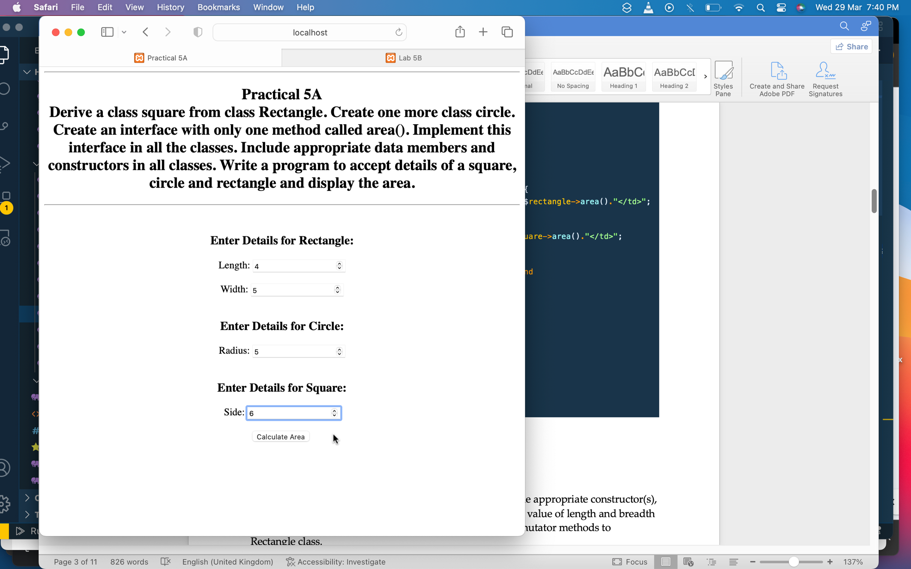

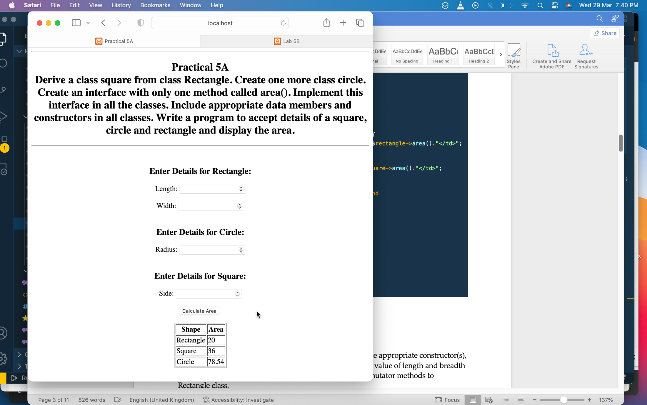

(B)

1. Define a class Rectangle with its length and breadth. Provide appropriate constructor(s), which gives facility of constructing rectangle object passing value of length and breadth externally to constructor. Provide appropriate accessor & mutator methods to Rectangle class.

Provide methods to calculate area & to display all information of Rectangle. Create five Rectangle objects and call appropriate methods.

**Methodology followed:**

<!DOCTYPE *html*>

<html *lang*="en">

<head>

<title>Lab 5B</title>

</head>

<body>

<center>

<h3><b>Practical 5B<br>Define a class Rectangle with its length and breadth.

Provide appropriate constructor(s), which gives facility of constructing rectangle object passing value of length and breadth externally to constructor.

Provide appropriate accessor & mutator methods to Rectangle class.

Provide methods to calculate area & to display all information of Rectangle.

Create five Rectangle objects and call appropriate methods.

</b></h3>

<hr>

<div *class*="Form">

<form *method*="post" *action*="<?php echo $_SERVER['PHP_SELF']?>">

<h3>

length: <input *type*="Number" *name*="length"></input><br>

breadth: <input *type*="Number" *name*="breadth"></input><br>

<div *class*="Button">

<button *type*="submit">Submit</button>

<h3>

</div>

</form>

</div>

<?php

class Rectangle{

*public* $length;

*public* $breadth;

function __construct($length, $breadth)

{

$this->length = $length;

$this->breadth = $breadth;

}

*public* function area()

{

return $this->length * $this->breadth;

}

*public* function perimeter()

{

return 2*($this->length + $this->breadth);

}

*public* function setLength($length){

$this->length = $length;

}

*public* function setBreadth($breadth){

$this->breadth = $breadth;

}

*public* function getLength(){

return $this->length;

}

*public* function getBreadth(){

return $this->breadth;

}

*public* function __toString(){

return ("Length :".$this->getLength()." "."Breadth :".$this->getBreadth()."<br>".

"Area :".$this->area()."<br>"."Perimeter :".$this->perimeter());

}

}

$rect1= new Rectangle(5,7);

$rect2= new Rectangle(6,4);

$rect3= new Rectangle(2,8);

$rect4= new Rectangle(3,9);

$rect5= new Rectangle(10,9);

echo "Calling Object 1<br>".$rect1;

echo"<br><br>";

echo "Calling Object 2<br>".$rect2;

echo"<br><br>";

echo "Calling Object 3<br>".$rect3;

echo"<br><br>";

echo "Calling Object 4<br>".$rect4;

echo"<br><br>";

echo "Calling Object 5<br>".$rect5;

echo"<br><br>";

if ($_SERVER["REQUEST_METHOD"] == "POST") {

$l = htmlspecialchars($_REQUEST['length']);

$b = htmlspecialchars($_REQUEST['breadth']);

if (empty($l)) {

echo "Enter Length";

}

if (empty($b)) {

echo "Enter Breadth";

}

else{

$rectangle = new Rectangle($l, $b);

echo $rectangle;

}

}

?>

</center>

</body>

</html>

Output:

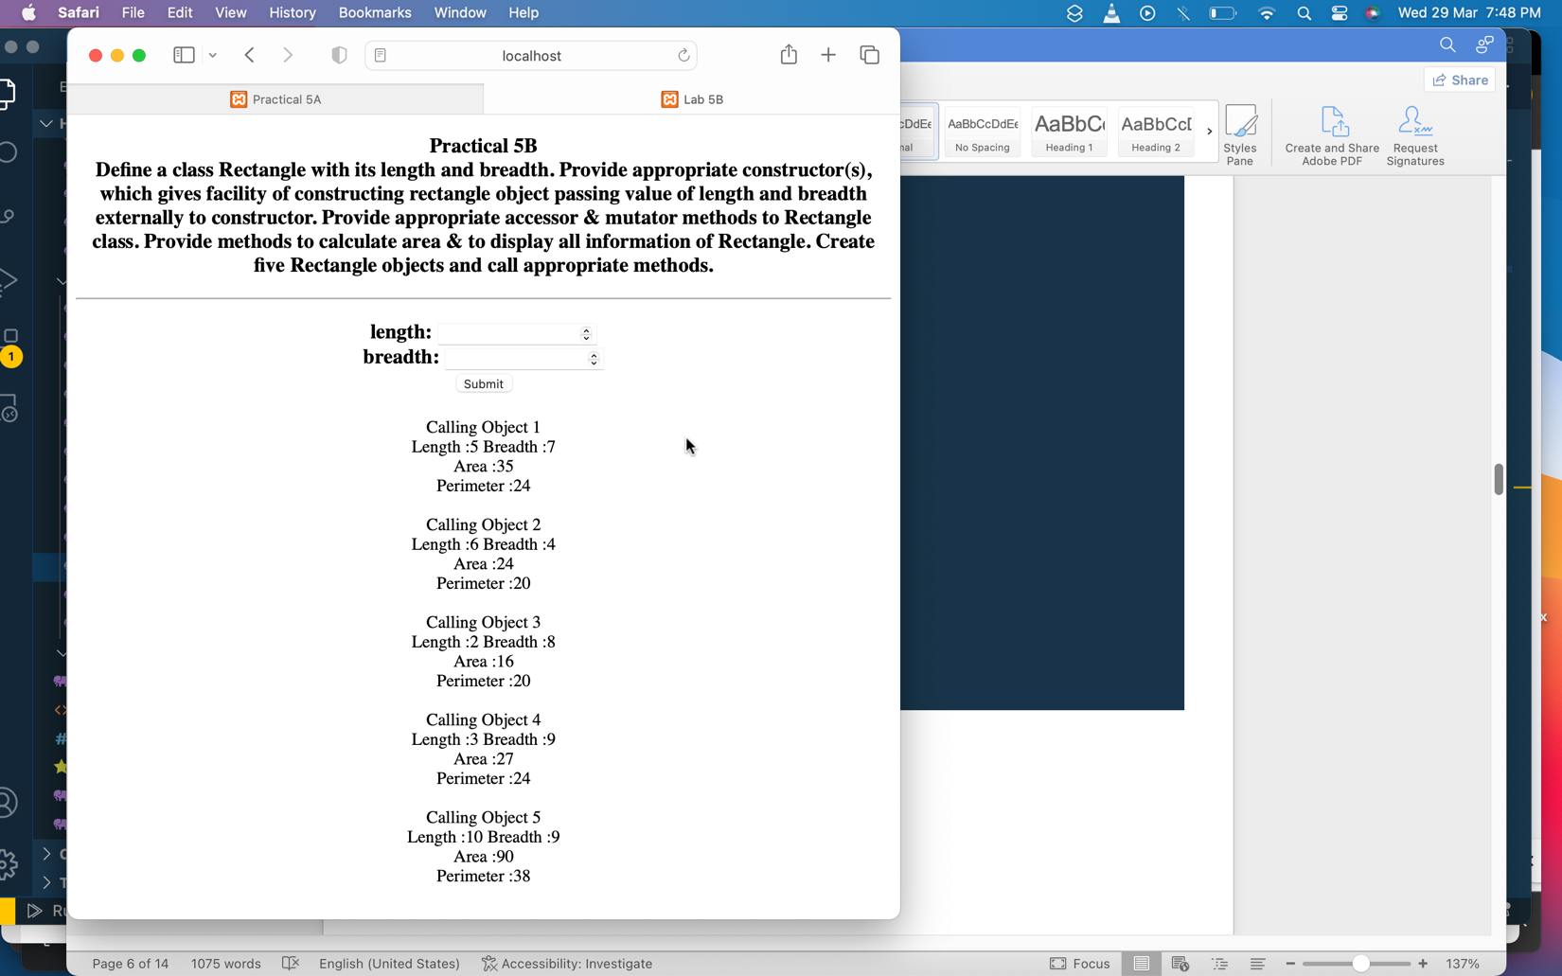

Practice Examples:

|  |  |
| --- | --- |
| 1. Different Access Modifiers:   <?php  class Person {  *public* $name;  *protected* $age;  *private* $address;    *public* function __construct($name, $age, $address){  $this->name = $name;  $this->age = $age;  $this->address = $address;  }    *public* function getName() {  return $this->name;  }    *protected* function getAge() {  return $this->age;  }    *public* function getAddress() {  return $this->address;  }  }  class Employee *extends* Person {  *public* function getAgeFromParent() {  return $this->getAge();  }  }  $person = new Person("Dhyan", 20, "Ahmedabad");  echo $person->name;  *//echo $person->age;*  echo $person->address;  echo"<br>";  *//echo $person->getName();*  *// echo $person->getAge();*  *//echo"Private variable accesed from public method<br>";*  *//echo $person->getAddress();*  echo"<br>";  echo"<br><br> Protected variable<br>";  $employee = new Employee("Alisha", 24, "Boston");  echo $employee->getAgeFromParent();  ?> | Output:    When trying to access Protected variable    When trying to access Private variable |
| 1. Introspection Functions:   <?php  class ParentClass {  *public* $a = 204;  *public* function Method1() {  echo "Hello, world!<br>";  }  *private* function Method2() {  *// do something private*  }  }  $obj = new ParentClass();  *// get class name*  echo "Class name: " . get_class($obj) . "<br>";  *// check if object is an instance of a class*  if ($obj instanceof ParentClass) {  echo "Object is an instance of ".get_class($obj)."<br>";  }  *// get class methods*  $methods = get_class_methods($obj);  echo "Class methods: " . implode(", ", $methods) . "<br>";  *// check if a method exists in a class*  if (method_exists($obj, 'Method2')) {  echo "Method2 exists in class<br>";  }  *// get class properties*  $properties = get_class_vars('ParentClass');  echo "Class properties: " . implode(", ", array_keys($properties)) . "\n";  ?> | Output: |

Conclusion:

We learned about OOP concepts in PHP like inheritance, access modifiers, interfaces, methods and Introspection Functions.