MechmanRetail
BI Portfolio Project
Help Page Design Specification
Author: Adiga Triumphant
Power BI Canvas — Report Page 5 (Hidden)
Simple white layout matching report pink and white theme

Purpose
The Help page is a hidden fifth page inside the MechmanRetail Power BI report. It is accessible via a ? button in the header of every analytics page — not from the left navigation panel. It provides a quick reference for report users on what each page covers and how to interact with it.

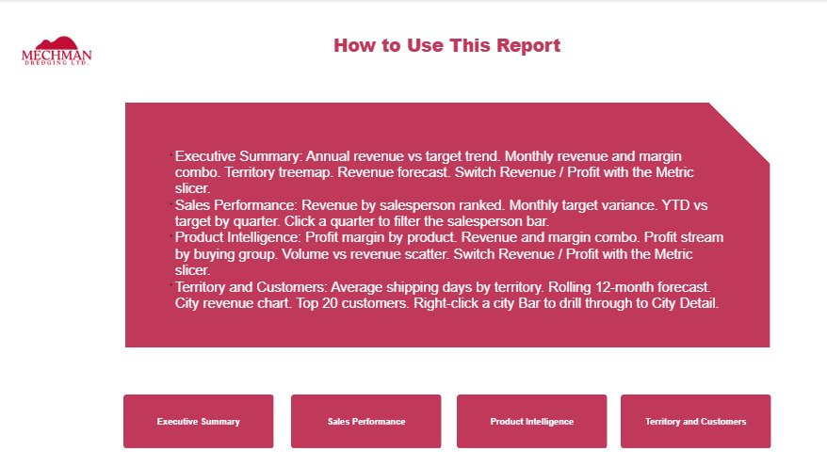

1 | Page Setup

Setting | Value
Page name | Help
Page visibility | Hidden — right-click page tab → Hide page
Canvas size | 1280 × 720 — 16:9 matching all other pages
Background | White — matching report light theme
Navigation | Not in left panel — accessible via ? button only

2 | ? Help Button  Add to header of every analytics page

A ? button is placed in the top right corner of the header on all four analytics pages. Clicking it navigates to the Help page.

Property | Value
Visual type | Button → Blank
Label | ?
Font | Arial Bold 14pt — White #FFFFFF
Fill | Pink #C0395A — matching report accent colour
Size | 40 × 40 pixels
Position | Top right of header — aligned with page title baseline
Action | Page navigation → Help
Tooltip | How to use this report
Copy to | All four analytics pages at identical position

3 | Canvas Layout  Three elements — title, content box, navigation buttons

Element 1 — Page Title
Property | Value
Text | How to Use This Report
Font | Arial Bold — Pink #C0395A
Size | 22pt
Alignment | Centre
Position | Top centre of canvas below the logo

Element 2 — Content Box
A large pink rounded rectangle containing four bullet points — one per analytics page. Each bullet describes the key visuals and interactions available on that page.

Property | Value
Shape | Rectangle with rounded corners
Fill | Pink #C0395A
Text colour | White #FFFFFF
Font | Arial 11pt
Width | Approximately 70% of canvas width — centred
Position | Centre of canvas below the title

Content — Four Bullet Points
Page | Text
Executive Summary | Annual revenue vs target trend. Monthly revenue and margin combo. Territory treemap. Revenue forecast. Switch Revenue / Profit with the Metric slicer.
Sales Performance | Revenue by salesperson ranked. Monthly target variance. YTD vs target by quarter. Click a quarter to filter the salesperson bar.
Product Intelligence | Profit margin by product. Revenue and margin combo. Profit stream by buying group. Volume vs revenue scatter. Switch Revenue / Profit with the Metric slicer.
Territory and Customers | Average shipping days by territory. Rolling 12-month forecast. City revenue chart. Top 20 customers. Right-click a city bubble to drill through to City Detail.

Element 3 — Navigation Buttons
Four pink rectangular buttons at the bottom of the canvas — one per analytics page. Each button navigates directly to its respective page.

Property | Value
Button count | Four — one per analytics page
Labels | Executive Summary, Sales Performance, Product Intelligence, Territory and Customers
Fill | Pink #C0395A
Font | Arial Bold 10pt — White #FFFFFF
Size | Each button approximately 22% of canvas width
Position | Bottom of canvas — equal spacing between buttons
Action | Each button: Page navigation → respective page

4 | Back Button  Return navigation on Help page

Property | Value
Visual type | Button → Back (Power BI built-in back navigation)
Position | Top right of Help page — matches ? button position on analytics pages
Style | Match report theme — pink or white fill
Action | Built-in back navigation — returns to source page automatically

5 | Implementation Order  Build sequence in Power BI Desktop

Step | Action
1 | Create new page named Help — right-click any page tab → Insert page → rename
2 | Set canvas background to white
3 | Add Mechman logo image top left
4 | Add title text box — How to Use This Report — pink, bold, centred
5 | Add pink rounded rectangle content box — centred, 70% canvas width
6 | Add four white bullet point text boxes inside the content box — one per page
7 | Add four pink navigation buttons at the bottom — one per analytics page, with Page navigation actions
8 | Hide the page — right-click Help tab → Hide page
9 | Add ? button to all four analytics pages — Insert → Button → Blank → Action: Page navigation → Help
10 | Add Back button to Help page — Insert → Button → Back
11 | Test — click ? on each analytics page → Help loads. Click navigation buttons → correct pages load. Click Back → returns.

