MechmanRetail
BI Portfolio Project
User Guide
Author: Adiga Triumphant
Mechman Retail Business Intelligence Report
How to navigate, interact, and get the most from the report

Report Overview
The Mechman Retail Business Intelligence Report is a four-page interactive dashboard covering sales performance, product profitability, salesperson contribution, and geographic distribution across 2017 to 2020. It is designed for executives who need headline performance at a glance and analysts who need to drill into product, salesperson, and territory detail.

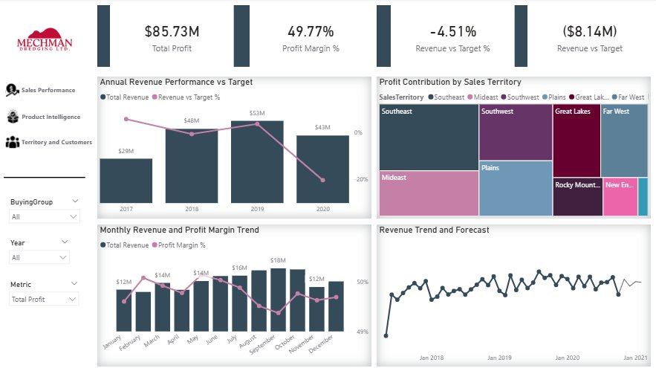

Navigation
The report opens on the Executive Summary page. A vertical navigation panel on the left side of every page contains page buttons for Sales Performance, Product Intelligence, and Territory and Customers. Executive Summary is the landing page and has no button for itself. A ? button in the top right corner of every page opens the Help page which provides a quick reference guide. Click the Back button on the Help page to return.

Element | What it does
Page buttons — left panel | Click to navigate between the four analytics pages
? button — top right header | Opens the Help page — quick reference for all interactions
Back button — Help page | Returns to the page you navigated from
BuyingGroup slicer | Filters all pages to Tailspin Toys, Wingtip Toys, Other, or All
Year slicer | Filters all pages to a specific calendar year or All
Metric slicer | Switches between Total Revenue and Total Profit on Pages 1 and 3 only

KPI Cards
Each page opens with KPI cards across the top providing an immediate headline summary before the user looks at any chart.

Card | What it shows
Total Revenue / Total Profit | Primary financial metric. Switches between Revenue and Profit on Pages 1 and 3 via the Metric slicer.
Profit Margin % | Percentage of revenue retained as profit. Always current period — not affected by Metric slicer.
Revenue vs Target % | How far revenue is above or below the monthly buying group target. Green = above. Red = below.
Revenue vs Target | Absolute monetary difference from target. Green = above. Red = below.
Avg Days to Ship | Average days between invoice date and delivery. Lower is faster. Pages 2 and 4 only.
Total Chiller Items | Quantity of chiller category items sold. Page 3 only. Chiller sales began in 2020.
Total Dry Items | Quantity of dry category items sold. Page 3 only.

Page 1 — Executive Summary


The Executive Summary provides the top-level business performance view for the selected year and buying group. All charts show full-year Actual figures — there is no Period slicer on this page.

Visual | What it shows and how to use it
Annual Revenue Performance vs Target | Revenue bars per year with Revenue vs Target % line. Always shows all four years regardless of Year slicer — cross-year comparison is the purpose of this visual.
Monthly Revenue and Profit Margin Trend | Monthly revenue bars and Profit Margin % line for the selected year. Use this to identify months where revenue was high but margin was compressed.
Revenue Contribution by Sales Territory | Treemap showing relative territory contribution. Larger tiles mean higher contribution. Switches between Revenue and Profit via Metric slicer. Click a tile to cross-filter other visuals.
Revenue Trend and Forecast | Full historical monthly revenue trend with projected forecast into 2021. Hover over the projected line to see lower bound, upper bound, and point forecast. Always uses full dataset regardless of Year slicer.

Page 2 — Sales Performance
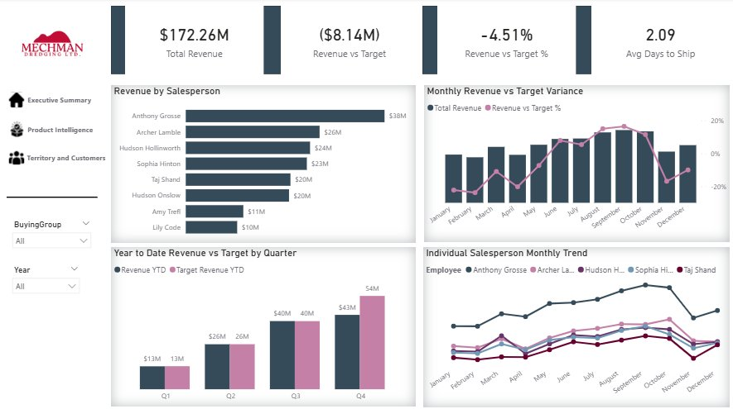

Sales Performance focuses on individual salesperson contribution, monthly target tracking, and year-to-date cumulative performance.

Visual | What it shows and how to use it
Revenue by Salesperson | Revenue per salesperson sorted descending. Click a bar to filter the Total Revenue card to that individual. Hover to see their revenue rank.
Monthly Revenue vs Target Variance | Monthly revenue bars and Revenue vs Target % line. Months where the line is above 0% exceeded target. Always shows Actual.
Year to Date Revenue vs Target by Quarter | Cumulative YTD revenue against cumulative YTD target per quarter. Both bars accumulate across the year — Q4 equals full year total. Click a quarter to filter the salesperson bar chart.
Individual Salesperson Monthly Trend | Monthly revenue trend for the top 5 salespersons. Shows growth, decline, and seasonal patterns across the year. Always shows Actual.

Page 3 — Product Intelligence
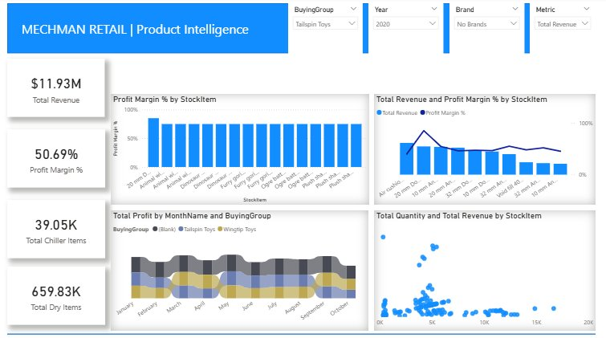

Product Intelligence analyses the product portfolio across margin, revenue, volume, and buying group profit distribution.

Visual | What it shows and how to use it
Profit Margin by Product | Margin percentage per product. Click a bar to update the KPI cards to that product's figures.
Revenue and Margin by Product | Revenue bars and Profit Margin % line per product. Identify high-revenue but low-margin products. Bars switch between Revenue and Profit via Metric slicer.
Profit Distribution by Buying Group | Stream chart showing how profit is distributed between buying groups across each month. Always shows Total Profit — not affected by Metric slicer.
Product Volume vs Revenue Analysis | Scatter plot — quantity on horizontal axis, revenue or profit on vertical axis per product. Top right = high volume and high value. Click a data point to highlight that product's margin bar.

Note: Total Chiller Items shows zero for 2017 and 2018. Chiller product sales only began in 2020 — this is correct data.

Page 4 — Territory and Customers
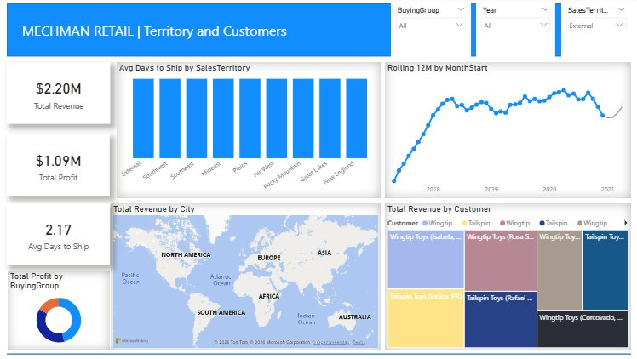

Territory and Customers provides geographic and customer-level analysis. The SalesTerritory slicer is the primary navigation control for this page.

Visual | What it shows and how to use it
Average Shipping Days by Territory | Average days between invoice and delivery per territory. Always shows all territories regardless of SalesTerritory slicer — use as a reference to compare selected territory against others.
Rolling 12-Month Revenue Trend and Forecast | Trailing 12-month revenue total per month with forecast into 2021. Always uses full dataset regardless of Year slicer.
Revenue Distribution by City | Bubble map — larger bubbles mean higher revenue. Select a territory in the SalesTerritory slicer to focus the map. Right-click a bubble to drill through to City Detail.
Profit Split by Buying Group | Donut showing total profit distribution between buying groups. Always shows all groups regardless of BuyingGroup slicer.
Top Customers by Revenue | Treemap of top 20 customers by revenue. Click a tile to filter the Rolling 12M chart and Total Revenue card to that customer.

City Detail — Drill Through
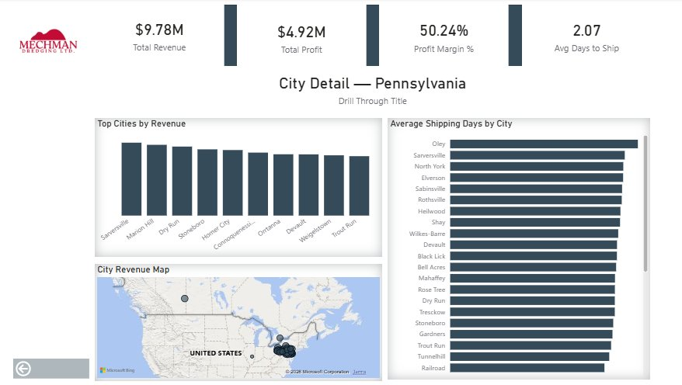

City Detail is a drill through page showing a state-level breakdown of cities, revenue, and shipping days. It is not accessible from the navigation panel — it opens via right-click on any data point containing state information.

Action | How to do it
Access City Detail | Right-click any bubble on the city map on Page 4 → Drill through → City Detail
Return to report | Click the Back button in the top right corner of the City Detail page

Glossary
Term | Definition
Total Revenue | Sum of all sales value excluding tax
Total Profit | Sum of profit — revenue minus cost of goods sold
Profit Margin % | Total Profit divided by Total Revenue
Target Revenue | Monthly sales target defined at buying group level — 2017 to 2020
Revenue vs Target | Difference between Total Revenue and Target Revenue
Revenue vs Target % | Revenue vs Target divided by Target Revenue
Revenue YTD | Cumulative revenue from January 1st of the selected year
Revenue LY | Same period revenue from the prior calendar year
Revenue YoY % | Percentage growth compared to the same period last year
Revenue Rolling 12M | Trailing 12-month total ending on the last available date
Avg Days to Ship | Average calendar days between invoice date and delivery date
BuyingGroup | Customer segment — Tailspin Toys, Wingtip Toys, or Other
SalesTerritory | US geographic region — Southeast, Southwest, Mideast, Plains, Far West, Rocky Mountain, Great Lakes, New England, External
Chiller Items | Products requiring refrigerated storage and transport
Dry Items | Products not requiring refrigeration
Drill Through | Right-click a data point to open a detailed page filtered to that context

