**Geodatabase on surge-type glaciers**

**Summary:**

We compiled a global inventory of surge-type glaciers based on 305 peer-reviewed publications and historical reports, consisting of either direct observations of a surge or identification of a glacier as being surge-type from glaciological or geomorphological evidence. The observations extend until 2013. No new observations, nor measurements were made in this study. All data is derived from publications.

By compiling such a large number of references, we faced a patchwork of interpretations of what a surge is, combined with a wide spectrum of glacier behaviors interpreted by researchers as a ‘surge’. For inclusion in the geodatabase, every identification of a surge-type glacier had to conform to the criteria listed in Table 1 (see below). The criteria are consistent with those adopted in existing inventories (e.g. Copland and others, 2003, 2011; Grant and others 2009). For glaciers for which a surge phase was not directly observed, the glacier and/or its proglacial environment had to display a sufficient combination of geomorphological/glacial geomorphological features to confirm surging (Clarke and others, 1986; Copland and others, 2003; Barrand and Murray, 2006; Grant and others, 2009).

Many existing inventories included in our database assign a study-specific ‘surge index’ to every glacier listed (Ommanney, 1980; Clarke and others, 1986; Hamilton and Dowdeswell, 1996; Jiskoot and others, 2000; Copland and others, 2003). These indices attempt to quantify the likelihood of a particular glacier being of surge type. In the published literature, a total of 75% of the glaciers of the geodatabase have been ranked using 11 different surge indices. While single observations were first filtered through the criteria written in Table 1, we decided to homogenize and qualitatively reassess every observation by applying our own harmonized surge index. This ranks every glacier on a scale from 1 to 3, 3 being a confirmed surge-type glacier, 2 a very probable surge-type glacier and 1 a possible surge-type glacier.

The geodatabase incorporates a total of 2281 glaciers and tributaries, of which 1148 are directly observed and dated surges, and 186 glaciers have more than one surge referenced (see Table 2 for numbers of surge-type glaciers for each region and for categories 1–3). Each glacier is georeferenced by the latitude/longitude of its centerpoint, and data on its geometry are provided. Tributaries are added as separate entries if their behavior differs from that of the main trunk. To allow comparison of surge-type glaciers with the total global population of glaciers, the geodatabase was combined with the Randolph Glacier Inventory (RGI) version 5.0, released July 20, 2015. and downloaded from http://www.glims.org/RGI/ (Pferrer et al., 2014).

Please note that this version of the geodatabase differs from the geodatabase used in Sevestre and Benn, 2015 (Journal of Glaciology). Among the differences are:

* Updated RGI ID for all glaciers, from RGI3.2 to RGI 5.0.
* All tributary glaciers are included, therefore many entries bare the same RGI ID.
* Data on glacier geometry are directly derived from the RGI 5.0.

**Correspondance:** heidi.sevestre@yahoo.fr

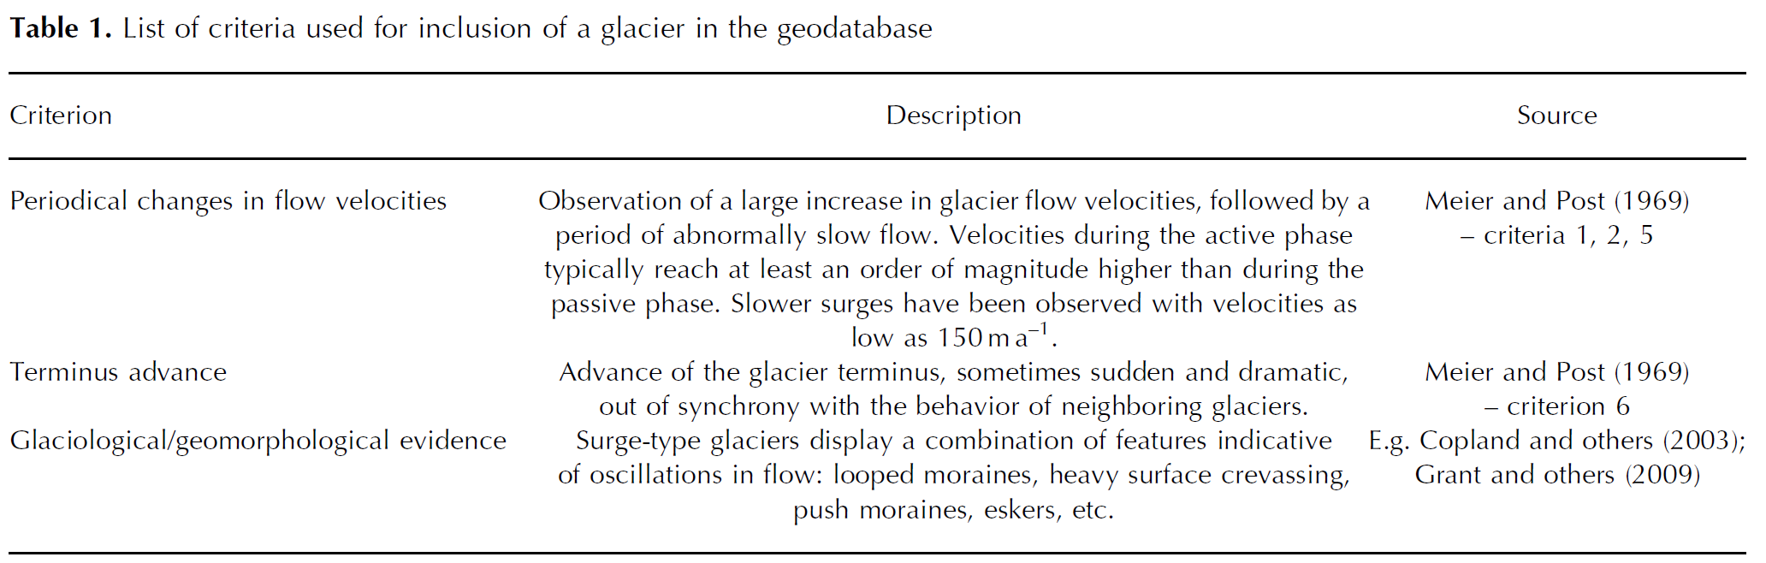

Citation: ?

**References:**

Barrand, N.E. and T. Murray 2006. Multivariate Controls on the Incidence of Glacier Surging in the Karakoram Himalaya. Arctic, Antarctic & Alpine Research, 38(4): 489-498.

Clarke, G.K.C., J.P. Schmok, C.S.L. Ommanney and S.G. Collins 1986. Characteristics of surge-type glaciers. Journal Of Geophysical Research, 91(B7): 7165-7180.

Copland, L., M.J. Sharp and J.A. Dowdeswell 2003. The distribution and flow characteristics of surge-type glaciers in the Canadian High Arctic. Annals of Glaciology, 36(1): 73-81.

Copland, L., T. Sylvestre, M.P. Bishop, J.F. Shroder, Y.B. Seong, L.A. Owen, A. Bush and U. Kamp 2011. Expanded and Recently Increased Glacier Surging in the Karakoram. Arctic, Antarctic, and Alpine Research, 43(4): 503-516.

Grant, K.L., C.R. Stokes and I.S. Evans 2009. Identification and characteristics of surge-type glaciers on Novaya Zemlya, Russian Arctic. Journal of Glaciology, 55(194): 960-972.

Hamilton, G.S. and J.A. Dowdeswell 1996. Controls on glacier surging in Svalbard. Journal of Glaciology, 42(140): 157-168.

Jiskoot, H., T. Murray and P. Boyle 2000. Controls on the distribution of surge-type glaciers in Svalbard. Journal of Glaciology, 46(154): 412-422.

Ommanney CSL (1980) The inventory of Canadian glaciers:procedures, techniques, progress and applications. IAHS Publ. 126 (Riederalp Workshop 1978 – World Glacier Inventory), 35–44

Pfeffer, T., A.A. Arendt, A. Bliss, T. Bolch, J.G. Cogley, A.S. Gardner, J.O. Hagen, R. Hock, G. Kaser, C. Kienholz, E.S. Miles, G. Moholdt, N. Mölg, F. Paul, V. Radic, P. Rastner, B.H. Raup, J. Rich and M. Sharp 2014. The Randolph Glacier Inventory, a globally complete inventory of glaciers. Journal of Glaciology, 60(221): 537-552.

Sevestre, H., and D. Benn (2015), Climatic and topographic controls on the global distribution of surge type glaciers: implications for a unifying model of surging. Journal of glaciology. DOI: 10.3189/2015JoG14J136

**Structure of the geodatabase:**

**Table 1 “Surge-type glaciers names”:**

* **Country:** country of location of the glacier (based on glacier centerpoint)
* **RGI_ID:** RGI ID of the glacier. This table contains both tributaries and main trunk of the same glacier system, therefore many entries can share the same RGI ID. 80 glaciers do not have an RGI ID, as their identifying lat/long does not fall into the RGI outlines any more due to recession.
* **GLIMS_ID:** GLIMS ID of the glacier.
* **Glacier_Name:** name of the glacier. Depending on the source of the information, some glaciers might have more than one name, due to different spelling, translations or successive identifications.
* **Number_of_dated_surges:** number of surges identified and dated for each glacier.
* **CENLAT:** latitude of the glacier centerpoint. From the RGI 5.0.
* **CENLON:** longitude of the glacier centerpoint. From the RGI 5.0.
* **AREA, ZMIN, ZMAX, ZMED, SLOPE, ASPECT, LMAX:** attributes derived from the RGI 5.0

**Table 2 “Surge dates”:**

* **Glacier_Name:** same as in Table 1.
* **Surge_ID:** individual ID for every surge observed. The surge ID is composed of the glacier name, and the initiation date of the observed surge. “X-1987” identifies the surge of glacier X that started in 1987, while “X_0” denotes that no surge has been directly observed for glacier X.
* **Surge_date_estimation:** qualifies whether the surge started/ended “before”, “after” or “between” certain dates.
* **Surge_onset:** when available, date of the onset of the surge.
* **Surge_termination:** when available, date of the termination of the surge.
* **Surge_diagnostic_features:** main evidence used to identify the glacier as being of “surge-type”. More information can be found in the corresponding reference, identified by a unique ID number such as “XX1987”. More than one reference may exist for a single glacier.
* **Study_surge_index:** see description above. “2a OGB1998” translates as the index 2a from the publication OGB1998.
* **Surge_index_description:** full description surge index.
* **Harmonised_surge_index:** see above.
* **Area_affected_km2:** Area of the glacier mobilized as the result of the surge in km2.
* **Advance?:** Yes or no classification. Some glacier surges have produced an advance, but this advance has not necessarily been measured.
* **Glacier_advance_km:** advance of the glacier as the result of the surge in km.
* **Peak_surge_velocities_m/day:** peak velocities measured during the surge in metres per day.
* **References_ID:** list of the references ID’s compiled listed in this entry.

**Table 3: References**

* **Reference_ID:** ID of the reference, composed of the initials of the first author, and the publication year.
* **Date:** publication year
* **Cluster_studied:** cluster(s) investigated in the study
* **Complete_reference:** full citation of the publication
* **Data_used:** datasets used for the study
* **Technique:** methods used in the study