**Name:** Sunishka Sharma

**University Roll No.:** 201500717

Create a Employee Collection add 5 documents:

Example:

{emono:111,ename:”Deepali

Vaidya”,sal:40000.00,dept:{deptno12,dname:,”Hr”,dloc:”Mumbai},

Desg:”Analyst”,mgr:{name:”Satish”,num:111},project:[{name:”Project-

1”,Hrs:4},{name:”project- 2”,Hrs:4}]}

1. All Employee’s with the desg as ‘CLERK’ are now called as (AO) Administrative Officers.

Update the Employee collection for this.

2. Change the number of hours for project-1 to 5 for all employees with designation analyst.

3. Add 2 projects project-3 and project-4 for employee whose name starts with ”Deep” with 2 hrs

4. Add bonus rs 2000 for all employees with salary > 50000 and 1500 if salary <50000 and >

30000 otherwise bonus will be 1000

5. Change manager name to Tushar for all employees whose manager is currently “satish”

And manager number to 3333

6. Increase salary of all employees from “purchase department” by 15000

7. Decrease number of hrs by 2 for all employees who are working on project-2

8. Delete project-2 from all employee document if they are working on the project for 4

hrs.

9. Change the salary of employees to 10000 only if their salary is < 10000

10. Increase bonus of all employees by 500 if the bonus is <2000 or their salary is <

20000 or if employee belong to sales department

11. Add 2 new project at position 2 for all employees with designation analyst or salary is

equal to either 30000 or 33000 or 35000

12. Delete last project of all employees with department name is “HR” and if the location

is Mumbai

13. Change designation of all employees to senior programmer if they are working on

name:”Project-1” for 4 hrs

14. Add list of hobbies in all employees document whose manager is Rajan or Revati

15. Add list of skillset in all employee documents who are working on project-4 for 3 hrs

or on project-3 for 4 hrs

16. Add a new hobby as blogging at 3 position in hobbies array for all employess whose

name starts with R or p and ends with j or s

17. Increase salary by 10000 for all employees who are working on project-2 or project-3

or project-1

Decrease bonus by 1000 rs And increase salary by 1000rs for all employees whose

department location is Mumbai

18. Remove all employees working on project-1

19. Replace document of employee with name “Deepak to some new document

20. Change skill python to python 3.8 for all employees if python is there in the skillset

21. Add 2 skills MongoDb and Perl at the end of skillset array for all employees who are

working at Pune location

22. Delete first hobby from hobby array for all employees who are working on project-1

or project-2

23. Delete last hobby from hobbies array for all employees who are working on project

which is at 2 nd position in projects array for 4 hrs

24. Add 2 new projects at the end of array for all employees whose skillset contains Perl

or python

25. Change hrs to 6 for project-1 for all employees if they working on the project-1 for <

6 hrs. otherwise keep the existing value.

Create a Employee Collection add 25 documents: Example: {emono:111,ename:”Deepali Vaidya”,sal:40000.00,dept:{deptno12,dname:,”Hr”,dloc:”Mumbai}, Desg:”Analyst”,mgr:{name:”Satish”,num:111},project:[{name:”Project-1”,Hrs:4},{name:”project- 2”,Hrs:4}]}

1. **All Employee’s with the desg as ‘CLERK’ are now called as (AO) Administrative Officers. Update the Employee collection for this.**

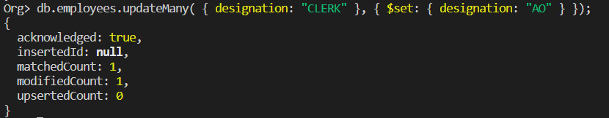

1. **Change the number of hours for project-1 to 5 for all employees with designation analyst.**

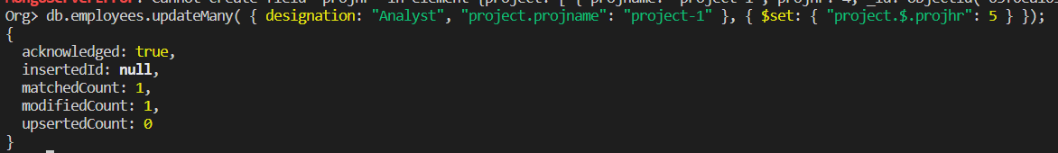

1. **Add 2 projects project-3 and project-4 for employee whose name starts with ”Deep” with 2 hrs**

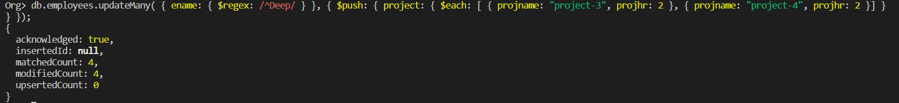

1. **Add bonus rs 2000 for all employees with salary > 50000 and 1500 if salary <50000 and > 30000 otherwise bonus will be 1000**



**5. Change manager name to Tushar for all employees whose manager is currently “satish” And manager number to 3333**

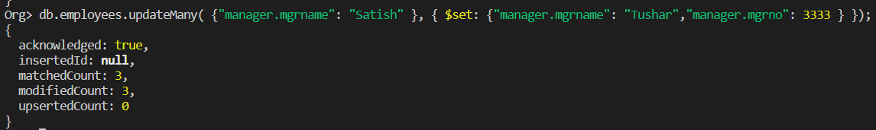

**6. Increase salary of all employees from “purchase department” by 15000**

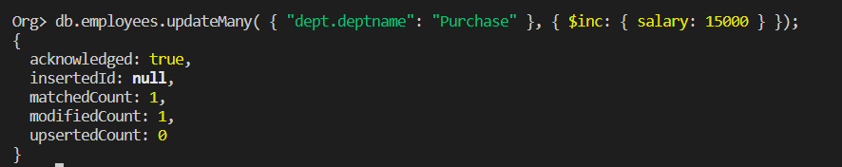

**7. Decrease number of hrs by 2 for all employees who are working on project-2**

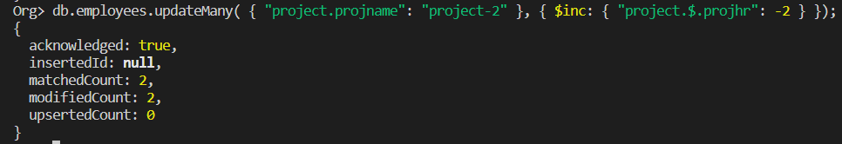

**8. Delete project-2 from all employee document if they are working on the project for 4 hrs.**

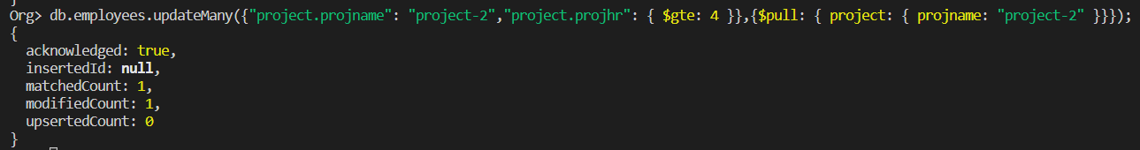

**9. Change the salary of employees to 10000 only if their salary is < 10000**

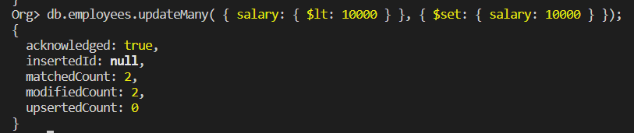

**10. Increase bonus of all employees by 500 if the bonus is <2000 or their salary is < 20000 or if employee belong to sales department**

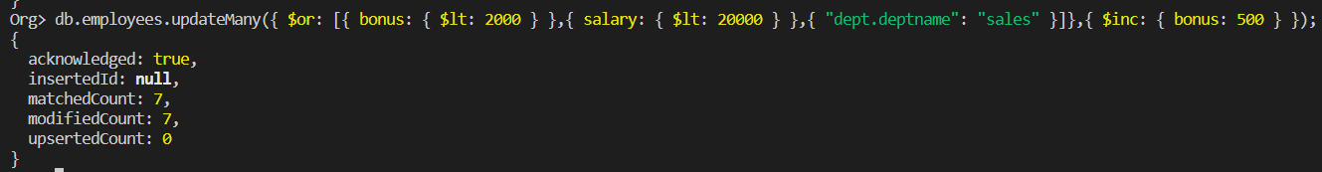

**11. Add 2 new project at position 2 for all employees with designation analyst or salary is equal to either 30000 or 33000 or 35000**

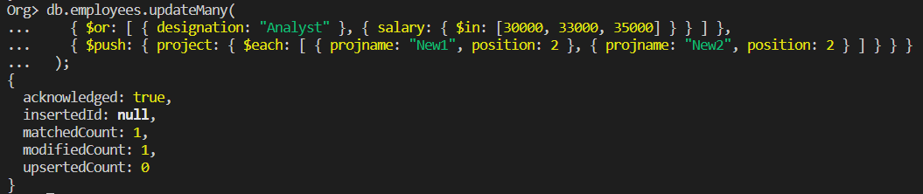

**12. Delete last project of all employees with department name is “HR” and if the location is Mumbai**

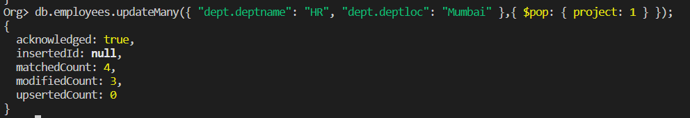

**13. Change designation of all employees to senior programmer if they are working on name:”Project-1” for 4 hrs**

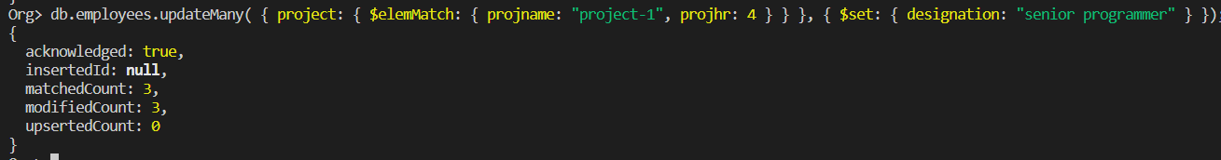

**14. Add list of hobbies in all employees document whose manager is Rajan or Revati**

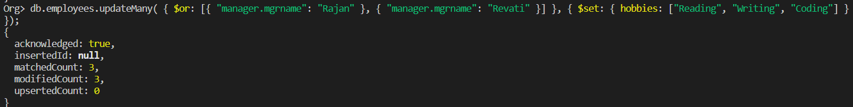

**15. Add list of skillset in all employee documents who are working on project-4 for 3 hrs or on project-3 for 4 hrs**

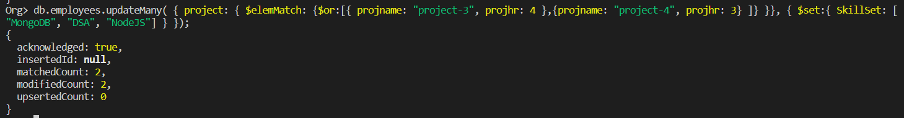

**16. Add a new hobby as blogging at 3 position in hobbies array for all employess whose name starts with R or p and ends with j or s**

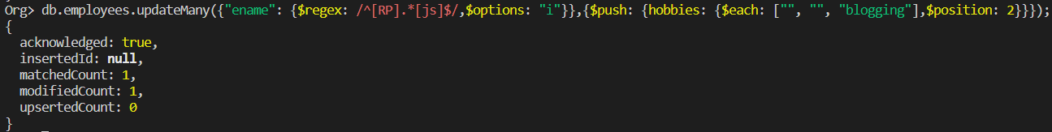

**17. Increase salary by 10000 for all employees who are working on project-2 or project-3 or project-1 Decrease bonus by 1000 rs And increase salary by 1000rs for all employees whose department location is Mumbai**

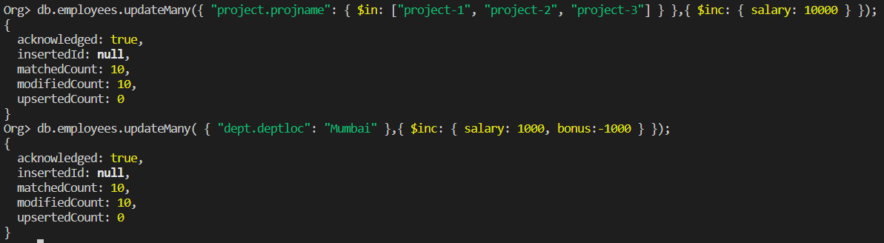

**18. Remove all employees working on project-1**



**19. Replace document of employee with name “Deepak to some new document**

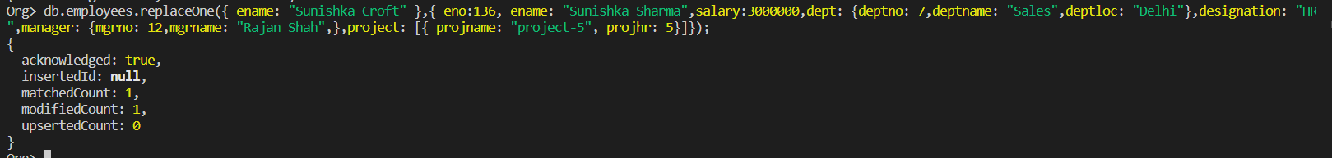

**20. Change skill python to python 3.8 for all employees if python is there in the skillset**

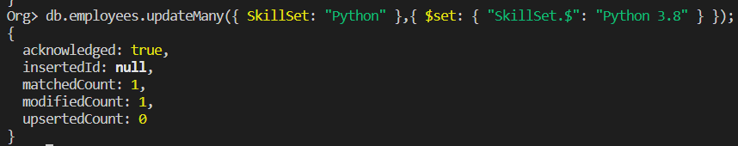

**21. Add 2 skills MongoDb and Perl at the end of skillset array for all employees who are working at Pune location**

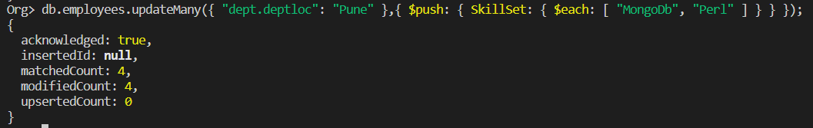

**22. Delete first hobby from hobby array for all employees who are working on project-1 or project-2**

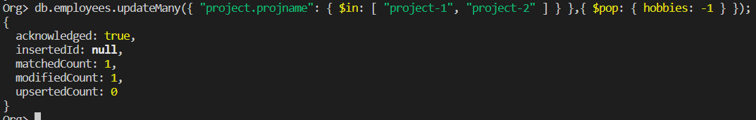

**23. Delete last hobby from hobbies array for all employees who are working on project which is at 2 nd position in projects array for 4 hrs**

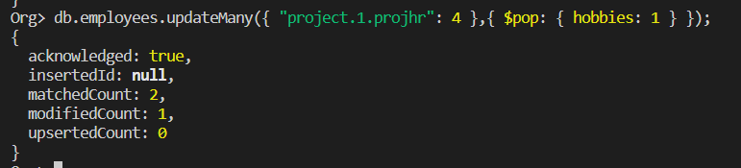

**24. Add 2 new projects at the end of array for all employees whose skillset contains Perl or python**

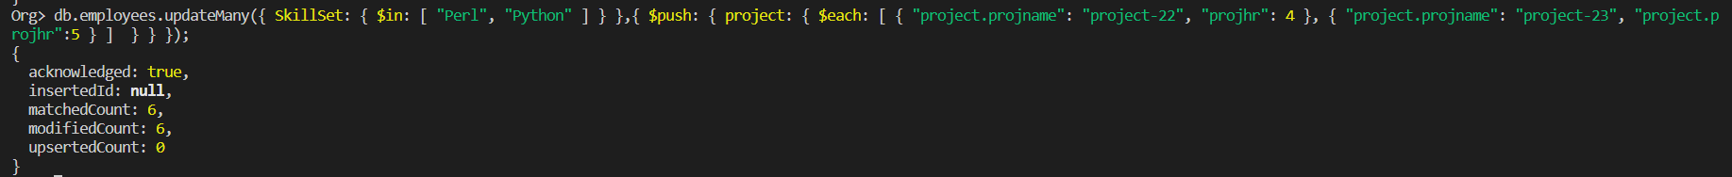

**25. Change hrs to 6 for project-1 for all employees if they working on the project-1 for < 6 hrs. otherwise keep the existing value.**

