Music City
Instawards delivery summary, verification links, and screenshot attachments
Builder
Enoch N. Chirima
Chapter
Southern Africa
Project Repository
github.com/music-city/music-city
Environment
Stellar Testnet

1. Delivered Items
Delivered item | Status
Stellar wallet connection and authentication | Delivered
Artist onboarding, artist profiles, and track management | Delivered
Music upload, media processing, and secure streaming playback | Delivered
Listener music catalog, subscription access, and streaming interface | Delivered
Subscription access control and qualified-stream tracking | Delivered
Royalty splits, royalty ledger, and admin payout controls | Delivered
Soroban royalty-split smart contract deployed to Stellar Testnet | Delivered
Music City publishing and on-chain verification of royalty splits | Delivered
Application and smart-contract test suites | Delivered

2. Verification Links
Technical proof for reviewers who wish to verify the Stellar Testnet deployment and an on-chain royalty-split publication.
Verification item | Address / transaction hash | Link
Source repository | Music City source code | Open repository
Live Music City application | https://music-city.vercel.app/ | Open live application
Deployed Soroban contract | CD2ONBXRTTPKFHNOI2BV3UYUZOOC75R5LPUPCLSRDZHUWM5OAQVACNF3 | Open contract
Music City treasury address | GCW3HD5EBMVNBGOWCPTP3WNYXXT5OYB2UIMKDNSL3IZRGLVMU4OEKFWO | Open account
Contract deployment transaction | c313274db1575c8c018dd2646e4e388e9a2794b0d21f738fbe55fc7e500b75d6 | Open transaction
Screenshot Evidence
Music City live application: https://music-city.vercel.app/
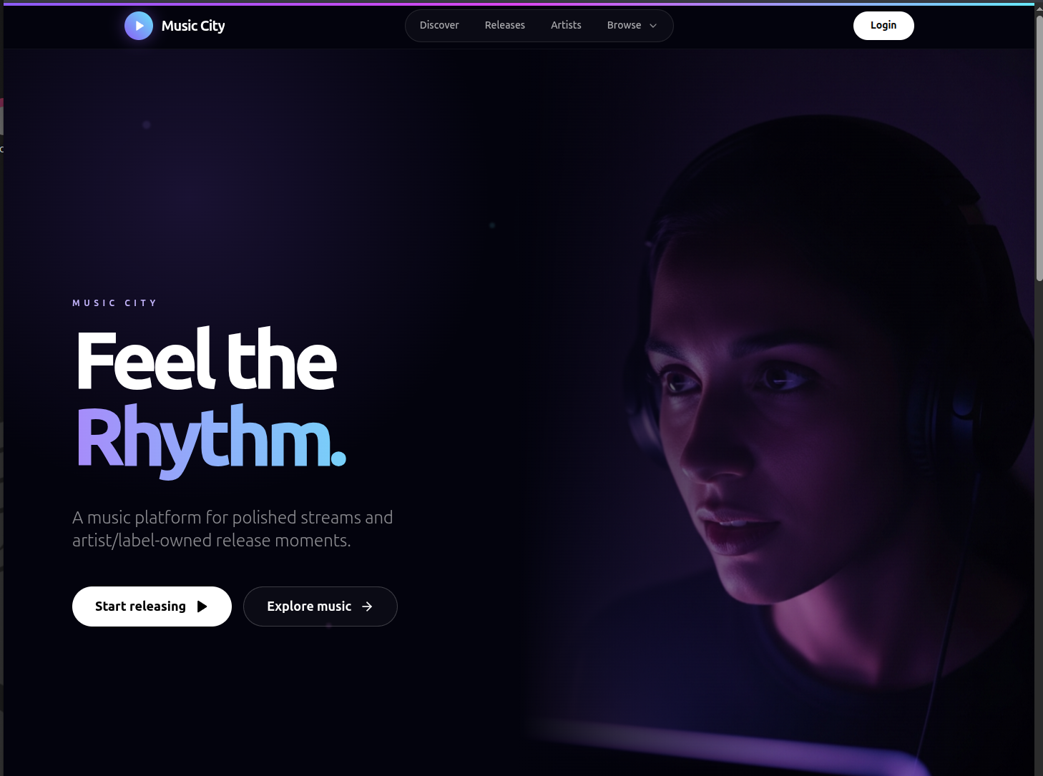
Screenshot 1 — Music City landing page
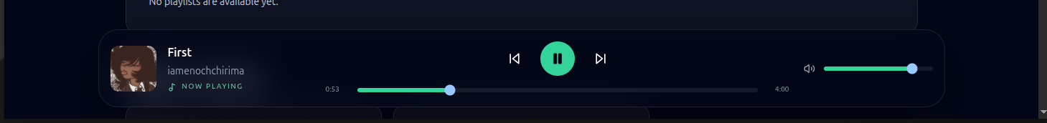
Screenshot 2 — Music playback controls
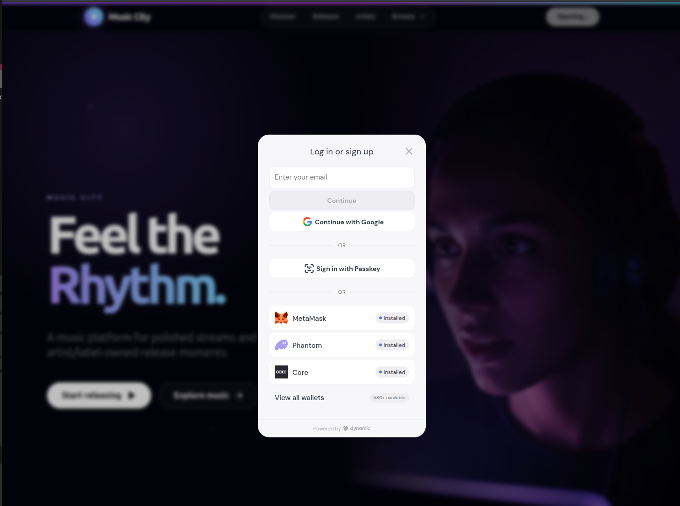
Screenshot 3 — User login and account access
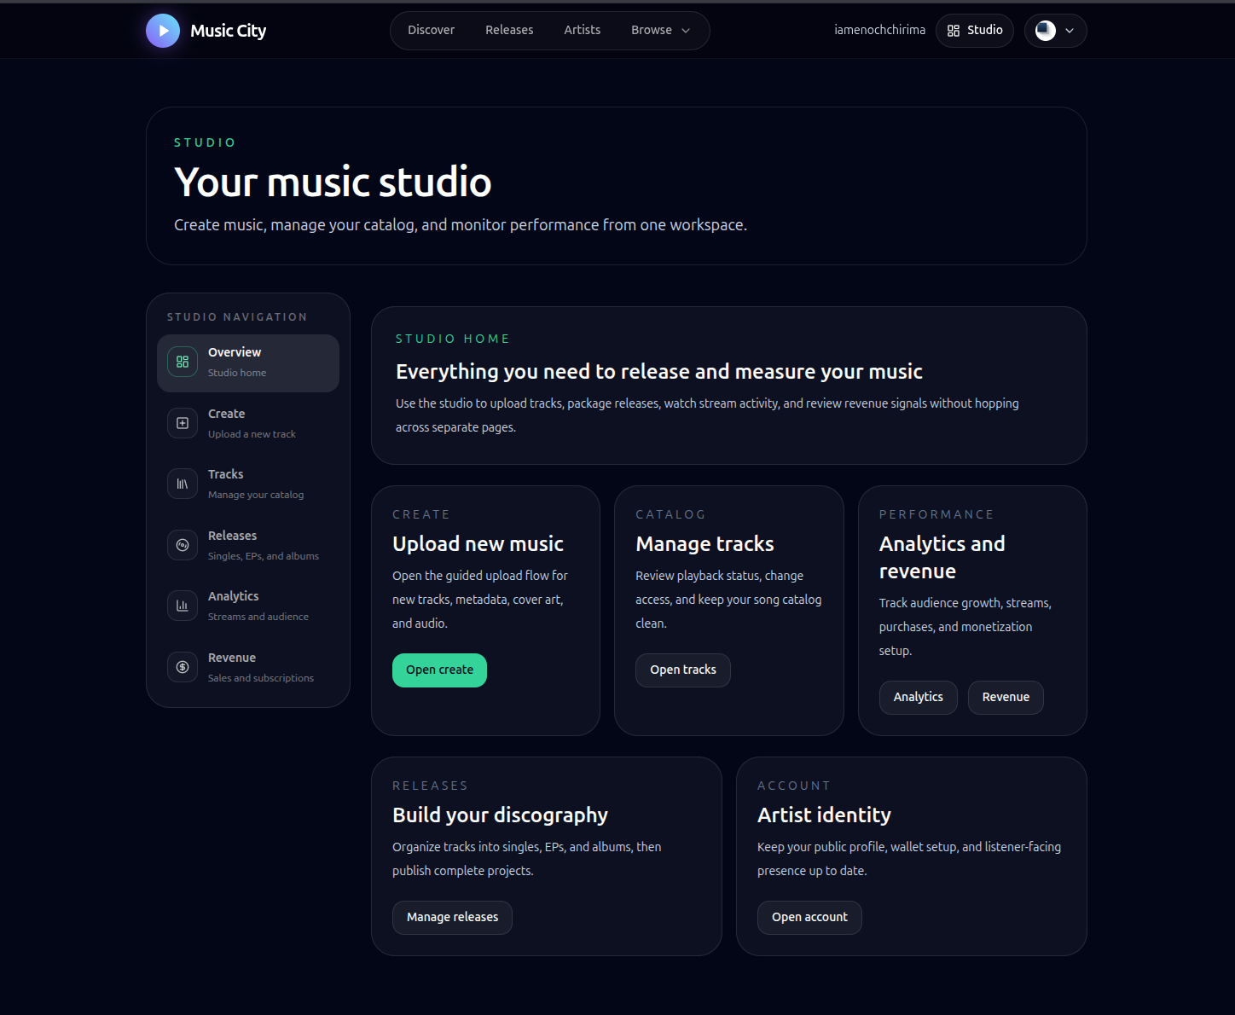
Screenshot 4 — Artist studio dashboard
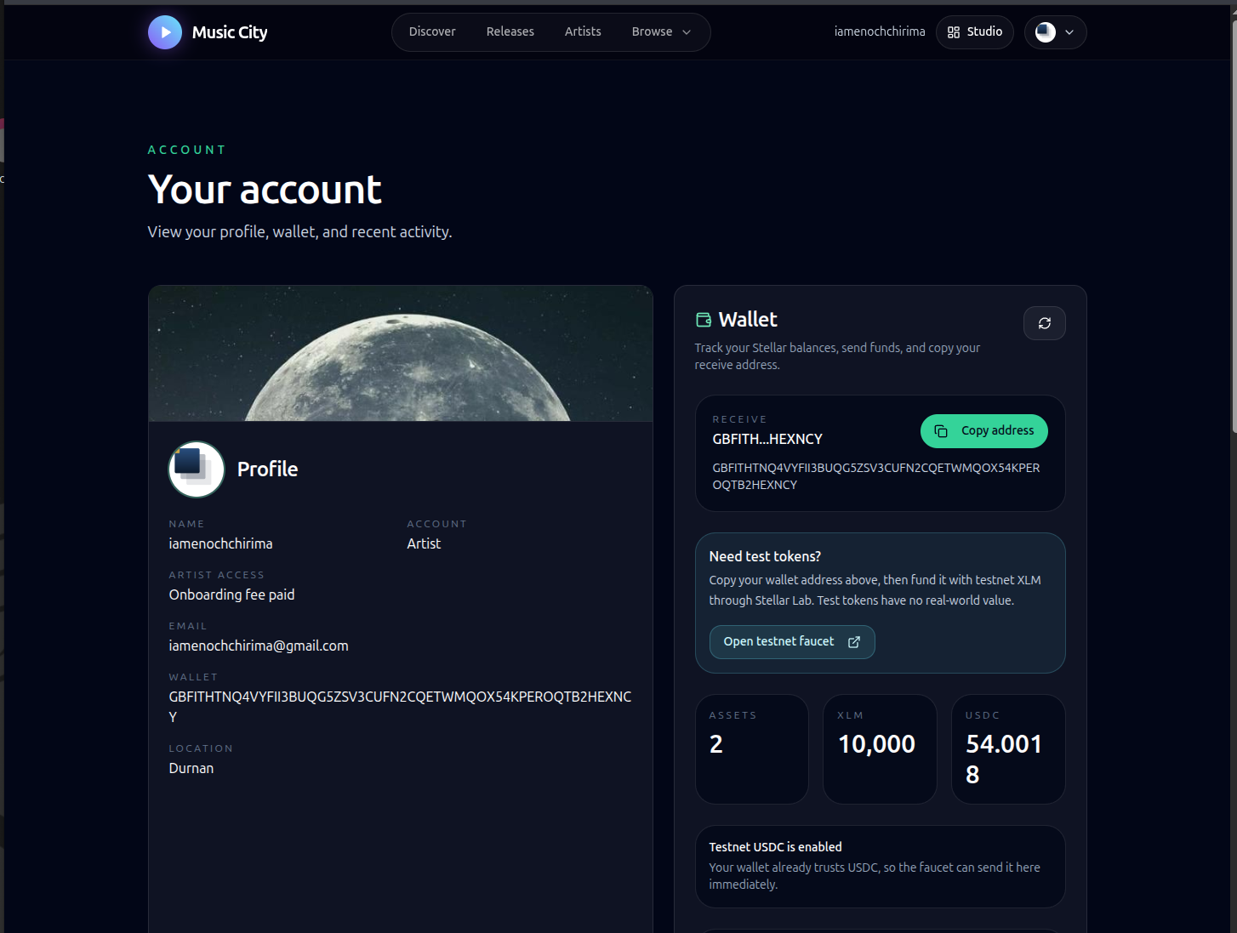
Screenshot 5 — Artist account and Stellar wallet
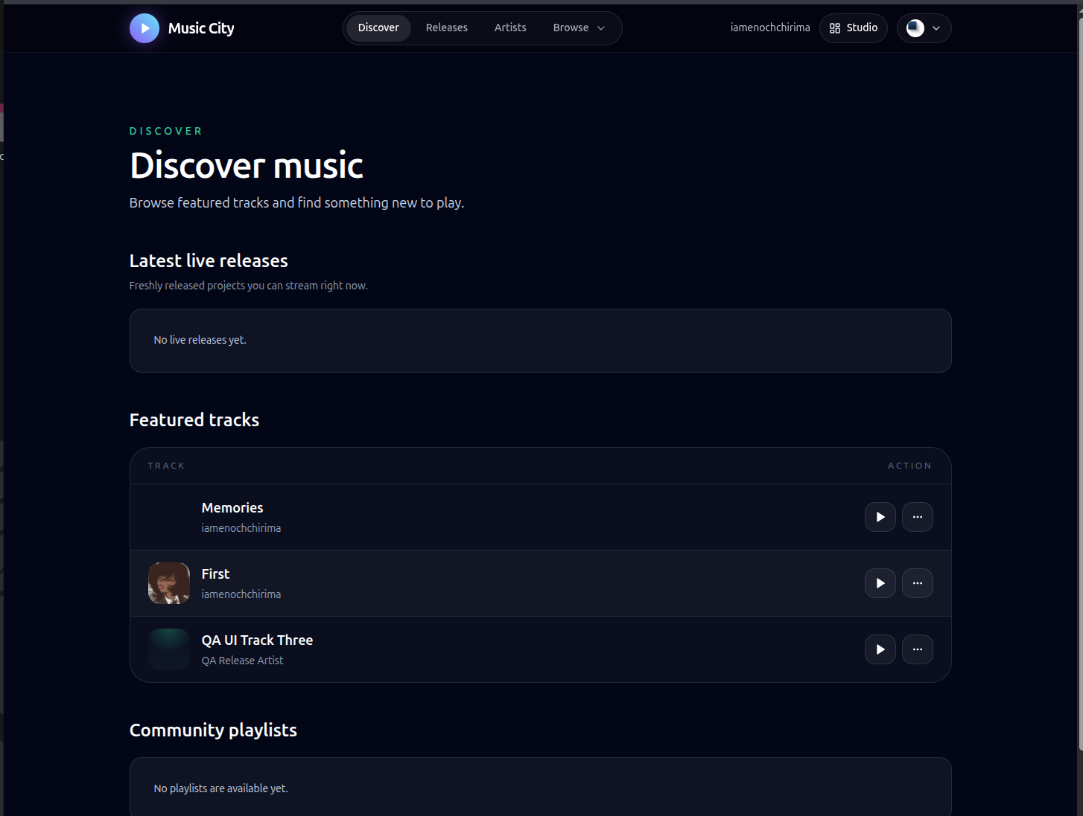
Screenshot 6 — Music discovery and track catalog
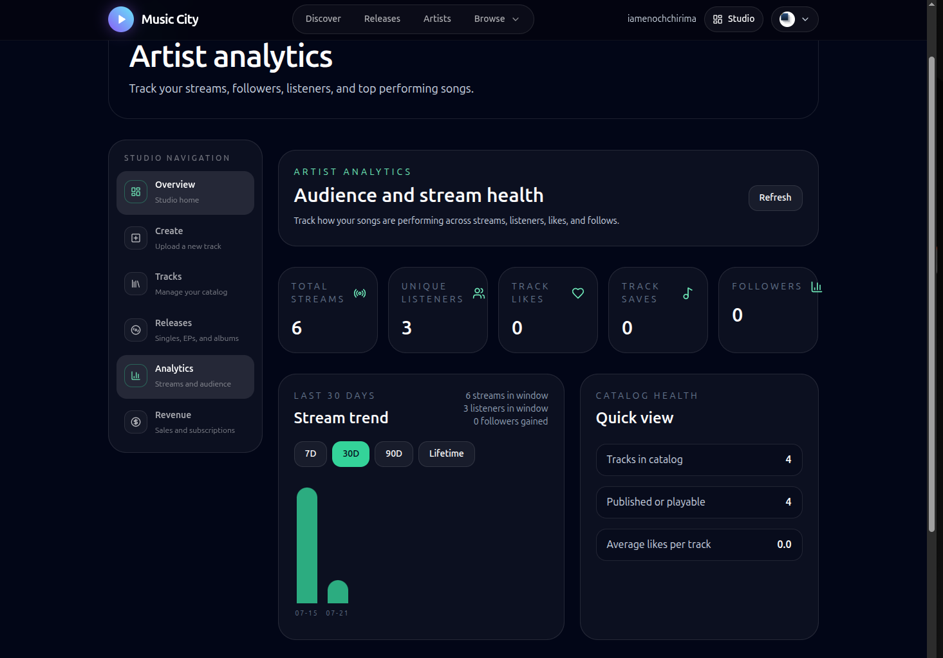
Screenshot 7 — Artist analytics and stream health

