1. **Sale Items:**

- Functionality:

- Items can be sold via listed price or auction.

- Unique identifiers assigned to each item.

- Sellers provide short descriptions and set reserve prices for auctioned items.

- Location specified for each item.

- Clarifications:

- Ensure clarity on the process of listing items for sale, including the auction mechanism and reserve price functionality.

- Extensions:

- Integration of image uploads for item listings to enhance user experience.

2. **Categories:**

- Functionality:

- Items categorized using a hierarchical tree structure.

- Descriptive names for each category node.

- Clarifications:

- Define the process for creating and managing categories, including how items are assigned to categories.

- Extensions:

- Implementation of a dynamic category system allowing for easy addition and modification of categories.

3. **Suppliers:**

- Functionality:

- Database maintains information about all suppliers.

- Information includes company details, contact information, and other relevant data.

- Clarifications:

- Specify the process for adding and updating supplier information.

- Extensions:

- Integration of supplier rating system based on the quality of products and services.

4. **Registered Users:**

- Functionality:

- Users register to sell or bid.

- Detailed user information collected including contact details and payment information.

- Clarifications:

- Define the registration process, including account verification and security measures.

- Extensions:

- Implementation of user authentication methods such as two-factor authentication for enhanced security.

5. **Rating:**

- Functionality:

- Users can rate and comment on other users' behavior to mitigate fraud.

- Clarifications:

- Specify how ratings influence user interactions and decisions within the platform.

- Extensions:

- Development of algorithms to detect and address fraudulent activities based on user ratings.

6. **Browsing and Searching:**

- Functionality:

- Users can browse items by navigating the category tree and search for items using keywords.

- Clarifications:

- Describe the browsing and searching interfaces and their integration with the category system.

- Extensions:

- Implementation of advanced search filters to refine search results based on user preferences.

7. **Sale and Bidding:**

- Functionality:

- Users can purchase items at listed prices or place bids on auctioned items.

- Clarifications:

- Outline the sales and bidding processes, including payment handling and transaction management.

- Extensions:

- Integration of real-time bidding system with bid notifications for users.

8. **Order and Sale Reports:**

- Functionality:

- Periodic reports generated summarizing ordering and sales information based on item categories.

- Clarifications:

- Define the frequency and format of generated reports and their accessibility to users.

- Extensions:

- Customization options for users to generate personalized reports based on specific criteria.

9. **Delivery:**

- Functionality:

- Mechanism ensuring successful payments for sellers and product receipt for buyers.

- Clarifications:

- Specify the logistics and tracking system for item delivery and receipt confirmation.

- Extensions:

- Integration of third-party shipping services for streamlined delivery management.

10. **Extensions:**

- Development of additional features beyond the basic requirements to enhance user experience and platform functionality.

- Examples include:

- Social media integration for user engagement.

- Customer support chatbot for instant assistance.

- Loyalty program for incentivizing user activity.

Example Product: Smartwatch

Attributes:

Product ID

Product Name

Description

Price

Supplier ID (Foreign Key)

Category ID (Foreign Key)

Image URL

* **Product Entity:**
  + Represents individual products available for sale.
  + Attributes include ProductID, Name, Description, Price, ImageURL, and Category and Supplier IDs, Rating, WishList.
* **Category Entity:**
  + Represents product categories.
  + Attributes include CategoryID and Name, All Projects.
* **Supplier Entity:**
  + Represents suppliers providing products.
  + Attributes include SupplierID, Name, Address, License&Recommendation, Phone Number, Email, and Rating.
* **Relationships:**
  + Each Product belongs to one Category and one Supplier, so the one-to-many relationships.
  + Each Category can have multiple Products.
  + Each Supplier can supply multiple Products.

**Example Instance:**

Let's say we have a Smartwatch product:

* **ProductID:** 001
* **Name:** Apple Watch 7
* **Description:** Advanced smartwatch with health monitoring features.
* **Price:** $199.99
* **ImageURL:** example.com/images/smartwatch.jpg
* **SupplierID:** 001 (Supplier ABC)
* **CategoryID:** 001 (Wearable Technologies)
* **Rating:** 4.5/5
* **WishList**
* **Characteristics**

Phase2:

Customer_id(PK)=>name, last name, phoneNumber, purchase_id(FK), cardNumber, address

purchase_id => wishlist, Product_id

Product_id=>about_id(FK),category_id(FK),delivery_id(FK)

about_id=>name,image_url,certificate, Price, description, characteristics, Rating

delivery_id => delivery address, postcase

box_id=>product_id,delivery_id

category_id=>...

Supplier_id=>name, last name, contacts, selle_id(FK)

Seller_id=>product_id(FK), address, cardNumber, guaranty, box_id(FK)

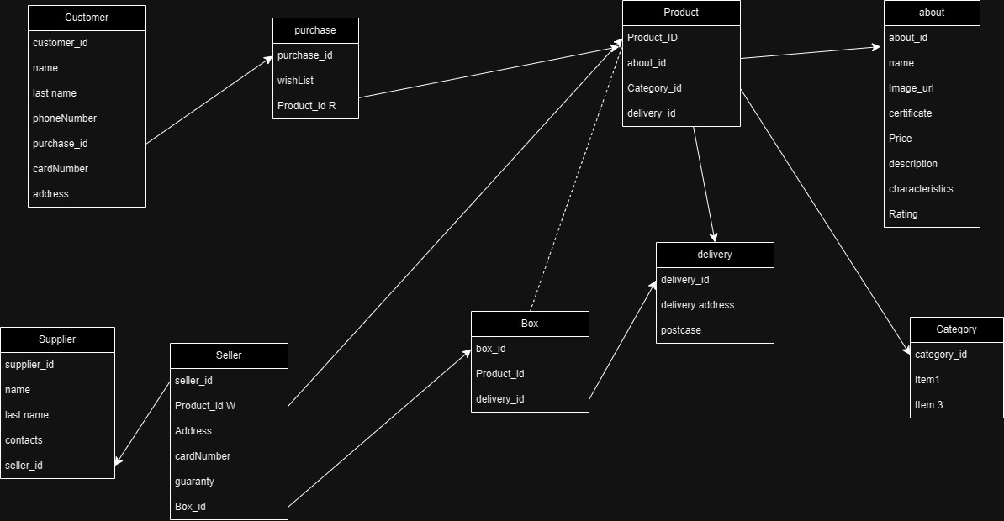

Phase3:

Customer_id(PK)=>name, last name, phoneNumber, purchase_id(FK), cardNumber, address

|  |  |  |  |
| --- | --- | --- | --- |
| Attribute’s name | Attribute’s content | Type, length | Additional |
| Customer_id |  |  | PK |
| name |  |  |  |
| Lname |  |  |  |
| Number |  |  |  |
| Purchase_id |  |  |  |
| cardNumber |  |  |  |
| address |  |  |  |

|  |  |  |  |  |  |
| --- | --- | --- | --- | --- | --- |
| Customer_id | name | Lname | Number | address | cardNum |
|  |  |  |  |  |  |

|  |  |
| --- | --- |
| Customer_id | Purchase_id |

|  |  |
| --- | --- |
| Purchase_id | wishlist |

|  |  |
| --- | --- |
| Purchase_id | Product_id |

**Shop Management System Report**

**Table of Contents:**

**Introduction**

**Abstract**

**Objectives**

**Format Guidelines**

**2.1. Section Headings**

**2.2. Figures and Tables**

**2.3. Appendices**

**Shop Overview**

**Customer Management**

**Product Management**

**Supplier and Seller Management**

**Purchase Tracking**

**Conclusion**

1. Introduction

Abstract:

This entry presents information on the design and implementation of a store management system. The device focuses on streamlining many aspects of store operations, which include buyer management, product inventory, provider family members, and purchase tracking. Using an entity relationship (ER) diagram as a foundation, the file outlines the structure and functionality of the gadget.

Objectives:

The primary goal of a store management system is to increase operational performance, improve customer experience, and optimize inventory management. With a robust database shape and user-friendly interface, the engine aims to facilitate a smooth interplay between customers, providers and store managers.

2. Formatting Guidelines

The record adheres to the specified layout suggestions, ensuring readability and coherence of the presentation. Contains appropriate section headings, figures, tables and appendices in accordance with the supplied layout guidelines.

Three. Shop overview

Shop Management System includes various ingredients necessary for running shops. It consists of modules for working with customers, goods, providers and sellers. Each module is intricately linked to provide a comprehensive business management solution.

4. Customer management

The machine enables efficient checking of client records, including private information that includes name, cell phone range, and settlement. Each reader is assigned a completely unique identifier (Customer_id) for easy identification and tracking. Additionally, the device tracks customer purchases via purchase_id, enabling personalized service and focused advertising and marketing campaigns.

5. Product management

Product management is a critical issue in store operations, and the system provides powerful features for cataloging and organizing merchandise. Product records along with name, description, fee and image URL are stored in the database. In addition, products are classified primarily based on category_id, with smooth navigation and search in mind.

6. Management of suppliers and vendors

Effective vendor and vendor control is critical to maintaining a constant supply of goods. The device stores provider statistics that include call, touch and vendor ID details, facilitating seamless communication and collaboration. Similarly, merchant information including store, card quantity and warranty is retained for transactional purposes.

7. Tracking your purchase

Purchase tracking is made easy with purchase id and wishlist integration. Customers can add items to their wishlist and after purchase, the gadget will generate a unique purchase_id for reference. In addition, shipping information including shipping address and PO Box is recorded for green order fulfillment.

8. Conclusion

Shop Management System offers a complete solution to deal with various aspects of storage operations. Utilizing a properly defined database structure and an intuitive user interface, the machine aims to increase productivity, streamline approaches, and increase the pride of the common buyer. Additionally, future upgrades may include integration with online pricing gateways and advanced analytics for predictive inventory management.