1. 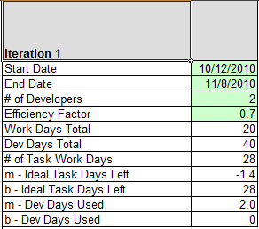**Efficiency Factor** 
   1. **Default : 0.7 or 70%**
2. **Work Days Total**
   1. **Default : 1 month = 20 days**
3. **Dev Days Total**
   1. **Work Days Total * # of Developers**
4. **# of Task Work Days**
   1. **Round (Efficiency Factor * Dev Days Total)**
5. **M-Ideal Task Days Left** 
   1. **(-1 * # of Task Work Days) / Work Days Total**
6. **B-Ideal Task Days Left**
   1. **# of Task Work Days**
7. **M-Dev Days Used**
   1. **Dev Days Total / Work Days Total**