CIS 2275 C++ Programming Part II NAME:

Program 9 Enigma Base Class Windows Form 100 pts Due: Thursday, April 14 by 11:59pm

Turn In Requirements:
- 5 pts Name your Visual C++ 2015 project LastnameP9, such as NelsonP9.
- 5 pts Upload your project to Visual Studio Online.
- 5 pts If you upload to Blackboard, print out the *.h and *.cpp files, staple this page to the front of your printed source code when you turn it in for grading.
- 5 pts If you upload to Blackboard, remove BOTH debug folders and the .sdf file from your project before uploading it to Blackboard.

Program Requirements:
- 3 pts Write your name, email address and file name at the top of your source code in a comment.
- 5 pts Your main function should have cout statements that write “header” information to the screen. The header info includes your name, course and program information, as well as a 1-2 line description of the program.
- 5 pts. Use good C++ programming style and formatting for your program. Use appropriate comments to explain what you are doing.

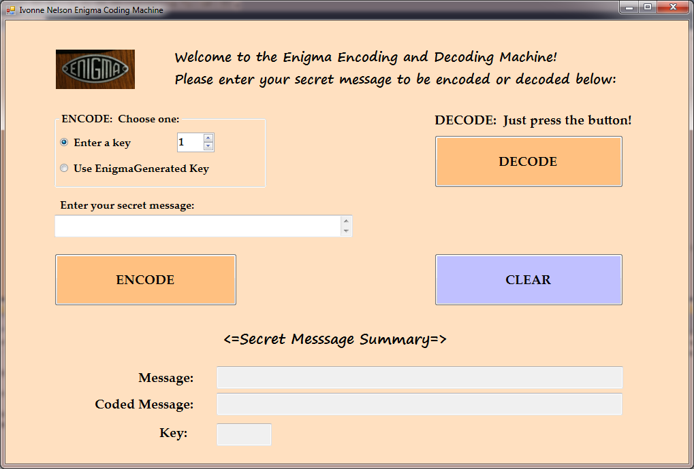

Open a C++ CLR project and choose a Windows Form Application. For the form, you will need:

- A label/textbox with an introduction to Enigma and any instructions about choosing encode/decode process
- A way to choose whether to enter the key or have Enigma randomly generate the key. I used a Group Box, two radio buttons and a numerical up/down. You may also choose to use text boxes and labels to indicate the choice, or check boxes, or even a combo box or… Take your pick.
- A text box (with label) where the user will enter the message to encode.
- A label/ instructions of how to decode
- Three buttons – one for ENCODE, one for DECODE, and one for CLEAR, so the user can code/decode another message
- Some way to report the results. Perhaps a multi-line, read-only text box, or three textboxes for Message, Coded Message, and Key. Whatever you provide, it must report those three values.
- Drag a SaveFileDialog and an OpenFileDialog control onto the form. You will see them in a strip below your form. Both dialogs are located in the Toolbox under Dialogs. We will talk about how to implement them.

Create event handlers for the three buttons, and put your interface code in there. Don’t forget your Utility Functions.h file for doing string conversions. We do need to pass strings for this program.

Right after #pragma once, at the top of your form1.h file, the one with the form1 class and all of the great code that VS writes for you, add #include “Enigma.h” and #include “UtilityFunction.h” just as you did for the calculator. Instantiate your Enigma class just above the beginning of the form class, ie, before public ref class MyForm. You will also need to add another namespace so that you can use the file dialogs. After using namespace System::Drawing; add using namespace System::IO;

We will go over the code for the event handlers in the lab and the file dialog boxes during lab time and I will put a copy of the pertinent parts of my form1.h on Blackboard.

Now to the coding requirements:
We are going to write a class that encodes and decodes strings of text. In the program, the user enters a string that is passed into the Enigma object, which encodes. The encoded message is obtained from the Enigma object and saved in a file. In order to decode the message, the string is read from a file, passed to the Enigma and the decoded message is obtained.

The algorithm that we’ll use for this class is straightforward. The user enters a string (in main) and it is passed into the Enigma object to be encoded. The Enigma class uses a “key” to encode the message. The key is an integer value between (and including) 1-50. To encode the message string, each character of the message is converted to its associated ASCII numeric value and the key value is added to it. The new number is then converted back to a character. To decode the message, each letter is converted to an int, the key subtracted from it, and the new value converted to a char.

Refer to an ASCII Character Code set (page 555 in text) to see a complete set of decimal/character values.

Example 1: In this example, all ASCII values remain in the 32-126 range after the key has been added.

Message: COMBO IS 7-43-19
Each character C O M B O sp I S sp 7 - 4 3 - 1 9
ASCII values 67 79 77 66 79 32 73 83 32 55 45 52 51 45 49 57
Key = 10, add 77 89 87 76 89 42 83 93 42 65 55 62 61 55 59 67
Encoded message: M Y W L Y * S ] * A 7 > = 7 ; C

Note: The ASCII Character set for the characters on a computer keyboard range from 32 (space) to 126 (~). For our Enigma, you will have to be sure that your coded message characters are all within 32-126. When the key is added to the character, if the value is larger than 126, you will need to figure out a way to have your values “wrap” around in the following manner. The value 127 => 32, 128 => 33, 129 => 34, etc.

Example 2: In this example, some of the new values are above the 126 range after the key has been added to the character. The values must “wrap” to within the valid range (32-126).

Message: See me at 7pm.
Each character S e e sp m e sp a t sp 7 p m .
ASCII values 83 101 101 32 109 101 32 97 116 32 55 112 109 46
Key = 20, add 103 121 121 52 129 121 52 117 136 52 75 132 129 66
Wrapped value 34 41 37 34
Encoded message: g y y 4 “ y 4 u ) 4 K % “ B

Write a class named Enigma that performs the encoding and decoding tasks as described above. YOU MUST FOLLOW THIS CLASS DESIGN. DO NOT DESIGN YOUR OWN CLASS!

The Enigma class has an int for the key, two strings—one for the message and one for the coded message. Do not have additional strings!

There are two private functions: Encode() and Decode(). The Encode() does the actual key-shift addition and builds the codedMessage string. The Decode() does the key-shift subtraction and builds the message string.

The public functions include two versions of the setMessage, as well as gets:
- SetMessage, is passed a string that contains the message to be encoded. When this function is called, the Enigma class generates its own key using the random number generator. The key must be between and including 1-50. Calls Encode().
- SetMessage,(overloaded) is passed a string that contains the message to be encoded AND an integer value for the key. This function first checks that the key is valid (1-50). If the input value is not valid, the function assigns the key value to 1. Calls Encode().
- SetCodedMessage, is passed the message to be decoded, as well as the integer key value that was used to code the original message. Calls Decode();
- GetCodedMessage, returns the coded message
- GetDecodedMessage, returns the decoded message ( alias the message).
- GetKey, returns the current key value.

Your form will serve as the interface to the Enigma coder/decoder.
- If the user chooses encode, the user will enter the message to be encoded, and choose whether to enter the key or have Enigma choose it. Then the encode button is pressed and the results will be reported on the form. The Encode button will also open a “SaveFileDialog” window for the user to choose a text file into which to write the encoded message. The appropriate SetMessage method will be called. The form will access SetCodedMessage, GetDecodedMessage, GetKey methods of the Enigma class.to report to the user and write in the file.

- If the user chooses decode, the decode button is pressed, a “OpenfileDialog” window opens, the uses chooses the text file to be read, and the decoding happens “behind the scenes”, and the results are reported on the form using GetCodedMessage, GetDecodedMessage, GetKey methods of the Enigma class.

- In both cases, the file dialog will be checked and if the file is not opened, a message will be presented to the user reporting that fact.

