ERCOT Nodal Operating Guides
Section 8
Attachment J
Initial and Sustained Measurements for Primary Frequency Response
December 1, 2024

Initial Primary Frequency Response Performance Calculation Methodology

This section establishes the process used to calculate initial Primary Frequency Response (PFR) performance for each Frequency Measurable Event (FME) for Generation Resources, Energy Storage Resources (ESRs), Settlement Only Transmission Generators (SOTGs), Settlement Only Transmission Self-Generators (SOTSGs), and Controllable Load Resources.

This process calculates the initial Per Unit PFR of a Resource (P.U.PFR_{Resource}) as a ratio between the Adjusted Actual PFR (APFR_{Adj}), adjusted for the pre-event ramping of the unit, and the Final Expected PFR (EPFR_{final}) as calculated using the Pre-perturbation and Post-perturbation time periods of the initial measure.
This comparison of actual performance to a calculated target value establishes, for each type of Resource, the initial P.U.PFR_{Resource} for any FME.
Initial Primary Frequency Response Measurement

P.U.PFR_{Resource} is the per unit measure of the initial PFR of a Resource during identified FMEs.

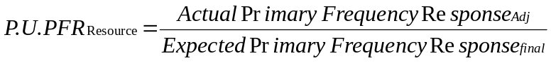

Where P.U.PFR_{Resource} for each FME is limited to values between 0.0 and 2.0.
The Adjusted Actual PFR (APFRAdj) and the Final Expected PFR (EPFRfinal) are calculated as described below.
EPFR calculations use Governor droop and Governor Dead-Band values as stated in Section 2.2.7, Turbine Speed Governors, with the exception of combined-cycle facilities while being evaluated as a single resource (MW production of both the combustion turbine generator and the steam turbine generator are included in the evaluation) where the evaluation Governor droop will be 5.78%
Actual Primary Frequency Response (APFR_{adj})
The Adjusted Actual Primary Frequency Response (APFRadj) is the difference between Post-perturbation Average MW and Pre-perturbation Average MW, including the ramp magnitude adjustment.

where:
Pre‐perturbation Average MW: Actual MW averaged from T‐16 to T‐2

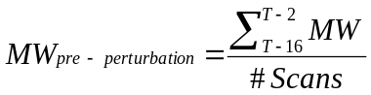

Post‐perturbation Average MW: Actual MW averaged from T+20 to T+52

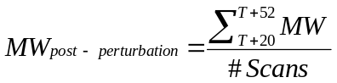

Ramp Adjustment: The Actual PFR number that is used to calculate P.U.PFRResource is adjusted for the ramp magnitude of the generating unit/generating facility during the pre‐perturbation minute. The ramp magnitude is subtracted from the APFR.
Ramp Magnitude = (MWT‐4 – MWT‐60)*0.59
(MWT‐4 – MWT‐60) represents unit’s MW ramp for a full minute prior to the FME. The factor 0.59 adjusts this full minute ramp to represent the ramp that should have been achieved during the post‐perturbation measurement period.

Expected Primary Frequency Response (EPFR)
For all Generation Resources, ESRs, SOTGs, SOTSGs, and Controllable Load Resources, the ideal Expected PFR (EPFR_{ideal}) is calculated as the difference between the EPFR_{post‐perturbation} and the EPFR_{pre‐perturbation}.

When the frequency is outside the Governor Dead-Band and above 60Hz:
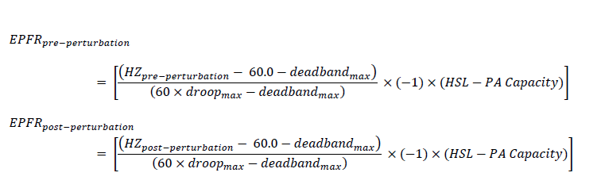

When the frequency is outside the Governor Dead-Band and below 60Hz:
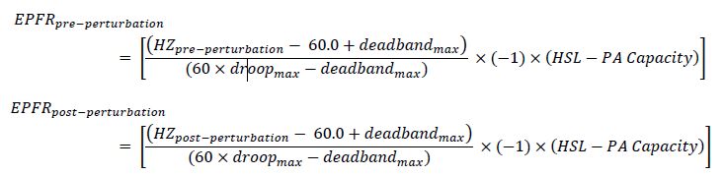

For each formula, when frequency is within the Governor Dead-Band the appropriate EPFR value is zero. The deadbandmax and droopmax quantities come from Section 2.2.7, Turbine Speed Governors.
Where:

Pre‐perturbation Average Hz: Actual Hz averaged from T‐16 to T‐2

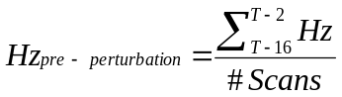

Post‐perturbation Average Hz: Actual Hz averaged from T+20 to T+52

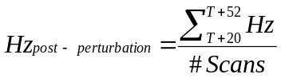

Power Augmentation: For combined cycle facilities, Real-Time telemetered High Sustained Limit (HSL) is adjusted by subtracting the Real-Time telemetered Non-Frequency Responsive Capacity (power augmentation (PA) capacity). Other generator types may also have power augmentation that is not frequency responsive. This could be “over‐pressure” operation of a steam turbine at valves wide open or operating with a secondary fuel in service. The Resource Entity should provide ERCOT with documentation and conditions when power augmentation is to be considered in PFR calculations as described in paragraph (11) of Protocol Section 6.5.5.2, Operational Data Requirements.
EPFR_{final} for Combustion Turbines and Combined Cycle Facilities
Note: The 0.00276 constant is the MW/0.1 Hz change per MW of capacity and represents the MW change in combustion turbine’s output due to the change in mass flow through the combustion turbine due to the speed change of the turbine during the post‐perturbation measurement period. This factor is based on empirical data from a major 2003 event as measured on multiple combustion turbines in ERCOT.
EPFR_{final} for Steam Turbine
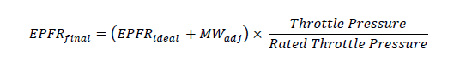
where:
where:
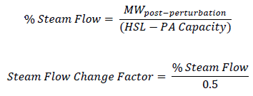
Throttle Pressure = Interpolation of Pressure curve at MWpre‐perturbation
The rated throttle pressure and the pressure curve, based on generator MW output, are submitted to ERCOT. This pressure curve is defined by up to six pair of pressure and MW breakpoints with the throttle pressure/MW output pair where rated throttle pressure is achieved as the first set and the throttle pressure/MW output pair where the minimum throttle pressure is achieved, as the last set of breakpoints. If fewer breakpoints are needed, the pair values will be repeated for different MW outputs (i.e., MW cannot be repeated on throttle pressure) to complete the six pair table.
The K factor is used to model the stored energy available to the Resource. The value ranges between 0.0 and 0.6 psig per MW change when responding during an FME. The Resource Entity can measure the drop in throttle pressure when the Resource is operating near 50% output of the steam turbine during an FME and provide this ratio of pressure change to ERCOT. K is then adjusted based on rated throttle pressure and Resource capacity. An additional sensitivity factor, the steam flow change factor, is based on resource loading (% steam flow) and further modifies the MW adjustment. This sensitivity factor will decrease the adjustment at Resource outputs below 50% and increase the adjustment at outputs above 50%. The Resource Entity should determine the fixed K factor for each Resource that generally results in the best match between EPFR and APFR (resulting in the highest P.U.PFRResource). For any generating unit, K will not change unless the steam generator is significantly reconfigured.
EPFR_{final} for Other Generating Units/Generating Facilities and Energy Storage Resources
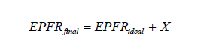

Where X is an adjustment factor that may be applied to properly model the delivery of PFR. The X factor will be based on known and accepted technical or physical limitations of the Resource. X may be adjusted by ERCOT and may be variable across the operating range of a resource. X shall be zero unless ERCOT accepts an alternative value.
[NOGRR263: Replace Initial Primary Frequency Response Performance Calculation Methodology above with the following upon system implementation of NPRR1244:]

Initial Primary Frequency Response Performance Calculation Methodology

This section establishes the process used to calculate initial Primary Frequency Response (PFR) performance for each Frequency Measurable Event (FME) for Generation Resources, Energy Storage Resources (ESRs), Settlement Only Transmission Generators (SOTGs), Settlement Only Transmission Self-Generators (SOTSGs), and Controllable Load Resources that are subject to this evaluation.

This process calculates the initial Per Unit PFR of a Resource (P.U.PFR_{Resource}) as a ratio between the Adjusted Actual PFR (APFR_{Adj}), adjusted for the pre-event ramping of the unit, and the Final Expected PFR (EPFR_{final}) as calculated using the Pre-perturbation and Post-perturbation time periods of the initial measure.
This comparison of actual performance to a calculated target value establishes, for each type of Resource, the initial P.U.PFR_{Resource} for any FME.
Initial Primary Frequency Response Measurement

P.U.PFR_{Resource} is the per unit measure of the initial PFR of a Resource during identified FMEs.

Where P.U.PFR_{Resource} for each FME is limited to values between 0.0 and 2.0.
The Adjusted Actual PFR (APFRAdj) and the Final Expected PFR (EPFRfinal) are calculated as described below.
EPFR calculations use Governor droop and Governor Dead-Band values as stated in Section 2.2.7, Turbine Speed Governors, with the exception of combined-cycle facilities while being evaluated as a single resource (MW production of both the combustion turbine generator and the steam turbine generator are included in the evaluation) where the evaluation Governor droop will be 5.78%
Actual Primary Frequency Response (APFR_{adj})
The Adjusted Actual Primary Frequency Response (APFRadj) is the difference between Post-perturbation Average MW and Pre-perturbation Average MW, including the ramp magnitude adjustment.

where:
Pre‐perturbation Average MW: Actual MW averaged from T‐16 to T‐2

Post‐perturbation Average MW: Actual MW averaged from T+20 to T+52

Ramp Adjustment: The Actual PFR number that is used to calculate P.U.PFRResource is adjusted for the ramp magnitude of the generating unit/generating facility during the pre‐perturbation minute. The ramp magnitude is subtracted from the APFR.
Ramp Magnitude = (MWT‐4 – MWT‐60)*0.59
(MWT‐4 – MWT‐60) represents unit’s MW ramp for a full minute prior to the FME. The factor 0.59 adjusts this full minute ramp to represent the ramp that should have been achieved during the post‐perturbation measurement period.

Expected Primary Frequency Response (EPFR)
For all Generation Resources, ESRs, SOTGs, SOTSGs, and Controllable Load Resources, the ideal Expected PFR (EPFR_{ideal}) is calculated as the difference between the EPFR_{post‐perturbation} and the EPFR_{pre‐perturbation}.

When the frequency is outside the Governor Dead-Band and above 60Hz:

When the frequency is outside the Governor Dead-Band and below 60Hz:

For each formula, when frequency is within the Governor Dead-Band the appropriate EPFR value is zero. The deadbandmax and droopmax quantities come from Section 2.2.7, Turbine Speed Governors.
Where:

Pre‐perturbation Average Hz: Actual Hz averaged from T‐16 to T‐2

Post‐perturbation Average Hz: Actual Hz averaged from T+20 to T+52

Power Augmentation: For combined cycle facilities, Real-Time telemetered High Sustained Limit (HSL) is adjusted by subtracting the Real-Time telemetered Non-Frequency Responsive Capacity (power augmentation (PA) capacity). Other generator types may also have power augmentation that is not frequency responsive. This could be “over‐pressure” operation of a steam turbine at valves wide open or operating with a secondary fuel in service. The Resource Entity should provide ERCOT with documentation and conditions when power augmentation is to be considered in PFR calculations as described in paragraph (11) of Protocol Section 6.5.5.2, Operational Data Requirements.
EPFR_{final} for Combustion Turbines and Combined Cycle Facilities
Note: The 0.00276 constant is the MW/0.1 Hz change per MW of capacity and represents the MW change in combustion turbine’s output due to the change in mass flow through the combustion turbine due to the speed change of the turbine during the post‐perturbation measurement period. This factor is based on empirical data from a major 2003 event as measured on multiple combustion turbines in ERCOT.
EPFR_{final} for Steam Turbine
where:
where:
Throttle Pressure = Interpolation of Pressure curve at MWpre‐perturbation
The rated throttle pressure and the pressure curve, based on generator MW output, are submitted to ERCOT. This pressure curve is defined by up to six pair of pressure and MW breakpoints with the throttle pressure/MW output pair where rated throttle pressure is achieved as the first set and the throttle pressure/MW output pair where the minimum throttle pressure is achieved, as the last set of breakpoints. If fewer breakpoints are needed, the pair values will be repeated for different MW outputs (i.e., MW cannot be repeated on throttle pressure) to complete the six pair table.
The K factor is used to model the stored energy available to the Resource. The value ranges between 0.0 and 0.6 psig per MW change when responding during an FME. The Resource Entity can measure the drop in throttle pressure when the Resource is operating near 50% output of the steam turbine during an FME and provide this ratio of pressure change to ERCOT. K is then adjusted based on rated throttle pressure and Resource capacity. An additional sensitivity factor, the steam flow change factor, is based on resource loading (% steam flow) and further modifies the MW adjustment. This sensitivity factor will decrease the adjustment at Resource outputs below 50% and increase the adjustment at outputs above 50%. The Resource Entity should determine the fixed K factor for each Resource that generally results in the best match between EPFR and APFR (resulting in the highest P.U.PFRResource). For any generating unit, K will not change unless the steam generator is significantly reconfigured.
EPFR_{final} for Other Generating Units/Generating Facilities and Energy Storage Resources

Where X is an adjustment factor that may be applied to properly model the delivery of PFR. The X factor will be based on known and accepted technical or physical limitations of the Resource. X may be adjusted by ERCOT and may be variable across the operating range of a resource. X shall be zero unless ERCOT accepts an alternative value.

SUSTAINED Primary Frequency Response Performance Calculation Methodology

This section establishes the process used to calculate sustained Primary Frequency Response (PFR) performance for each Frequency Measurable Event (FME).

This process calculates the Per Unit Sustained PFR of a Resource (P.U.SPFRResource) as a ratio between the maximum actual unit response at any time during the period from T+46 to T+60, adjusted for the pre‐event ramping of the unit, and the Final Expected Primary Frequency Response (EPFR) value at time T+46.

This comparison of actual performance to a calculated target value establishes, for each type of Resource, the P.U.SPFRResource for any FME.

Sustained Primary Frequency Response performance measurement:

Sustained Primary Frequency Response Calculation (P.U.SPFR)

P.U.SPFRResource is the per unit (P.U.) measure of the sustained PFR of a Resource during identified FME. The P.U.SPFRResource for each FME will be limited to values between 0.0 and 2.0.

Actual Sustained Primary Frequency Response (ASPFR) Calculations
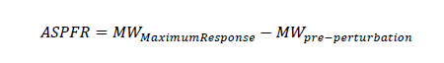
where:
Pre‐perturbation Average MW: Actual MW averaged from T‐16 to T‐2.

and:

MWMaximumResponse = maximum MW value telemetered by a unit from T+46 through T+60 during low frequency FMEs and the minimum MW value telemetered by a unit from T+46 through T+60 during a high frequency FME.

Actual Sustained Primary Frequency Response, Adjusted (ASPFRAdj)

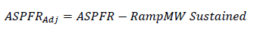

RampMW Sustained (MW) – Generation Resources, Energy Storage Resources (ESRs), Settlement Only Transmission Generators (SOTGs), Settlement Only Transmission Generators (SOTSGs), and Controllable Load Resources are required to sustain their response to an FME. An adjustment available in determining sustained Primary Frequency Response (PFR) performance (P.U.SPFRResource ) is to account for the direction in which a Resource was moving (increasing or decreasing output) when the FME occurred T=t(0). This is the RampMW Sustained adjustment:

RampMW Sustained = (MWT‐4 – MWT‐60) x 0.821
Note: The terminology “MWT‐4” refers to MW output at 4 seconds before the FME occurs at T=t(0).

By subtracting a reading at 4 seconds before, from a reading at 60 seconds before, the formula calculates the MWs a generator moved in the minute (56 seconds) prior to T=t(0). The formula is then modified by a factor to indicate where the unit would have been at T+46, had the FME not occurred: the “RampMW Sustained.” It does this by multiplying the MW change over 56 seconds before the event (MWT‐4 – MWT‐60) by a modifier. This extrapolates to an equivalent number of MWs the generator would have changed if it had been allowed to continue on its ramp to T+46 unencumbered by the FME. The modifier is 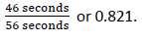

Expected Sustained Primary Frequency Response (ESPFR) Calculations
The Expected Sustained Primary Frequency Response (ESPFRfinal) is calculated using the actual frequency at T+46, HZT+46.
This ESPFRfinal is the MW value a Generation Resource, ESR, SOTG, SOTSG, or Controllable Load Resource should have responded with, if it is properly sustaining the output of its generating unit/generating facility in response to an FME. Determination of this value begins with establishing where it would be in an ideal situation; considers proper Governor droop and Governor Dead‐Band values established in Section 2.2.7, Turbine Speed Governors, High Sustained Limit (HSL), Low Sustained Limit (LSL) and actual frequency. It then allows for adjusting the value to compensate for the various types of limiting factors each Generation Resource, ESR, SOTG, SOTSG, or Controllable Load Resource may have and any Non-Frequency Responsive Capacity (NFRC) that may be included in the HSL.

Establishing the Ideal Expected Sustained Primary Frequency Response
For Generation Resources, ESRs, SOTGs, SOTSGs, and Controllable Load Resources, the ideal Expected Sustained PFR (ESPFRideal) is calculated as the difference between the ESPFRT+46 and the EPFRpre‐perturbation. The EPFRpre‐perturbation is the same EPFRpre-perturbation value used in the Initial measure.

When the frequency is outside the Governor Dead-Band and above 60Hz:
When the frequency is outside the Governor Dead-Band and below 60Hz:

For combined cycle facilities, determination of frequency responsive capacity includes subtracting power augmentation (PA) capacity, if any, from the original telemetered HSL. Other generator types may also have power augmentation that is not frequency responsive. This could be “over‐pressure” operation of a steam turbine at valves wide open or operating with a secondary fuel in service. The Resource Entity is required to provide ERCOT with documentation and conditions when power augmentation is to be considered in PFR calculations as described in paragraph (11) of Protocol Section 6.5.5.2, Operational Data Requirements.
ESPFR_{final} for Combustion Turbines and Combined Cycle Facilities

Note: The 0.00276 constant is the MW/0.1 Hz change per MW of capacity and represents the MW change in combustion turbine’s output due to the change in mass flow through the combustion turbine due to the speed change of the turbine at HZT+46. (This is based on empirical data from a major 2003 event as measured on multiple combustion turbines in ERCOT.)

ESPFR_{final} for Steam Turbine

where:

where:

Throttle Pressure = Interpolation of Pressure curve at MWpre‐perturbation

ESPFRfinal for Other Generating Units/Generating Facilities and Energy Storage Resources

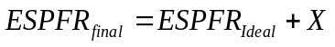

where X is an adjustment factor that may be applied to properly model the delivery of PFR. The X factor will be based on known and accepted technical or physical limitations of the resource. X may be adjusted by ERCOT and may be variable across the operating range of a resource. X shall be zero unless ERCOT accepts an alternative value.

Limits on calculation of PFR Performance (Initial & Sustained)

For frequency deviations below 60Hz (HZ_{post-perturbation} < 60)
If for a generating unit/generating facility

Then Primary Frequency Response is not evaluated for this Frequency Measurable Event (FME).
For frequency deviations above 60Hz (HZ_{post-perturbation} > 60)
If for a generating unit/generating facility

Then Primary Frequency Response is not evaluated for this FME.

For Energy Storge Resources (ESRs), while discharging, if operating within the larger of 3 MW or 2% of the Real-Time Maximum Operating Discharge Power Limit for low frequency disturbances then Primary Frequency Response is not evaluated for this FME.
For ESRs, while charging, if operating within the larger of 3 MW or 2% of the Real-Time Maximum Operating Charge Power Limit for high frequency disturbances then Primary Frequency Response is not evaluated for this FME.

When Expected Primary Frequency Response_{Final} is greater than operating margin Caps and limits exist for resources operating with adequate reserve margin to be evaluated (greater of 2% of (High Sustained Limit (HSL) less PA Capacity) or 5 MW), but with Expected Primary Frequency Response_{Final} greater than the actual margin available.

(1) The will be set to the greater of 0.75 or the calculated if all of the following conditions are met:

(a) The generating unit/generating facility’s or ESR’s pre‐perturbation operating margin (appropriate for the frequency deviation direction) is greater than 2% of its and greater than 5 MW; and

(b) The is greater than the generating unit/generating facility’s or ESR’s available frequency responsive capacity; and

(c) The generating unit/generating facility’s or ESR’s response is in the correct direction.

(2) When calculation of the uses the resource’s as the maximum expected output, the calculated will not be greater than 1.0.

(3) When calculation of the uses the resource’s as the minimum expected output, the calculated will not be greater than 1.0.

(4) If the is in the wrong direction, then is 0.0.

(5) These caps and limits apply to both the Initial and Sustained Primary Frequency Response measures.

INITIAL PFR and SUSTAINED PFR PERFORMANCE REQUIREMENT

ERCOT computes an average Initial PFR and Sustained PFR performance based on either all FMEs evaluated within 12 months or the last eight FMEs (applicable if a minimum threshold of eight FMEs within the 12 month period is not met). Each Generation Resource, ESR, Settlement Only Transmission Generator (SOTG), Settlement Only Transmission Self-Generator (SOTSG), and Controllable Load Resource shall meet a minimum rolling average initial Primary Frequency Response performance and sustained Primary Frequency Response performance of 0.75.

Initial PFR requirement:
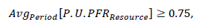

Sustained PFR requirement:



The time designations used in this section refer to relative time after an FME occurs. For example, “T+46” refers to 46 seconds after the frequency deviation occurred.
In this circumstance, when frequency is below 60 Hz, the EPFR_final is set to operating margin based on HSL (adjusted for any augmentation capacity) AND when frequency is above 60 Hz, the EPFR_final is set to operating margin based on LSL for the purpose of calculating PUPFR_resource.

