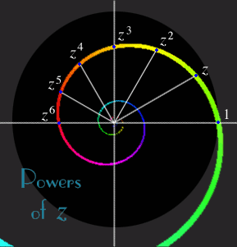**Drawing Histograms**

Draw a labelled Histogram for each set of data. Ensure this is done accurately! Remember to think carefully about how you label the x-axis…

1. Money Spent in a clothes shop.

|  |  |  |
| --- | --- | --- |
| Money Spent (£) | Frequency | Frequency Density |
| 0 ≤ £ < 20 | 40 |  |
| 20 ≤ £ < 30 | 50 |  |
| 30 ≤ £ < 40 | 55 |  |
| 40 ≤ £ < 50 | 40 |  |
| 50 ≤ £ < 100 | 50 |  |

2. Kilometres travelled by bike.

|  |  |  |
| --- | --- | --- |
| Distance Travelled (km) | Frequency | Frequency Density |
| 0 ≤ x < 50 | 55 |  |
| 5 ≤ x < 10 | 45 |  |
| 10 ≤ x < 15 | 30 |  |
| 15 ≤ x < 30 | 30 |  |
| 30 ≤ x < 50 | 25 |  |

3. People’s earnings in the UK.

MCj01335230000[1]

|  |  |  |
| --- | --- | --- |
| Earnings (₤) | Frequency | Frequency Density |
| 0 ≤ x < _ | 5,000 | 0.5 |
| ≤ x < | 120,000 | 12 |
| ≤ x < | 50,000 | 10 |
| ≤ x < | 32,000 | 6.4 |
| ≤ x < | 12,000 | 1.2 |
| ≤ x < | 5,000 | 0.5 |
| ≤ x < 100,000 | 10,000 | 0.2 |