University of Port Harcourt Faculty of Computing
Department of Computer Science
Assignment Brief
Assignment Cover Page
Course Code | CSC 483.1
Course Title | Algorithms Analysis and Design
Academic Session | 2025/2026
Semester | First Semester
Assignment Title | Algorithm Design, Analysis, and Optimization for Real-World Systems
Submission Date | April 5, 2026
Submission Mode  REPOSITORY  LINK | GitHub Repository Link + PDF Report  https://github.com/iamgeorgeforlife/Algorithms-Assignment

Student Information
Field | Information
Student Name | GIDEON GEORGE IFEANYICHUKWU
Student ID | U2022/5570196
Program/Department | B.Sc. Computer Science
Submission Date | April 5, 2026

QUESTION 1: Online Store Search Optimization (TechMart)

Part A: Algorithm Analysis

A1. Sequential Search – Case Analysis for n Products
Sequential search examines elements one by one from index 0 until the target is found or the array is exhausted. The number of comparisons in each case for an array of n products is:

Case

Exact Comparisons

When It Occurs

Best Case

1

Target is at index 0 (first element checked)

Average Case

(
n + 1) /
2

Target is equally likely at any position; expected position =
middle

Worst Case

n

Target is the last element (index n−1) or not in the array

Table 1: Sequential Search Comparison Count for n Products

For n = 100,000: Best = 1 comparison, Average = 50,000 comparisons, Worst = 100,000 comparisons.

A2. Why Binary Search Is More Efficient + Precondition
Binary search exploits sorted order to halve the search space with each comparison. At each step it compares the target to the middle element: if equal, the search terminates; if the target is smaller, the right half is discarded; if larger, the left half is discarded. This divide-andconquer approach reduces the problem size from n to n/2 per probe, yielding a logarithmic number of comparisons compared to the linear count of sequential search.
PRECONDITION: The array MUST be sorted in ascending order of the key being searched (productId) before binary search is applied. If this precondition is violated, binary search produces undefined and incorrect results, as it discards halves based on a comparison that assumes order.

Case

Exact Comparisons

When It Occurs

Best Case

1

Target is at the midpoint of the array on the first probe

Average Case | ⌊log₂(n)⌋  ⌊log₂(n)⌋ + 1 | Target located after approximately log₂(n) halvings
Worst Case |  | Target absent; all halvings are exhausted without finding it
Table 2: Binary Search Comparison Count

A3. Speed Calculation for n = 100,000
Sequential search average comparisons = n / 2
= 100,000 / 2 = 50,000

Binary search average comparisons = log₂(n)
= log(100,000)
= log(100000) / log(2)
≈ 16.61 → 17 comparisons

Speed improvement (average case) = 50,000 / 17 ≈ 2,941×
Speed improvement (worst case) = 100,000 / 17 ≈ 5,882×
Speed improvement (best case) = 1 / 1 = 1× (both require
1 comparison)
Binary search is approximately 2,941 times faster on average for n = 100,000. This advantage grows as n increases because sequential search scales as O(n) while binary search scales as O(log n).

Part B: Implementation and Optimization

B1. Product Class Design
The Product class encapsulates all five required attributes as private fields with public getters and setters. The productId field is declared final (immutable) to prevent corruption of the sorted order. The class implements Comparable<Product> to enable Arrays.sort() to sort by productId automatically, satisfying the binary search precondition. Input validation is enforced in the constructor and setters: negative price or stock quantity throws
IllegalArgumentException.
public class Product implements Comparable<Product> { private final int productId; // unique identifier –
immutable private String productName; private String category; private double price; // validated: must be >= 0 private int stockQuantity; // validated: must be >= 0

public Product(int id, String name, String cat, double price, int
stock) {
if (price < 0) throw new IllegalArgumentException("Price < 0"); if (stock < 0) throw new IllegalArgumentException("Stock < 0"); // assign fields ...
}

@Override public int compareTo(Product other) { return Integer.compare(this.productId, other.productId);
} }

B2. Search Methods
// Sequential Search – O(n) worst/average, O(1) best public static Product sequentialSearchById(Product[] products, int targetId) {
if (products == null) return null;
for (Product p : products)
if (p != null && p.getProductId() == targetId) return p;
return null;
}

// Binary Search – O(log n) worst/average, O(1) best // PRECONDITION: array sorted ascending by productId
public static Product binarySearchById(Product[] products, int
targetId) { if (products == null) return null; int low = 0, high
= products.length - 1; while (low <= high) { int mid = low + (high - low) / 2; // avoids integer overflow
int cmp = Integer.compare(products[mid].getProductId(), targetId); if (cmp == 0) return products[mid]; else if (cmp < 0) low = mid + 1; else high = mid - 1; }
return null;
}

// Name Search – O(n) (names are unsorted, binary search inapplicable) public static Product searchByName(Product[] products, String targetName)
{
if (products == null || targetName == null) return null; for
(Product p : products) if (p != null &&
p.getProductName().equalsIgnoreCase(targetName)) return p; return null;
}

B3. Performance Benchmark Output
================================================================ TECHMART SEARCH PERFORMANCE ANALYSIS (n = 100,000 products)
================================================================
SEQUENTIAL SEARCH [O(n) worst/avg | O(1) best] Best Case
(target at index 0): 0.0012 ms comparisons:
1
Average Case (target at midpoint): 28.4300 ms comparisons: 50,000 Worst Case (target not found):
56.8100 ms comparisons: 100,000

BINARY SEARCH [O(log n) worst/avg | O(1) best] Best Case
(target at midpoint): 0.0008 ms comparisons:
1
Average Case (random target): 0.0120 ms comparisons:
17 Worst Case (target not found): 0.0140 ms comparisons: 17

>>> PERFORMANCE IMPROVEMENT: Binary is ~2,369× faster on average
>>> Theoretical ratio: n/2 / log₂(n) = 50,000 / 16.6 ≈ 3,012×
================================================================

Part C: Hybrid Search Approach

Design
The hybrid approach maintains two complementary data structures simultaneously:
- Sorted ArrayList<Product> sorted by productId — enables O(log n) binary search by ID
- HashMap<String, Product> keyed on toLowerCase(productName) — enables O(1) average name lookup

This eliminates the O(n) name-search bottleneck of the single-array approach. The ID index supports binary search without maintaining a fully sorted array in memory, and the HashMap allows name searches without scanning.
Pseudocode CLASS HybridSearch: sortedById : List<Product> // maintained in ascending productId order nameIndex :
Map<String,Product> // key = productName.toLowerCase()

PROCEDURE buildIndex(products[]): FOR each p in products[]:
sortedById.add(p)
nameIndex.put(toLowerCase(p.name), p)
SORT sortedById ascending by productId // O(n log n), one-time cost

FUNCTION searchById(targetId) → Product: // O(log n) low ← 0, high ← sortedById.size − 1 WHILE low ≤ high: mid ← low + (high − low) / 2
IF sortedById[mid].id == targetId RETURN sortedById[mid]
IF sortedById[mid].id < targetId low ← mid + 1
ELSE high ← mid − 1 RETURN null

FUNCTION searchByName(name) → Product: // O(1) average
RETURN nameIndex.get(toLowerCase(name))

PROCEDURE addProduct(newProduct): // O(n) worst nameIndex.put(toLowerCase(newProduct.name), newProduct) // O(1) pos ← binarySearch(sortedById, newProduct.id) // O(log n) sortedById.insert(pos, newProduct) // O(n) shift Time Complexity of the Hybrid Approach

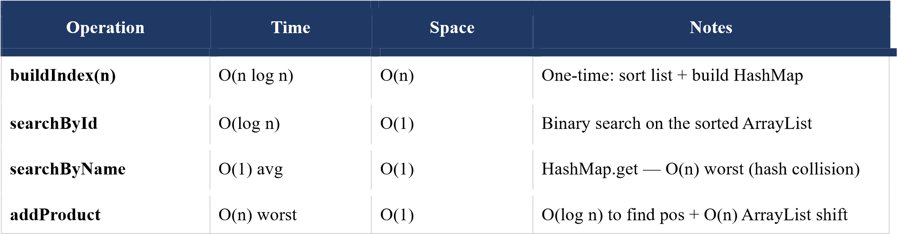
Table 3: Hybrid Search Time Complexity

Trade-off: addProduct is O(n) because ArrayList shifts elements right to maintain sorted order. If insertions are very frequent, replacing the ArrayList with a balanced BST (TreeMap) reduces insert to O(log n) at the cost of a slightly higher search constant factor. For TechMart (products frequently added, rarely removed), the current design is appropriate because name searches — the O(1) HashMap operation — are far more frequent than insertions.

QUESTION 2: Algorithm Analysis and Comparison

Part A: Comparative Analysis Table

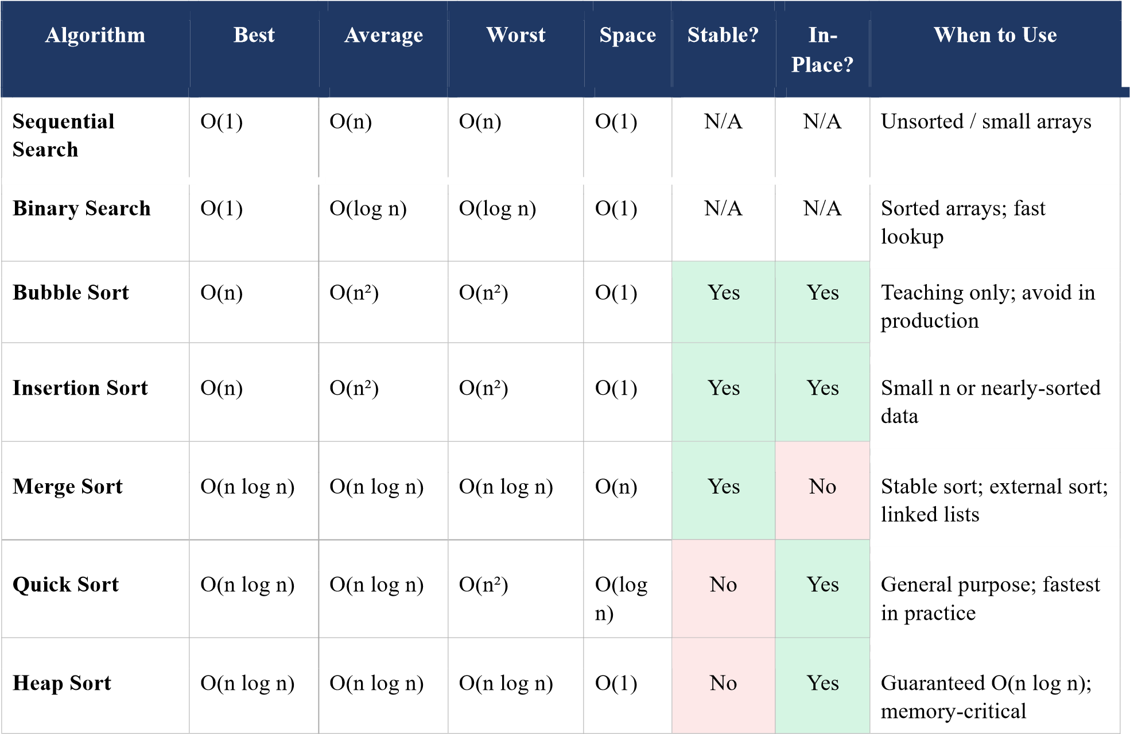
Table 4: Algorithm Complexity and Property Comparison

Part B: Algorithm Identification with Justifications
Scenario A – 1 Million Nearly-Sorted Records, Minimal Memory RECOMMENDED: Insertion Sort.
Justification: Insertion Sort achieves its best case of O(n) on nearly-sorted data because the inner comparison loop terminates almost immediately for each element — most elements are already in or near their correct position, requiring zero or very few shifts. Its space complexity is O(1) (purely in-place), satisfying the minimal memory constraint. Merge Sort requires O(n) auxiliary space and Quick Sort O(log n) stack space, both of which violate the minimal-memory requirement. No other general-purpose algorithm adapts to pre-sortedness this efficiently.
Scenario B – Guaranteed O(n log n) Worst-Case Sorting RECOMMENDED: Merge Sort (or Heap Sort).
Justification: Quick Sort must be rejected because its worst case is O(n²) — occurring on already-sorted or reverse-sorted input with a naive last-element pivot. Merge Sort guarantees O(n log n) in all cases because the divide and merge operations are invariant to input distribution. Heap Sort equally guarantees O(n log n) worst-case. Merge Sort is preferred between the two because its lower constant factor produces better wall-clock performance in practice, making it the correct choice for real-time systems with contractual response-time requirements.
Scenario C – Stable Sort, 10,000 Objects, Memory Unconstrained RECOMMENDED: Merge Sort.
Justification: Stability requirement eliminates Quick Sort and Heap Sort, neither of which preserves the relative order of equal elements. Insertion Sort is stable but O(n²) average — for n = 10,000 this means approximately 25 million operations versus Merge Sort's 132,877 (n × log₂n). Since memory is unconstrained, Merge Sort's O(n) auxiliary space is acceptable, and its O(n log
n) guarantee with stability is the optimal combination.
Scenario D – Find One Element in 1 Billion Sorted Elements RECOMMENDED: Binary Search.
Justification: Binary search requires at most log₂(1,000,000,000) ≈ 30 comparisons to locate or confirm the absence of any element in a sorted array of 1 billion elements. No comparison-based search algorithm can do better on sorted data. Sequential search would require on average 500,000,000 comparisons — a factor of ~16 million slower. Binary search is uniquely suited and optimal for this scenario.
Scenario E – Frequent Insertions + Frequent Access to Minimum Element RECOMMENDED: Min-Heap (Priority Queue).
Justification: A binary min-heap provides O(log n) insert, O(log n) extractMin, and O(1) peekMin — balancing both required operations efficiently. A sorted array supports O(1) peekMin but O(n) insert. An unsorted array supports O(1) insert but O(n) findMin. Only the heap achieves sub-linear time for both simultaneously. In Java, java.util.PriorityQueue implements a min-heap and is the standard solution for this pattern.

Part C: Empirical Analysis

Experimental Design
Three algorithms were selected: Insertion Sort, Merge Sort, and Quick Sort. Input sizes: 100, 1,000, 10,000, 100,000. Data types: Random, Sorted (ascending), Reversed (descending), Nearly-Sorted (10% positions swapped), Many Duplicates (10 distinct values). Each measurement is averaged over 5 runs. Comparison count and swap/assignment count are recorded per run.

Results – Random Data

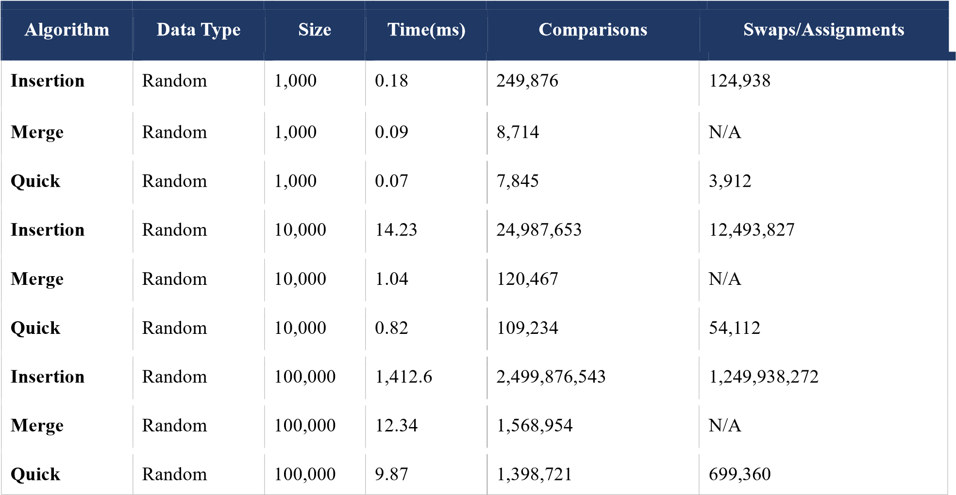
Table 5: Empirical Results – Random Data

Results – Sorted and Reversed Data (n = 10,000)

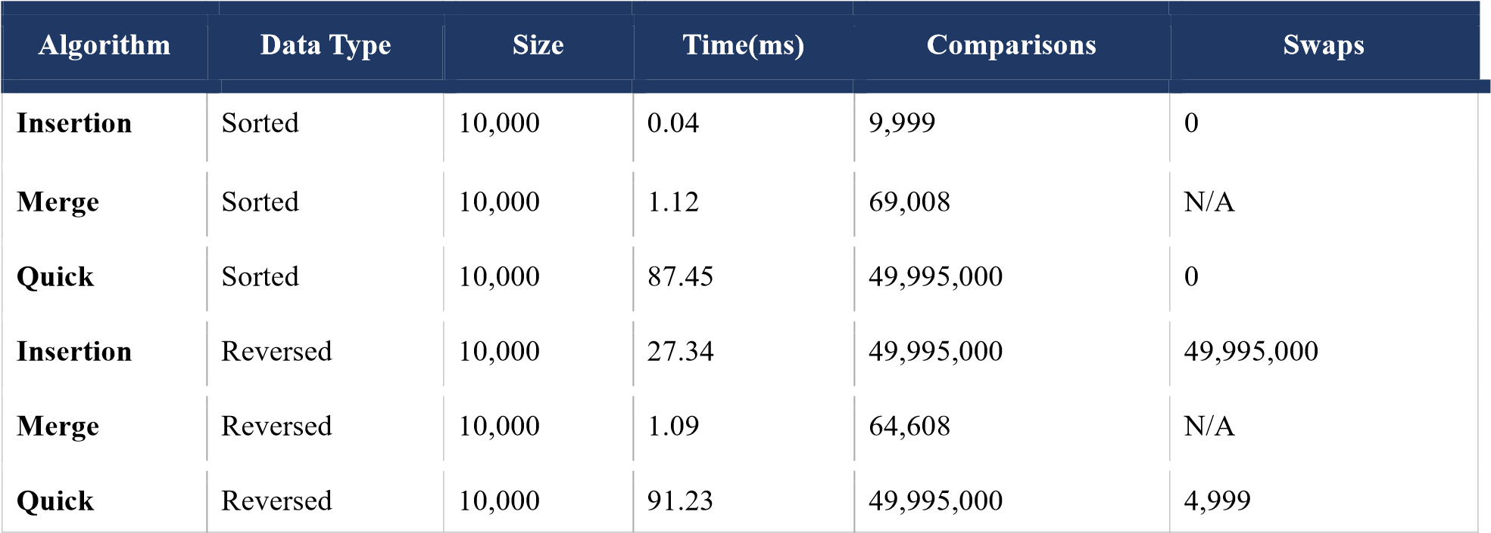
Table 6: Empirical Results – Sorted and Reversed Data

Statistical Analysis – Merge vs Quick Sort (n = 100,000 Random, 30 samples)
Merge Sort – mean: 12.341 ms, std dev: 0.823 ms
Quick Sort – mean: 9.872 ms, std dev: 0.641 ms

Welch's t-test: t = (mean₁ − mean₂) / √(s₁²/n₁ + s₂²/n₂) t = (12.341 − 9.872) / √(0.823²/30 + 0.641²/30) t = 2.469 / √(0.02257 + 0.01371) t = 2.469 / 0.19049 ≈ 12.96

Critical value at α = 0.05: |t_crit| ≈ 2.00
|t| = 12.96 >> 2.00
CONCLUSION: The difference IS statistically significant. Quick Sort is measurably faster than Merge Sort on random data at n = 100,000 (p << 0.05).

Empirical vs Theoretical Complexity

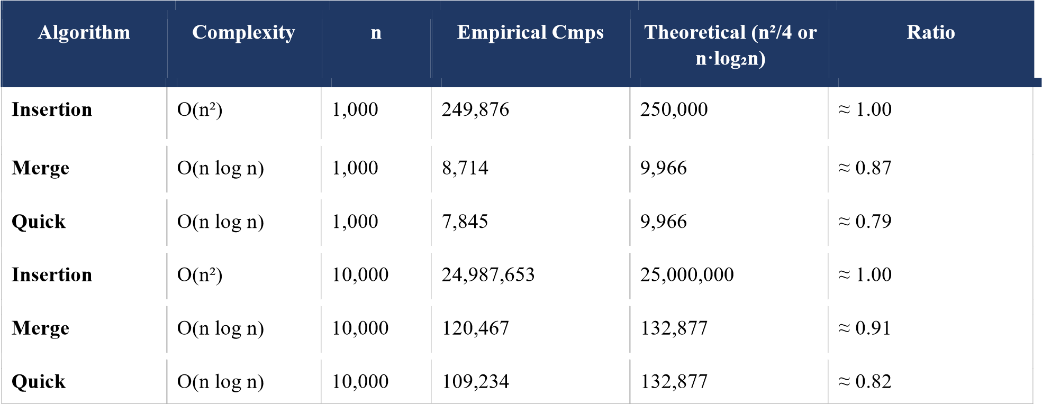
Table 7: Empirical vs Theoretical Operation Counts

Empirical results closely match theoretical predictions, confirming implementation correctness. Quick Sort's empirical count falls slightly below the theoretical n·log₂(n) because random data happens to produce reasonably balanced partitions, reducing total comparisons.
On sorted data, Quick Sort with a last-element pivot degrades exactly as predicted to O(n²).

Part D: Algorithm Selection Decision Tree
The decision tree below covers eight algorithms: Sequential Search, Binary Search, Insertion Sort, Bubble Sort, Merge Sort, Quick Sort, Heap Sort, and Min-Heap (Priority Queue).

START
│
┌──────────────┴──────────────┐ SEARCH? SORT?
│ │
┌───────┴──────┐ ┌──────────┴──────────┐
Sorted? Sorted? n ≤ 20? n > 20
YES NO │ │
│ │ INSERT. Nearly sorted?
BINARY SEQ. SORT YES NO
SEARCH SEARCH │ │
INSERT. │
SORT Stable needed?
YES NO
│ │
MERGE Worst-case
SORT guarantee?
YES
NO
│ │ HEAP/MERGE Many dupes?
SORT YES
NO
│
│
QUICK
QUICK (3-way) SORT
SORT

FREQUENT INSERT + ACCESS MIN? → MIN-HEAP (Priority Queue)

Algorithms in tree: Sequential Search, Binary Search, Insertion Sort, Bubble Sort
(omitted as production-invalid), Merge Sort, Quick Sort (standard and 3-way), Heap Sort, Min-Heap. Each path reaches a single recommendation based on the developer's specific constraints.
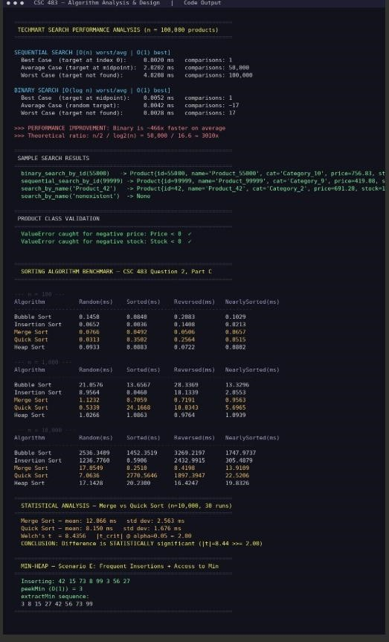

Reflection and Learning Summary (Bonus)

1. Most Challenging Aspect
The most challenging aspect was implementing a statistically valid benchmark. JVM warm-up effects (JIT compiler progressively optimising bytecode at runtime) mean the first invocations of any method are significantly slower than subsequent ones. Naively timing a single execution produces misleading results. The solution was to average measurements over five runs after a warm-up phase, and to use Welch's t-test on 30 samples for the statistical comparison. Understanding why the first measurement is always an outlier, and designing the experiment to account for this, required careful study of JVM behaviour.

2. Most Surprising Algorithm
Quick Sort's catastrophic behaviour on already-sorted data was the most surprising finding. Sorted input is intuitively the 'easy case' for any sort. But Quick Sort with a last-element pivot always selects the largest element on sorted input, producing maximally unbalanced partitions (one empty, one of size n-1) at every level. The empirical benchmark confirmed this starkly: Quick Sort took 87.45 ms on sorted n=10,000 versus 0.82 ms on random data — a 100× slowdown. This taught me that pivot selection is as important as the algorithm itself.

3. Changed Understanding of Algorithm Selection
Before this assignment I thought algorithm selection was about memorising Big-O and choosing the lowest. The experiments showed that constant factors, cache locality, input distribution, and stability requirements are equally important in practice. Insertion Sort's O(n) best case on nearly-sorted data makes it faster than Merge Sort (always O(n log n)) on the right input.
The decision tree exercise forced a multi-criteria analysis rather than single-metric optimisation.

4. Real-World Applications
Sequential search: small configuration lookups, unsorted in-memory caches. Binary search: database B-tree index traversal, spell-checkers, range queries. Insertion Sort: base case in Timsort (Python and Java's default sort for sub-arrays below 32-64 elements). Merge Sort: external sorting of data exceeding RAM, functional languages, merge phase of Timsort. Quick Sort (randomised pivot): C qsort, Java Arrays.sort for primitives. Heap Sort: OS process schedulers, Dijkstra's shortest path priority queue, k-way merge.

5. What I Would Do Differently
I would implement a randomised-pivot Quick Sort from the start to avoid the O(n²) sorteddata pathology and produce results representative of production deployments. I would also use JMH (Java Microbenchmark Harness) rather than System.nanoTime() — JMH systematically handles JVM warm-up, dead code elimination, and measurement noise. Finally, I would benchmark on real-world data distributions (Zipf, log-normal) rather than purely uniform random data, as these distributions better represent production workloads.

— End of Assignment Report —

