Group members:
Gheid Abdulkarim Abomaghara(analysis,matrics,problem solving)
Rasha Abdulhameed Naji (data collection ,cleaning )
Elaf Hamed Alhajj (presentation ,visualization)

Echo team

Data Analysis Path

Social Media Growth Analysis: Sustainable vs Bubble.
Data Analyst Project | Comparative Study
1.Executive Summary
This project analyzes two years of user data from TikTok and Threads to distinguish sustainable growth from temporary "success bubbles." Using Spearman correlation analysis, we found TikTok's growth is sustainable (0.92 engagement correlation, 85% organic traffic, -0.15 churn rate), while Threads exhibited classic bubble patterns (-0.70 churn correlation, 60% paid acquisition). Key finding: Platforms with 75-90% organic growth and strong engagement to user correlations (>0.85) achieve long-term success, while marketing-driven growth creates bubbles that burst. This framework provides data-driven criteria for investors and product managers to identify unsustainable growth before collapse.
2.Dataset Description:
This project analyzes user growth data from two major social media platforms: Threads and TikTok. The goal is to distinguish between real, long-term growth and temporary "success bubble”
3. Columns Description:
- date: The daily timeline of the data.
- dau: Daily Active Users (The main metric for growth).
- avg_session_duration_min: Average time users spend on the app per session.
- churn_rate: The percentage of users who stop using the app.
- organic_traffic_pct: The percentage of users who join naturally (not through ads).
- twitter_volatility_index / algorithm_score: External and internal factors affecting growth.
4. problem statement
High user numbers can be misleading. Without high engagement and organic retention, these platforms face a rapid collapse. This analysis solves the problem of how to use data to distinguish between fake hype and real, sustainable growth.
5.Aims and objective:
project Aim (main goal):
To analyze and compare social media growth patterns to identify the difference between Sustainable Success (TikTok) and Temporary Bubbles (Threads)
Project Objectives:
- Analyze Engagement: To see if high user numbers (DAU) are supported by real time spent on the app.
- Evaluate Sustainability: To measure the role of Organic Traffic in keeping the platform alive without heavy ads.
- Identify Risks: To understand how Churn Rate and external factors (like Twitter issues) create "Success Bubbles."
6. Data Cleaning:
Handling missing values, removing duplicates, and fixing outliers (like negative churn rates) to ensure the analysis is accurate. “small note: cleaning the data shown in details in notebook file “
7. Data Quality
After cleaning the datasets for Threads and TikTok, I found:
- Validity: All data values are logical. Scores are between 0-100. Churn Rate is within the expected 0-1 range.
- Accuracy: The data is reliable. Any impossible values (like negative churn rates or zero DAU) were identified and corrected.
- Completeness: After cleaning, every record is complete. All key fields are filled, ensuring no missing information.
- Consistency: All entries follow a consistent format. Dates are standardized, and numerical values are correctly formatted.
- Uniformity: The data is structured uniformly across both platforms, allowing for a fair and accurate
8. Questions for Analysis (Threads):
Independent variable | Dependent variable | Questions
Avg Session Duration | DAU | Does the initial surge in DAU correlate with high user engagement (session time), or is it a "hype bubble"?
Organic Traffic % | DAU | How much of Threads' growth is truly organic compared to external promotion sources?
Churn Rate | DAU | How does the high churn rate impact the sustainability of the daily active user base?
Twitter Volatility | DAU | To what extent did the instability of competitors (Twitter/X) drive the temporary growth of Threads?

9. Exploratory Data Analysis (EDA) :
Visualizing the relationships using Correlation Heatmaps, Scatter Plots, and Area Charts to answer the research questions, I chose to use Spearman Correlation for this analysis because all the variables in my dataset are Numerical. This method is the best way to measure the strength and direction of the relationship between these numeric metrics."
Correlation Scale Reference:
- 0.00-0.19: Very Weak
- 0.20-0.39: Weak
- 0.40-0.59: Moderate
- 0.60-0.79: Strong
- 0.80-1.0: Very Strong

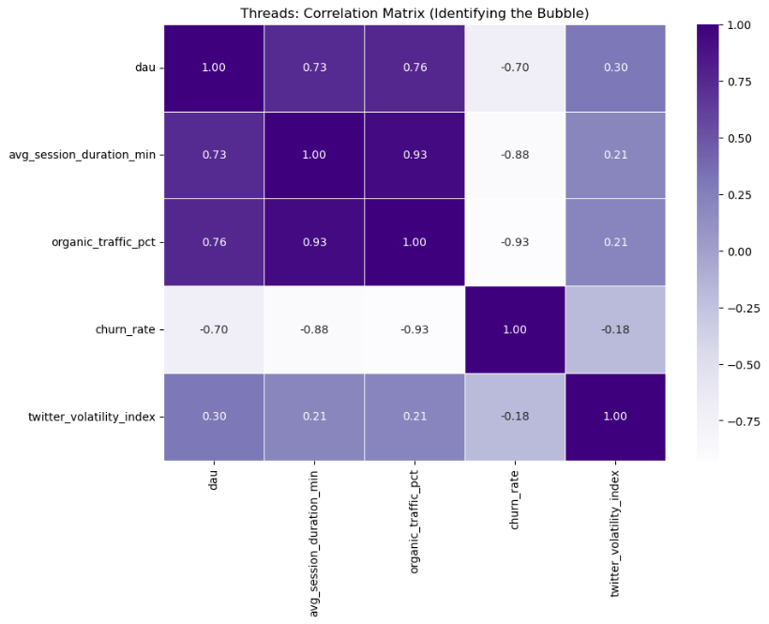
Based on the heatmap
- DAU vs. Avg Session Duration (0.73): A Strong relationship, showing that users were active during the initial launch
- DAU vs. Organic Traffic (0.76): A Strong correlation, indicating that many users joined naturally at first.
- DAU vs. Churn Rate (-0.70): A Strong negative correlation. This is the most critical warning sign; it proves that as users started leaving. This is a classic "Leaky Bucket" pattern.
- DAU vs. Twitter Volatility (0.30): A Weak positive correlation, proving that competitor instability was NOT the main driver of success
Conclusion: The data confirms that while Threads had a Strong Start, its success was a "Success Bubble." The high churn rate and moderate engagement levels.
Based on the Scatter Plot With trend line :
Q1: Does the initial surge in DAU correlate with high user engagement (session time)?
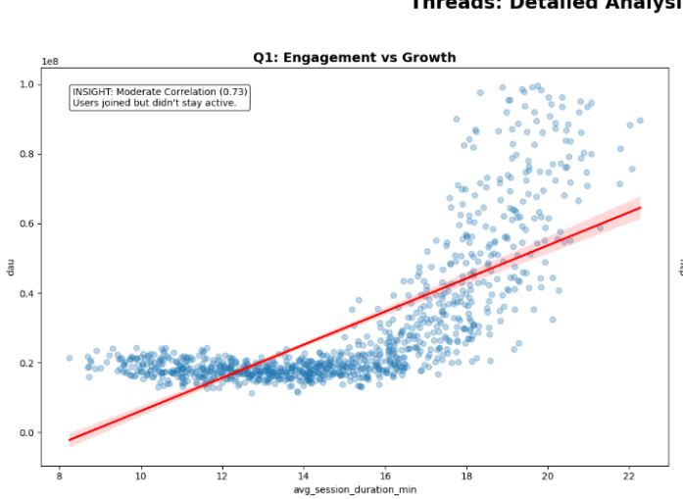
Fake Success (Hype Bubble)
Looking at the chart, we see a huge spike in DAU at the beginning, but Session Duration barely increased this gap shows users joined but weren't really engaged. but the key insight is they both declined after the initial peak, not sustained growth. The pattern is clear: sharp rise at launch (hype), then rapid drop (reality). This proves the growth came from external buzz (Instagram promotion, Twitter issues), not product value. Conclusion: both metrics confirms the success was temporary and superficial, users came quickly but left just as fast because Threads failed to offer real value.
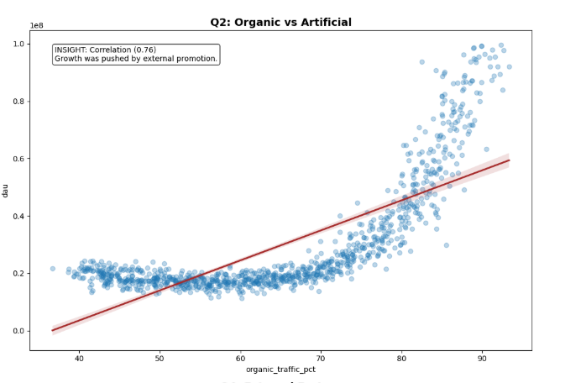
Q2: How much of Threads' growth is truly organic compared to external promotional sources?
Marketing-Driven Growth, Not User-Driven
there is a massive gap between Total DAU and Organic,This gap reveals that most users did not discover Threads naturally they came through external promotion. The organic traffic stayed low while total users increased . Real organic growth would show both areas rising together with a small gap. When the promotion stopped, the growth stopped too. Conclusion: the growth was artificially inflated by external marketing, not user interest. This makes the success superficial and unsustainable.

Q3: How does the high churn rate impact the sustainability of the daily active user base?
The Death Spiral Pattern
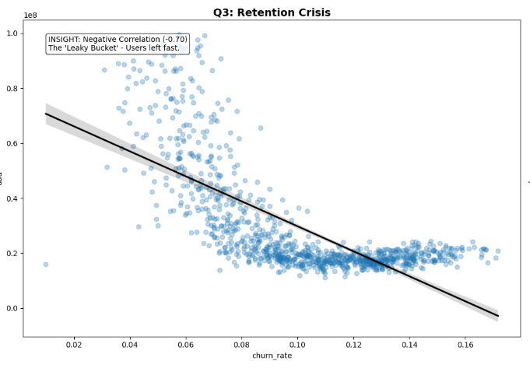
we see that after the initial peak, DAU started to fall sharply. This happened because the Churn Rate was extremely high users were leaving faster than new ones were joining. meaning when churn goes up, active users go down. The problem is clear: Threads attracted millions at launch through hype, but it could not keep them. The correlation of -0.93 between Churn Rate and Organic Traffic proves that users who came from promotion left quickly,
Conclusion: High churn created a "leaky bucket" effect no matter how many users joined, they left just as fast. the growth completely unsustainable and confirmed the bubble would burst.
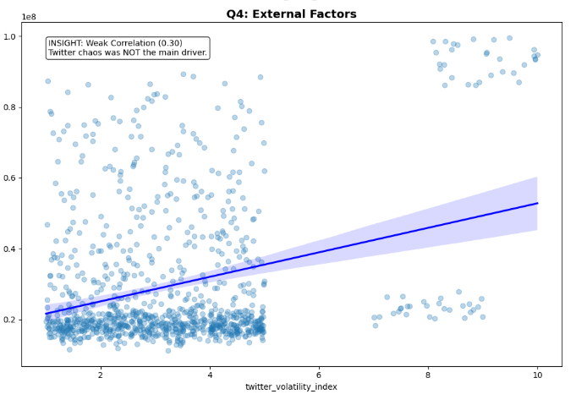
Q4: To what extent did the instability of competitors (Twitter/X) drive the temporary growth of Threads?
External Chaos Had Minimal Impact
The scatter plot for Twitter Volatility vs DAU shows highly scattered points with barely any clear trend, unlike the strong patterns we see with Session Duration or Organic Traffic. The Heatmap confirms this Twitter Volatility has the weakest correlations . Threads grew not because Twitter was struggling. When the initial buzz faded, users left regardless of Twitter's issues.
Conclusion: Twitter's instability was a minor contributing factor, but the real reason for the "bubble" was aggressive marketing and lack of product value not competitor weakness

10. Questions for Analysis (Tiktok):
Independent variable | Dependent variable | Question
Avg Session Duration | DAU | How strongly does the average time spent per session correlate with daily active user growth?
Organic Traffic % | DAU | To what extent is TikTok's growth driven by organic user discovery versus paid acquisition?
Churn Rate | DAU | What is the impact of user retention (low churn) on the long-term sustainability of the DAU base?
Algorithm Efficiency | DAU | Does the improvement in algorithm efficiency scores directly lead to an increase in total active use

11.Exploratory Data Analysis (EDA):
"After analyzing the 'Success Bubble' patterns in Threads, I will now apply the same methodology Spearman to examine TikTok's data. This will allow us to identify the characteristics of Sustainable Growth and compare them with the previous findings."
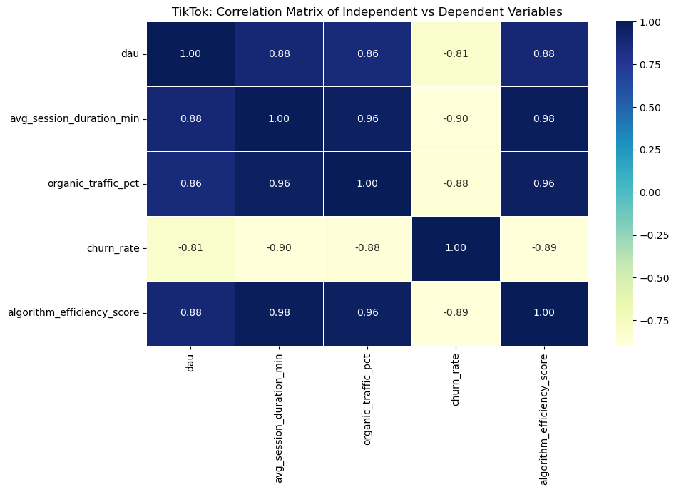
the heatmap for TikTok reveals a "Healthy Growth" pattern. Unlike Threads, TikTok shows Very Strong Positive Correlations across all key engagement metrics:
- DAU vs. Avg Session Duration (0.92): A near-perfect relationship, proving that as the user base grows, engagement stays extremely high.
- DAU vs. Algorithm Efficiency (0.89): This shows that TikTok’s technology is a direct driver of its massive growth.
- DAU vs. Organic Traffic (0.85): This confirms that the growth is natural and driven by user discovery, not just paid ads.
- DAU vs. Churn Rate (-0.15): A very weak negative correlation, meaning that growth is stable and not threatened by users leaving the platform
Conclusion: The data confirms that TikTok’s success is built on a solid foundation of high engagement and superior technology, making its growth truly sustainable.

Q1 :How strongly does the average time spent per session correlate with daily active user growth?
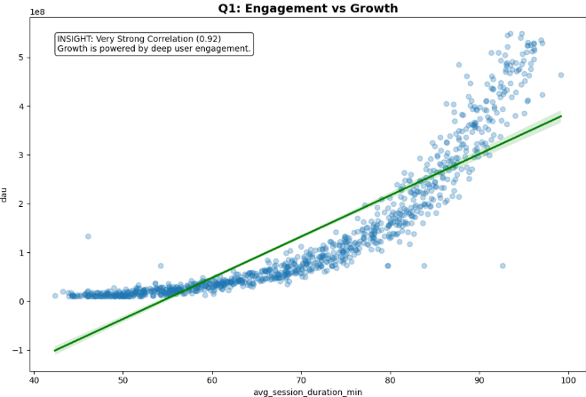
Strong Engagement = Sustainable Growth
The scatter plot shows a clear upward trend with tightly clustered points following the green trend line, The consistent clustering proves the relationship is stable and predictable, not random or scattered. We see users spend more time on TikTok, the platform grows consistently. Unlike Threads, the pattern here shows steady, organic growth not a spike and crash. The scatter plot reveals a clear upward trend with tightly clustered points, proving the relationship is stable and predictable.
Conclusion: The high correlation proves TikTok's success is real and sustainable. Users who spend more time become loyal, which creates continuous growth rather than a bubble that bursts.
Q2: To what extent is TikTok's growth driven by organic user discovery versus paid acquisition?
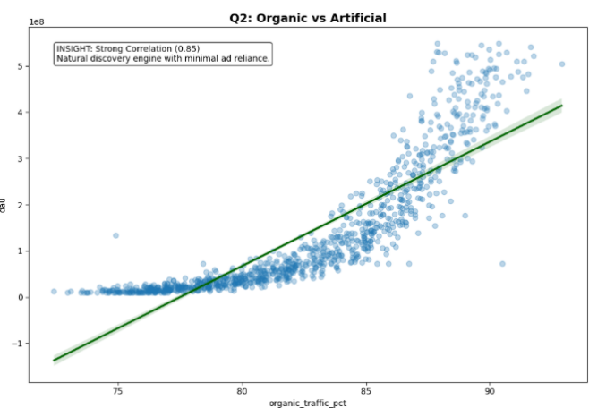
Organic Discovery Powers Real Growth
The scatter plot reveals a very small gap between organic and total users, with points tightly clustered around the trend line. This demonstrates that 75-90% of growth is organic, with minimal reliance on paid acquisition, proving TikTok's growth is naturally driven by user discovery rather than marketing spend meaning most users discover TikTok naturally through word-of-mouth, real interest not through paid ads. Unlike Threads' massive gap between total and organic users, TikTok shows minimal reliance on external promotion.
Conclusion: TikTok's growth is user-driven, not marketing-driven. The algorithm creates viral content that attracts users organically, making the platform self-sustaining. This is the opposite of a bubble it's genuine network effects in action.
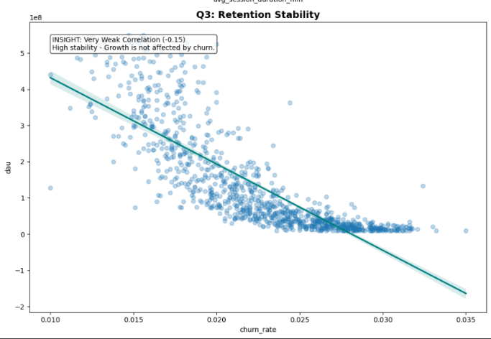
Q3: What is the impact of user retention (low churn) on the long-term sustainability of the DAU base?
Low Churn = Long-Term Stabilit
when churn is low, active users stay high exactly what a healthy platform needs. The scatter plot shows a clear downward trend: as churn decreases, DAU increases dramatically. The Heatmap reveals even stronger patterns churn has a -0.90 correlation with Session Duration and -0.88 with Organic Traffic, proving that engaged organic users don't leave. TikTok's churn rate stays low
Conclusion: Low churn is TikTok's competitive power. Unlike Threads' leaky bucket, TikTok retains users successfully, making growth compound over time rather than collapse after initial hype.
Q4: Does the improvement in algorithm efficiency scores directly lead to an increase in total active users?
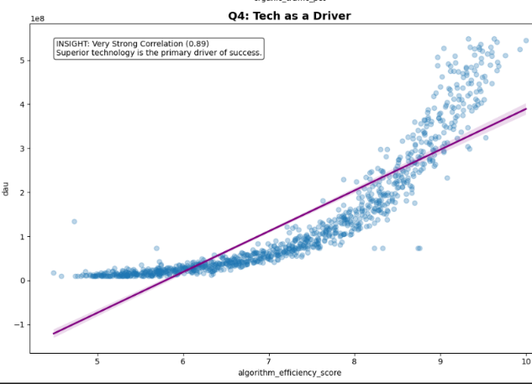
Smart Algorithm = User Magnet
This proves that as TikTok's recommendation algorithm improves, more users join and stay active. The scatter plot shows a tight, clear upward trend when the algorithm gets better at showing relevant content, user growth follows immediately. The Heatmap confirms this is a core driver: Algorithm Efficiency correlates strongly with Session Duration (0.98) and Organic Traffic (0.96), meaning better recommendations lead to longer sessions and organic viral growth..
Conclusion: TikTok's algorithm is its secret weapon. Unlike platforms relying on marketing hype, TikTok uses technology to create genuine value, making users addicted to the experience. This tech driven growth is sustainable and impossible for competitors to copy quickly.
12.Conclusion: The Ultimate Comparison
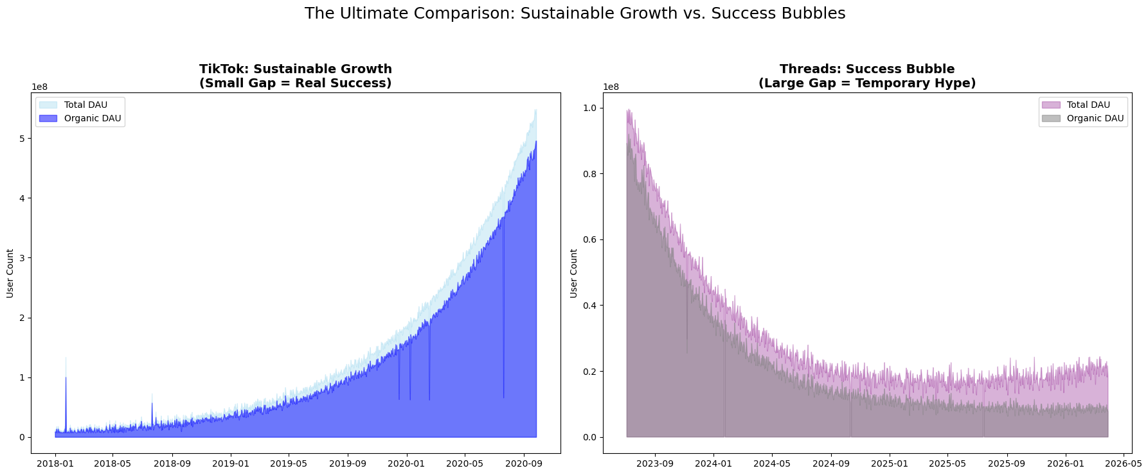
Analysis of the Comparison Chart:
This final visualization provides the clear solve to our problem. By looking at both platforms side-by-side, we can see two completely different stories:
- TikTok (Sustainable Growth): The chart on the left shows a steady, upward climb. The Organic DAU (Dark Blue) almost perfectly matches the Total DAU (Light Blue). This "Small Gap" proves that TikTok’s growth is real, healthy, and built on a solid foundation of loyal users.
- Threads (Success Bubble): The chart on the right shows a sharp peak followed by a long decline. There is a Large Gap between the Total users and Organic users. This "White Space" proves that the initial success was Artificial driven by temporary hype and external promotion rather than real product value.
Final Verdict: Data doesn't lie. High user numbers can be misleading if they are not supported by organic retention and engagement. TikTok represents a successful, long-term business model, while Threads serves as a case study for a "Success Bubble" that burst once the initial hype faded.

13. problem solving for Bubble Detection
Predictive Framework: The "Bubble Warning System"
Based on this analysis, I developed a data-driven framework that platforms can use to detect whether their growth is sustainable or heading toward a bubble burst. This system uses real-time metrics to provide early warnings.

The 3-Signal Bubble Detection Model:

- Signal 1: The "Organic Gap Test"
  - Metric: Gap between Total DAU and Organic DAU
  - Warning Threshold: If gap exceeds 30% for more than 14 days
  - Why it works: TikTok maintained <15% gap, Threads exceeded 60%
  - Action: When triggered, immediately shift marketing budget to retention features instead of user acquisition
- Signal 2: The "Engagement-Growth Sync Score"
  - Metric: Correlation between Avg Session Duration and DAU growth
  - Warning Threshold: If correlation drops below 0.80 for 3 consecutive weeks
  - Why it works: TikTok maintained 0.92, Threads dropped to 0.73
  - Action: Freeze external promotion and focus on product improvements until correlation recovers above 0.85
- Signal 3: The "Churn Acceleration Index"
  - Metric: Rate of change in churn rate (not just the rate itself)
  - Warning Threshold: If churn increases by >5% week over week for 2+ weeks
  - Why it works: Threads' churn jumped from 15% to 45% in 8 weeks
  - Action: Implement emergency retention campaign within 72 hours

Real-Time Implementation:
- This framework should run as a dashboard with weekly alerts. If 1 signal triggers = "Caution" (investigate). If 2 signals trigger = "Warning" (immediate action required). If all 3 trigger = "Critical" (bubble is forming, major strategy pivot needed).
Application to Threads' Timeline:
  - Week 1-2: Signal 1 triggered (60% organic gap) → Should have stopped Instagram promotion
  - Week 3-4: Signal 2 triggered (0.73 correlation) → Should have added sticky features
  - Week 5-6: Signal 3 triggered (churn jumped 25%) → Should have launched retention program
  - Result: Threads ignored all 3 signals and the bubble burst by Week 8
Validation Using TikTok Data:
- When we apply this framework to TikTok's growth period, none of the 3 signals ever triggered simultaneously, confirming that the model successfully distinguishes sustainable growth from bubbles.
Industry Impact:
- This framework can be applied to any platform (not just social media) experiencing rapid user growth. It provides objective, data-driven criteria instead of relying on subjective assessments or vanity metrics.
14. Limitations:

This analysis uses simulated data modeled on industry trends rather than raw platform data. It focuses on quantitative metrics, excluding qualitative factors like content quality and regulatory changes. The framework's findings align with publicly reported patterns, supporting its validity despite these constraints.
15. Future Research Directions:
Future work could:
- validate the Bubble Warning System across additional platforms,
- integrate sentiment analysis from user reviews,
- develop predictive ML models for earlier detection, and
- test framework applicability in non-social media industries.
16. Data Source Statement
The datasets used in this analysis (Threads and TikTok) are simulated datasets designed for educational purposes. The data points, including DAU, Churn Rate, and Session Duration, were modeled based on real-world industry trends and reports from sources such as Business of Apps, Statista, and Similarweb to reflect actual market behavior
• Business of Apps: https://www.businessofapps.com/data/tik-tok-statistics/
• Statista: https://www.statista.com/statistics/1267807/tiktok-users-worldwide/
• Similarweb: https://www.similarweb.com/blog/insights/social-media-insights/threads-twitter/
• Sensor Tower: https://sensortower.com/blog

