

Faculty of Computer Studies
Department of Information Technology and Computing



Qurb

By Group
Gheid Abdulkarim Ahmed Abomaghara
Elaf Hamed Abdulqader Ali Al-Hajj"

Declaration
I affirm that project Qurb is entirely result of my own work. I have not engaged in plagiarism. All sources have been appropriately cited. I am fully accountable for its accuracy and integrity.
Signature:

Name: Gheid Abdulkarim

Abstract

The management of Quranic memorization circles (Halaqas) faces significant operational and educational challenges that directly impact student learning and retention. Stakeholder interviews identified three critical gaps: the difficulty students and parents face in locating suitable Halaqas due to the absence of a centralised location-based database; the disruption caused by unplanned teacher absences and the lack of a rapid substitution mechanism; and the absence of structured, data-driven tools to support effective home revision after sessions.
To address these challenges, this project introduces Qurb — a smart GIS-based platform integrating Geographic Information Systems with a specialised Analytical Engine. Qurb resolves the discovery gap through an interactive map enabling users to locate nearby Halaqas based on their geographical position. It ensures educational continuity through a spatial matching algorithm that automatically coordinates the nearest qualified volunteer teacher during emergencies. Finally, it transforms home revision by analysing daily oral evaluations and generating personalised weekly study schedules that target each student's specific weaknesses.
By unifying these three solutions, Qurb creates a cohesive educational ecosystem that makes Quranic memorization accessible through intelligent discovery, operationally stable through smart substitution, and educationally sustainable through continuous data-driven guidance.

TABLE OF CONTENTS
Contents
Qurb i
Declaration ii
Abstract iii
TABLE OF CONTENTS iv
ACKNOWLEDGMENTS vii
GLOSSARY of TERMS and DEFINITIONS vii
Chapter 1: Introduction 7
1.1 Background Information 8
1.2 Motivations of the Project 8
1.3 Problems of the Project 9
1.4 Aims and Objectives of the Project 9
1.5 Proposed Solution of the Project 9
1.6 Constraints of the Project 10
1.7 Assumptions of the Project 10
1.8 Target Audience 10
1.9 Timeline Table 10
1.10 Gantt Chart 12
1.11 Structure of the Project 12
Chapter 2: A Literature Review 12
2.1 Introduction 13
2.2 Related Works 13
2.2.1 Taahadou Application 13
2.2.2 National Volunteer Platform 15
2.2.3 Maknon Map 16
2.2.4 C-Iqraa (Classera) 18
2.3 Comparison Between Related Works and Qurb 19
2.4 Chapter Summary 19
Chapter 3: The Team Members and their Responsibilities 20
3.1 Introduction 20
3.2 Data Collection Results 20
3.3 Functional Requirements (FR) 21
3.3.1 Business Requirements 21
3.3.2 Technical Requirements 21
3.4 Non-Functional Requirements (NFR) 22
3.4.1 Usability 22
3.4.2 Performance 22
3.4.3 Security and Privacy 22
3.4.4 Support and Maintenance 22
3.4.5 Cultural Compliance 22
3.5 Use Case Diagram 23
3.5.1 Actors and Interactions 23
3.5.2 Central System Functions 24
3.5.3 Use Case Scenario 25
3.6 Activity Diagram 26
3.7 Class Diagram 27
3.8 Software Requirements 27
3.9 Hardware Requirements 28
3.10 Chapter Summary 28
References 29
Bibliography 29
Appendix 29
Appendix A: Methodology and Environment 29
Appendix B: Stakeholders and Interview Duration 29
Appendix C: Interview Question Samples 30
Appendix C.1 — Group 1: Students and Parents (Discovery and Education) 30
Appendix C.2 — Group 2: Tech Administrator and Teachers (Operations and the Tech Gap) 30

List of figures
Figure 1 Gantt chart of the project 5
Figure 2 Taahadou app 7
Figure 3 National Volunteer Platform 8
Figure 4 Maknon Map 10
Figure 5 C-Iqraa (Classera) 11
Figure 6 Use case Diagram 17
Figure 7 Activity Diagram 20
Figure 8 Class Diagram 21

List of tables

Table 1: Timeline table 11
Table 2 Comparison Between Related Works and Qurb 19
Table 3 Use Case Scenario 25
Table 4 Stakeholders and Interview Duration 30

ACKNOWLEDGMENTS

First and foremost, all praise and gratitude belong to Allah, without whose guidance and blessings this work would not have been possible.
Finally, I owe my heartfelt thanks to my family, whose unconditional love, patience, and endless support have been my greatest source of strength throughout this entire journey.

GLOSSARY of TERMS and DEFINITIONS

- Qurb : An integrated smart platform for managing Quran memorization circles, derived from the Arabic word (قُرب) meaning "nearness."
- Halaqa (Halakat) :An organised Quran memorization circle conducted in a mosque, led by a qualified teacher.
- Hifz :The complete memorization of the Holy Quran, requiring sustained systematic revision.
- GIS ) Geographic Information Systems( :A geographic framework integrated into Qurb to enable interactive Halaqa discovery and location-aware emergency substitution. .
- Emergency Substitution System : Detects teacher absences, identifies the nearest certified volunteer spatially, and confirms a replacement without manual intervention.
- Analytical Engine : Analyses daily evaluation records to identify student weaknesses and generate personalised revision plans.
- Volunteer Teacher : A certified teacher registered in Qurb who receives emergency substitution alerts and can accept session coverage requests.

Chapter 1: Introduction

1.1 Background Information
The memorization of the Holy Quran is one of the most sacred educational pursuits in the Islamic world. Across Saudi Arabia, thousands of Halakat operate daily in mosques and Islamic centers, organized under charitable associations — known as Jam'iyyat — responsible for teacher deployment, student enrollment, and progress tracking.
Despite the cultural significance of this tradition, its operational infrastructure remains largely informal. Coordination relies primarily on platforms such as WhatsApp, leaving critical information — attendance records, error logs, and teacher availability — scattered and unactionable. Parents seeking a nearby Halaqa have no centralized digital resource to consult, and associations lack reliable mechanisms to identify geographic gaps in service coverage
عن ابي موسى الاشعري قال رسول الله ﷺ: "تَعاهَدوا القُرآنَ؛ فوالذي نَفسي بيَدِه لَهو أشَدُّ تَفَصِّيًا مِنَ الإبِلِ في عُقُلِها"
(رواه البخاري ومسلم)
The Prophet Muhammad (ﷺ) said: "Keep refreshing your knowledge of the Quran, for by Him in Whose Hand is my soul, it is more liable to escape than camels which are tethered." (Al-Bukhari & Muslim, n.d.)
This Hadith underscores the necessity of consistent, structured review — the very foundation upon which Qurb is built. Qurb (meaning 'nearness' in Arabic) is proposed as an integrated digital platform addressing these structural deficiencies, bringing students geographically closer to quality Halakat while elevating the memorization experience to modern standards of tracked, data-driven learning. (Ar, 2017)

1.2 Motivations of the Project
The development of Qurb is motivated by converging educational, logistical, and technological factors:
- No Geographic Intelligence: No existing platform allows parents to locate nearby Halakat filtered by curriculum type, age group, or gender .
- Fragile Continuity: When a teacher is unexpectedly absent, there is no systematic mechanism to identify a qualified substitute, resulting in session cancellations that disrupt student memorization.
- Lack of Personalized Revision: Students receive no structured follow-up between sessions, leaving home revision unguided and disconnected from in-session error records.
- Growing Digital Readiness: Smartphone penetration among parents and teachers in Saudi Arabia has reached a level where a well-designed application can realistically replace informal communication channels.

1.3 Problems of the Project
Three primary problem domains were identified:
Problem 1 – Logistical Fragmentation: No centralized platform exists through which parents can discover nearby Halakat, register their children, and receive structured progress updates. Enrollment depends on personal networks, creating inequity for families without strong community ties, and no digital record of student history is maintained across sessions.
Problem 2 – Emergency Substitution Crisis: Teacher absence creates an immediate operational crisis. Without a geographically-aware roster of certified substitutes, sessions are cancelled at short notice. Resolving this requires real-time geographic data and verified credential management — neither of which is currently available.
Problem 3 – Unstructured Home Revision: Retention depends critically on structured home revision, yet no mechanism exists for in-session error logs to generate personalized revision plans. Parents receive at most informal verbal feedback, breaking the learning loop and reducing memorization efficiency.

1.4 Aims and Objectives of the Project
Aim: To design and develop an integrated mobile and web platform that digitizes the operational and pedagogical lifecycle of Quran memorization circles, connecting all stakeholders within a geographically-aware, data-driven environment.
Objectives:
- To develop a GIS-based interactive map enabling parents to discover, filter, and register for nearby Halakat based on location, curriculum, gender, and age group.
- To implement an emergency substitution system that detects teacher absences, identifies the nearest certified volunteer teachers, and dispatches real-time alerts to ensure session continuity.
- To build a Smart LMS that converts teacher-recorded error logs and attendance data into personalized home revision plans, automatically delivered to students and parents.
- To provide a unified performance dashboard enabling progress monitoring for both teachers and parents.
- To equip association supervisors with administrative tools for teacher deployment, neighborhood monitoring, vacancy management, and credential approval.

1.5 Proposed Solution of the Project
Qurb is built around two core subsystems:
Feature 1 – GIS Operations Hub (Interactive Map): A geographic information layer serving as the administrative brain of the platform. It enables real-time Halaqa discovery with filtering by gender, age, and curriculum; geographic visualization of teacher density and neighborhood demand; and an emergency substitution engine that dispatches alerts to the nearest certified volunteer teachers when a session requires emergency coverage.
Feature 2 – Smart LMS and Predictive Analytics: A learning management layer that transforms informal session interactions into structured digital records. Teachers log attendance and verse-level errors; the system analyzes these records and generates personalized revision schedules for each student, with automated notifications delivered to parents.

1.6 Constraints of the Project
- Geographic Scope: Initial deployment is limited to Halakat operating under registered associations. Independent unaffiliated circles are excluded from the emergency substitution system due to credential verification requirements.
- Volunteer Verification: The system can only dispatch alerts to teachers whose credentials have been approved by a registered association supervisor..
- Data Privacy: Student data, error logs, and location data are subject to Saudi Arabia's Personal Data Protection Law (PDPL).
- Time Constraint: Delivery within a single academic year limits advanced machine learning features to rule-based scheduling in the initial release.

1.7 Assumptions of the Project
- Registered associations will appoint at least one active supervisor to manage teacher approvals, vacancy postings, and Halaqa data.
- Teachers possess a smartphone and are willing to log session data immediately following each Halaqa session..
- Certified volunteer teachers have agreed, at the time of registration, to receive and respond to emergency alerts within a reasonable time window.

1.8 Target Audience
- Qurb is designed for students and parents seeking nearby Quran memorization circles, as well as teachers and volunteer teachers managing sessions within mosque environments. It also serves charitable association supervisors responsible for overseeing Halaqa operations, teacher deployment, and neighborhood coverage across Jeddah .

1.9 Timeline Table

Table 1: Timeline table
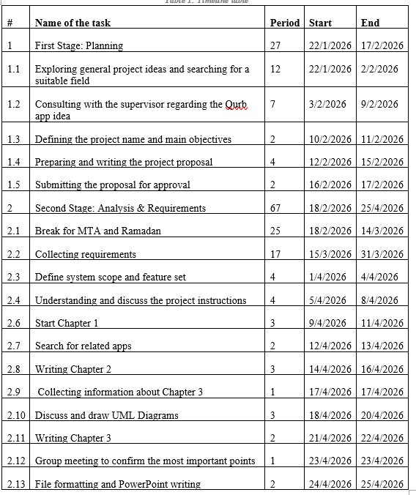

1.10 Gantt Chart

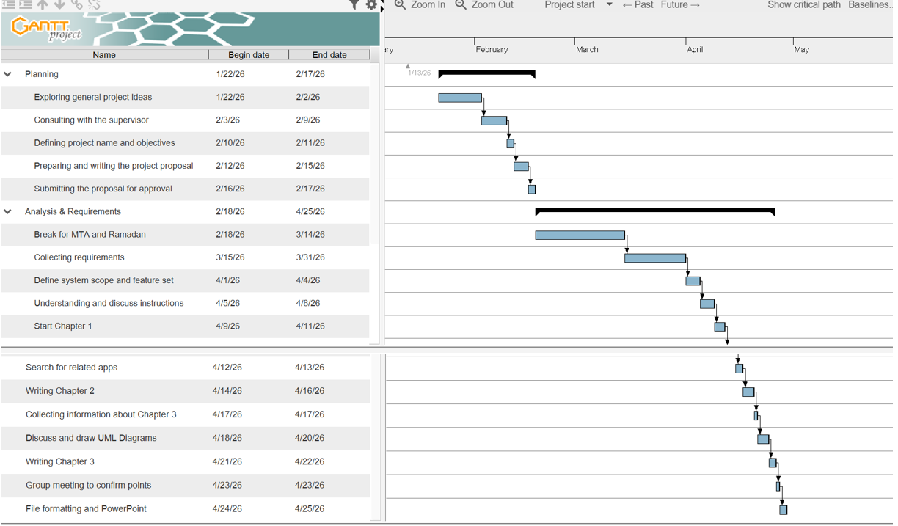
Figure 1 Gantt chart of the project

1.11 Structure of the Project
- Chapter 1: Outlines the problem statement, proposed solution, project scope, target users, limitations, aims, objectives, and overall project plan.
- Chapter 2: Explores related systems, highlights differences between this project and existing solutions, and presents a comparative analysis in table format.
- Chapter 3: Defines functional and non-functional requirements, and incorporates use case, activity, and class diagrams.
- Chapters 4, 5, and 6 are included in Part Two of the project.

Chapter 2: A Literature Review

2.1 Introduction
The Holy Quran occupies a central place in every Muslim's life, with memorization and regular review forming the foundation of a memorizer's journey. Consistent review directly reinforces retention and deepens the student's bond with the Book of Allah over time. With rapid technological advancement, digital applications have become a practical necessity in organising and scheduling review sessions to suit the demands of daily life. (Lubis، 2025)
The method of review itself significantly influences memorization quality. Educational research indicates that peer review surpasses individual review in reinforcing information and sustaining attention, as reviewing in front of a partner heightens focus and accountability while reducing forgetting rates. This makes the group Halaqa environment in the mosque an irreplaceable educational tool that individual review alone cannot replicate. (aslam، 2012)
This chapter reviews and analyses the most prominent systems related to Halaqa management, examining their features and limitations through an objective comparison with Qurb, to highlight the added value the project offers and clarify the gaps it seeks to address. (Shukri، 2020)


2.2 Related Works
Figure 2 Taahadou app

2.2.1 Taahadou Application
Taahadou is a virtual Quran memorization platform that connects students, teachers, and peers globally through four review modes: self-study, AI-powered recitation, peer review, and teacher-led recitation. It motivates users through badges, certified achievement certificates, and multilingual support across Arabic, English, French, and Urdu.
Advantages:
• Diverse Review Modes:
The platform offers four distinct pathways catering to learners of all levels, from beginners requiring close supervision to advanced students who prefer independent practice.
• Digital Motivation System:
Badges, leaderboards, and certified certificates endorsed by the Khairukum association promote healthy competition and encourage sustained daily engagement.
• Multilingual Support:
Interfaces in four languages make the platform accessible to Muslim communities in non-Arabic-speaking countries that lack native-language digital alternatives.
Disadvantages:
• No Behavioral Monitoring:
Without direct supervision, discipline depends entirely on personal motivation, which is particularly challenging for younger users who require consistent follow-up.
• High Technical Requirements:
The platform demands a stable internet connection and capable device, limiting its accessibility in areas with poor connectivity or restricted data plans.
• Manual Progress Reporting:
Users are responsible for self-reporting their own progress, which reduces the accuracy of statistics and weakens the effectiveness of personalized review plans.
Similarities with Qurb:
• Digital Record Management:
Both platforms replace paper-based tracking with automated digital systems that preserve each student's full learning history.
• Data-Driven Revision Plans:
Both analyze error logs to generate personalized review strategies that target actual weak points rather than relying on random repetition.
• Engagement Tools:
Both use smart notifications and digital leaderboards to maintain student connection to their curriculum and support consistent progress.
Differences from Qurb:
• System Philosophy:
Taahadou is a purely remote virtual platform, whereas Qurb is a hybrid system that bridges mosque-based learning with digital tools, making it more aligned with real-world field education.
• Geospatial Features:
Qurb incorporates an interactive GIS map enabling physical Halaqa discovery based on location — a feature entirely absent in Taahadou.
• Emergency Substitution:
Qurb resolves teacher absences through a real-time spatial matching system; Taahadou offers no intervention in the operational matters of physical learning environments.
.

Figure 3 National Volunteer Platform

2.2.2 National Volunteer Platform
The National Volunteer Platform is an official Saudi government initiative that connects organizations with individual volunteers through identity verification via the National Information Center, automated hour tracking, and government-linked certified certificates — directly supporting Vision 2030 targets. (National Volunteer Platform, n.d.)
Advantages:
• Official Certification:
Volunteer hours are automatically tracked and translated into government-certified certificates, adding measurable professional value to participants' records.
• Smart Opportunity Matching:
A filtering system aligns volunteers with suitable opportunities based on their skills, academic background, and geographic location.
• Security and Verification:
Integration with the National Information Center verifies both volunteer identities and organization eligibility, creating a trustworthy engagement environment.
Disadvantages:
• Bureaucratic Accreditation:
The lengthy approval process for new opportunities delays their availability and limits responsiveness to urgent community needs.
• No Internal Communication:
The absence of a built-in messaging system forces all coordination through external channels, increasing the risk of miscommunication..
Similarities :
• Geolocation-Based Matching:
Both leverage GPS technology to connect volunteers with nearby opportunities, reducing transportation barriers and directing resources efficiently.
• Verification Standards:
Both require credential verification before assigning volunteers to sensitive roles, reflecting shared institutional responsibility.
Differences :
• Specialization vs. Generality:
The National Platform covers all volunteer fields broadly; Qurb focuses exclusively on Quran Halaqa environments with purpose-built tools.
• Emergency Response:
Qurb resolves sudden teacher absences within minutes through real-time spatial matching; the National Platform relies only on pre-scheduled opportunities.
• Academic Continuity:
In Qurb, substitute teachers remain linked to student academic records; on the National Platform, involvement ends once volunteer hours are completed.

Figure 4 Maknon Map

2.2.3 Maknon Map
Maknon Map is an interactive geographical tool launched by the Maknon Quran Memorization Association in Riyadh, displaying the distribution of affiliated Halaqas using color coding and symbols. All locations are verified and linked directly to the association's official database.
Advantages:
• Visual Spatial Filtering:
Color coding and symbols allow users to quickly distinguish between center types, reducing the time needed to identify the most suitable learning environment.
• Data Reliability:
Every location is verified and accredited through direct integration with the Maknon Association's official database, giving parents confidence in listed centers.
• Planning Support:
Association management can monitor student density and center distribution to make data-driven decisions about expanding services into underserved neighborhoods.
Disadvantages:
• Limited Scope:
The map covers only Maknon Association centers within Riyadh, excluding all other associations and regions and preventing wider adoption.
• Static Data:
No live updates on seat availability or teacher attendance are provided, meaning parents may arrive to find a Halaqa full or a teacher absent.
• No Enrollment Integration:
Users cannot complete registration through the map, requiring additional steps outside the platform that may reduce actual enrollment completion rates.
Similarities with Qurb:
• Geospatial Discovery:
Both platforms use interactive map technology as a primary interface for connecting users to nearby Halaqas, recognizing geographic proximity as a key enrollment driver.
• Digital Directory:
Both provide a verified digital reference to help families find available Halaqas, reducing reliance on word-of-mouth or fragmented search methods.
Differences from Qurb:
• Live vs. Static Map:
Maknon Map is a fixed location reference; Qurb provides a real-time map reflecting current Halaqa status and operational availability.
• Emergency Management:
Qurb's substitution system resolves teacher absences through geolocation matching; Maknon Map offers no operational or logistical functionality beyond location display.
• Administrative Integration:
Qurb connects its map to enrollment, academic tracking, and the parental dashboard; Maknon Map remains a standalone tool.

Figure 5 C-Iqraa (Classera)

2.2.4 C-Iqraa (Classera)
C-Iqraa is a product by Classera that adapts a general-purpose LMS for Quran memorization contexts. It supports roles including teachers, students, parents, and mosque managers, and offers virtual classrooms, digital libraries, and a points-based motivation system.
Advantages:
• Comprehensive Dashboard:
Administrators can manage student files, design personalized study plans, and prepare examinations from a single unified management panel.
• Virtual Learning Support:
The platform supports electronic recitation circles, digital libraries, and recorded sessions, enabling learning to continue beyond the physical mosque.
• Certification and Motivation:
A structured points and rewards system incentivizes students throughout their journey, culminating in officially recognized achievement certificates.
Disadvantages:
• Generic LMS Rebranded:
C-Iqraa was built for schools and corporations, not Halaqas. It lacks field-level capabilities such as teacher substitution, neighborhood monitoring, or geographic discovery.
• Poor Multi-Child Management:
Families with more than one enrolled student find it difficult to switch between accounts, making simultaneous monitoring frustrating and time-consuming.
Similarities with Qurb:
• Digital Progress Tracking:
Both replace paper-based tracking with structured digital records documenting memorization progress, review sessions, and academic performance.
• Parental Monitoring:
Both provide parents with a dedicated interface to monitor their children's progress and receive performance reports.
• Motivation Through Data:
Both use performance indicators and visual progress tools to help students maintain commitment toward the long-term goal of Quran completion.
Differences from Qurb:
• Purpose-Built vs. Repurposed:
Qurb was designed from the ground up for Halaqa environments; C-Iqraa is a general LMS that does not recognize Halaqa-specific operational needs as problems.
• Emergency Substitution:
Qurb automatically assigns the nearest certified volunteer upon teacher absence without manual intervention; C-Iqraa offers no response to teacher absence.
• Geospatial Discovery:
Qurb's interactive map allows parents to discover, evaluate, and register for nearby Halaqas; C-Iqraa operates only within pre-established institutional boundaries.

2.3 Comparison Between Related Works and Qurb
The following table summarizes the key feature differences between Qurb and the four reviewed systems:

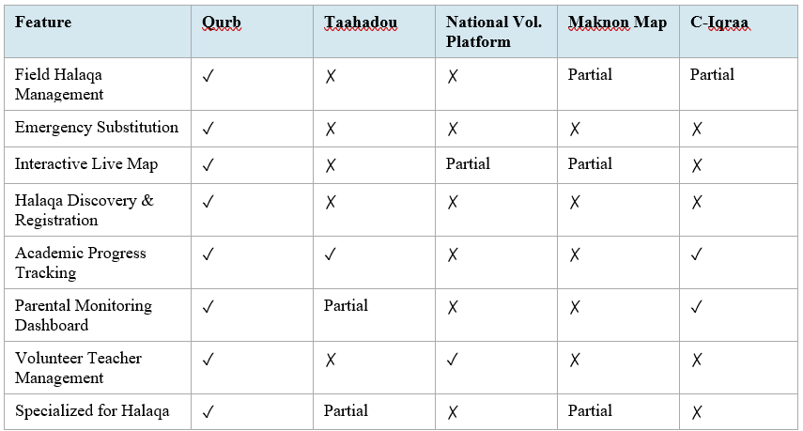 Table 2 Comparison Between Related Works and Qurb

2.4 Chapter Summary
This chapter examined four systems relevant to Qurb ,The analysis demonstrated that while each system addresses certain aspects of the memorization experience, none integrates geographic discovery, emergency substitution, academic tracking, and parental monitoring into a single cohesive platform. This gap positions Qurb as a comprehensive smart ecosystem that uniquely combines all these dimensions, delivering operational and educational value that no existing system provides on its own.

Chapter 3: The Team Members and their Responsibilities

3.1 Introduction
This chapter presents the technical analysis phase of Qurb, covering the requirements necessary for its development. The process began with stakeholder interviews — including teachers, students, parents, and the technology officer at Khairukum Association — to uncover real-world challenges within Quranic education. These findings informed the classification of both functional and non-functional requirements, ensuring the system is efficient, usable, and field-ready.
The chapter further covers the system's structural and behavioral models: the Use Case Diagram defines system boundaries and user interactions, the Activity Diagram illustrates the logical flow of operations, and the Class Diagram establishes the data infrastructure and relationships between system entities.

3.2 Data Collection Results
To ensure Qurb addresses genuine gaps in Quranic education, data was gathered through field interviews with key stakeholders and a consultation session with the technology officer at Khairukum Association. The findings were organized into five strategic dimensions:
• Discovery Gap:
Parents and students reported fragmented search methods and the absence of a centralized spatial database, resulting in disorganized registration. An interactive GIS-based map was identified as the essential solution to transform Halaqa discovery into a seamless spatial experience.
• Educational Continuity:
Teacher absences frequently lead to session cancellations due to slow manual coordination. Spatial substitution logic was concluded to be necessary, automatically matching vacant sessions with the nearest approved volunteer in real time.
• Smart Review Assistance:
Students lack structured home review tools after leaving the mosque, as verbal feedback is often forgotten. This led to developing an analytical engine that converts Halaqa session records into automated weekly personalized review plans.
• Parental Transparency:
Parents expressed dissatisfaction with non-digital documentation, feeling disconnected from their children's progress. A real-time parental dashboard was identified as a critical requirement for accurate and instant monitoring.
• Specialization vs. General Platforms:
General systems like Classera lack memorization-specific pedagogical tools. Qurb fills this gap as a purpose-built platform tailored to the unique spiritual and technical needs of Quran study circles.

3.3 Functional Requirements (FR)
These requirements define the processes and services the system must deliver, divided into business and technical perspectives.

3.3.1 Business Requirements
• Halaqa Discovery:
Students and parents can locate geographically available Halaqas and select the most suitable mosque based on their location.
• Intelligent Revision Guidance:
Students receive smart guidance highlighting areas needing greater focus during home review, derived from their actual performance data.
• Real-Time Parental Monitoring:
Parents are provided with real-time visibility into their child's daily attendance and academic progress for continuous monitoring.
• Session Continuity:
Halaqa continuity is guaranteed during teacher absence by rapidly connecting the session with approved substitute teachers.

3.3.2 Technical Requirements
• Geospatial Processing:
GPS coordinates are processed using PostGIS to calculate accurate distances between users and nearby mosques.
• Capacity Verification:
Halaqa capacity is verified programmatically before enrollment requests are forwarded to the supervisor.
• Automated Error Analysis:
Daily error logs covering recitation, memorization, and fluency are automatically analyzed to update each student's learning file.
• Role-Based Access Control:
A role-based access layer ensures data security and privacy across all user types.
• Personalized Scheduling:
Customized review schedules and periodic alerts are automatically generated based on each student's daily performance.
• Automatic Substitution:
Substitute teachers are automatically assigned to Halaqas experiencing sudden teacher absences.

3.4 Non-Functional Requirements (NFR)
These requirements establish the quality and performance benchmarks that underpin the system's long-term success and operational continuity in real-world field conditions.

3.4.1 Usability
• Inclusive Design:
Full Arabic language support and an intuitive interface suitable for children and elderly users are required to ensure broad accessibility.

3.4.2 Performance
• Map Loading Speed:
Map loading and marker placement must complete within 3 seconds to ensure a smooth and responsive user experience.

3.4.3 Security and Privacy
• Data Encryption:
All student data and assessment records must be encrypted both in transit and at rest to protect sensitive information.
• Session-Based Access:
Volunteer teacher access to student records expires automatically upon session completion, preventing unauthorized data retention.

3.4.4 Support and Maintenance
• Technical Support:
A dedicated support team must be available throughout official Halaqa hours to address any issues that could disrupt the educational process.

3.4.5 Cultural Compliance
• Gender Validation:
Strict gender validation must be enforced during registration, with female Halaqa maps and data visible exclusively to authorized female users in accordance with cultural privacy standards.

3.5 Use Case Diagram
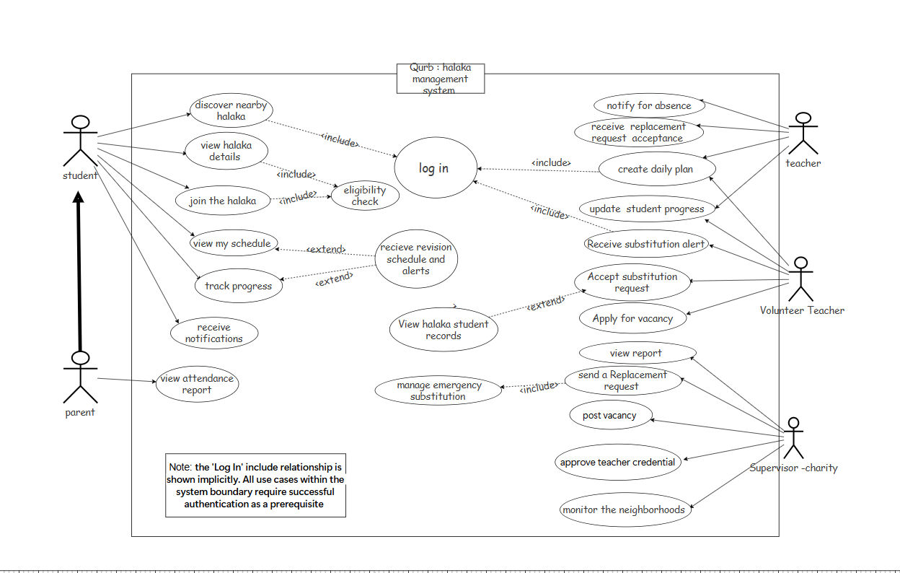
Figure 6 Use case Diagram

The use case diagram illustrates the interactions between users and the Qurb system — a Halaqa management platform connecting students, parents, teachers, volunteer teachers, and charity supervisors within a unified digital environment. The system involves five main actors, each interacting according to their role and responsibilities.

3.5.1 Actors and Interactions
• Student:
The primary beneficiary of the system. The student can discover nearby Halaqas, view Halaqa details, and join after passing an eligibility check. Once enrolled, the student can view their personal schedule, receive revision schedules and alerts, track their progress, and receive system notifications.
• Parent:
Shares a generalisation relationship with the student, inheriting relevant interactions. The parent's dedicated function is viewing attendance reports, keeping them informed about their child's engagement and regularity within the Halaqa.
• Teacher:
Holds the core instructional role. After logging in, the teacher can notify the system of their absence, receive replacement request acceptances, create daily lesson plans, and update student progress records to ensure educational continuity.
• Volunteer Teacher:
Serves as a backup instructional resource. Can receive substitution alerts, accept requests to cover absent teachers, and apply for open vacancies within the system.
• Supervisor-Charity:
Responsible for full administrative oversight. Can view reports, send replacement requests, post vacancies, approve teacher credentials, and monitor neighbourhoods to ensure appropriate geographic coverage.

3.5.2 Central System Functions
• Log In:
A core security function required across all system features, ensuring only authorised users access their respective functionalities. All use cases within the system boundary require successful authentication as a prerequisite.
• Eligibility Check:
Included in the Join the Halaqa use case, ensuring students meet required criteria before enrolment is processed.
• Receive Revision Schedule and Alerts:
Extended by both 'View My Schedule' and 'Track Progress,' providing students with automated reminders and structured revision timelines based on their performance data.
• View Halaqa Student Records:
Accessible through the managed emergency substitution flow, allowing authorised users to review attendance, progress, and enrolment data for the affected Halaqa.
• Manage Emergency Substitution:
A central supervised workflow triggered upon teacher absence. It includes the Send a Replacement Request function and extends to View Halaqa Student Records, coordinating
between the supervisor and volunteer teachers to ensure uninterrupted Halaqa sessions.

3.5.3 Use Case Scenario
The following table describes the main success scenario for the emergency substitution use case, which represents the most critical operational flow within the Qurb system.

Identifier and Name | Manage Emergency Substitution
Initiator | Teacher (via absence notification)
Goal | To ensure Halaqa continuity by automatically finding and assigning a qualified volunteer teacher when the assigned teacher is absent.
Precondition | The teacher is registered in the system, the Halaqa session is scheduled, and at least one volunteer teacher is available and registered.
Postcondition | A volunteer teacher is successfully assigned to the Halaqa session and all relevant parties are notified.
Assumptions | Internet connectivity is available, the supervisor has an active account, and volunteer teachers have completed their profiles and are marked as available.
Main Success Scenario | 1. Teacher logs in and submits an absence notification.  2. System records the absence and flags the affected Halaqa session.  3. The system automatically triggers the emergency substitution workflow.  4. Supervisor receives a notification and sends a replacement request. 5. System identifies available volunteer teachers based on location and qualifications.  6. A substitution alert is sent to eligible volunteers.  7. A volunteer accepts; system confirms the assignment, updates records, and notifies students and parents.
Extensions | E1 – No Volunteer Available: System escalates to the supervisor for manual resolution or rescheduling. E2 – Volunteer Declines: System automatically alerts the next available volunteer in the queue. E3 – Supervisor Unresponsive: System sends an automatic reminder and logs the delay for accountability reporting.
Table 3 Use Case Scenario

3.6 Activity Diagram
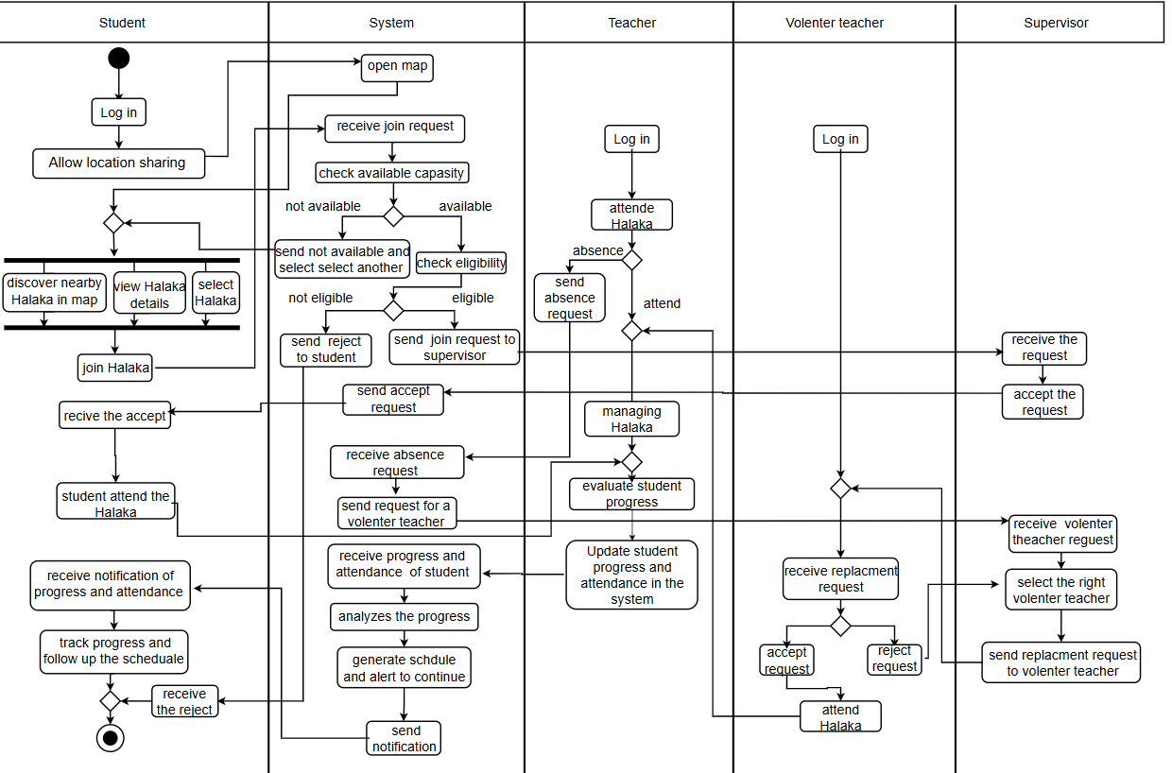
Figure 7 Activity Diagram

The activity diagram illustrates the end-to-end operational workflow of Qurb across five primary actors: Student/Parent, Qurb System, Teacher, Volunteer Teacher, and Supervisor. (See Figure 7)
• Discovery and Validation Phase:
The workflow begins when the student opens the GIS map to discover nearby Halaqas. Upon submitting a join request, the system automatically verifies capacity and eligibility — forwarding approved requests to the supervisor while rejecting or redirecting ineligible ones.
• Emergency Substitution Mechanism:
When a teacher reports an absence, the system triggers the substitution workflow. A spatial query identifies certified volunteers within the geographic vicinity, and the supervisor selects the most suitable candidate to ensure uninterrupted session continuity.

3.7 Class Diagram
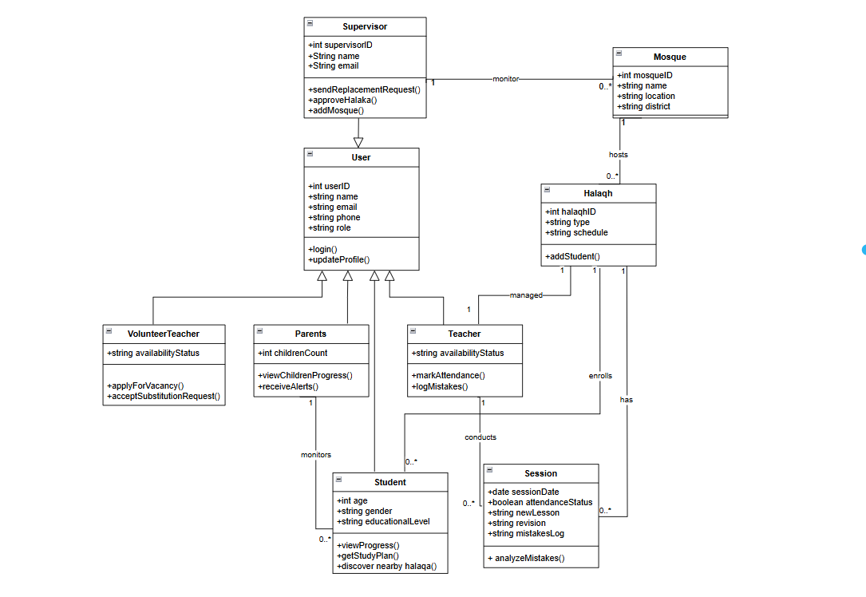
Figure 8 Class Diagram

The UML class diagram represents the data structure of the Halaqa Management System. The system is built around a base User class from which four roles inherit: Supervisor, Teacher, Parents, and VolunteerTeacher. Each Mosque hosts one or more Halaqas, which are managed by a Teacher and enrolled in by Students. The Session class captures each class's details including attendance, new lessons, revisions, and mistake logs. Together, these classes model a complete educational management flow connecting all stakeholders within a structured Islamic learning environment. (See Figure 8)

3.8 Software Requirements
To ensure high performance, scalability, and seamless GIS integration, the following technologies were selected:
• Operating System:
Windows 11 / macOS for the development environment.
• Frontend Framework:
Flutter (Dart) for a unified cross-platform experience across Android and iOS.
• Backend Environment:
Python (FastAPI) for managing the analytical engine and handling concurrent requests efficiently.
• Database:
PostgreSQL with PostGIS extension for advanced spatial and geographical data management.
• Geospatial Services:
Google Maps API for interactive map rendering and real-time location tracking.
• Push Notifications:
Firebase Cloud Messaging (FCM) for real-time alerts to parents and students.

3.9 Hardware Requirements
• Development Machine:
A workstation with a minimum of 16GB RAM and an Intel Core i7 processor to support mobile emulation and backend processing workloads.
• Client Devices:
GPS-enabled smartphones running Android or iOS with stable internet connectivity are required for end-user access.
• Server Hosting:
Cloud-based infrastructure such as AWS or Google Cloud to maintain a minimum availability of 99.5% and ensure data integrity.

3.10 Chapter Summary
This chapter established a comprehensive analytical foundation for the Qurb system. Through a structured fact-finding process involving teachers, students, and technical stakeholders, critical deficiencies in existing platforms were identified and translated into well-defined functional and non-functional requirements.
The system's architecture was formalized through three complementary models: the Use Case Diagram, defining system boundaries and actor interactions; the Activity Diagram, illustrating operational workflows; and the Class Diagram, capturing the underlying data structures and relationships. Together, these models form a definitive blueprint guiding the subsequent design and implementation phases.

References

Bibliography
- Al-Bukhari, M. & Muslim, A. A.-H., n.d. Sahih Al-Bukhari and Sahih Muslim. s.l.:Standard Islamic Scholarly Compilations.
- Ar, M. S., 2017. تطبيق طريقة تكرار لترقية جودة حفظ القرآن في معهد روضة العلوم الثاني بفتوكرجوا كوندانكلكي. s.l.:s.n.
- aslam, m., 2012. "E-hafiz: Intelligent system to help muslims in recitation and memorization of Quran." ‏. s.l.:s.n.
- Lubis, A. H., 2025. "An Innovative Community-Based Model of Flexible Qur’an Memorization in Rural Indonesia.". s.l.:s.n.
- Platform, N. V., n.d. National Volunteer Platform. Kingdom of Saudi Arabia: s.n.
- Shukri, N. H. A. M. K., 2020. " International Journal of Academic Research in Progressive Education and Development ". s.l.:s.n.
- Wijaya, A. C., 2024. "The Effectiveness of Traditional and Modern Memorization Techniques for Quranic Learning in Indonesia." .‏. s.l.:s.n.

Appendix

Appendix A: Methodology and Environment
Research Methodology: Semi-structured qualitative interviews.
Field Environment: Face-to-face interviews conducted within mosque Halaqa settings to capture authentic operational context.
Communication Channels: Hybrid approach combining in-person meetings with WhatsApp for follow-up inquiries and parent communication.

Appendix B: Stakeholders and Interview Duration
The following table summarises the stakeholder groups engaged during the data collection phase, along with the methods and settings used for each:

Role | Count | Methods | Interaction Setting | Average Duration
Quran Teachers | 3 | Semi-structured Interviews | Mosque Halaqas & WhatsApp | 30 – 40 Minutes
Students | 2 | Semi-structured Interviews | Mosque Halaqas | 20 – 25 Minutes
Technical Lead | 1 | Technical Consultation | Office & WhatsApp | 45 – 60 Minutes
Parents | 1 | Qualitative Inquiry | WhatsApp (Text Messaging) | Continuous (Text)
Table 4 Stakeholders and Interview Duration

Appendix C: Interview Question Samples

Appendix C.1 — Group 1: Students and Parents (Discovery and Education)
- How do you currently find a new Halaqa? Do you find existing maps such as Maknon interactive enough?
- How much time do you spend searching for a suitable Halaqa before registering?
- What is the biggest challenge you face when reviewing at home?
- Is teacher feedback verbal or written, and how does this affect your recall?
- Would a digital assistant tracking your progress and generating revision plans motivate you to review consistently?

Appendix C.2 — Group 2: Tech Administrator and Teachers (Operations and the Tech Gap)
- What is your professional opinion of Qurb compared to general-purpose platforms like Classera?
- Why do systems like Classera fail to meet the specific needs of Quran memorization circles?
- What criteria are used when selecting a substitute teacher — proximity, availability, or qualification?
- Based on your experience, how difficult is it for parents to find a suitable Halaqa currently?
- How do you assess the importance of an interactive GIS-based map as a core feature of this project?
- How would automating the conversion of session assessments into revision plans reduce your daily administrative workload?

