**CHAPTER ONE**

**1.0 INTRODUCTION**

**1.1 BACKGROUND OF STUDY**

A school timetable is a table for coordinating these four elements which [Students](https://en.wikipedia.org/wiki/Student), [Teachers](https://en.wikipedia.org/wiki/Teacher), [Rooms](https://en.wikipedia.org/wiki/Classroom) and [Time slots](https://en.wikipedia.org/wiki/Period_%28school%29) (also called periods). School timetables usually cycle every week or every fortnight. The phrase "school timetables" largely refers to high schools, because primary schools typically have simple structures.

[High school](https://en.wikipedia.org/wiki/High_school) timetables are quite different from [university](https://en.wikipedia.org/wiki/University) timetables. The main difference is the fact that in high schools, students have to be occupied and supervised every hour of the school day, or nearly every hour. Also, high school teachers generally have much higher teaching loads than is the case in universities. As a result, it is generally considered that university timetables involve more human judgment whereas high school timetabling is a more computationally intensive task,

Timetable production is a periodic activity carried out in many academic institutions. Each year, they produce one or more timetables for their courses and exams. Computers can help significantly reduce production costs. In certain cases, automation starts with the use of timetabling software; in others, with the automatic processing of the data related with the work of the institution, for example the follow-up of students. Some software applications, such as Diamant are designed to carry out timetable construction, but there are many others.

In general, timetable software uses one or more files as input, and one or more files as output. Working with files generates problems. It is necessary to build input files each time a timetable is produced. There are two ways of producing those files: manually or automatically. If the files are produced manually, typing errors can occur. Such errors can produce unexpected effects in the software. Furthermore, they are very hard to detect, because all the data have to be checked manually. In the other case, the files are produced in an automatic way. Then, the software must check the validity and the coherence of all the data. Another source of problems, and even more expensive than the former one, is when a change is introduced into the system, either in the construction software, in the production software or in both. The change could originate from persons in charge in the institution, for example a new nomenclature for the buildings, a new teaching approach, or anything which can affect the way of creating groups, etc.

The problem of modifying software is not solely limited to timetable production software; it is a general problem in software development. The solution to the first problem rests upon the automation of data checking and data validation at the time of data acquisition, in order to ensure that the construction software will work with the right data.

The second problem is more difficult to solve. With a production software system designed to be modified (i.e. extensible), the cost of a modification is low, but if the system is monolithic and closed, any modification will be very expensive. A way of minimizing the effects of this problem he development of software featuring extensibility. In this article, we propose a timetable production system architecture for courses and exams having the following qualities: openness and extensibility. This architecture represents an easy solution to the two problems mentioned above. It reduces the cost of modifications, performs data checking and validation in precise stages of the process, and prevents redundancy of both code and data.

* 1. **MOTIVATIONS**

The motivation to develop this web based timetable management System came from the fact that Lecture Timetable Scheduling is still mostly done manually due to its inherent difficulties polytechnics and other academic institutions are supposed to make time tables for each semester or term. Manually creating timetables is a very boring, tedious and a pain staking job. Hence the project’s idea to computerize this hectic process.

* 1. **OBJECTIVES OF THE STUDY**

The main objective of developing the Web based Timetable is to have a quality and feasible timetable which is to improve the current system that Mapoly Computer science department is using. Another objective is the system should be user-friendly and easy to maintain. The system produced should be easily modified to address any form of constraints in an actual situation. The system should also be robust and produce a feasible solution for any big problem.

* 1. **SCOPE OF THE STUDY**

The scope of this system is to develop Mapoly Computer Science Department timetable management system, which can improve the current manual system that Mapoly Computer science department is using. In order to achieve the objectives, due to the time constraints, the scope of the timetable system covers the following features and functions: -

An administrative Section which includes the following:-

* Manage students’ profiles
* Manage lecturers’ profile
* Manage the add, delete, and edit room
* Manage the add, delete, and edit course
* Manage the add, delete, and edit timeslot
* Manage the username, password and change password
* Manage the add, edit and drop subject
* Manage the add, edit and delete class

At Students Section which includes the following:-

* Register to gain access the timetable
* View and print their timetable
* Manage personal information and change password.

**1.5 EXISTING PROBLEM OF THE SYSTEM**

The existing system is manual system. Needs to be converted into automated system

* Risk management of data
* less security
* No proper coordination between different application and users.
* Fewer users-friendly
* Accuracy not guaranteed.
* Not in reach of distant users.
  1. **SOLUTION APPROACH**

The development of the new system contains the following activates, which try to automate the entire process keeping in view of the database integration approach.

1. User friendliness is provided in the application with various controls.
2. The system makes the overall project management much easier and flexible.
3. There is no risk of data mismanagement at any level while the project development is under process.
4. it provides high level of security with different level of authentication
5. Users from any part of the world can make use of the system
6. New system will process accurate result.
7. New system will be much better in performance as compared to existing one.
   1. **LIMITATION OF THE STUDY**

The current manual timetable system is use by the department of computer science. This

manual system will make sure there are no clashes for the every timetable produced.

The current timetable always change and involved many lecturer to handle it. Its taking too much of their time. The conclusion is that they need a system to help and improve the process of preparing the timetable

* 1. **DEFINITIONS OF TERMS**

1. **School Timetable:** is a table for coordinating these four elements: Students. Teachers. Rooms and Time slots.
2. **Time management:** is the act or process of [planning](https://en.wikipedia.org/wiki/Planning) and exercising conscious control over the amount of time spent on specific activities, especially to increase [effectiveness](https://en.wikipedia.org/wiki/Effectiveness), [efficiency](https://en.wikipedia.org/wiki/Efficiency) or [productivity](https://en.wikipedia.org/wiki/Productivity).
3. **Timetable:** is aschedule (something) to take place at a particular time.
4. **Class schedule:** provide easy access *to* courses offered by academic departments, including undergraduate, graduate/professional schools, continuing education, and summer sessions.
5. **Timeslot:** is a conventionally defined time interval in a schedule.
6. **Course management:** is a platform that enables the instructor to manage course title, course unit, course description, course code and post it on the Web without having to handle HTML or other programming languages.
7. **Staff management:** is the management of subordinates in an organization.
8. **Lecture:** is an educational talk to an audience, especially one of students in a university.
9. **Web based System:** is an information **system** that uses Internet **web** technologies to deliver information and services, to users or other information **systems**/applications.
10. **Capacity:** this refers to the number of students a room will accommodate.
11. **Scheduling:** This is the process of actually timetabling events or lessons.
12. **Curriculum:** is often defined as the courses offered by a school, but it is rarely used in such a general sense in schools.

**CHAPTER TWO**

**2.0 LITERATURE REVIEW**

**2.1 HISTORICAL BACKGROUND OF THE STUDY**

A large number of variants of the timetabling problem have been proposed in the literature, which differ from each other based on the type of institution (university or school) involved and the type of constraints. We classify the timetabling problems into three main classes:

* School timetabling: The weekly scheduling for all the classes of a school, avoiding teachers meeting two classes at the same time, and vice versa;
* Course timetabling: The weekly scheduling for all the lectures of a set of university courses,
* minimizing the overlaps of lectures of courses having common students;
* Examination timetabling: The scheduling for the exams of a set of university courses, avoiding overlap of exams of courses having common students, and spreading the exams for the students as much as possible.

Based on this classification, we develop a separate discussion for each of the three problems and we devote a section to each of them. However, such classification is not strict, in the sense that there are some specific problems that can fall between two classes, and cannot be easily placed within the above classification. For example, the timetabling of a specific school which gives large freedom to the student regarding the set of courses can be similar to a course timetabling problem (A. Schaerf, 1999).

In some cases, the timetabling problem consists of finding any timetable that satisfies all the constraints. In these cases, the problem is formulated as a search problem. In other cases, the problem is formulated as an optimization problem. That is, what is required is a timetable that satisfies all the hard constraints and minimizes (or maximizes) a given objective function which embeds the soft constraints. As shown later, in some approaches, the optimization formulation is just a means to apply optimization techniques to a search problem. In this case, what is minimized is the so-called distance to feasibility. Even when the problem is a true optimization problem, the distance to feasibility may be included in the objective function. This is generally done to facilitate the search for the best solution. In both cases (search and optimization), we define the underlying problem, which is the problem of deciding if there exists a solution, in the case of a search problem, and the problem of deciding if there exists a solution with a given value of the objective function, in the case of an optimization problem. When we mention the complexity of the problem, we refer to the complexity of the underlying decision problem (A. Schaerf, 1999).

As we will see later, the underlying problem is NP complete in almost all variants. Therefore, an exact solution is achievable only for small cases (e.g., less than 10 courses), whereas real instances usually may involve a few hundreds of courses. It follows that only heuristic methods (Pearl, 1984) are feasible, which have not guaranteed to reach the (optimal) solution.

Most of the early techniques (Schmidt and Strohlein, 1979) were based on a simulation of the human way of solving the problem. All such techniques, that we call direct heuristics, were based on a successive augmentation. That is, a partial timetable is extended, lecture by lecture, until all lectures have been scheduled. The underlying idea of all approaches is “schedule the most constrained lecture first", and they differ only on the meaning they give to the expression `most constrained'. Later on, researchers started to apply general techniques to this problem. We therefore see algorithms based on integer programming, network flow, and others. In addition, the problem has also been tackled by reducing it to a well-studied problem: graph coloring. More recently, some approaches based on search techniques used also in Artificial Intelligence appeared in the literature; among others, we have simulated annealing, tabu search, genetic algorithms, and constraint satisfaction. In this research, the solution techniques are surveyed, putting the emphasis on the most recent approaches in general, and on Artificial Intelligence techniques in particular. Notice that included in the list of techniques also are some items, e.g., logic programming, which are general tools for the development of the solution, rather than real solution techniques. In those cases, specified also is the technique implemented using the given tool. Many authors believe that the timetabling problem cannot be completely automated. The reason is twofold: On the one hand, there are reasons that make one timetable better than another one that cannot easily be expressed in an automatic system. On the other hand, since the search space is usually huge, a human intervention may bias the search toward promising directions that the system by itself might be not able to find. For the above reasons, most of the systems allow the user at least to adjust manually the final output. Some systems however, require a much larger human intervention, so that we call them interactive (or semi-automatic) timetabling systems (A. Schaerf, 1999).

Trying to develop a web based software which helps to generate Timetable for an Institution automatically. By looking at the existing system we can understand that timetable generation is done manually. Manually adjust the timetable when any of the faculty is absent, and this is the big challenge for Automatic Timetable Generator that managing the timetable automatically when any of the faculty is absent. As we know all institutions) organizations have its own timetable, managing and maintaining these will not be difficult. Considering workload with this scheduling will make it more complex. As mentioned, when Timetable generation is being done, it should consider the maximum and minimum workload that is in a college. In those cases timetable generation will become more complex. Also, it is a time consuming process.

**2.2 TIMETABLE SOLUTION GENERATION ALGORITHMS**

**2.2.1 TABU SEARCH**

Tabu search is a local search technique designed to solve optimization problems (Glover, 1989; Glover and Laguna, 1993). Local search techniques are based on the notion of neighbour: Given an optimization problem P, let S be the search space of P, and let f be the objective function to minimize (the case of maximization problems is analogous). A function N, which depends on the structure of the specific problem, assigns to each feasible solution s є S its neighbourhood N(s) C S. Each solution ś є N(s) is called a neighbour of s.

A local search technique, starting from an initial solution sinit, which can be obtained with some other technique or generated at random, the algorithm enters in a loop that navigates the search space, stepping from one solution to one of its neighbours. The connectivity of the search space, w.r.t. the neighbour relation, is a necessary condition for the technique to work effectively.

In tabu search, the algorithm explores a subset V of the neighbourhood N(s) of the current solution s; the member of V that gives the minimum value of the objective function becomes the new current solution independently of the fact that its value is better or worse than the value in s.

In order to prevent cycling, there is a so-called tabu list, which is the list of solutions to which it is forbidden to move back. It is the list of the last k current solutions, where k is a parameter of the method, and it is run as a queue; that is, when a new solution is added, due to a move, the oldest one is discarded.

There is also a mechanism that overrides the tabu status of a solution: If a solution gives a large improvement of the objective function, then its tabu status is dropped and the solution is accepted as new current one. More precisely, we define an aspiration function A that, for each value of the objective function, returns another value for it, which represents the value that the algorithm aspires to reach from the given value. Given a current solution s, the objective function f, and the best neighbour solution ś, if f (ś) < A (f(s)) then ś becomes the new current solution, even if ś is a tabu move.

The procedure stops either when the number of iterations reaches a given value or when the value of the objective function in the current solution reaches a given lower bound. The main control parameters of the procedure are the length of the tabu list k, the aspiration function A and the cardinality of the set V of neighbour solutions tested at each iteration.

**2.2.2 SIMULATED ANNEALING**

Simulated annealing is a probabilistic local search technique for finding solutions to optimization problems. It has been proposed by Kirkpatrick et al. (1983) and extensively studied by van Laarhoven and Aarts, Aarts and Korst (1987, 1989). Its name comes from the fact that it simulates the cooling of a collection of hot vibrating atoms. The process starts by creating a random initial solution. The main procedure consists of a loop that generates at random at each iteration a neighbour of the current solution. Like for tabu search, the definition of neighbour depends on the specific structure of the problem.

**2.2.3 TILING ALGORITHMS**

A tiling algorithm collects the classes to be scheduled into clusters known as tiles. Each of these tiles hold classes which can run simultaneously; these tiles are then assigned times using a separate search algorithm of some kind. This approach was used with some degree of success (Kingston, 2005), but only in situations such as that in a high school where several classes of students sit the same subject simultaneously. These groups of classes are clustered into the tiles for scheduling – this does not tend to happen in a university timetable where cohort groups sit far more varied courses.

**2.2.4 AGENTS**

Multi Agent Systems, such as that described by Kaplansky (Kaplansky, 2004), employ several software agents communicating with each other working towards different goals. Each agent can be set up to view the timetable from a different perspective and amends it until a stable timetable satisfying all agents is found.

**2.2.5 LINEAR/INTEGER PROGRAMMING**

The Linear and Integer Programming techniques, the first applied to timetabling, were developed from the broader area of mathematical programming. Mathematical programming is applicable to the class of problems characterised by a large number of variables that intersect within boundaries imposed by a set of restraining conditions (Thompson, 1967). The word "programming" means planning in this context and is related to the type of application (Feiring, 1986). This scheme of programming was developed during World War II in connection with finding optimal strategies for conducting the war effort and used afterwards in the fields of industry, commerce and government services (Bunday, 1984).

Linear Programming (LP) is that subset of mathematical programming concerned with the efficient allocation of limited resources to known activities with the objective of meeting a desired goal such as maximising profits or minimising costs (Feiring, 1986). Integer Programming (IP) deals with the solution of mathematical programming problems in which some or all of the variables can assume non-negative integer values only. Although LP methods are very valuable in formulating and solving problems related to the efficient use of limited resources they are not restricted to only these problems (Bunday, 1984). Linear programming problems are generally acknowledged to be efficiently solved by just three methods, namely the graphical method, the simplex method, and the transportation method (Palmers and Innes, 1976; Makower and Williamson, 1985). The construction of a linear programming model involves three successive problem-solving steps. The first step identifies the unknown or independent decision variables. Step two requires the identification of the constraints and the formulation of these constraints as linear equations. Finally, in step three, the objective function is identified and written as a linear function of the decision variables.

**CHAPTER THREE**

**3.0 SYSTEM DESIGN METHODOLOGY**

**3.1 DATA COLLECTION METHODS**

The purpose of data is to obtain information to keep on records, to make decisions about important issues, to pass information on to others. In the course of this project, the various method of data collection used in gathering necessary facts and information needed to design and implement this project are:-

* **EXPERIMENTAL METHOD**

This was done by attracting patients to interact with the system. The result of this method will be analyzed to make easy and robust in comparing the result of the existing system.

* **DIRECT INTERVIEW**

This method is used to gather facts and information by carrying out one-on-one analysis with the respondent in other to get their opinion on certain issues like that of the existing system. To realize this, there was series of meeting and interrogating with some of the staff and students of the computer science department, Mapoly. This was done to know about their impression about the existing system and how to improve it.

* **INTERNET CONSULTATION**

This method was carried out by gathering information on the web. This method was adopted because internet has always been a platform for learning and it’s therefore provides us vital information about the system and the existing one.

**3.2 DESIGN APPROACH**

The application software has to do with developing of a web application which is an internet platform and also be could an intranet platform. This project application consist of different pages which are linked together to establish a connection between those pages. The pages were developed using PHP (Hypertext Preprocessor), which was formerly called “Personal Homepage”. The database that was used as the data store is named as “Timetable” which was created using MYSQL. The design of this web-based timetable includes the following; input to the system, the process and the output from the system.

**3.2.1 INPUT TO THE SYSTEM:** The input to this system includes the following

* Input of the personal details of the student: This consists of the data like the matric number which is the unique identifier of the student and password which is the login credential together with the username. The student such as first name, surname, email, phone number, student picture, level, programmer, stream and session year are also stored.
* Input of data of the new staff: This input consists of data of course staff. The data includes “surname, first name, phone number, staff picture, gender and marital status.. The system is designed to generate a unique Staff ID Number after a new staff has been registered or added to the database. The Staff ID is the identifier to refer to any staff registered

**3.2.2 PROCESS OF THE SYSTEM:** The process of the system includes the following:

* Accepting student’ details and saving them into the database.
* Accepting of staff details and saving them into the database.
* Accepting of course details and saving them into the database.
* Accepting of timeslot details and saving them into the database.
* Scheduling of the timetable and saving them into the database.

**3.2.3 OUTPUT OF THE SYSTEM:** Output from the system includes the following:

* Student ID for newly registered student.
* Staff ID for newly registered staff.

**3.3 DESIGN APPROACH**

The purpose of system design is to provide detailed information about the new system to be built. System design begins with the analysis of the system model and then transforming them into the three following levels of system design details, which are:\

1. Database Design
2. User Interface Design
3. Program Design

There are two (2) major phases which links to other pages in this design, they are:

* **WELCOME PAGE OR HOMEPAGE**

The welcome page or homepage is a page that consists of a quick link to other pages like public timetable, login and forget password. Figure 3.1 below illustrates this

**Figure 3.1: Home Page Diagram**

* **ADMIN PAGE**

This is the page that contains the details of every patient. The admin page also links to other pages like Home page, catalog, orders, customers, price rules, Shipping, Administration, Preferences and log out. Figure 3.2 below illustrates the dashboard in the admin phase.

Admin

**Figure 3.2: Use Case Diagram of the Admin Dashboard**

**3.4 SYSTEM FLOWCHART**

No

Home

Room Module

Course Module

Student Mod

ule

Staff Module

Timeslot Module

Log out

No

Yes

Sign in

Enter User ID and Password

Register

Is User ID & Password valid?

If admin?

Admin Dashboard

If student?

Student Dashboard

Home

View Timetable

Update Profile

Log Out

Stop

Yes

No

Yes

Class Schedule

Update Profile

**Fig 3.3 System Flowchart**

**3.5 DATABASE DESIGN**

Database is an integrated collection of data. Database files are the key source of information into the system. It is the process of designing database files, which are the key source of information to the system in which the files are properly designed and planned for collections, accumulation, editing and retrieving the required information.

The System stores information that is relevant for processing in the MYSQL server database. This database contains seven (7) tables in which each table corresponds to one type of information. Each piece of information in the table is called field or columns. The table contains records, which is a set of fields. All records in a table have the same set of fields with different information. There are primary key fields that uniquely identify a record in a table.

The database that was created to work hand in hand with the website is called “timetable”, and it has seven (7) tables, which are:

1. Admin Table
2. Course Table
3. Room Table
4. Schedule Table
5. Staff Table
6. Student Table
7. Timeslot Table

**3.5.1 TABLE DESCRIPTION:**

1. **Admin Table:** This would be used to capture administrator’s details such as username, password, first name, surname, photo, and phone number.
2. **Course Table:** All details such as course code, course title, course description, unit, level and semester are capture in the table.
3. **Room Table:** This table was created for the purpose of capturing details such as room number, and room picture.
4. **Schedule Table:**  This would be used to capture timetable details such as year, course code, weekdays, staff, class, semester, programme, level, room number and time
5. **Staff Table:** This table was created for the purpose of capturing staff details such as surname, first name, phone number, staff’s picture, gender and marital status.
6. **Student Table:** This would be used to capture student details such as matric number, surname, first name, email address, level, programme, stream, year admitted, phone number, stream, username and password.
7. **Timeslot Table:** This creation of this table was done for the purpose of collecting time frame details such as hour, start time and end time.

Table 6 (Student)

Table 7 (Timeslot)

Table 4 (Schedule)

Table 2 (Course)

**Database (Timetable)**

Table 1 (Admin)

Table 5 (Staff)

Table 3 (Room)

**Fig 3.4 Hierarchical Database Sketch**

**CHAPTER FOUR**

**4.0 IMPLEMENTATION AND EVALUATION**

**4.1 IMPLEMENTATION**

This chapter discussed the implementation and testing of the designed system for the purpose of verification and validation of the various program or function modules. The system was implemented using a web development programming language which is PHP (HYPERTEXT Preprocessor). The website is also connected to a database named “Timetable” which was also created using MYSQL Server.

The development of pages of the website, the connection and the use of if-else statement were done through direct coding in an integrated development environment (IDE) called Notepad++.

**4.2 SYSTEM REQUIREMENT**

This system requirement is categories into two which are as follows:

**4.2.1 Hardware Requirement**

The minimum hardware requirements for the development of this system are:

1. **System:** IBM Compatible PC’s
2. **Processor:**  787MHZ or Higher Pentium
3. **RAM:** 32 MB plus
4. **Screen Resolution:** 800 X 600 with 256 colors minimum.
5. **Hard disk** Storage of 20 GB minimum

**4.2.2 Software Requirements:**

The minimum software requirements for this system are:

1. **OS:** Windows 9x/NT/XP/2000, Solaris, Linux.
2. **Browser:** Netscape 4.6/ IE 5.0 or Compatible, Mozilla Firefox.
3. **Languages:** HTML, JavaScript, PHP, CSS, JQuery.
4. **Database** MySQL
5. **Web Server** XAMPP
6. **Anti-virus:** Reliable and licensed Antivirus software like Avast.

**4.3 TESTING**

After implementation and sometimes during design, the application must be subjected to testing varieties which are:

1. **Alfa Test:** This means self or in-house test of designed application for any syntactic bugs or exceptions. It is done by the programmers during the design completion.
2. **Beta Test:** This application will be released to the store used as a case study for testing to see the suitability of usage.
3. **Audit Test:** This test is likewise to be chosen in preference to beta test depending on the organization’s choice concordance with the programmer. It is achieved while the program designer establishes a scheduled training to the supermarket in study.

**4.4 CHOICE OF PROGRAMMING LANGUAGE**

\The choice of programming language used to develop this project is Hypertext Preprocessor (PHP) because it is a server-side scripting language designed for web development to produce dynamic webpages. It is also robust which extremely flexible, easy to learn and also it is a stand-alone shell on almost every operating system and platform. MYSQL was a choice language used for database because it is one of the standard programming languages to interact with the database. It is an open source and also SQL database server that is free and extremely fast. It is also a cross platform.

**4.5 IMPLENTATION SCREENSHOT**

The screenshot are the communicating part of the system, it describes how the user interact with the system and how the software communicate within itself. The following screenshots are the webpages that will interact with the application users whenever it is launched.

**4.5.1 HOMEPAGE**

The Homepage forms the abstract of the entire website and also it is the first page that a user perceives when entering the website URL at the browser address area. The entire website depends on how the homepage is designed which forms the platform for viewing other pages. The user of the application would have to enter the login credentials such as user Id or matric number and password.

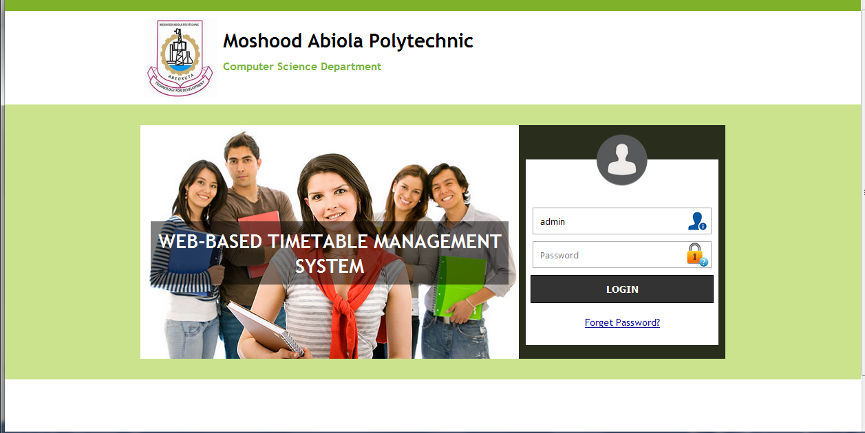

**Fig 4.1 Screenshot of the Welcome Page**

**4.5.2 ROOM MANAGER PAGE:**

This page provide the interface of displaying the list of existing rooms that has been added by the administrator of the web-based timetable management system. It is shown links for editing and deleting of rooms for each rooms. The room manager page is shown in figure 4.2

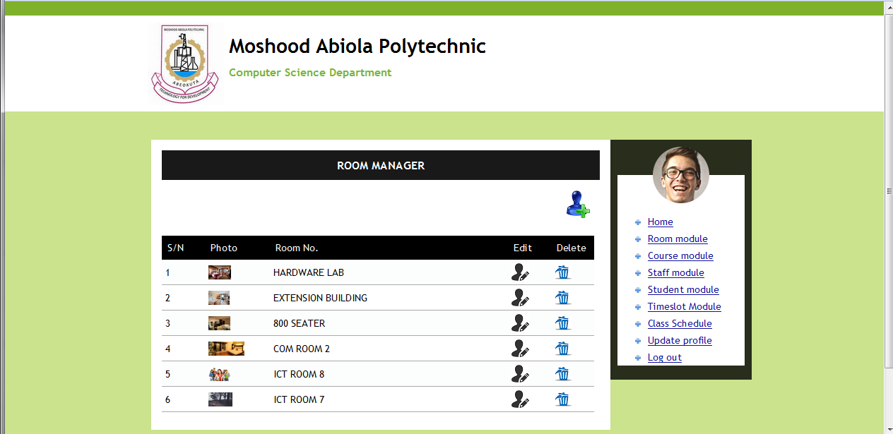

**Figure 4.2 Screenshot of the room manager**

**4.5.3 ADD ROOM PAGE:**

The page provides the interface where the administrator of the web-based timetable management system can add up information of room such as room no, room description and room pictures and click the submit button in order to save into the database for earlier retrieval and modification for future use. The add room page is shown in figure 4,3.

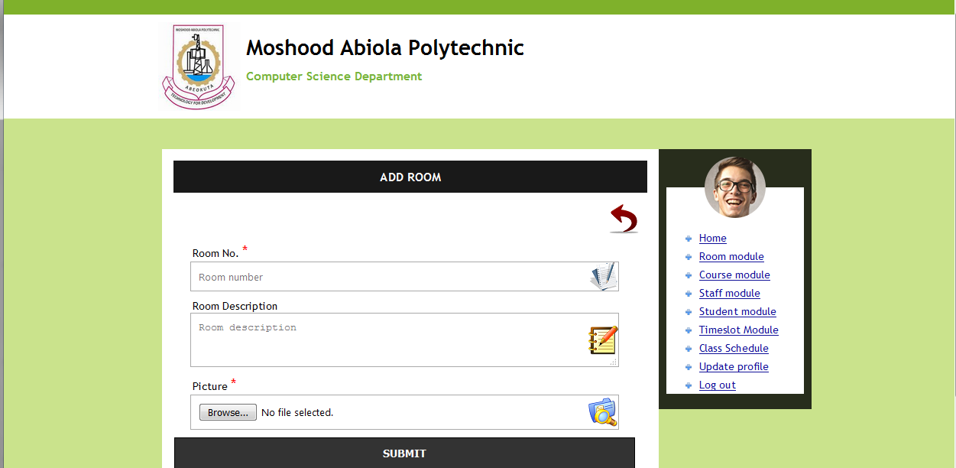

**Figure 4.3 Screenshot of the add room page**

**4.5.4 COURSE MANAGER PAGE:**

This page provides the interface for showing the list of courses that has already been registered by the administrator of the web-based timetable management system. The list of courses is displayed in a tabular set which contain course code, course title, course unit, level, semester, and option columns for edit and delete link. The course manager page is shown below.

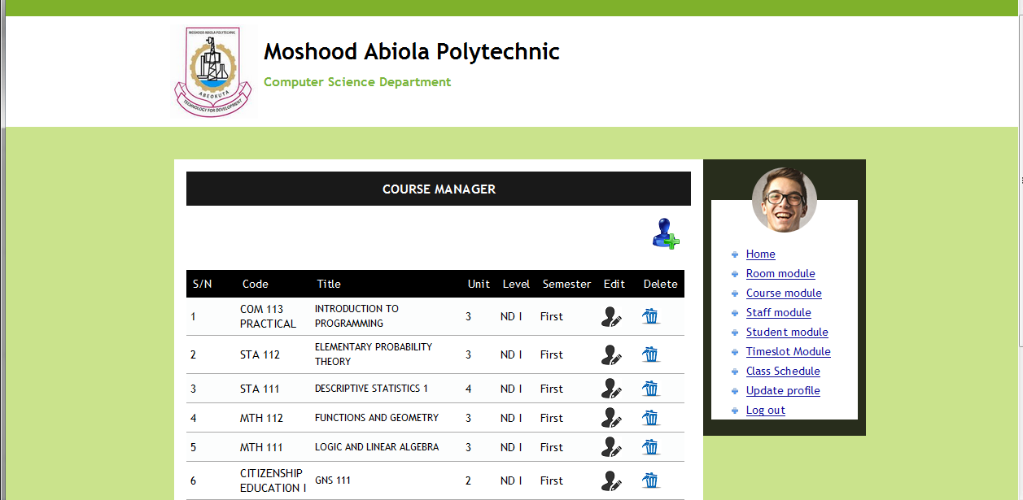

**Figure 4.4 screenshot of the course manager page**

**4.5.5 ADD COURSE PAGE:**

This page provides the interface where the administrator of the web-based timetable management system enter course details such as course code, course title, course unit, level, and semester and save them into the database. The add course page is shown in figure 4.5

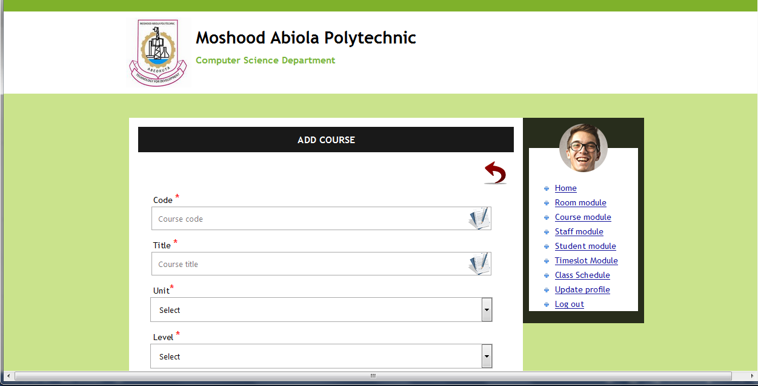

**Figure 4.5: Screenshot of the add course page**

**4.5.6 STAFF MANAGER PAGE:**

This page was created for the purpose of showing the list of staff (such as staff names, staff photo, and phone number) that has already been registered in table. The administrator of the web-based timetable management system can also use this page to edit an existing staff record and as well as deleting it also. The staff manager page is shown in figure 4.6.

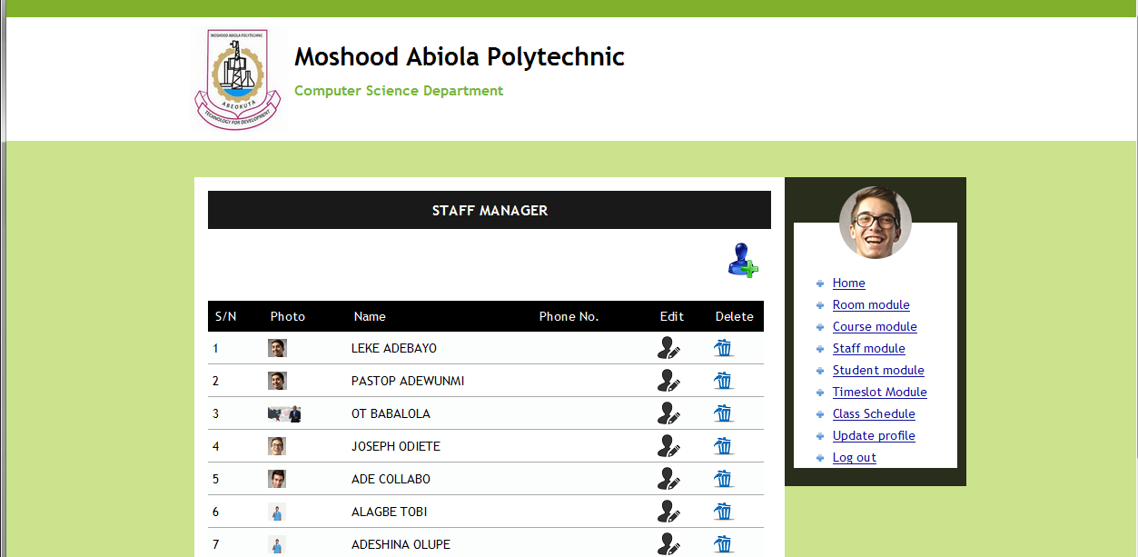

**Figure 4.6 Screenshot of staff manager**

**4.5.7 ADD STAFF PAGE:**

This page provides the interface where the administrator of the web-based timetable can enter staff details such as surname, first name, phone number, gender, marital status, and staff picture and save them into the database. The add staff page is shown in figure 4.7.

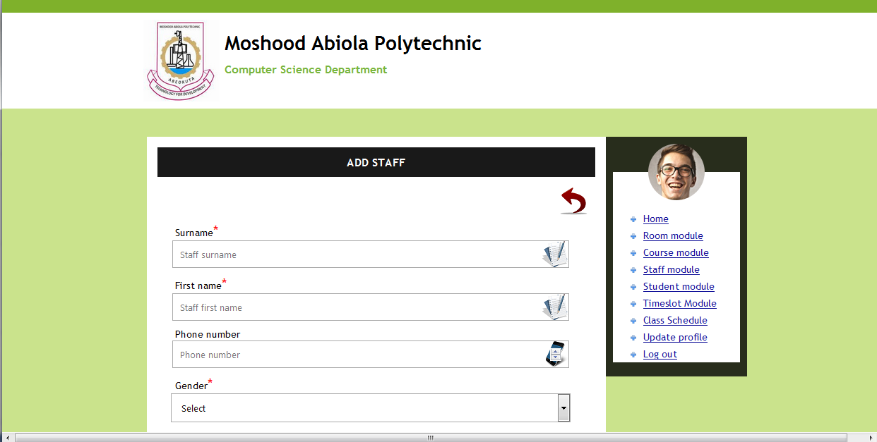

**Figure 4.7 Screenshot of add staff page**

**4.5.8 STUDENT MANAGER PAGE**:

This page was created for the purpose of showing the list of students that has been registered on the web-based timetable management system. The field name displayed in the table are matric number, name of student, level and programme done by the student and a edit and delete link used by the administrator to perform specific actions. The student manager page is shown in figure 4.8.

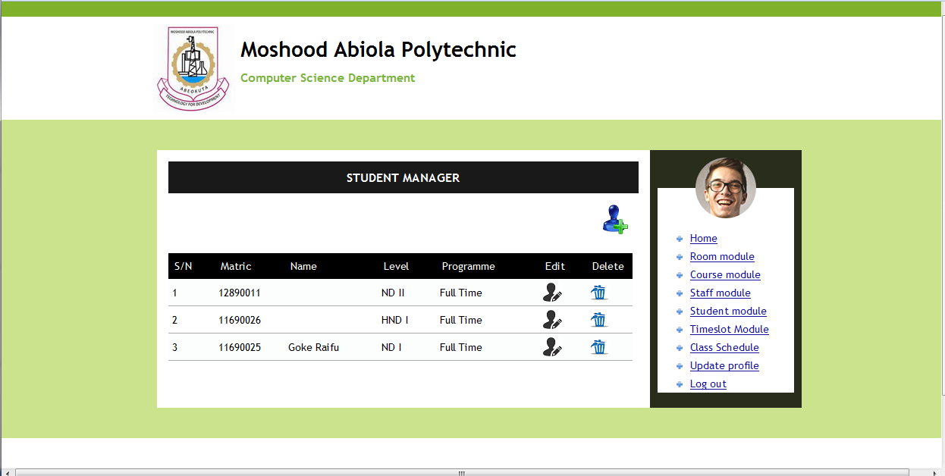

**Figure 4.8 Screenshot of student Manager page**

**4.5.9 ADD STUDENT PAGE:**

This page provides the interface where the administrator of the web-based timetable management system would enter student’s information such as matric number, academic year, level, and programme before the student can has directly access to make us of the timetable management system. The add student page is shown in figure 4.9 below.

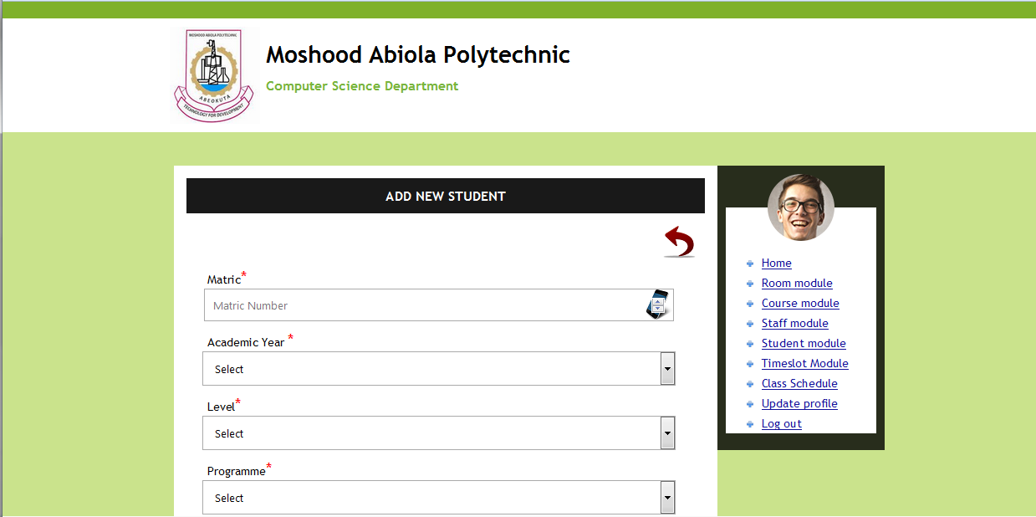

**Figure 4.9 Screenshot of add student page**

**4.5.10 TIMESLOT MANAGER PAGE:**

This page provides the interface where the administrator of the web-based timetable management system would display the hour and time frame that has already been added. The time slot is shown in figure 4.10:

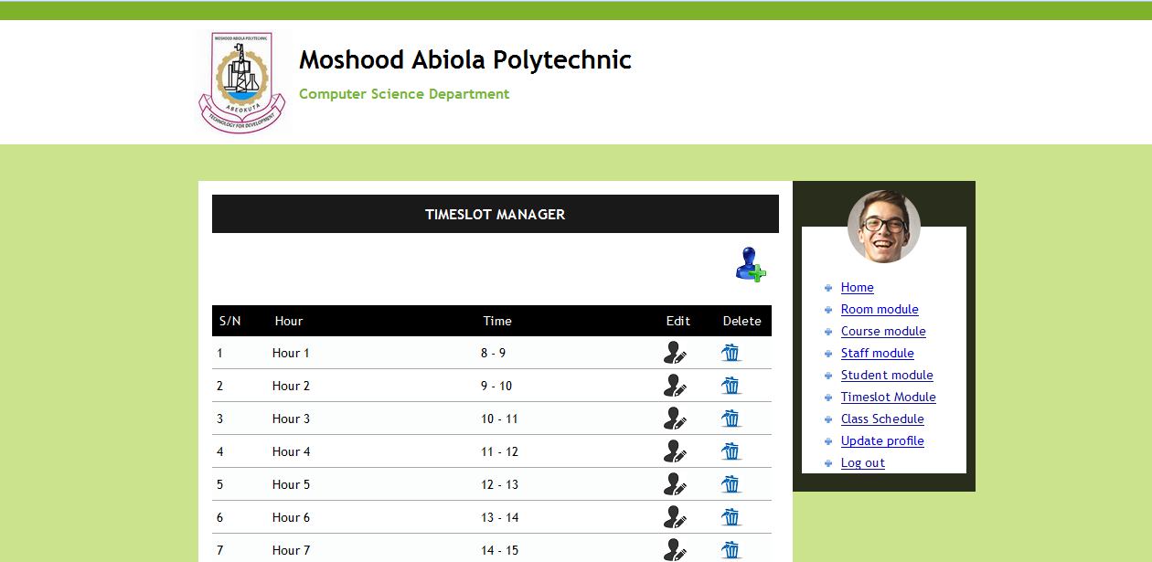

**Figure 4.10 Screenshot of timeslot page**

**4.5.11 ADD CLASS SCHEDULE PAGE:**

This page provides the interface whereby the administrator of the web-based timetable management system enter the scheduling details such as academic year, level, programme, semester, course code, instructor, stream, room number, week day, and time frame and click the submit button to save the information into the database . The class schedule page is shown in figure 4.11.

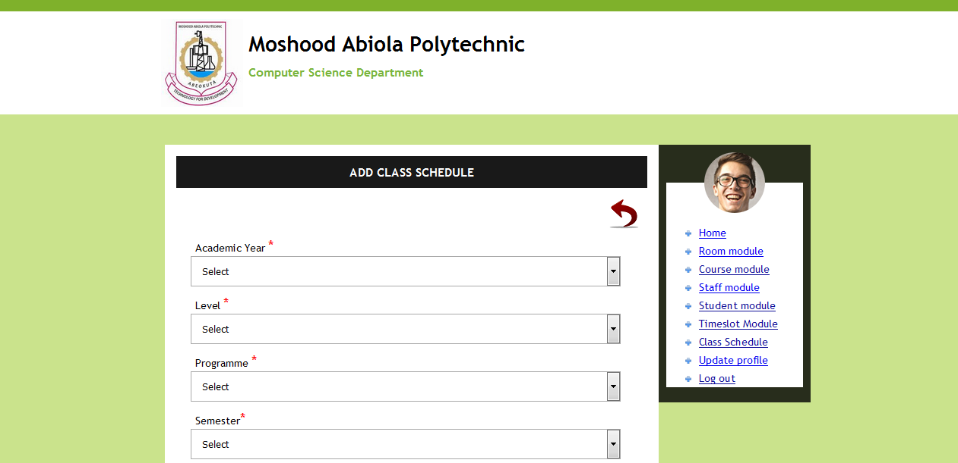

**Figure 4.11 screenshot of class schedule page**

**4.6 DATABASE DIAGRAM**

The diagram of tables created in the Web-based Timetable database is shown below

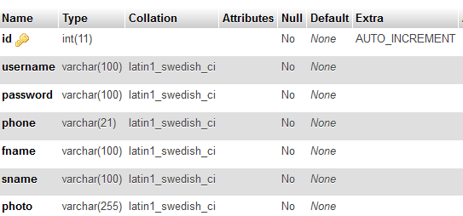

**Figure 4.12 Admin Table**

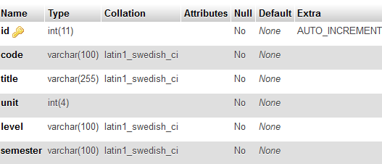

**Figure 4.13 Course Table**

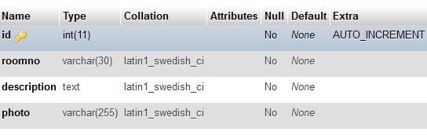

**Figure 4.14 Room Table**

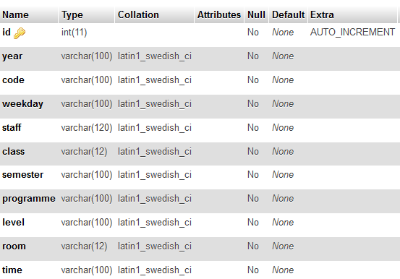

**Figure 4.15 Schedule Table**

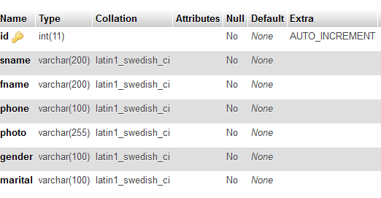

**Figure 4.16 Staff Table**

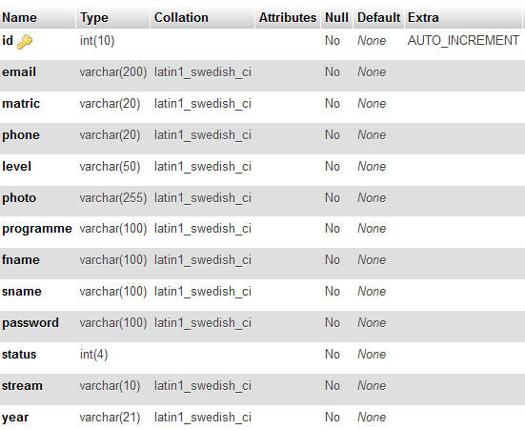

**Figure 4.17 Student Table**

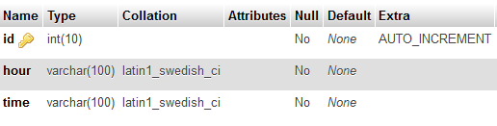

**Figure 4.18 Timeslot Table**

**CHAPTER FIVE**

**5.0 SUMMARY, RECOMMENDATIONS AND CONCLUSION**

**5.1 SUMMARY**

The project includes a development presentation of a web based timetable system for managing the seller’s, buyer’s, supplier’s and manufacturer’s data within a small company or organization. The system as such as it has been developed is called Shopping Cart System (SCS). Shopping Cart System comprises the personal details of a customers, products in stocks, and employees among others.

* 1. **RECOMMENDATIONS**

With regard to the introduction of the new system to the company, there is need for review and maintenance as well as adequate provision made to ensure that the following steps are taken into consideration.

1. There should be regular and constraint measurement of system performance.
2. Unauthorized and untrained personnel should not be permitted by the administration officer to work with the new system in order to avoid viruses from destroying the system
3. Constant system testing should be performed on the new system.

The system is recommended for polytechnics t and for sa to monitor the inventory of their stock for an improved production. More so, it is strongly recommended for local, state, and federal ministries of Nigeria and be implemented on intranet. Modification could be made to the system as times goes on so as to meet up with changes. Modification should be carried out by computer personnel that have good knowledge of programming.

* 1. **CONCLUSION**

The use of computer system in shopping will greatly reduce human error. The introduction of the proposed system will enhance efficient functioning of shopping process taking.

In conclusion, the Shopping Cart system will not only make the entire process simple but it will also provide a well-structured and analyzed report pattern of the products purchased and time management which will further help in calculating and generating report.

**REFERENCE**

1. A Nielsen Report, “Global Trends in Online Shopping. 2010”, Retrieved on April 20, 2013 from http://hk.nielsen.com/documents/Q12 010OnlineShoppingTrendsReport.pdf.
2. Agrawal, M., Sandhir, V. and Gupta, G, “Emerging Profile of Online Apparel Shoppers in India and Comparison with the US Online shoppers: A Few Marketing Implications”, Advances in Consumer Research, 8(2), 2010, 6-15.
3. Alba, J., Lynch, J., Weitz, B., Janizszewski, C., Lutz, R., Sawyer, A. and Wood, S., “Interactive home shopping: consumer, retailer, and manufacturer incentives to participate in electronic marketplaces”, Journal of Marketing, 61(3), 1997, 38-53.
4. An Office of Fair Trading Market Study, “Internet Shopping”, 2007, retrieved on April 20, 2013 from http://www.oft.gov.uk/shared oft/reports/consumer protection/oft921.pdf.
5. Bosnjak, M., Galesic, M. and Tuten, T., “Personality determinants of online shopping: Explaining online purchase intentions using a hierarchical approach,” Journal of Business Research 60(3), 2007, 597–605.
6. Boston Consulting Group, ”The Connected World Internet Economy in the G-20 World The $4.2 Trillion Growth Opportunity”, 2012, Retrieved on Nov 10, 2014 from https://www.bcg.com/documents/file100409.pdf.
7. Brengman, M., Guens, M., Weijters, B., Smith, S. M. and Swinyard, W. R., “Segmenting internet shoppers based on their web-usage related lifestyle: a cross-cultural validation,” Journal of Business Research, 58(1), 2005, 79-88.
8. Celik, H., ”Influence of social norms, perceived playfulness and online shopping anxiety on customers adoption of online retail shopping,” International journal of retail and distribution management. 39(6), 2011, 390-413.
9. Choi, J. and Lee, K. H., “Risk perception and e-shopping: a cross-cultural study,” Journal of Fashion Marketing and Management, 7(1), 2003, 49-64.
10. Comscore, “Online Shopping Customer Experience Study,” 2012, Retrieved on April 18, 2013 from http://www.pressroom.ups.c om/pressroom/staticfiles/pdf/factsheets/comScoreC ustomerExperienWhitePaper.pdf.
11. Comscore Report, “India digital future in focus 2013,” 2013, Retrieved on Nov 10, 2014 from www.comscore.com/content/.../India-Digital-Future-in-Focus-2013.pdf.
12. Constantinides, E., “Influencing the online consumer’s behavior: the Web experience,” Internet Research, 14(2), 2004, 111-126.
13. Cyr, D., Bonanni, C., Bowes, J. and Ilsever, J., “Beyond trust: website design preferences across cultures,” Journal of Global Information Management,

**APPENDICE**

**INDEX.PHP**

<?php include (‘header.php’);?>

<div id="top_column" class="center_column col-xs-12 col-sm-12"><!-- Module HomeSlider -->

<div class="col-xs-8" id="homepage-slider">

<div style="max-width: 779px; margin: 0px auto;" class="bx-wrapper"><div style="width: 100%; overflow: hidden; position: relative; height: 448px;" class="bx-viewport"><ul id="homeslider" style="max-height: 448px; width: 515%; position: relative; left: -1558px;"><li style="float: left; list-style: outside none none; position: relative; width: 779px;" class="homeslider-container bx-clone"><a href="http://localhost/tyra.com/page/" title="sample-3">

<img src="http://localhost/tyra.com/page/modules/homeslider/images/sample-3.jpg" alt="sample-3" height="448" width="779"></a>

<div class="homeslider-description"><h2>THE BIG STORE MAKEOVER</h2>

<p>Special Women wears and clothes are sold here.</p><p><button class="btn btn-default" type="button">Shop now !</button></p></div></li><li style="float: left; list-style: outside none none; position: relative; width: 779px;" class="homeslider-container"><a href="http://localhost/tyra.com/page/"title="sample-1"><imgsrc="http://localhost/tyra.com/page/modules/homeslider/images/sample-1.jpg" alt="sample-1" height="448" width="779"></a>

<div class="homeslider-description"><h2>FIRST ARRIVED FIRST SERVED</h2>

<p>Browse the store and find your favorite goods.</p>

<p><button class="btn btn-default" type="button">Shop now !</button></p></div></li>

<a href="http://localhost/tyra.com/page/" title="sample-2">

<img src="http://localhost/tyra.com/page/modules/homeslider/images/sample-2.jpg" alt="sample-2" height="448" width="779"></a><div class="homeslider-description"><h2>New Deal &amp; Saving</h2>

<h4 class="seoHeading ltr-content">Buy your accessories Outlet in Nigeria - Best online price</h4>

<p><button class="btn btn-default" type="button">Shop now !</button></p></div></li>

<li style="float: left; list-style: outside none none; position: relative; width: 779px;" class="homeslider-container">

<a href="http://localhost/tyra.com/page/" title="sample-3">

<img src="http://localhost/tyra.com/page/modules/homeslider/images/sample-3.jpg" alt="sample-3" height="448" width="779"></a>

<div class="homeslider-description"><h2>THE BIG STORE MAKEOVER</h2>

<p>Special Women wears and clothes are sold here.</p>

<p><button class="btn btn-default" type="button">Shop now !</button></p></div></li>

<li style="float: left; list-style: outside none none; position: relative; width: 779px;" class="homeslider-container bx-clone">

<a href="http://localhost/tyra.com/page/" title="sample-1">

<img src="http://localhost/tyra.com/page/modules/homeslider/images/sample-1.jpg" alt="sample-1" height="448" width="779">

</a>

<div class="homeslider-description"><h2>FIRST ARRIVED FIRST SERVED</h2>

<p>Browse the store and find your favorite goods.</p>

<p><button class="btn btn-default" type="button">Shop now !</button></p></div>

</li></ul></div><div class="bx-controls bx-has-controls-direction"><div class="bx-controls-direction"><a class="bx-prev" href="">Prev</a><a class="bx-next" href="">Next</a></div></div></div>

</div>

<!-- /Module HomeSlider -->

<div id="htmlcontent_top">

<ul class="htmlcontent-home clearfix row">

<li class="htmlcontent-item-1 col-xs-4">

<a href="http://www.prestashop.com/" class="item-link" title=""> <img src="http://localhost/tyra.com/page/modules/themeconfigurator/img/banner-img6.jpg" class="item-img " title="" alt="" height="219" width="381">

</li>

<li class="htmlcontent-item-2 col-xs-4"><a href="http://www.prestashop.com/" class="item-link" title=""> <img src="http://localhost/tyra.com/page/modules/themeconfigurator/img/banner-img7.jpg" class="item-img " title="" alt="" height="219" width="381"></li></ul></div></div>

<?php include(‘footer.php’);?>

**ABOUT.PHP**

<?php include(‘header.php’);?>

<!-- Breadcrumb -->

<div class="breadcrumb clearfix"><a class="home" href="http://localhost/tyra.com/page/" title="Return to Home"><i class="icon-home"></i></a><span class="navigation-pipe">&gt;</span>About us</div><!-- /Breadcrumb --><div id="slider_row" class="row">

<div id="top_column" class="center_column col-xs-12 col-sm-12"></div></div><div class="row"><div class="rte"><h1 class="page-heading bottom-indent">About us</h1>

<div class="row"><div class="col-xs-12 col-sm-4"><div class="cms-block"><h3 class="page-subheading">Our company</h3><strong>Tyra Shopping&nbsp; </strong>is one of the best shopping Mall in Nigeria<br class="dark"><ul class="list-1"><li><em class="icon-ok"></em>Top quality products</li><li><em class="icon-ok"></em>Best customer service</li>

<li><em class="icon-ok"></em>30-days money back guarantee</li></ul></div></div>

<div class="col-xs-12 col-sm-4"><div class="cms-box"><h3 class="page-subheading">Our team</h3><img title="cms-img" src="../img/cms/cms-img.jpg" alt="cms-img" height="192" width="370"><p><strong class="dark">Our Building<br></strong></p><p>.....</p></div>

</div><div class="col-xs-12 col-sm-4"><div class="cms-box"><h3 class="page-subheading">Testimonials</h3><div class="testimonials"><div class="inner"><span class="before">“It is so nice using shopping with Tyra s</span>.<span class="after">”</span></div></div><p><strong class="dark">Alexander Says<br></strong></p><div class="testimonials"><div class="inner"><span class="before">“</span>.<span class="after">”</span></div></div><p><strong class="dark"> </strong></p></div></div></div></div><br></div><!-- #center_column --></div><!-- .row -->

<?php include(“footer”);?>

**CONTACT.PHP**

<?php include(“header.php”);?>

<!-- Breadcrumb --><div class="breadcrumb clearfix">

<a class="home" href="http://localhost/tyra.com/page/" title="Return to Home"><i class="icon-home"></i></a><span class="navigation-pipe">&gt;</span>Contact</div>

<!-- /Breadcrumb --><div id="slider_row" class="row"><div id="top_column" class="center_column col-xs-12 col-sm-12"></div></div><div class="row"><div id="center_column" class="center_column col-xs-12 col-sm-12"><h1 class="page-heading bottom-indent">Customer service - Contact us</h1><form action="/tyra.com/page/contact-us" method="post" class="contact-form-box" enctype="multipart/form-data"><fieldset>

<h3 class="page-subheading">send a message</h3><div class="clearfix"><div class="col-xs-12 col-md-3"><div class="form-group selector1"><label for="id_contact">Subject Heading</label>

<div style="width: 265.767px;" id="uniform-id_contact" class="selector"><span style="width: 255.767px; -moz-user-select: none;">-- Choose --</span><select id="id_contact" class="form-control" name="id_contact"><option value="0">-- Choose --</option><option value="2">Customer service</option><option value="1">Webmaster</option></select></div> </div><p id="desc_contact0" class="desc_contact">&nbsp;</p><p id="desc_contact2" class="desc_contact contact-title unvisible"><i class="icon-comment-alt"></i>For any question about a product, an order</p><p id="desc_contact1" class="desc_contact contact-title unvisible"> <i class="icon-comment-alt"></i>If a technical problem occurs on this website</p><p class="form-group"><label for="email">Email address</label><input class="form-control grey validate" id="email" name="from" data-validate="isEmail" value="" type="text"></p><div class="form-group selector1"><label>Order reference</label><input class="form-control grey" name="id_order" id="id_order" value="" type="text"></div><p class="form-group"><label for="fileUpload">Attach File</label><input name="MAX_FILE_SIZE" value="134217728" type="hidden"><div id="uniform-fileUpload" class="uploader"><input name="fileUpload" id="fileUpload" class="form-control" type="file"><span style="-moz-user-select: none;" class="filename">No file selected</span><span style="-moz-user-select: none;" class="action">Choose File</span></div></p></div><div class="col-xs-12 col-md-9"><div class="form-group"><label for="message">Message</label><textarea class="form-control" id="message" name="message"></textarea></div></div></div><div class="submit"><button type="submit" name="submitMessage" id="submitMessage" class="button btn btn-default button-medium"><span>Send<i class="icon-chevron-right right"></i></span></button></div> </fieldset></form></div><!-- #center_column --></div><!-- .row -->

<?php include(“footer.php”);?>

**SIGN_IN.PHP**

<?php include(“header.php”);?>

<div id="center_column" class="center_column col-xs-12 col-sm-12">><h1 class="page-heading">Authentication</h1><!----><div class="row"><div class="col-xs-12 col-sm-6">

<form action="http://localhost/tyra.com/page/login" method="post" id="create-account_form" class="box"><h3 class="page-subheading">Create an account</h3><div class="form_content clearfix"><p>Please enter your email address to create an account.</p><div class="alert alert-danger" id="create_account_error" style="display:none"></div><div class="form-group">

<label for="email_create">Email address</label><input class="is_required validate account_input form-control" data-validate="isEmail" id="email_create" name="email_create" value="" type="email"></div><div class="submit"><input class="hidden" name="back" value="my-account" type="hidden"> <button class="btn btn-default button button-medium exclusive" type="submit" id="SubmitCreate" name="SubmitCreate"><span><i class="icon-user left"></i>Create an account</span></button><input class="hidden" name="SubmitCreate" value="Create an account" type="hidden"></div></div></form></div><div class="col-xs-12 col-sm-6"><form action="http://localhost/tyra.com/page/login" method="post" id="login_form" class="box"><h3 class="page-subheading">Already registered?</h3><div class="form_content clearfix"><div class="form-group"><label for="email">Email address</label><input class="is_required validate account_input form-control" data-validate="isEmail" id="email" name="email" value="" type="email"></div><div class="form-group"><label for="passwd">Password</label><input class="is_required validate account_input form-control" data-validate="isPasswd" id="passwd" name="passwd" value="" type="password"></div><p class="lost_password form-group"><a href="http://localhost/tyra.com/page/password-recovery" title="Recover your forgotten password" rel="nofollow">Forgot your password?</a></p><p class="submit"><input class="hidden" name="back" value="my-account" type="hidden"><button type="submit" id="SubmitLogin" name="SubmitLogin" class="button btn btn-default button-medium"><span><i class="icon-lock left"></i>Sign in</span></button>

</p></div></form></div></div></div><!-- #center_column -->

<?php include(“footer.php”);?>

**TERMS-AND-CONDITION.PHP**

<?php include(“header.php”);?>

<h2 style="text-align:justify;"><strong>TERMS AND CONDITIONS</strong></h2><p style="text-align:justify;">&nbsp;</p>

<h3 style="text align:justify;"><strong>INTRODUCTION</strong></h3>

<p style="text-align:justify;">Welcome to the Tyra.com.ng website (the "Site"). These terms &amp; conditions ("Terms and Conditions") apply to the Site, and all of its divisions, subsidiaries, and affiliate operated Internet sites which reference these Terms and Conditions.</p><p style="text-align:justify;">This website is owned and operated by Ecart Internet Services Nigeria Limited. For the purposes of this website, "seller", "we", "us" and "our" all refer Tyra.com.ng.</p><p style="text-align:justify;">The Site reserves the right, to change, modify, add, or remove portions of both the Terms and Conditions of Use and the Terms and Conditions of Sale at any time. Changes will be effective when posted on the Site with no other notice provided. Please check these Terms and Conditions regularly for updates. Your continued use of the Site following the posting of changes to these Terms and Conditions constitutes your acceptance of those changes.</p><p style="text-align:justify;"><strong>DATA PROTECTION</strong></p>

<p style="text-align:justify;">Any personal information collected in relation to the use of this website will be held and used in accordant with our Privacy Policy, which is available on our Site.</p><p style="text-align:justify;"><strong>INDEMNITY</strong></p><p style="text-align:justify;">You agree to indemnify and hold us, our affiliates, officers, directors, agents and/or employees, as the case may be, free from any claim or demand, including reasonable legal fees, related to your breach of these Terms of Use and User Agreement.</p><p style="text-align:justify;"><strong>APPLICABLE LAW AND JURISDICTION</strong></p><p style="text-align:justify;">These Terms and Conditions of Use shall be interpreted and governed by the laws in force in the Federal Republic of Nigeria. Subject to the Arbitration section below, each party hereby agrees to submit to the jurisdiction of the courts of Nigeria and to waive any objections based upon venue.</p>

<p style="text-align:justify;"><strong>ARBITRATION</strong></p><p style="text-align:justify;">Any controversy, claim or dispute arising out of or relating to these Terms and Conditions of Use will be referred to and finally settled by private and confidential binding arbitration before a single arbitrator held in Nigeria in English and governed by Nigeria law pursuant to the Arbitration and Conciliation Act Cap A18 Laws of the Federation of Nigeria 2004, as amended, replaced or re-enacted from time to time.</p>

<p style="text-align:justify;">The arbitrator shall be a person who is legally trained and who has experience in the information technology field in Nigeria and is independent of either party. Notwithstanding the foregoing, the Site reserves the right to pursue the protection of intellectual property rights and confidential information through injunctive or other equitable relief through the courts.</p><p style="text-align:justify;"><strong>SEVERABILITY</strong></p>

<p style="text-align:justify;">If any portion of these terms or conditions is held by any court or tribunal to be invalid or unenforceable, either in whole or in part, then that part shall be severed from these Terms and Conditions of Use and shall not affect the validity or enforceability of any other section listed in this document.</p>

<p style="text-align:justify;"><strong>&nbsp;</strong></p>

<p style="text-align:justify;"><strong>TERMS AND CONDITIONS OF SALE</strong></p>

<p style="text-align:justify;"><strong>GENERAL</strong></p><p style="text-align:justify;">You confirm that you are at least 18 years of age or are accessing the Site under the supervision of a parent or legal guardian. You agree that if you are unsure of the meaning of any part of the Terms and Conditions of Sale, you will not hesitate to contact us for clarification prior to making a purchase.</p>

<p style="text-align:justify;">These Terms and Conditions of Sale fully govern the sale of goods and services purchased on this Site. No extrinsic evidence, whether oral or written, will be incorporated.</p>

<p style="text-align:justify;"><strong>FORMATION OF CONTRACT</strong></p>

<p style="text-align:justify;">Both parties agree that browsing the website and gathering information regarding the services provided by the seller does not constitute an offer to sell, but merely an invitation to treat. The parties accept that an offer is only made once you have selected the item you intend to purchase, chosen your preferred payment method, proceeded to the checkout and completed the checkout process.</p>

<p style="text-align:justify;">Both parties agree that the acceptance of the offer is not made when the seller contacts you by phone or by email to confirm that the order has been placed online. Your offer is only accepted when we dispatch the product to you and inform you either by email or by phone of the dispatch of your ordered product.</p>

<p style="text-align:justify;">Before your order is confirmed, you may be asked to provide additional verifications or information, including but not limited to phone number and address, before we accept the order.</p>

<p style="text-align:justify;">Please note that there are cases when an order cannot be processed for various reasons. The Site reserves the right to refuse or cancel any order for any reason at any given time.</p>

<?php include(“footer.php”);?>

**SITEMAP.PHP**

<?php include(“header.php”);?>

<h1 class="page-heading">Sitemap</h1><div id="sitemap_content" class="row"><div class="col-xs-12 col-sm-6"><div class="sitemap_block box"><h3 class="page-subheading">Our offers</h3><ul><li><a href="http://localhost/tyra.com/page/new-products" title="View a new product">New products </a></li><li><a href="http://localhost/tyra.com/page/best-sales" title="View top-selling products">Best sellers</a></li><li><a href="http://localhost/tyra.com/page/prices-drop" title="View products with a price drop">Price drop</a> </li><li><a href="http://localhost/tyra.com/page/manufacturers" title="View a list of manufacturers">Manufacturers</a></li><li><a href="http://localhost/tyra.com/page/supplier" title="View a list of suppliers">Suppliers </a> </li></ul></div> </div><div class="col-xs-12 col-sm-6"><div class="sitemap_block box"><h3 class="page-subheading">Your Account</h3><ul>

<li><a href="http://localhost/tyra.com/page/login" rel="nofollow" title="Authentication">

Authentication</a></li><li><a href="http://localhost/tyra.com/page/login" rel="nofollow" title="Create new account">Create new account</a></li></ul></div></div></div>

<div id="listpage_content" class="row"><div class="col-xs-12 col-sm-6"><div class="categTree box"><h3 class="page-subheading">Categories</h3><div class="tree_top"> <a href="http://localhost/tyra.com/page/" title="Home"></a></div><ul class="tree">

<li><a href="http://localhost/tyra.com/page/3-women" title="You will find here all woman fashion collections. This category includes all the basics of your wardrobe and much more:

shoes, accessories, printed t-shirts, feminine dresses, women's jeans!">Women</a>

<ul>

<li><a href="http://localhost/tyra.com/page/4-tops" title="Choose from t-shirts, tops, blouses, short sleeves, long sleeves, tank tops, 3/4 sleeves and more.

Find the cut that suits you the best!">Tops</a><ul>

<li><a href="http://localhost/tyra.com/page/5-tshirts" title="The must have of your wardrobe, take a look at our different colors,shapes and style of our collection!">T-shirts</a></li>

<li class="last"><a href="http://localhost/tyra.com/page/7-blouses" title="Match your favorites blouses with the right accessories for the perfect look.">Blouses</a></li><ul></li>

<li class="last"><a href="http://localhost/tyra.com/page/8-dresses" title="Find your favorites dresses from our wide choice of evening, casual or summer dresses! We offer dresses for every day, every style and every occasion.">Dresses</a><ul>.<li>

<a href="http://localhost/tyra.com/page/9-casual-dresses" title="You are looking for a dress for every day? Take a look at our selection of dresses to find one that suits you.">Casual Dresses</a>

</li><li><a href="http://localhost/tyra.com/page/10-evening-dresses" title="Browse our different dresses to choose the perfect dress for an unforgettable evening!">Evening Dresses</a></li>

<li class="last"><a href="http://localhost/tyra.com/page/11-summer-dresses" title="Short dress, long dress, silk dress, printed dress, you will find the perfect dress for summer.">Summer Dresses</a></li></ul></li></ul></li><li class="last"<a href="http://localhost/tyra.com/page/12-mens" title="You will find here all woman fashion collections.This category includes all the basics of your wardrobe and much more:shoes, accessories, printed t-shirts, masculine dresses, men's jeans!">Mens</a><ul><li class="last"><a href="http://localhost/tyra.com/page/13-top" title="Choose from t-shirts, tops, trousers, short nicker, Singlet, Boxer, long sleeves, tank tops, 3/4 sleeves and more.Find the cut that suits you the best!">Top</a><li></ul></li></ul></div></div>

<div class="col-xs-12 col-sm-6"><div class="sitemap_block box"><h3 class="page-subheading">Pages</h3><ul><li><a href="http://localhost/tyra.com/page/content/category/1-home" title="Home">Home</a></li><li><a href="http://localhost/tyra.com/page/content/1-delivery" title="Delivery">Delivery</a></li><li><a href="http://localhost/tyra.com/page/content/2-legal-notice" title="Legal Notice">Legal Notice

</a></li><li><a href="http://localhost/tyra.com/page/content/3-terms-and-conditions-of-use" title="Terms and conditions of use">Terms and conditions of use</a></li><li><a href="http://localhost/tyra.com/page/content/4-about-us" title="About us">About us</li>

<li>

<a href="http://localhost/tyra.com/page/content/5-secure-payment" title="Secure payment">

Secure payment</a></li><li><a href="http://localhost/tyra.com/page/contact-us" title="Contact">Contact</a></li></ul></div></div></div>

<?php include(“footer.php”);?>