PUBLIC TRANSPORT OPTIMIZATION

Project Objectives

Public transport optimization IoT projects can benefit from a variety of sensors to collect data and improve efficiency. Some common sensors used in such projects include:

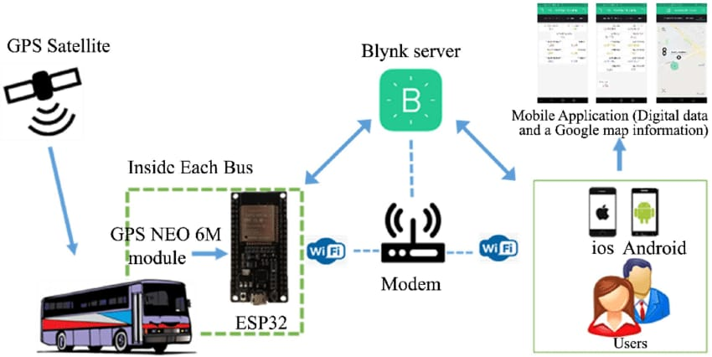

The aim is to find a set of routes, each assigned to a vehicle, in order to satisfy the set of requests, under capacity, time windows, precedence and pairing conditions.

The main objectives of public transport optimization are to improve the efficiency, accessibility, and overall quality of public transportation systems, while also promoting sustainability and enhancing the passenger experience.

IoT sensor deployment

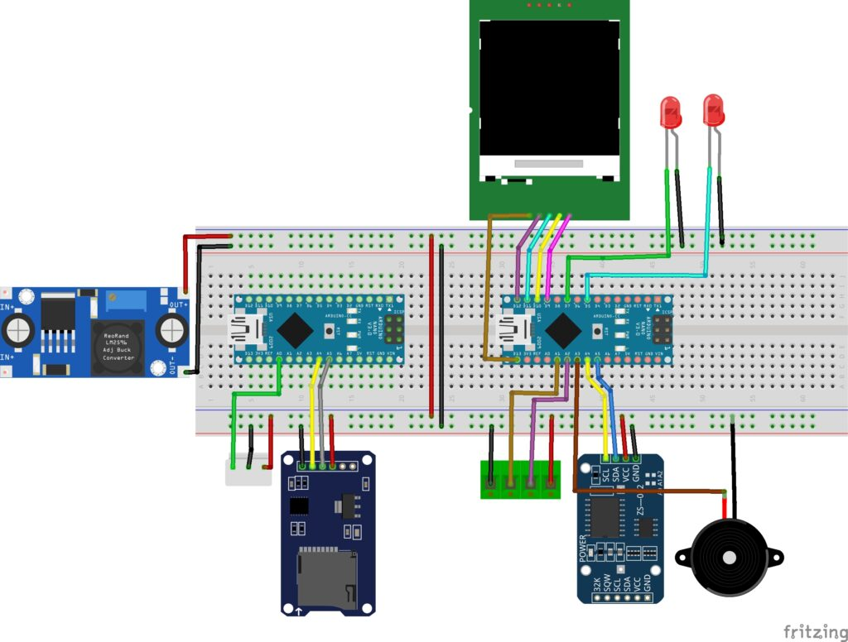
1. *Select Hardware*:
- Choose suitable IoT sensors like GPS modules, accelerometers, temperature sensors, and cameras.
- Select microcontrollers (e.g., Arduino, Raspberry Pi) to interface with these sensors.
2. *Data Collection*:
- Connect the sensors to the microcontroller and write code to collect data.
- Use a GPS module to track the vehicle's location, accelerometers for motion detection, temperature sensors for environmental data, and cameras for visual information.
3. *Data Processing*:
- Process the collected data to extract relevant information.
- Filter, aggregate, and format the data for transmission.
4. *Connectivity*:
- Choose the appropriate communication method, such as Wi-Fi, cellular (3G/4G/5G), or LoRa for transmitting data.
- Implement protocols like MQTT or HTTP for data transmission.
5. *Cloud Platform*:
- Set up a cloud platform (e.g., AWS, Azure, Google Cloud) to receive and store the sensor data.
- Implement security measures to protect data in transit and at rest.
6. *Data Storage and Analysis*:
- Store the collected data in a database.
- Analyze data using cloud-based tools for insights and optimization.
7. *Real-time Monitoring*:
- Create a dashboard for real-time monitoring using tools like Grafana or custom web applications.
- Visualize vehicle locations, passenger loads, and other relevant data.
8. *Alerts and Notifications*:
- Implement alerting systems to notify operators or passengers about delays, issues, or other important events.
9. *Machine Learning* (Optional):
- Implement machine learning algorithms for predictive maintenance, demand forecasting, or route optimization.
10. *Integration*:
- Integrate the IoT system with existing public transport infrastructure and management systems.
11. *User Interfaces*:
- Develop user interfaces for passengers and administrators, allowing them to access real-time data and services.
12. *Testing and Deployment*:
- Thoroughly test the entire system to ensure it functions correctly.
- Deploy sensors on public transport vehicles.
13. *Scalability and Maintenance*:
- Ensure the system can scale as the public transport network grows.
- Establish regular maintenance and updates to keep the system operational.
14. *Compliance and Regulations*:
- Ensure compliance with data privacy and transportation regulations.
15. *Security*:
- Implement robust security measures to protect data and devices from unauthorized access.

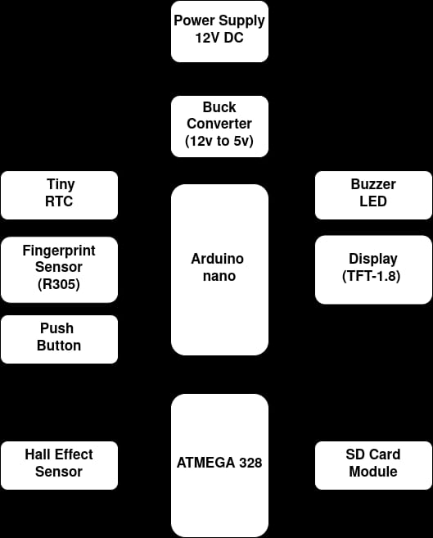
Platform Development

Developing a platform for public transport optimization requires a comprehensive approach that combines technology, data, and various functionalities to achieve efficient, accessible, and sustainable public transportation. Here are key steps and considerations for the development of such a platform:

Develop algorithms for processing and analyzing the data to provide insights into route optimization, scheduling, and vehicle performance.
Utilize machine learning and predictive analytics to improve accuracy and efficiency in real-time decision-making.

Developing a platform for public transport optimization is a complex undertaking that requires collaboration between technology providers, transit agencies, and city planners. The goal is to create a system that improves the efficiency, accessibility, and sustainability of public transportation, ultimately benefiting commuters and the communities they serve.
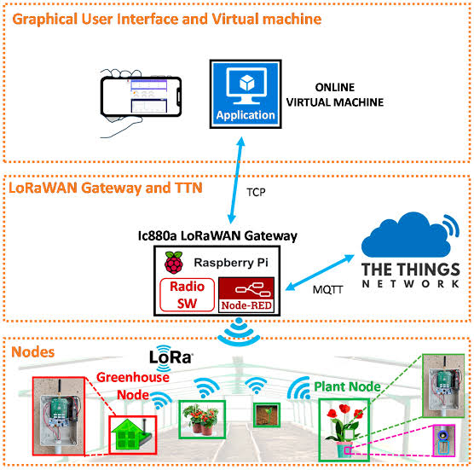
code implementation
import pulp
# Define stops, demand, travel times, and resource constraints
stops = ["A", "B", "C", "D"]
demand = {"A": 20, "B": 30, "C": 25, "D": 15}
travel_time = {"A-B": 10, "B-C": 15, "C-D": 12}
max_buses = 3
# Create a linear programming problem
problem = pulp.LpProblem("PublicTransportOptimization", pulp.LpMinimize)
x = pulp.LpVariable.dicts("Route", [(i, j) for i in stops for j in stops], lowBound=0, upBound=1, cat=pulp.LpInteger)
y = pulp.LpVariable.dicts("Bus", stops, lowBound=0, upBound=max_buses, cat=pulp.LpInteger)
problem += pulp.lpSum(x[(i, j)] * travel_time[i + "-" + j] for i in stops for j in stops)
for i in stops:
problem += pulp.lpSum(x[(i, j)] for j in stops) == 1 # Each stop is visited once
problem += pulp.lpSum(x[(j, i)] for j in stops) == 1 # Each stop is left once
for j in stops:
problem += pulp.lpSum(x[(i, j)] for i in stops) <= max_buses * y[j] # Bus capacity constraint
for i in stops:
problem += pulp.lpSum(demand[j] * x[(i, j)] for j in stops) >= demand[i]
problem.solve()
print("Optimization Status:", pulp.LpStatus[problem.status])
for var in problem.variables():
print(f"{var.name}: {var.varValue}")
print("Total Travel Time: ", pulp.value(problem.objective))
Public transport optimization sensors play a crucial role in monitoring and improving the efficiency and safety of public transportation systems. These sensors are strategically placed on vehicles and infrastructure to collect data related to vehicle performance, passenger flow, and environmental conditions

#include <TinyGPS.h>
#include <SoftwareSerial.h>
SoftwareSerial gpsSerial(8, 9); // RX, TX pins for GPS module
TinyGPS gps;
void setup() {
Serial.begin(9600);
gpsSerial.begin(9600);
}
void loop() {
while (gpsSerial.available() > 0) {
if (gps.encode(gpsSerial.read())) {
float lat, lon;
unsigned long age;
gps.f_get_position(&lat, &lon, &age);
if (age < 1000) { // Consider data valid if age < 1000 milliseconds
Serial.print("Latitude: ");
Serial.println(lat, 6); // Print latitude with 6 decimal places
Serial.print("Longitude: ");
Serial.println(lon, 6); // Print longitude with 6 decimal places
// Send this data to a cloud platform or server for further processing
// You can use MQTT, HTTP, or other protocols to transmit the data
}
}
}
}

Real-time transit information systems can improve public transportation services

Abstract
Promoting the use of public transportation and Intelligent Transport Systems, as well as improving transit accessibility for all citizens, may help in decreasing traffic congestion and air pollution in urban areas.
In general, poor information to customers is one of the main issues in public transportation services, which is an important reason for allocating substantial efforts to implement a powerful and easy to use and access information tool. This paper focuses on the design and development of a real time mobility information system for the management of unexpected events, delays and service disruptions concerning public transportation in the city of Milan. Exploiting the information on the status of urban mobility and on the location of citizens, commuters and tourists, the system is able to reschedule in real time their movements.
The service proposed stems from the state of the art in the field of travel planners for public transportation, available for Milan. Peculiarly, we built a representation of the city transit based on a time-expanded graph that considers the interconnections among all the stops of the rides offered during the day.
The structure distinguishes the physical stations and the get on/get off stops of each ride, representing them with two different types of nodes. Such structure allows, with regard to the main focus of the project, to model a wide range of service disruptions, much more meaningful than those possible with approaches currently proposed by transit agencies. One of the most interesting point lies in the expressive capability in describing the different disruptions: with our model it is possible, for instance, to selectively inhibit getting on and/or off at a particular station, avoid specific rides, and model temporary deviations.

Reducing wait times

Passengers can use real-time information to plan their trips and avoid waiting for their ride.
A study found that people with access to real-time transit information spent 15% less time waiting at bus stops.
Access to real-time transit information has revolutionized the way passengers plan their trips, offering numerous advantages that translate into enhanced efficiency and convenience. The study's revelation that individuals with such access spent 15% less time waiting at bus stops underscores the significant impact of this technology.

Real-time transit information allows passengers to make informed decisions about when to leave for their destination, reducing the uncertainty associated with public transportation. This means passengers can time their arrival at the bus stop to coincide with the bus's actual arrival, minimizing idle waiting time. This not only reduces frustration but also contributes to improved punctuality and overall passenger satisfaction.

Moreover, the benefits extend beyond simply reducing waiting time. Real-time transit information empowers passengers to make alternate route choices if a particular bus is delayed or rerouted due to unforeseen circumstances, further enhancing their travel experience. Additionally, it encourages more people to opt for public transportation as they can plan their journeys with greater confidence, potentially reducing traffic congestion and environmental impacts.

Increasing ridership

The study on Chicago's bus routes, revealing a 2% increase in average daily ridership due to access to real-time transit information, underscores the substantial impact of this technology on public transportation systems. This increase in ridership is indicative of the transformative role real-time information plays in making public transit more attractive and accessible.

Access to real-time transit information enhances the overall passenger experience in several ways. It reduces uncertainty by providing precise information about bus arrival times, empowering commuters to plan their journeys with confidence. This increased predictability encourages more people to rely on public transportation, as they can better align their schedules with bus arrivals. As a result, more individuals are likely to choose buses over personal vehicles, contributing to reduced traffic congestion and associated environmental benefits.
Moreover, the 2% increase in daily ridership can have a substantial economic impact on the transit system. Increased ridership leads to higher fare revenues, potentially reducing the financial burden on the transit authority and taxpayers. It can also stimulate urban development around transit hubs, fostering economic growth and community connectivity.
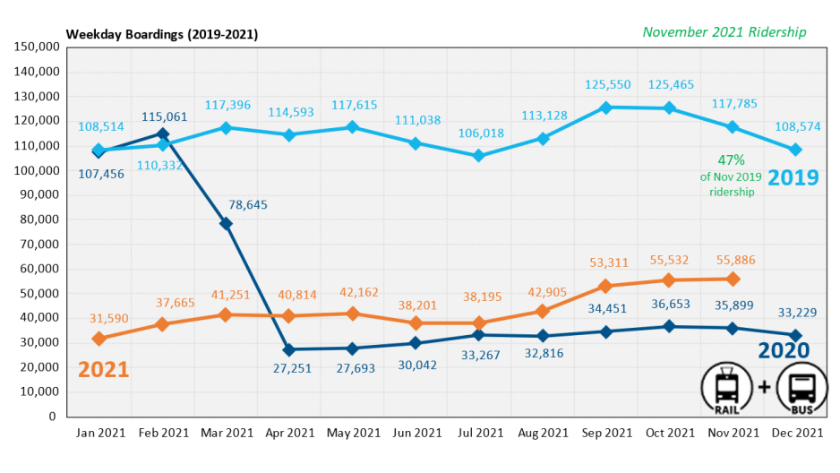

In summary, the 2% rise in average daily ridership in Chicago is not merely a statistic; it represents a tangible shift toward more efficient, sustainable, and user-friendly public transportation systems, with real-time transit information serving as a catalyst for this positive change. The 2% increase in average daily ridership due to access to real-time transit information also reflects the evolving nature of urban mobility. In an era where convenience and information are at our fingertips, public transportation systems must adapt to meet the expectations of modern commuters. Real-time transit information aligns public transit with the on-demand nature of contemporary living, making it more competitive with personal vehicle usage and ride-sharing services.
This increase in ridership can lead to a cascading effect on public transit infrastructure and funding. A higher demand for bus services can justify investments in expanding routes, improving bus fleet efficiency, and enhancing the overall transit experience. Additionally, the increase in revenue from fare collection can help ensure the long-term sustainability of public transportation systems, reducing the burden on government subsidies and taxpayers.
In conclusion, the 2% increase in daily ridership is indicative of a broader trend towards making public transportation more responsive, efficient, and appealing to a growing urban population, ultimately contributing to the development of more sustainable and connected cities.

Reducing anxiety

Passengers can use real-time information to learn about delayed buses or other problems before arriving at a stop or station.
Access to real-time information in public transportation has become a game-changer for passengers, providing them with invaluable insights into the status of their journeys before even setting foot at a stop or station. This capability is particularly transformative when it comes to learning about delayed buses or other problems in the system, offering a myriad of benefits that enhance the overall transit experience.

First and foremost, real-time information equips passengers with the knowledge of bus delays or disruptions in advance. This means they can make informed decisions about when to leave home or work, reducing the inconvenience and frustration associated with unforeseen delays. Passengers can adjust their schedules accordingly, making the most of their time and reducing the stress that can come with uncertain travel.
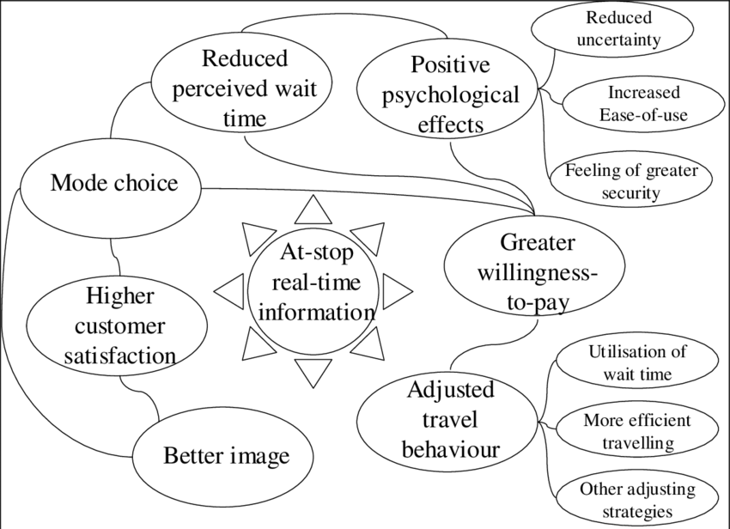

Additionally, this early awareness of delays allows passengers to explore alternative routes or modes of transportation, thus ensuring that they can reach their destination with minimal interruption. Whether opting for a different bus line, a train, or even ride-sharing services, having this information empowers passengers to maintain control over their journeys.

Furthermore, real-time information fosters a sense of trust and reliability in the public transportation system. Passengers are more likely to rely on public transit when they have access to transparent and timely information, and this can contribute to increased ridership, reduced traffic congestion, and lower environmental impacts.

Overall, real-time information offers passengers a proactive approach to their transit experience, reducing uncertainty, improving time management, and fostering a more favorable view of public transportation. It is a vital tool in the modernization of transit systems, enhancing accessibility, convenience, and efficiency for commuters and ensuring that public transportation remains a cornerstone of urban mobility.

Real-time information not only benefits passengers but also aids transit authorities in managing their services more effectively. By identifying delays and issues promptly, they can take corrective actions, allocate resources efficiently, and improve the overall reliability of the transit network. This two-way communication between passengers and transit agencies contributes to a more resilient and responsive public transportation system that meets the evolving needs of urban commuters.

Real-time transit information systems can provide passengers with information

The current location of buses
The integration of real-time bus tracking and the use of current location data have become indispensable elements in the optimization of public transport systems. These technologies offer several key benefits

The speed of the bus
Real-time transit information systems can provide the speed of a bus by integrating data from various sources and sensors onboard the vehicle. Here's how they can do it

GPS Technology:Most modern buses are equipped with GPS (Global Positioning System) devices. These devices constantly track the bus's location with high accuracy. By monitoring the change in position over time, real-time transit information systems can calculate the bus's speed. This data can then be transmitted to a central server and made available to passengers through mobile apps, websites, or electronic signage at bus stops.
Onboard Sensors: Buses may have onboard sensors that monitor speed, such as wheel speed sensors or accelerometers.
Data Fusion: Real-time transit information systems often use data fusion techniques to combine information from multiple sources, such as GPS, onboard sensors, and even traffic data from external sources
Data Transmission: The speed information is transmitted to a central server, where it is processed and made available to passengers in real time.
User Interfaces: Passengers can access this information through various user interfaces, including mobile apps, websites, or electronic displays at bus stops.

The arrival time
Real-time transit information systems provide arrival time estimates by collecting and processing data from various sources, including GPS, sensors, and historical data.
Route Information:
The system has access to detailed route information, including the locations of bus stops and the expected travel time between them. This data is used to calculate the estimated time of arrival (ETA) for each stop along the route.
Real-Time Traffic Data: In addition to GPS data, real-time transit information systems may also incorporate live traffic information. By monitoring current traffic conditions, the system can adjust its arrival time estimates to account for traffic congestion, accidents, or road closures, which can impact the bus's travel time.
Historical Data: Real-time transit systems often use historical data to improve their predictions. They analyze past bus performance on specific routes and at particular times of day to refine their arrival time estimates. This helps the system adapt to recurring patterns and variations.
Data Processing and Algorithms: The system processes all of this data using complex algorithms to generate accurate arrival time predictions for each bus stop. These algorithms consider variables such as distance to the stop, current speed, expected route delays, and historical performance.
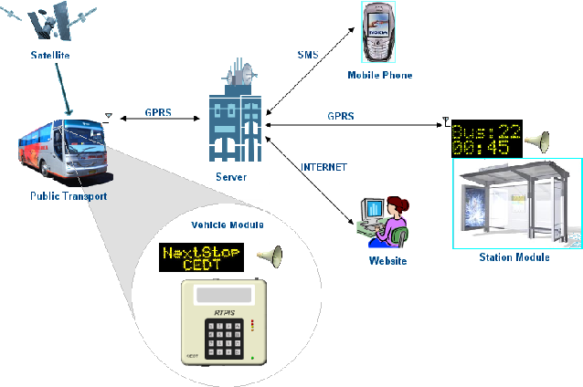

The ditance
Real-Time Updates: The system continuously updates the distance information as the bus moves along its route. Passengers can access this real-time distance data through various user interfaces, such as mobile apps, websites, or electronic displays at bus stops.

