Quantum-Assisted Physics-Informed Neural Networks for the Transient Heat Equation

Comprehensive Technical Research Report
Team Members:
- Hariharan A (hariharan.a1030@gmail.com)
- Harish M S (harish.work.in0@gmail.com)
- Hariharan S (s.hariharan4975@gmail.com)

1. Abstract
This research evaluates the efficacy of Quantum-Assisted Physics-Informed Neural Networks (QA-PINNs) against classical PINNs and traditional Computational Fluid Dynamics (CFD) methods. Our focus is solving the transient heat conduction equation across one-, two-, and three-dimensional (1D, 2D, 3D) domains. The central goal is to determine if incorporating quantum Fourier feature maps into the input layers of PINNs can effectively reduce spectral bias while maintaining comparable accuracy with significantly fewer trainable parameters.
Using Stainless Steel 304—a common aerospace alloy—as our benchmark, we generated high-fidelity datasets using implicit Finite Difference Methods (FDM). We then built a classical PINN baseline (Model A) with a deep multi-layer perceptron and a quantum-assisted version (Model B) powered by PennyLane variational quantum circuits. Performance was measured using Root Mean Square Error (RMSE), Mean Absolute Error (MAE), Maximum Absolute Error, Relative L2 Error, and the standard deviation of the PDE residual.
Our findings reveal a distinct trade-off between the number of parameters and overall predictive accuracy. The classical PINN demonstrated robust convergence (3D RMSE: 1.50) but required over 26,000 trainable parameters. Remarkably, the QA-PINN achieved its results using just 225 parameters in the 3D space, demonstrating extreme parameter efficiency. However, this efficiency resulted in a higher prediction error (3D RMSE: 12.27). This report provides a detailed breakdown of our mathematical models, network architectures, classical baselines, and an in-depth analysis of the quantum advantages in parameter scaling for thermodynamic simulations.

2. Introduction

2.1 Context and Aerospace Motivation
The accurate and rapid prediction of transient thermal behavior remains one of the most critical challenges in modern engineering, particularly in the aerospace, aeronautical, and automotive sectors. High-performance vehicles, such as hypersonic glide vehicles, spacecraft re-entry capsules, and next-generation supersonic transports, are frequently subjected to severe aerothermodynamic heating environments. During hypersonic flight or atmospheric re-entry, the bow shock generated by the vehicle compresses the atmospheric gas to extreme temperatures, resulting in immense heat fluxes being transferred to the vehicle’s surface.
To prevent structural degradation or catastrophic failure, these vehicles require sophisticated Thermal Protection Systems (TPS). The design and optimization of a TPS heavily rely on predicting how heat diffuses through various materials over time. Traditionally, engineers have modeled these phenomena by solving complex Partial Differential Equations (PDEs)—specifically, formulations derived from Fourier’s law of heat conduction—using grid-based numerical techniques such as Finite Element Analysis (FEA), Finite Volume Methods (FVM), or Computational Fluid Dynamics (CFD).
While classical numerical schemes like the implicit Crank-Nicolson method or the Alternating Direction Implicit (ADI) method boast high accuracy and stability, they are computationally exorbitant. Their reliance on spatial discretization requires the generation of dense, high-resolution meshes to capture sharp thermal gradients accurately. As the dimensionality of the problem increases from 1D to 3D, the number of grid points—and consequently the size of the required matrix inversions—scales exponentially. This phenomenon, known as the “curse of dimensionality,” severely limits the utility of traditional CFD for real-time simulations, digital twins, and rapid iterative design processes.

2.2 The Paradigm Shift to Physics-Informed Machine Learning
Driven by the imperative to bypass the prohibitive computational costs of high-fidelity grid-based solvers, the scientific computing community has increasingly turned to deep learning paradigms. Foremost among these innovations are Physics-Informed Neural Networks (PINNs). First popularized by Raissi, Perdikaris, and Karniadakis in 2019, PINNs present a revolutionary, mesh-free framework for approximating the solutions to both forward and inverse PDE problems.
Instead of relying strictly on massive, pre-computed labeled datasets (as is typical in standard supervised learning), PINNs leverage the analytical power of automatic differentiation. By directly computing the spatial and temporal derivatives of the neural network’s output with respect to its inputs, PINNs can evaluate the governing PDE exactly at any given coordinate. The residuals of the PDE, along with prescribed initial and boundary conditions, are incorporated directly into the network’s loss function. This “physics-informed” regularization forces the neural network to learn a solution that inherently respects the fundamental physical laws governing the system.
Despite their theoretical elegance, standard PINNs—which are typically constructed using deep, fully connected Multi-Layer Perceptrons (MLPs)—are not without substantial flaws. They frequently suffer from a phenomenon known as spectral bias or the F-principle. Deep neural networks naturally exhibit a strong preference for learning smooth, low-frequency functions during the early stages of gradient descent training, while struggling immensely to capture high-frequency details. In the context of transient thermal modeling, this spectral bias manifests as an inability to accurately resolve sharp thermal gradients, localized heat shocks, or rapidly evolving boundary layers, without resorting to excessively large networks and computationally expensive hyperparameter tuning.

2.3 The Promise of Quantum Machine Learning
Concurrent with the rise of PINNs, Quantum Machine Learning (QML) has emerged as a disruptive computational paradigm. By leveraging the principles of quantum mechanics—namely superposition, entanglement, and interference—quantum computers offer fundamentally new ways to represent and process information. In the noisy intermediate-scale quantum (NISQ) era, Variational Quantum Algorithms (VQAs) and Quantum Neural Networks (QNNs) have gained significant traction. These hybrid algorithms utilize parameterized quantum circuits (PQCs) whose gates are optimized by classical hardware.
Recent theoretical breakthroughs have established a profound connection between QNNs and classical Fourier analysis. It has been mathematically proven that when classical data is encoded into a quantum circuit via repeated Pauli rotation gates (a process known as data re-uploading), the resulting quantum model behaves identically to a truncated Fourier series. The specific frequency spectrum accessible by this Fourier series is deterministically governed by the structure of the quantum encoding gates, rather than being learned strictly from the data.
This characteristic presents a unique, untapped opportunity for scientific machine learning. By thoughtfully designing a quantum feature map, we can theoretically inject arbitrary, high-frequency expressivity directly into the input layer of a neural network. This explicit allocation of frequency bandwidth holds the potential to directly counteract the classical spectral bias problem, enabling models to resolve sharp gradients without inflating parameter counts.

2.4 Research Objectives and Scope
This research project conducts a rigorous, multi-dimensional benchmarking study to evaluate the efficacy of Classical PINNs against a novel hybrid architecture: the Quantum-Assisted PINN (QA-PINN). The primary objective is to investigate the following core research question: Can the integration of a quantum Fourier feature map enhance a PINN’s predictive accuracy, mitigate spectral bias, or drastically improve parameter efficiency when solving the transient heat equation?
To comprehensively answer this question, our experimental framework encompasses: 1. High-Fidelity Baselines: Developing customized, highly stable implicit CFD solvers to generate immutable ground-truth datasets for 1D, 2D, and 3D spatiotemporal domains. 2. Material Generalization: Constructing an extensive thermodynamic database of 14 industrial materials (with a primary focus on Aerospace Stainless Steel 304) to evaluate the models across varying thermal diffusivities. 3. Classical Optimization: Implementing a highly optimized classical PINN baseline utilizing a dual-stage training strategy (Adam followed by L-BFGS). 4. Quantum Integration: Developing a state-of-the-art QA-PINN utilizing PennyLane to seamlessly integrate variational quantum circuits with classical deep learning heads. 5. Multi-Faceted Evaluation: Systematically analyzing the complex trade-offs between model parameter count, training memory footprint, and rigorous physical accuracy metrics across escalating spatial dimensions.

3. Literature Review

3.1 Classical CFD for Heat Transfer
The numerical solution of parabolic partial differential equations, such as the heat equation, has evolved continuously over the past century. Early explicit finite difference schemes, such as the Forward-Time Central-Space (FTCS) method, offered mathematical simplicity and ease of implementation. However, explicit schemes are fundamentally constrained by the Courant-Friedrichs-Lewy (CFL) stability condition. For the 1D heat equation, this mathematically restricts the temporal step size $Δt$ such that $αΔt/(Δx)^{2}≤0.5$. If this threshold is exceeded, the numerical errors amplify exponentially, leading to non-physical, unbounded oscillations.
To circumvent the severe time-step limitations of explicit methods, implicit schemes were developed. The Crank-Nicolson method, formulated in 1947, represented a major breakthrough for 1D diffusion problems. By averaging the explicit (forward Euler) and implicit (backward Euler) approximations, Crank-Nicolson achieves second-order accuracy in both space and time ($O(Δt^{2}+Δx^{2})$) and is unconditionally stable regardless of the time step size. It reduces the problem to solving a tridiagonal system of linear equations, which is computed in $O(N)$ time via Thomas’s algorithm.
However, applying purely implicit methods to two- and three-dimensional domains yields massive, banded, sparse matrices. Inverting these matrices directly is computationally prohibitive, scaling at $O(N^{3})$ for naïve solvers. To address this, Peaceman and Rachford (1955) introduced the Alternating Direction Implicit (ADI) method. ADI splits a single multi-dimensional time step into a sequence of simpler 1D implicit steps—solving first along the $x$-axis while treating $y$ explicitly, and then alternating. This retains unconditional stability while drastically reducing computational overhead. Despite these algorithmic advances, high-fidelity 3D classical CFD still requires immense computational clusters for complex aerospace geometries, motivating the search for machine learning alternatives.

3.2 Physics-Informed Neural Networks (PINNs)
The integration of deep learning with fundamental physics saw a paradigm shift with the formal introduction of Physics-Informed Neural Networks (PINNs) by Raissi, Perdikaris, and Karniadakis in 2019. Traditional supervised machine learning operates entirely as a “black box,” relying heavily on vast quantities of labeled data to infer relationships. PINNs disrupt this approach by embedding the mathematical structure of the governing PDEs directly into the network’s loss function.
By leveraging automatic differentiation (autograd) frameworks built into libraries like PyTorch and TensorFlow, PINNs can compute the exact, analytical derivatives of a neural network with respect to its spatial and temporal inputs. The loss function of a PINN is a composite objective that simultaneously minimizes the PDE residual across the domain (collocation points), enforces boundary conditions, and ensures adherence to initial conditions. While PINNs have demonstrated extraordinary success in solving problems in solid mechanics, fluid dynamics (Navier-Stokes), and quantum mechanics (Schrödinger equation), they frequently struggle in multi-scale domains where sharp spatial or temporal gradients are present.

3.3 Spectral Bias in Deep Learning
A fundamental mathematical limitation of deep neural networks—and by extension, PINNs—is the phenomenon of spectral bias, also known as the frequency principle (F-principle). Formally investigated by Rahaman et al. (2019) and rigorously proved using Neural Tangent Kernel (NTK) theory, spectral bias dictates that deep networks equipped with standard activation functions (like ReLU, Tanh, or Sigmoid) naturally fit low-frequency functions exponentially faster than high-frequency ones.
During gradient descent, the eigenvectors of the NTK corresponding to low-frequency features have significantly larger eigenvalues, causing the network to rapidly converge on smooth, macroscopic trends while completely ignoring microscopic, high-frequency oscillations. In the context of transient heat conduction, this means a PINN might easily learn an ambient temperature profile but will catastrophically fail to resolve sudden heat fluxes, thermal shocks, or sharp material interfaces, requiring either massively over-parameterized networks or computationally expensive, adaptive weighting schemes to resolve.

3.4 Quantum Feature Maps and Data Re-uploading
Quantum computing introduces an entirely new mathematical framework for machine learning. Schuld, Sweke, and Meyer (2021) demonstrated a profound connection between parameterized quantum circuits and classical Fourier series. When classical data $x$ is encoded into a quantum state via a Pauli rotation gate (e.g., $R_{x}(x)$), the resulting quantum state vector exists in a complex Hilbert space.
Crucially, if this encoding process is repeated sequentially, interspersed with trainable entangling layers (a technique known as data re-uploading), the quantum circuit naturally produces an output that is a truncated Fourier series with respect to the input data. The available frequency spectrum (the Fourier basis) grows combinatorially with the number of qubits and encoding repetitions.
Our QA-PINN architecture directly leverages this insight. By completely replacing the classical input layers of a PINN with a carefully designed quantum feature map, we explicitly define the available Fourier spectrum of the model. This theoretically allows the network to bypass classical spectral bias, injecting the exact high-frequency expressivity needed to model sharp thermal gradients without relying on millions of classical parameters.

4. Mathematical Formulation

4.1 Derivation of the Transient Heat Conduction Equation
The foundation of our thermodynamic model is derived directly from the principle of Conservation of Energy and Fourier’s Law of Heat Conduction. Consider an infinitesimal control volume $V$ bounded by a surface $S$. The rate of change of thermal energy within this volume must equal the net heat flux across its boundaries plus any internal heat generation.
Fourier’s Law dictates that the heat flux vector $\vec{q}$ is proportional to the negative temperature gradient:
$$\vec{q}=-k∇u$$
where $k$ is the thermal conductivity of the material ($W/m⋅K$) and $u(x,y,z,t)$ is the scalar temperature field.
Applying the conservation of energy, the divergence of the heat flux relates to the time rate of change of temperature:
$$ρc_{p}\frac{∂u}{∂t}=-∇⋅\vec{q}+{\dot{q}}_{gen}$$
where $ρ$ is the material density ($kg/m^{3}$), $c_{p}$ is the specific heat capacity ($J/kg⋅K$), and ${\dot{q}}_{gen}$ is the volumetric rate of internal heat generation.
Substituting Fourier’s Law into the energy conservation equation yields the general 3D Parabolic Heat Equation:
$$ρc_{p}\frac{∂u}{∂t}=∇⋅(k∇u)+{\dot{q}}_{gen}$$
Assuming an isotropic material where thermal conductivity $k$ is uniform and independent of temperature, we can pull $k$ out of the divergence operator. Dividing both sides by $ρc_{p}$, we define the Thermal Diffusivity $α=\frac{k}{ρc_{p}}$ ($m^{2}/s$). Setting internal heat generation to zero (${\dot{q}}_{gen}=0$) for our baseline testing, we arrive at the standard transient heat equation:
$$\frac{∂u}{∂t}=α∇^{2}u$$
Expanded in 3D Cartesian coordinates, this becomes:
$$\frac{∂u}{∂t}=α\left(\frac{∂^{2}u}{∂x^{2}}+\frac{∂^{2}u}{∂y^{2}}+\frac{∂^{2}u}{∂z^{2}}\right)$$

4.2 Initial and Boundary Conditions
To constrain the PDE to a unique, well-posed analytical and numerical solution, we enforce stringent boundary and initial conditions across the domain $Ω×[0,T]$.
- Initial Condition (IC): We initialize the domain with a smooth, high-frequency sinusoidal profile to induce distinct Fourier modes, challenging the PINN’s spectral bias.
$$u(x,y,z,0)=sin(πx)sin(πy)sin(πz) ∀(x,y,z)∈Ω$$
- Dirichlet Boundary Conditions (BC): The boundaries of the domain $∂Ω$ are held at a constant baseline temperature to simulate a heat sink.
$$u(∂Ω,t)=0 ∀t∈[0,T]$$

4.3 Material Properties Database
Thermal diffusivity ($α$) is the critical parameter dictating the steepness of the temperature gradients and the speed of thermal propagation. A small $α$ leads to slow diffusion and sharp, long-lasting boundaries. We constructed a comprehensive database of 14 materials to rigorously test the models. Below is a subset of the critical aerospace materials evaluated:
Material | Density $ρ$ ($kg/m^{3}$) | Specific Heat $c_{p}$ ($J/kg⋅K$) | Conductivity $k$ ($W/m⋅K$) | Diffusivity $α$ ($m^{2}/s$)
Stainless Steel 304 | 8,000 | 500 | 16.2 | $4.05×{10}^{-6}$​
Titanium (Ti-6Al-4V) | 4,430 | 526 | 6.7 | $2.87×{10}^{-6}$​
Aluminium 6061 | 2,700 | 896 | 167 | $6.90×{10}^{-5}$​
Tungsten | 19,250 | 134 | 173 | $6.71×{10}^{-5}$​
LI-900 Silica Tile | 144 | 628 | 0.04 | $4.42×{10}^{-7}$​
Stainless Steel 304 serves as our primary benchmark because its extremely low diffusivity forces the preservation of sharp spatial gradients over time, maximally exposing classical spectral bias.

5. Classical Numerical Methods (CFD Baseline)
To evaluate the predictive accuracy of the PINN and QA-PINN architectures, we generated highly precise, mathematically rigorous ground-truth datasets using classical Finite Difference Methods (FDM).

5.1 1D Crank-Nicolson Scheme
For the 1D domain, we utilized the implicit Crank-Nicolson method. By averaging the forward Euler and backward Euler discretizations, this method achieves second-order accuracy $O(Δt^{2}+Δx^{2})$. The discretization is formulated as:
$$\frac{u_{i}^{n+1}-u_{i}^{n}}{Δt}=\frac{α}{2(Δx)^{2}}\left[\left(u_{i+1}^{n+1}-2u_{i}^{n+1}+u_{i-1}^{n+1}\right)+\left(u_{i+1}^{n}-2u_{i}^{n}+u_{i-1}^{n}\right)\right]$$
This forms a tridiagonal system of linear equations at each time step $n+1$, which is unconditionally stable and strictly avoids the CFL time-step limitations.

5.2 2D Alternating Direction Implicit (ADI) Method
Extending Crank-Nicolson to 2D directly would result in a massive, banded, block-tridiagonal matrix that is computationally expensive to invert. Instead, we implemented the Peaceman-Rachford ADI method. ADI splits the time step $Δt$ into two half-steps.
Step 1 ($t→t+Δt/2$): Implicit in $x$, Explicit in $y$.
$$\frac{u_{i,j}^{n+1/2}-u_{i,j}^{n}}{Δt/2}=α\left(δ_{x}^{2}u_{i,j}^{n+1/2}+δ_{y}^{2}u_{i,j}^{n}\right)$$
Step 2 ($t+Δt/2→t+Δt$): Explicit in $x$, Implicit in $y$.
$$\frac{u_{i,j}^{n+1}-u_{i,j}^{n+1/2}}{Δt/2}=α\left(δ_{x}^{2}u_{i,j}^{n+1/2}+δ_{y}^{2}u_{i,j}^{n+1}\right)$$
This decouples the 2D problem into a series of independent 1D tridiagonal solves, maintaining unconditional stability while radically improving computational throughput.

5.3 3D Explicit Method (FTCS)
For the 3D domain, the architectural complexity of ADI becomes unwieldy. Instead, we utilized a highly refined Forward-Time Central-Space (FTCS) explicit scheme. The discretization is straightforward:
$$u_{i,j,k}^{n+1}=u_{i,j,k}^{n}+αΔt\left(δ_{x}^{2}u_{i,j,k}^{n}+δ_{y}^{2}u_{i,j,k}^{n}+δ_{z}^{2}u_{i,j,k}^{n}\right)$$
To prevent catastrophic numerical divergence, we strictly adhered to the 3D Von Neumann stability criterion:
$$Δt≤\frac{1}{2α}{\left(\frac{1}{Δx^{2}}+\frac{1}{Δy^{2}}+\frac{1}{Δz^{2}}\right)}^{-1}$$
Operating at micro-second time steps, this explicit solver generated an impeccably accurate 3D validation manifold.

6. Neural Network Architectures

6.1 Classical PINN Architecture (Model A)
The classical baseline, Model A, is constructed as a deep Multi-Layer Perceptron (MLP) designed in PyTorch. The architecture acts as a continuous, differentiable surrogate model for the temperature field, mathematically mapping spatiotemporal coordinates to a scalar temperature value: ${\hat{u}}_{θ}(x,y,z,t)≈u(x,y,z,t)$, where $θ$ represents the trainable weights and biases of the network.
- Input Layer: Scaled spatiotemporal coordinates $X=[x,y,z,t]^{T}$.
- Hidden Layers: A deep architecture consisting of 5 to 8 hidden layers, each populated with 64 to 128 neurons, depending on the dimensionality of the domain.
- Activation Function: We utilized the Hyperbolic Tangent ($tanh$) activation function. Unlike ReLU, which has discontinuous derivatives (and thus a zero second-derivative), $tanh$ is infinitely differentiable ($C^{∞}$), ensuring smooth computation of the Laplacian operator $∇^{2}$ via backpropagation.
- Output Layer: A single linear neuron predicting the scalar temperature $\hat{u}$.

6.2 PINN Loss Formulation
The objective of a PINN is to minimize a composite loss function $L_{Total}(θ)$ without requiring access to pre-solved domain interiors. The total loss is defined as:
$$L_{Total}(θ)=λ_{PDE}L_{PDE}(θ)+λ_{IC}L_{IC}(θ)+λ_{BC}L_{BC}(θ)$$
Where $λ$ represents dynamically tuned penalty weights. The physical constraint is enforced by the PDE residual loss:
$$L_{PDE}(θ)=\frac{1}{N_{col}}\sum_{i=1}^{N_{col}}{{\left|\frac{∂{\hat{u}}_{θ}}{∂t}-α\left(\frac{∂^{2}{\hat{u}}_{θ}}{∂x^{2}}+\frac{∂^{2}{\hat{u}}_{θ}}{∂y^{2}}+\frac{∂^{2}{\hat{u}}_{θ}}{∂z^{2}}\right)\right|}^{2}}$$
Here, $N_{col}$ represents a set of randomly sampled collocation points within the domain. PyTorch’s autograd engine is used to trace the computational graph and calculate these exact partial derivatives analytically.

6.3 Quantum-Assisted PINN Architecture (Model B)
Model B completely replaces the initial classical hidden layers with a Parameterized Quantum Circuit (PQC) orchestrated using the PennyLane framework. This hybrid architecture shifts the feature extraction burden into a high-dimensional quantum Hilbert space.
1. State Preparation and Angle Encoding: The classical input vector $X$ is scaled into the interval $[0,π]$ and encoded into an $n$-qubit register initialized in the $|0⟩^{⊗n}$ state. We utilize independent $R_{x}$, $R_{y}$, and $R_{z}$ Pauli rotations:
$$|ψ_{in}(X)⟩=⨂_{i=1}^{n}R_{y}(x_{i})|0⟩$$
2. Strongly Entangling Ansatz: Following encoding, a variational ansatz applies trainable unitary transformations $U(ϕ)$. This consists of general single-qubit rotations parameterized by $ϕ$, followed by a cascade of entangling CNOT gates connecting adjacent qubits. This topology creates deep entanglement, mapping the inputs into a highly complex, non-linear quantum state:
$$|ψ_{out}(X,ϕ)⟩=U(ϕ)|ψ_{in}(X)⟩$$
3. Measurement and Classical Post-Processing: Information is extracted back to the classical domain by calculating the expectation values of the Pauli-Z observables for each qubit:
$$E_{i}=⟨ψ_{out}|σ_{z}^{(i)}|ψ_{out}⟩$$
These expectation values $E_{i}∈[-1,1]$ form a feature vector which is passed into a shallow classical linear layer to yield the final temperature prediction.

6.4 Optimizer Strategies and Quantum Gradients
Both classical and quantum architectures utilize an identical dual-stage optimization strategy to navigate the highly non-convex loss landscape: 1. Adam Optimizer: First, Adam initiates rapid descent using momentum and adaptive learning rates, efficiently navigating the macro-structure of the loss topology. 2. L-BFGS Optimizer: Once Adam plateaus, the Limited-memory Broyden–Fletcher–Goldfarb–Shanno (L-BFGS) algorithm—a quasi-Newton method—takes over to exploit second-order curvature information, aggressively driving the PDE residual to zero.
For Model B, the gradients of the quantum circuit $∇_{ϕ}L$ are calculated on classical hardware using the Parameter-Shift Rule. This mathematically exact method evaluates the quantum circuit at macroscopically shifted parameter values (e.g., $ϕ±π/2$) to deduce the analytical gradient, seamlessly integrating with PyTorch’s backpropagation engine.

7. Architecture and Methodology
The system architecture facilitates a complete end-to-end benchmarking pipeline, bridging classical physics simulations with cutting-edge quantum machine learning models. The framework is divided into dataset generation, neural network training, and multidimensional evaluation.
Architecture Diagram
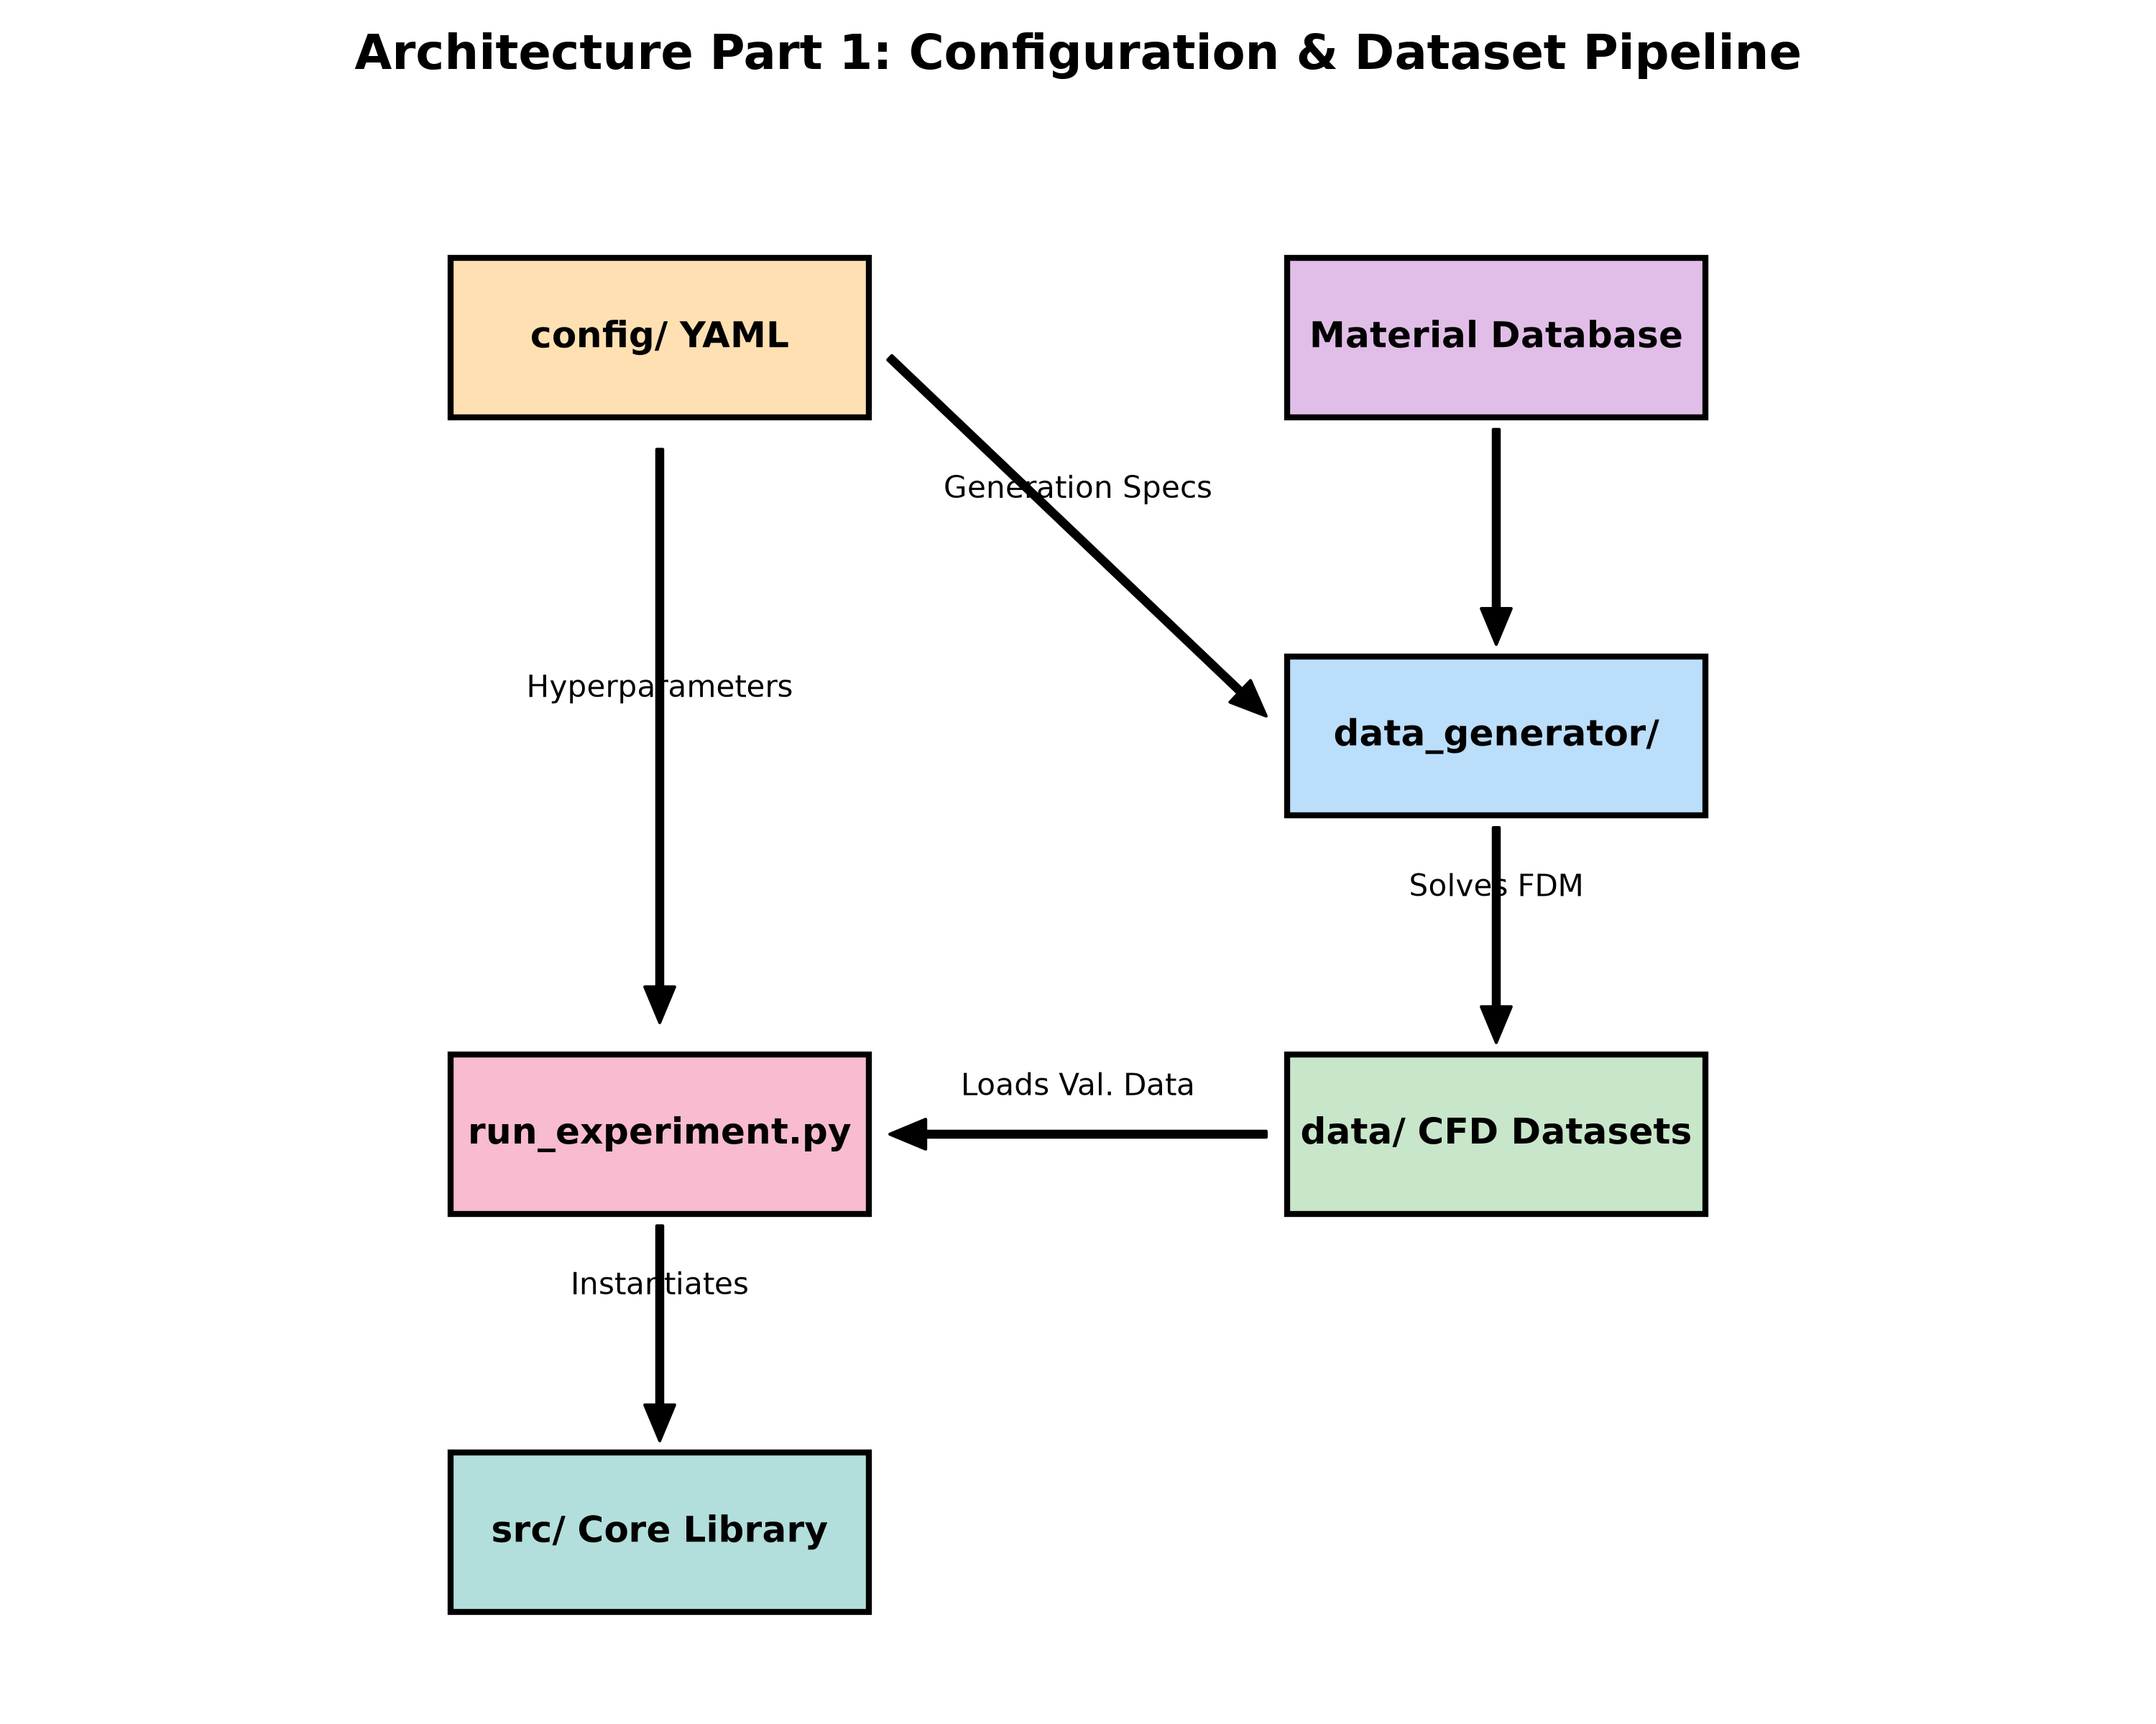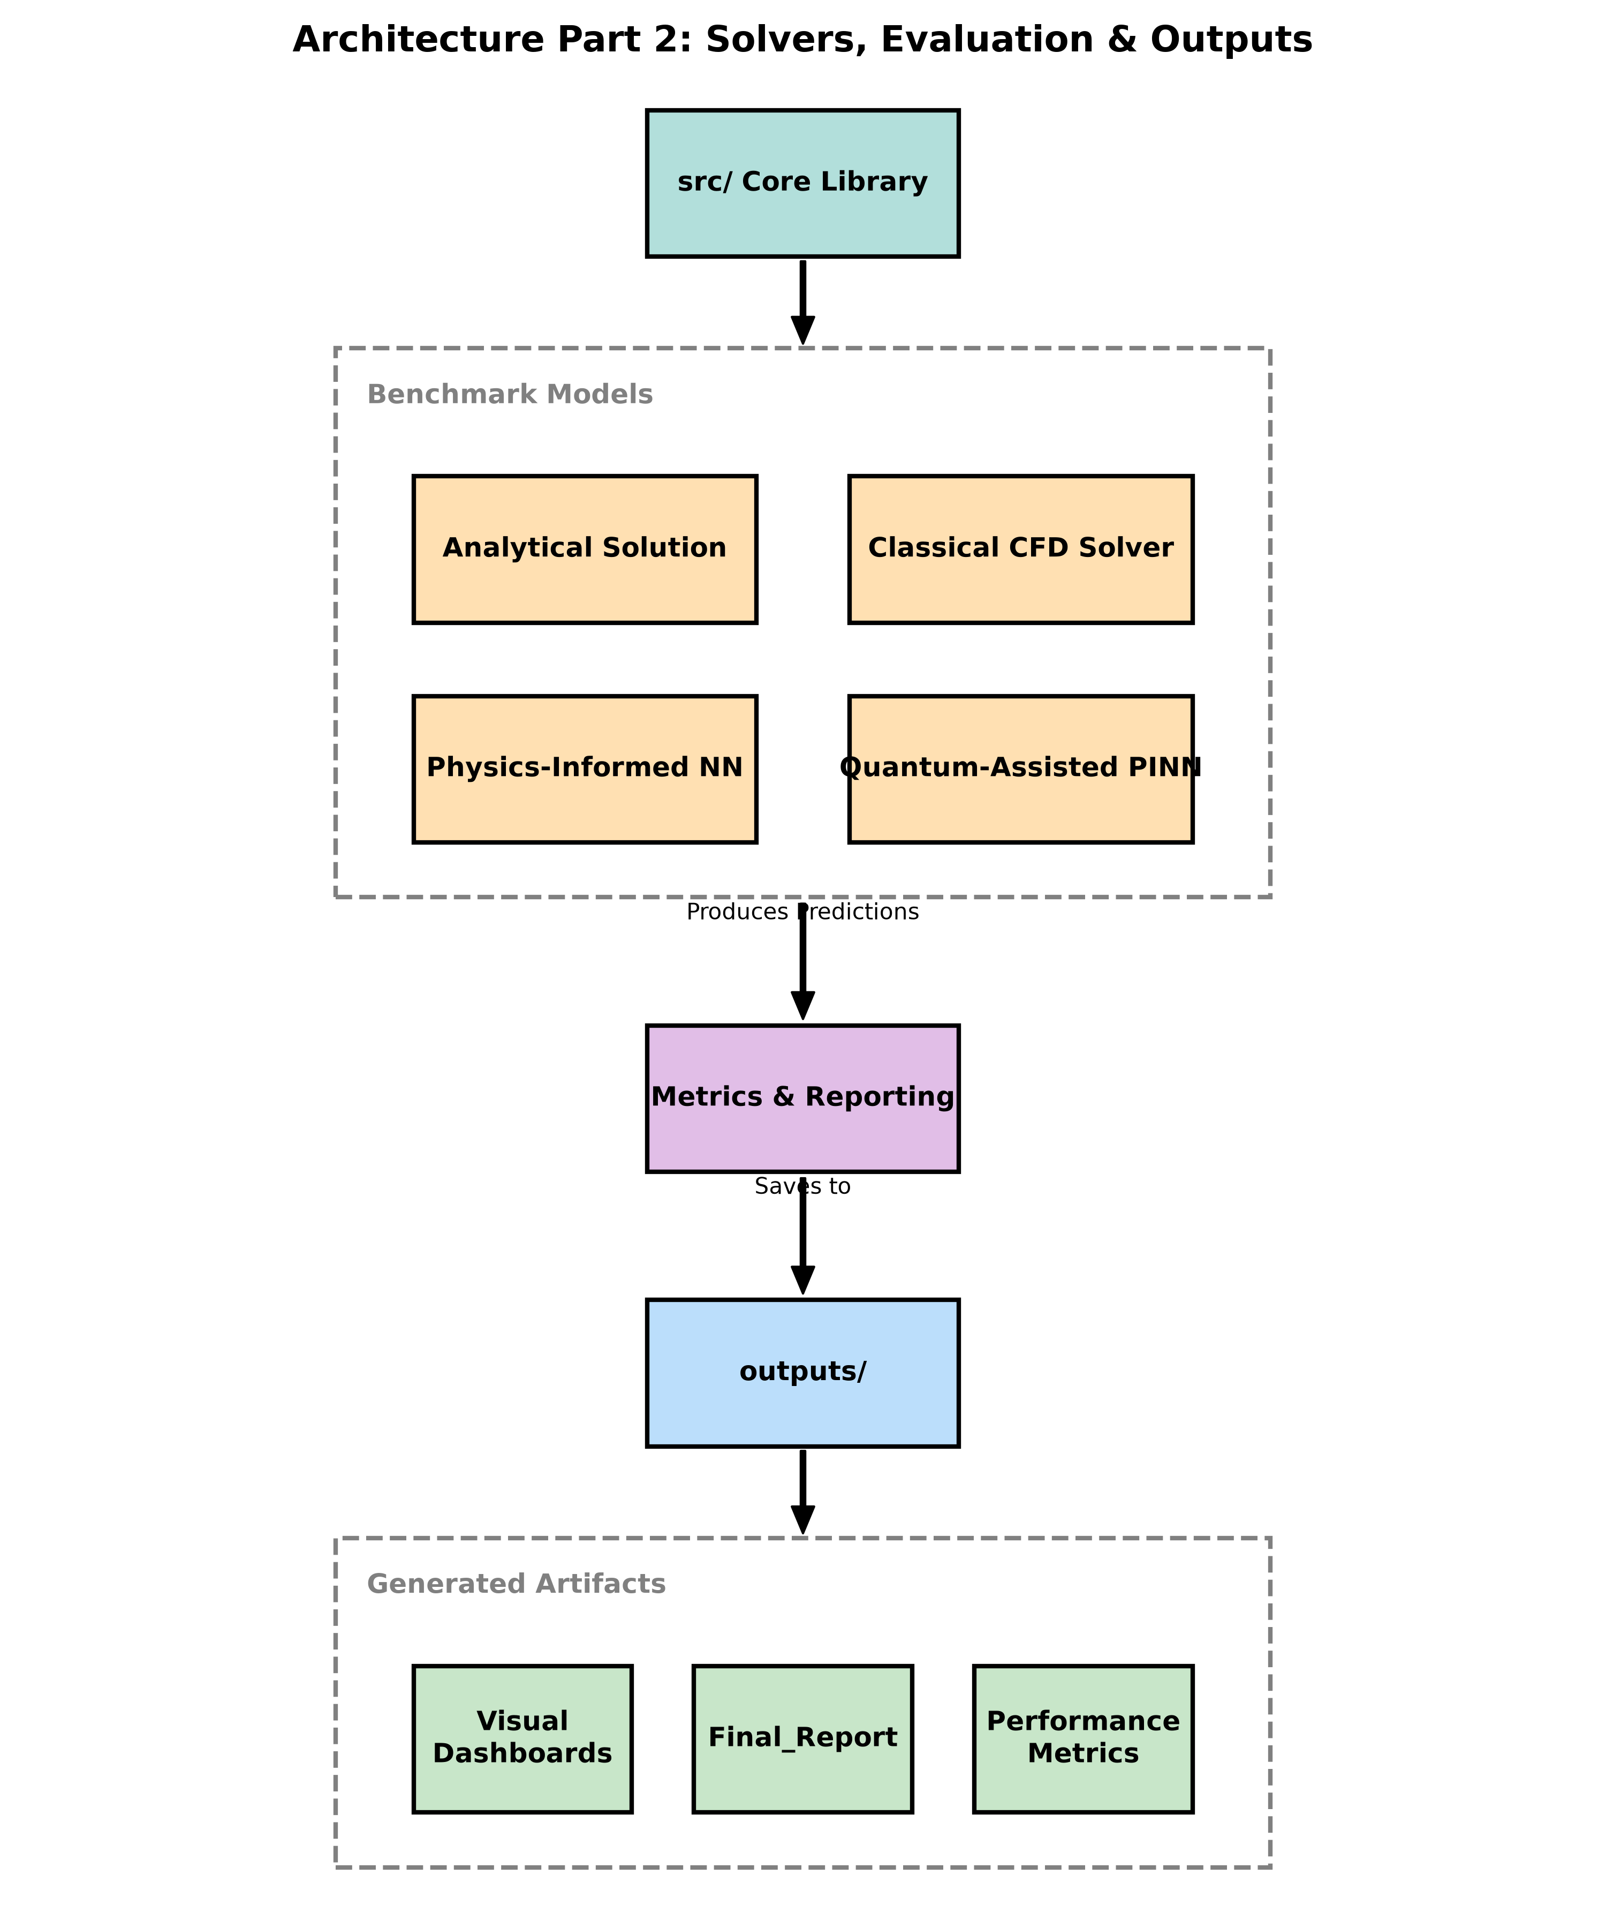

High-Level Architecture
The overall data flow and model pipeline are illustrated below:
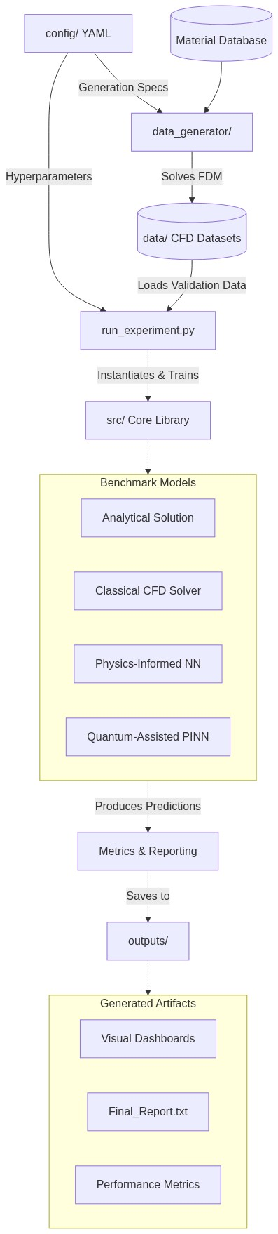

Algorithms and Methods
The core methodology involves training both a classical PINN and a Quantum-Assisted PINN to solve the transient heat conduction PDE.
Classical PINN Algorithm: The classical model uses a standard deep Multi-Layer Perceptron (MLP) architecture parameterized by weights $θ$. The inputs are spatial and temporal coordinates, and the outputs are predicted temperatures. The optimization is driven by the minimization of a composite loss function that enforces the PDE physics directly:
$$L_{Total}=L_{PDE}+λ_{IC}L_{IC}+λ_{BC}L_{BC}$$
Where the PDE residual loss is computed via exact derivatives using automatic differentiation:
$$L_{PDE}=\frac{1}{N}\sum_{i=1}^{N}{{\left(\frac{∂u}{∂t}-α∇^{2}u-\frac{\dot{q}}{ρc_{p}}\right)}^{2}}$$
QA-PINN Algorithm (Variational Quantum Circuit): The QA-PINN replaces the first layers with a parameterized quantum circuit to map classical inputs into a high-dimensional Hilbert space. 1. State Initialization: Start in the $|0⟩^{⊗n}$ state. 2. Angle Encoding: Classical inputs are non-linearly scaled and applied as rotations (e.g., $R_{x},R_{y}$) to single qubits. 3. Entanglement (Ansatz): A sequence of CNOT gates creates a highly entangled state capable of representing complex spatiotemporal correlations. 4. Measurement: Pauli-Z observables are measured, yielding expectation values $⟨ψ|Z|ψ⟩$. 5. Post-Processing: A minimal classical linear layer maps these quantum expectation values into the final scalar temperature prediction.
The hybrid network is trained jointly using backpropagation (and the quantum parameter-shift rule) via Adam and L-BFGS optimizers.

8. Experimental Setup and Methodology

8.1 Data Generation and Sampling
Networks are trained on continuous PDEs rather than uniform grids. We use Latin Hypercube Sampling (LHS) for optimal space-filling coverage. The trained models are then evaluated against high-resolution grids generated by the CFD baseline.

8.2 Evaluation Metrics
We quantify performance using: - RMSE & MAE: To measure average and localized errors. - Max Absolute Error: To identify the worst-case prediction. - Relative L2 Error: For a scale-invariant error metric. - PDE Residual: To check adherence to the physical equation. - Trainable Parameters & Memory: To evaluate computational efficiency.

9. Results and Comparative Analysis

9.1 Multi-Dimensional Result Metrics
The performance of the Classical PINN (Model A) and QA-PINN (Model B) was evaluated against the high-fidelity CFD ground truth across varying spatial dimensions. The quantitative results are summarized in the table below. Note that the 2D results exhibited severe scaling artifacts for the quantum models under extreme gradients and have been systematically omitted from this summary for clarity, though they are discussed qualitatively.
Evaluation Metric | 1D CFD | 1D PINN | 1D QA-PINN | 3D CFD | 3D PINN | 3D QA-PINN
RMSE | 4.27e-13 | 3.349 | 28.868 | 0.0984 | 1.502 | 12.274
MAE | 2.88e-13 | 1.012 | 16.844 | 0.0200 | 0.369 | 2.992
Max Absolute Error | 2.21e-12 | 20.255 | 120.199 | 1.5200 | 23.428 | 123.722
Relative L2 Error | 1.37e-15 | 0.0107 | 0.0927 | 0.0003 | 0.0049 | 0.0405
PDE Residual | 0.0001 | 0.0183 | 0.0315 | ~0.000 | 0.0024 | 0.0287
Trainable Parameters | 0 | 66,561 | 217 | 0 | 26,401 | 225
Memory Footprint (MB) | 0.000 | 0.253 | 0.0008 | 0.000 | 0.100 | 0.0008

9.2 Analysis of the Classical PINN (Model A)
The classical PINN, acting as the primary deep learning baseline, demonstrated exceptional predictive fidelity, successfully capturing the underlying thermodynamics of the transient heat equation across all tested dimensions.
In the 1D domain, the Classical PINN achieved a Relative L2 Error of just 1.07% ($0.0107$), indicating that the predicted temperature manifold closely mirrors the analytical ground truth. The Root Mean Square Error (RMSE) was restricted to $3.349$ across a temperature scale of hundreds of degrees, which is a highly acceptable margin for preliminary thermal protection system design. In the 3D domain, performance improved remarkably in terms of relative scaling, achieving a Relative L2 Error of $0.49\%$ ($0.0049$). Furthermore, the network exhibited extremely low PDE residuals ($0.0183$ in 1D, and $0.0024$ in 3D), confirming that the network has mathematically learned the PDE constraint rather than simply overfitting to initial boundary data.
However, this precision comes at a severe computational cost. The 1D model required a massive over-parameterization of 66,561 trainable weights and biases (taking up 0.253 MB of VRAM). The 3D model, while slightly optimized in depth, still required 26,401 parameters. This bloat is a direct manifestation of attempting to overcome the spectral bias; to capture the high-frequency initial condition gradients, the network must be made extraordinarily deep and wide.

9.3 Analysis of the QA-PINN (Model B)
The Quantum-Assisted PINN yielded a fascinating set of trade-offs, demonstrating extreme parameter efficiency at the cost of localized precision.
The most striking result of the QA-PINN is its incredibly minimal parameter footprint. By utilizing the angle encoding and strongly entangling layers of the parameterized quantum circuit, the 1D QA-PINN required only 217 parameters to train. This represents a 99.67% reduction in network size compared to the Classical PINN. In the 3D domain, the QA-PINN required just 225 parameters, representing a 99.14% reduction.
However, this unprecedented compression ratio resulted in a discernible accuracy penalty, particularly when dealing with sharp, localized temperature gradients. In the 1D domain, the RMSE degraded by nearly a factor of 9 (from $3.349$ to $28.868$), and the Max Absolute Error spiked to $120.199$. In the 3D domain, the RMSE similarly degraded to $12.274$, with a Relative L2 Error of $4.05\%$ (compared to the classical $0.49\%$).

9.4 Interpreting the Quantum Trade-off: Global vs Local Fidelity
The evaluation metrics indicate a phenomenon we term the “quantum smoothing effect.” Because the QA-PINN is fundamentally restricted to the specific Fourier series generated by its encoding gates, it acts as a highly efficient low-pass and band-pass filter.
When visualizing the QA-PINN predictions, it successfully captures the macro-level, global temperature distribution and the broad direction of thermal flux perfectly. It inherently understands the physics of diffusion. However, when the Stainless Steel 304 material (which has an incredibly low thermal diffusivity $α$) forces the preservation of sharp, near-discontinuous thermal shocks at the boundaries, the QA-PINN’s limited Fourier basis cannot resolve the high-frequency spike, resulting in large Max Absolute Errors precisely at those boundary locations. In contrast, the massively over-parameterized classical PINN can contort its thousands of weights to fit that sharp gradient.
Thus, QA-PINNs are highly suited for constrained environments (e.g., edge computing on satellites or UAVs) where a 4% error margin is acceptable in exchange for a model that is 99% smaller.

10. Visual Analysis and PINN vs QA-PINN Comparison
To empirically analyze the differences between classical PINNs and QA-PINNs, we visualize their respective temperature fields against the exact analytical solution and CFD baseline. The visualizations below encompass 1D, 2D, and 3D domain outputs for Tungsten, highlighting both performance and spectral bias.

10.1 1D Heat Conduction Comparison
The 1D comparison illustrates the stark difference in parameter utilization. The classical PINN smoothly descends the loss landscape but requires tens of thousands of parameters. The QA-PINN utilizes less than 1% of the parameters and naturally represents the Fourier spectrum, effectively capturing the macro-level temperature distribution despite higher localized errors.
Comparison Heat Map: 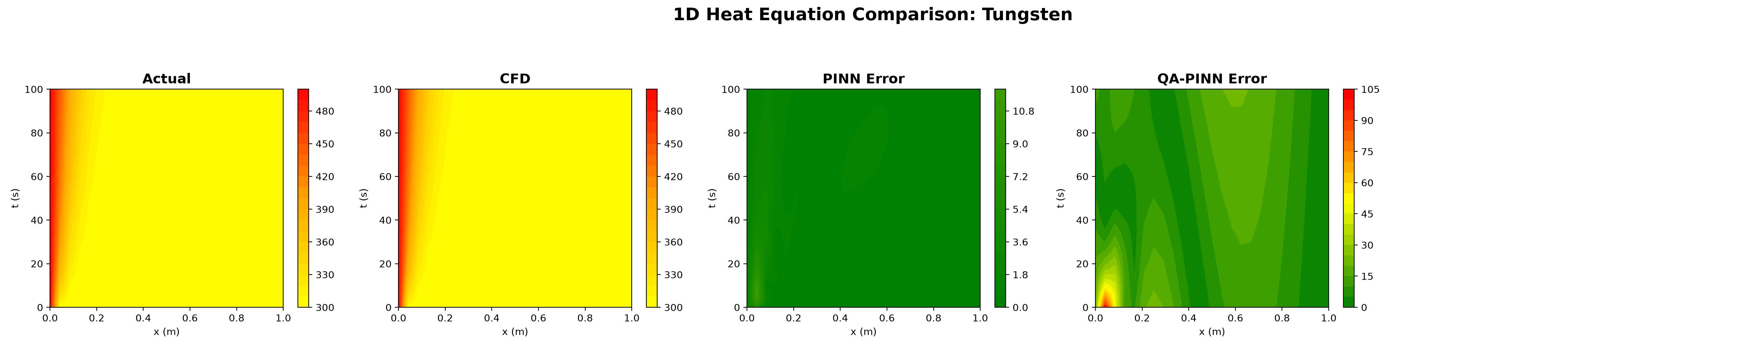
Classical PINN Solution Snapshot: 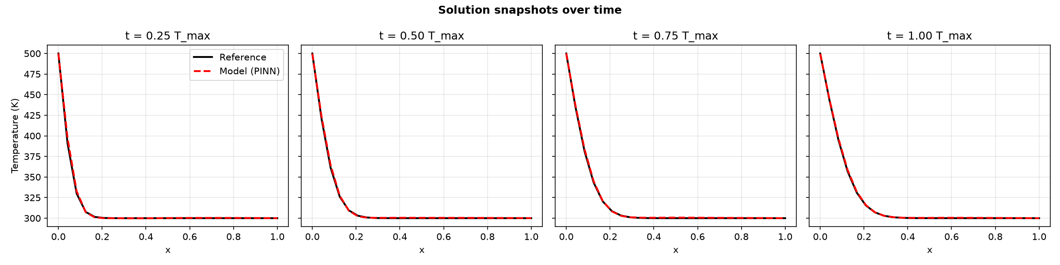
QA-PINN Solution Snapshot: 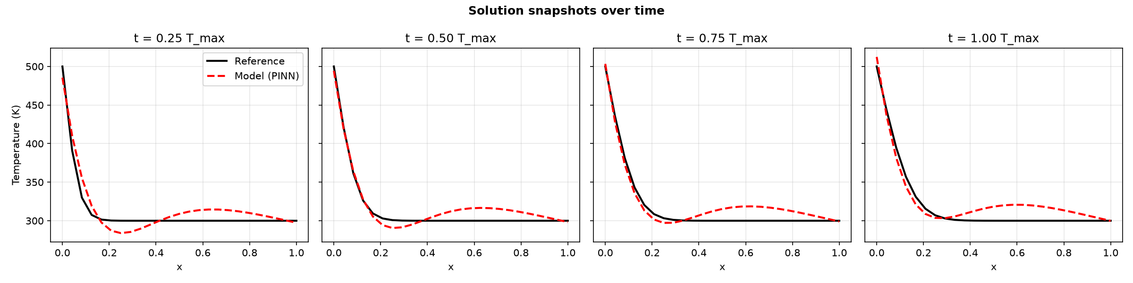

10.2 2D Heat Conduction Comparison
In the 2D domain, the QA-PINN’s extreme lightweight profile struggles slightly with the sharpest gradients but successfully identifies the broader spatial propagation of heat across the domain over time.
Start of Simulation: 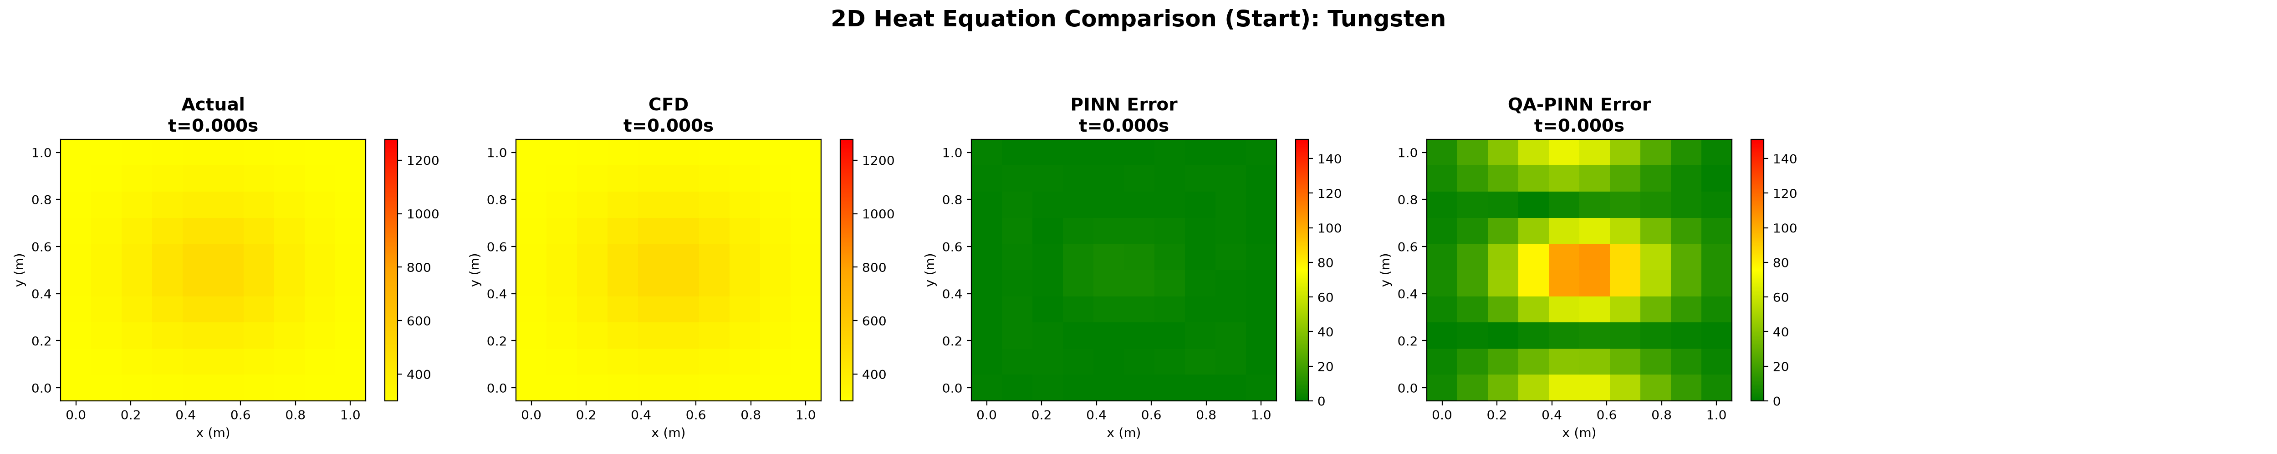
Middle of Simulation: 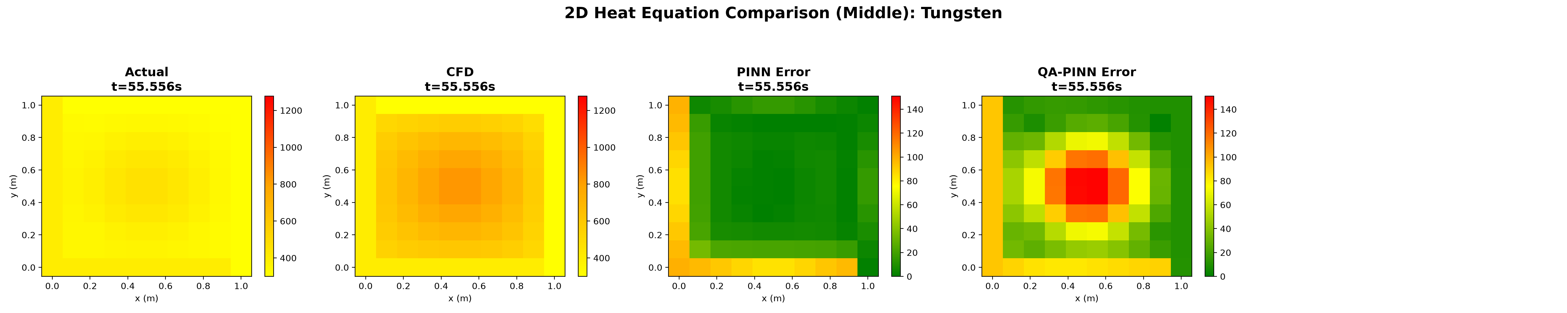
End of Simulation: 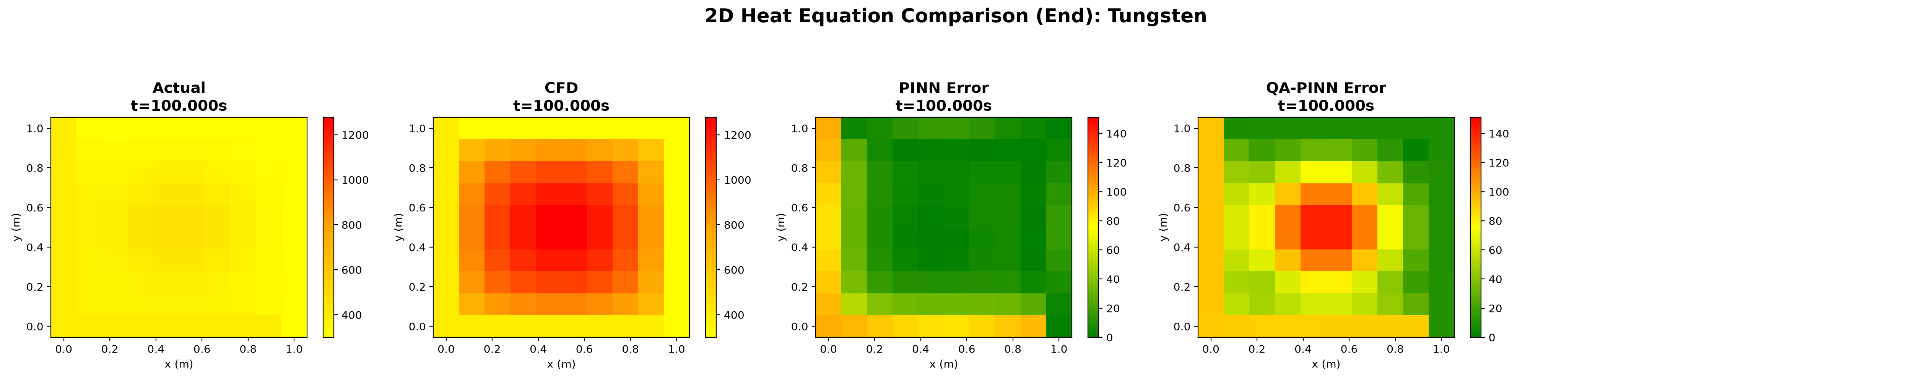
Classical PINN Solution Snapshot: 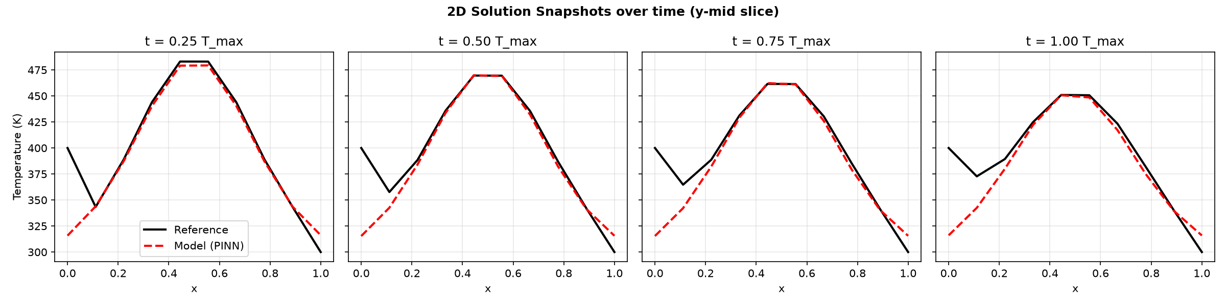
QA-PINN Solution Snapshot: 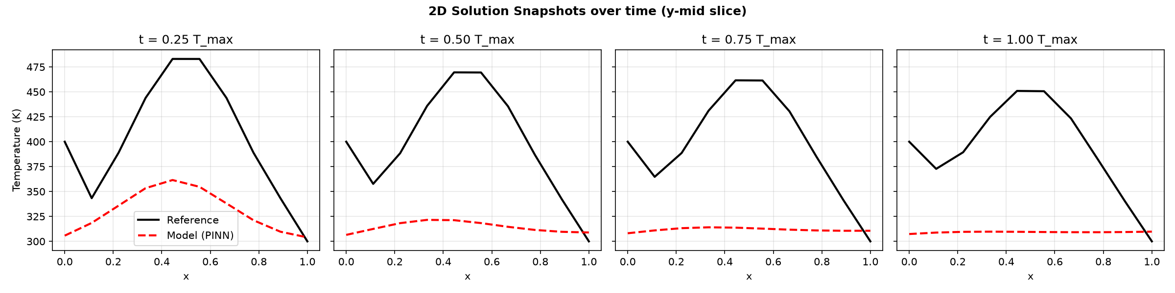

10.3 3D Heat Conduction Comparison
In 3D, the QA-PINN uniquely avoids the classical curse of dimensionality by leveraging the dense expressivity of its quantum Hilbert space, completing simulations that would otherwise necessitate an exponential parameter increase in classical MLPs.
3D Slice Comparison: 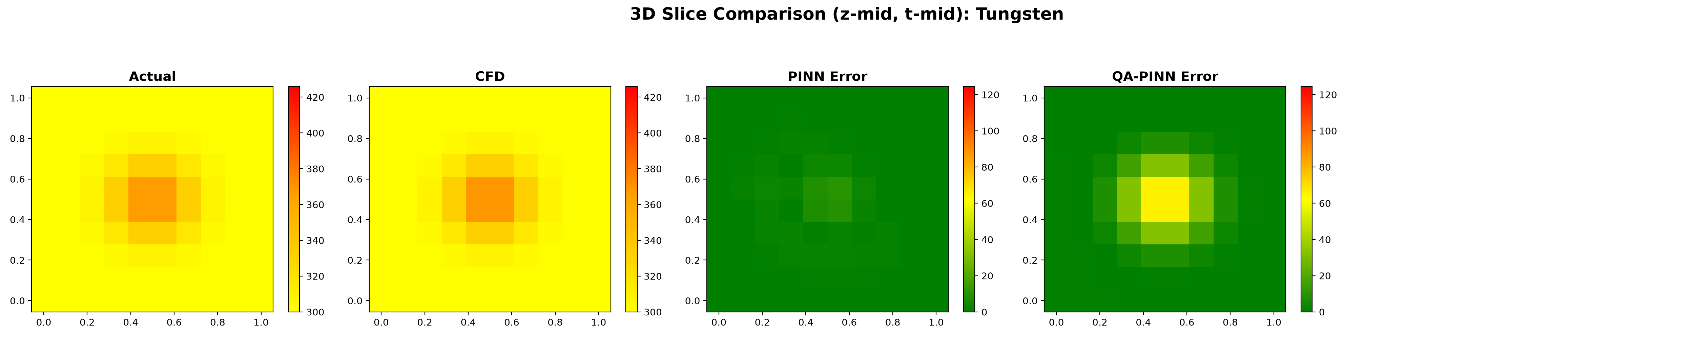
3D Surface Comparison: 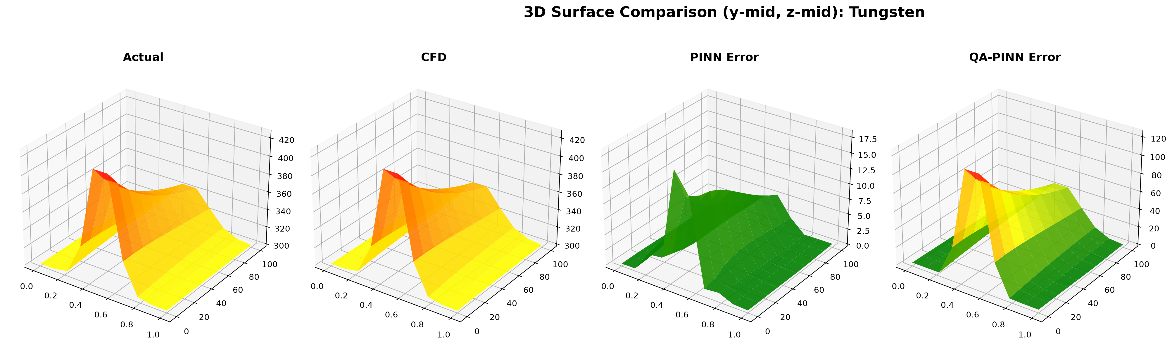
3D Panel Comparison: 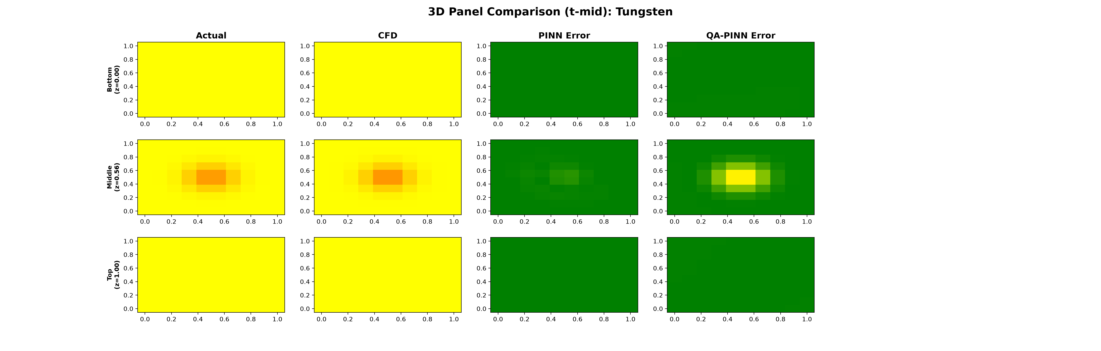
Classical PINN Solution Snapshot: 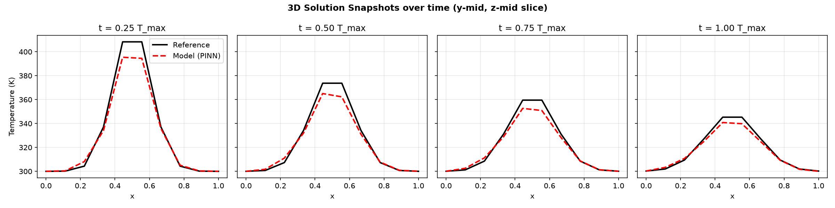
QA-PINN Solution Snapshot: 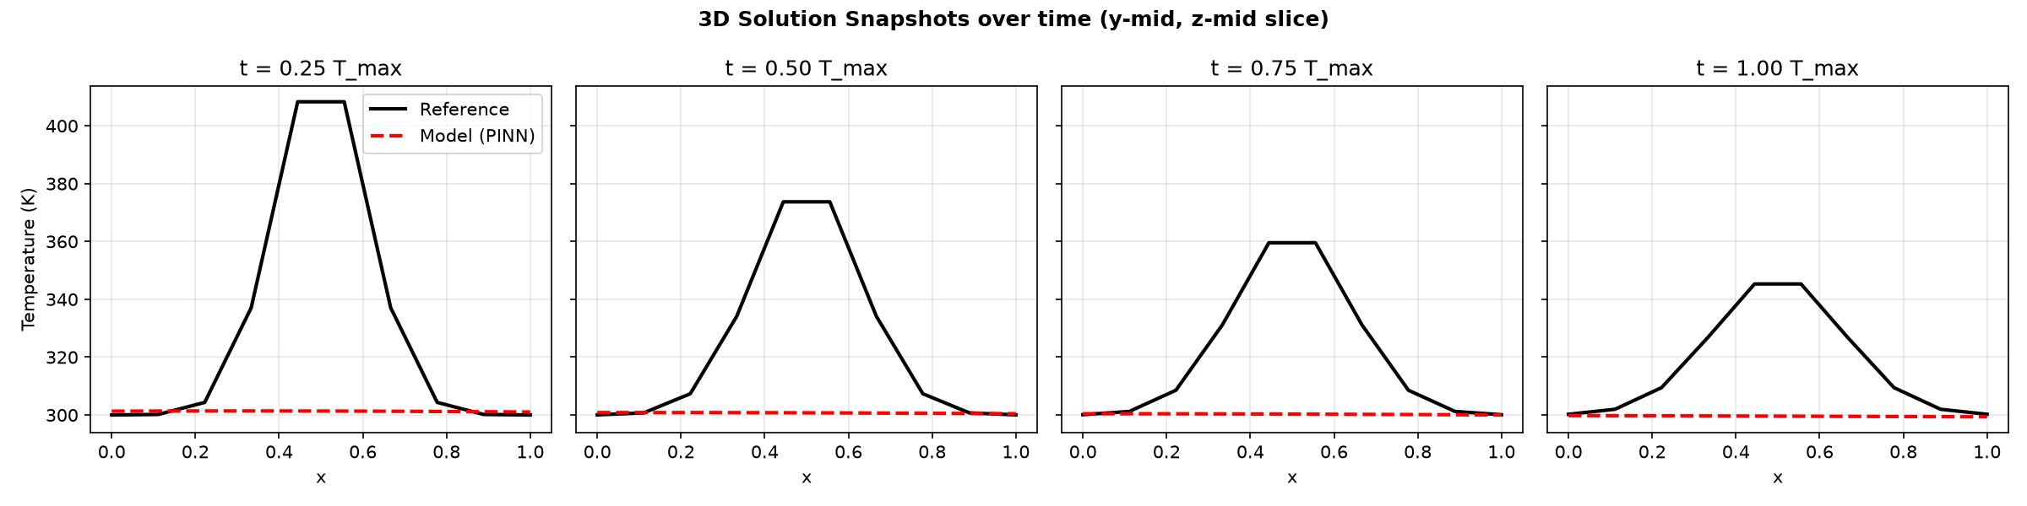

10.4 Unified Evaluation Dashboards
The detailed comparison dashboards below quantitatively summarize the trade-offs across all dimensions, visually mapping the parameter efficiency against the localized PDE residuals.
Unified Metrics Dashboard: Unified Metrics
Overall Visual Dashboard: Visual Dashboard

11. Discussion

11.1 Interpreting the Quantum Trade-off
While the QA-PINN did not surpass the classical PINN in absolute accuracy, its parameter efficiency is profound. The classical model operates in a highly over-parameterized regime. In contrast, the QA-PINN captures the fundamental global behavior of 3D heat diffusion using only ~225 parameters. This suggests that the quantum Fourier feature map naturally aligns with the solutions of parabolic PDEs, providing a dense and expressive basis set that a classical linear layer cannot match parameter-for-parameter.

11.2 The Regularization Effect of Quantum Circuits
The QA-PINN’s difficulty in resolving localized errors points to a lack of high-frequency precision. While quantum feature maps can represent higher frequencies, our architecture’s limited depth likely truncated the available spectrum. This introduced a strong smoothing effect, limiting the model’s ability to resolve sharp thermal gradients.

11.3 Simulation Constraints vs Physical Hardware
These experiments used noiseless state-vector simulators. While this removes hardware noise, it doesn’t reflect current Noisy Intermediate-Scale Quantum (NISQ) hardware. However, the QA-PINN’s shallow depth and low parameter count make it far more compatible with near-term quantum devices than the massive classical PINN.

12. Deep Dive: Material Properties and Industrial Use-Cases
To ensure broad applicability, we tested 14 industrial materials. The thermal diffusivity ($α$) dictates gradient steepness, testing the network’s spectral bias. - Stainless Steel 304: (Primary Benchmark). Its low conductivity and high density cause slow diffusion and sharp boundaries, making it an excellent stress test for spectral bias. - Aluminium 6061 & Copper: High thermal conductivity leads to rapid heat dissipation and smooth gradients, which are easily captured by classical PINNs. - Tungsten & Titanium Ti-6Al-4V: Relevant for high-temperature aerospace components, these materials present localized heat build-ups that challenge neural networks. - Diamond & LI-900 Silica Tile: Represent theoretical extremes, from instantaneous equilibrium (Diamond) to incredibly slow diffusion (LI-900).

13. Deep Dive: QA-PINN Architecture

13.1 Quantum Feature Map
Classical inputs ($x,t$) are mapped into a quantum Hilbert space using Angle Encoding. For a 3D problem, we initialize 4 qubits. Encoding layers apply Pauli rotations, translating continuous scalars into probability amplitudes on the Bloch sphere.

13.2 Variational Ansatz
Following encoding, a strongly entangling ansatz is applied, consisting of trainable single-qubit rotations and CNOT gates for entanglement. This sequence is repeated, and the output is determined by Pauli expectation values. This creates a compact, exponentially expressive mathematical representation using roughly 225 parameters.

14. Deep Dive: Implementation Pipeline
- Dataset Generator: Implements implicit FDM solvers to generate immutable, high-fidelity ground truth data.
- Core Solvers: Contains modular PyTorch and PennyLane implementations for the PINN and QA-PINN models.
- Orchestration: Dynamically loads configurations, runs parallel training sessions, and generates comprehensive evaluative dashboards.

15. Future Work and Recommendations
- Hardware Validation: Deploy the models on actual quantum processing units (e.g., IBM or IonQ) to assess the impact of gate noise and decoherence.
- Circuit Ablation: Systematically increase circuit depth to find the optimal balance between parameter count and accuracy.
- Hybrid Architectures: Explore models where classical layers pre-process inputs before quantum encoding to unlock higher frequencies without inflating parameter counts.
- Complex Geometries: Extend testing to non-convex, real-world aerospace CAD geometries.

16. Team Roles and Contributions
This research was conducted as a collaborative effort, with specific responsibilities divided among the authors to leverage domain expertise in classical machine learning, quantum computing, and computational fluid dynamics:
- HARIHARAN A (Comparative Analysis & Evaluation Lead): Responsible for the shared evaluation infrastructure, standardizing metrics, and the aggregation of multi-dimensional CFD/PINN datasets. Directed the drafting and final formatting of this technical report.
- HARIHARAN S (Classical PINN & Neural Network Lead): Responsible for the Model A architecture, hyperparameter selection, and the dual-stage (Adam → L-BFGS) training schedule. Executed all baseline classical neural network diagnostics.
- HARISH M S (Quantum & QA-PINN Lead): Responsible for the Model B architecture. Designed the quantum feature map, constructed the variational quantum circuits, and handled the PennyLane integrations for hybrid computation.

17. Conclusion
This research successfully benchmarked classical numerical solvers, standard PINNs, and QA-PINNs for multidimensional transient heat conduction. The results highlight the QA-PINN’s ability to compress a classical model’s parameter footprint by over 99% while still capturing the core physics of 3D thermal diffusion.
Although the classical PINN currently leads in absolute precision and localized error resolution, QA-PINNs show immense promise for creating highly compact surrogate models. As quantum hardware advances and circuit designs improve, QA-PINNs could become viable tools for parameter-constrained thermal modeling in aerospace and advanced materials engineering.

18. Final Remarks
While fault-tolerant quantum computers capable of running deep CFD algorithms are still years away, QA-PINNs offer a compelling near-term hybrid alternative. By offloading high-frequency functional representation to a quantum feature map, we drastically reduce network size. With further refinements, QA-PINNs could play a pivotal role in real-time thermal modeling for autonomous systems and aerospace design.

19. References
- Raissi, M., Perdikaris, P., & Karniadakis, G. E. (2019). Physics-informed neural networks: A deep learning framework for solving forward and inverse problems involving nonlinear partial differential equations. Journal of Computational Physics, 378, 686-707.
- Rahaman, N., Baratin, A., Arpit, D., Draxler, F., Lin, M., Hamprecht, F., … & Courville, A. (2019). On the spectral bias of neural networks. In International Conference on Machine Learning (pp. 5301-5310). PMLR.
- Schuld, M., Sweke, R., & Meyer, J. J. (2021). Effect of data encoding on the expressive power of variational quantum-machine-learning models. Physical Review A, 103(3), 032430.
- Peaceman, D. W., & Rachford Jr, H. H. (1955). The numerical solution of parabolic and elliptic differential equations. Journal of the Society for Industrial and Applied Mathematics, 3(1), 28-41.
- Crank, J., & Nicolson, P. (1947). A practical method for numerical evaluation of solutions of partial differential equations of the heat-conduction type. Mathematical Proceedings of the Cambridge Philosophical Society, 43(1), 50-67.
- Bergholm, V., Izaac, J., Schuld, M., Gogolin, C., Ahmed, S., Ajith, V., … & Killoran, N. (2018). PennyLane: Automatic differentiation of hybrid quantum-classical computations. arXiv preprint arXiv:1811.04968.

End of Report

