Project Title: Olive E-commerce company customer behavior analysis.
Name: Harish Kumar
Tools Used: Python, SQL, Power Bi

Problem Statement: - Analysis e-commerce data to understand customer behavior, revenue trend, and identify the opportunity to business growth.

Tools Used: These are the tools which are used in this project.
- Python – Python used to clean the dataset such as handling missing values, remove duplicates, fix the datatypes.
- Excel – Understand the variable.
- SQL -
- Power BI- Graphical representation of key finding, KPI’s using different kind of charts and graphs.

Dataset Overview: These are the different tables dataset contains.

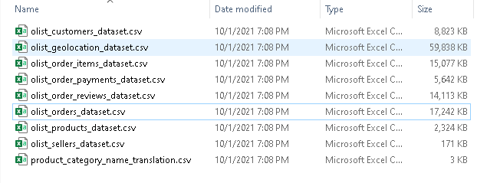
We will use 4 tables from the given dataset to analysis data using SQL.
- Olist_customer_dataset.csv
- Olist_order_items_dataset.csv
- Olist_orders_dataset.csv
- Olist_products_dataset.csv

Tables Overview: We will overview each table and will understand the columns of the tables one by one.

Olist_orders_dataset.csv contains columns order_id, customer_id, order_status, order_purchase_timestamp, order_approved_at, order_delivered_carrier_date, order_delivered_customers_date, order_estimate_delivery_date.
- Olist_order_items_dataset.csv contains columns order_id, order_item_id, seller_id, shipping_limit_date, price, freight_value.
- Olist_products_dataset contains columns product_id, product_category_name, product_name_lenght, product_description_lenght, product_photos_qyt, product_weight_g, product_lenght_cm, product_height_cm, product_width_cm.
- Olist_customer_dataset contains columns

Day-1 What I Did:
- Downloaded the Olist e-commerce dataset from Kaggle and extracted the files.
- Identified that the dataset contains multiple tables (approximately 9 tables).
- Installed MySQL Server and MySQL Workbench for database management and SQL analysis.
- Configured a new connection in MySQL Workbench and successfully connected to the MySQL Server.
- Executed basic SQL queries to verify that the database setup is functioning correctly.
- Created a new database using SQL queries for project use.
- Set up a new notebook in Google Collab for data cleaning and preprocessing using Python.
- Installed Microsoft Power BI for data visualization.
- Verified that Power BI is working correctly by launching the application.

Day-2 What I Did:
- Created a relational database ecommerce using MySQL in MySQL Workbench
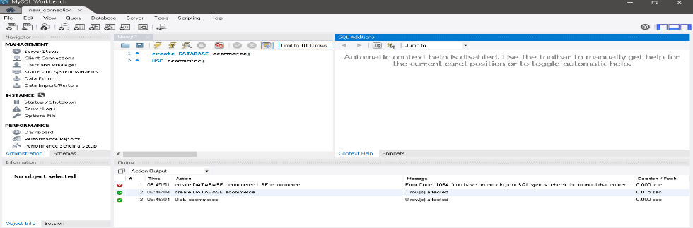
- Imported multiple datasets from the Olist E-commerce dataset (stored locally), including:
- customers
- orders
- payments
- order_items
- Verified successful data import by executing sample queries (SELECT * FROM table LIMIT 10)
- Established relationships between tables using:
- customer_id (customers ↔ orders)
- order_id (orders ↔ payments / order_items)
- Performed initial SQL analysis to extract key business metrics:
- Total Revenue
- Total Orders
- Total Customers
- Top 5 Customers by Revenue
- Monthly Revenue Trends
- Used SQL aggregation functions (SUM, COUNT, GROUP BY) and JOIN operations for analysis
- Saved all queries in a structured SQL file for reproducibility and future.

Day 3: What I Did:
- I have perform SQl analysis of dataset to identify business KPI’s and customer insights which are given below:
- Total revenue is '16008872'.
- Total orders is ‘99441’.
- Total customers is 96096.
- Top 5 customers by revenue
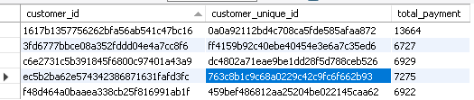
- Monthly revenue
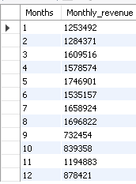
6. Avg order value is 161.
7. Top performing category
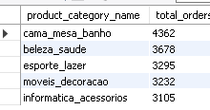
8. Top States by order count
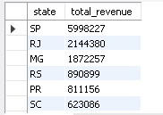

Day 4 What I Did: Perform RFM + Customer Segmentation
- Prepare data for perform RFM. RFM mean R for recency, F means frequency and M means monetary.
- Merge data (orders + customers) + payments.
- Create RFM table.
- Score customers.
- Create segments.
- Identify customer types.
- Create Visualization.

