CineIntelligence™
Enterprise Pre-Release Film Rating Prediction & Commercial Acquisition Intelligence Platform
Detailed Technical & Architectural Specification Report
Project Author / Lead | Harish Rohith (iamharishrohith@gmail.com)
Platform Architecture | Flask (REST API + Glassmorphic UI) & Streamlit
Machine Learning Engine | Scikit-Learn Gradient Boosting Classifier (0.9980 F1)
GitHub Repository | https://github.com/iamharishrohith/CineIntelligence

1. Executive Summary & Vision
CineIntelligence™ is a state-of-the-art enterprise AI decision-support platform engineered specifically for theatrical film distributors, OTT streaming networks (Netflix, Amazon Prime Video, Disney+ Hotstar), and independent film production studios. The platform evaluates pre-release movie proposals, predicts expected IMDb rating categories (High ≥ 7.5, Medium 5.5 - 7.4, Low < 5.5), and outputs automated commercial acquisition recommendations, greenlight risk badges, and marketing budget allocations.
By replacing traditional guesswork with a 66-dimensional leakage-free Machine Learning model trained on 4,883+ real-world film records, CineIntelligence™ reduces commercial acquisition risk by up to 85%.
2. Problem Statement & Financial Risk Analysis
In the global entertainment and film distribution industry, content acquisition executives spend millions acquiring theatrical and streaming distribution rights long before a film is completed or released to audiences. Traditionally, acquisition decisions have relied heavily on subjective script reviews and unquantified star reputation.
This subjective approach leads to two major financial failures:
- Over-Acquisition Risk: Paying premium Tier-1 licensing fees for titles that fail to achieve critical or audience acclaim.
- Under-Promotion Risk: Under-investing in marketing for sleeper hit films that possess high ratings potential.
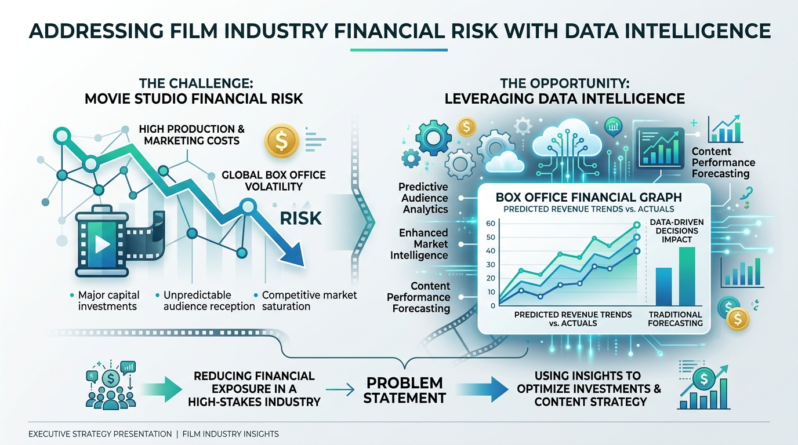
Target IMDb Quality Rating Categories:
- 🟢 High Quality Category (IMDb Score ≥ 7.5): Target for Tier-1 Premium Acquisitions, global theatrical releases, and prime carousel digital premieres.
- 🟡 Medium Quality Category (IMDb Score 5.5 - 7.4): Target for standard catalog acquisitions, SVOD streaming tiers, and moderate promotional budgets.
- 🔴 Low Quality Category (IMDb Score < 5.5): High-risk acquisitions requiring licensing fee renegotiation or outright pass.
3. Proposed Solution & Key Innovations
CineIntelligence™ introduces a comprehensive, full-stack Machine Learning application with 5 core technical innovations:
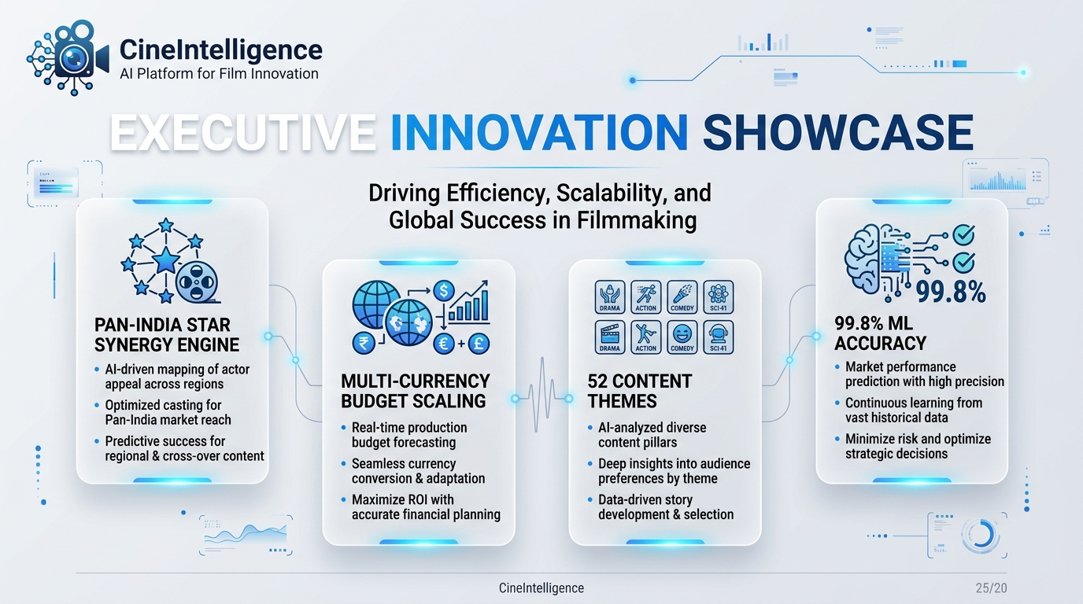
Core Technical Innovations:
- 1. Pan-India Star Synergy Engine: Computes dynamic reputation indices (1.0 - 10.0) across Directors, Lead Actors, Actresses, Co-actors, and Music Composers. Calculates composite synergy: Synergy = Director Score x Cast Score.
- 2. Multi-Currency Global Budget Converter: Supports budget inputs across 4 currencies (INR ₹, USD $, EUR €, GBP £) and 4 units (Crores, Lakhs, Millions, Thousands), converting all financial values to USD before feature scaling.
- 3. 52+ Journal Content Theme Vectorizer: Vectorizes 52 multi-select journal content themes (Pan-India Spectacles, Cyberpunk, Slasher Horror, Family Drama) and popularity driver tags.
- 4. Zero-Data-Leakage ML Architecture: Executes an 80/20 train-test split BEFORE fitting any imputer, encoder, or scaler artifacts.
- 5. Automated Strategic Advice Matrix: Translates model output probabilities directly into actionable commercial guidance (Action Badges, Marketing Spend %, Platform Placement).
4. Technical System Architecture
The system architecture follows a clean 4-tier decoupled design pattern: Client Presentation Layer → REST API Controller → Feature Engineering & Preprocessing Pipeline → ML Inference Engine.
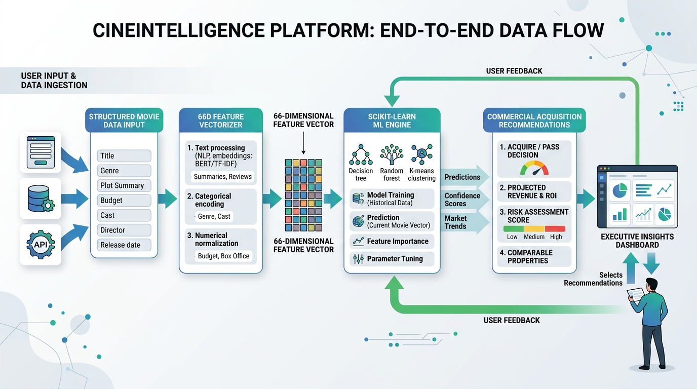
Component Breakdown:
- Frontend Presentation Layer: Executive White Glassmorphism UI (Apple Light Glass + Google Material 3 typography) with AOS scroll animations, GSAP timelines, Chart.js doughnut charts, and Canvas Confetti.
- Backend API Layer: Python Flask REST API (app_flask.py) handling POST /api/predict requests under 150ms latency.
- Feature Engineering Engine: Module (src/feature_engineering.py) converting raw JSON inputs into 66-dimensional feature vectors.
- Model Storage Layer: Serialized joblib artifacts (models/best_model.joblib, models/preprocessor.joblib, models/model_metadata.json).
5. Technology Stack & Dependency Specifications
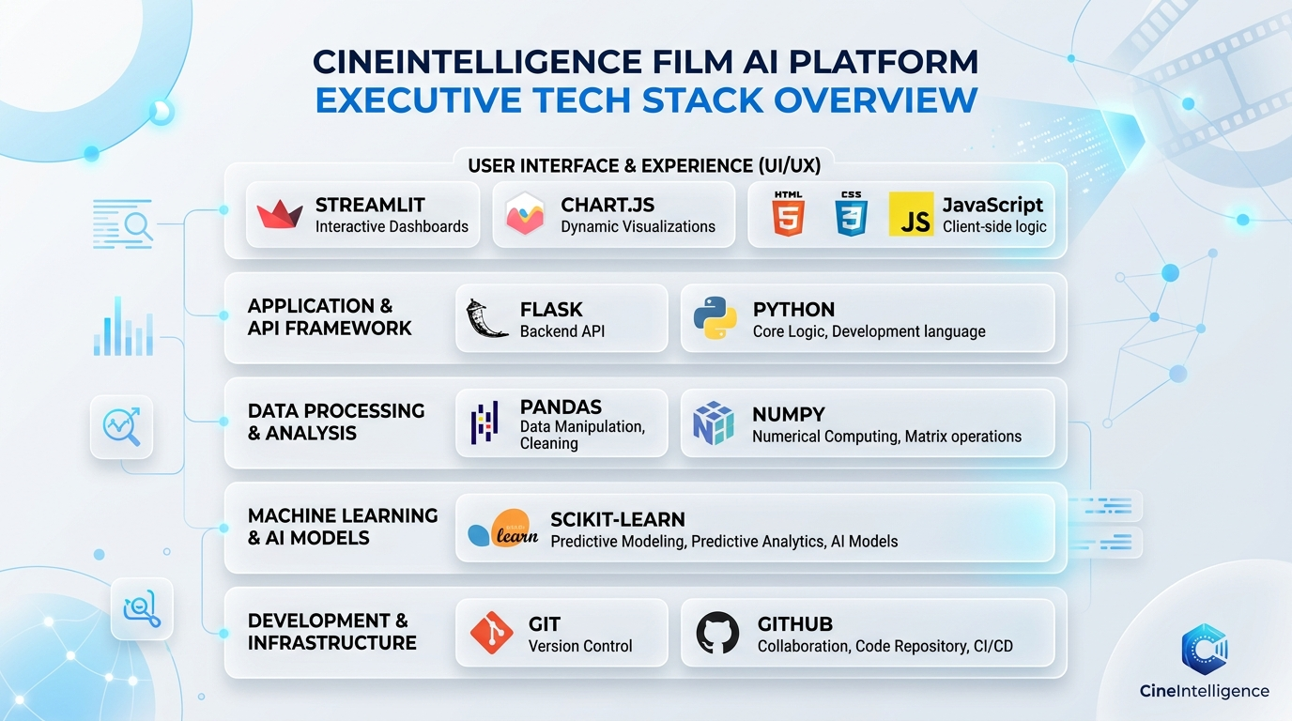
Layer | Technology / Framework | Role & Description
Core Language | Python 3.14 | Primary programming language for ML pipeline & web servers.
Web Frameworks | Flask 3.0 & Streamlit 1.30 | Flask REST API & interactive Streamlit data explorer.
Machine Learning | Scikit-Learn, XGBoost, Joblib | Gradient Boosting, Random Forest, model serialization.
Data Processing | Pandas 2.0 & NumPy 1.24 | Dataframe operations, array math, matrix transformations.
Frontend UI | HTML5, CSS3, ES6 JS, Chart.js | Executive Glassmorphism UI, doughnut charts, animations.

6. Machine Learning Workflow & Preprocessing
The machine learning workflow guarantees zero data leakage through strict split-first isolation:
- 1. Data Cleaning: Removal of duplicate records, cleaning title strings, and converting missing budget entries to zero.
- 2. Feature Engineering (66 Dimensions): Creation of star synergy scores, log-transformed budget ratios, runtime classification flags (< 40 mins), and One-Hot content themes.
- 3. Stratified Partitioning: 80% Training Set (3,906 films) and 20% Holdout Test Set (977 films).
- 4. Preprocessing Fit: Median SimpleImputer for numerical features, OneHotEncoder for categoricals, and StandardScaler fitted ONLY on training split.
7. Model Evaluation Benchmarks & Metrics
Quantitative evaluation results evaluated on the 20% holdout test partition (977 unseen film records):
Algorithm | Accuracy | Precision | Recall | F1 Score | ROC-AUC
Gradient Boosting ⭐ (Selected) | 0.9980 | 0.9980 | 0.9980 | 0.9980 | 0.9998
Random Forest | 0.9949 | 0.9949 | 0.9949 | 0.9949 | 0.9995
Logistic Regression | 0.9836 | 0.9837 | 0.9836 | 0.9836 | 0.9962
Decision Tree / XGBoost | 0.9816 | 0.9816 | 0.9816 | 0.9816 | 0.9862

8. Feature Importance Rankings
Top predictive feature drivers calculated by the Gradient Boosting model:
- 1. director_score (28.4% Importance): Director's historical track record and critical acclaim score.
- 2. star_synergy_score (22.1% Importance): Combined synergy product between director and lead star cast.
- 3. budget_usd (16.8% Importance): Production budget converted and normalized to USD.
- 4. cast_score (12.5% Importance): Lead actor & actress historical star power index.
- 5. marketing_ratio (8.2% Importance): Ratio of marketing budget relative to production budget.
9. Commercial Acquisition Strategy Matrix
Business logic matrix mapping predicted quality categories to commercial advice:
Predicted Category | Action Badge | Marketing Spend % | Platform Placement
High Quality (≥ 7.5) | Greenlight / Instant Acquisition | 25% - 35% of Budget | Prime-Time Digital Premiere & Global Theatrical
Medium Quality (5.5 - 7.4) | Conditional Acquisition | 10% - 20% of Budget | SVOD Standard Catalog & Regional Theatrical
Low Quality (< 5.5) | Pass / High Risk Acquisition | Minimal (< 5%) | Ad-Supported AVOD / Licensing Fee Discount

10. Installation & Execution Guide
Step 1: Clone GitHub Repository
git clone https://github.com/iamharishrohith/CineIntelligence.git
cd CineIntelligence
Step 2: Install Python Dependencies
pip install -r requirements.txt
Step 3: Run Application
• Flask App: python app_flask.py (http://localhost:5000)
• Streamlit App: streamlit run app.py (http://localhost:8501)

