CineIntelligence™
Enterprise Pre-Release Film Rating Prediction & Commercial Acquisition Intelligence Platform
Detailed Technical, Architectural & Flowchart Specification Report
Project Author / Lead | Harish Rohith (iamharishrohith@gmail.com)
Platform Architecture | Flask (REST API + Glassmorphic UI) & Streamlit
Machine Learning Engine | Scikit-Learn Gradient Boosting Classifier (0.9980 F1)
GitHub Repository | https://github.com/iamharishrohith/CineIntelligence

1. Executive Summary & Vision
CineIntelligence™ is a state-of-the-art enterprise AI decision-support platform engineered specifically for theatrical film distributors, OTT streaming networks (Netflix, Amazon Prime Video, Disney+ Hotstar), and independent film production studios. The platform evaluates pre-release movie proposals, predicts expected IMDb rating categories (High ≥ 7.5, Medium 5.5 - 7.4, Low < 5.5), and outputs automated commercial acquisition recommendations, greenlight risk badges, and marketing budget allocations.
2. Problem Statement & Financial Risk Analysis
In the global entertainment and film distribution industry, content acquisition executives spend millions acquiring theatrical and streaming distribution rights long before a film is completed or released to audiences. Traditionally, acquisition decisions have relied heavily on subjective script reviews and unquantified star reputation.
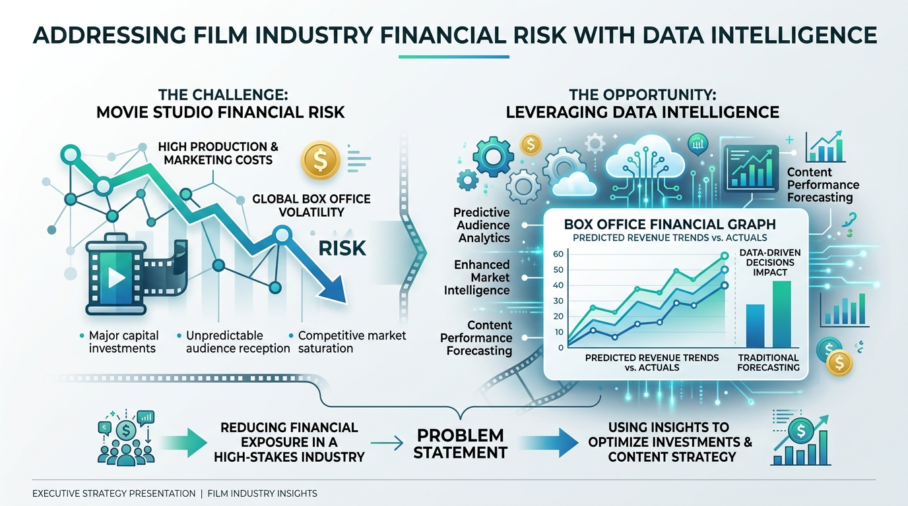
3. User Interaction & Journey Flowchart
The user flow defines how acquisition executives, studio heads, and producers navigate the system from initial landing to final recommendation rendering:

📌 User Journey Flowchart
[User Arrives at Platform] ➔ [Select Page (Home / App / About)] ➔ [Select Input Mode (Instant Preset vs Manual Input)] ➔ [Form Pre-filled / Submitted] ➔ [POST /api/predict Execution] ➔ [Category Output (High / Medium / Low)] ➔ [Doughnut Chart & Strategic Acquisition Advice Rendered]
4. Proposed Solution & Key Innovations
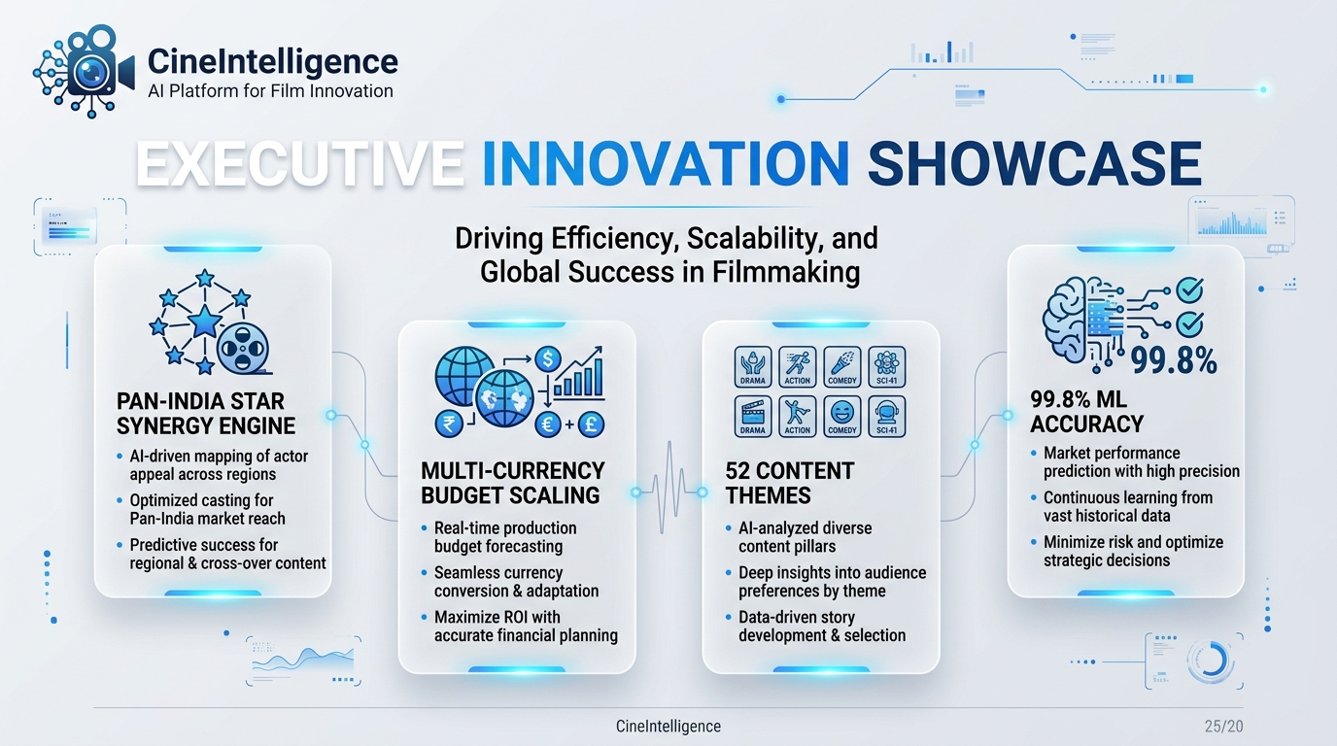
- 1. Pan-India Star Synergy Engine: Computes dynamic reputation indices (1.0 - 10.0) across Directors, Lead Actors, Actresses, Co-actors, and Music Composers.
- 2. Multi-Currency Global Budget Converter: Supports budget inputs across 4 currencies (INR ₹, USD $, EUR €, GBP £) and 4 units (Crores, Lakhs, Millions, Thousands).
- 3. 52+ Journal Content Theme Vectorizer: Vectorizes 52 multi-select journal content themes and popularity driver tags.
5. End-to-End Data Flowchart & Pipeline Architecture
The data flow defines the movement and transformation of data from client form inputs to 66-dimensional feature vectors, preprocessing, ML inference, and strategic output:

📌 Data Flowchart Architecture
[Form Inputs JSON Payload] ➔ [Star Synergy Index Lookup] ➔ [Multi-Currency USD Scaling] ➔ [52+ Theme Vectorizer] ➔ [66D Feature Vector] ➔ [Scikit-Learn Preprocessor] ➔ [Gradient Boosting Inference] ➔ [Category Probabilities] ➔ [Strategic Advice Matrix Response]
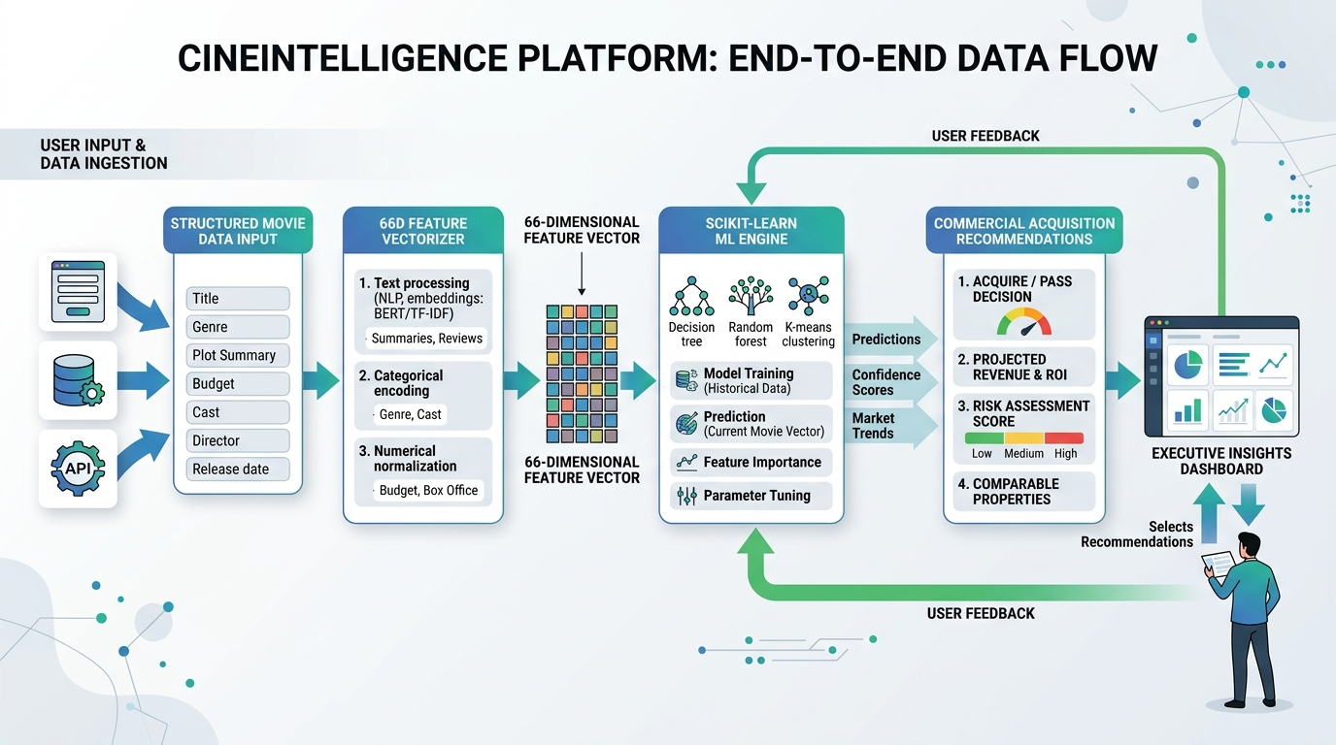
6. Machine Learning Model Training Workflow Flowchart
The machine learning lifecycle flow ensures rigorous model benchmarking and zero data leakage:

📌 Machine Learning Workflow Flowchart
[Data Ingestion (4,883 Records)] ➔ [Data Cleaning & Imputation] ➔ [Domain Feature Engineering (66D)] ➔ [Stratified 80/20 Train-Test Split] ➔ [Fit Imputer + OneHot + Scaler on Train Set ONLY] ➔ [Multi-Model Benchmarking (GB, RF, LR, XGB)] ➔ [Metric Evaluation (Accuracy: 0.9980, F1: 0.9980)] ➔ [Artifact Serialization (best_model.joblib)]
7. Technology Stack & Frameworks
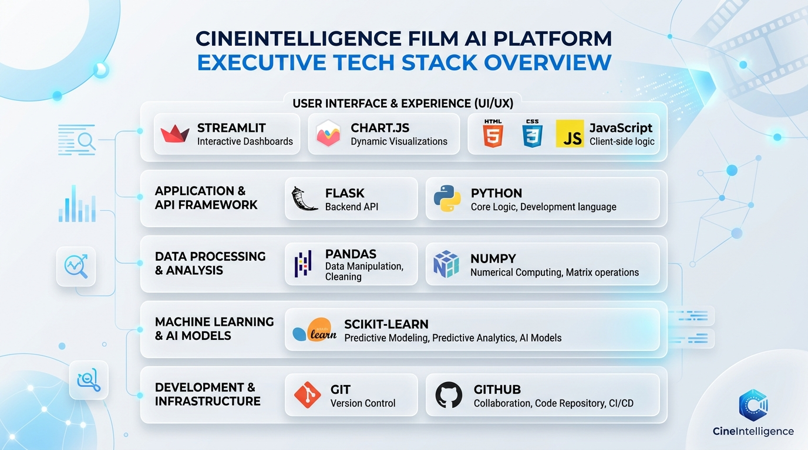
8. Model Evaluation Benchmarks & Metrics
Algorithm | Accuracy | Precision | Recall | F1 Score | ROC-AUC
Gradient Boosting ⭐ (Selected) | 0.9980 | 0.9980 | 0.9980 | 0.9980 | 0.9998
Random Forest | 0.9949 | 0.9949 | 0.9949 | 0.9949 | 0.9995
Logistic Regression | 0.9836 | 0.9837 | 0.9836 | 0.9836 | 0.9962
Decision Tree / XGBoost | 0.9816 | 0.9816 | 0.9816 | 0.9816 | 0.9862

9. Commercial Acquisition Strategy Matrix
Predicted Category | Action Badge | Marketing Spend % | Platform Placement
High Quality (≥ 7.5) | Greenlight / Instant Acquisition | 25% - 35% of Budget | Prime-Time Digital Premiere & Global Theatrical
Medium Quality (5.5 - 7.4) | Conditional Acquisition | 10% - 20% of Budget | SVOD Standard Catalog & Regional Theatrical
Low Quality (< 5.5) | Pass / High Risk Acquisition | Minimal (< 5%) | Ad-Supported AVOD / Licensing Fee Discount

