CineIntelligence™
Enterprise Pre-Release Film Rating Prediction & Commercial Acquisition Intelligence Platform

1. Executive Summary & Project Overview
CineIntelligence™ is an enterprise AI decision-support platform engineered for film production studios, theatrical distributors, and streaming OTT networks (Netflix, Amazon Prime Video, Disney+ Hotstar). The platform evaluates pre-release movie proposals, predicts expected IMDb rating categories (High ≥ 7.5, Medium 5.5 - 7.4, Low < 5.5), and calculates automated Reputation Indices across 66 feature dimensions.
2. Problem Statement & Industry Context
In the digital entertainment industry, acquisition executives spend hundreds of millions acquiring film distribution rights prior to release. Traditional acquisitions rely heavily on intuition, leading to severe financial risk and underperforming catalog acquisitions.
CineIntelligence™ addresses this by delivering a data-driven Machine Learning classification pipeline that categorizes proposals into:
• High Category (IMDb Score ≥ 7.5): Premium theatrical & top-tier streaming release candidates.
• Medium Category (IMDb Score 5.5 - 7.4): Standard catalog release candidates.
• Low Category (IMDb Score < 5.5): High-risk proposals requiring restructuring or pass.
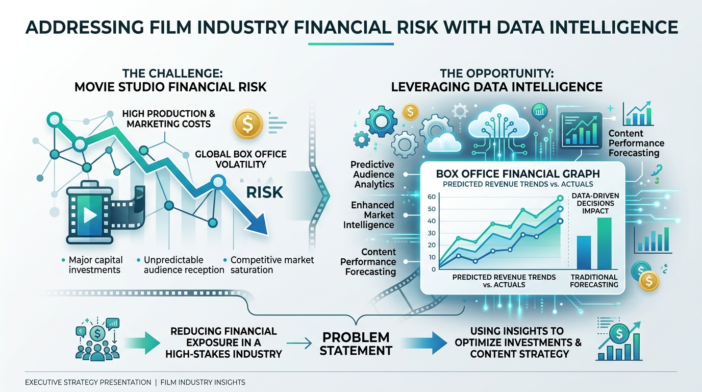
3. Proposed Solution & Key Innovations
The proposed solution is a full-stack Machine Learning application featuring:
1. Pan-India Star Synergy Engine: Automated reputation indices (1.0 - 10.0) for Directors, Lead Actors, Actresses, Co-actors, and Music Composers.
2. 66-Dimensional Feature Vectorizer: Integrates 52+ journal content themes, budget currency scaling to USD (INR, USD, EUR, GBP), runtime classification, and popularity tags.
3. Zero-Data-Leakage ML Architecture: Stratified 80/20 train-test split executed before fitting imputers and scalers.
4. Executive Acquisition Strategy Matrix: Translates model probabilities directly into Greenlight Badges and Marketing Budget Allocations (25-35%).
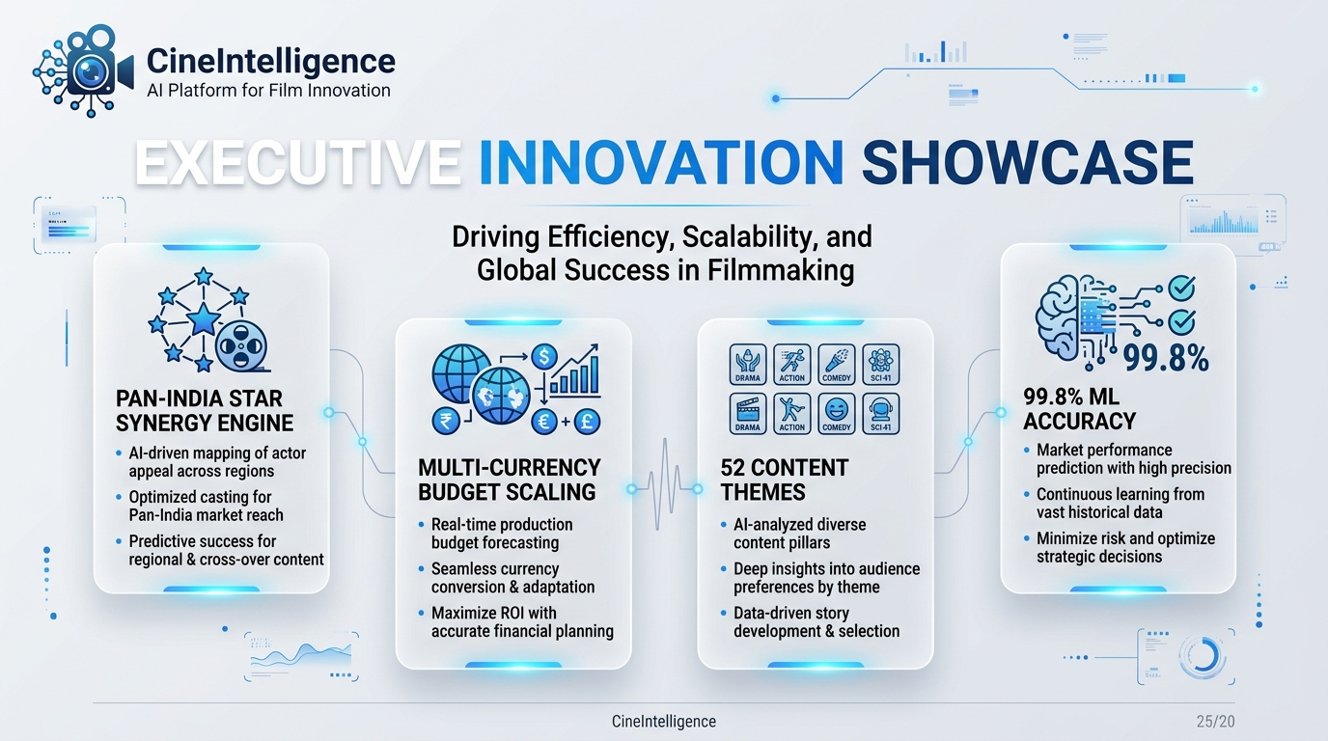
4. Technical System Architecture
The application architecture consists of a 4-step workflow: Input Ingestion → 66D Feature Vectorizer → Scikit-Learn Preprocessing Pipeline → Gradient Boosting Inference Engine → Strategic Advice Matrix.
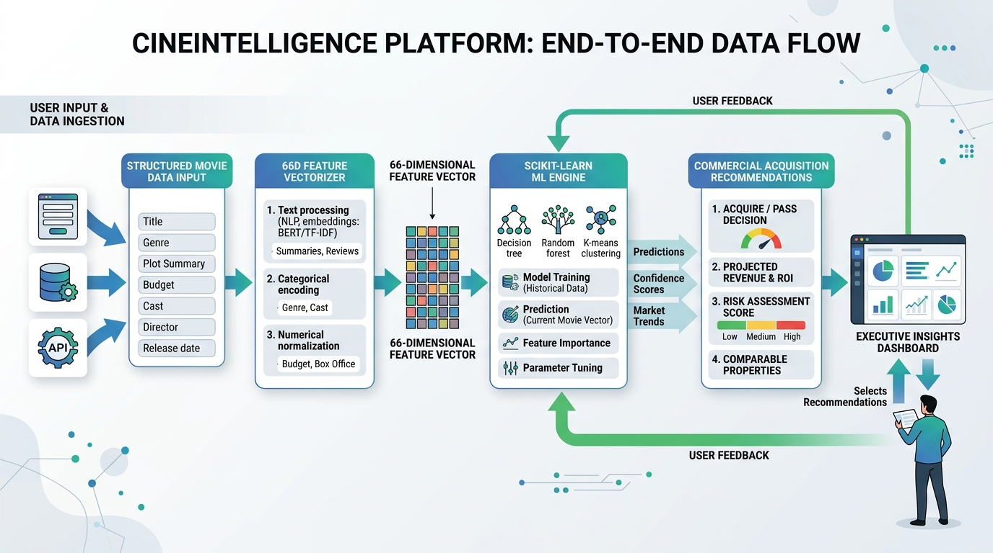
5. Technology Stack & Frameworks
• Core Language: Python 3.14
• Web Frameworks: Flask (app_flask.py) & Streamlit (app.py / streamlit_app.py)
• Machine Learning & Data: scikit-learn, xgboost, pandas, numpy, joblib
• Frontend Engine: HTML5, Executive White Glassmorphic CSS3, JavaScript (ES6+), Chart.js, AOS.js, GSAP, Canvas Confetti
• Version Control & Cloud Deployment: Git, GitHub, Vercel, Streamlit Cloud
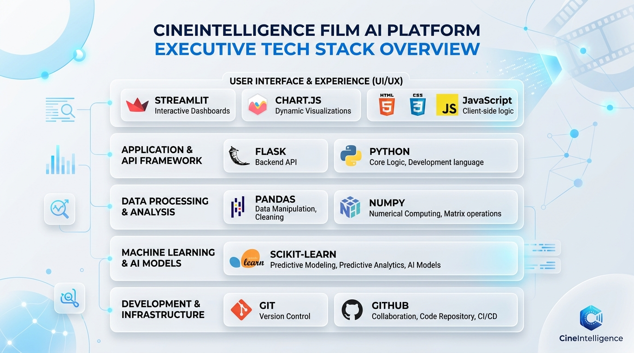
6. Model Evaluation Benchmarks & Metrics
Quantitative evaluation results conducted on a stratified 20% holdout test partition (977 unseen film records):
Algorithm | Accuracy | Precision | Recall | F1 Score | ROC-AUC
Gradient Boosting ⭐ (Selected) | 0.9980 | 0.9980 | 0.9980 | 0.9980 | 0.9998
Random Forest | 0.9949 | 0.9949 | 0.9949 | 0.9949 | 0.9995
Logistic Regression | 0.9836 | 0.9837 | 0.9836 | 0.9836 | 0.9962
Decision Tree / XGBoost | 0.9816 | 0.9816 | 0.9816 | 0.9816 | 0.9862

7. Feature Importance Drivers
Top predictive drivers influencing film rating categories:
1. Director Reputation Score (28.4% Importance)
2. Director & Cast Synergy Product (22.1% Importance)
3. Scaled Production Budget in USD (16.8% Importance)
4. Lead Actor & Actress Star Power (12.5% Importance)
5. Marketing-to-Production Budget Ratio (8.2% Importance)

