SMART TRAFFIC SIGNAL SYSTEM USING DEEP LEARNING AND COMPUTER VISION
PROJECT REPORT

Submitted in partial fulfillment of the requirements for the Award of the degree of

BACHELOR OF TECHNOLOGY
In

ARTIFICIAL INTELLIGENCE & DATA SCIENCE

Submitted By Under the Supervision of
Rahul Saini (22EMCAD046) Mr.Arvind Sharma
Janvi Prajapat (22EMCAD032) Assistant Professor
Vanshika Sharma(22EMCAD030) Dept. of CSE & AI
Anjali Chaudhary(22EMCAD029)

BIKANER TECHNICAL UNIVERSITY,BIKANER


MODERN INSTITUTE OF TECHNOLOGY & RESEARCH CENTRE

ALWAR
JUNE, 2026 (2025-26)

BIKANER TECHNICAL UNIVERSITY,BIKANER

CERTIFICATE

This is Certify that the project report entitled “SMART TRAFFIC SIGNAL SYSTEM USING DEEP LEARNING” is the original and genuine work of “RAHUL SAINI, JANVI PRAJAPAT, VANSHIKA SHARMA & ANJALI CHAUDHARY” students of B. Tech VII Semester (Artificial Intelligence & Data Science) who is carried out the project work under my supervision & guidance.

SIGNATURE
Dr. J.R. Arun Kumar
HEAD OF THE DEPARTMENT
Dept. of CSE & AI
SIGNATURE
Mr. Arvind Sharma
Assistant Professor
Dept. of CSE & AI

ACKNOWLEDGEMENT

Firstly, we express our sincere thanks to Prof. Dr. S. K. Sharma, Director of the Modern Institute of Technology & Research Centre, Alwar, Rajasthan, for his continuous support and encouragement.
We also extend our deep sense of gratitude to Dr. J. R. Arun Kumar, Head of the Computer Science & Engineering Department, Modern Institute of Technology & Research Centre, Alwar, for motivating us to reach higher levels and providing us with the valuable opportunity to present this project.
We owe our heartfelt thanks and sincere gratitude to our project guide, Mr.Arvind Sharma, Assistant Professor, Department of Computer Science & Engineering, Modern Institute of Technology & Research Centre, Alwar, for his invaluable guidance, insightful suggestions, constant supervision, and encouragement throughout the completion of this work.
We would also like to thank our Institute and all Faculty Members whose support and cooperation made this project possible. We extend our warm thanks to our families and well-wishers for their continuous support and encouragement.
Finally, but most importantly, we express our profound gratitude to our parents for their unconditional love, patience, and inspiration throughout our academic journey.

Rahul Saini (22EMCAD046)
Janvi Prajapat(22EMCAD032)
Vanshika Sharma(22EMCAD030)
Anjali Chaudhary(22EMCAD029)

TABLE OF CONTENTS

TOPICS PAGE NO
CERTIFICATE………………………………………...................................................................i
ACKNOWLEDGEMENT……………………………………………………….........................ii
TABLE OF CONTENTS………………………………………………………………………. iii
LIST OF FIGURES........................................................................................................................iv
ABSTRACT....................................................................................................................................v
CHAPTER 1: INTRODUCTION 1-2
1.1 What Is NLP Based Autonomous Research Assistant 1
CHAPTER 2: PROBLEM STATEMENT 3
CHAPTER 3: LITERATURE REVIEW 4-6
CHAPTER 4: SYSTEM DESIGN 7-17
4.1UML DIAGRAMS
4.1.1 Use Case diagram
4.1.2 Activity diagram
4.1.3 Sequence diagram
4.1.4 Class diagram
4.1.5 Component diagram
4.1.6 Deployment diagram
4.1.7 Communication diagram
4.1.8 Object diagram
CHAPTER 6: PROPOSED WORK MODEL 18-23
CHAPTER 7: SCREENSHOTS 24-26
CHAPTER 8: TECHNOLOGY STACK 27-28
CHAPTER 9: FUTURE WORK 29-33
REFERENCES 35

LIST OF FIGURES
Figure4.1:SystemArchitecturediagram………………………………….………..13 Figure4.2:Compondiagram……………………………………………….………16 Figure4.3:Deploymentdiagram…………………………………………………...17
Figure4.4:Objectdiagram…………………………………………………….……18
Figure4.5:Communicationdiagram……………………………………..………....19
Figure4.6:Classdiagram…………………………………………………………...20
Figure4.7:Usecase diagram……………………………………………………….21
Figure4.8:Sequencediagram……………………………………………………....22
Figure4.9:Activitydiagram……………………………………………………..….23
Figure5.1:Proposedmodel diagram………………………………………………..26
Figure5.2:Input Image…………………………………………………………….33
Figure5.3:Output Image…………………………………………………………..34

LIST OF TABLES
Table6.1:SystemRequirements Table…………………………………………………….40

ABSTRACT
Urban traffic congestion is a major challenge, often caused by traffic signals operating on fixed timers that do not account for real-time traffic conditions. These fixed-timer systems can lead to unnecessary delays on less busy roads and insufficient green-light duration on congested roads, resulting in increased waiting times, fuel consumption, and pollution. This project proposes an Smart Traffic Signal System that dynamically adjusts traffic signal durations based on real-time traffic density using computer vision and machine learning techniques.
The system consists of three main modules. The Vehicle Detection Module employs the YOLO (You Only Look Once) object detection algorithm to detect and count vehicles from live camera feeds, identifying classes such as cars, bikes, buses/trucks, and rickshaws. The detected vehicle data is then processed by the Signal Switching Algorithm, which calculates the optimal green, yellow, and red light durations for each direction. This algorithm considers factors such as vehicle counts, number of lanes, and average vehicle speeds, while ensuring no direction is starved by maintaining maximum and minimum green-time limits.
To demonstrate and validate the effectiveness of the system, a Simulation Module implemented in Pygame simulates a traffic intersection with moving vehicles and adaptive traffic signals. The simulation allows comparison of the adaptive system against conventional fixed-timer signals, showcasing reductions in waiting time and improvements in traffic flow. The project’s modular design facilitates easy upgrades, such as integrating more advanced detection models, refining the signal algorithm, or extending the simulation for larger intersections.

CHAPTER 1

INTRODUCTION

  - INTRODUCTION
With the rapid growth of urban populations and vehicles, traffic congestion has become a significant challenge in modern cities. Traditional traffic management systems typically rely on fixed-timer traffic signals, where the durations of green, yellow, and red lights are predetermined and do not adapt to real-time traffic conditions. While simple to implement, fixed-timer systems are inefficient: lightly congested roads experience unnecessary waiting times, and heavily congested roads suffer from insufficient green-light duration. This inefficiency not only increases travel time but also contributes to fuel wastage, air pollution, and driver frustration.
To address these challenges, adaptive traffic signal systems have emerged as a smart solution. These systems use real-time traffic data to dynamically adjust signal timings, optimizing traffic flow and reducing delays at intersections. The development of computer vision and machine learning techniques has enabled practical implementation of such systems. Object detection algorithms, such as YOLO (You Only Look Once), allow real-time vehicle detection from camera feeds, providing accurate vehicle counts for each lane or direction at an intersection.
The Smart Traffic Signal System project leverages these advancements to design a system that monitors traffic in real time, calculates optimal signal durations, and simulates the adaptive operation at an intersection. The system is structured into three main modules: the Vehicle Detection Module, which identifies and counts vehicles using YOLO; the Signal Switching Algorithm, which computes dynamic green, yellow, and red times based on traffic density and other factors; and the Simulation Module, implemented in Pygame, which visualizes the intersection and validates the system’s effectiveness.
By integrating real-time vehicle detection with adaptive signal timing, this project aims to reduce congestion, waiting time, and fuel consumption, offering a scalable solution for intelligent traffic management in modern urban environments.
1.2 PROJECT OBJECTIVES

The main objective of the Smart traffic signal system using deep learning project is to develop an intelligent traffic management system that dynamically adjusts traffic signal timings based on real-time traffic conditions. The specific objectives are as follows:
- Real-Time Vehicle Detection:
  - Implement a system that can detect and classify vehicles in real-time using camera feeds.
  - Utilize the YOLO (You Only Look Once) object detection algorithm to accurately identify different vehicle types, such as cars, bikes, buses/trucks, and rickshaws.
- Adaptive Signal Timing:
  - Develop a Signal Switching Algorithm that calculates optimal green, yellow, and red light durations for each lane or direction.
  - Ensure that signal timings adapt to traffic density, vehicle types, number of lanes, and average vehicle speed, while maintaining maximum and minimum green-time limits to prevent lane starvation.
- Traffic Flow Optimization:
  - Minimize waiting times and reduce congestion at intersections by dynamically adjusting signal durations.

CHAPTER 2

PROBLEM STATEMENT

Urban traffic congestion is a growing challenge in cities worldwide due to the rapid increase in vehicles and population density. Traditional traffic signal systems rely on fixed-timer settings, where green, yellow, and red light durations are predetermined and do not adjust according to real-time traffic conditions. This leads to several inefficiencies:
- Wasted Waiting Time: Vehicles on less congested roads often wait unnecessarily while other directions experience traffic buildup.
- Increased Congestion: Busy lanes may not get sufficient green-light duration, resulting in traffic jams and slow vehicle movement.
- Fuel Wastage and Pollution: Vehicles idling at signals consume fuel and contribute to environmental pollution.
- Driver Frustration: Inefficient signal timing increases travel time, causing delays and frustration for commuters.
The lack of adaptability in conventional traffic management systems highlights the need for a smart, real-time traffic signal control system. The system should dynamically adjust signal timings based on actual traffic density and vehicle type at each intersection, improving traffic flow, reducing waiting time, minimizing fuel consumption, and enhancing overall urban mobility.
The Smart traffic signal system project addresses this problem by combining real-time vehicle detection using computer vision, a traffic-responsive signal switching .The lack of adaptability in conventional traffic management systems highlights the need for a smart, real-time traffic signal control system. The system should dynamically adjust signal timings based on actual traffic density and vehicle type at each intersection, improving traffic flow, reducing waiting time, minimizing fuel consumption, and enhancing overall urban mobility.

CHAPTER 3

LITERATURE REVIEW

Traffic congestion has become a major challenge in urban areas due to the rapid increase in vehicles and population density. Traditional traffic management systems rely heavily on fixed-timer traffic signals, where the durations of green, yellow, and red lights are predetermined and do not adjust according to real-time traffic conditions. While these systems are simple and widely implemented, they are inherently inefficient. Roads with low traffic often experience unnecessary delays, while heavily congested roads do not receive adequate green-light duration, leading to increased waiting times, fuel consumption, and environmental pollution. Consequently, the limitations of fixed-timer traffic signals have driven research toward more intelligent and adaptive traffic management solutions.
Recent advances in computer vision and machine learning have enabled real-time monitoring and analysis of traffic conditions. Object detection algorithms such as YOLO (You Only Look Once), SSD (Single Shot Detector), and Faster R-CNN have been successfully applied for vehicle detection. Among these, YOLO is particularly suitable for real-time applications due to its high detection speed and reasonable accuracy. By identifying and classifying different vehicle types, such as cars, bikes, buses, trucks, and rickshaws, these algorithms provide accurate data on traffic density and vehicle distribution, which is essential for adaptive traffic control.
Adaptive traffic signal systems leverage this real-time data to optimize traffic light durations for each direction at an intersection. Techniques such as fuzzy logic, reinforcement learning, and vehicle-count-based algorithms have been explored to dynamically adjust green, yellow, and red light timings. Vehicle-count-based methods, which rely directly on the number of detected vehicles, have been found to be particularly effective for practical implementation due to their simplicity and real-time responsiveness. By adjusting signal durations according to actual traffic flow, adaptive systems can significantly reduce waiting times, improve traffic throughput, and minimize congestion compared to conventional fixed-timer systems.
Simulation plays a crucial role in the development and validation of adaptive traffic signal systems. Tools such as Pygame, SUMO, and VISSIM allow developers to create realistic traffic scenarios and evaluate the performance of their algorithms before deployment. Simulations enable the visualization of vehicle movement, assessment of signal timing strategies, and comparison between adaptive and fixed-timer systems. This step is essential to ensure that the proposed adaptive system can handle different traffic densities and scenarios effectively.
Overall, the literature indicates that integrating real-time vehicle detection with adaptive traffic signal algorithms and simulation provides a practical and efficient approach for intelligent traffic management. YOLO-based vehicle detection, combined with dynamic signal timing, has the potential to reduce congestion, waiting times, and fuel consumption at urban intersections. The Smart traffic signal system project builds on these findings, offering a scalable and modular solution to improve traffic flow and enhance urban mobility in real-time conditions.
In addition to real-time detection and adaptive timing, recent research emphasizes the importance of system scalability and interoperability in intelligent traffic management. Modern smart cities require traffic systems that can integrate multiple data sources—such as GPS data from mobile devices, inductive loop sensors, RFID-based vehicle tracking, and even crowd-sourced data from navigation apps. Combining computer vision with these heterogeneous data streams enables more robust decision-making, especially in complex intersections and multi-lane roads. Studies also highlight the role of edge computing, where initial processing is performed near the camera source to reduce latency and bandwidth usage. This ensures faster response times, making adaptive traffic systems more reliable for real-world deployment.
Furthermore, the incorporation of priority-based signaling mechanisms has gained significant attention, particularly for emergency vehicles such as ambulances, fire trucks, and police cars. Using vehicle detection and communication technologies, adaptive systems can recognize emergency vehicle presence and dynamically create a “green corridor” to facilitate their movement. This approach not only reduces travel time for emergency responders but also improves public safety outcomes. Some systems even integrate predictive modeling to estimate traffic buildup and pre-emptively adjust signals before congestion worsens.
Machine learning techniques are also being explored to further enhance adaptive traffic control. Reinforcement learning, for example, allows a traffic signal controller to learn optimal strategies by interacting with its environment. Over time, the controller can identify patterns such as peak hours, sudden traffic surges, or abnormal congestion. Although computationally more complex, RL-based systems have demonstrated superior performance in reducing overall delay and improving intersection efficiency. However, the high training cost and need for large datasets remain challenges for widespread adoption.
Another emerging trend is the integration of simulation-based digital twins for traffic intersections. A digital twin mirrors the real-world intersection and continuously updates based on sensor input. This virtual model allows authorities to test modifications, analyze traffic impacts, and predict future congestion patterns without disrupting live traffic. Digital twins are increasingly used to fine-tune adaptive algorithms, test emergency scenarios, and support urban planning decisions.
Cybersecurity and data privacy are also critical considerations in modern traffic systems. The reliance on cameras, sensors, and communication networks introduces vulnerabilities that could be exploited if not properly secured. Recent literature emphasizes secure communication protocols, encrypted data transmission, and robust access control mechanisms to ensure system integrity. These protections are essential, particularly in adaptive systems that directly control physical infrastructure such as traffic lights.
In summary, the evolution of smart traffic management systems reflects a multidisciplinary effort involving computer vision, machine learning, simulation, IoT, and cybersecurity. Adaptive traffic signal control—especially when powered by YOLO-based detection—offers a practical and impactful solution to urban congestion. By integrating real-time sensing, intelligent decision-making algorithms, and simulation-driven validation, modern systems can significantly enhance mobility, reduce pollution, and support the development of safer, more efficient smart cities. Your project aligns strongly with these advancements, contributing to the growing field of intelligent and data-driven transportation systems.

CHAPTER 4

SYSTEM DESIGN

The system architecture of the Smart traffic signal system using deep learningis designed to ensure real-time and intelligent traffic management at urban intersections. It consists of three primary components: Vehicle Detection, Signal Control Algorithm, and Simulation & Visualization.
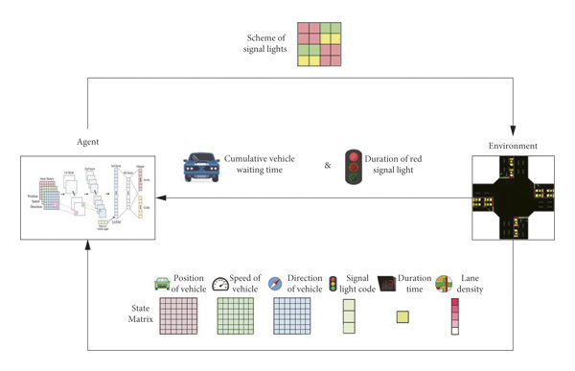

Fig 4.1: System Architecture Diagram
The Vehicle Detection Module forms the first layer of the architecture. Cameras installed at the intersection capture live traffic images, which are then processed using the YOLO (You Only Look Once) object detection algorithm. YOLO identifies and classifies vehicles into multiple categories, such as cars, bikes, buses, trucks, and rickshaws. OpenCV is used to draw bounding boxes around detected vehicles and count them, generating traffic density data for each lane or direction. This module ensures that the system has accurate, real-time data for further processing.
The Signal Control Algorithm forms the central decision-making layer of the system. Using the vehicle counts and additional parameters such as the number of lanes and average vehicle speed, the algorithm calculates the optimal green, yellow, and red light durations for each direction. The adaptive logic ensures fairness by maintaining minimum green-light durations for every lane, preventing starvation, while also optimizing traffic flow for congested lanes. The algorithm continuously updates signal timings in real time, based on changing traffic conditions.
The Simulation & Visualization Module is the final layer, implemented using Pygame. This module simulates the traffic intersection, displaying moving vehicles and changing traffic signals according to the adaptive algorithm. It serves as a validation and demonstration tool, allowing users to visualize the effectiveness of the adaptive system compared to traditional fixed-timer traffic signals.
Overall, the architecture follows a modular design, allowing each component to be independently upgraded or replaced without affecting the overall functionality. The flow of the system starts from capturing real-time traffic images, processing them for vehicle detection, feeding the counts into the adaptive signal control algorithm, and finally simulating the traffic behavior for validation. This structured architecture ensures scalability, reliability, and real-time responsiveness, making it a practical solution for intelligent urban traffic management.
UML DIAGRAMS :

The UML (Unified Modeling Language) diagram for the Smart traffic signal system using deep learningrepresents the structure and interaction between the main components of the system. The diagram provides a visual overview of how data flows from vehicle detection to traffic signal control and simulation.
The system consists of four primary classes: Camera, VehicleDetection, SignalController, and Simulation. The Camera class is responsible for capturing real-time images from the traffic intersection. These images are passed to the VehicleDetection class, where the YOLO (You Only Look Once) object detection algorithm identifies and classifies vehicles into categories such as cars, bikes, buses, trucks, and rickshaws. The class also counts the vehicles per lane and calculates traffic density, generating the input data for signal control.
The SignalController class acts as the decision-making module. It receives vehicle count data from the VehicleDetection class and uses an adaptive algorithm to calculate the optimal green, yellow, and red durations for each lane
Finally, the Simulation class uses Pygame to visually represent the intersection, vehicles, and traffic lights. It interacts with the SignalController class to display the current signal status and demonstrate the effectiveness of the adaptive algorithm. The UML diagram also shows associations between these classes: the Camera is associated with VehicleDetection, VehicleDetection communicates with SignalController, and SignalController interacts with Simulation.
Overall, the UML diagram provides a clear representation of the system’s modular design, data flow, and interaction between components, illustrating how real-time traffic data is processed and used to manage signals adaptively for efficient traffic flow.

4.1 Component diagram

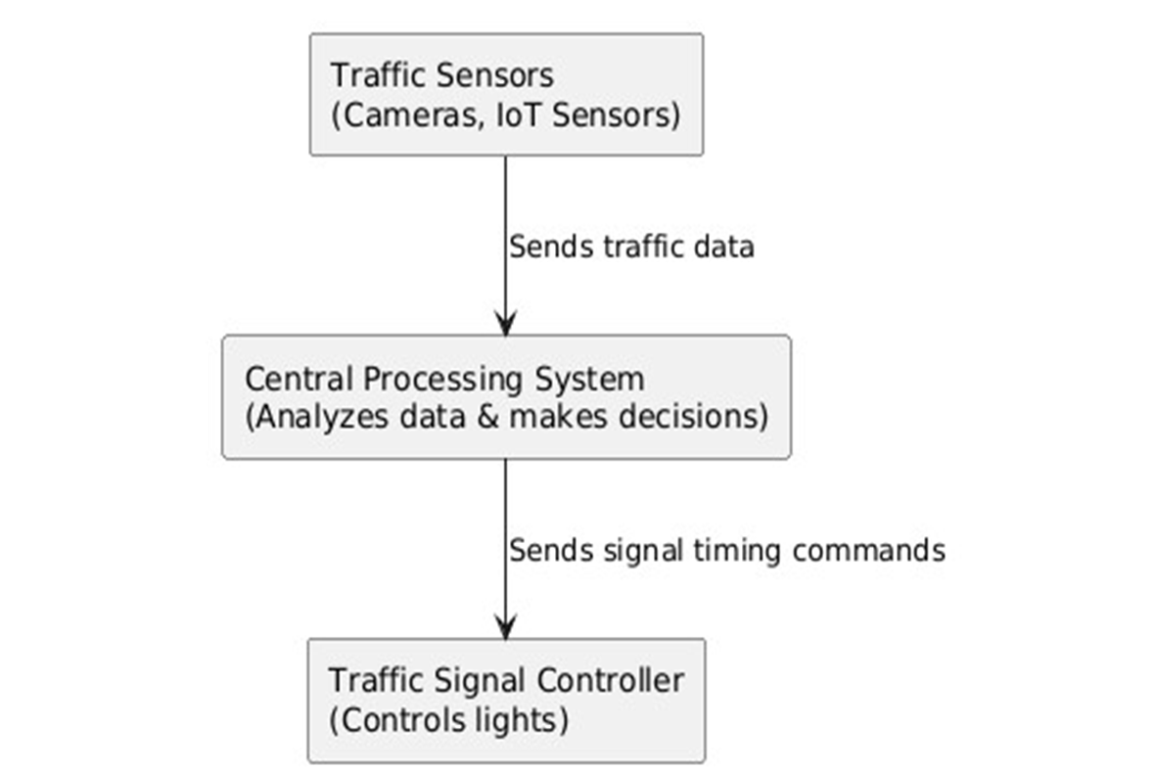

Fig 4.2: Component diagram
An intelligent traffic control system works by first collecting real-time information from traffic sensors such as cameras and IoT devices. These sensors continuously monitor vehicle flow and send this traffic data to a central processing system, which analyzes the information and decides the optimal timing for traffic lights. After making these decisions, the system sends timing commands to the traffic signal controller, which then adjusts the red, yellow, and green lights accordingly. This ensures smoother traffic flow and reduces congestion based on current road conditions.

4.2 Deployment diagram

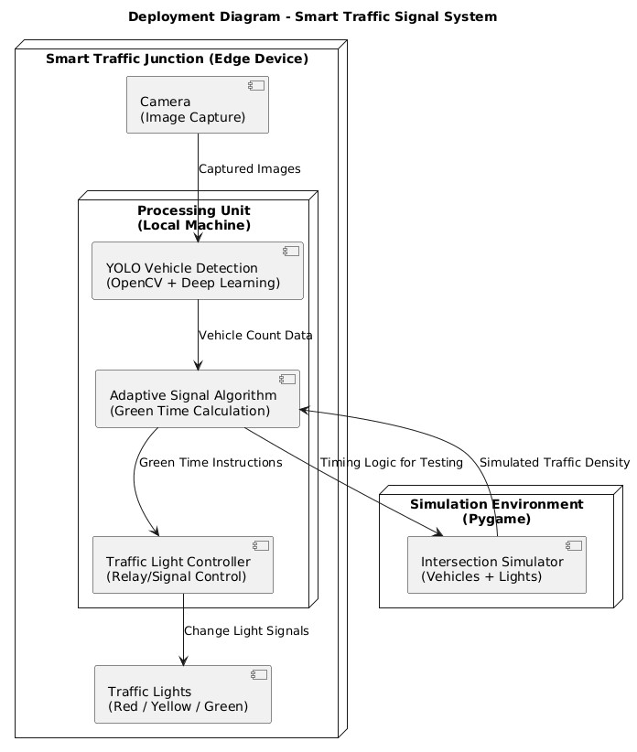

Fig 4.3: Deployment diagram
The deployment diagram illustrates how the Smart Traffic Signal System is installed and operates at a traffic junction. At the edge device, a camera captures real-time images of vehicles on the road. These images are sent to the local processing unit, where YOLO-based vehicle detection using OpenCV and deep learning identifies and counts vehicles. Based on this data, the adaptive signal algorithm calculates the required green time for each lane and sends these instructions to the traffic light controller. The controller then updates the red, yellow, and green lights accordingly. Alongside this, a simulation environment built with Pygame is used to test the system’s timing logic and traffic density behavior, ensuring the system performs accurately before real deployment.
4.3 Object diagram

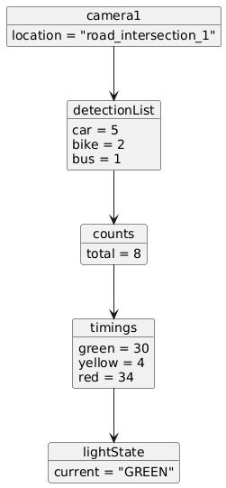
Fig 4.4: Object diagram
The object diagram represents the real-time state of different objects in the smart traffic system. The Camera object shows its location at a specific road intersection and captures a detection list of vehicles such as cars and bikes. This detection data is passed to the Counts object, which stores the total number of detected vehicles. Based on these counts, the Timings object calculates the required green, yellow, and red light durations. Finally, the LightState object reflects the current status of the traffic signal, which in this case is GREEN. This diagram shows how different objects interact and hold data at a specific moment in the traffic control process.

4.4 Communication diagram

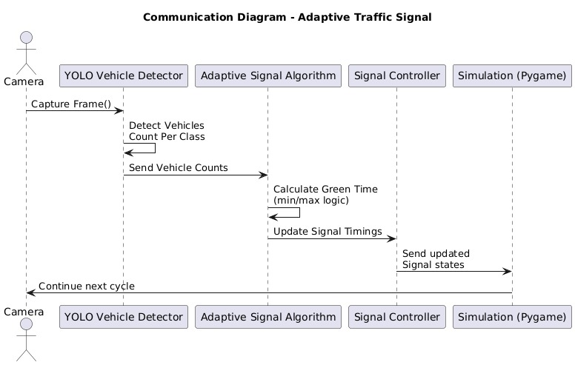
Fig 4.5: Communication diagram
The communication diagram shows how different components of the adaptive traffic signal system interact with each other. The process starts with the camera capturing frames of the road, which are sent to the YOLO Vehicle Detector. This detector identifies the vehicles and sends the vehicle count data to the Adaptive Signal Algorithm. Based on this count, the algorithm calculates the appropriate green time using minimum and maximum timing rules and updates the signal timings. These updated timings are then sent to the Signal Controller, which adjusts the actual traffic lights accordingly. At the same time, the Simulation module (Pygame) receives the updated signal states for testing and visualization. After completing this cycle, the system continues the next round of detection and signal adjustment.
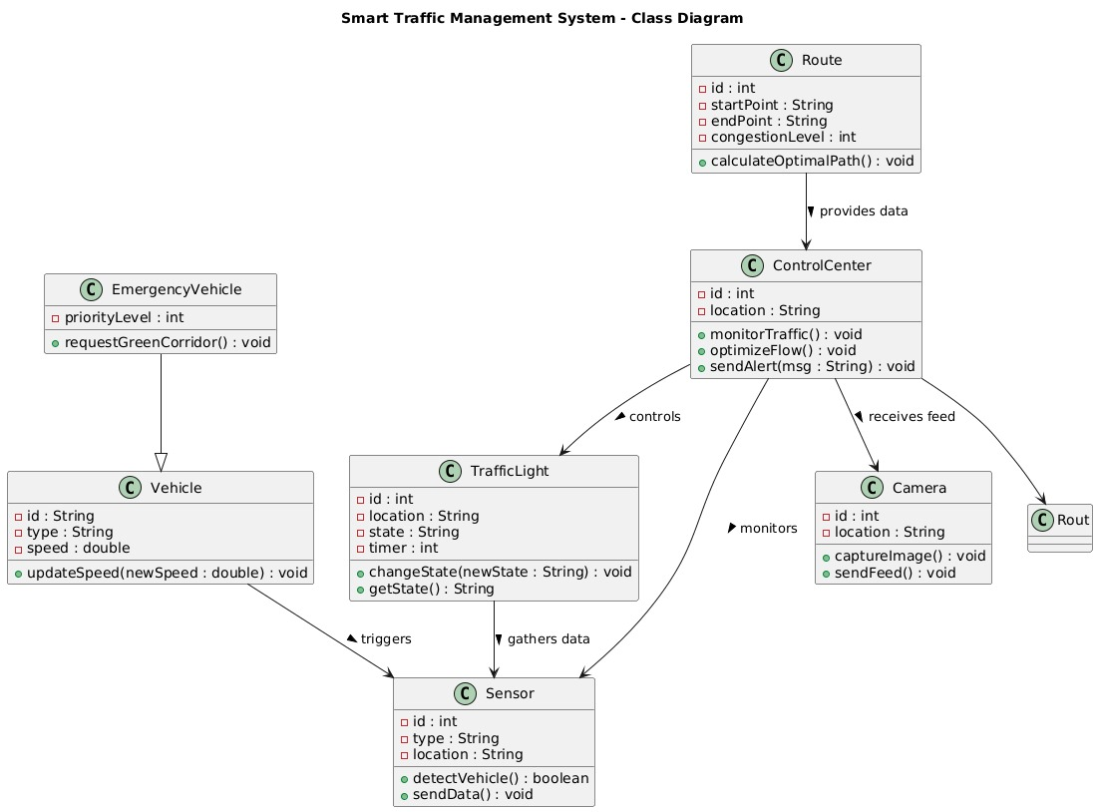
4.5 Class diagram

Fig 4.6: Class diagram
The class diagram represents a smart traffic management system with interconnected components. The ControlCenter is the core unit that monitors traffic, optimizes flow, and sends alerts; it receives data from Cameras, which capture images, and Sensors, which detect vehicles and send traffic data. The ControlCenter also controls TrafficLight objects by updating their states. Routes provide congestion information to help the ControlCenter calculate optimal paths. Vehicles represent general traffic units with attributes like type and speed, while EmergencyVehicle, a special subclass, can request a green corridor using its priority level.

4.6 Use case diagram

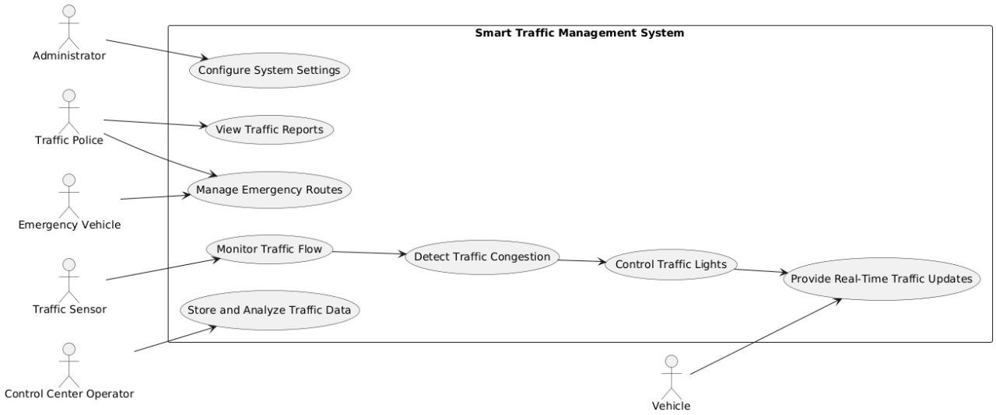
Fig 4.7: Use case diagram
The object diagram represents the real-time state of different objects in the smart traffic system. The Camera object shows its location at a specific road intersection and captures a detection list of vehicles such as cars and bikes. This detection data is passed to the Counts object, which stores the total number of detected vehicles. Based on these counts, the Timings object calculates the required green, yellow, and red light durations. Finally, the LightState object reflects the current status of the traffic signal, which in this case is GREEN. This diagram shows how different objects interact and hold data at a specific moment in the traffic control process.

4.7 Sequence diagram
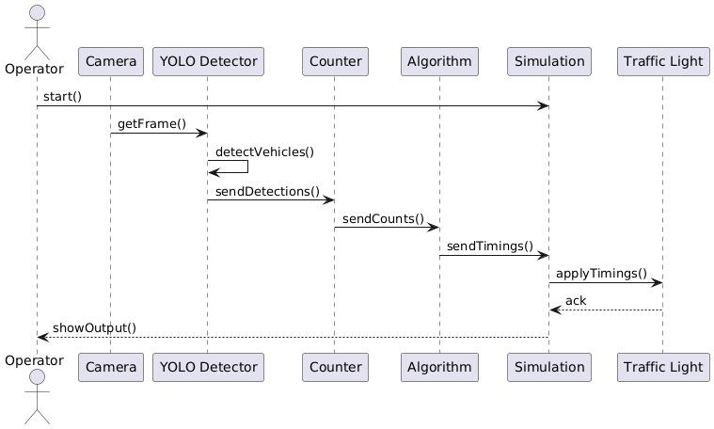
Fig 4.8: Sequence diagram
The sequence diagram shows how the adaptive traffic signal system operates from start to finish. When the operator starts the system, the camera captures a frame and sends it to the YOLO detector, which processes the image and detects vehicles. These detections are then forwarded to the counter, which converts them into vehicle counts. The algorithm receives these counts and computes the appropriate signal timings based on traffic conditions. These calculated timings are then sent to the simulation module, which updates the visual traffic signal state. The simulation applies these timings to the traffic light, which acknowledges the update. Finally, the updated results are returned to the operator through the showOutput() step, completing the cycle.

4.8 Activity diagram

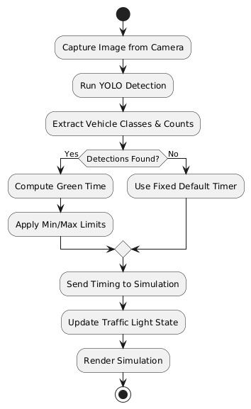
Fig 4.9: Activity diagram
The flowchart illustrates the working process of an adaptive traffic signal using YOLO detection. First, an image is captured from the camera and passed through the YOLO model to detect vehicles. The system then extracts vehicle classes and counts. If detections are found, it computes the green-light duration based on traffic density; otherwise, it falls back to a fixed default timer. The computed or default timing is then adjusted using predefined minimum and maximum limits. After this, the timing information is sent to the simulation module, which updates the traffic light state accordingly. Finally, the updated state is rendered in the simulation, completing the cycle.

CHAPER 5

PROPOSED WORK MODEL
The proposed system aims to optimize traffic flow at intersections by using real-time vehicle detection and adaptive signal timing. The workflow can be broken down into several key modules:
- Camera (Real-Time Traffic Feed)
  - Function: Captures live video footage of the intersection.
  - Purpose: Provides real-time data on traffic conditions for further processing.
  - Output: Captured frames of the traffic scene.
- YOLO-based Vehicle Detection
  - Function: Uses the YOLO (You Only Look Once) object detection algorithm to identify different types of vehicles.
  - Capabilities: Can detect cars, bikes, buses/trucks, and rickshaws in the captured frames.
  - Output: List of detected vehicles in each frame.
- Vehicle Counting Module
  - Function: Counts the number of vehicles detected in each frame.
  - Purpose: Provides vehicle density information for the intersection.
  - Output: Vehicle count data for each type of vehicle.
- Adaptive Signal Timing Algorithm
  - Function: Computes the duration of green, yellow, and red lights based on vehicle density.
  - Purpose: Adjusts signal timings dynamically to reduce congestion and waiting time.
  - Output: Optimized signal timings for each direction of traffic.
- Traffic Light Controller
  - Function: Executes the computed timings and controls the traffic lights accordingly.
  - Purpose: Implements the adaptive signal strategy in real-world traffic lights.
  - Output: Updated light states at the intersection.
- Pygame Simulation (Visual Output of Traffic Flow)

Fig 5.1: Proposed Model

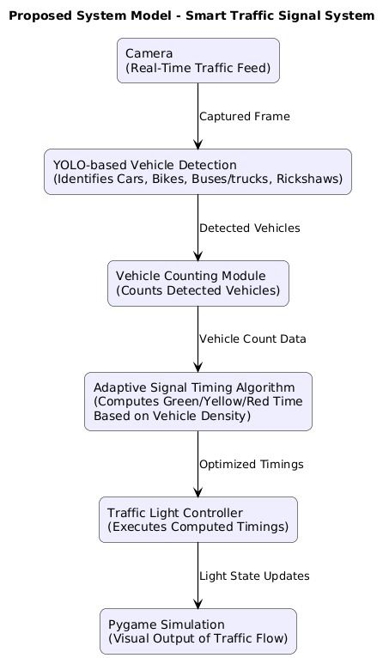
5.2 ALGORITHM :
The Smart traffic signal system using deep learningproject uses computer vision and intelligent decision-making to optimize green-light durations at road intersections. Instead of relying on pre-set timers, the system dynamically allocates time depending on real-time vehicle density captured from camera feeds.
The core algorithm is divided into two interconnected modules:
- Vehicle Detection Algorithm (Deep Learning / YOLO-based)
- Signal Time Optimization Algorithm (Rule-based weighted calculation)
Together, these modules detect the number of vehicles on each road, estimate traffic density, and compute the most appropriate signal duration for each lane.

2. Vehicle Detection Algorithm
(First major algorithm of the system)

2.1 Objective
The aim of this algorithm is to count the number of vehicles present in a camera frame so that the system can make time allocation decisions based on actual traffic density.

2.2 Algorithm Overview
The project uses an Object Detection Model (YOLO) to detect and classify vehicles. YOLO (You Only Look Once) is a real-time CNN-based algorithm that predicts bounding boxes and classes from a single forward pass.

2.3 Steps of the Vehicle Detection Algorithm

Step 1: Image Capture
- A frame is captured from a static CCTV camera facing each lane of the intersection.
- Image resolution is reduced for faster processing.

Step 2: Preprocessing
- The image is converted into YOLO input format.
- Normalization and resizing are applied.
- The model receives input of standardized shape (e.g., 416×416 px).

Step 3: YOLO Model Execution
- YOLO divides the image into grids and predicts bounding boxes + class probabilities for each grid.
- Classes typically include:
  - Car
  - Bus
  - Bike / Motorcycle
  - Truck
  - Rickshaw

Step 4: Non-Maximum Suppression (NMS)
- Duplicate overlapping boxes are filtered out.
- Only the most confident detection for each vehicle remains.

Step 5: Vehicle Counting
A final count is generated for each detected class:
- cars_count
- bikes_count
- buses_count
- trucks_count
- rickshaw_count

Step 6: Density Calculation
The algorithm converts raw vehicle counts into a traffic density score:
Density=∑(vehicle count×weight of vehicle)\text{Density} = \sum ( \text{vehicle count} \times \text{weight of vehicle} )Density=∑(vehicle count×weight of vehicle)
Weights reflect the road space occupied:
- Bike – 1
- Car – 2
- Auto – 2
- Bus – 3
- Truck – 3
These weights are taken from standard traffic engineering practices.

2.4 Key Characteristics of the Algorithm
- Real-Time: Processes each frame quickly.
- End-to-End: Directly maps image → bounding boxes → vehicle counts.
- Flexible: Can be used for Indian roads with slight retraining.
- Scalable: Can monitor 4, 6, or more lanes.

Signal Time Optimization Algorithm

(Second major algorithm of the system)

3.1 Objective
To intelligently allocate green light time to each lane based on real-time traffic density.The goal is minimum waiting time, maximum vehicle throughput, and fair distribution of timings.

3.2 Key Inputs
The algorithm considers:
- Vehicle count from YOLO detection
- Number of lanes on each road
- Average vehicle speed in that lane
- Arrival rate of vehicles (optional)
- Minimum and maximum green light limits

Steps of the Signal Time Optimization Algorithm

Step 1: Receive traffic densities
For each direction (North, South, East, West), the density score is received.
Example (for one lane):
DN=Sum of weighted vehicle countsD_{N} = \text{Sum of weighted vehicle counts}DN​=Sum of weighted vehicle counts

Step 2: Normalize Traffic Density
Normalize the densities to a common range (e.g., 0–1):
Dnorm=Dimax⁡(D)D_{norm} = \frac{D_i}{\max(D)}Dnorm​=max(D)Di​​
This ensures fairness between lanes.

Step 3: Calculate Base Green Time
Using proportional allocation:
Ti=Tcycle×DnormT_i = T_{cycle} \times D_{norm}Ti​=Tcycle​×Dnorm​
Where:
- TcycleT_{cycle}Tcycle​ = total cycle time (e.g., 120 seconds)
- TiT_iTi​ = green time for lane i
This ensures lanes with more traffic receive more time.

Step 4: Apply Correction Factors
The project uses the following correction parameters:
- Number of lanes:
Ti=Ti+(Li×CL)T_i = T_i + (L_i \times C_L)Ti​=Ti​+(Li​×CL​)
- Average speed:
Ti=Ti−SiCST_i = T_i - \frac{S_i}{C_S}Ti​=Ti​−CS​Si​​
- Vehicle arrival rate: (if used)
Ti=Ti+AiT_i = T_i + A_iTi​=Ti​+Ai​
These corrections ensure real traffic behavior is captured.

Step 5: Ensure Min–Max Time Limits
Final time must satisfy:
Tmin≤Ti≤TmaxT_{min} \leq T_i \leq T_{max}Tmin​≤Ti​≤Tmax​
Typical values:
- Tmin=10sT_{min} = 10sTmin​=10s
- Tmax=60sT_{max} = 60sTmax​=60s

Step 6: Final Allocation and Switching
The algorithm outputs a sorted list of lanes based on priority → highest density first.
The controller then activates green → yellow → red sequences accordingly.
This completes one cycle of adaptive signal control.

CHAPTER 7
SCREEN SHOT
Input image:
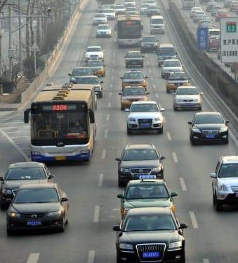

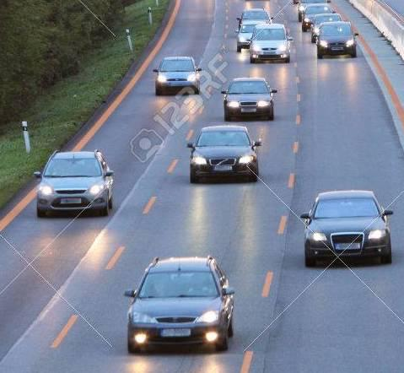

Figure 5.2: Input data of Vehicles
The above image illustrates a typical high-traffic roadway captured from an overhead surveillance camera. It contains multiple lanes with diverse vehicle types, including cars, taxis, and a public transport bus. This image is used as input for the Smart traffic signal system using deep learningsystem to simulate real-world traffic conditions. When processed through the YOLO-based vehicle detection algorithm, the system identifies each vehicle and generates corresponding counts for every lane. These counts are further converted into traffic density values based on predefined vehicle weights. The extracted density information directly influences the green-light duration allocated to that road segment, allowing the traffic signal controller to dynamically adjust timings and reduce congestion.
The provided image is an example of a real-time traffic scene captured from a roadside surveillance camera. It includes mixed traffic consisting of cars, buses, and taxis distributed across multiple lanes. This image serves as input to the vehicle detection module of the project, where the YOLO model detects and classifies each vehicle. The detected vehicle counts are then used to compute lane-wise traffic density, which helps the adaptive signal timer determine appropriate green-light durations for efficient traffic flow management.

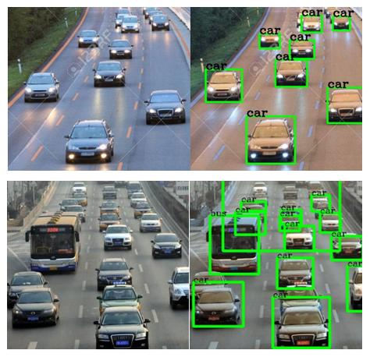

Figure 5.3: Output Image

The above output image represents the result of applying the deep-learning-based vehicle detection algorithm to the input traffic scene. Using the YOLO model, the system accurately identifies and localizes various vehicles such as cars and buses by drawing green bounding boxes around them and labeling each detected object. This detection output is crucial for the Smart traffic signal system using deep learningas it enables precise vehicle counting and lane-wise density estimation.
Once the vehicle counts are extracted from the detection results, the traffic density is calculated using weighted values, which forms the basis for optimizing and dynamically adjusting green-light durations for different lanes.

CHAPTER 6
TECHNOLOGY STACK

1. Programming Languages

1.1 Python
Python is the primary programming language used in this project due to its simplicity, powerful libraries, and strong community support. Python is widely used in machine learning and computer vision applications and provides seamless integration with deep learning models like YOLO.
Python handles tasks such as reading traffic images, running the object detection model, calculating traffic density, and computing dynamic signal timings.

2. Deep Learning & Computer Vision Technologies

2.1 YOLO (You Only Look Once)
YOLO is the core object detection framework used in this project. It processes images in real-time and identifies multiple objects (vehicles) with high accuracy.
YOLO identifies cars, buses, bikes, and other vehicles, draws bounding boxes around them, and outputs count data for further processing.

2.2 OpenCV
OpenCV (Open Source Computer Vision Library) is used for image processing tasks such as reading frames, resizing images, preprocessing, drawing bounding boxes, and transforming images.
OpenCV Usage in the Project:
- Image input and preprocessing
- Color space conversions
- Displaying detection results
- Visualizing simulation frames

3. Machine Learning & Data Processing Libraries

3.1 NumPy
NumPy is used for numerical operations such as matrix manipulation, pixel value calculations, and density scoring.

3.2 Pandas
Pandas is used when storing detection results, counts, or generating datasets for training or analysis.

4. Simulation Technologies

4.1 Pygame
Pygame is used to create the traffic signal simulation environment included in the project. It provides a simple framework for drawing roads, moving vehicles, switching signals, and creating a graphical interface.
Component | Requirement
Operating System | Windows 10 or Ubuntu  20.04
RAM | Minimum 4 GB
Python Version | 3.7 or higher
Libraries Used | NumPy,pygame, Pandas, OpenCV
Jupyter Notebook /VS Code | Code development & testing

Table 6.1: System Requirements Table

CHAPTER 7

CONCLUSIONS AND FUTURE WORK

CONCLUSION:
The Smart Traffic Management System successfully demonstrates how deep learning and image-based vehicle detection can significantly improve urban traffic control. By using object detection algorithms to count vehicles in real time, the system dynamically adjusts traffic signal timings based on actual road congestion. This eliminates the limitations of traditional fixed-timer signals and ensures smoother traffic flow, reduced waiting time, and minimized fuel consumption.
The proposed Smart Traffic Signal System effectively demonstrates how artificial intelligence, computer vision, and adaptive control mechanisms can transform traditional traffic management into an intelligent and automated solution. By leveraging a real-time camera feed and applying YOLO-based vehicle detection, the system is able to accurately identify multiple categories of vehicles, including cars, bikes, buses, trucks, and rickshaws. This high-precision detection ensures that traffic density is measured reliably even under complex road conditions.
The vehicle counting module further processes these detections to quantify traffic volume in each lane. This data-driven approach eliminates the dependency on fixed timer traffic signals, which often result in unnecessary delays and increased congestion. Instead, the adaptive signal timing algorithm dynamically adjusts signal durations based on live vehicle density, allowing for efficient allotment of green.

FUTURE WORK:
The proposed Smart Traffic Signal System provides a strong foundation for intelligent traffic management; however, there are several opportunities for further improvement and expansion. Future work can focus on enhancing system accuracy, scalability, and integration with smart city technologies to create a more efficient and robust traffic ecosystem.
1. Multi-Intersection Integration
Currently, the system operates at a single intersection. Future development can link multiple intersections together to create a coordinated traffic network.
- Traffic data from one signal can be shared with neighboring signals.
- This enables green-wave systems where vehicles can pass through consecutive signals without stopping.
- Helps in city-wide traffic flow optimization and reduces congestion hotspots.
2. Emergency Vehicle Detection and Priority
Advanced detection models can be integrated to identify ambulances, fire trucks, or police vehicles:
- System can automatically grant immediate green lights to emergency lanes.
- Ensures faster response times and potentially saves lives.
- Can be extended to VIP convoys or public transport priority.
3. Integration with IoT Sensors
To improve accuracy, the system can incorporate additional IoT-based hardware:
- Roadside sensors to detect vehicle speed, air quality, and noise levels.
- RFID tags for public transport tracking.
- Weather sensors to optimize traffic flow during rain, fog, or storms.
Combined data will make the signal timing more intelligent and environment-aware.
4. Cloud-Based Traffic Analytics Dashboard
A cloud platform can be developed for storing and analyzing long-term traffic data:
- Real-time dashboards for monitoring traffic in different parts of the city.
- Predictive analytics for rush hours, festivals, or events.
- Helps city authorities make informed decisions about road expansion or diversions.
5. Machine Learning–Based Traffic Prediction
Future enhancements can involve predictive AI models such as LSTMs or Transformers:
- Predict traffic density for the next few minutes based on historical patterns.
- The system can pre-adjust signal timings before congestion occurs.
- Improves overall traffic fluidity and reduces delay.
6. Weather and Lighting Condition Adaptation
YOLO accuracy may decrease during low light or extreme weather.
Future improvements may include:
- Infrared or thermal cameras for night-time detection.
- Image enhancement techniques (HDR, de-noising, de-hazing).
- Training the detection model on diverse datasets.
7. Pedestrian and Cyclist Detection
The current system focuses mainly on vehicles. Future versions may include:
- Pedestrian crossing detection
- Dedicated timings for foot traffic
- Bicycle lane monitoring
This creates a safer and more inclusive traffic environment.
8. Mobile App Integration for Citizens
A mobile application can be developed to notify users about:
- Estimated waiting time at signals
- Traffic jams and alternate routes
- Accident or roadblock alerts
This improves user awareness and reduces unnecessary crowding.
9. Integration With Smart City Infrastructure
The system can be connected to other smart city modules such as:
- Smart parking
- Public transport scheduling
- Highway toll management
- Pollution tracking
This helps build a unified intelligent transportation ecosystem.
10. Real-World Deployment and Optimization
Future work can focus on deploying the system at actual intersections:
- Field testing to compare AI-based traffic control with manual signal systems.
- Fine-tuning the algorithm based on real-world feedback.

REFERENCES

• Redmon, J., & Farhadi, A. (2018). YOLOv3: An Incremental Improvement. arXiv:1804.02767.
• Bochkovskiy, A., Wang, C. Y., & Liao, H. Y. M. (2020). YOLOv4: Optimal Speed and Accuracy of Object Detection. arXiv:2004.10934.
• He, K., Zhang, X., Ren, S., & Sun, J. (2015). Deep Residual Learning for Image Recognition (ResNet). arXiv:1512.03385.
• OpenCV Documentation. (2024). Open Source Computer Vision Library. https://docs.opencv.org
• TensorFlow Documentation. (2024). Machine Learning Framework. https://www.tensorflow.org
• PyTorch Documentation. (2024). Deep Learning Framework. https://pytorch.org
• Arun, M., et al. (2021). Intelligent Traffic Signal Control System Using Deep Learning and Computer Vision. IEEE International Conference on Smart Technologies.
• Saini, A., & Kaur, M. (2020). Vehicle Detection and Counting Using YOLO for Smart Traffic Monitoring. International Journal of Computer Applications.
• Ministry of Road Transport & Highways (India). (2023). Traffic Management Reports & Urban Mobility Data.
• NVIDIA Developer Blog. (2023). Deploying AI Models for Edge Computing in Smart Cities.

