Designing Interactive Power BI Dashboards
for Construction Analytics
Dashboard Design Blueprint & Storyboard
Task 4 — Interactive Dashboard Design for a Virtual Construction Business
Prepared by: Harsh Mishra
Date: September 2026
Builds on: Task 3 — Advanced Data Model & DAX Calculations

1. Objective
This document presents the complete design blueprint for an interactive Power BI dashboard suite built on top of the star-schema data model and DAX measures developed in Task 3 for the virtual construction business. Where Task 3 established the data foundation (dimension/fact tables and KPI formulas), this task turns that foundation into a decision-support tool: a set of dashboard pages that a construction executive, project manager, or resource planner can open, filter, and drill into to answer real operational questions in seconds rather than minutes.
The blueprint covers three things end to end: (1) which metrics deserve a visual and why, (2) a page-by-page storyboard of the dashboard layout with every visual element placed and explained, and (3) the interactivity model — slicers, drill-through, tooltips, and bookmarks — that lets one report serve both a five-second executive glance and a twenty-minute operational deep-dive.
The design is aimed squarely at three recurring construction-business needs: workflow efficiency (fewer clicks to the answer), resource management (spotting over/under-allocation before it becomes a delay), and project performance (cost and schedule health, with a forward-looking forecast rather than only a historical view).

2. Conceptualization — Metrics and KPIs Worth Visualizing
Every metric below already exists as a DAX measure in the Task 3 model. The selection criteria for what earns a place on the dashboard: does it change a decision, and is it something a user would otherwise have to build a mental model of from raw numbers?
Metric | Business question it answers | Source (Task 3 measure) | Best visual
Cost Variance % | Are we over or under budget, and where? | Cost Variance % | KPI card + bar by Project/Category
CPI (Cost Performance Index) | Is money being spent efficiently against value earned? | Cost Performance Index (CPI) | KPI card + trend line
SPI (Schedule Performance Index) | Are we ahead of or behind schedule? | Schedule Performance Index (SPI) | KPI card + trend line
Cumulative Actual vs Budget | How is spend trending over the project life (S-curve)? | Cumulative Actual Cost | Line/area chart
Estimate at Completion (EAC) | What will this project actually cost if trends continue? | Estimate at Completion (EAC) | Gauge vs Budget at Completion
Forecasted Completion Date | When will the project realistically finish? | Forecasted Completion Date | Card with variance to planned date
Resource Utilization Rate | Are crews/equipment over- or under-used? | Resource Utilization Rate | Bar + conditional-formatted table
% Complete (Progress) | How far along is each project, physically? | FactProjectProgress[ActualPercentComplete] | KPI card + gauge
Over-allocated Resource Count | How many crews/equipment are booked past capacity? | COUNTROWS filter on Utilization > 100% | KPI card
Portfolio Health (composite) | At a glance, which projects need attention today? | Weighted CPI/SPI/Cost Variance | Table with conditional formatting + drill-through

3. Design Blueprint — Dashboard Storyboard
The dashboard is built as a three-page report, designed to be opened in that order the first time and then jumped between freely afterward: an executive summary page, a cost-and-schedule deep-dive, and a resource-management page. All three share a common header, filter bar, and colour language (blue = plan/budget, orange = actual/attention, red = unfavourable variance, green = favourable) so a user only has to learn the visual grammar once.

3.1 Page 1 — Executive Overview
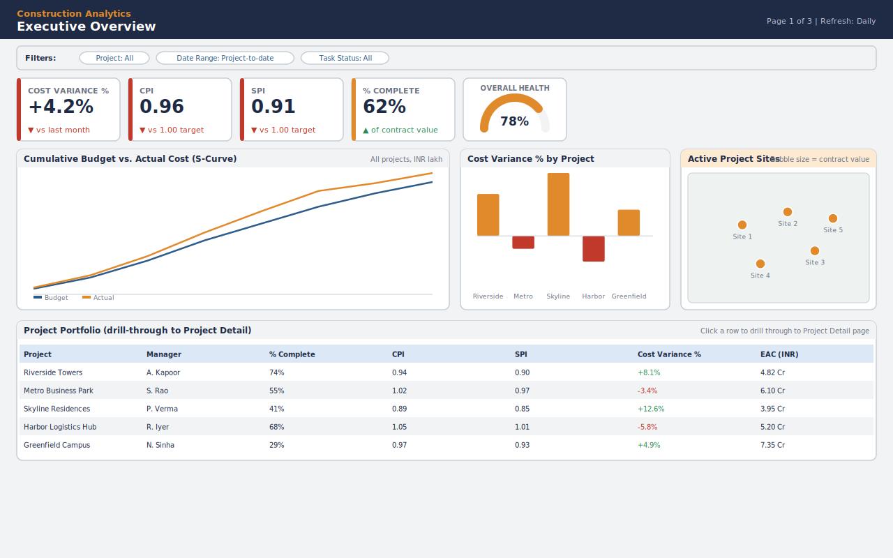
Figure 1 — Executive Overview page (wireframe/storyboard).
Purpose: a single-screen answer to "how is the portfolio doing right now, and which project needs my attention?" This is the landing page and is designed to be read in under 30 seconds.
- Filter bar — Project, Date Range, Task Status slicers, sitting above the fold so every visual below responds immediately without scrolling.
- KPI card row — Cost Variance %, CPI, SPI and % Complete as headline cards with an up/down indicator against last period; a portfolio-wide Overall Health gauge blends CPI, SPI and Cost Variance into one traffic-light number for a true at-a-glance read.
- Cumulative Budget vs. Actual Cost (S-curve) — the classic EVM chart; the gap between the two lines is the single fastest way to see whether the whole portfolio is trending over budget.
- Cost Variance % by Project — a sorted bar chart that immediately ranks projects from best to worst performer, colour-coded red/orange for unfavourable variance.
- Active Project Sites (map) — bubble map of project locations sized by contract value, giving geographic context that a table alone cannot.
- Project Portfolio table — every project with its core KPIs in one row; clicking a row drills through to Page 2 pre-filtered to that project.

3.2 Page 2 — Cost & Schedule Performance
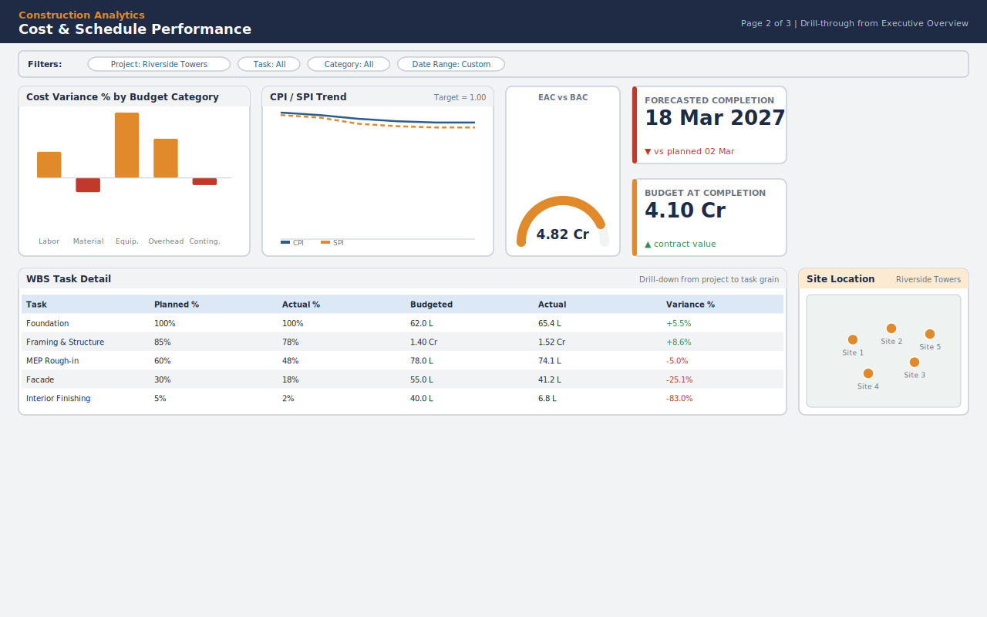
Figure 2 — Cost & Schedule Performance page (wireframe/storyboard), reached via drill-through from Page 1.
Purpose: once an executive has flagged a project on Page 1, this page answers "why is this project over/under, and what will it cost/when will it finish if nothing changes?"
- Filter bar — inherits the Project filter from the drill-through, plus local Task, Budget Category and Date Range slicers for further narrowing.
- Cost Variance % by Budget Category — pinpoints whether the overrun is in Labor, Material, Equipment, Overhead or Contingency.
- CPI / SPI Trend — a two-line chart against a Target = 1.00 reference so a user can see whether performance is improving, flat, or deteriorating month over month.
- EAC vs BAC gauge and Forecasted Completion Date / Budget at Completion cards — the predictive heart of the dashboard, turning historical trend into a forward-looking number a project manager can act on today.
- WBS Task Detail table — task-level Planned % / Actual % / Budgeted / Actual / Variance %, so the user can trace a project-level problem down to the exact task causing it.
- Site Location map — reminds the viewer which physical site this deep-dive belongs to.

3.3 Page 3 — Resource Management
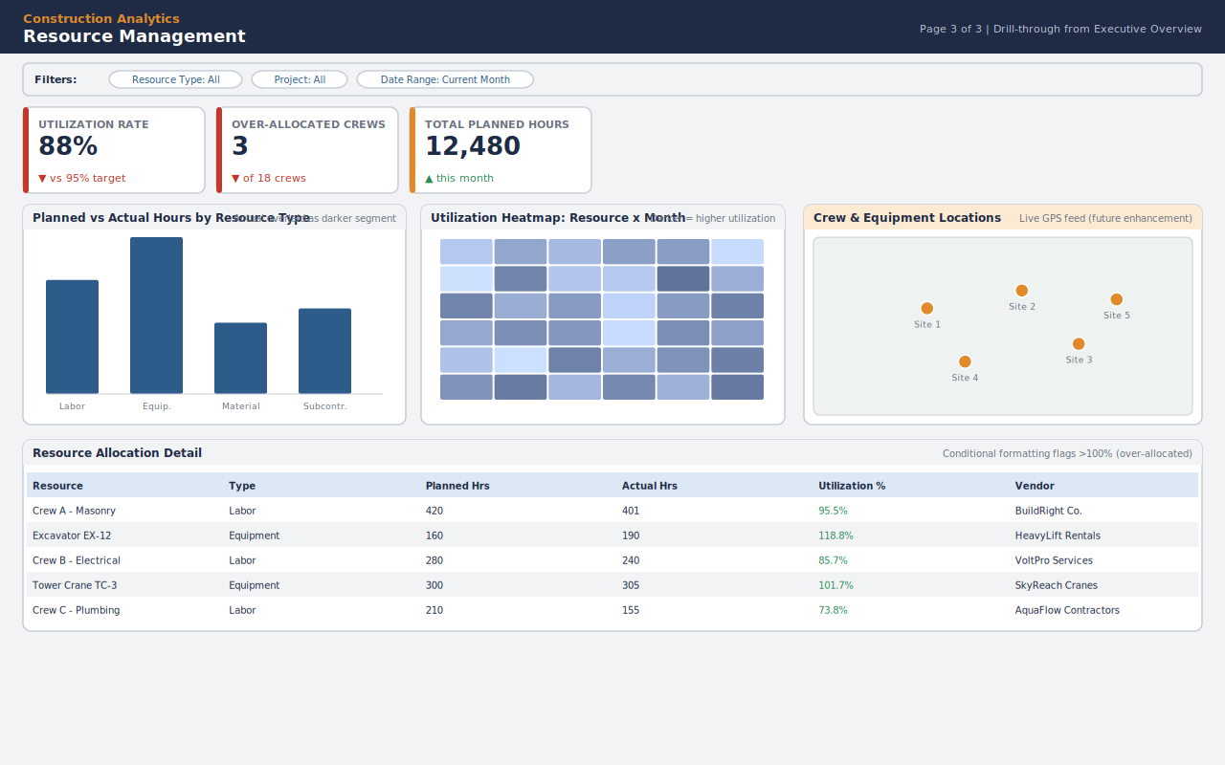
Figure 3 — Resource Management page (wireframe/storyboard), reached via drill-through from Page 1 or navigated to directly.
Purpose: answers "are our crews and equipment allocated efficiently, and where is the next bottleneck?" — the page a resource/operations planner would live on.
- KPI cards — overall Utilization Rate against a 95% target, a count of over-allocated crews/equipment, and total planned hours for the period.
- Planned vs Actual Hours by Resource Type — a clustered bar comparing the plan to the ground truth for Labor, Equipment, Material and Subcontractors.
- Utilization Heatmap (Resource x Month) — a matrix visual with colour saturation as the value, the fastest way to spot a resource that is quietly over capacity for several consecutive months.
- Crew & Equipment Locations map — placeholder for a future live-GPS feed; included now so the dashboard's information architecture doesn't need rework when that data becomes available.
- Resource Allocation Detail table — one row per resource with conditional formatting that flags anything over 100% utilization in red.

4. Interactivity Planning
Interactivity is what turns three static pictures into one usable analytical tool. Every interactive element below is something Power BI supports natively — nothing in this plan requires custom visuals.

4.1 Slicers and cross-filtering
- Project, Date Range, Task Status, Budget Category and Resource Type slicers are placed in a consistent filter bar on every page; Power BI's default cross-filtering means selecting one visual (e.g. a bar for "Skyline Residences") automatically highlights that project across every other visual on the page.
- Slicers are synced across pages using Power BI's "Sync Slicers" pane, so a Project selection made on Page 1 is remembered when the user navigates to Page 2 or Page 3.

4.2 Drill-through and drill-down
- Drill-through: right-clicking (or, on touch, long-pressing) a row in the Project Portfolio table on Page 1 jumps to Page 2 filtered to that exact project — this is the primary executive-to-operational navigation path.
- Drill-down: the WBS Task Detail table supports drilling from Project grain down to Task grain, and the Resource Allocation table drills from Resource Type down to individual crew/equipment, using Power BI's built-in hierarchy drill icons.

4.3 Tooltips
- Custom report-page tooltips are used on the S-curve and CPI/SPI trend charts: hovering any point shows a small pop-up page with that week's exact Budget, Actual, CPI and SPI values, avoiding cluttering the main chart with data labels.

4.4 Bookmarks and buttons
- A bookmark-driven toggle button on Page 2 switches the CPI/SPI Trend chart between "Monthly" and "Weekly" granularity without needing a separate visual.
- A "Reset filters" button (bookmark) on every page returns all slicers to their default (All Projects, project-to-date) state in one click.

4.5 Conditional formatting
- Cost Variance % and Utilization % columns use background-colour rules (green/amber/red) rather than plain numbers, so a scan down the table alone reveals problem rows.
- KPI cards use a small up/down triangle plus colour to indicate whether the current value is favourable or unfavourable against target — decided automatically by the underlying DAX measure's sign, not hard-coded.

4.6 Mobile layout
Each page has a companion Power BI mobile layout: KPI cards and the single most important chart (S-curve on Page 1, CPI/SPI trend on Page 2, Utilization heatmap on Page 3) are stacked vertically for a site manager checking the dashboard from a phone on-site.

5. Detailed Explanation of Visual Components
The table below maps every visual on the storyboard to its Power BI visual type, the fields/measures it is bound to, and the interactive behaviour attached to it — this is the specification a developer would build directly from in Power BI Desktop.
Visual | Power BI visual type | Fields / measures | Interactivity
KPI cards (all pages) | Card / KPI visual | Cost Variance %, CPI, SPI, Utilization Rate, etc. | Conditional colour + trend arrow via DAX
Overall Health / EAC vs BAC | Gauge | Composite score / EAC measure vs BAC target | Target line driven by BAC measure
Cumulative Budget vs Actual (S-curve) | Line chart | DimDate[Date], Cumulative Actual Cost, cumulative Budget | Report-page tooltip on hover
Cost Variance % by Project/Category | Clustered bar chart | DimProject / DimBudgetCategory, Cost Variance % | Cross-filters all visuals on click
CPI / SPI Trend | Line chart | DimDate[Month], CPI, SPI measures | Bookmark toggle: Weekly/Monthly
Active/Site Location map | Map / bubble map | Project site coordinates, Contract Value | Cross-filters on bubble click
Project Portfolio / WBS Task Detail / Resource Allocation | Table / matrix | Project or Task or Resource grain with KPI columns | Drill-through, drill-down, conditional formatting
Utilization Heatmap | Matrix (conditional formatting as colour scale) | DimResource, DimDate[Month], Resource Utilization Rate | Cross-filters table below on cell click

6. Narrative — How This Dashboard Serves the Construction Business

6.1 Workflow efficiency
Before this dashboard, answering "which project is over budget and why" meant opening separate cost reports, schedule trackers, and resource sheets. The three-page structure collapses that into one flow: Page 1 identifies the problem project in seconds, drill-through takes the user straight to Page 2's root-cause view, and the WBS table pinpoints the exact task — a workflow that used to take three files and a spreadsheet now takes three clicks.

6.2 Resource management
The Resource Management page turns a reactive process ("we noticed the crew was overbooked after the delay happened") into a proactive one. The utilization heatmap and the over-allocation KPI card are designed to be checked weekly by a resource planner, surfacing an over-100%-utilization crew before it causes a schedule slip, not after.

6.3 Project performance and predictive insight
CPI and SPI give a construction stakeholder industry-standard performance language rather than ad-hoc percentages, and the EAC / Forecasted Completion Date cards convert that historical performance into a forward-looking number — directly answering the brief's requirement for a predictive-completion view, and giving a project manager a number to negotiate against (with a client or head office) rather than just a status update.

6.4 Serving two audiences from one report
The page order is deliberately audience-aware: Page 1 is built for a 30-second executive glance, while Pages 2 and 3 are built for the 20-minute operational review a project or resource manager would do. Because both audiences share the same underlying model and colour language, there is no second report to maintain and no risk of the two audiences working from different numbers.

7. Review and Reflection

7.1 Strengths
- Every visual traces back to a named Task 3 DAX measure, so the design is implementable immediately with no new data-model work.
- The drill-through path (Portfolio -> Project -> Task) mirrors the star schema's own grain (Project -> Task -> Resource), so the navigation model and the data model reinforce each other.
- A consistent colour and layout language across all three pages means a user who learns Page 1 already knows how to read Pages 2 and 3.
- The predictive cards (EAC, Forecasted Completion Date) give the dashboard a forward-looking element that most basic BI reports skip entirely.

7.2 Limitations
- The map visuals assume real latitude/longitude site data; the current sample model does not include a site-coordinates field, so this would need a small addition to DimProject before the map visuals can be built exactly as wireframed.
- The live-GPS crew tracking on Page 3 is explicitly a placeholder — it depends on a future data source outside the current model's scope.
- As with Task 3's own limitation, EAC and Forecasted Completion Date assume the current CPI/SPI trend continues and do not factor in known future risks (e.g. a monsoon-season delay) that a human planner would apply as judgment on top of the number.
- Wireframes in this document are storyboard-fidelity (layout, hierarchy and interactivity intent), not a pixel-exact Power BI screenshot; exact visual polish (fonts, precise spacing) will be finalised once built in Power BI Desktop.

8. Deliverable Files
The following files accompany this document and are structured to be uploaded together to a GitHub repository:
- Dashboard_Design_Document.docx — this document.
- mockups/page1_executive_overview.png / .svg — Executive Overview storyboard.
- mockups/page2_cost_schedule_performance.png / .svg — Cost & Schedule Performance storyboard.
- mockups/page3_resource_management.png / .svg — Resource Management storyboard.
- Dashboard_Narrative.md — the business-needs narrative in plain-text/Markdown form for quick GitHub viewing.
- README.md — repository overview, file guide, and how this task builds on Task 3.

