Advanced Data Models and DAX Calculations
Power BI Data Model & KPI Design for a Virtual Construction Business
Week 3 Task — Building Advanced Data Models and DAX Calculations
Prepared by: Harsh Mishra
Date: September 2026

1. Objective
This report presents the design and implementation of an advanced Power BI data model for a virtual construction business. The goal is to relate project timelines, budgets, and resource allocations into a single analytical model, and to demonstrate how Power BI can leverage that model through custom DAX measures that calculate key performance indicators (KPIs) such as cost variance, cumulative project cost, schedule performance, and predictive project completion.
The deliverable set includes this document (data model design, ERD, DAX explanations, and documentation), a set of sample CSV tables representing the model's data layer, and a text file containing every DAX measure written for the model, ready to be pasted into Power BI Desktop.

2. Data Model Design
The model follows a star schema, the pattern Power BI is optimized for. Five dimension tables describe the who/what/when of a construction project, and three fact tables capture the transactional and periodic measurements — cost, resource hours, and physical progress. All fact tables connect to dimensions through single-direction, one-to-many relationships, which keeps filter propagation predictable and keeps DAX measures fast.

2.1 Entity-Relationship Diagram
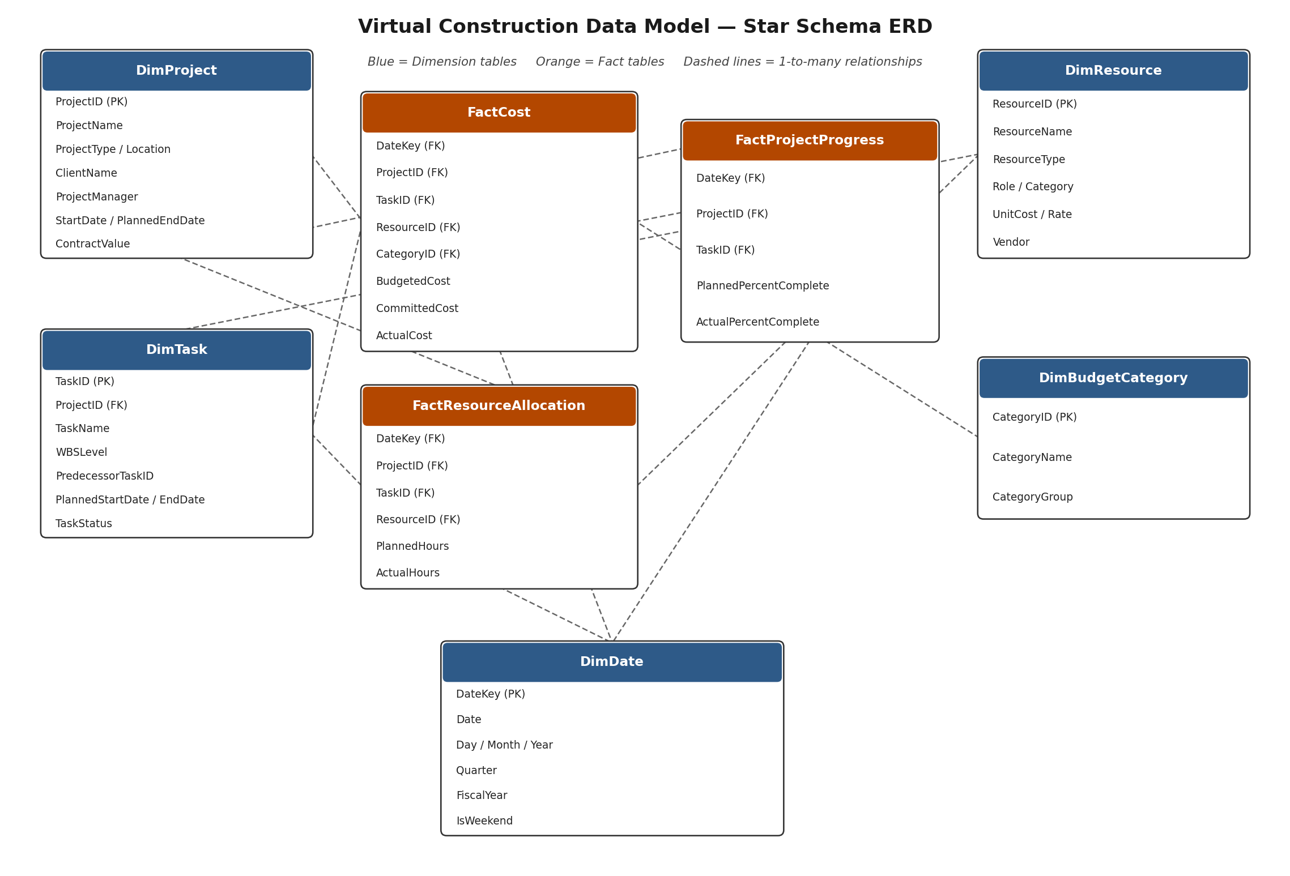
Figure 1 — Star schema ERD: dimension tables (blue) surround the three fact tables (orange); DimDate is shared by all fact tables for time intelligence.

2.2 Table Inventory
Dimension tables
Table | Grain | Purpose
DimProject | One row per project | Master data for each construction project: client, manager, location, contract value, planned dates.
DimTask | One row per WBS task | Work-breakdown-structure tasks within a project (e.g. foundation, framing, MEP), with planned dates and dependency.
DimResource | One row per resource | Labor crews, equipment, and material line items, each with a unit cost or hourly rate and a vendor.
DimBudgetCategory | One row per cost category | Groups costs into Labor / Material / Equipment / Overhead / Contingency for budget reporting.
DimDate | One row per calendar day | Standard calendar table (day, month, quarter, fiscal year) enabling all time-intelligence DAX.

Fact tables
Table | Grain | Purpose
FactCost | Date x Project x Task x Resource x Category | Budgeted, committed, and actual cost transactions — the core table for variance and EVM measures.
FactResourceAllocation | Date x Project x Task x Resource | Planned vs. actual hours consumed by labor and equipment resources, for utilization analysis.
FactProjectProgress | Date x Project x Task | Periodic snapshots of planned % complete vs. actual % complete, feeding Earned Value calculations.

2.3 Relationships
From | To | Cardinality | Cross-filter
DimDate[DateKey] | FactCost / FactResourceAllocation / FactProjectProgress[DateKey] | 1 : many | Single
DimProject[ProjectID] | DimTask[ProjectID] | 1 : many | Single
DimProject[ProjectID] | FactCost / FactResourceAllocation / FactProjectProgress[ProjectID] | 1 : many | Single
DimTask[TaskID] | FactCost / FactResourceAllocation / FactProjectProgress[TaskID] | 1 : many | Single
DimResource[ResourceID] | FactCost / FactResourceAllocation[ResourceID] | 1 : many | Single
DimBudgetCategory[CategoryID] | FactCost[CategoryID] | 1 : many | Single
All relationships use single-direction cross-filtering (dimension -> fact). This is the recommended star-schema pattern: it avoids ambiguous filter paths and the performance cost of bidirectional relationships, while still letting a slicer on any dimension (e.g. Project or Resource Type) filter every fact table simultaneously.

3. Assumptions Made During Design
- Each construction project is broken into WBS-level tasks; the model tracks progress and cost at the task level, not at a deeper activity level, to keep the fact tables at a manageable grain for a virtual business exercise.
- Resources are cost-bearing entities (labor crews, equipment, or material line items) rather than named individual workers, matching how construction budgets are typically tracked at the crew/vendor level.
- "Actual" figures (cost, hours, % complete) are assumed to already be validated/approved figures fed from a site-reporting process; the model does not include a data-quality or approval-workflow layer.
- Earned Value calculations assume the contract value can be apportioned linearly by % complete. In practice a quantity-surveyor's Bill of Quantities would weight this more precisely, but linear apportionment is a standard simplification for a KPI-design exercise.
- DimDate is a contiguous calendar table spanning from the earliest project start date to a buffer beyond the latest planned end date, marked with a fiscal year starting in April (common for Indian financial reporting).
- All monetary values are in INR; no currency-conversion dimension is modeled, since the business is assumed to operate in a single country/currency.

4. Advanced DAX Formulas
Six KPI groups are implemented as DAX measures (the task requires at least three; additional measures are included to demonstrate range and to support the predictive-completion requirement in the brief). The full, ready-to-paste code for every measure below is provided in the accompanying DAX_Measures.dax file.

4.1 Cost Variance %
Purpose: flags whether actual spend on a project, task, resource, or category is running above or below the budgeted amount, expressed as a percentage so it is comparable across projects of very different sizes.
Cost Variance % =
VAR Budgeted = [Total Budgeted Cost]
VAR Actual = [Total Actual Cost]
RETURN
DIVIDE ( Actual - Budgeted, Budgeted, BLANK () )
How it integrates: [Total Budgeted Cost] and [Total Actual Cost] are simple SUM() measures over FactCost. Because Cost Variance % is itself a measure (not a calculated column), it recalculates correctly no matter which dimension a report slices by — Project, Task, Resource, Category, or Date — thanks to the star-schema relationships doing the filtering automatically.

4.2 Cumulative (Running-Total) Project Cost
Purpose: shows the accumulating actual spend over time for a project, essential for an S-curve chart comparing cumulative budget vs. cumulative actual cost.
Cumulative Actual Cost =
CALCULATE (
[Total Actual Cost],
FILTER (
ALLSELECTED ( DimDate[Date] ),
DimDate[Date] <= MAX ( DimDate[Date] )
)
)
How it integrates: ALLSELECTED(DimDate[Date]) removes the implicit date filter from the current row context of a visual (e.g. a matrix by month) while still respecting any slicer the report user has applied on Project or Task. The FILTER then keeps only dates up to the current row's date, producing a true running total along the DimDate relationship.

4.3 Earned Value Management (EVM) Indices — CPI and SPI
Purpose: Cost Performance Index (CPI) and Schedule Performance Index (SPI) are the two headline construction-industry KPIs for project health. CPI < 1 means the project is spending more than the value it is earning; SPI < 1 means the project is behind schedule.
Earned Value (EV) =
SUMX (
FactProjectProgress,
DIVIDE ( FactProjectProgress[ActualPercentComplete], 100 )
* RELATED ( DimProject[ContractValue] )
)
Cost Performance Index (CPI) =
DIVIDE ( [Earned Value (EV)], [Total Actual Cost], BLANK () )
Schedule Performance Index (SPI) =
DIVIDE ( [Earned Value (EV)], [Planned Value (PV)], BLANK () )
How it integrates: RELATED() pulls ContractValue from DimProject into the row context of FactProjectProgress via the DimProject -> FactProjectProgress relationship, so Earned Value can be computed per progress snapshot and then aggregated with SUMX. CPI and SPI then simply divide EV by Actual Cost and Planned Value respectively.

4.4 Predictive Project Completion — Estimate at Completion & Forecasted Date
Purpose: this is the model's forward-looking KPI, directly addressing the brief's request for a "predictive project completions" calculation. It projects the final cost and completion date if the project continues at its current cost and schedule performance trend.
Estimate at Completion (EAC) =
VAR BAC = [Contract Value (BAC)]
VAR CPI = [Cost Performance Index (CPI)]
RETURN
IF ( CPI = 0 || ISBLANK ( CPI ), BAC, DIVIDE ( BAC, CPI, BAC ) )
Forecasted Completion Date =
VAR StartDate = CALCULATE ( MIN ( DimProject[StartDate] ) )
VAR PlannedEnd = CALCULATE ( MAX ( DimProject[PlannedEndDate] ) )
VAR PlannedDurationDays = DATEDIFF ( StartDate, PlannedEnd, DAY )
VAR SPI = [Schedule Performance Index (SPI)]
VAR AdjustedDurationDays =
IF ( SPI = 0 || ISBLANK ( SPI ), PlannedDurationDays,
DIVIDE ( PlannedDurationDays, SPI, PlannedDurationDays ) )
RETURN
StartDate + AdjustedDurationDays
How it integrates: EAC is the standard EVM forecasting formula (Budget At Completion / CPI). Forecasted Completion Date applies the same logic to schedule: if SPI is 0.9 (10% behind), the remaining planned duration is stretched by dividing by 0.9, then added back to the project start date. Both measures update live as new cost and progress rows are loaded, giving a rolling forecast rather than a static one.

4.5 Resource Utilization Rate
Purpose: compares actual hours consumed by a labor crew or piece of equipment against planned hours, surfacing over- or under-allocation risks that affect both cost and schedule.
Resource Utilization Rate =
DIVIDE ( [Total Actual Hours], [Total Planned Hours], BLANK () )
How it integrates: [Total Actual Hours] and [Total Planned Hours] are SUM() measures over FactResourceAllocation. Because DimResource connects directly to this fact table, the measure can be broken down by ResourceType (Labor / Equipment) or by individual crew without any change to the DAX.

5. Review and Reflection

5.1 Strengths
- The star schema keeps every DAX measure simple and reusable: a small set of base measures (Total Actual Cost, Earned Value, etc.) is composed into higher-level KPIs, avoiding duplicated logic.
- Because DimDate is shared across all three fact tables, one calendar table drives time intelligence (cumulative totals, month-over-month growth, forecasting) consistently across cost, hours, and progress.
- Earned Value Management indices (CPI, SPI) give the model industry-standard KPIs that a construction stakeholder would recognize immediately, rather than ad-hoc metrics.
- The predictive measures (EAC, Forecasted Completion Date) turn the model from a purely historical reporting tool into a forward-looking planning aid, directly satisfying the brief's request for predictive project completion KPIs.

5.2 Limitations
- Earned Value is apportioned linearly from overall contract value rather than from a task-level Bill of Quantities, which would give a more precise picture on projects with very uneven task costs.
- The forecasting measures (EAC, Forecasted Completion Date) assume the current CPI/SPI trend continues; they do not account for known future risks (e.g. a monsoon season delay) that a human planner would factor in.
- The model does not include a currency, region, or safety/incident dimension; a larger real-world deployment would likely add these, along with a change-order fact table to track scope changes against the original contract value.
- Sample data volumes here are small (illustrative), so while the DAX patterns are production-ready, real deployments should validate performance against Power BI's VertiPaq engine at full data volume, particularly for the ALLSELECTED-based running totals.

6. Deliverable Files
The following files accompany this document and can be uploaded together to a GitHub repository:
- Advanced_Data_Model_DAX_Report.docx — this document.
- erd_diagram.png — the entity-relationship diagram (Figure 1).
- DAX_Measures.dax — every DAX measure in this report, as plain text ready to paste into Power BI.
- data/DimProject.csv, DimTask.csv, DimResource.csv, DimBudgetCategory.csv, DimDate.csv — dimension tables.
- data/FactCost.csv, FactResourceAllocation.csv, FactProjectProgress.csv — fact tables.
- README.md — repository overview and setup instructions for loading the CSVs into Power BI.

