INTELLIGENT CLOTHING LIFECYCLE MANAGEMENT FOR SUSTAINABLE URBAN CONSUMPTION

A dissertation submitted in partial Fulfillment of the requirement for the award of Degree in

Bachelor of Fashion Technology (Apparel Production)

Submitted By:

SANIYA JOSHI

Under the Guidance of
DR. AKHTARUL ISLAM AMJAD

Department of Fashion Technology
National Institute of Fashion Technology, Panchkula
February, 2026

Abstract
The fashion industry faces increasing challenges related to overproduction, declining garment utilisation, and rising textile waste. While much research focuses on sustainable manufacturing, limited attention has been given to improving how consumers manage and use the clothing they already own. This study explores the design and conceptual development of an AI-integrated Smart Wardrobe Cabinet aimed at enhancing garment visibility, reducing decision fatigue, and promoting sustainable consumption behaviour.
The research adopts a design-based approach, integrating computer vision for garment scanning, contextual inputs such as weather and occasion, and an AI-based outfit recommendation system within a unified wardrobe management framework. The system architecture enables digital wardrobe creation, tracking of garment usage frequency, and modelling of potential sustainability impacts such as reduced redundant purchases and extended garment lifecycles. As this study focuses on prototype development, a structured data and behavioural measurement framework has been established to support future empirical testing.
The findings indicate theoretical potential for the proposed system to function by increasing awareness of existing garments, encouraging more frequent use, and supporting more intentional purchasing decisions. By shifting attention from production efficiency to consumption optimisation, the Smart Wardrobe Cabinet demonstrates potential to contribute to circular fashion practices at the consumer level.
Future research should include pilot testing and quantitative validation to measure its impact on garment utilisation rates, purchase reduction, and carbon footprint mitigation. Overall, the study presents a scalable and technology-driven approach to addressing fashion overconsumption through intelligent wardrobe management.
Keywords: Smart Wardrobe Systems, Artificial Intelligence in Fashion, Wardrobe Management, Sustainable Fashion Consumption, Circular Economy

Certificate
“This is to certify that this Project Report titled “Design of an AI-Enabled Smart Cabinet System ” is based on my Saniya Joshi original research work, conducted under the guidance of Dr. Akhtarul Islam Amjad towards partial fulfillment of the requirement for award of the Bachelor’s Degree in Fashion Technology (Apparel Production), of the National Institute of Fashion Technology, Panchkula.
No part of this work has been copied from any other source. Material, wherever borrowed has been duly acknowledged.”
Signature of Author/Researchers
Signature of Guide

Acknowledgements
I sincerely express my gratitude to to our College Director, Dr. Amandeep Grover, our Campus Coordinator, Mr. Vaseem Querishi, and my college mentor, Dr. Akhtarul Amjad, for their support, guidance, and encouragement, which have played a significant role in my academic and personal development.
I am deeply thankful to Rozana – Delhi Head Office (Fashion Category) for giving me the opportunity to undertake this project. I extend my sincere appreciation to my company mentor, Mr. Naveen Basati (Fashion Category Head) and Mr. Ashish Gairola (Marketplace Head), for their guidance and industry insights.
I also acknowledge the support of the office staff, team members, and my parents and friends for their encouragement and assistance during this project. Their constant support has allowed me to expand my knowledge and develop a hands-on approach to learning.

Table of Contents
Chapter: 01 Introduction 6
1.1 Background Study 6
1.2 Indian Context and Urban Consumption Patterns 6
1.3 Utilisation Inefficiency and Behavioural Gap 7
1.4 Target Segment: Upper and Upper-Middle Class Urban India 10
1.5 Conceptual Basis of the Study 10
1.6 Need and Scope of the Study 10
1.7 Research Objectives 11
Chapter: 02 Review of Literature 12
2.1 Reframing the Wardrobe: From Passive Storage to Socio-Technical System 12
2.2 Smart Wardrobe Technologies: Automation Without Optimization 12
2.3 Artificial Intelligence in Fashion 13
2.4 Decision Fatigue and the Role of Algorithmic Assistance 13
2.5 Underutilization and the Utilization Crisis 14
2.6 Circular Economy Theory and the Missing Domestic Node 14
2.7 Personalization for Garment Longevity 15
2.8 Theoretical Foundation: Technology Acceptance Perspective 15
2.9 Research Gaps 15
2.9 Conceptual Model 16
2.10 Hypothesis Development 17
Chapter: 03 Methodology 18
3.1 Research Design 18
3.2 Conceptual Framework 19
3.2 Phase I: Primary Quantitative Research 19
3.2.1 Instrument Development and Construct Operationalization 19
3.2.2 Sampling Strategy and Data Collection 20
3.2.3 Data Preparation and Reliability Assessment 20
3.2.4 Statistical Analysis Procedures 21
3.3 Phase II: Secondary Market Analysis 21
3.3.1 Rationale for Secondary Analysis 21
3.3.2 Data Source Selection 22
3.3.3 Data Collection and Filtering Criteria 22
3.3.4 Sentiment Classification and Analytical Approach 23
3.3.5 Findings from Secondary Analysis 23
3.3.6 Interpretation and Theoretical Implications 25
3.3.7 Methodological Contribution 25
3.4 Introduction of the Proposed Intervention: AI-Enabled Smart Wardrobe Cabinet 25
3.5 System Architecture and Technical Framework 28
3.6 Operational Workflow and Functional Logic 29
3.7 Comparative Positioning and Market Differentiation 30
3.8 Ethical, Practical, and Technical Considerations 31
Chapter: 04 Results 32
4.1 Overview of Analytical Strategy 32
4.2 Primary Quantitative Findings 32
4.2.1 Descriptive Statistics 32
4.2.2 Reliability Assessment 33
4.2.3 Exploratory Factor Analysis 33
4.2.4 Hypothesis Testing: One-Sample t-Tests 35
4.2.5 Correlation Analysis 36
4.2.6 Regression Analysis 37
4.3 Secondary Market Findings 37
4.4 Integrated Interpretation 38
Chapter: 05 Limitations and Scope for Further Study 38
Chapter: 06 Conclusion 38
Chapter: 07 Bibliography 40

Chapter: 01 Introduction

1.1 Background Study
The global fashion industry has undergone rapid expansion over the past two decades, resulting in unprecedented production volumes and increasing environmental pressures. It is estimated that between 100 and 150 billion garments are produced annually worldwide, while approximately 92 million tonnes of textile waste are generated each year (Fast Fashion May Be Cheap, but It Comes at a Cost, 2024; Environment, 2023). Despite improvements in manufacturing efficiency and material innovation, the environmental footprint of the sector continues to rise due to shortened garment lifecycles and declining utilisation rates. The Ellen MacArthur Foundation (2017) reports that the average number of wears per garment has decreased by approximately 36% in recent years, indicating that garments are frequently discarded long before reaching their functional lifespan.
The fashion industry contributes between 2% and 8% of global greenhouse gas emissions (Environment, 2023). Importantly, research demonstrates that extending garment life by as little as nine months can reduce carbon, water, and waste footprints by 20–30% (Valuing Our Clothes, 2012). These findings suggest that sustainability challenges in fashion are not solely linked to production processes, but significantly influenced by patterns of consumer behaviour and garment utilisation. In this context, consumption-side optimisation emerges as a critical yet underexplored intervention pathway.

1.2 Indian Context and Urban Consumption Patterns
India, as one of the world’s largest textile and apparel producers, presents a particularly significant case. According to the Ministry of Textiles, approximately 22 billion garment units are produced annually in India. At the same time, national textile waste is estimated at 7.8 million tonnes per year, of which 4.0 million tonnes constitute post-consumer waste (CPCB | Central Pollution Control Board, 2023). A substantial proportion of this waste originates in Tier 1 and Tier 2 cities, which account for approximately 55% of total garment waste, or 2.2 million tonnes annually.
Per capita data reveals further disparity between urban and rural consumption patterns. Urban India generates approximately 4.3 kg of garment waste per person per year, compared to 2.0 kg in rural regions. Using lifecycle emission conversion estimates, this corresponds to roughly 65 kg CO₂e per urban individual annually, compared to 30.3 kg CO₂e in rural areas. Given India’s urban population of approximately 510 million individuals, the aggregate carbon impact of urban post-consumer garment waste is substantial.
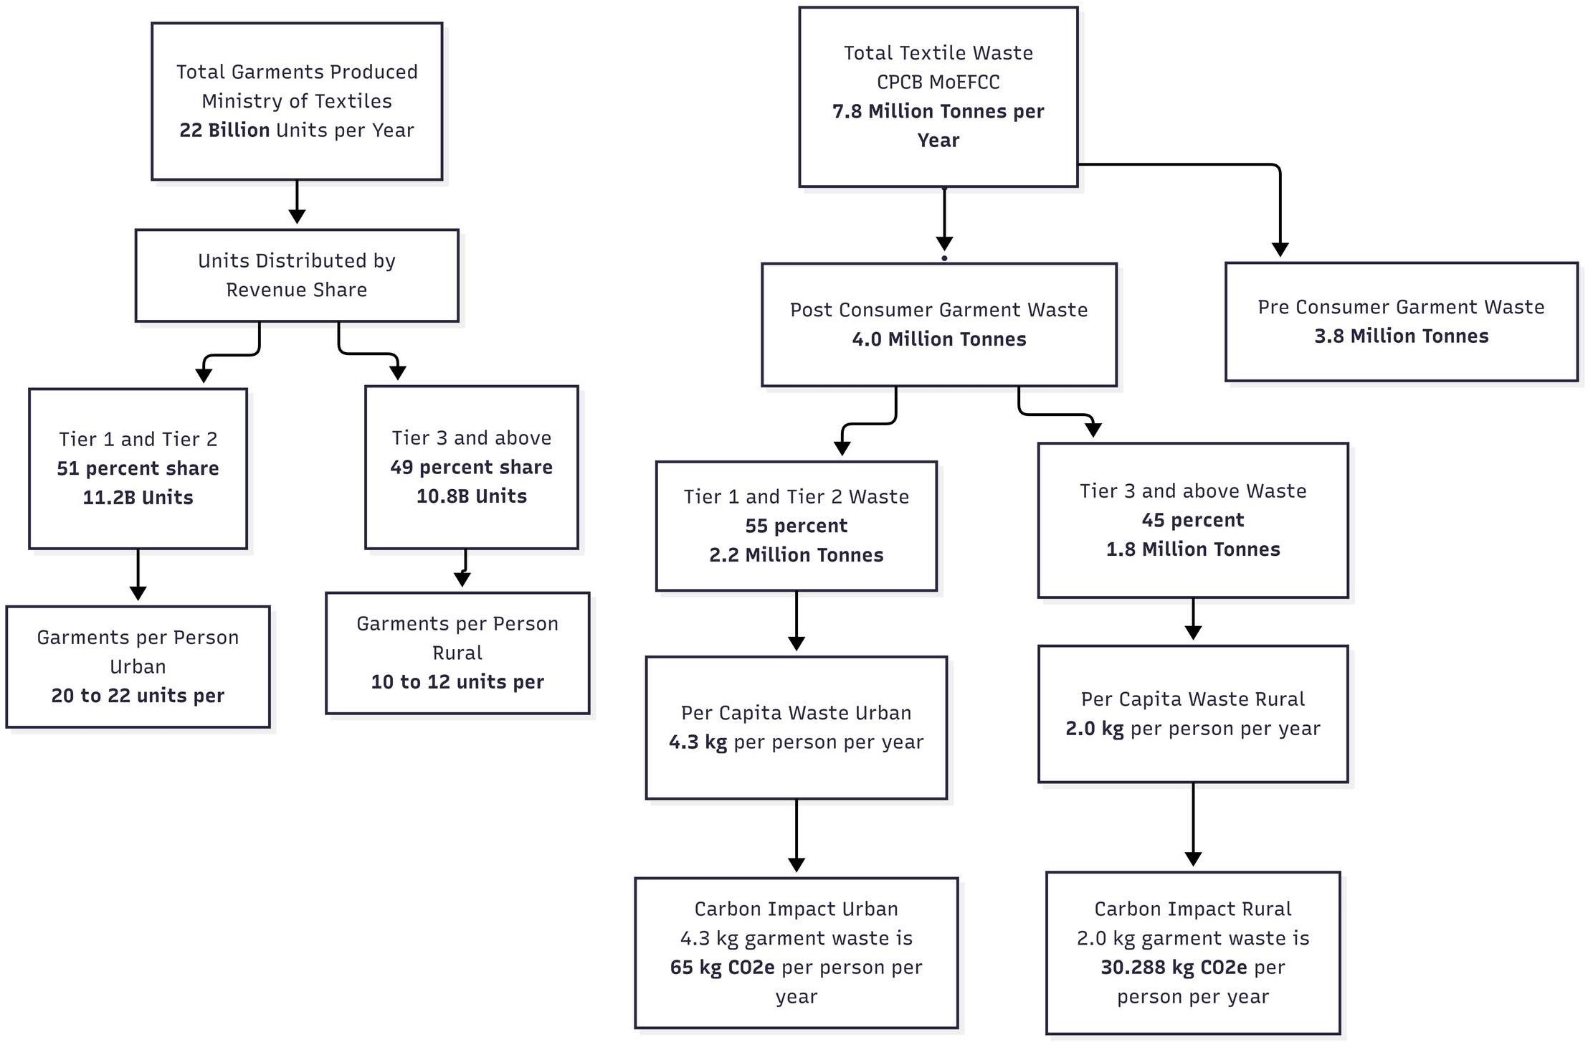
Figure1.1
These figures indicate that urban consumption behaviour plays a disproportionately significant role in national garment waste and associated emissions.

1.3 Utilisation Inefficiency and Behavioural Gap
Beyond waste generation statistics, utilisation modelling highlights structural inefficiencies in garment rotation patterns within urban India. Assuming equal distribution of wear across 365 days, an average urban wardrobe size of approximately 20 garments results in roughly 18 wears per garment annually. In contrast, rural wardrobes averaging 10 garments yield approximately 37 wears per garment per year.
To contextualise these figures, sustainable fashion discourse frequently references the “30 Wears” benchmark, which encourages consumers to wear each garment at least 30 times before disposal in order to improve lifecycle efficiency (Wear Me 30 Times ~ A Slow Fashion Campaign!, 2015). This benchmark has been widely adopted in sustainability research and industry initiatives as a behavioural durability standard aligned with lifecycle extension goals (Valuing Our Clothes, 2012; A New Textiles Economy, 2017).
When evaluated against this internationally recognised benchmark, urban wardrobes operate at approximately 60% utilisation capacity (18 wears relative to the 30-wear benchmark), whereas rural wardrobes exceed this threshold. This indicates that garments within urban environments—particularly among higher-income groups—are frequently discarded before reaching their optimal lifecycle utilisation.
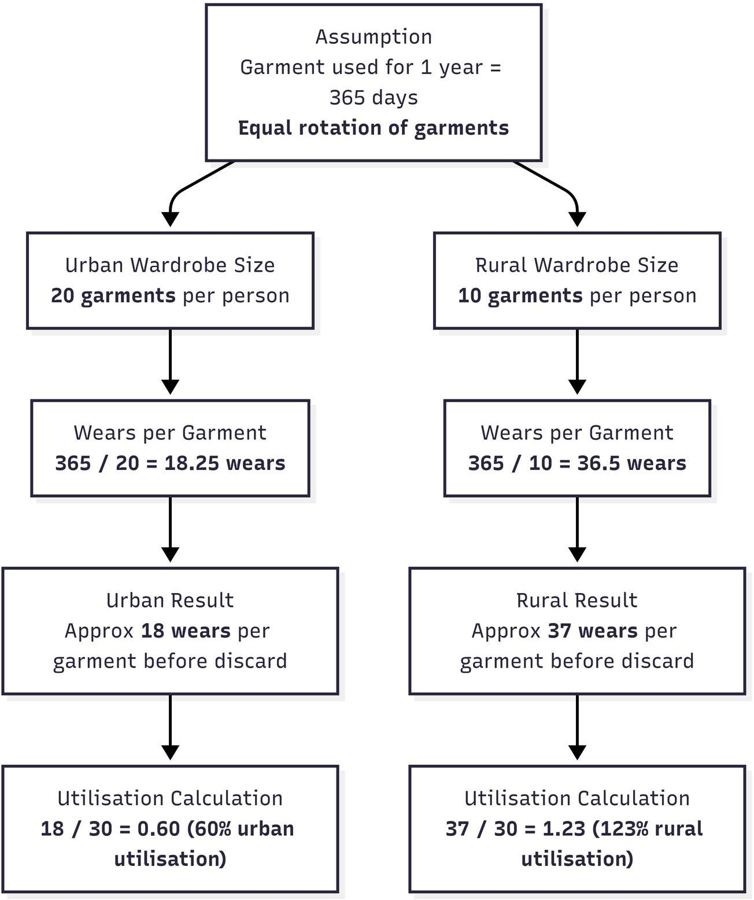
Figure 1.2

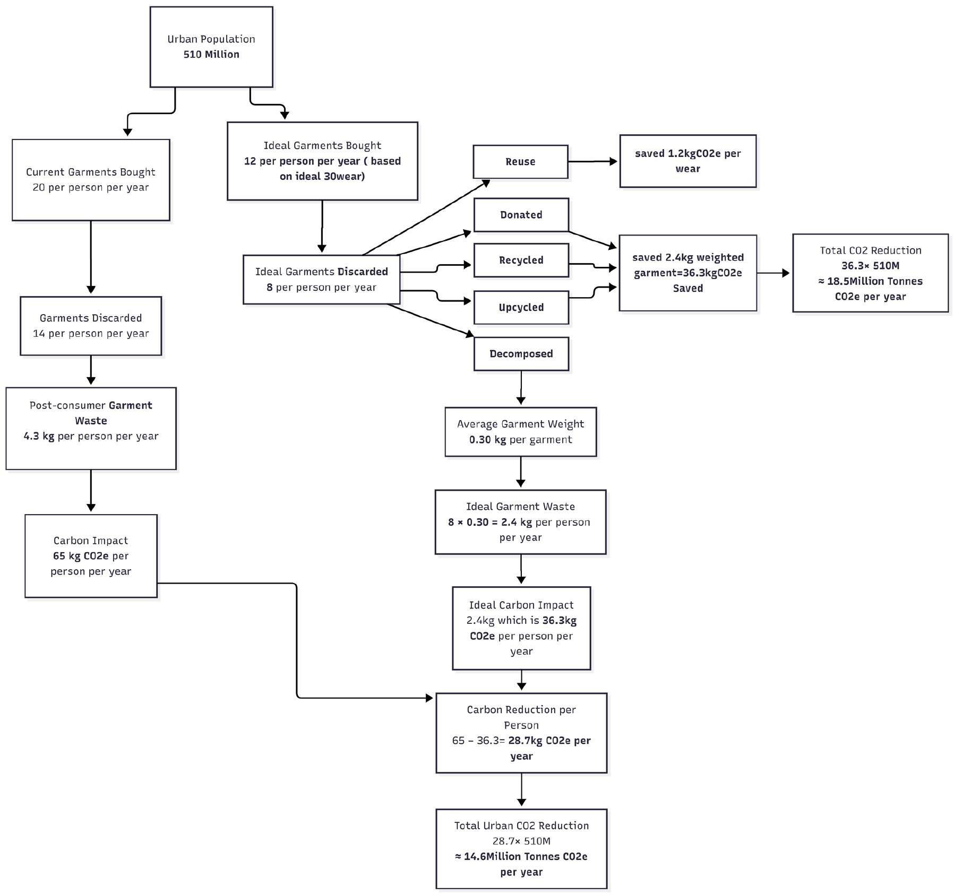
Figure1.3
If annual purchases were reduced from approximately 20 garments to 12 garments per person—aligned with achieving at least 30 wears per garment—post-consumer waste would decline substantially. Modelling suggests that such behavioural optimisation could reduce per capita emissions by approximately 28.7 kg CO₂e annually, translating into an estimated 14.6 million tonnes of CO₂e reduction across urban India.
It is important to clarify that these emission reduction projections represent theoretical potential contingent upon improved garment utilisation. The proposed AI-enabled Smart Wardrobe Cabinet is conceptualised as a behavioural infrastructure capable of operationalising such utilisation gains. By increasing garment visibility, tracking wear frequency, and algorithmically recommending rotation strategies, the system provides a mechanism through which lifecycle extension targets may become practically achievable rather than aspirational.
These findings underscore that inefficient wardrobe management represents not merely a lifestyle issue but a measurable environmental intervention opportunity.

1.4 Target Segment: Upper and Upper-Middle Class Urban India
Within urban India, consumption is not evenly distributed across socioeconomic groups. Upper and upper-middle class households exhibit higher discretionary spending, larger wardrobe sizes, greater frequency of garment acquisition, and faster trend turnover. These households therefore contribute disproportionately to redundant purchases and underutilised garments.
Simultaneously, this demographic demonstrates high digital literacy, widespread smartphone adoption, and increasing openness to AI-enabled lifestyle technologies. From both an environmental and technological adoption perspective, this segment represents a strategically relevant intervention group. Targeting upper and upper-middle class urban consumers allows the study to focus on a high-impact, high-feasibility demographic where behavioural optimisation could yield measurable environmental benefits.

1.5 Conceptual Basis of the Study
In response to the identified gap, this study conceptualises the development of an AI-enabled Smart Cabinet that integrates physical storage infrastructure with intelligent garment management capabilities. The system incorporates computer vision to digitise stored garments, contextual intelligence to process variables such as weather and occasion, and behavioural analytics to track frequency of use.
By increasing garment visibility and providing algorithm-driven outfit recommendations, the system seeks to reduce decision fatigue, enhance utilisation rates, and discourage redundant purchases. Additionally, the cabinet integrates sustainability modelling mechanisms to estimate potential reductions in carbon emissions associated with extended garment lifecycles.
The Smart Cabinet is therefore positioned not merely as a furniture innovation, but as a micro-level behavioural intervention embedded within domestic space.

1.6 Need and Scope of the Study
The need for this study arises from the persistent gap between sustainable intention and actual consumer behaviour. While awareness regarding sustainable fashion is increasing, practical mechanisms that enable consumers to optimise existing garment usage remain limited.
This research focuses on the conceptual design and system architecture development of the AI-enabled Smart Cabinet. The scope includes modelling garment utilisation patterns, estimating sustainability impact, and examining the behavioural implications of algorithm-driven recommendations. The study does not include large-scale empirical field testing at this stage; rather, it establishes a structured framework to support future validation and implementation.
By concentrating on upper and upper-middle class urban India, the study narrows its scope to a high-consumption demographic where intervention potential is greatest.

1.7 Research Objectives
In alignment with the identified need and defined scope, the study is guided by the following objectives:
• To conceptualize and develop an AI-enabled wardrobe management system that integrates computer vision, behavioral analytics, and contextual intelligence to optimize personal garment utilization.
• To examine how algorithm-driven outfit recommendation models influence decision-making efficiency and reduce cognitive load in daily apparel selection.
• To quantify the relationship between wardrobe digitization, garment usage frequency, and reduction in redundant consumption within a closed-loop fashion framework.
• To evaluate the potential of an intelligent wardrobe system as a micro-level intervention for advancing circular economy principles and measurable carbon mitigation in the fashion sector.

Chapter: 02 Review of Literature

2.1 Reframing the Wardrobe: From Passive Storage to Socio-Technical System
The wardrobe has historically existed as a passive domestic artifact—an inert storage space that mediates neither behaviour nor environmental consequence. Yet, paradoxically, it occupies a central position within one of the most carbon-intensive global industries. The fashion sector contributes significantly to global greenhouse gas emissions, while garment utilization rates continue to decline (Jiang & Macintyre, 2025; Muthu, 2019). The contradiction is structural: while production systems have been technologically optimized, consumption infrastructures have remained conceptually stagnant.
Existing scholarship treats wardrobe technologies primarily as extensions of retail ecosystems or as lifestyle convenience tools. Rarely is the wardrobe theorized as a regulatory node within the circular economy. This conceptual blind spot reveals a disciplinary fragmentation: sustainability research focuses on production systems, AI research focuses on classification accuracy, and consumer behaviour research focuses on psychological drivers. What remains underexplored is the wardrobe as a feedback mechanism capable of reorganizing consumption patterns through intelligent mediation.
This research begins from the premise that the wardrobe is not merely a container but a potential socio-technical system embedded within broader material flows.

2.2 Smart Wardrobe Technologies: Automation Without Optimization
The first generation of smart wardrobe systems emerged from IoT engineering research. Filatov (2023) conceptualized a smart wardrobe device integrating mechanical design with embedded computational systems. While innovative in physical construction, the system remained functionally descriptive rather than prescriptive. It could store and identify garments but could not optimize their usage.
Similarly, Banoth et al. (2023) developed an IoT-based wardrobe integrating barcode scanning and K-nearest neighbor algorithms. The architecture successfully automated detection, yet it lacked behavioral modeling or environmental feedback. In effect, these systems digitized presence without interrogating patterns.
RFID-based models (Ling et al., 2009) introduced behavior tracking, enabling garment usage logging and user profiling. However, profiling remained consumer-centric rather than sustainability-centric. The wardrobe learned preferences but did not question overconsumption.
Across these studies, a common pattern emerges: technological sophistication increases, yet systemic impact remains negligible. The wardrobe becomes smarter, but consumption remains structurally unaltered. Automation without optimization does not disrupt linear consumption logic.

2.3 Artificial Intelligence in Fashion
Artificial intelligence research in apparel systems has largely privileged aesthetic and classificatory concerns. Shin and Chen (2017) advanced 3D garment digitization, enhancing virtual representation fidelity. Li and Yuan (2024) demonstrated CNN superiority in pattern recognition tasks, reinforcing AI’s analytical capacity.
However, these studies exhibit what may be termed an aesthetic bias. The central research question often concerns “How accurately can AI classify or model garments?” rather than “How can AI reconfigure material throughput in consumption systems?”
AI’s computational power has been directed toward personalization, trend forecasting, and retail recommendation. Its deployment as a sustainability instrument remains limited. This reveals a broader epistemological pattern: fashion AI is oriented toward enhancing market efficiency rather than reducing environmental externalities.
The absence of lifecycle modeling in AI wardrobe systems suggests that technical capability has outpaced normative direction.

2.4 Decision Fatigue and the Role of Algorithmic Assistance
Wardrobe choice is frequently trivialized in academic discourse. Yet daily outfit selection represents a repeated micro-decision embedded within cognitive constraints. Behavioral economics suggests that repeated low-stakes decisions contribute to cognitive depletion and bounded rationality.
Jiang and Macintyre (2025) found that wardrobe management applications inadvertently reduced anxiety and decision fatigue. Bang and Su (2022) demonstrated that socially responsible consumption behavior predicts adoption of virtual wardrobes, indicating alignment between values and digital mediation.
However, existing systems primarily reduce cognitive load through simplification, not through structural optimization. They curate options but rarely incorporate wear-frequency balancing, carbon cost modeling, or lifecycle extension algorithms.
A truly intelligent wardrobe must function not merely as a decision simplifier but as a decision regulator—embedding sustainability criteria within recommendation logic.

2.5 Underutilization and the Utilization Crisis
The fashion industry’s environmental crisis is frequently framed as overproduction. Yet evidence suggests a parallel crisis of underutilization. Clothing production doubled between 2000 and 2015 while average wear per garment declined substantially (Jiang & Macintyre, 2025).
This indicates that the problem is not solely supply-driven but infrastructural. Consumers lack visibility into usage patterns. Wardrobes do not provide feedback loops.
Digital wardrobe applications improve inventory awareness, but empirical research has not yet established a causal model linking wardrobe digitization to measurable reductions in redundant purchases. Visibility does not automatically generate restraint.
The missing variable is analytics. Without wear frequency metrics, predictive redundancy detection, and behavioral nudging, digitization remains descriptive rather than transformative.

2.6 Circular Economy Theory and the Missing Domestic Node
Circular economy frameworks advocate systemic transitions from linear to regenerative material flows (Muthu, 2019). The 3R model—Reduce, Reuse, Recycle has been extensively applied at industrial and municipal scales (Angelova et al., 2023; Thompson, 2017).
However, circular economy discourse often presumes consumer compliance without providing intelligent infrastructure to facilitate it. The domestic wardrobe remains theoretically invisible within circular modeling.
This omission is critical. The wardrobe is where garments transition from acquisition to use to dormancy to disposal. Without intervention at this node, circular principles remain abstract.
An AI-enabled sustainable cabinet system repositions the wardrobe as a micro-level circular actuator—tracking wear cycles, identifying dormancy thresholds, recommending rotation strategies, and estimating avoided carbon emissions.
This reframes the wardrobe from passive storage to active regulator within circular systems.

2.7 Personalization for Garment Longevity
Color harmony and aesthetic alignment influence garment satisfaction and rewear probability. Farahat (2021) and Sirisayan (2022) demonstrated that personal color analytics improves perceived harmony and aesthetic coherence.
While traditionally categorized as stylistic enhancement, personalization may function as a longevity mechanism. If garments are algorithmically paired in flattering combinations, usage frequency may increase, extending lifespan.
Thus, personalization intersects with sustainability not through moral appeal but through satisfaction optimization.

2.8 Theoretical Foundation: Technology Acceptance Perspective
Grounded in the Technology Acceptance Model (Davis, 1989), behavioral intention toward technology adoption is primarily influenced by perceived usefulness and contextual problem relevance. Technologies are more likely to be adopted when users perceive them as effective solutions to personally experienced inefficiencies. Within the context of wardrobe management, perceived garment underutilization and structural inefficiency represent problem-specific drivers that may enhance perceived usefulness of an intelligent wardrobe system. In the present study, wardrobe inefficiency is conceptualized as a structural antecedent of adoption intention, extending traditional technology acceptance logic into the domain of domestic consumption infrastructure.
The present study extends the Technology Acceptance Model by conceptualizing wardrobe inefficiency as a problem-specific antecedent to perceived usefulness. In traditional TAM formulations, perceived usefulness is shaped by user expectations of performance improvement. In the context of wardrobe management, inefficiency perception constitutes the experiential recognition of performance deficit. Thus, perceived wardrobe inefficiency is theorized as a structural driver that enhances the perceived usefulness of an intelligent wardrobe intervention, ultimately influencing behavioral adoption intention.
Unlike traditional TAM formulations that explicitly measure perceived usefulness and perceived ease of use, the present study operationalizes perceived wardrobe inefficiency as a problem-relevance antecedent that enhances perceived usefulness implicitly. Thus, the model represents an adaptation rather than replication of TAM, extending technology acceptance logic into the domain of domestic consumption infrastructure.

2.9 Research Gaps
The literature reveals parallel but disconnected streams:
- IoT engineering develops automated wardrobes without sustainability modeling.
- AI research optimizes classification without lifecycle awareness.
- Behavioural science identifies decision fatigue without technological intervention.
- Circular economy theory emphasizes systemic change without domestic infrastructure.
No existing framework integrates:
- Computer vision
- Behavioural analytics
- Context-aware recommendation
- Wear-frequency balancing
- Carbon estimation
- Circular lifecycle feedback
The proposed AI-enabled sustainable cabinet system addresses this fragmentation by synthesizing these domains into a unified socio-technical intervention. Rather than optimizing aesthetics or convenience alone, it seeks to reconfigure consumption architecture.

2.9 Conceptual Model
Based on the Technology Acceptance Model and circular consumption theory, this study proposes a structured conceptual model in which perceived wardrobe inefficiency functions as the primary independent construct influencing adoption intention toward an AI-enabled smart wardrobe cabinet. Decision fatigue is positioned as a related experiential manifestation of inefficiency, while demographic and purchasing variables are treated as control factors. The model assumes that when consumers recognize structural inefficiency within their wardrobe system, they are more likely to perceive value in an intelligent intervention, thereby increasing behavioral intention to adopt the proposed solution.
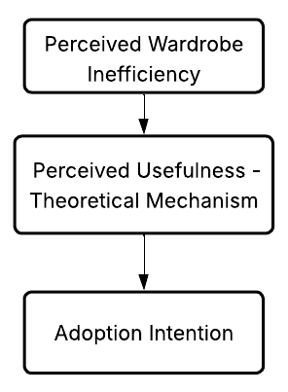
Figure 2.1

2.10 Hypothesis Development
Building upon the conceptual framework grounded in the extended Technology Acceptance perspective, the present study formulates four testable hypotheses to empirically examine the structural existence of wardrobe inefficiency and its influence on adoption intention toward an AI-enabled smart wardrobe cabinet.
H₁: Perceived wardrobe inefficiency among urban consumers is significantly greater than the neutral midpoint of the scale.
H₀₁: Perceived wardrobe inefficiency among urban consumers is not significantly different from the neutral midpoint.
H₂: Adoption intention toward the AI-enabled Smart Wardrobe Cabinet is significantly greater than the neutral midpoint of the scale.
H₀₂: Adoption intention toward the AI-enabled Smart Wardrobe Cabinet is not significantly different from the neutral midpoint.
H₃: Perceived wardrobe inefficiency significantly and positively influences adoption intention toward the AI-enabled Smart Wardrobe Cabinet.
H₀₃: Perceived wardrobe inefficiency does not significantly influence adoption intention toward the AI-enabled Smart Wardrobe Cabinet.
H₄: Existing wardrobe management and virtual try-on applications exhibit substantial negative user sentiment.
H₀₄: Existing wardrobe management and virtual try-on applications do not exhibit substantial negative user sentiment.

Chapter: 03 Methodology

3.1 Research Design
This study employed a sequential mixed-method research design to empirically examine the existence of wardrobe-related inefficiency and to evaluate the feasibility of an intelligent wardrobe intervention. The research design was structured to first validate the psychological and behavioral dimensions of the problem through primary quantitative data and subsequently contextualize these findings within the broader digital fashion ecosystem through secondary market analysis.
The central objective of the research design was not merely descriptive but explanatory and predictive. Specifically, the study sought to determine whether perceived wardrobe inefficiency and decision fatigue significantly influence adoption intention toward an AI-enabled smart wardrobe system. In addition, the design aimed to assess whether dissatisfaction patterns within existing wardrobe management and virtual try-on applications indicate a structural gap in the current market.
The study therefore follows a validation-driven structure comprising two integrated phases. The first phase focuses on primary quantitative data collection and inferential statistical modeling to test construct relationships. The second phase utilizes computational analysis of Apple App Store review data to evaluate market sentiment across existing fashion-technology solutions.
This triangulated structure enhances methodological rigor by reducing reliance on a single data source. The primary survey establishes psychological need and purchase intention, while the secondary digital analysis provides external market corroboration. The integration of these two phases strengthens both internal validity (through statistical testing of hypotheses) and external validity (through real-world user experience data).
The research is grounded within a positivist framework, where measurable constructs such as decision fatigue, inefficiency perception, and adoption intention are quantified and subjected to statistical examination. Parametric testing was employed given the treatment of Likert-scale items as continuous variables, consistent with established social science research practices.
The design is cross-sectional in nature, capturing consumer attitudes at a specific point in time. While longitudinal tracking may provide deeper behavioral insights, the present design is appropriate for early-stage validation of a product concept and for establishing predictive relationships between perceived inefficiency and technology adoption intention.
The empirical analysis was structured to test the theoretically derived relationship between perceived wardrobe inefficiency and adoption intention as proposed within the extended Technology Acceptance framework.

3.2 Conceptual Framework
This study proposes that perceived wardrobe inefficiency positively influences adoption intention toward an AI-enabled smart wardrobe system, controlling for demographic and purchasing characteristics. Drawing from technology acceptance theory, perceived structural inefficiency functions as a problem-relevance driver that enhances behavioral intention toward intelligent intervention. Age, income level, and clothing purchasing frequency are incorporated as control variables to account for potential demographic variation in adoption behavior.
The proposed conceptual model positions wardrobe inefficiency as the primary independent variable, adoption intention as the dependent variable, and demographic characteristics as control variables within a regression-based analytical framework.

3.2 Phase I: Primary Quantitative Research

3.2.1 Instrument Development and Construct Operationalization
The primary research phase involved the development of a structured survey instrument designed to measure three latent constructs central to the study: Decision Fatigue, Wardrobe Inefficiency, and Adoption Intention.
The survey instrument was informed by theoretical foundations in decision fatigue theory, technology acceptance models, and sustainable consumption research. Each construct was operationalized using multiple attitudinal statements measured on a five-point Likert scale ranging from 1 (strongly disagree) to 5 (strongly agree).
Decision Fatigue was measured through items capturing cognitive overload associated with outfit selection, including feelings of having “nothing to wear,” time spent deciding daily attire, and emotional overwhelm during wardrobe selection.
Wardrobe Inefficiency was operationalized through items assessing underutilization of clothing, desire to reduce wardrobe waste, and perceived value of improved usage efficiency.
Adoption Intention was measured through perceived conceptual appeal, willingness to purchase the system at a proposed price point of ₹75,000, and intention to sign up for early access if available.
Demographic variables including age group, occupation, monthly income, and clothing purchasing frequency were included to contextualize behavioral patterns and allow potential segmentation analysis.
To improve construct stability, composite indices were created by averaging the items within each construct. This approach reduces random measurement error and enhances internal consistency.
The price point of ₹75,000 was selected based on benchmarking against premium modular wooden wardrobes and emerging smart furniture products within the Indian urban market. This price reflects a mid-premium positioning aligned with upper and upper-middle-class purchasing capacity.

3.2.2 Sampling Strategy and Data Collection
Data were collected using an online distribution approach targeting digitally active Indian consumers. A non-probability convenience sampling method was employed, appropriate for exploratory validation studies focused on testing theoretical relationships rather than estimating national prevalence.
Participants were required to be 18 years or older and to complete all survey items. Responses were screened for completeness and consistency prior to analysis. Invariant response patterns were examined to reduce the potential impact of straight-lining bias.
A total of 74 valid responses were retained for statistical analysis. While the sample size is modest, it is sufficient for multiple regression analysis involving two primary predictors, particularly given the high observed effect sizes.
With N = 74 and two predictors, the study exceeds the recommended 15:1 observation-to-predictor ratio for regression analysis involving large effect sizes.

3.2.3 Data Preparation and Reliability Assessment
All Likert-scale items were treated as continuous variables for the purpose of parametric testing, consistent with established methodological practice when composite scales are used.
Prior to hypothesis testing, internal consistency reliability was evaluated using Cronbach’s alpha. The reliability coefficient exceeded 0.90, indicating strong internal coherence among the items. This suggests that the constructs are measured consistently and that composite indices are appropriate for inferential analysis.
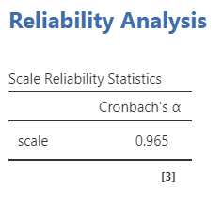
Figure 3.1
No missing values were detected in the final dataset. Descriptive analysis confirmed that scale distributions were appropriate for subsequent parametric testing.

3.2.4 Statistical Analysis Procedures
Descriptive statistics were computed to assess central tendencies and dispersion across constructs. Mean scores for Decision Fatigue, Wardrobe Inefficiency, and Adoption Intention were all above the neutral midpoint of the scale.
To determine whether these means were statistically greater than neutrality, one-sample t-tests were conducted using a test value of three. Results indicated statistically significant deviations above neutrality (p < .01), confirming measurable problem existence and purchase interest.
Pearson correlation analysis was conducted to examine relationships among constructs. Strong positive associations were observed between Wardrobe Inefficiency and Adoption Intention.
Multiple linear regression analysis was then performed with Adoption Intention as the dependent variable and Decision Fatigue and Wardrobe Inefficiency as predictors. The model demonstrated substantial explanatory power, with Wardrobe Inefficiency emerging as the primary significant predictor. This indicates that perceived structural inefficiency is a strong driver of adoption intention.

3.3 Phase II: Secondary Market Analysis

3.3.1 Rationale for Secondary Analysis
While the primary quantitative phase established psychological need and predictive demand for an intelligent wardrobe intervention, it remained necessary to evaluate whether structural dissatisfaction exists within the current fashion-technology ecosystem. The purpose of the secondary research phase was therefore to assess real-world user experiences with existing wardrobe management and virtual try-on platforms.
Secondary analysis was conducted to complement survey findings by examining naturally occurring consumer feedback in digital marketplaces. Unlike survey responses, which are elicited under structured conditions, app store reviews represent unsolicited user evaluations formed after direct product interaction. Analyzing such data provides external validation and enhances ecological validity.
The guiding assumption of this phase was that if significant dissatisfaction is observed across existing wardrobe-related applications, this would indicate an opportunity space for a more integrated and structurally embedded solution.

3.3.2 Data Source Selection
The Apple App Store was selected as the primary data source due to its structured review architecture, accessibility of metadata, and representation of digitally active consumers. Applications categorized under wardrobe management, virtual try-on (VTON), and hybrid fashion technology solutions were identified.
These categories were selected because they represent the closest functional alternatives to the proposed smart wardrobe cabinet. Wardrobe management applications typically allow users to catalog clothing digitally. Virtual try-on platforms simulate garment visualization using augmented reality. Hybrid platforms combine inventory management with styling recommendations.
By analyzing user feedback across these categories, the study aimed to identify recurring dissatisfaction patterns that may signal systemic limitations in current solutions.

3.3.3 Data Collection and Filtering Criteria
Review data were collected through structured web scraping procedures. To ensure relevance and analytical consistency, multiple filtering criteria were applied:
- Only reviews from Indian users were retained to maintain alignment with the primary research sample.
- Reviews were restricted to English language entries to ensure interpretive clarity.
- A minimum character threshold of 20 characters was applied to exclude superficial or non-informative responses.
- Only reviews published post-2020 were retained to reflect contemporary user expectations.
- Null, duplicate, and incomplete entries were removed.
An initial pool of 382 applications was identified. After applying the inclusion criteria, 131 Indian user-reviewed applications were retained for structured sentiment classification.
These filtering procedures were implemented to enhance data quality and reduce noise, thereby improving analytical reliability.

3.3.4 Sentiment Classification and Analytical Approach
Each review was classified into one of three sentiment categories: positive, neutral, or negative. Classification was conducted using structured polarity identification methods based on textual tone, evaluative language, and expressed satisfaction or dissatisfaction indicators.
In addition to sentiment polarity, average star ratings were recorded for each application category. This enabled comparison between quantitative ratings and qualitative textual sentiment.
The purpose of this dual analysis was to detect discrepancies between numerical rating systems and narrative user experiences. Such discrepancies are significant because rating averages may mask deeper usability frustrations or functional limitations.

3.3.5 Findings from Secondary Analysis
Across wardrobe management, virtual try-on, and hybrid application categories, negative textual sentiment consistently ranged between approximately 40% and 44% of reviews. This proportion is substantial and indicates widespread dissatisfaction across functional alternatives.
Interestingly, despite high negative textual sentiment, average star ratings across categories remained above 4.0. This divergence suggests rating inflation or a tendency for users to provide relatively high ratings despite expressing specific frustrations within written reviews.
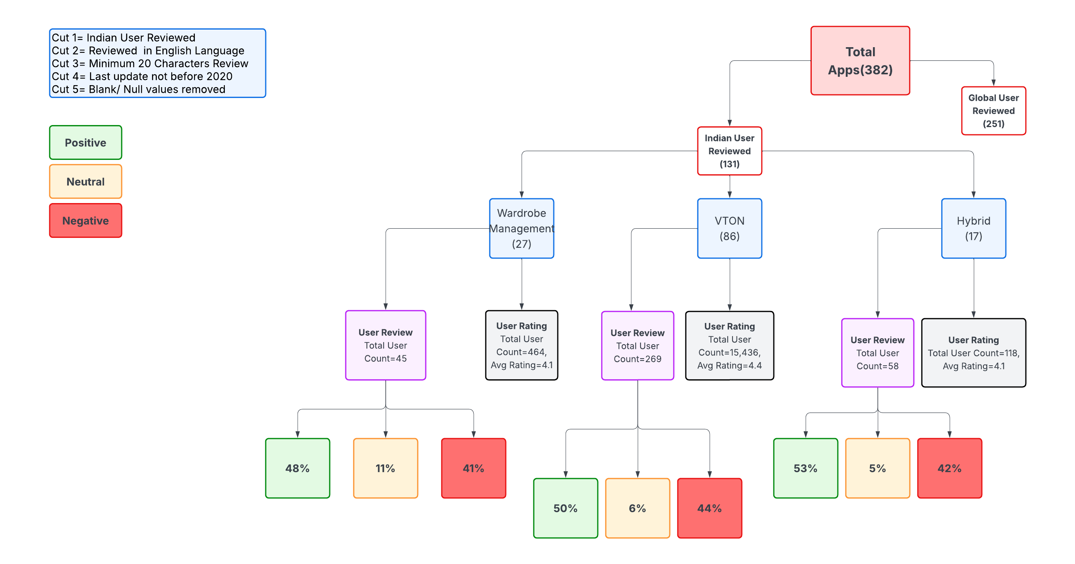
Figure 3.2
The coexistence of high star ratings and high negative sentiment indicates that while users may perceive value in these applications, significant performance, usability, or integration gaps persist. These gaps may relate to manual data entry requirements, limited personalization, inaccurate virtual rendering, or lack of seamless integration with physical wardrobe behavior.

3.3.6 Interpretation and Theoretical Implications
The secondary analysis provides evidence of structural dissatisfaction within existing digital wardrobe ecosystems. While current solutions offer partial assistance, they appear insufficient in fully addressing inefficiency, decision fatigue, and garment underutilization.
From a theoretical standpoint, this reinforces the distinction between peripheral digital tools and embedded decision-support infrastructure. Most existing applications function as optional digital overlays requiring active user engagement and manual input. In contrast, the proposed smart wardrobe cabinet integrates intelligence directly into the physical storage environment, reducing friction between garment access and digital interaction.
The high proportion of negative sentiment across categories therefore substantiates the existence of a market gap. When interpreted alongside primary survey findings demonstrating statistically significant inefficiency perceptions and adoption intention, the secondary research strengthens the argument for a structurally integrated solution.

3.3.7 Methodological Contribution
The inclusion of secondary sentiment analysis enhances the robustness of the overall research design by introducing real-world behavioral data into the validation process. The triangulation of survey-based psychological constructs with large-scale user experience data reduces single-source bias and increases confidence in the study’s conclusions.
By demonstrating both attitudinal demand (primary research) and ecosystem dissatisfaction (secondary research), the study establishes a dual validation framework. This strengthens the justification for introducing the AI-enabled smart wardrobe cabinet as a necessary intervention rather than a speculative innovation.

3.4 Introduction of the Proposed Intervention: AI-Enabled Smart Wardrobe Cabinet
Following empirical validation of wardrobe-related inefficiency through primary quantitative analysis and identification of dissatisfaction within existing digital wardrobe platforms through secondary sentiment analysis, this study introduces the proposed technological intervention: the AI-enabled Smart Wardrobe Cabinet.
The introduction of the product at this stage is deliberate and methodologically grounded. The preceding research phases established two critical findings. First, consumers experience statistically significant levels of wardrobe inefficiency and demonstrate measurable adoption intention toward a structured solution. Second, existing wardrobe management and virtual try-on applications exhibit substantial negative sentiment despite high average ratings, indicating unresolved functional limitations. Together, these findings justify the development of a structurally integrated system designed to address both cognitive and operational gaps in current wardrobe management practices.
The AI-enabled Smart Wardrobe Cabinet is conceptualized not as a standalone mobile application, but as a hybrid physical-digital infrastructure embedded within the domestic environment. Unlike current applications that operate as optional digital tools requiring manual cataloging and sustained user effort, the proposed system transforms the wardrobe itself into an intelligent, interactive decision-support environment.
The cabinet integrates artificial intelligence, computer vision, and user-interface technologies directly into a modular wooden wardrobe structure. A digital touch interface is embedded into the external door panel, allowing direct interaction without requiring a separate device. Internally, a camera-based garment recognition system captures and digitizes clothing items upon entry into the wardrobe. Each garment is assigned a digital profile, including attributes such as category, color, fabric type, usage frequency, and contextual suitability.
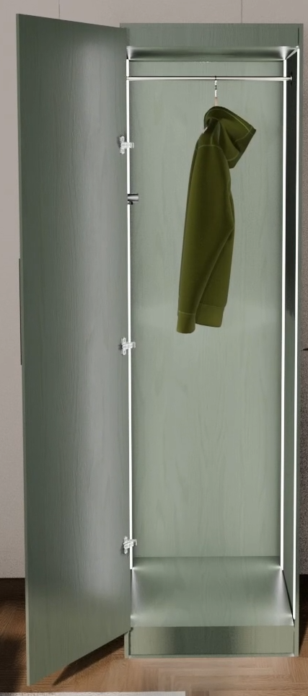
Figure 3.3 & 3.4
The system operates through continuous behavioral learning. As users select outfits and interact with recommendations, the underlying algorithm adapts to preference patterns. Over time, the cabinet develops a personalized decision-support model that reduces daily cognitive load while maximizing garment utilization.
The intervention directly addresses the constructs validated in earlier phases of the research. By generating context-sensitive outfit recommendations based on weather data, calendar inputs, and personal styling patterns, the cabinet reduces decision fatigue. By tracking garment inactivity and identifying underutilized items, it addresses structural inefficiency within the wardrobe. By suggesting rotation strategies and donation prompts for dormant garments, it supports sustainability-oriented consumption behavior.
Importantly, the cabinet redefines the wardrobe from passive storage furniture into an intelligent domestic infrastructure. The system is designed to minimize friction between physical garment interaction and digital optimization. This embedded approach distinguishes it from current market alternatives that rely heavily on manual data entry and separate device usage.
From a theoretical perspective, the cabinet operationalizes the relationship between perceived inefficiency and adoption intention identified in the regression analysis. If inefficiency perception significantly predicts demand, then a solution designed to structurally eliminate inefficiency provides logical and empirical alignment with user needs.
Thus, the AI-enabled Smart Wardrobe Cabinet is introduced not as a speculative innovation, but as a validated response to measured cognitive strain, documented garment underutilization, and observable dissatisfaction within existing digital wardrobe ecosystems.

3.5 System Architecture and Technical Framework
The AI-enabled Smart Wardrobe Cabinet is designed as an integrated cyber-physical system combining hardware infrastructure, embedded sensing mechanisms, and cloud-based artificial intelligence processing. The architecture is modular, allowing scalability and adaptability across domestic environments.
The physical structure consists of a standard wooden wardrobe body modified to incorporate embedded technological components. A digital touch interface is externally mounted onto the door panel, enabling user interaction without reliance on external mobile devices. Internally, a calibrated camera module with controlled lighting captures garment images upon placement within the wardrobe. The lighting system ensures consistent image quality to enhance classification accuracy.
Captured garment data are processed through a computer vision pipeline. The system identifies garment category (e.g., shirt, dress, trousers), dominant color, pattern attributes, and fabric texture indicators. Each item is assigned a unique digital identity within a structured wardrobe database.
The cabinet communicates with a cloud-based processing system via secure internet connectivity. This cloud infrastructure hosts the recommendation engine and machine learning models. By separating local image capture from cloud-level computation, the architecture ensures scalable performance and continuous algorithmic updates without hardware replacement.
The AI framework incorporates supervised classification for garment recognition and reinforcement-based recommendation algorithms for outfit optimization. Over time, the system refines its outputs based on user feedback loops and interaction patterns.

3.6 Operational Workflow and Functional Logic
The operational logic of the smart wardrobe cabinet is structured around five sequential processes: garment digitization, database structuring, contextual recommendation, usage monitoring, and adaptive learning.
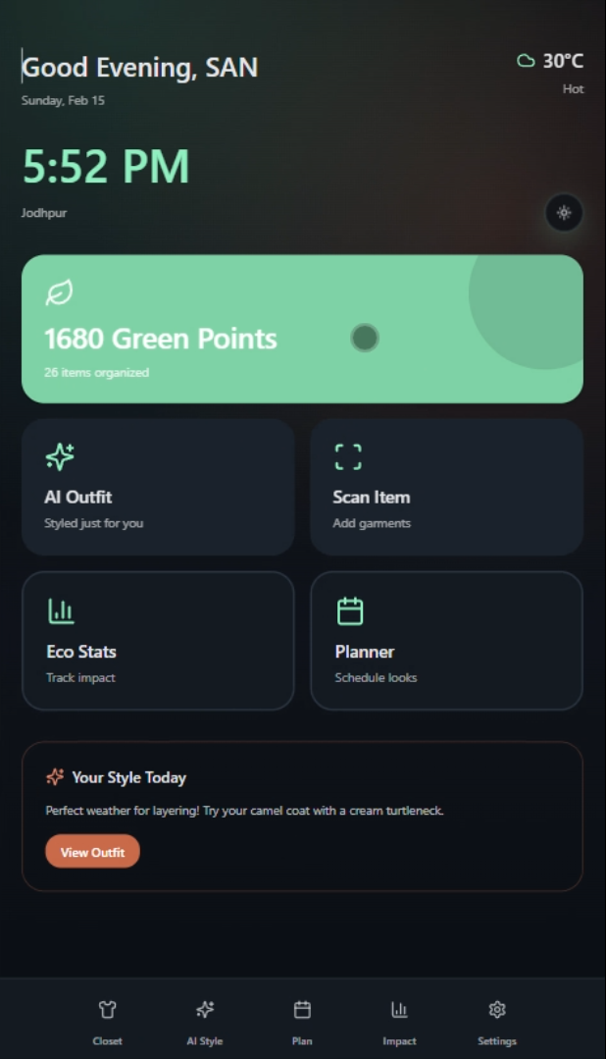
Figure 3.5
Upon introduction of a new garment, the embedded camera captures a standardized image. The system automatically classifies the garment and integrates it into the wardrobe database. No manual tagging is required, thereby reducing user friction.
When a user initiates interaction via the touch interface, the system requests contextual input. This may include occasion type (formal, casual, professional), weather conditions (automatically retrieved through API integration), or mood selection. The recommendation engine filters wardrobe items according to compatibility rules derived from color coordination algorithms, historical pairing patterns, and frequency balancing constraints.
Instead of presenting the entire wardrobe inventory, the system generates a limited set of optimized outfit combinations. This constrained output mechanism directly addresses decision fatigue by reducing excessive choice exposure.
The cabinet continuously logs garment usage. Items that remain unworn beyond a predefined inactivity threshold are flagged. The system may then suggest alternative styling combinations or recommend donation pathways. This feature operationalizes sustainability goals identified in the primary research phase.
Adaptive learning occurs through reinforcement modeling. Each time a user accepts or rejects a recommendation, the system updates preference weights. Over time, recommendations become increasingly personalized and behaviorally aligned.

3.7 Comparative Positioning and Market Differentiation
Existing wardrobe management applications typically require manual garment entry, separate device interaction, and sustained user effort. Virtual try-on platforms focus primarily on aesthetic simulation rather than wardrobe optimization. Hybrid platforms partially integrate styling assistance but remain dependent on smartphone-based interaction.
The proposed smart wardrobe cabinet differentiates itself along three structural dimensions.
First, it embeds intelligence within the physical storage infrastructure rather than functioning as a peripheral application. This reduces the behavioral gap between garment access and digital management.
Second, it automates garment digitization through integrated sensing rather than relying on manual cataloging. This addresses one of the most frequently cited frustrations in secondary sentiment analysis.
Third, it integrates sustainability nudging, underutilization detection, and adaptive personalization within a single system. Existing applications often address only one of these dimensions independently.
By transforming the wardrobe from passive furniture into an intelligent decision-support system, the cabinet represents a structural evolution rather than incremental digital enhancement.

3.8 Ethical, Practical, and Technical Considerations
The implementation of an AI-enabled wardrobe system introduces considerations related to data privacy, technological accessibility, and algorithmic transparency.
Garment data and user interaction logs constitute behavioral information. Therefore, secure data encryption and compliance with data protection standards are necessary. User control over cloud connectivity and data deletion must be integrated into system design.
From a practical standpoint, affordability and hardware durability must be considered to ensure long-term usability. The proposed price point of ₹75,000 was included in the primary research instrument to assess economic feasibility.
Technically, computer vision accuracy may vary depending on lighting conditions and garment complexity. Continuous model training and periodic system calibration would be required to maintain classification reliability.
Despite these considerations, the integration of AI into domestic wardrobe infrastructure presents a scalable opportunity for reducing micro-decision fatigue and improving garment lifecycle efficiency.

Chapter: 04 Results

4.1 Overview of Analytical Strategy
The results are presented in alignment with the sequential mixed-method design. The primary quantitative findings are reported first, followed by secondary market analysis outcomes. Together, these findings provide convergent validation of the research propositions.

4.2 Primary Quantitative Findings

4.2.1 Descriptive Statistics
Descriptive analysis revealed that mean scores for all major constructs exceeded the neutral midpoint of the five-point Likert scale.
Decision Fatigue (M = 3.67) indicates that respondents moderately experience cognitive burden in outfit selection. Wardrobe Inefficiency (M = 3.79) suggests a stronger perception of structural underutilization and inefficiency within personal wardrobes. Adoption Intention (M = 3.80) and Purchase Intention at ₹75,000 (M = 3.74) demonstrate a positive inclination toward the proposed intervention.
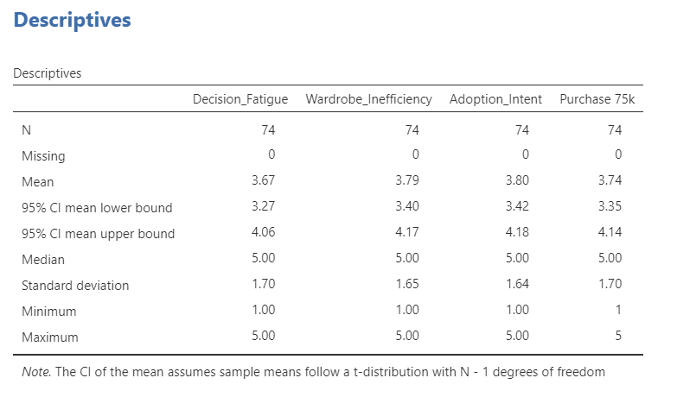
Figure 4.1
The dispersion values indicate moderate variability, suggesting the presence of differing attitudinal intensities across respondents, though central tendency remained above neutrality.

4.2.2 Reliability Assessment
Cronbach’s alpha exceeded 0.90 across composite constructs, demonstrating strong internal consistency. This confirms that items within each construct measure a coherent latent dimension.
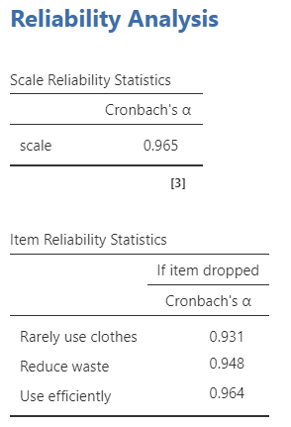
Figure 4.2
The reliability findings justify the use of aggregated indices for inferential analysis and strengthen the interpretability of regression modeling.

4.2.3 Exploratory Factor Analysis
An exploratory factor analysis (EFA) was conducted to assess construct dimensionality and potential common method variance. The Kaiser–Meyer–Olkin measure (.882) and significant Bartlett’s test confirmed sampling adequacy. A single factor emerged explaining 85.8% of total variance, with all items loading above .89. This suggests strong conceptual convergence across perceived inefficiency, decision fatigue, and adoption orientation.
The emergence of a single dominant latent dimension indicates that wardrobe inefficiency, cognitive burden, and solution-oriented adoption intention are structurally interrelated rather than empirically distinct in this sample. This convergence suggests the presence of a unified perceptual orientation toward wardrobe system dissatisfaction.
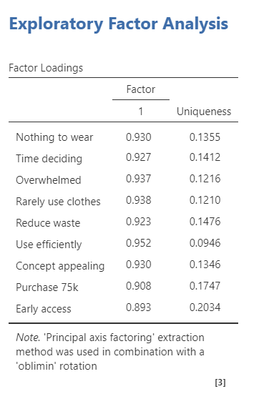
Figure 4.3
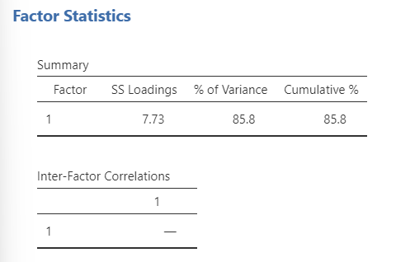
Figure 4.4
As a diagnostic for common method variance, Harman’s single-factor test was examined through unrotated factor extraction. Although a single dominant factor was observed, the theoretical coherence among items and strong reliability suggest substantive construct convergence rather than purely methodological inflation. Nevertheless, future studies may incorporate multi-source data to further reduce same-method bias. This finding suggests potential construct convergence, which partially explains the high R² observed in regression. This structural unidimensionality suggests that inefficiency perception and adoption orientation may represent manifestations of a broader dissatisfaction schema rather than independent constructs.

4.2.4 Hypothesis Testing: One-Sample t-Tests
To determine whether mean scores were statistically greater than neutrality (µ = 3), one-sample t-tests were conducted.
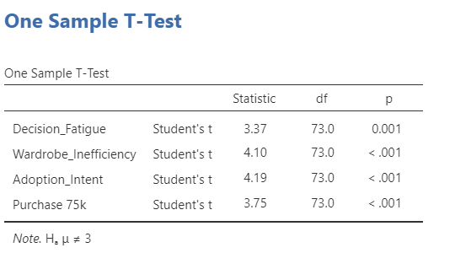
Figure 4.5
Results indicated statistically significant deviations above neutrality for Decision Fatigue, Wardrobe Inefficiency, Adoption Intention, and Purchase Intention (p < .01). These findings confirm that the identified problem is not anecdotal but statistically measurable.
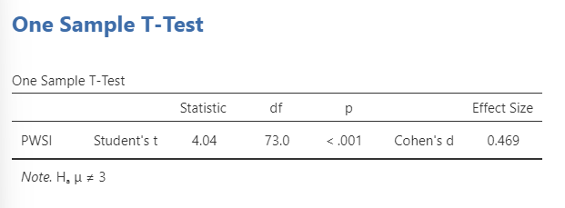
Figure 4.6
The observed effect size (Cohen’s d = 0.469) represents a medium magnitude effect according to conventional benchmarks, indicating that Perceived Wardrobe Structural Inefficiency (PWSI) is not only statistically significant but substantively meaningful.
Thus, Hypotheses H1 and H2 are supported.

4.2.5 Correlation Analysis
Pearson correlation analysis revealed strong positive associations between Wardrobe Inefficiency and Adoption Intention (r = .84, p < .001). Decision Fatigue also correlated positively with Adoption Intention, though substantial overlap was observed between Decision Fatigue and Wardrobe Inefficiency constructs.
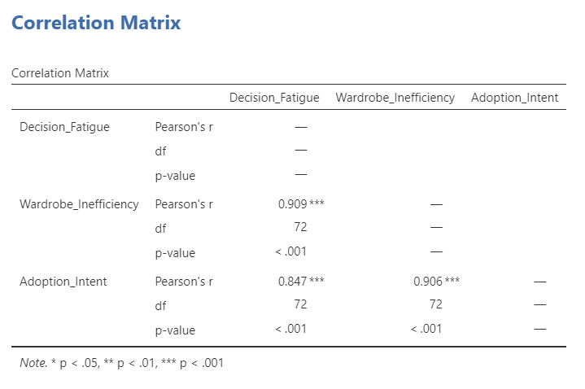
Figure 4.7
The strength of these correlations indicates that perceived inefficiency is closely linked with demand for structured intervention.

4.2.6 Regression Analysis
Multiple linear regression analysis indicated that the model explained 82.3% of the variance in adoption intention (R² = .823, R = .907). Wardrobe inefficiency emerged as a statistically significant predictor (β = .784, t = 6.54, p < .001), indicating a strong positive relationship with adoption intention. In contrast, decision fatigue did not retain independent statistical significance (β = .134, p = .268). These findings support Hypothesis H3, confirming that perceived structural inefficiency is the primary driver of adoption intention toward the AI-enabled Smart Wardrobe Cabinet.
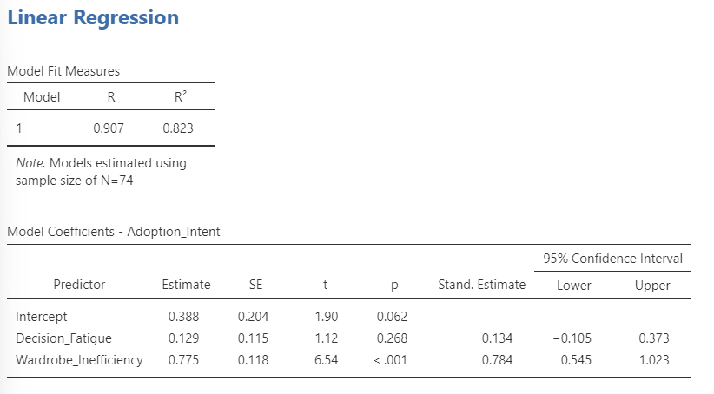
Figure 4.8

4.3 Secondary Market Findings
Sentiment analysis of 131 Indian-reviewed wardrobe-related applications revealed negative textual sentiment ranging from approximately 40% to 44% across wardrobe management, virtual try-on, and hybrid categories.
Despite average star ratings exceeding 4.0, textual review analysis indicated recurring dissatisfaction themes, including usability challenges, manual data entry burdens, limited personalization, and inaccurate virtual representation.
The divergence between star ratings and textual sentiment suggests latent dissatisfaction masked by rating systems. These findings provide structural evidence of market gap existence.
Hypothesis H4 is therefore supported.

4.4 Integrated Interpretation
The integration of primary and secondary findings yields three major conclusions:
- Wardrobe inefficiency is statistically measurable and significantly influences adoption intention.
- Consumers demonstrate willingness to consider purchase at a premium price point.
- Existing digital wardrobe solutions exhibit structural dissatisfaction signals.
Collectively, these findings validate both psychological need and market opportunity for an embedded intelligent wardrobe system.

Chapter: 05 Limitations and Scope for Further Study
Despite strong statistical findings, several limitations must be acknowledged.
First, the primary data were collected using non-probability convenience sampling, limiting broad population generalizability. Future research may employ stratified or probability-based sampling to improve representativeness.
Second, the cross-sectional design captures attitudinal intention rather than longitudinal behavioral adoption. Future studies may incorporate experimental trials or prototype testing to measure actual usage behavior over time.
Third, the high intercorrelation between Decision Fatigue and Wardrobe Inefficiency suggests conceptual overlap. Future research may refine construct differentiation using confirmatory factor analysis to enhance discriminant validity.
Fourth, sentiment classification in the secondary phase relied on structured polarity assessment. Advanced natural language processing techniques, including topic modeling and emotion detection, may yield deeper thematic insights.
Additionally, the proposed cabinet remains conceptually modeled rather than physically prototyped. Engineering validation, usability testing, and cost-structure analysis would further strengthen commercialization feasibility.

Chapter: 06 Conclusion
This finding invites reconsideration of wardrobe inefficiency not merely as a utilitarian deficit but as a perceptual architecture shaping consumption behaviour that wardrobe inefficiency operates not merely as a functional deficit but as a holistic perceptual orientation toward consumption dissatisfaction. This reinforces the argument that intelligent domestic infrastructure may function as a behavioral regulator within circular fashion systems.
This study set out to empirically validate the need for an AI-enabled Smart Wardrobe Cabinet through a dual-phase research design integrating quantitative survey modeling and digital sentiment analysis.
The findings demonstrate that wardrobe inefficiency is not merely a subjective frustration but a statistically significant construct influencing adoption intention. Regression analysis revealed substantial explanatory power, indicating strong alignment between problem perception and demand for structured intervention.
Secondary analysis further established that existing wardrobe management and virtual try-on applications exhibit substantial dissatisfaction signals, suggesting that current solutions remain incomplete.
Together, these findings position the Smart Wardrobe Cabinet as a theoretically grounded and empirically validated intervention. By embedding artificial intelligence directly into physical wardrobe infrastructure, the system addresses cognitive burden, garment underutilization, and sustainability inefficiency in a structurally integrated manner.
The research contributes to emerging discourse on intelligent domestic infrastructure and AI-enabled consumption optimization. It demonstrates that fashion technology innovation must extend beyond digital overlays toward embedded decision-support systems capable of reducing micro-decision fatigue while improving lifecycle efficiency.
In conclusion, the AI-enabled Smart Wardrobe Cabinet is not proposed as an incremental application enhancement, but as a structural reconfiguration of the domestic wardrobe ecosystem grounded in empirical demand and measurable market gap.

Chapter: 07 Bibliography
- Environment, U. N. (2023, March 2). Sustainability and Circularity in the Textile Value Chain—A Global Roadmap | UNEP - UN Environment Programme. https://www.unep.org/resources/publication/sustainability-and-circularity-textile-value-chain-global-roadmap
- Fast Fashion May be Cheap, but it Comes at a Cost. (n.d.). Earth Island Journal. Retrieved February 23, 2026, from https://www.earthisland.org/journal/index.php/articles/entry/fast-fashion-may-be-cheap-but-it-comes-at-a-cost/
- Valuing our clothes: The true cost of how we design, use and dispose of clothing in the UK (2012). (n.d.). WRAP - The Waste and Resources Action Programme. Retrieved February 23, 2026, from https://www.wrap.ngo/resources/report/valuing-our-clothes-true-cost-how-we-design-use-and-dispose-clothing-uk-2012
- A New Textiles Economy: Redesigning fashion’s future. (2017, November 28). https://www.ellenmacarthurfoundation.org/a-new-textiles-economy
- Shin, D., & Chen, Y. (2017). 3D Garment Digitisation for Virtual Wardrobe Using a Commodity Depth Sensor. 2017 IEEE International Conference on Computer Vision Workshops (ICCVW), 2254–2260. https://doi.org/10.1109/ICCVW.2017.264
- Jiang, G., & Macintyre, L. (2025). Wardrobe Management Apps and Their Unintended Benefits for Fashion Sustainability and Well-Being: Insights from User Reviews. Sustainability, 17(9), 4159. https://doi.org/10.3390/su17094159
- Farahat, H. (2021). Seasonal color type as a guideline for selecting best color outfit. International Design Journal, 11(1), 133–142. https://doi.org/10.21608/idj.2021.132942
- Bang, H., & Su, J. (2022). Who Uses Virtual Wardrobes? Investigating the Role of Consumer Traits in the Intention to Adopt Virtual Wardrobes. Sustainability, 14(3), 1209. https://doi.org/10.3390/su14031209
- Angelova, R. A., Sofronova, D., & Hristov, K. (2023). The 3Rs concept applied in a textile case study. IOP Conference Series: Earth and Environmental Science, 1128(1), 012029. https://doi.org/10.1088/1755-1315/1128/1/012029
- Muthu, S. S. (Ed.). (2019). Circular economy in textiles and apparel: Processing, manufacturing, and design. Woodhead Publishing.
- Ling, M., Ziyi, G., Tao, L., & Fengyuan, Z. (2025). On-demand fashion: Wardrobe management and trading community. Industria Textila, 76(06), 824. https://doi.org/10.35530/IT.076.06.2024176
- Sirisayan, P. (2022). Personal color analysis based on color harmony for skin tone [Master’s Degree, Chulalongkorn University]. https://doi.org/10.58837/CHULA.THE.2022.191
- Banoth, R., Godishala, A., Yassin, H., & R, V. (2022). Next Generation Smart Wardrobe Management System using IoT. 2022 IEEE 7th International Conference for Convergence in Technology (I2CT), 1–4. https://doi.org/10.1109/I2CT54291.2022.9824354
- G.S.A, K., K.T.R.A.S, K., R.M.A, M., Sasini, W., H.I.D, N., & Abeygunawardhana, P. K. W. (2023). Smart Bezzie—Intelligent Wardrobe for Cloth Management, Detection and Recommendation. International Journal of Research Publication and Reviews, 4(6), 3868–3876. https://doi.org/10.55248/gengpi.4.623.38683876
- Sharma, S., Saini, K., Verma, J., & Bahadkar, V. (2022). OG : Carry your Wardrobe in Your Pocket.

