**Assignment 2 : HXV180001**

**Social Network and Yelp Business Data Analysis :**

**Project details:**

**Jar file:** **scalabigdata_2.12-0.1.jar**

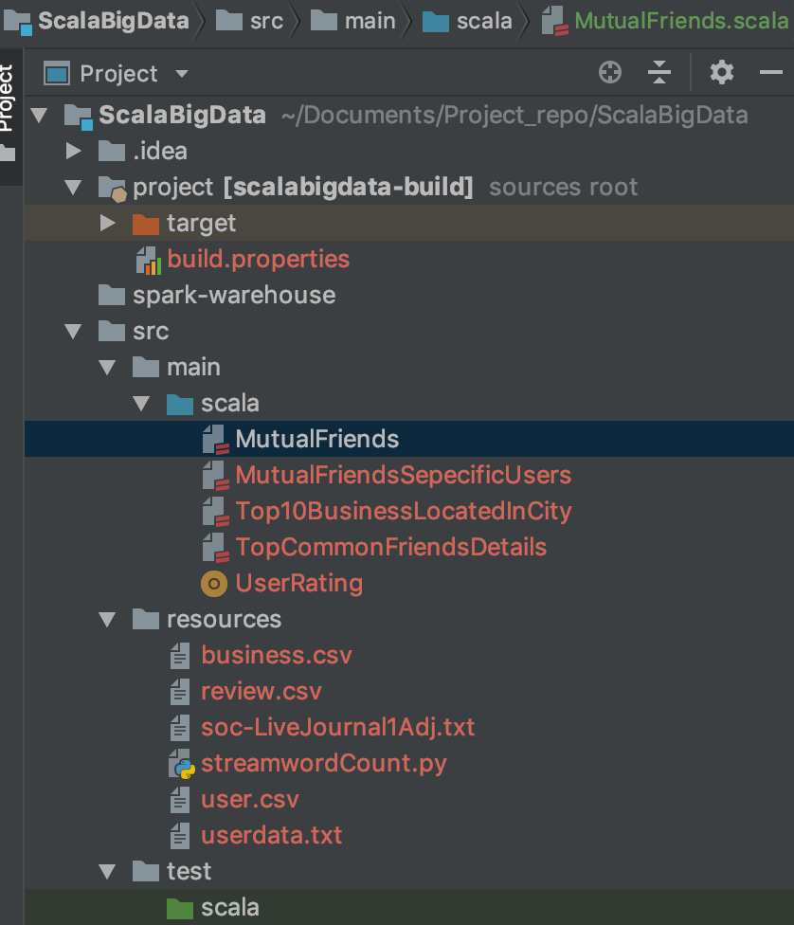The package contains project directory as specified in screenshot

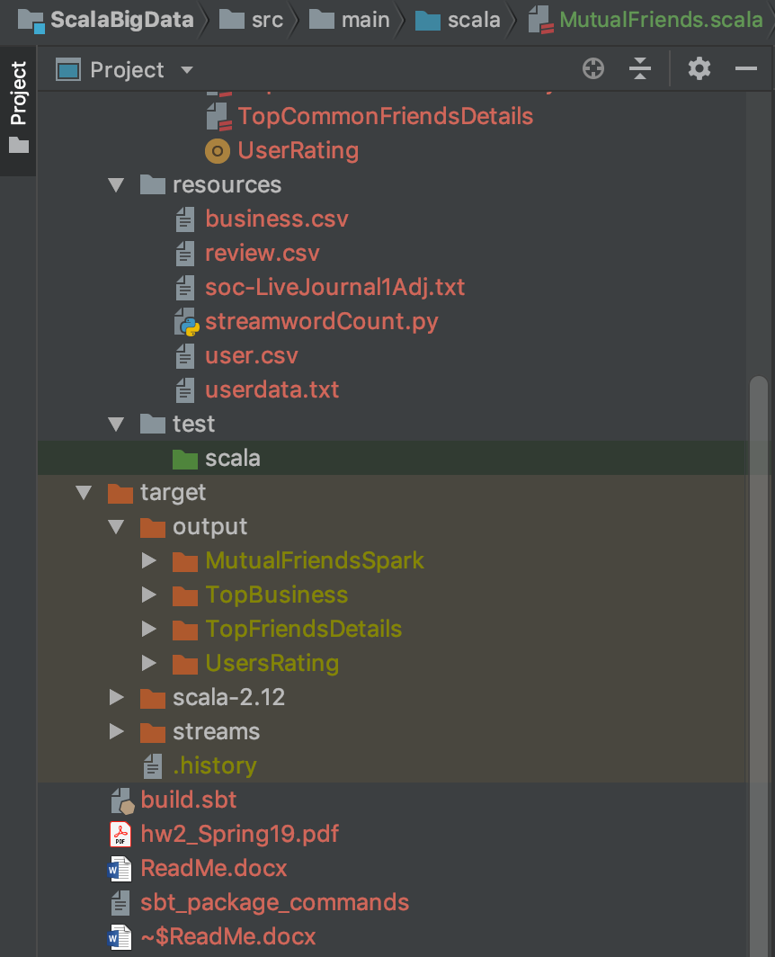

**Solutions are present in following files :->**

Question1 : MutualFriends.scala

Question 2 : TopCommonFriends.scala

Question 3 : Top10BusinessLocatedInCity.scala

Question 4 : UserRating.scala

Each question has its own java file within the above-mentioned jar file.

1. **Filename:** MutualFriends.scala

Command to run the program:

File name: Spark-Shell Files/ MutualFriends.scala

To run: Save your soc-LiveJournal1Adj.txt in your local hdfs system in the folder “input”. And Run the code line by line in your spark-shell. To view output: Output will be displayed on console

**To view the output: check file “mutualFriends.csv”**

**Output directory path : /output/MutualFriendsSpark/mutualFriends.csv**

**Sample Output For the following given pairs:**

6986,41335 4

47299,47302 6

44416,44419 9

12549,42831 2

38678,38688 3

18676,18682 60

14065,34189 1

31056,31057 2

36927,37044 3

18963,36698 12

36806,37000 2

13557,13569 0

15610,15611 0

13834,45423 1

24115,26927 1

16176,47263 0

23704,32956 1

4550,4575 8

44291,44298 5

31763,31766 9

17441,31756 2

18702,18767 60

11015,32075 0

5823,25459 1

17785,27792 0

12401,27406 2

15302,38779 1

14982,16639 5

18385,42822 0

14230,34602 0

19450,19570 4

1506,17678 8

1. **Filename:** TopCommonFriends.scala

**To view the output: check file “**TopFriendsDetails.csv**”**

**Output directory path : /output/TopFriendsDetails/mutualFriends.csv**

**Output For the following :**

99 Arron Batz 4301 Doe Meadow Drive Roger Salls 1144 Kinney Street

99 Bambi Villegas 1329 Grove Avenue Amanda Turner 1164 Hewes Avenue

99 Charles Davis 2359 West Fork Drive Anthony Manley 258 Eastland Avenue

99 Gregory Won 1146 Meadow Drive Anthony Manley 258 Eastland Avenue

99 Gerald Wisner 4414 Cambridge Place Anthony Manley 258 Eastland Avenue

99 Thomas Hook 1153 Sycamore Circle Amanda Degroot 1705 Upton Avenue

99 Nola Joyner 1872 Lyndon Street Jane Irish 582 Dogwood Road

99 William Carey 91 School Street Jane Irish 582 Dogwood Road

99 Paul Mackenzie 4092 Marigold Lane Paul Nguyen 471 Spring Street

99 Gregory Won 1146 Meadow Drive Gerald Wisner 4414 Cambridge Place

1. **Filename:** Top10BusinessLocatedInCity.scala

**To view the output: check file “**Top10BusinessInNY.csv**”**

**Output directory path : /output/TopBusiness/mutualFriends.csv**

**Output For the following :**

business_id full_address categories average

WXx3gZnrIysGFnpGMCskwg 79 Vandenburgh AveTroy, NY 12180 List(Shopping, Drugstores) 5.0

1KWaczlXfDi9Z3urqlh_Yw 1080 Danby RdIthaca, NY 14850 List(Food, Bakeries, Coffee & Tea, Cafes, Restaurants) 5.0

JfZY98Jopy8OvYrXqKrF0Q 408 E Upland RdIthaca, NY 14850 List(Optometrists, Health and Medical) 5.0

dkGTj5FVVqN4DbR7uWi8rw 128 E State StIthaca, NY 14850 List(Shopping, Jewelry, Antiques) 5.0

nL6fL-kFpNSCrLdYM7qNZg 3066 BroadwayMorningside HeightsManhattan, NY 10027 List(Barbers, Beauty and Spas) 5.0

_ckbnVhwrD3vEowWVN8SnQ 119 S Cayuga St Ste 301Ithaca, NY 14850 List(Active Life, Yoga, Fitness & Instruction) 5.0

JMQx87SPt0vt71MKniTz6Q 179 Graham RdSte FIthaca, NY 14850 List(Massage, Beauty and Spas) 5.0

KNfrxyHr1oIGaRYAJK-W8Q 414 Elmira Rd#6155Ithaca, NY 14850 List(Hardware Stores, Shopping, Home & Garden) 5.0

oBkgwRPRVa3Mnh9oP7CloQ 3102 7th AveTroy, NY 12180 List(Automotive, Body Shops, Towing) 5.0

5BM0cmJvxaFlFuh0L-b4Ow 217 N Greenbush RdTroy, NY 12180 List(Hardware Stores, Shopping, Home & Garden) 5.0

1. **Filename:** UserRating.scala

**To view the output: check file “**users_average_ratting.csv**”**

**Output directory path : /output/**UsersRating**/mutualFriends.csv**

**Below is the output snapshot:**

Output :

KK_hwlNUOoIIMFM33tczww 2.0

DyMuthKkxYdl2LL5hOtRJw 1.0

jOvBTs3g4sl-nFXp7zXEzw 3.0

1pp1jjHmw2KhljOgOr-H7A 4.0

zqq8U-oz4IQtH-xTZoxtmw 5.0

2gJ0FifyABaEQ92uEKNQnQ 5.0

HKC-j6ShF_wUfB0q1BH5cw 3.0

fpMaUmBc2U5tOisT017VQw 4.0

SVans0JF-AgH4T65WF82CA 5.0

_K9sKlA4fVkWI4hyGSpoPA 4.0

j46QH7rV60lZ9sGLusS3Uw 2.0

TLTbtobx10vpK3rYP8-2sw 4.0

2WPS6dCSfx3PjqLKqljOFQ 3.0

jyCoGta9NHZP5naYb6kedQ 3.0

9JdlfwAdVY0DR5rPU_4WPQ 4.0

RepbaM5Opkimc95QNy8aPw 3.0

4Aj9NpdxnT5CHZnn95SlKA 2.0

Qqs0nylFFIefn65okipNww 5.0

cPLBdGuwEk0XzzIIc1zQMg 5.0

CXQmzlxUdLcwkejENv2txA 5.0

6ORQMKnxhZPpUHKJ_rjrMg 5.0

1nuqhY2Z7sttekz-0MzwIg 5.0

Lpsb00v0EiC2iKGzbyHXNA 5.0

M0e5k4FmE4KKyc5kjSTUsw 4.0

FtxmuQGdxg9dAmhat08MzA 5.0

oOML59F9CP6O0lPnqAo4Jg 3.0

Fk6pJP2Vv_MLe9N3nB2qTA 5.0

8cbCK3WfRw-S7GbM1DhksA 5.0

juzFEMz9lX7910qngNkSYw 5.0

0CqAmHUSWPEQdrnCbDiaVA 5.0

5ZhwDuvwhghCYFKTrH_kDA 5.0

CdJ1M_EJhcdG4Cul6Tc62w 5.0

QF0urZa-0bxga17ZeY-9lw 5.0

i8ORiviNEHCbRRtmCMiiTA 5.0