AlexNet + SVM
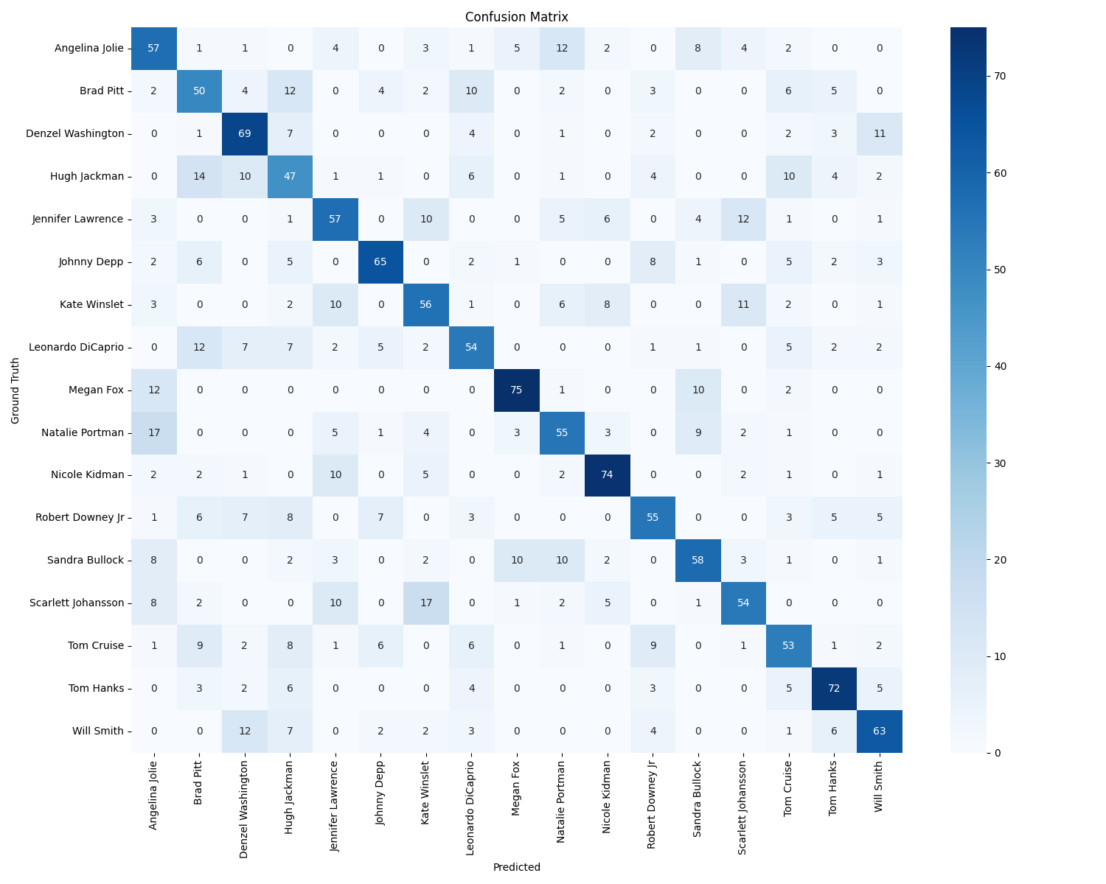
Mean Accuracy: 59.65%

Improvement:
Applying Data Augmentation
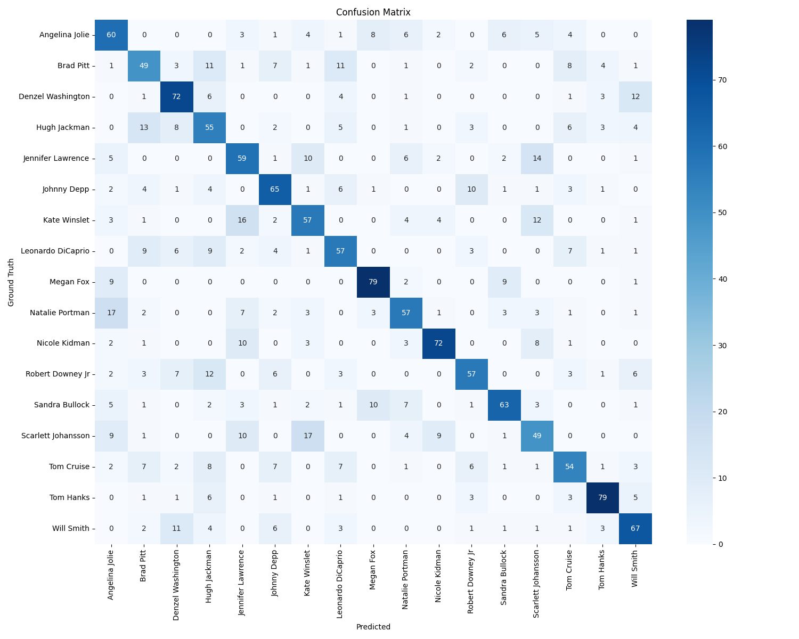
Mean Accuracy: 61.82%

