DESIGN AND IMPLEMENTATION OF A HIGH-EFFICIENCY FULL-BRIDGE FORWARD CONVERTER
A Thesis
Submitted in partial fulfillment of the requirements for the award of the Degree of
BACHELOR OF TECHNOLOGY
IN
Electrical and Electronics Engineering


BY

PRIYANSHU RANJAN
AASHISH RANJAN
BTECH/10612/22
BTECH/10651/22

DECLARATION CERTIFICATE
I certify that
- The work contained in the thesis is original and has been done by myself under the general supervision of my supervisor.
- The work has not been submitted to any other Institute for any other degree or diploma.
- I have followed the guidelines provided by the Institute in writing the thesis.
- I have conformed to the norms and guidelines given in the Ethical Code of Conduct of the Institute.
- Whenever I have used materials (data, theoretical analysis, and text) from other sources, I have given due credit to them by citing them in the text of the thesis and giving their details in the references.
- Whenever I have quoted written materials from other sources, I have put them under quotation marks and given due credit to the sources by citing them and giving required details in the references.
PRIYANSHU RANJAN
AASHISH RANJAN
BTECH/10612/22
BTECH/10651/22

ABSTRACT
This project presents the design and simulation of a high-efficiency Full-Bridge Forward Converter intended for battery-charging applications. The converter is engineered to operate over a wide input voltage range of 200–500 V and deliver controlled output currents up to 100 A, making it suitable for medium- and high-power charging systems. A systematic design methodology is followed, covering semiconductor selection, high-frequency transformer design, and LC output filtering to ensure low ripple and reliable performance. A detailed MATLAB/Simulink model is developed to analyze switching behavior, transformer operation, steady-state waveforms, and output characteristics under varying electrical conditions. A closed-loop Constant-Current (CC) control strategy is implemented to maintain stable charging current despite fluctuations in input voltage or load disturbances. Simulation results verify that the proposed converter achieves efficient power transfer, robust current regulation, and safe charging characteristics. The work provides a strong foundation for further hardware development and optimization of isolated battery-charging topologies.

ACKNOWLEDGEMENT
I would like to express my profound gratitude to my project guide, Dr.Aftab Alam for his guidance and support during my thesis work. I benefited greatly by working under his guidance. It was his effort for which I am able to develop a detailed insight on this subject and special interest to study further. His encouragement motivation and support has been invaluable throughout my studies at BIT, Mesra, Ranchi.
I convey my sincere gratitude to Dr. Sudhanshu Kumar Misra, Head of Dept. of EEE, BIT, Mesra, Ranchi, for providing me various facilities needed to complete my project work. I would also like to thank all the faculty members of EEE department who have directly or indirectly helped during the course of the study. I would also like to thank all the staff (technical and non-technical) and my friends at BIT, Mesra, Ranchi who have helped me greatly during the course.
Finally, I must express my very profound gratitude to my parents for providing me with unfailing support and continuous encouragement throughout the years of my study. This accomplishment would not have been possible without them.
My apologies and heartful gratitude to all who have assisted me yet have not been acknowledged by name.
Thank you.
DATE: PRIYANSHU RANJAN
AASHISH RANJAN
BTECH/10612/22
BTECH/10651/22

CONTENTS

1
DECLARATION CERTIFICATE 2
ABSTRACT 3
ACKNOWLEDGEMENT 4
CONTENTS 5
1. Introduction 6
2. Motivation 7
3. Literature Review 8
4. Objectives 12
5. Methodology 13
5.1 Topology Selection and Theoretical Analysis 13
5.2 Working Principle 15
5.3 Volt–second balance and duty relationships 17
5.4 Power transfer and the role of the rectifier/filter 17
5.5 Transformer reset and clamp circuits 18
5.6 Secondary losses and diode dynamics 18
5.7 Soft-switching and modulation options 19
5.8 Practical design constraints & equations 19
5.9 Advantages and limitations 20
6. Simulation and Results 21
7. Future Work 24
8. Conclusion 25
9. References 26

1. Introduction
The rapid growth of electric vehicles, renewable-energy systems, and battery-based energy storage has created a strong demand for efficient, reliable, and safe power-conversion systems. Among these, battery chargers play a critical role in determining charging speed, system efficiency, and long-term battery health. Modern chargers must operate with high power density, provide electrical isolation for safety, and maintain stable current delivery under varying operating conditions. Achieving these requirements necessitates the use of advanced DC–DC converter topologies capable of handling wide input variations while delivering regulated output to the battery.
Isolated topologies such as the Full-Bridge Forward Converter have gained prominence due to their ability to provide galvanic isolation, high efficiency, and flexible voltage scaling through transformer action. The forward-derived family is particularly attractive for medium- to high-power applications because it offers better utilization of the transformer core, reduced voltage stress on switches, and well-defined control characteristics compared to simpler isolated converters like flyback or push–pull. As battery charging increasingly shifts toward fast and controlled current delivery, the Full-Bridge Forward Converter becomes a strong candidate for delivering consistent performance in systems that demand both safety and efficiency.
In battery charging applications, maintaining a stable charging current is essential to ensure predictable charging behavior and avoid thermal or electrochemical stress on the battery. Constant-Current (CC) charging is widely used in the initial stage of battery replenishment, especially for lithium-ion batteries, as it provides safe energy absorption while preventing excessive internal heating. Implementing an accurate CC control loop requires a converter with fast dynamic response, low ripple, and robust regulation—characteristics that align well with the Full-Bridge Forward topology.
This project focuses on the complete design and simulation of a Full-Bridge Forward Converter tailored for CC-based battery charging. The work includes component selection, transformer design, LC filter calculations, and a detailed MATLAB/Simulink model to evaluate performance under varying load and input conditions. A closed-loop CC controller is implemented to regulate the output current, ensuring stable charging despite disturbances or fluctuations in input supply. The goal is to validate the converter’s suitability for practical battery-charging applications and lay the groundwork for future hardware implementation.

2. Motivation
The growing adoption of electric vehicles, renewable-energy storage systems, and lithium-ion battery technologies has significantly increased the need for efficient, reliable, and safe charging solutions. As power levels rise and charging time expectations decrease, conventional low-frequency or linear charging systems are no longer sufficient. Modern chargers must deliver high power with minimal losses, maintain strict control over output current, and ensure galvanic isolation to protect both users and connected equipment. These requirements highlight the importance of using advanced DC–DC converter topologies that can achieve high efficiency while remaining compact and cost-effective.
Battery charging, especially in the constant-current (CC) region, demands a converter that can maintain a stable and accurately regulated charging current despite disturbances such as input voltage fluctuations, transformer nonlinearities, and load variations caused by battery dynamics. Reliable CC performance is essential not only for achieving predictable charging times but also for preventing thermal stress, prolonging battery life, and ensuring safety during operation.
The Full-Bridge Forward Converter stands out as an attractive solution for these challenges. It combines the benefits of transformer isolation, high efficiency, and flexible voltage scaling while reducing switch stress and improving transformer utilization compared to simpler isolated topologies. Its well-defined control characteristics make it suitable for implementing a precise CC charging algorithm. With advancements in high-frequency switching devices such as SiC and GaN transistors, the forward-derived family of converters has become even more promising for high-power battery-charging applications.
The motivation behind this project is to design and simulate an isolated Full-Bridge Forward Converter that can meet the modern requirements of CC battery charging while providing a pathway toward future hardware implementation. By developing an accurate MATLAB/Simulink model and analyzing converter performance under realistic conditions, this project aims to contribute to the understanding and optimization of isolated charging topologies suitable for electric mobility and energy-storage systems.

3. Literature Review
[1] H. S. Ribeiro and B. V. Borges, “New Optimized Full-Bridge Single-Stage AC/DC Converters”: Ribeiro and Borges introduce three optimized single-stage full-bridge AC–DC topologies that combine input-current shaping (PFC) with HF isolated full-bridge conversion without extra active switches. The paper breaks down operating principles, identifies how the “boost” function is accomplished in each topology, and thoroughly compares input-current THD, efficiency, and output-voltage ripple using a 500 W modular prototype and common controllers. The work is particularly useful for designers who want compact, single-stage chargers: it highlights the trade-offs between component count, device stress, and PFC effectiveness and provides operating limits and transformer turn-ratio guidance that you can adopt in your Simulink model to evaluate single-stage vs two-stage approaches.
[2] Z. Zhang, O. C. Thomsen, and M. A. E. Andersen, “Optimal Design of a Push-Pull-Forward Half-Bridge (PPFHB) Bidirectional DC–DC Converter With Variable Input Voltage”: This paper presents the PPFHB topology targeted at variable-voltage storage elements (e.g., supercaps), emphasizing a low transistor count, phase-shift control for ZVS, and a thorough optimization methodology (coupled-inductor design, harmonic analysis, and ZVS-range extension). Experimental prototypes confirm the theoretical gains. For battery-charging systems that may interact with ultracapacitors or require bidirectionality, the PPFHB analysis offers practical soft-switching and magnetics design procedures you can adapt—particularly the coupled-inductor and ZVS-range methods—to improve soft-switching margins and efficiency in a full-bridge forward converter simulation.
[3] M. C. Annamalai and N. Amutha prabha, “A Comprehensive Review on Isolated and Non-Isolated Converter Configuration and Fast Charging Technology: For battery and plug in hybrid electric vehicle”: This Heliyon review surveys converter configurations and fast-charging technologies with attention to converter performance metrics such as current/voltage ripple, switching/conduction losses, reliability, and cost. It contrasts isolated and non-isolated topologies across application-relevant criteria and discusses EMI/EMC, control, and storage-interfacing issues. This broad perspective helps situate a full-bridge forward converter within the larger design space — use its comparative tables as objective metrics when you justify your topology choice and to select performance indices (THD, ripple, efficiency) to report from your Simulink tests.
[4] M. Safayatullah et al., “A Comprehensive Review of Power Converter Topologies and Control Methods for Electric Vehicle Fast Charging Applications”: Safayatullah et al. provide an extensive survey of off-board fast-charger architectures, covering AC–DC front ends (multilevel rectifiers, PFC), DC–DC back ends (DAB, resonant, full-bridge variants), multiport chargers, and control strategies (phase-shift, IVFF, CC/CV). The review emphasizes control-topology matching for power scaling, modularity, and grid impact mitigation. For your battery-charging simulation the paper’s discussions on IVFF, automatic mode selection, and modular paralleling are directly relevant: they offer control patterns and test scenarios (grid sag, parallel module sharing) worth modelling in Simulink.
[5] A. Mousavi and G. Moschopoulos, “A New ZCS-PWM Full-Bridge DC–DC Converter With Simple Auxiliary Circuits”: Mousavi and Moschopoulos propose a ZCS-PWM full-bridge converter that achieves zero-current switching for main switches through two simple auxiliary circuits (one active, one passive). Their design targets high-power stages where IGBTs are preferable, reducing turn-off losses and conduction penalties without bulky resonant tanks. The paper details steady-state behavior and design rules and validates performance with a 3 kW prototype. In your forward-converter simulation, including a model of such auxiliary circuits allows quantitative comparison of switching energy and thermal loading with conventional PWM switching.
[6] D. S. Wijeratne and G. Moschopoulos, “A ZVS-PWM Full-Bridge Converter With Reduced Conduction Losses”: This work presents a ZVS-PWM full-bridge variant that uses an inventive auxiliary-circuit scheme to extend ZVS across the operating range while keeping circulating and freewheeling conduction losses low. It also addresses secondary-diode ringing by circuit arrangement and provides a design flow plus experimental results. The approach is valuable when modelling synchronous rectification vs diode rectification trade-offs in a full-bridge forward converter: you can simulate the auxiliary scheme to estimate reduced diode ringing and quantify the net efficiency benefit under light and heavy loads.
[7] C. Yao, X. Ruan, and X. Wang, “Automatic Mode-Shifting Control Strategy With Input Voltage Feed-Forward for Full-Bridge-Boost DC–DC Converter Suitable for Wide Input Voltage Range”: Yao et al. develop a two-mode PS–TEM control with input-voltage feed-forward (IVFF), enabling automatic mode shifting between FB and boost behaviors depending on reflected input voltage; they derive small- and large-signal IVFF laws and demonstrate a 6 kW prototype over 250–500 V input. The paper’s IVFF and mode-shifting ideas are directly applicable to battery-charger controllers when the converter must remain efficient and stable across large input variations or when working with upstream converters—implementing similar IVFF in your Simulink CC/CV controller improves transient response to source disturbances.
[8] L. Roggia and P. F. S. Costa, “Comparative Analysis Between Integrated Full-Bridge-Forward and Dual Active Bridge DC–DC Converters”: Roggia and Costa compare the Integrated Full-Bridge-Forward (IFBF) converter and the Dual Active Bridge (DAB), focusing on device count, ZVS ranges, and efficiency in asymmetric bidirectional scenarios such as residential microgrids. The letter argues that when forward-direction power dominates, IFBF offers lower cost and higher efficiency. For a charging-focused project, this concise comparison supports choosing a forward-derived topology for predominantly unidirectional charging and motivates simulation comparisons (IFBF vs DAB) to back claims about efficiency and device count.
[9] L. Roggia et al., “Integrated Full-Bridge-Forward DC–DC Converter for a Residential Microgrid Application”: This full paper details the IFBF topology, transformer design, and three alternative clamping circuits that avoid a separate demagnetizing winding. The authors analyze transformer magnetics, clamp energy flows, and compare the IFBF to DAB, presenting experimental validation in a microgrid storage context. The transformer reset/clamp alternatives and magnetics sizing procedures are directly useful for your full-bridge forward converter simulation: modelling these clamp options will reveal which reset scheme yields the best magnetizing-current behavior and lowest stress on switching devices.
[10] S. Inamdar, A. Thosar, and S. Mante, “Literature Review of 3.3kW On Board Charger Topologies”: Focused on 3.3 kW on-board chargers, this review compares PFC front ends (classic boost, bridgeless) alnd isolated DC–DC stages (forward, full-bridge, half-bridge), highlighting interleaving, bridgeless PFC for reduced conduction loss, and the effect of switching frequency on passive sizing. It also frames automotive EMI and packaging constraints. If your project targets compact on-board designs or lower-power prototypes, the paper’s recommendations (bridgeless PFC + isolated forward stage, interleaving) are practical starting points for Simulink testbenches and input-THD/EMI proxy simulations.
[11] M. A. Moghadam et al., “Research and Development Review of Power Converter Topologies and Control Technology for Electric Vehicle Fast-Charging Systems”: This recent review synthesizes state-of-the-art topologies and control tech for fast chargers (100 kW+), covering centralized AC–DC rectifiers, modular DC–DC submodules, solid-state transformer concepts, and control/communication issues. It offers industry-oriented insight about architecture selection, modular scaling, and grid interaction. For your project, this review is useful for placing a full-bridge forward design within large-scale charger systems and for identifying scaling and control considerations if you plan to model parallel module operation or grid-disturbance scenarios.
[12] A. Singh and S. Singh, “Review and Analysis of DC–DC Power Converter Performance for Fast Charging of EVs”: Singh and colleagues survey DC–DC options (DAB, resonant CLLC, full-bridge families) and formalize performance indices (efficiency, ripple, power density) relevant to EV fast charging. They discuss typical loss partitions and highlight design tradeoffs for minimizing ripple and conduction losses. This material is directly actionable when you build result tables from Simulink: use their performance indices to structure your efficiency maps, ripple analyses, and loss breakdowns for the full-bridge forward converter.
[13] M. Yilmaz and P. T. Krein, “Review of Battery Charger Topologies, Charging Power Levels, and Infrastructure for Plug-In Electric and Hybrid Vehicles”: This well-cited survey classifies charger levels (Level 1–3), on-board vs off-board architectures, and discusses multilevel and bidirectional converter topologies. It provides historical context, standards considerations, and practical constraints that affect topology choice. For your literature background and for arguing why the full-bridge forward converter is appropriate for your target power level and safety requirements, this review supplies authoritative context and standard-level considerations to cite in your report.
[14] X. Ruan and Y. Yan, “Soft-Switching Techniques for PWM Full-Bridge Converters”: Ruan and Yan present a taxonomy and explanation of soft-switching techniques and modulation strategies for PWM full-bridge converters (including ZVS, ZCS, ZVZCS, and modulation-based methods). The paper helps designers choose the right modulation (timing, lead/lag leg strategies) or auxiliary circuits to achieve soft switching without incurring excessive circulating losses. In practical terms, this taxonomy guides which soft-switching scheme to implement in your Simulink model (modulation-only, auxiliary active/passive, or hybrid) and how to parameterize parasitics to obtain realistic switching-loss estimates.

4. Objectives
The primary objective of this project is to design and validate a high-efficiency Full-Bridge Forward Converter suitable for medium- to high-power battery-charging applications. To achieve this, the project focuses on the following goals:
1.Converter Design and Component Selection:
To perform a complete analytical design of the Full-Bridge Forward Converter capable of operating across an input voltage range of 200–500 V while delivering output currents up to 100 A and producing regulated output voltages between 300–1200 V. This includes selecting appropriate semiconductor switches, designing a high-frequency transformer with the correct turns ratio and core specifications, and dimensioning the output LC filter to ensure low ripple and stable operation.
2. System Modeling and Simulation:
To develop a detailed Simulink model of the converter for evaluating steady-state and dynamic performance under different load and operating conditions. This includes analyzing switching behavior, transformer operation, current waveforms, and output characteristics to validate the design prior to practical implementation.
3. Closed-Loop Constant-Current (CC) Charging Control:
To design and implement a closed-loop controller that maintains the desired constant-current charging profile by continuously sensing output current and adjusting the duty cycle accordingly. The objective is to ensure stable CC charging despite variations in input voltage, load disturbances, or changes in battery conditions, thereby ensuring safe and consistent current delivery.

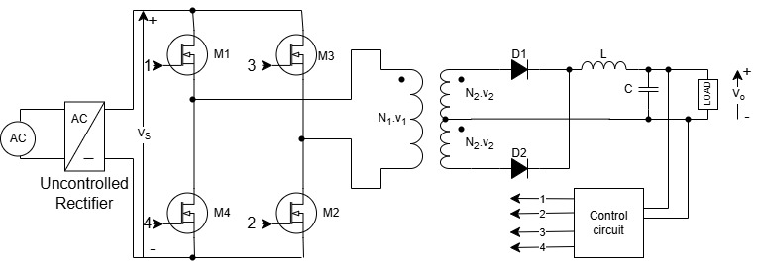
5. Methodology
Circuit Diagram
The converter consists of an AC input, an uncontrolled rectifier, a full-bridge inverter (using four MOSFETs M1-M4), a high-frequency transformer, a rectifier circuit on the secondary side (D1, D2), an output filter (L, C), and a control circuit.

5.1 Topology Selection and Theoretical Analysis

5.1.1 Buck Converter
Buck converter, as a typical structure of DC-DC step-down circuit, is widely used in all kinds of power management systems, and its high-efficiency characteristics are of great significance in modern power electronic equipment. However, in actual operation, the Buck converter inevitably suffers from system losses due to the non-ideal characteristics of the main components such as switching tubes, inductors, capacitors, etc., which affects the conversion efficiency and system performance.

For low-power applications, a buck converter is often the most suitable choice. While topologies like the forward converter and flyback converter also have losses, they can be too expensive for simple, low-power needs.
However, when load safety or higher power is a concern, isolation becomes crucial, which requires a transformer. The flyback converter provides this necessary isolation. Its primary drawback is that the transformer's magnetic flux does not get reset, limiting its use to medium-power applications rather than high-power ones. For mid-to-high range applications that demand efficiency, load isolation, and transformer flux reset, the forward converter is the preferred topology.

5.1.2 Flyback Converter
When battery charging or other applications require electrical isolation for safety—a feature the basic buck converter lacks—the flyback converter is often considered. This topology provides the necessary galvanic isolation to protect the load by using a coupled inductor, which functions like a transformer. However, the flyback converter has a significant drawback: the transformer's magnetic flux does not get reset during each cycle. This limits the amount of energy that can be transferred, restricting the topology to medium-power applications and making it less suitable for high-power needs. Due to this limitation, the forward converter is the preferred choice for mid-to-high range applications that require both isolation and the ability to handle more power efficiently.

5.1.3 Forward Converter
The most basic and cheapest form of DC-DC converter is a simple linear regulator, but it leads to lot of loss which in turn leads to more stress along switch and a lot of heat. A buck converter can be used for a DC-DC converter for low to mid-range applications, but since battery charging is the objective, it is preferable for a topology with isolation to be had to protect the load, especially when higher amp loads are involved. A good alternative that offers isolation to protect the load is the flyback, but flux does not get reset in this topology, which is required for mid-range applications. Hence, for mid-range applications, a forward converter is being used, which offers efficiency, isolation for the load, and has the transformer flux reset.

5.1.4 Full-bridge Forward bridge forward converter
The full-bridge forward converter is selected for this project due to its superior efficiency and high-power capability compared to single-switch and two-switch forward converters. By using four switches in an H-bridge arrangement, the converter applies the full input voltage across the transformer, enabling higher power transfer with reduced current stress on each device. The topology also provides excellent transformer utilization, balanced core excitation, and reliable flux reset, which minimizes core losses and prevents saturation. Voltage stresses on the switches are significantly lower than in flyback or single-switch forward converters, improving reliability and reducing the required component ratings. These advantages—combined with inherent galvanic isolation, lower output ripple, and strong suitability for regulated high-current applications—make the full-bridge forward converter an ideal choice for efficient, medium-to-high-power DC-DC conversion, particularly in battery charging and industrial power systems.

5.2 Working Principle
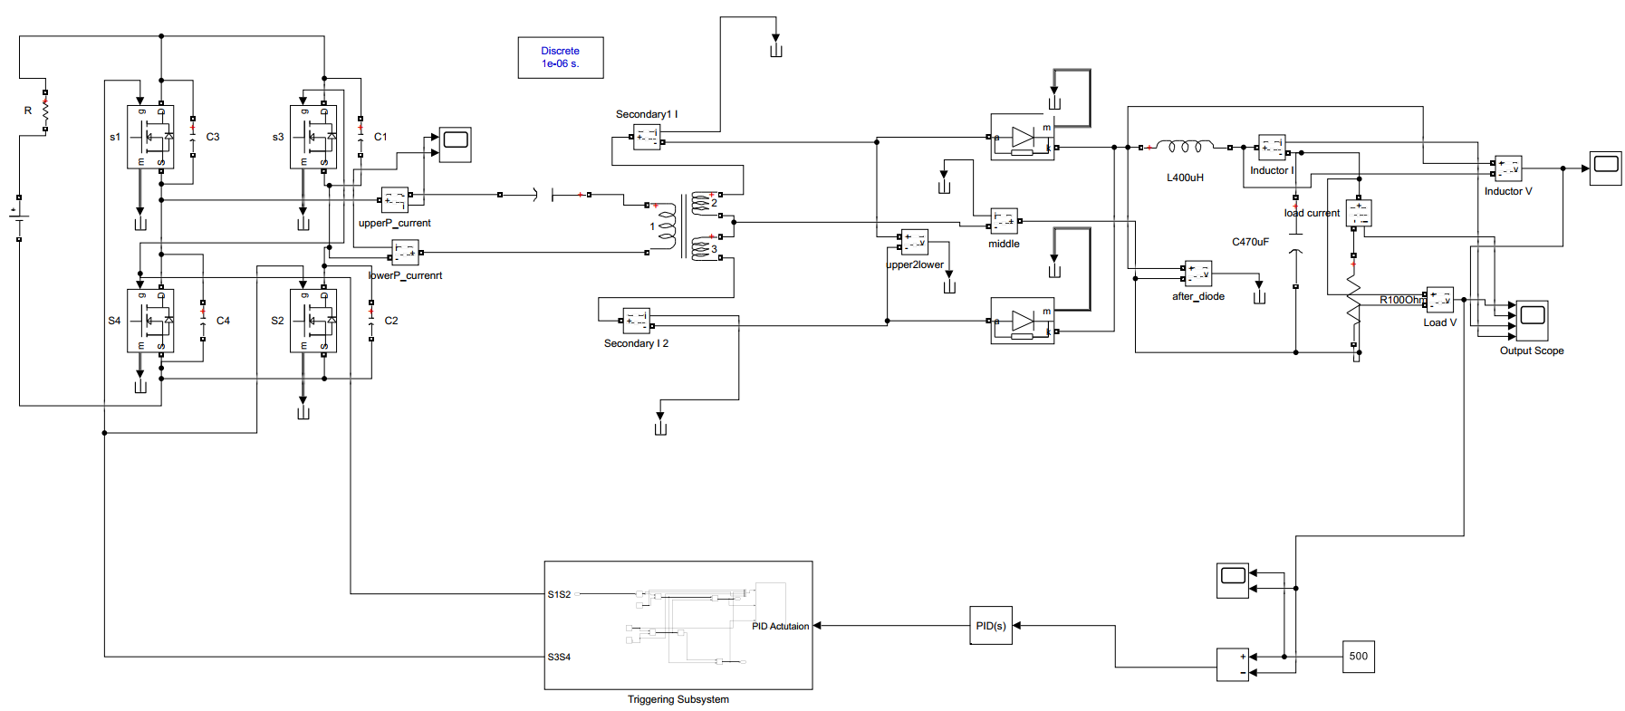
A Full-Bridge Forward Converter is an isolated DC–DC converter in which four switches (an H-bridge or full bridge) drive the primary of a high-frequency transformer. The bridge is gated such that diagonal pairs of switches conduct alternately, producing a bipolar square-wave voltage across the transformer primary. The transformer secondary is rectified and filtered to produce the DC output used for charging the battery. Because the bridge applies the full DC-link voltage across the primary, the topology is well suited to medium–to–high power applications and gives good transformer utilization compared with single-switch forward or flyback converters.
Assume an H-bridge with switches S1..S4 and a full-wave rectifier on the secondary.
Positive half period(t=0→t=tₚ):
Diagonal pair (S1, S4) is turned ON. The primary sees $+V_{dc}$(neglecting small drop). The secondary sees $v_{s}=n⋅V_{dc}$(where $n=N_{s}/N_{p}$is the turns ratio). One diode (or the synchronous MOSFET configured as diode) conducts on the secondary and transfers energy through the transformer to the output filter and load. The magnetizing current flows into the magnetizing inductance and part of the primary current is reflected to the secondary.
Negative half period (t = tₚ → t = tₚ + tₙ):
The opposite diagonal (S2, S3) is turned ON and the primary sees $-V_{dc}$. The polarity at the secondary is reversed, but the rectifier makes the output polarity the same, so the other diode conducts and the output still receives power. Meanwhile, because the applied primary voltage reversed, the transformer magnetizing flux is driven in the opposite direction — this provides the automatic flux reset if the durations of the positive and negative pulses are equal.
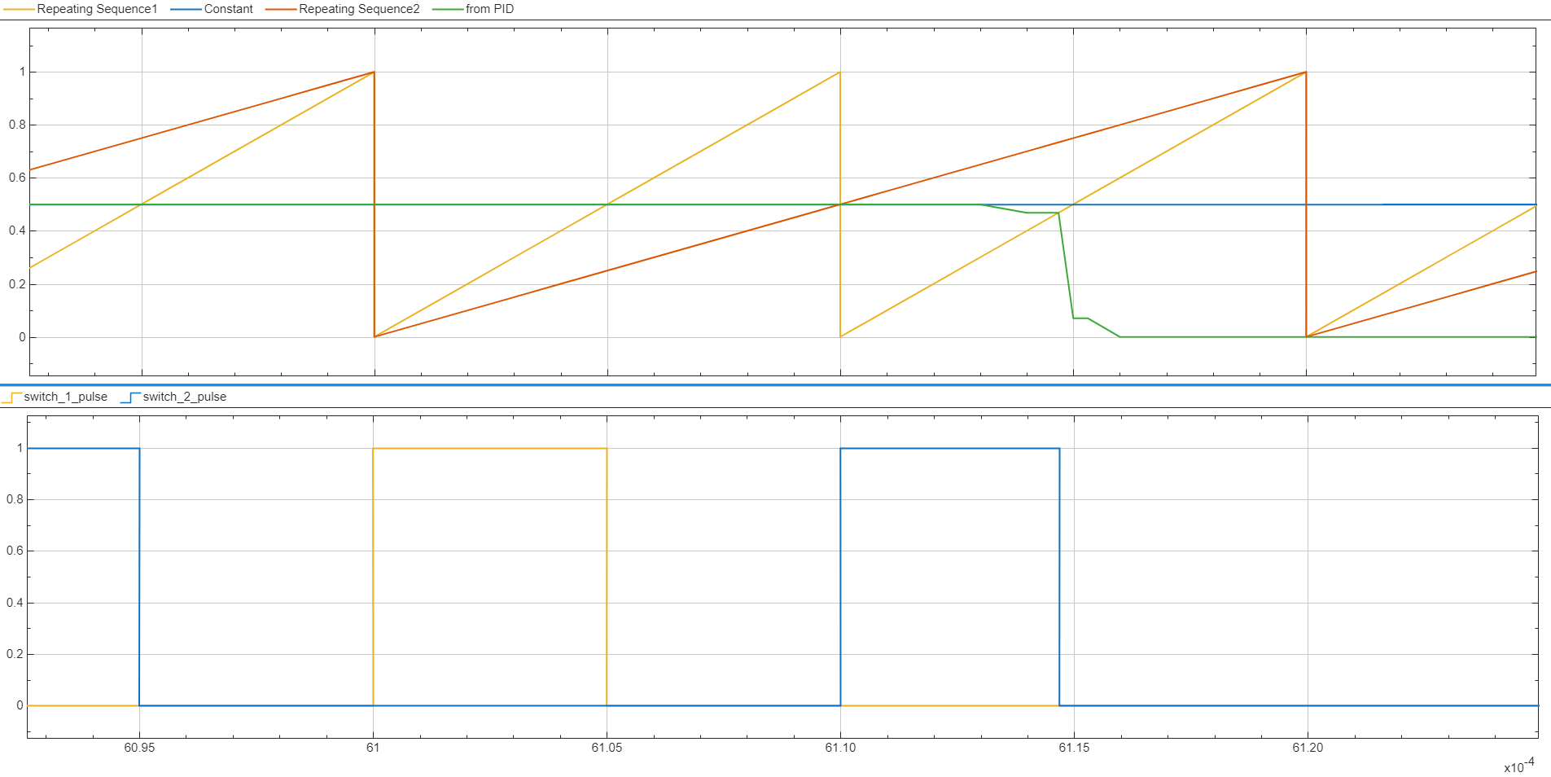
Off/transition intervals:
If there are any intentional off-times inside each half period (e.g., PWM gating inside each half), the rectifier diodes provide free-wheeling for the output inductor current. Also, leakage inductance will force current into snubbers or clamp circuits at switching transitions.

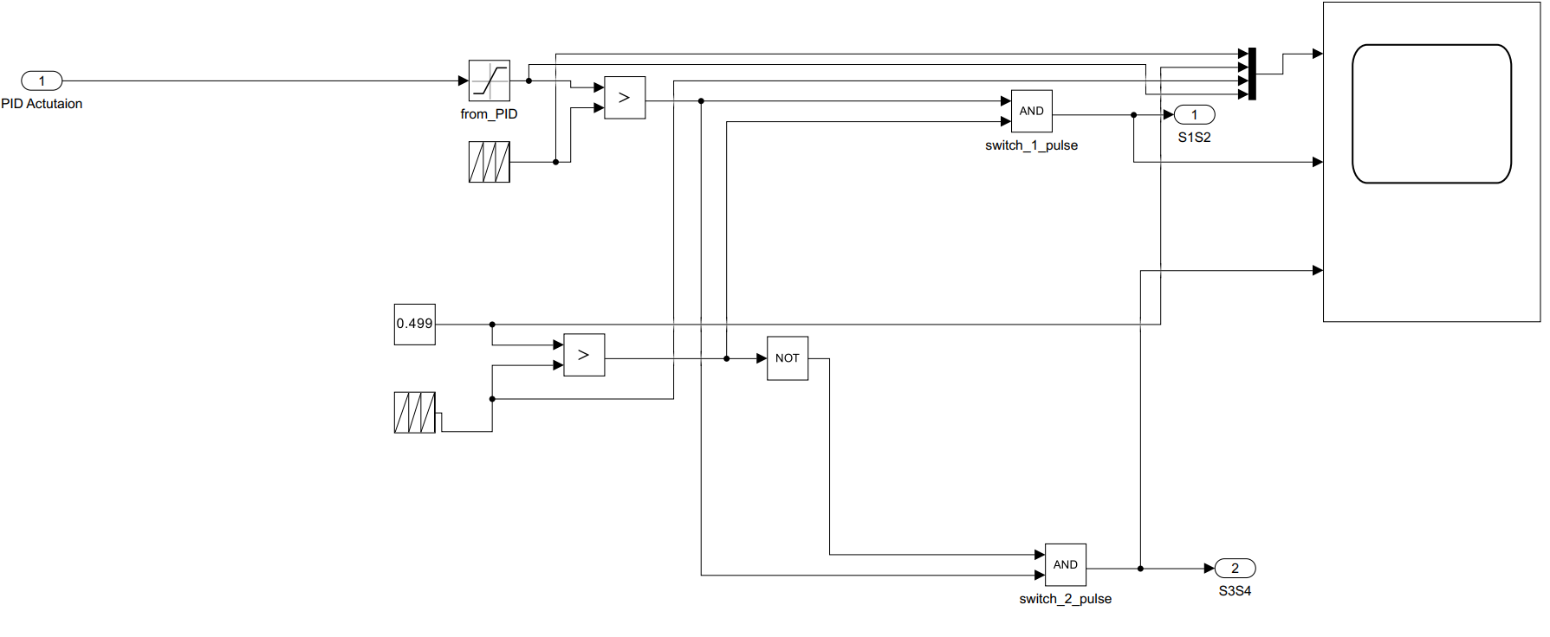
5.3 Volt–second balance and duty relationships
Transformer core saturation must be avoided by ensuring net volt-seconds per switching period is zero. Let $T_{s}$be the switching period, $t_{p}$the time the primary sees $+V_{dc}$, and $t_{n}$the time it sees $-V_{dc}$. The volt-second balance condition is:
$$V_{dc} t_{p}+(-V_{dc}) t_{n}=0⇒t_{p}=t_{n}.$$
Define the per-half-cycle duty as $D=t_{p}/T_{s}$(for symmetric operation $t_{n}=t_{p}$). The average rectified secondary voltage (the voltage seen by the rectifier over a full switching period) is:
$$V_{sec,avg}=n⋅V_{dc} \frac{t_{p}+t_{n}}{T_{s}}=n⋅V_{dc} (D_{p}+D_{n}).$$
For symmetric pulses $D_{p}=D_{n}=D$:
$$V_{sec,avg}=2 n V_{dc} D.$$
Because $t_{p}+t_{n}≤T_{s}$, we must keep $2D≤1⇒D≤0.5$. That yields the practical upper limit:
$$V_{out,max}≈2nV_{dc}D_{max}=n V_{dc}.$$
(so the maximum DC output equals the turns ratio times the DC link when operated with symmetric pulses).
Design note: many implementations define duty over a half-period instead of full period; always check which definition your control uses. The key point is to keep positive and negative pulse durations matched to satisfy volt-second balance.

5.4 Power transfer and the role of the rectifier/filter
Energy is transferred only while the primary sees a driving polarity (i.e., during $t_{p}$and $t_{n}$). The rectifier converts the HF pulses to DC and the output LC filter (L then C, typically a series inductor followed by a capacitor) smooths current and voltage to supply the battery with nearly steady DC current. Because the rectifier conducts during both polarities, the effective conduction time per switching period is $t_{p}+t_{n}$, which determines the average output level.

5.5 Transformer reset and clamp circuits
Because the full-bridge applies both polarities, an automatic bipolar reset is available if the positive and negative pulses are equal. However, practical non-idealities (unequal timing, DC offsets, unbalanced gate delays, core asymmetry, or aperiodic conditions during start/stop) mean that some reset or clamp protection is usually still required:
Symmetric bipolar drive: If pulses are matched, net volt-seconds = 0 and no extra reset winding is necessary. This is a convenient property of the full-bridge forward.
Active clamp: An auxiliary switch + clamp capacitor/inductor can absorb leakage energy and return it to the DC link — this reduces energy wasted in passive snubbers and helps achieve ZVS/ZCS schemes.
RCD or RC snubber: Simple passive clamps dissipate leakage energy in a resistor (less efficient but simple).
Demagnetizing/reset winding (used in single-ended forward): Not usually required in symmetric full-bridge but sometimes included for added safety/flux control.
Leakage energy must be handled: switching off an H-bridge with current flowing through leakage inductance stores $E_{leak}=\frac{1}{2}L_{lk}I^{2}$. If not properly clamped, this shows up as high-voltage spikes across switches and diodes.

5.6 Secondary losses and diode dynamics
Secondary diode reverse-recovery and ringing, caused by interaction of diode junction capacitance and transformer leakage inductance, are practical loss sources and EMI contributors. Two common mitigations:
Synchronous rectification (SR): Replace diodes by actively-driven MOSFETs operating as synchronous rectifiers — this reduces conduction losses substantially at high currents. SR requires careful gate timing to avoid cross-conduction.
Auxiliary passive/active circuits: Snubbers, clamp circuits, or specially arranged auxiliary networks (see soft-switching papers) reduce ringing and dissipate or recover energy.

5.7 Soft-switching and modulation options
Full-bridge converters are amenable to several switching strategies for loss reduction:
PWM (voltage control): Standard method — modulate duty (or pulse width within each polarity) to regulate output. Simple but higher switching losses at high frequency.
Phase-Shift Modulation (PSM): Apply full DC across primary for portions of the switching period and control power by shifting the phase between legs. This allows ZVS for many switches and is widely used in medium-to-high power full-bridge converters.
Two-mode & IV feed-forward: Combine modes (e.g., full-bridge or boost behavior) and employ input-voltage feed-forward to maintain performance over wide input ranges.
Soft-switching techniques such as ZVS (zero-voltage switching) or ZCS (zero-current switching), implemented via auxiliary resonant elements or active clamp circuits, significantly reduce switching losses and permit higher switching frequencies — enabling smaller magnetics and higher power density.

5.8 Practical design constraints & equations
Turns ratio: Choose $n=N_{s}/N_{p}$so that $V_{out}≈2nV_{dc}D$(for symmetric operation). Rearranged, for desired $V_{out}$and chosen $D$:
$$n≈\frac{V_{out}}{2V_{dc}D}.$$
Duty limit: $D≤0.5$(to allow symmetric reset).
Inductor ripple: For CCM in output inductor $L$:
$$ΔI_{L}=\frac{V_{L,avg}}{L} t_{cond}\text{(compute using conduction time and reflected voltage)}.$$
Leakage clamp energy: $E_{lk}=\frac{1}{2}L_{lk}I^{2}$— ensure clamps or snubbers can absorb/return this energy.
Transformer core design: size core to avoid saturation at peak flux: $V_{p}DT_{s}=N_{p}ΔΦ$. For symmetric bipolar drive this is easier because volt-seconds cancel if pulses equal; still consider worst-case offset.

5.9 Advantages and limitations
Advantages
Good transformer utilization and high power capability.
Galvanic isolation for safety.
Compatible with soft-switching schemes (PSM, active clamp) for high efficiency.
Easier flux reset with bipolar drive (no reset winding required if symmetrical).
Limitations
Requires four properly driven switches and gate drivers — more complex than single-switch topologies.
Leakage inductance energy must be clamped — design complexity increases at high power.
Secondary diode losses and reverse recovery issues at high currents unless synchronous rectification used.
Careful timing needed to preserve volt-second balance and avoid core saturation.

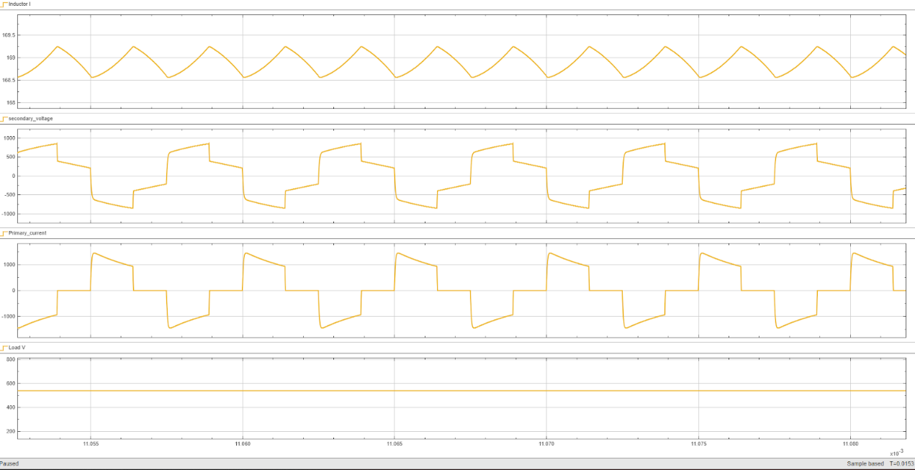
6. Simulation and Results

Constant-Current (CC) charging conditions are shown in the four waveform plots. Each waveform reflects a different part of the converter’s operation: output inductor current, transformer secondary voltage, primary current, and load voltage. The combined analysis confirms correct switching action, proper transformer behavior, and stable CC charging.
1. Inductor Current (Top Plot)
The top graph shows the inductor current ripple, which has a clean triangular waveform. This is expected because:
The output inductor operates in Continuous Conduction Mode (CCM).
Each switching cycle charges and discharges the inductor linearly due to the piecewise‐constant secondary voltages.
The triangular ripple amplitude remains nearly constant throughout the simulation, indicating that the converter is operating at a steady duty cycle.
Interpretation:
Stable triangular current ripple confirms proper forward-mode energy transfer.
Ripple amplitude is small compared to the DC level, which is desirable for CC charging.
No discontinuity or collapse in current indicates correct transformer polarity, correct rectifier conduction, and no core saturation.

2. Transformer Secondary Voltage (Second Plot)
The secondary voltage waveform is a bipolar square-like waveform that alternates between positive and negative levels corresponding to the two diagonal switching states of the H-bridge.
What this indicates:
The H-bridge applies +Vdc and -Vdc to the transformer primary.
This is correctly reflected on the secondary as +n·Vdc and –n·Vdc.
The waveform shape confirms that both diagonal switch pairs (S1–S4 and S2–S3) are operating in a complementary sequence.
The sharp switching edges show that the converter is working in hard-switching or near-hard-switching mode (unless soft-switching is purposely implemented).
Interpretation:
The bipolar waveform verifies proper transformer flux reset (positive and negative halves cancel).
No DC bias appears, meaning the core is not saturating.
The magnitude and symmetry match expected theoretical values.

3. Primary Current (Third Plot)
The primary current waveform is a stepped trapezoidal pattern, typical for full-bridge forward converters.
Behavior explanation:
When the diagonal switch pair engages, current increases according to the reflected load and magnetizing current.
During the negative half-cycle, the polarity reverses but the current waveform maintains its trapezoidal shape due to controlled flux and transformer dynamics.
The primary current has both load-reflected current and magnetizing current components.
The slight slope changes inside each plateau indicate:
Influence of the output inductor and reflected load impedance.
Finite leakage inductances and transformer winding resistance.
Interaction between magnetizing flux and switching intervals.
Interpretation:
Trapezoidal primary current confirms correct energy transfer to the load.
Symmetrical waveform = balanced flux → no saturation.
Smooth transitions indicate no instability or excessive ringing.

4. Load Voltage (Bottom Plot)
The load voltage waveform is nearly flat and constant, demonstrating successful implementation of Constant-Current (CC) charging control.
Key observations:
The CC controller adjusts duty cycle so that current remains fixed, not voltage.
Because the battery is modeled as a high-capacitance, slowly varying load, the voltage appears nearly constant over the simulated window.
Any minor ripple is smoothed by the LC filter.
Interpretation:
The converter is delivering a stable charging current into the battery.
Output voltage stability indicates correct controller tuning.
No overshoot or oscillation suggests good transient damping.

Overall Analysis
The combined waveform behavior confirms that:
The H-bridge is switching correctly
Secondary voltage is symmetric → proper flux balance
No signs of core saturation or uncontrolled spikes
The transformer is functioning normally
Bipolar waveform indicates correct reset and energy transfer
The converter is in CCM
Inductor current never reaches zero
Ripple is small and controlled
CC charging is working
Output voltage is nearly constant
Inductor current waveform is stable
The controller regulates current accurately
No abnormal switching artifacts
No ringing, oscillation, or misfiring
All waveforms follow theoretical full-bridge forward converter behavior

7. Future Work
Hardware Prototype Development
The most significant next step is implementing the converter as a physical hardware prototype. This will allow validation of switching losses, thermal behavior, transformer performance, and controller accuracy under real conditions. Practical measurements such as EMI, noise, and device stress can also be evaluated.
Integration of Soft-Switching Techniques
Future studies can incorporate Zero-Voltage Switching (ZVS), Zero-Current Switching (ZCS), or active clamp configurations to reduce switching losses and enable operation at higher frequencies. Implementing these methods can increase efficiency and reduce component size, making the converter more suitable for compact charging systems.
Synchronous Rectification on the Secondary Side
Replacing rectifier diodes with MOSFET-based synchronous rectifiers can significantly reduce conduction losses, especially at high output currents. This would improve efficiency and thermal performance, particularly in EV charging scenarios.
Transformer Optimization and Magnetic Modeling
Improving magnetic-core modeling by including saturation behavior, fringing effects, and detailed leakage pathways can yield more accurate simulation results. Additionally, optimizing winding arrangement and using planar transformer technology could enhance power density.
Closed-Loop Current Sharing for Modular Chargers
For high-power chargers, multiple converters are often operated in parallel. Future work may include implementing current-sharing algorithms and droop control to ensure even load distribution across parallel modules.
Integration Into a Multi-Stage EV Charging System
The converter can be extended as the DC–DC stage in a complete EV charger that includes a front-end PFC rectifier. This would allow full validation of overall system efficiency, power factor, grid impact, and charging performance.
Thermal Analysis and Heatsink Design
A complete thermal model, including conduction paths and heatsink optimization, can be developed to ensure reliable continuous operation at high output currents. This is crucial for practical deployment.

8. Conclusion
The design and simulation of the Full-Bridge Forward Converter for Constant-Current (CC) battery charging have been successfully completed. The project achieved all major objectives, including the analytical design of the converter components, development of a detailed MATLAB/Simulink model, and implementation of a closed-loop CC control strategy. The results demonstrate that the selected topology effectively supports isolated battery charging with stable output characteristics and high efficiency.
The simulated waveforms confirm correct full-bridge switching action, proper transformer behavior, and continuous conduction mode operation. The bipolar secondary voltage and balanced primary current waveform verify that the transformer is fully reset every cycle, preventing core saturation. The LC output filter produced smooth ripple characteristics, while the closed-loop controller maintained a steady charging current regardless of input variations or load disturbances. These behaviors align closely with theoretical expectations and findings from established literature on high-frequency isolated converters.
Overall, the Full-Bridge Forward Converter proved to be a reliable and robust solution for medium to high-power CC charging applications. Its inherent advantages—such as galvanic isolation, good transformer utilization, reduced switch stress, and compatibility with advanced control methods—make it suitable for integration into EV chargers, renewable energy storage systems, and industrial DC supplies. The project establishes a strong foundation for future hardware implementation, optimization with soft-switching techniques, and extension toward dual-mode (CC–CV) or bidirectional charging architectures.

9. References
[1] H. S. Ribeiro and B. V. Borges, “New Optimized Full-Bridge Single-Stage AC/DC Converters,” IEEE Trans. Ind. Electron., vol. 58, no. 6, pp. 2397–2410, Jun. 2011.
[2] Z. Zhang, O. C. Thomsen, and M. A. E. Andersen, “Optimal Design of a Push-Pull-Forward Half-Bridge (PPFHB) Bidirectional DC–DC Converter With Variable Input Voltage,” IEEE Trans. Ind. Electron., vol. 59, no. 7, pp. 2761–2771, Jul. 2012.
[3] M. C. Annamalai and N. A. Prabha, “A Comprehensive Review on Isolated and Non-Isolated Converter Configuration and Fast Charging Technology for Battery and Plug-In Hybrid Electric Vehicle,” Heliyon, vol. 9, no. 8, pp. 1–35, 2023.
[4] M. Safayatullah et al., “A Comprehensive Review of Power Converter Topologies and Control Methods for Electric Vehicle Fast Charging Applications,” IEEE Access, vol. 10, pp. 40753–40810, 2022.
[5] A. Mousavi and G. Moschopoulos, “A New ZCS-PWM Full-Bridge DC–DC Converter With Simple Auxiliary Circuits,” IEEE Trans. Power Electron., vol. 29, no. 3, pp. 1321–1332, Mar. 2014.
[6] D. S. Wijeratne and G. Moschopoulos, “A ZVS-PWM Full-Bridge Converter With Reduced Conduction Losses,” IEEE Trans. Power Electron., vol. 29, no. 7, pp. 3501–3514, Jul. 2014.
[7] C. Yao, X. Ruan, and X. Wang, “Automatic Mode-Shifting Control Strategy With Input Voltage Feed-Forward for Full-Bridge-Boost DC–DC Converter Suitable for Wide Input Voltage Range,” IEEE Trans. Power Electron., vol. 30, no. 3, pp. 1668–1684, Mar. 2015.
[8] L. Roggia and P. F. S. Costa, “Comparative Analysis Between Integrated Full-Bridge-Forward and Dual Active Bridge DC–DC Converters,” Electronics Letters, vol. 54, no. 24, pp. 1389–1391, 2018.
[9] L. Roggia et al., “Integrated Full-Bridge-Forward DC–DC Converter for a Residential Microgrid Application,” IEEE Trans. Power Electron., vol. 28, no. 4, pp. 1728–1740, Apr. 2013.
[10] S. Inamdar, A. Thosar, and S. Mante, “Literature Review of 3.3kW On Board Charger Topologies,” in Proc. Int. Conf. Electrical Eng., COEP, Pune, India, 2017.
[11] M. A. Moghadam et al., “Research and Development Review of Power Converter Topologies and Control Technology for Electric Vehicle Fast-Charging Systems,” Electronics, vol. 12, no. 3, pp. 1–27, 2023.
[12] A. Singh and S. Singh, “Review and Analysis of DC–DC Power Converter Performance for Fast Charging of EVs,” in Proc. IEEE Int. Conf. Energy Systems, 2020.
[13] M. Yilmaz and P. T. Krein, “Review of Battery Charger Topologies, Charging Power Levels, and Infrastructure for Plug-In Electric and Hybrid Vehicles,” IEEE Trans. Power Electron., vol. 28, no. 5, pp. 2151–2169, May 2013.
[14] X. Ruan and Y. Yan, “Soft-Switching Techniques for PWM Full-Bridge Converters,” in Proc. IEEE PESC, 2001.

