Excel Assignment - Project Documentation
Name: Mohamed Hisham
Date: 06-06-2026

Objective
To perform Excel operations using SUM, COUNT, AVERAGE, MIN, MAX, IF, SUMIF, COUNTIF, LEFT, RIGHT, and MID functions.

Completed Work
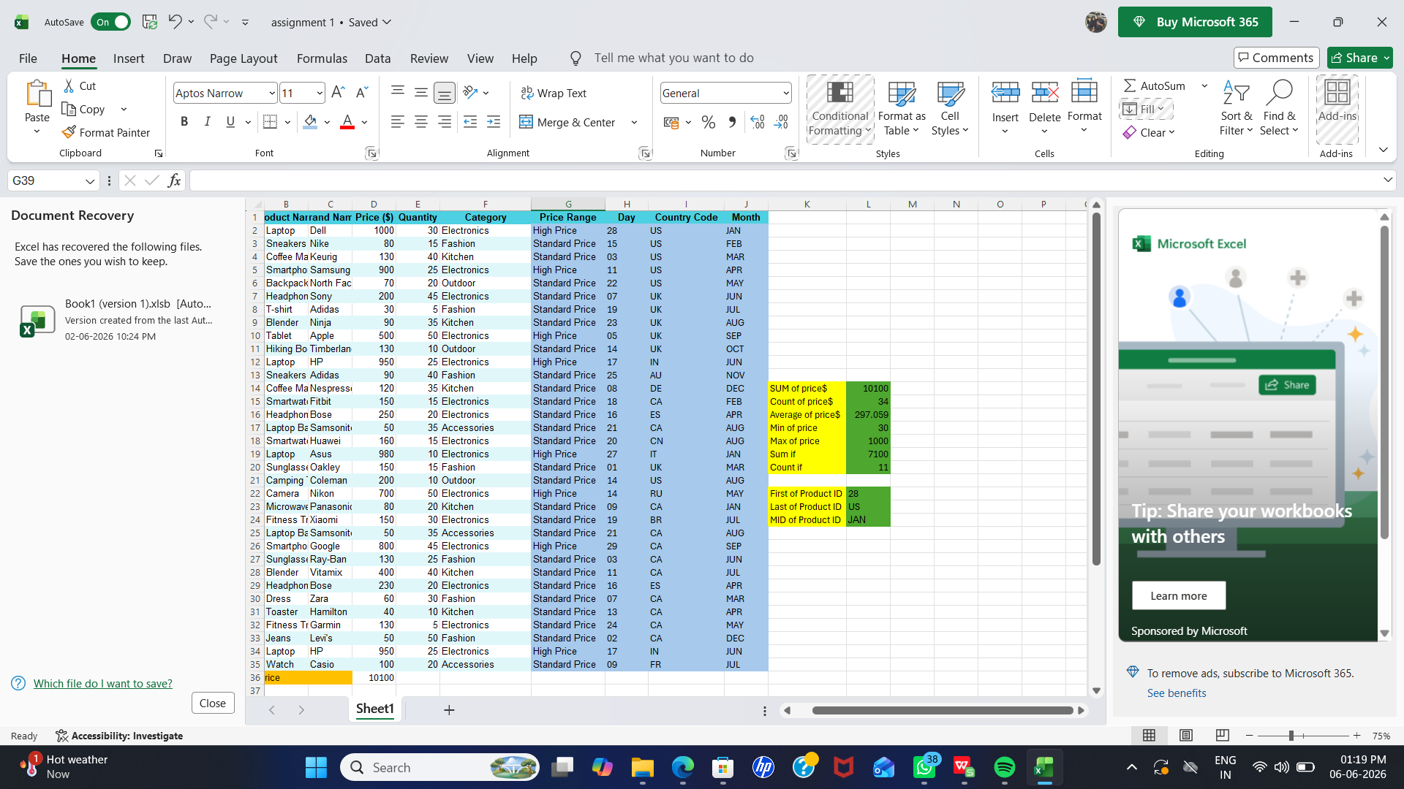
The screenshot above shows the completed Excel worksheet containing the dataset, Price Range classification, Day/Country Code/Month extraction, and the calculated results.

Results Summary
- Sum, Count, and Average calculated
- Minimum and Maximum price identified
- IF function used to classify products into High Price and Standard Price
- SUMIF and COUNTIF functions applied
- LEFT, RIGHT, and MID functions used to extract Product ID information

Conclusion
The Excel assignment was completed successfully. Various Excel functions were applied to analyze and process the dataset.

