The Global Energy Transition: A Heart-Wrenching Race Against Time Amid Carbon Politics

Key Takeaways:

- Global Progress with Setbacks: Renewable energy investments and adoption are rising in 2025, but CO₂ emissions remain at record highs, highlighting the urgent need to close the gap between ambition and action.
- Carbon Politics and Social Tensions: Emissions policies and carbon markets spark emotional debates worldwide—balancing climate goals with job losses, justice, and political resistance.
- Human Stories Power the Transition: From solar-lit villages in Africa to wind-powered classrooms in Morocco, inspiring local successes remind us that the energy transition is deeply personal and emotionally driven.

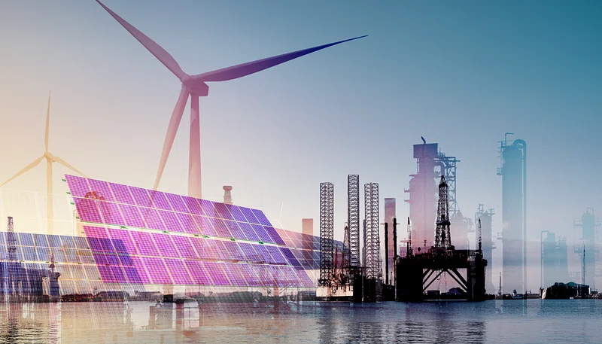

In the crisp autumn of 2025, as leaves turn fiery shades of red and gold, the world grapples with a far more scorching reality: our planet's feverish warming.

Imagine families in coastal villages watching rising seas swallow their homes, or farmers staring at parched fields where crops once flourished.

This isn't just a distant nightmare; it's the emotional toll of climate change, fueled by decades of fossil fuel dependence.

Yet, amidst this heartbreak, there's a flicker of hope—the global energy transition. This shift from coal, oil, and gas to renewables like solar, wind, and hydro isn't merely technical; it's a profound human story of innovation, struggle, and political intrigue.

Carbon politics, the heated debates over emissions reductions, taxes, and international agreements, add layers of frustration and urgency. As we delve into this worldwide saga, we'll uncover triumphs that inspire, setbacks that dismay, and the raw emotions driving humanity's quest for a sustainable future.

The Pulse of the Energy Transition in 2025: Progress Amid Peril

In 2025, the world’s vast web of power lines and pipelines is pulsing with change.
Global fossil fuel generation has dipped by 27 terawatt-hours—a small but hopeful victory—while renewables surge toward overtaking coal as the leading power source.
Clean energy investment is set to hit a record $3.3 trillion, proof of humanity’s resilience.
Yet CO₂ emissions still climb to new highs, revealing the painful gap between ambition and action.
The IEA warns that, despite $1.5 trillion flowing into electricity, millions remain in energy poverty. In regions scarred by fires and floods, the slow pace of transition feels like a marathon with weighted ankles.

Carbon Politics: The Fiery Arena of Global Debates

- A fight beyond policy: Carbon politics isn’t just bureaucracy—it’s an emotional clash over who pays for a greener world.
- Rising accountability: In 2025, 38 emissions trading systems (ETS) span the globe, expanding the fight to make polluters pay.
- Paris tension: The Paris Agreement’s goals—45% emissions cuts by 2030 and net zero by 2050—ignite both determination in leaders and dread among fossil fuel workers fearing job loss.
- Offset scandals: Once hailed as a climate fix, carbon offsets are now tainted by fraud and “intractable” flaws, with cases like Kenya’s illegal project exposing exploitation and broken trust.
- Public backlash: In Australia and Canada, carbon pricing sparks outrage—ordinary families bear higher costs while elites dodge responsibility.
- Uneven progress: The Climate Change Performance Index reveals a fractured world: bold pioneers on one side, laggards on the other.
- America’s crossroads: The Inflation Reduction Act envisions 100% clean power by 2035, yet political pushes like Project 2025 threaten to unravel it.
- Global irony: Even as leaders unite at COP summits, deep divisions persist—turning climate cooperation into both a triumph and a tragedy.

Regional Heartbeats: Triumphs and Tribulations Across Continents

Europe – Resilience in Motion
- The continent hums with renewal as LNG demand falls and wind and solar surge ahead.
- Germany and Denmark’s offshore wind farms stand like steel guardians of a cleaner future, bringing jobs and pride.
- Yet, political uncertainty post-elections casts a shadow—leaders walking the tightrope between energy security and green ambition.

Asia – Ambition Meets Anxiety
- China, the world’s top emitter, races ahead with a 35% jump in solar and 5% in wind installations, backed by $700 billion in investments. Skies clear, cities breathe again.
- In India, solar microgrids light up rural lives—empowering women, children, and hope itself. But urban sprawl and coal phase-out battles leave workers caught in emotional crossfire.

The Americas – From Outrage to Opportunity
- In the U.S., a renewables job boom sweeps across California and Texas—oil rig workers turning wind warriors.
- Brazil races forward with green patents and bioenergy innovation, though deforestation pains the Amazon’s heart.
- Canada’s carbon pricing backlash exposes the divide between policy ideals and the daily grind of fossil-reliant families.

Africa – Light and Longing
- Blessed with vast solar and wind wealth, nations like Kenya and South Africa chase a cleaner tomorrow.
- Community solar projects light up schools and clinics, stirring joy and pride—yet energy poverty still grips millions.
- Frustration brews as wealthier nations dominate global talks, leaving Africa yearning for fairer support.

The Middle East – Heritage in Transition
- From oil to sunlight, Saudi Arabia and the UAE invest billions in renewables, crafting a new economic identity.
- Solar farms bloom in the desert, symbols of transformation—but beneath the optimism lies emotional conflict, as pride in oil legacies meets the urgency of change.

Inspiring Success Stories: Beacons of Hope

Amid the gloom, success stories ignite passion and pride. Globally, 65% of countries improved their Energy Transition Index scores in 2025, advancing in security, sustainability, and equity.

Energy storage installations rose 76%, and EV sales continue to climb, electrifying commutes and reducing urban pollution that once suffocated lungs.

In Latin America, Indigenous-led lawsuits—over 50% of global cases since 2009—protect lands from extractive projects, empowering communities with a sense of justice.

These tales aren't abstract; they're about real people. Think of a fisherman in Vietnam whose solar-powered boat saves fuel costs, allowing him to feed his family better, or a teacher in Morocco using wind-generated electricity to inspire the next generation.

Such victories fuel emotional resilience, proving that collective action can heal our wounded planet.

The Daunting Challenges: Frustrations and Fears

No transition is without tears. Economic hurdles loom large: while investors accelerate into energy efficiency (64%) and renewables (56%), 75% still fund fossil fuels, a conflicting reality that exasperates activists.

Socially, job displacements in coal towns evoke heartbreak, as families face uncertainty.

Politically, growing divisions—23% of experts cite state-based conflicts as top risks—amplify fears that geopolitical tensions could derail progress.

Greenwashing in carbon markets adds insult to injury, with scandals eroding faith in voluntary credits.

Citizens grow anxious about climate, yet wane in confidence toward governments, a disheartening trend across 33 countries.

The paradox of global carbon credits—promising yet flawed—leaves many feeling betrayed.

A Hopeful Horizon: Emotions Guiding the Way Forward

Looking to the future, 2025's lessons from BloombergNEF remind us: clean tech will grow, and the transition won't halt, even if arduous.

Advancements in carbon capture and stricter regulations promise breakthroughs, stirring excitement. Nations updating Nationally Determined Contributions (NDCs) could reignite global momentum, fostering unity.

Yet, success demands tailored solutions—country-specific, inclusive of all voices—to avoid leaving anyone behind. It's an emotional imperative: empathy for the displaced, joy in shared victories, and fierce determination to press on.

Conclusion: Our Shared Emotional Odyssey

The energy transition and carbon politics of 2025 are more than statistics; they're a tapestry woven with human emotions—fear, hope, anger, love.

As we stand at this crossroads, let's channel our collective heartache into action.

Support policies that heal, innovate with passion, and hold leaders accountable.

For our children, for the earth that cradles us, let's turn this race into a triumphant embrace of a sustainable world. The journey is fraught, but oh, the glory of arriving together.

