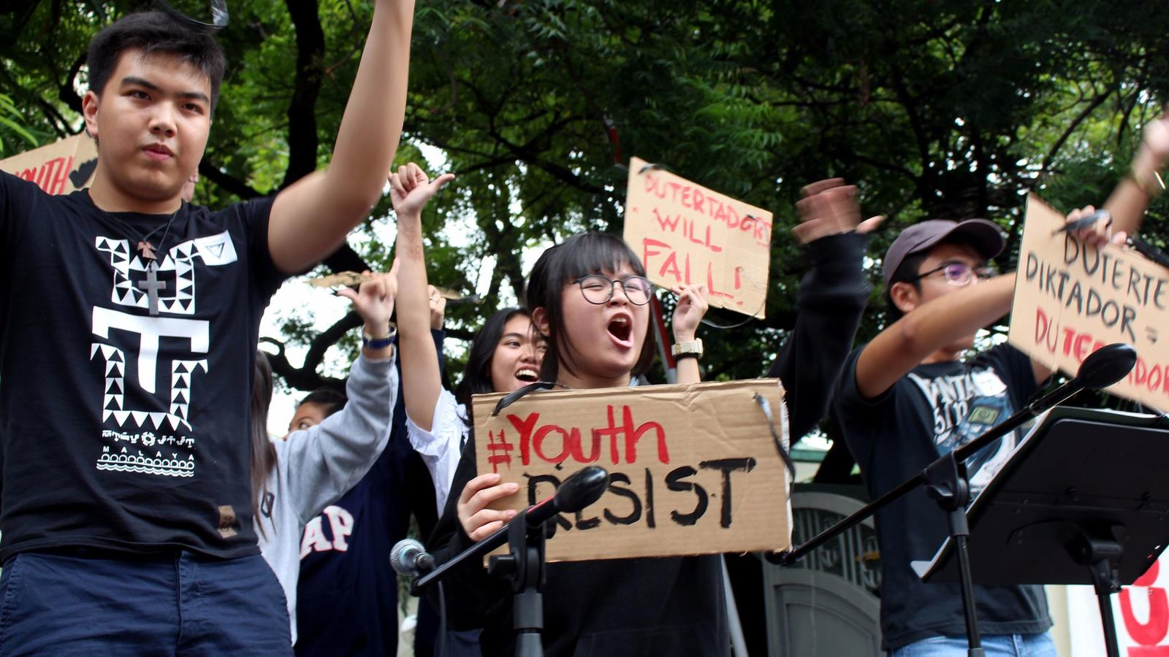

The Fire Within: Youth Activism and Protests Igniting Change Across the Globe

- Global Surge of Youth Protests: From Kenya to Nepal, Gen Z is rising against corruption, inequality, and climate inaction—sparking tangible political changes and igniting a worldwide movement of digitally connected, emotionally driven activism.

- Powerful Impacts with Deep Costs: Youth-led movements raise awareness, topple regimes, and empower new leaders, but also bring dangers—ranging from police brutality and deaths to emotional trauma and societal instability.

- The Urgent Need for Support and Sustainability: To harness the transformative power of youth activism, governments and societies must ensure safety, mental health support, and genuine inclusion—turning fleeting protests into lasting progress.

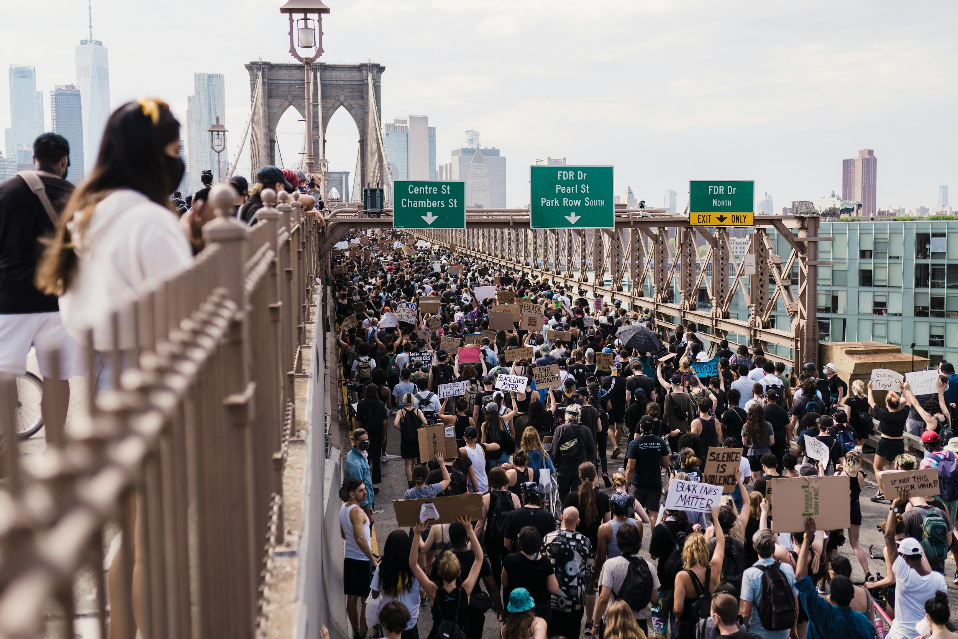
Protest— youth activists all over the world

In the bustling streets of Nairobi, Kenya, a sea of young faces, flushed with determination and defiance, chants echoed through the air in June 2024. These weren't just shouts; they were the raw cries of a generation weary of corruption, economic hardship, and unfulfilled promises.

Gen Z protesters, armed with smartphones and unyielding passion, forced President William Ruto to withdraw a controversial finance bill, sack his cabinet, and even engage in dialogue—victories that rippled like shockwaves across Africa and beyond.

This scene, repeated in Nepal where youth-led uprisings toppled a government in September 2025, or in Morocco and Madagascar where fervent demonstrations against governance failures left dozens injured and heartbroken families mourning lost lives, encapsulates the surging tide of youth activism worldwide.

Youth activism refers to the collective efforts of young people, typically under 30, to challenge systemic injustices through protests, campaigns, and advocacy.

From climate strikes that paralyzed cities globally in 2019 to the Black Lives Matter (BLM) movement's anguished outpourings against racial violence in 2020, these actions stem from a deep-seated frustration with the status quo.

In an era of polycrisis—climate change, economic inequality, political corruption, and social marginalization—young activists feel the weight of a world teetering on the brink, their hopeful dreams clashing against harsh realities.

A Historical Tapestry of Youthful Rebellion

The roots of modern youth activism stretch back decades, woven with threads of courage and sacrifice.

In the 1960s, American youth, fueled by righteous anger over the Vietnam War and civil rights injustices, marched in Washington, D.C., their voices trembling with emotion as they demanded peace and equality.

These protests, often met with tear gas and batons, not only shifted public opinion but also inspired global echoes, like the student uprisings in Paris in 1968 that nearly toppled the French government.

Fast-forward to the 21st century, and the Arab Spring of 2010-2011 showcased the digital savvy of young Arabs in Tunisia, Egypt, and beyond. Passionate bloggers and protesters, hearts pounding with excitement and fear, used social media to organize, toppling dictators like Hosni Mubarak in Egypt.

Yet, the euphoria was short-lived; many felt betrayed as new regimes failed to deliver promised reforms, leaving a bittersweet legacy of empowerment mixed with disillusionment.

More recently, the 2019 global climate strikes, inspired by Swedish teenager Greta Thunberg's solitary protest, saw millions of youths skip school in over 150 countries, from Australia to India. Their faces, painted with urgent pleas like "There's No Planet B," radiated a mix of youthful innocence and grave determination.

In 2020, amid the COVID-19 pandemic, BLM protests erupted across the U.S. and internationally, with young people channeling grief over George Floyd's death into powerful demonstrations that highlighted systemic racism. These movements, amplified by platforms like Twitter (now X) and TikTok, demonstrated how digital tools could turn isolated frustrations into global symphonies of change.

In Africa, youth have long been at the forefront. The 2019 Sudanese Revolution, led by young professionals and students, ousted Omar al-Bashir after months of resilient sit-ins, despite brutal crackdowns that left protesters mourning fallen comrades.

Similarly, in Asia, Hong Kong's 2019 pro-democracy protests saw teenagers braving tear gas, their eyes stinging not just from chemicals but from the pain of watching freedoms erode.

These historical threads reveal a pattern: youth activism often arises from marginalization, igniting when the burden of inequality becomes unbearable, and leaving indelible marks on the world's political fabric.

Current Waves: Protests Rippling Across Continents

Today, in 2025, youth protests are surging with unprecedented fervor, driven by economic woes, climate anxiety, and governance failures.

In Africa, the continent's youthful population—over 60% under 25—has become a force of nature. Kenya's Gen Z uprising in 2024, sparked by tax hikes, evolved into demands for accountability, with protesters' chants echoing desperate pleas for jobs and justice. The movement spread like wildfire, inspiring similar actions in Uganda, Nigeria, Malawi, and Zimbabwe, where young voices, hoarse from shouting, decry corruption and unemployment.

Further south, in Madagascar, weeks of protests against water shortages and corruption have turned deadly, with 22 lives lost in clashes that left families shattered and communities in mourning.

In Morocco, youth rage over government spending on the 2030 FIFA World Cup instead of education and healthcare has led to violent confrontations, killing two and injuring hundreds, their blood staining streets as a poignant reminder of unheeded cries.

Togo and Gambia join this chorus, with protesters in Lomé and Banjul facing repression while demanding fair governance, their resilient spirits unbroken despite the fear.

Asia is no stranger to this fervor. In Nepal, September 2025 saw youth-led protests force a government change, their jubilant celebrations masking the underlying frustration with political instability.

Bangladesh's student-led movement against job quotas in 2024 escalated into a nationwide revolution, toppling Sheikh Hasina's regime amid heart-wrenching violence that claimed hundreds of lives.

In Indonesia and the Philippines, young activists, eyes blazing with hope, protest corruption and environmental degradation, drawing inspiration from anime and pop culture to mobilize peers.

Peru and Serbia have seen similar uprisings, with youths in Lima and Belgrade marching against inequality, their steps heavy with the weight of generational burdens.

Even in Europe and the Americas, echoes resound. Climate actions continue, with young Europeans in Germany and Austria striking for greener policies, their youthful optimism clashing against political inertia.

In Ecuador, three weeks of strikes in 2025 paralyzed the nation, youths demanding reforms amid economic despair. These protests, often organized via social media, blend digital innovation with on-the-ground passion, creating a global network of empathetic solidarity.

The Radiant Advantages: Sparks of Hope and Transformation

The advantages of youth activism are luminous, illuminating paths toward a better world and infusing societies with renewed vigor.

Foremost, these movements raise awareness, turning whispers of injustice into thunderous demands.

In the climate strikes, young protesters' fervent pleas have pressured governments to adopt greener policies, fostering a global consciousness that saves ecosystems and inspires hope for future generations. Their passionate energy has led to tangible revolutions, like in Sudan and Bangladesh, where corrupt leaders fell, paving the way for democratic reforms and alleviating deprivation for millions.

On a personal level, activism empowers youth, transforming timid individuals into courageous leaders. Participating in BLM protests, for instance, boosted civic engagement among adolescents, instilling a sense of purpose and community that combats isolation.

In low-income areas, these actions yield community benefits, like improved human rights and alliances that bridge divides, creating bonds forged in shared joy and triumph. Digitally, platforms enable rapid mobilization, allowing young voices from Uganda's Vanessa Nakate to Australia's Ambrose Hayes to connect globally, amplifying marginalized stories and evoking empathy worldwide.

Moreover, protests pressure diplomats and institutions, leading to policy shifts. The UNICEF report highlights how youth actions in polycrisis contexts build better futures by addressing environmental and social issues, infusing societies with innovative ideas from fresh perspectives.

Emotionally, the exhilaration of marching alongside peers fosters resilience, turning despair into defiant hope and creating legacies of progress that warm the hearts of entire nations.

The Shadowed Disadvantages: Pain, Peril, and Pitfalls

Yet, the path of activism is fraught with shadows, where advantages give way to profound disadvantages that wound individuals and destabilize societies.

The risks are visceral: young protesters often face physical harm, as seen in Morocco's deadly clashes or Madagascar's mounting death toll, leaving families in agonizing grief and communities fractured by loss.

In Kenya and Uganda, police brutality has scarred young bodies and spirits, with arrests and injuries evoking widespread fear and trauma.

Mental health suffers deeply; studies show that exposure to protests worsens psychological well-being, with youths reporting anxiety, depression, and a haunting sense of futility amid repression. The BLM movement, while empowering, left many adolescents grappling with emotional exhaustion, their initial passion dimmed by the weight of ongoing injustice.

Digital activism, though advantageous, has drawbacks like "slacktivism"—superficial engagement that dilutes real change—and the spread of misinformation, which can escalate conflicts and sow confusion.

In polycrisis scenarios, protests can lead to instability, as in Ecuador's paralyzing strikes or Zimbabwe's stifled dissent, disrupting economies and heightening vulnerability for the very marginalized groups they aim to help.

Youth often feel instrumentalized, thrust into the front lines without true agency, their sacrifices exploited by older leaders, breeding resentment and disillusionment.

Globally, these movements can polarize societies, inviting backlash from authorities who label protesters as disruptors, further entrenching divisions and evoking a cycle of frustration and despair.

A Balanced Flame: Reflecting on the Future

Youth activism and protests, with their blend of radiant advantages and shadowed disadvantages, embody the human spirit's complex dance between hope and hardship.

They propel the world toward justice, yet demand we acknowledge the toll on young hearts and minds. As movements continue in Nepal, Morocco, and beyond, the key lies in channeling this passion constructively—ensuring safety, amplifying voices, and bridging generations for sustainable change.

In the end, these courageous youths remind us that amid the chaos, their resilient fire can light the way to a more equitable world, if only we listen to their emotional pleas.

