Date: | May 30, 2013
Name: | Lucy Hutcheson
Course: | APD
Director: | Wendy Jones
document: | Application Design Document
HOUSE BOSS

OVERVIEW: http://youtu.be/qE0u4cGIMsk

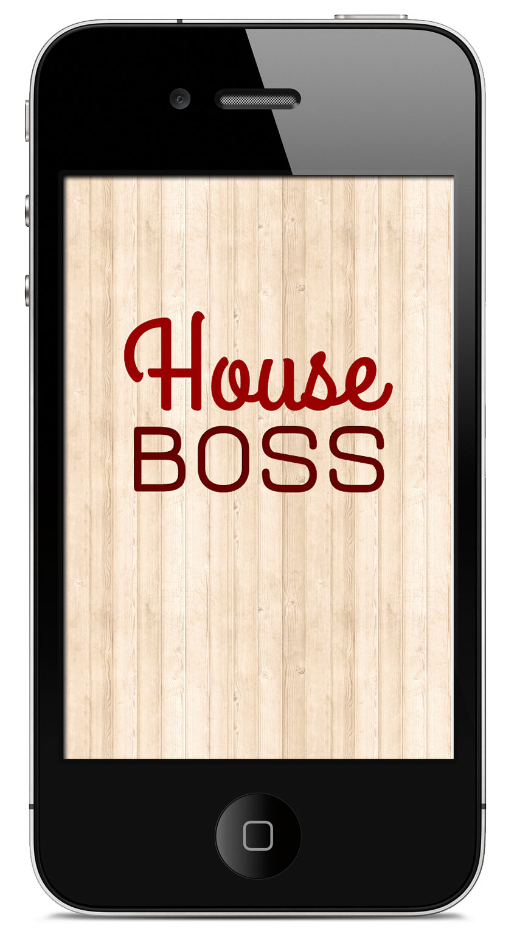
Application Definition Statement
A concise, concrete declaration of the application’s main purpose and its intended audience

Purpose or Main Intent
An application that allows the tracking of home maintenance tasks.

Description of Intended Audience
Homeowners or renters that want to maintain his or her home by being reminded of maintenance tasks throughout the year.

Core Functionality
Allows adding, editing, deleting of home reminders and other home information like brands, filter sizes, etc.

Application User Feature Set
A list of features from the user’s perspective

- Users can view their home reminders
- Users can add a new home reminder
- Users can edit their home reminders
- Users can delete home reminders
- Users can add notes for each home reminder
- User has the ability to take pictures and save it to an album
- User has the ability to add pictures to each reminder
- User has the ability to take videos
- User has the ability to post to their Twitter timeline
- User has the ability to view current weather information

Application Breakdown
All the views and screens in the application broken down with functionality and data
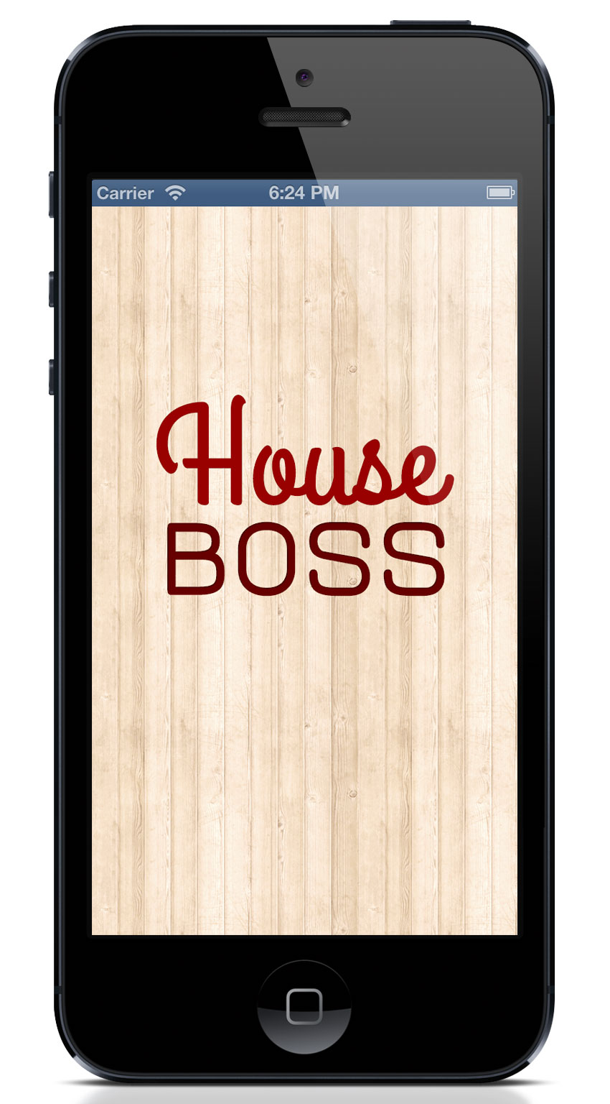

Title Screen

Description: The name of the application is House Boss. The icon will consist of a house and a clock.

UI Screens

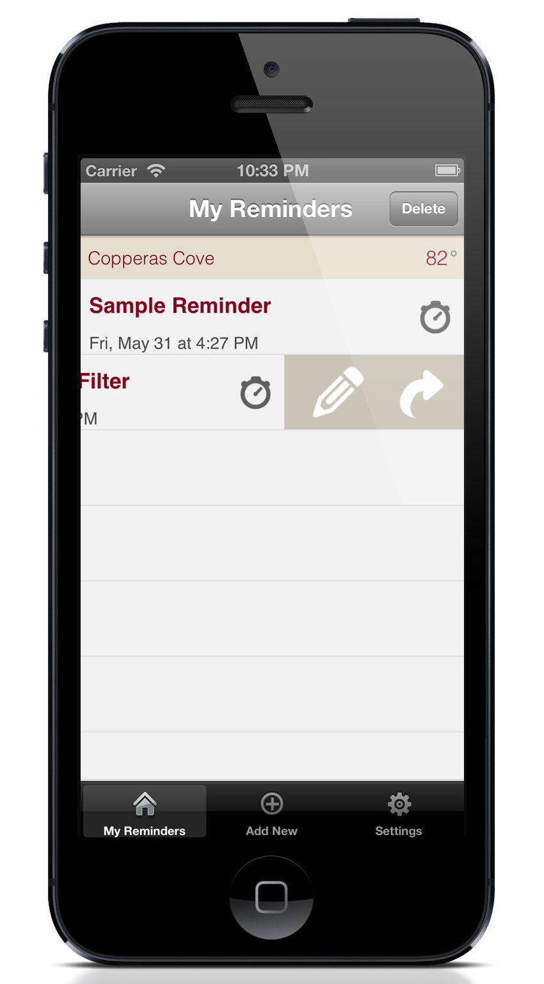

Main Reminders View

Description: The main UI consists of a list of reminders in a table view. Clicking on one of the reminders allows additional controls to become visible.

Main Purpose: The main purpose of this view is to allow users to view their reminders, add new reminders, change user settings.

Functionality:
  - Tableview – The tableview consists of a list of reminders.
    - Each tablecell will contain the name of the reminder, the next date and time that you will be reminded.
    - Clicking or swiping on a post will animate out a menu from the right side of the cell containing the following buttons: edit (edit or delete) and share (tweet or email).
    - Selecting the edit button will display the edit reminder view (see Edit Reminder View Description) with the reminder information already filled out.
    - Selecting the share button will display a popup asking if the user would like to tweet or email someone about this reminder. (See Share popup description)
  - Selecting the Add New button will display the New Reminder view (see New Reminder View Description).
  - Selecting the Settings will present the User Settings View (see User Settings View Description)
  - Selecting the Home button will display the Main Reminders View

Data Needed: Data necessary for this page consists of a JSON feed from the weather server. See the JSON data schema for details.

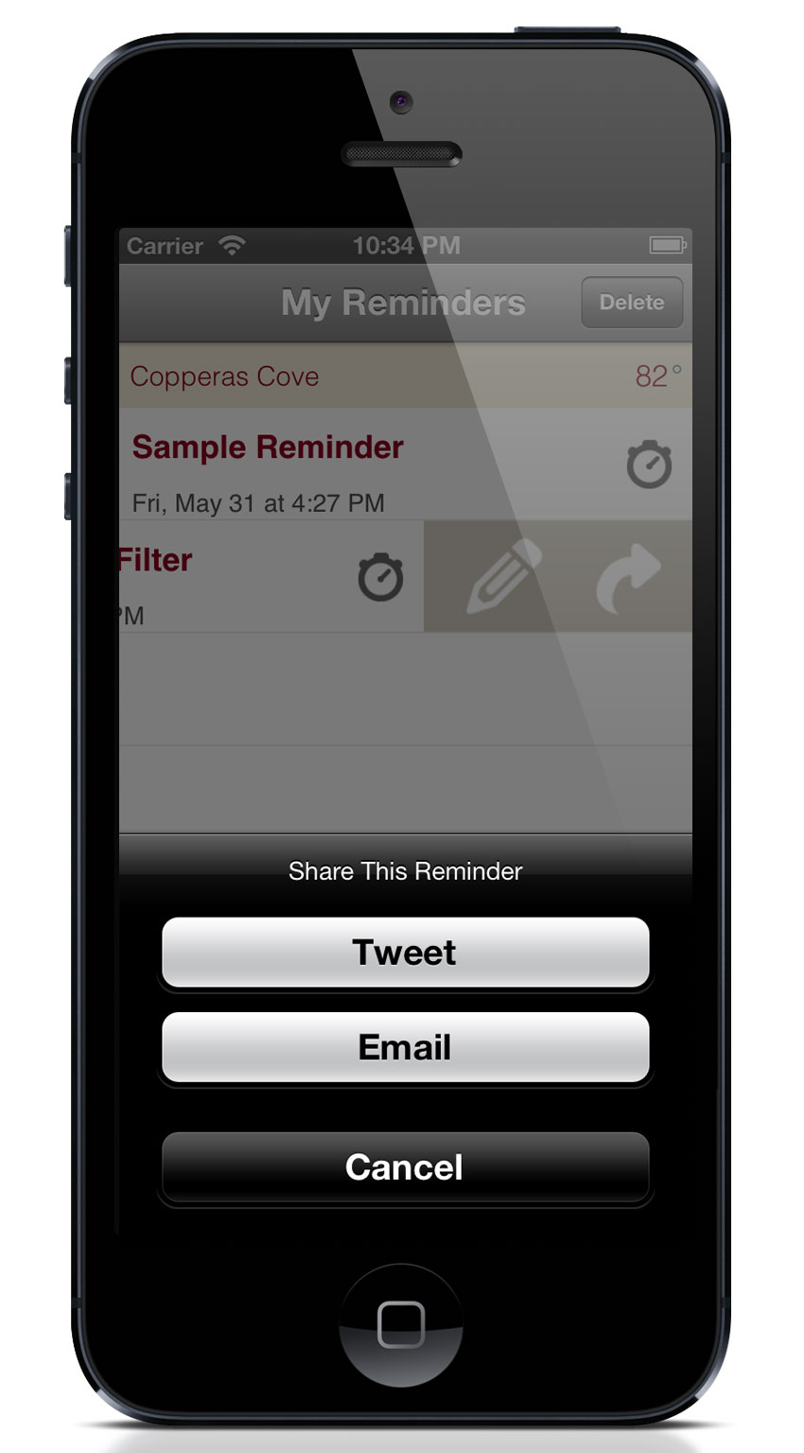

Share Popup View

Description: The UI consists of an action sheet with a tweet and email button.

Functionality:
  - Clicking on the tweet button will open up the Twitter posting view (see Twitter Posting View Description).
  - Clicking on the email button will open up the Email view (see Email View Description).

Data Needed: No data needed.

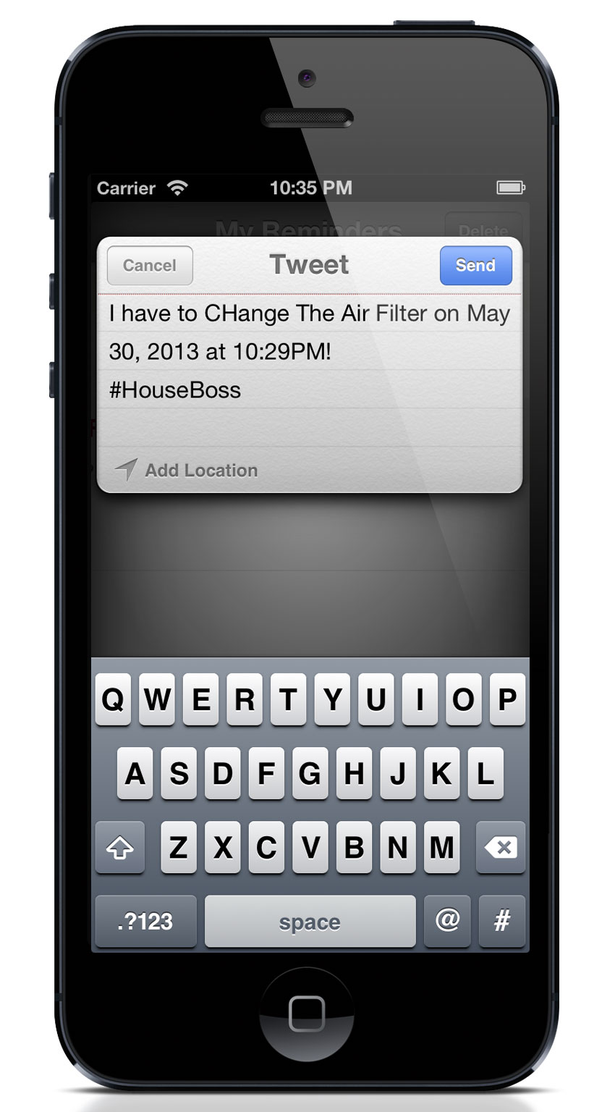

Twitter Posting View

Description: The UI consists of an action sheet with a tweet and email button.

Functionality:
  - Clicking on the tweet button will open up the Twitter posting view (see Twitter Posting View Description).
  - Clicking on the email button will open up the Email view (see Email View Description).

Data Needed: No data needed.

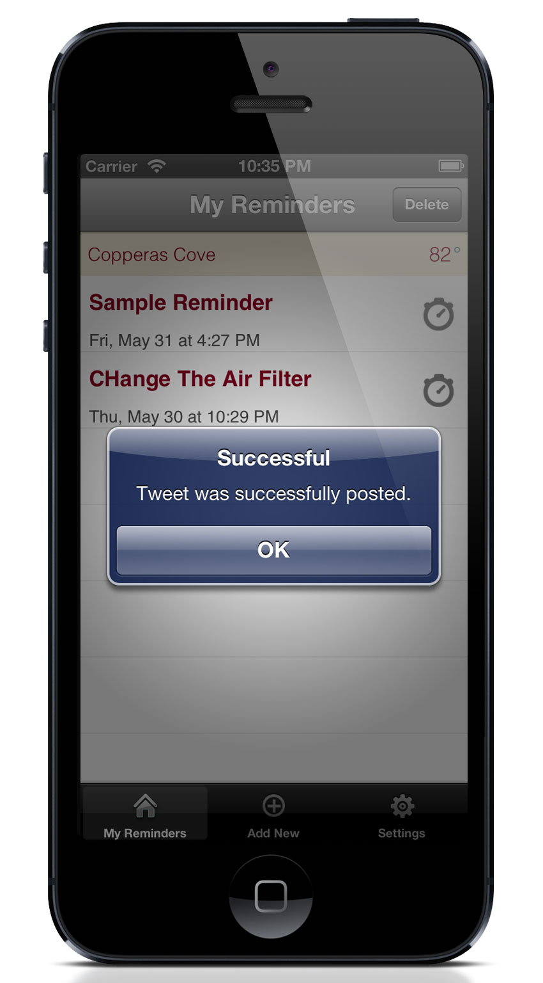

Twitter Successful Post Alert

Description: The UI consists of an alert that the tweet was successful with an Ok button.

Functionality:
  - Clicking on the Ok button dismisses the alert and sends user back to main list view.

Data Needed: No data needed.

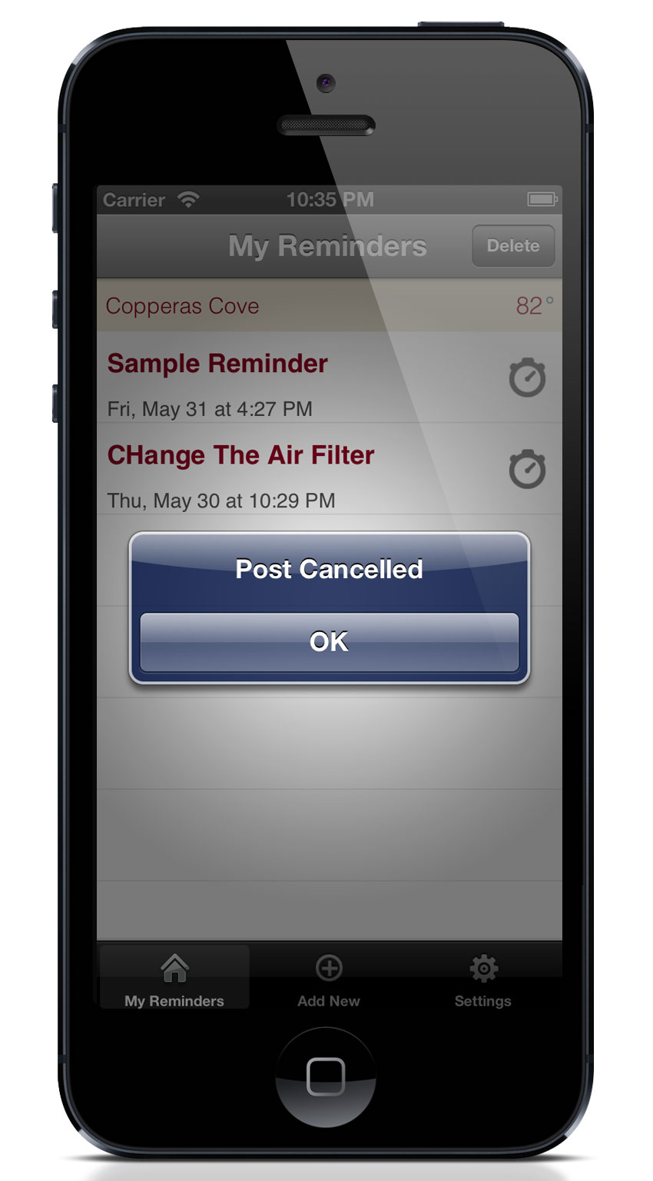

Twitter Cancelled Post Alert

Description: The UI consists of an alert that the tweet was cancelled with an Ok button.

Functionality:
  - Clicking on the Ok button dismisses the alert and sends user back to main list view.

Data Needed: No data needed.

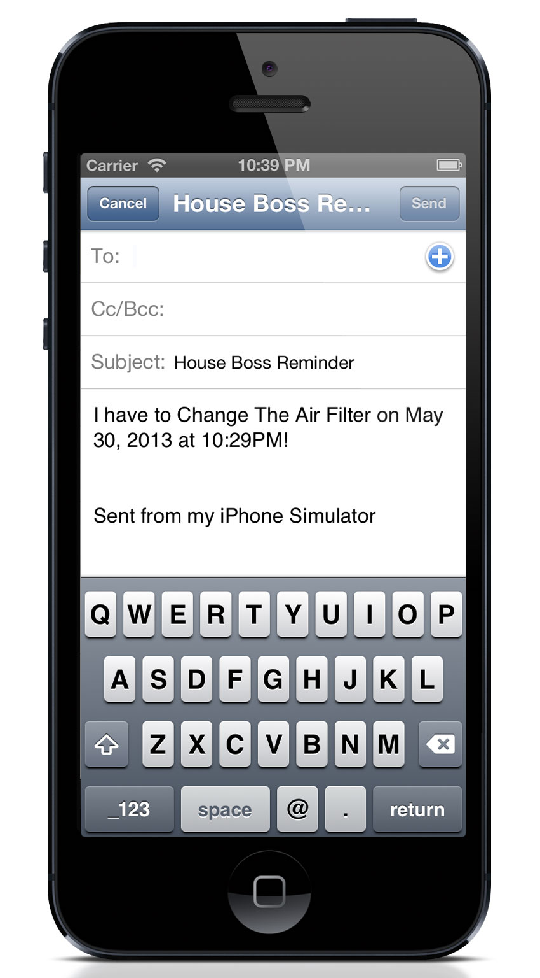
Email View

Description: The UI consists of email fields with To, Cc, Subject, Body, Send button, Cancel button.

Functionality:
  - Clicking on the tweet button will open up the Twitter posting view (see Twitter Posting View Description).
  - Clicking on the email button will open up the Email view (see Email View Description).

Data Needed: No data needed.

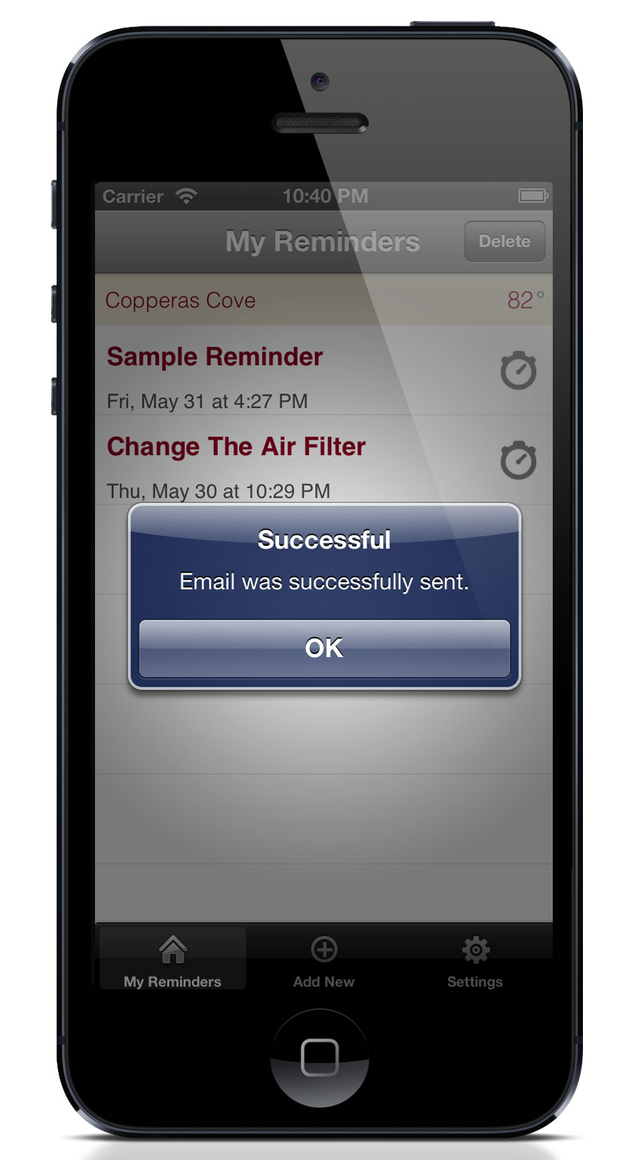

Email Successful Alert

Description: The UI consists of an alert that the email was successful with an Ok button.

Functionality:
  - Clicking on the Ok button dismisses the alert and sends user back to main list view.

Data Needed: No data needed.

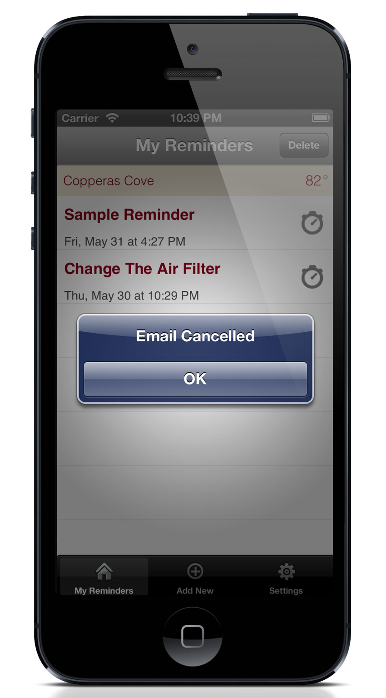

Email Cancelled Alert

Description: The UI consists of an alert that the email was cancelled with an Ok button.

Functionality:
  - Clicking on the Ok button dismisses the alert and sends user back to main list view.

Data Needed: No data needed.

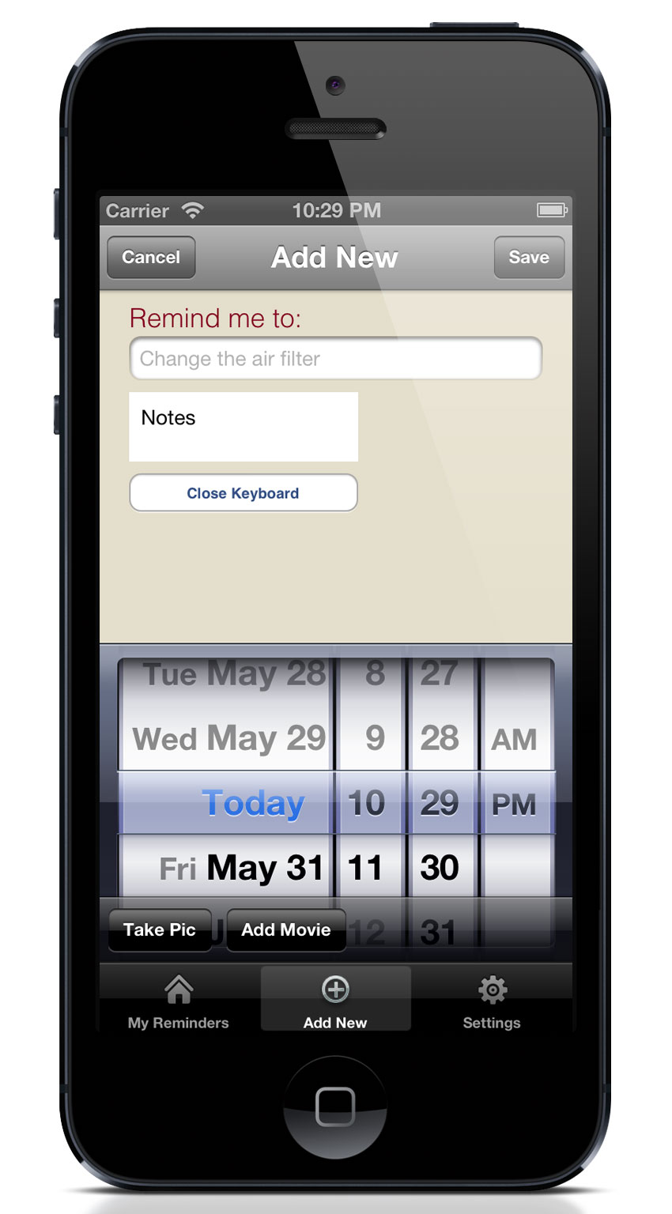

New Reminder View

Description: The UI consists of a text field, text area, picker, save and cancel button.

Functionality:
  - Entering into the text field will bring up the keyboard.
  - Entering into the text area will bring up the keyboard.
  - Date and time selected with the picker will be saved

Data Needed: No data needed.

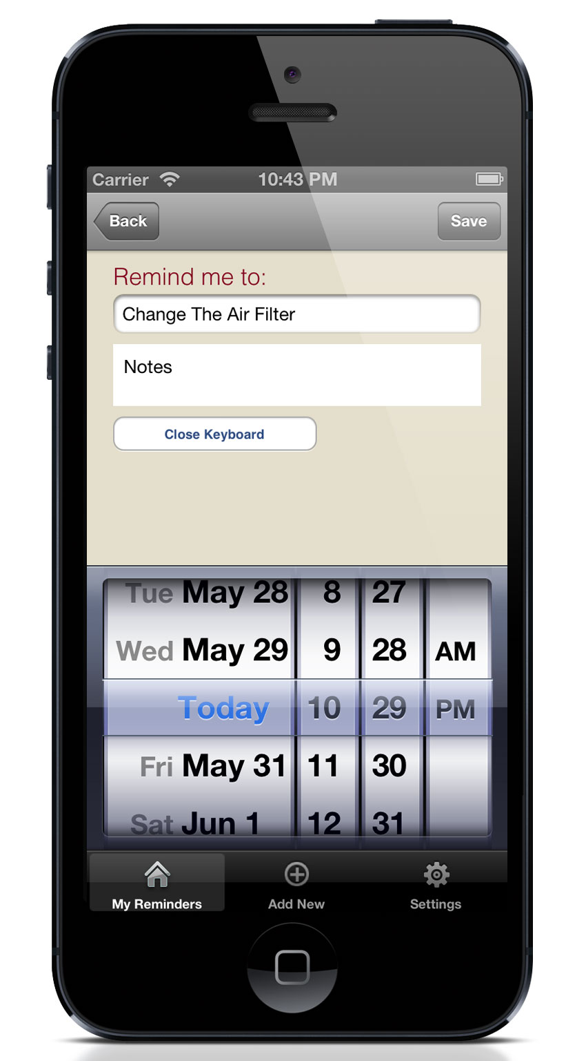

Edit Reminder View

Description: The UI consists of a text field, text area, picker, save and cancel button.

Functionality:
  - Entering into the text field will bring up the keyboard.
  - Entering into the text area will bring up the keyboard.
  - Date and time selected with the picker will be saved.
  - Clicking on the Delete button will bring up the Delete Alert (see Reminder Delete Alert).
  - Clicking on Cancel will send user back to main list view.
  - Clicking on the Save button will save the reminder and bring up the Successful alert (see Reminder Successful Alert).

Data Needed: Local data from current reminder.

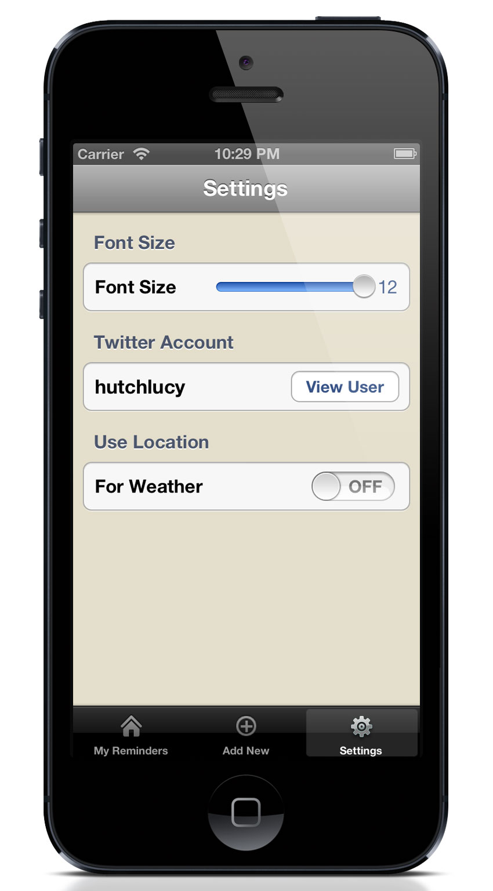
Settings View
Description: The settings screen gives the user the ability to update the font size settings for the application.
Main Purpose: The main purpose of this screen is to collect settings information usable throughout the application.

Functionality: The view consists of a scrollable tableview with one
- Font size slider can be changed on this page and saved when you navigate away from page
- Clicking on “View User” will bring up the Twitter User info
- Clicking on “On/Off” Weather switch will save the selection

Data Needed: This view utilizes a plist to store the settings data and is saved when the user exits the screen. See the Settings schema for details on data.

Settings Data Schema
Data Description: The settings for the application are stored in a plist using the following keys:
- Font Size – integer
- Twitter – string
- Weather – string

Application Flow
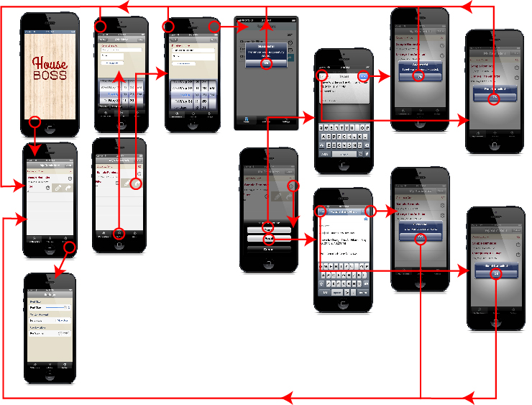
The Flow of UI through the Application

Application Project Features

- UIKit – Tab Bar (5points)
- UIKit – Nav Bar (5 points)
- UIKit – Toolbar (4 points)
- UIKit – Modal View Popup (4 points)
- UIKit – Table View with multiple sections (5 points)
- UIKit – UIAlertView (2 points)
- UIKit – UIImage View (2 points)
- UIKit – Table Cell Animation (5 points)
- UIKit – Editable Table Cells (5 points)
- UIKit – Custom TableView Cells (4 points)
- UIKit – Swipe Gesture (2 points)
- UIKit – Table headers (2 points)
- Multimedia – Photo Capture (8 points)
- Multimedia – Movie Capture (8 points)
- OS Integration – User Defaults (4 points)
- OS Integration – Local Notifications (3 points)
- OS Integration – Ability to send email (3 points)
- OS Integration – Standard and Retina Graphics (5 points)
- Web Services – JSON via Web Service (8 points)
- Web Services – Twitter Account (3 points)
- Web Services – Twitter Posting (5 points)
- Coding – Code Blocks (5 points)
- Advanced – 3rd Party Library (3 points)

