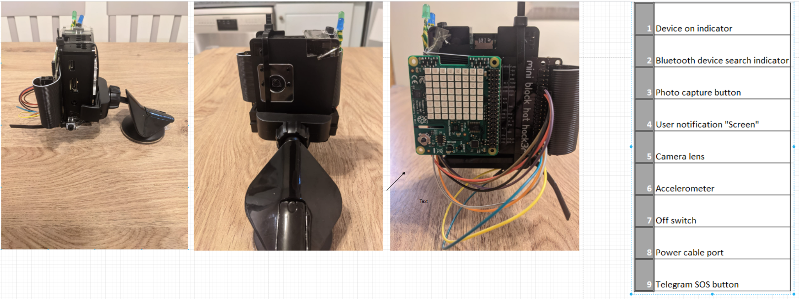

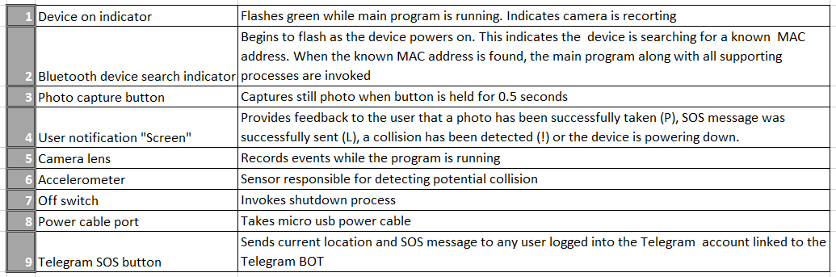

**Operating Procedure**

* **Power the device with micro USB cable via the cockpit power outlet**
* **Allow the device time to power up**
* **Ensure mobile tethering is enabled on your smartphone to provide internet connection to Raspberry Pi device**
* **Run Blynk AutoPi app to provide current location**
* **Note the blue flashing light indicator searching for known devices using hardcoded MAC address**
* **Toggle on smartphone Bluetooth connectivity**
* **Device should begin to record if known MAC address is detected in device PAN**
* **Collision detection procedure will trigger if rapid change in acceleration is detected**

**Collision Detection procedure**

* **When collision is detected.** 
  + **The device stops recording**
  + **Sub processes providing/updating location data are ceased to encapsulate a point in time**
  + **Video files are converted from h264 to mp4**
  + **An SOS message is posted to telegram API BOT**
  + **Video footage leading up to the potential accident is also shared to Telegram AutoPi BOT**
  + **Video footage and the latest image captured on the device are pushed to Firebase realtime DB**
  + **The original h264 files are removed from the device to ensure faster power up times**
  + **Finally the poweroff process is initiated.**