**CODE GLADIATOR**

DEBUG ROUND :-

**TEAM MEMBERS:**

* DEBASHIS GHOSH (iamdeba.g@gmail.com)
* SHUBHAM KUMAR (shubhamshaw035@gmail.com)

IDE USED: Dev-C++ 5.11

**PROBLEM STATEMENT:**

This program is a simple calculator that reads its input from a character buffer. If integers are read, they are pushed on a stack. If one of the operators (+ - * ⁄) is read, the top two elements are popped off the stack, the operation is performed on them, and the result is pushed on the stack. The = operator writes out the value of the top element of the stack to a buffer.

**DEBUGGED CODE SNIPPET**

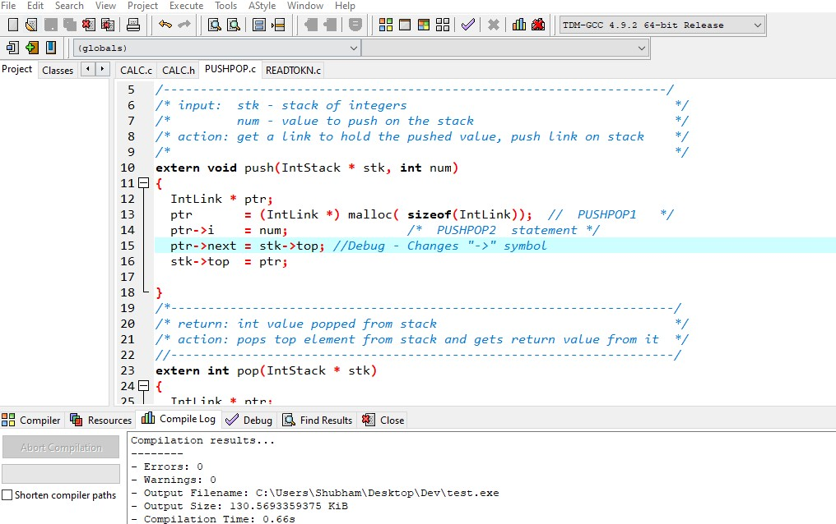

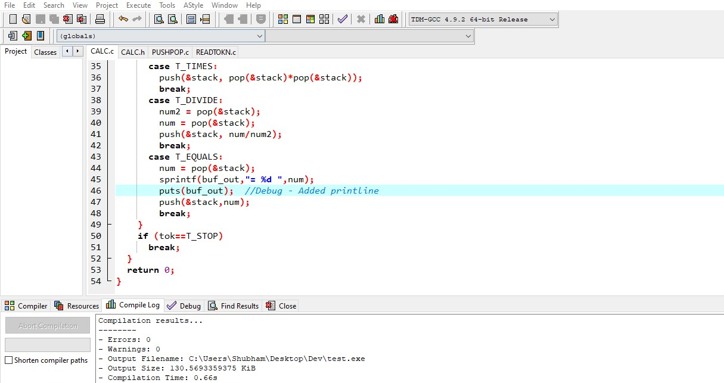

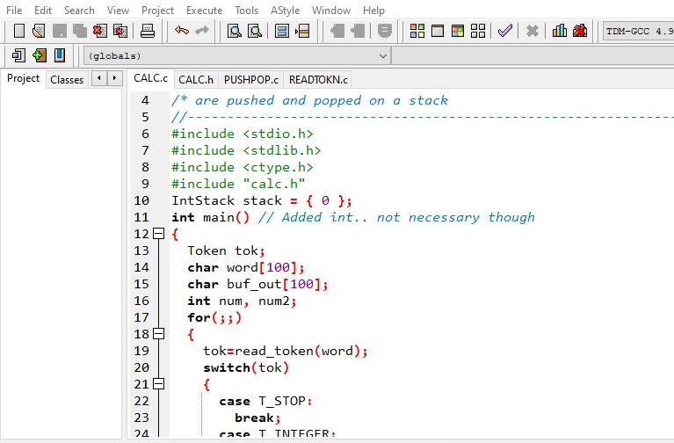

**OUTPUT:**

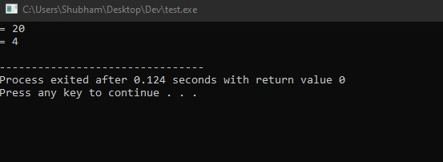

Thanking You!!